### **Steps**

1. Read carefully the case study
2. Work on the use case (detailed info to follow)
3. Share with us your responses by the time agreed with Talent Acquisition
   1. The analysis in the notepad of the tool(s) you decided to work on
   2. The tables populated with the figures you calculated.

Description:

A member of SB Team has contacted last minute to help her with some data needed for a Top Management presentation.

The case she wants to advocate about is whether the German Sportsbook players bet more on club Soccer Leagues, such as Champions League, Bundesliga etc. or they are equally passionate about International Football Championships such as EURO. Based on the results, the sportsbook team will decide if it is worth investing more on the upcoming World Cup.

Your task is to fill out the following tables with data.

**Table 1:** Per Championship as reported on Sportsbook Table, share the following numbers.

*Note 1: First bets should refer to customers that have registered within the period in scope.*

*Note 2: Avg Customer Value can be calculated by dividing Turnover by Customers*

*Note 3: Similar calculation should be done for Avg Bet Value*

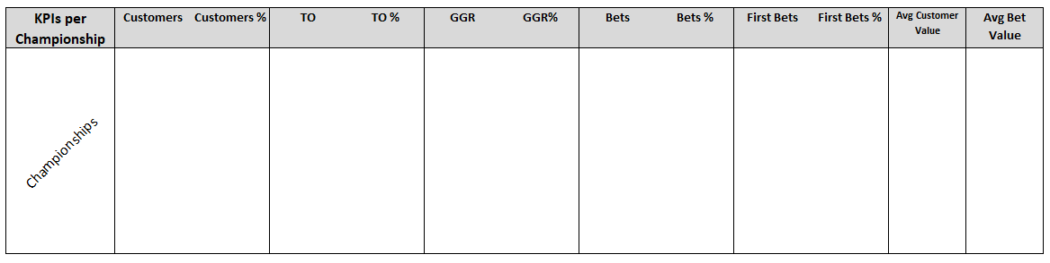

**Table 2:** Per month based on placement dates, we need to report the customer distribution per CRM Level.

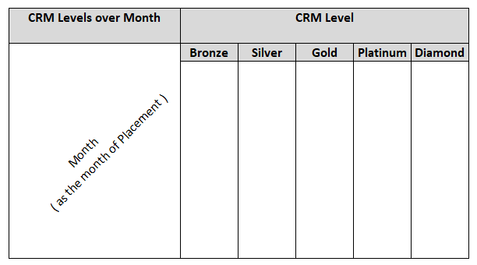

**Table 3:** Same as Table 2, but instead of all customers, we need to focus on customers registered on this month.

Data you will need:

**CRM Level.csv**

* SportBetSettled_Customer_ID: Unique customer ID
* Date_YearMonth: Month that the label was assigned
* CRM_Level: CRM Level Label

*HINT – For the months between two labels, CRM Level per customer is the latest level received.*

*Example: Customer A is Bronze on Oct ’18 & Silver on Jan’19, hence during November & December Customer A was Bronze.*

**Registrations.csv**

* SportBetSettled_Customer_ID: Unique customer ID
* Registration_Date: Day the customer registered

**Sportsbook.txt**

* Event_Class_Name: Championship
* SportBetSettled_Bet_ID: Bet ID
* SportBetSettled_Customer_ID: Customer ID
* SportBetSettled_Settled: Bet Settlement Date
* SportBetSettled_Placed: Bet Placement Date
* Channel_Name: Device
* Turnover: Value of Bet Placed
* Winnings: Value of Bet Winnings

*HINT – Gross revenue is an important KPI which is calculated as (Turnover – Winnings)*