Q1.
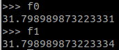
Q2.

a)

= Cardinal
= Ordinal

b)
It compares both the number of ordinals and cardinal moves of the current cell with the given distance.

c)
__add__(self, distance)

d)
from_separation(idx0, idx1)

Q3)

a)
g_cost = f_cost = inf , h_cost = 0

b)
When the cell is unknown, free and not inflated.

Q4)

a)
(1,4) is an idx while (1.23, 3.921) is a pos. Both tuple can be pos.

b)
occ_grid.idx2cell((1,2)).is_occupied()

c)
update_at_idx(self, idx, occupied)

d)
mask_idx

Q5)
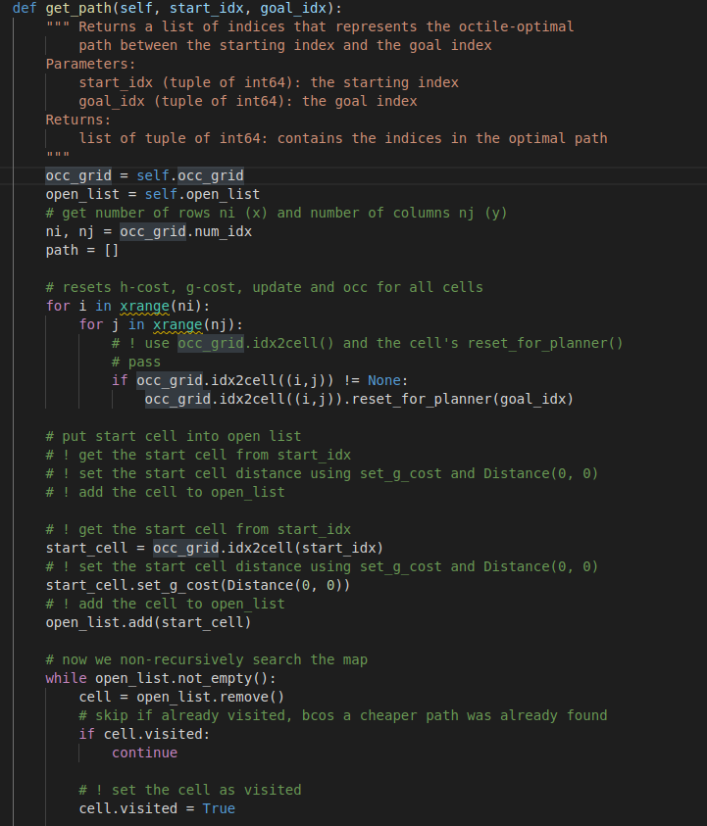
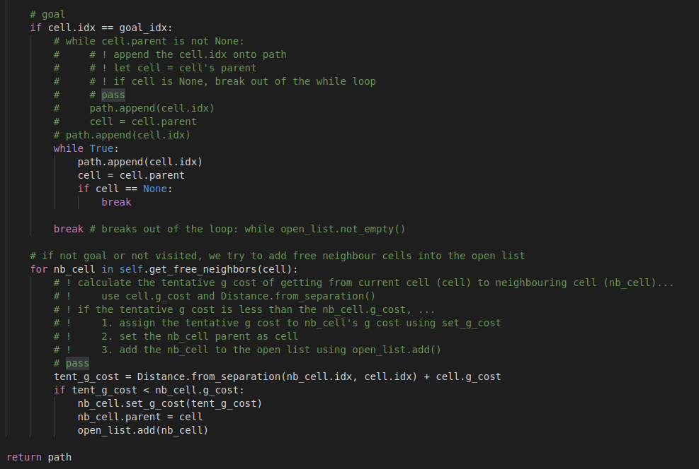

Q6)
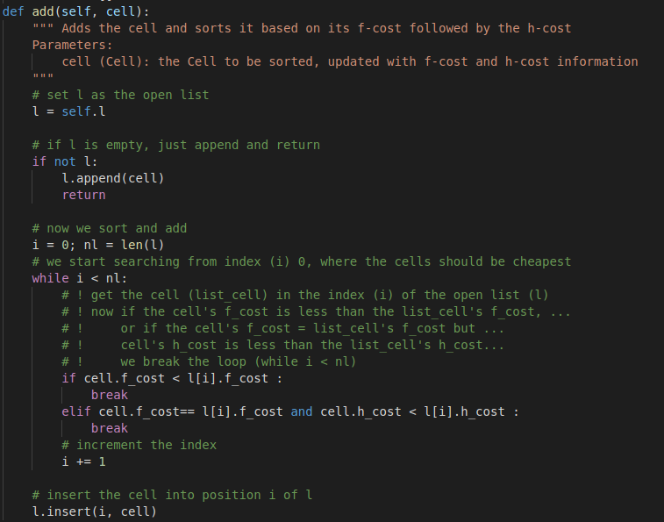
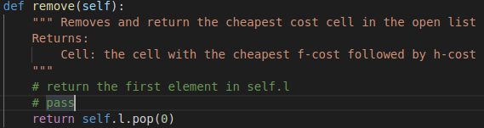

Q7)
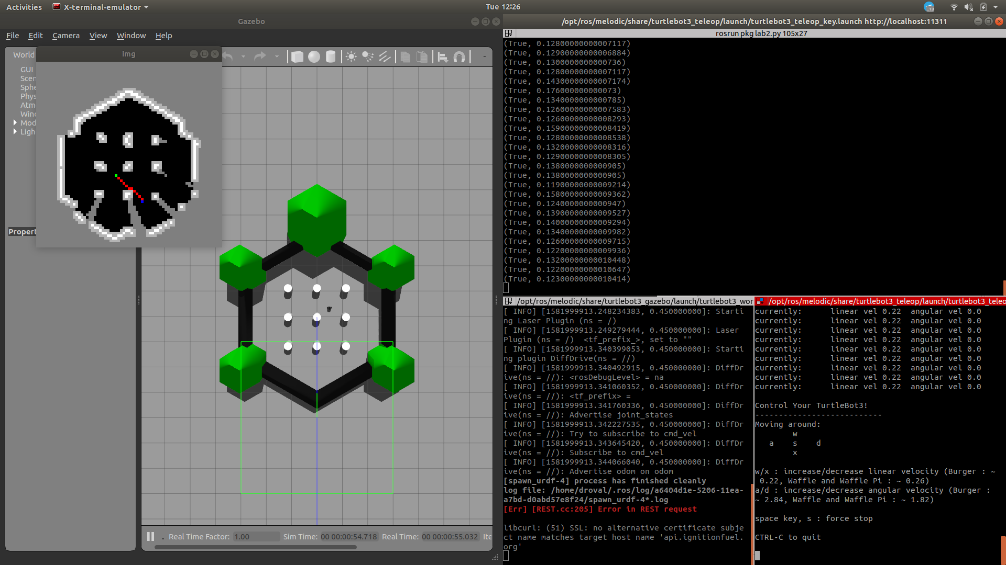
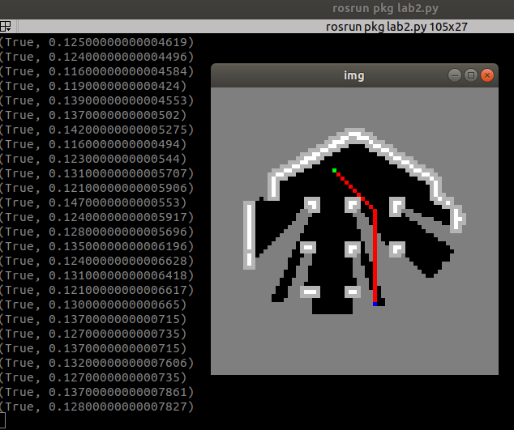

Q8)
Cell.set_occupancy:
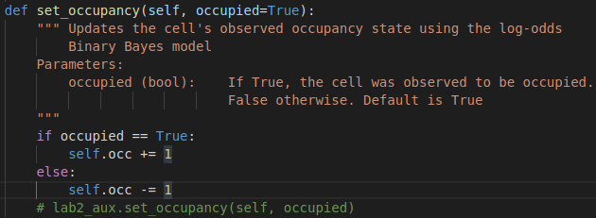
subscribe_wheels:
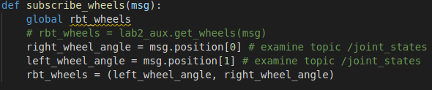
gen_mask:
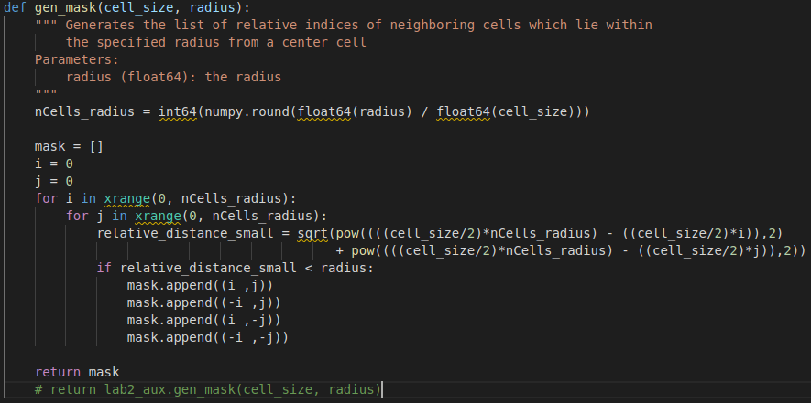
OdometryMM:
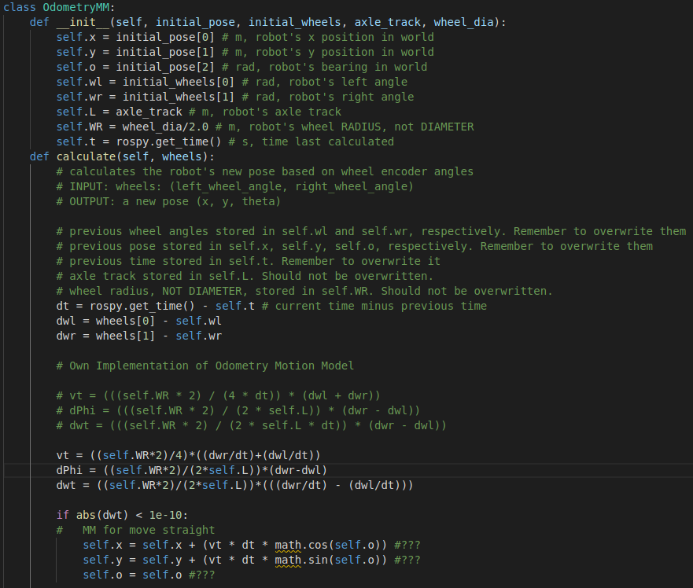
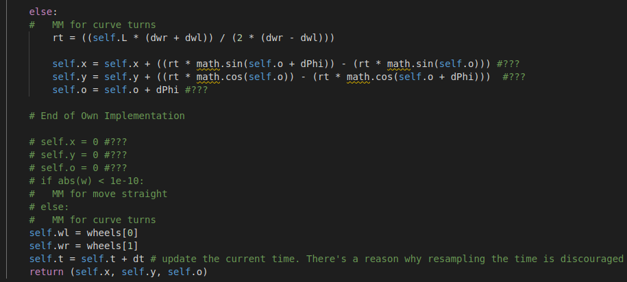

LOS:
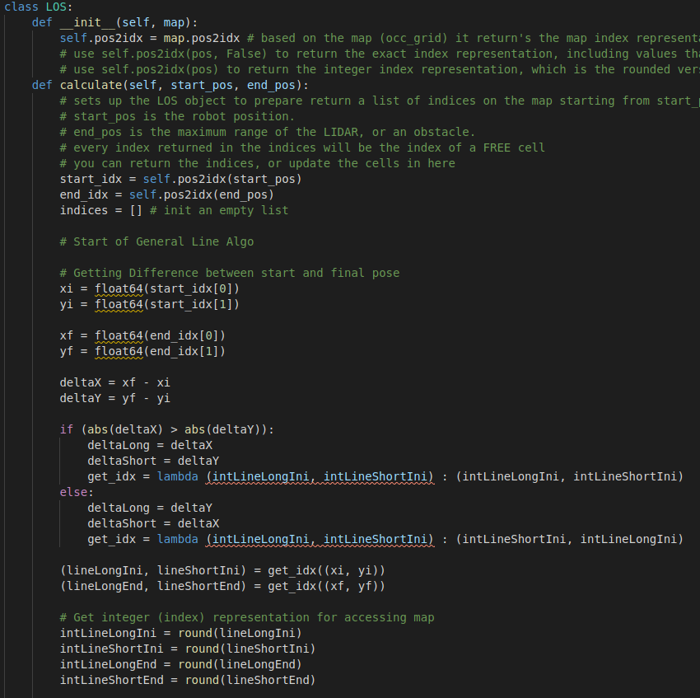
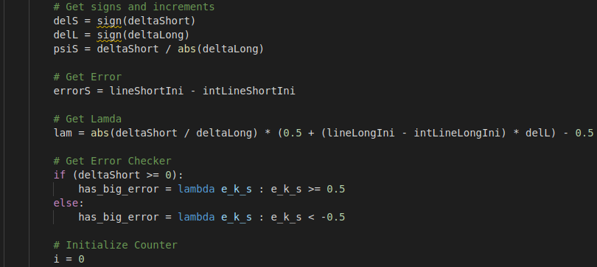
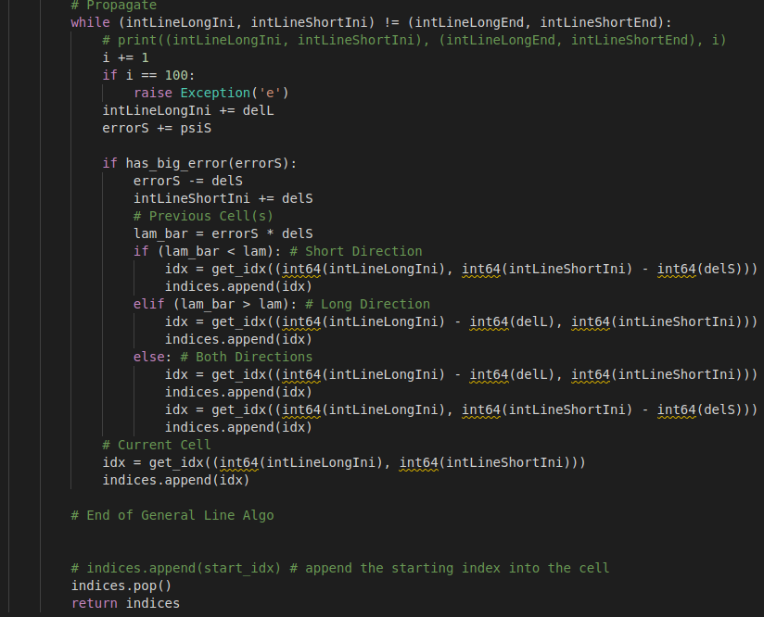
inverse_sensor_model:
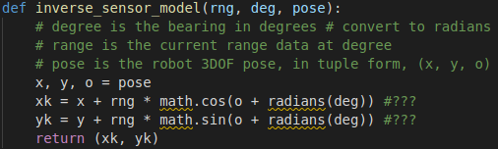
MAX_RNG:

