Description
------------
The project includes the console application to compute tax calculation.
The application is capable of processing information from the console as well
as from a file.

File Structure
--------------
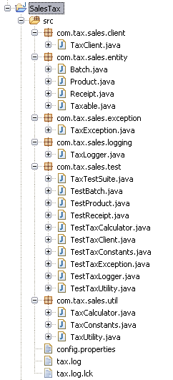

com.tax.sales.client.TaxClient.java – Entry point for the application

com.tax.sales.entity.Batch.java – Class to represent the batch of purchasing
com.tax.sales.entity.Product.java – Class to represent the product for purchasing, implements the Taxable interface for tax calculations
com.tax.sales.entity.Receipt.java – Class to print out the receipt after tax computation
com.tax.sales.entity.Taxable.java – Interface to compute the tax for the product

com.tax.sales.exception.TaxException.java – Exception class for tax calculation

com.tax.sales.logging.TaxLogger.java – Logger file for computing tax

com.tax.sales.util.TaxCalculator.java – Class to calculate specific taxes like Basic tax, Import duty tax etc

com.tax.sales.util.TaxConstants.java – Includes the constants used in the tax application
com.tax.sales.util.TaxUtility.java – Utility class includes helper methods for effective tax calculation

config.properties – contains information for the calculation, user can change the properties

Application demo for manual entry
---------------------------------
The TaxClient class is the entry point for the application

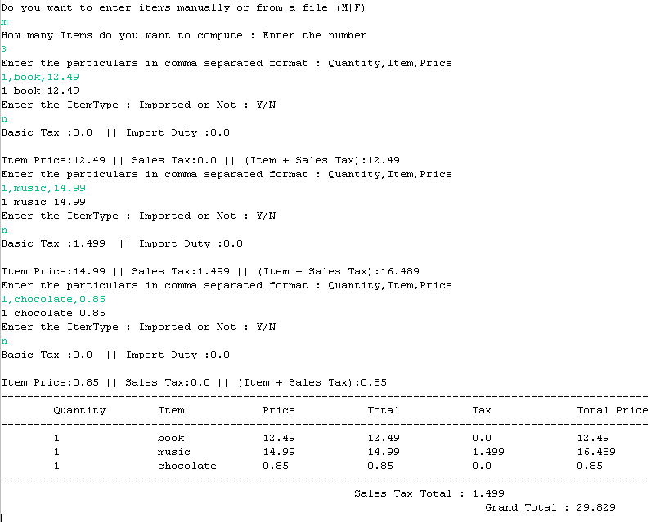

Application demo for file entry
---------------------------------
