Track changes in Word

When you want to see who’s been making changes to your document, turn on the Track Changes feature.

[2016, 2013](javascript:)

[](javascript:)

[20102007](javascript:)

What would you like to do?

[Turn on Track Changes](javascript:)

* On the **Review** tab, in the **Tracking** group, choose **Track Changes**.

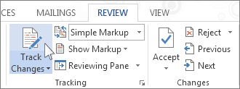

[Show changes (revisions) in document](javascript:)

When you turn on Track Changes, Word marks up and shows any changes that anyone makes to the document.

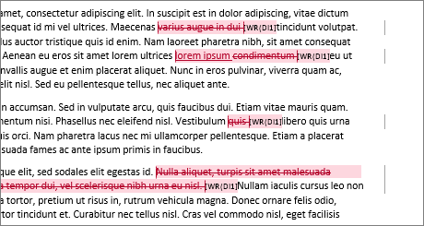

1. On the **Review** tab, in the **Tracking** group, in the **Simple Markup** list, choose a view option.
   * **Simple Markup** is the default option, and indicates where changes are with a red line in the margin.

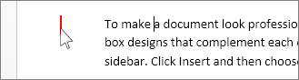

* + **No Markup** hides markup to show what the incorporated changes will look like.

**Note:** You can see the markup again by choosing **Simple Markup** or **All Markup**.

* + **All Markup** shows all edits with different colors of text and strikethrough.
  + **Original** shows the document in its original form.

1. In the **Show Markup** list, choose the revisions you'd like to see—Comments, Ink, Insertions and Deletions, Formatting, Balloons, Specific people.

[Keep Track Changes turned on](javascript:)

You can prevent someone else from turning off Track Changes by turning on Lock Tracking and adding a password. When Tracked Changes is locked, you can't turn off the feature, and you can’t accept or reject the changes.

1. On the **Review** tab, in the **Track Changes** list, choose **Lock Tracking**.

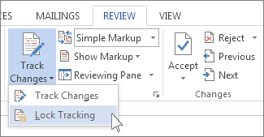

1. Do one of the following:
   * In the **Lock Tracking** dialog box, enter a password, type it again in the **Reenter to confirm** box, and then choose **OK**.

**Note:** Adding a password is optional. It's not a security feature. It is intended, however, to discourage others from turning off Track Changes.

* + In the **Lock Tracking** dialog box, choose **Cancel**.

**Turn off Lock Tracking**

1. In the **Track Changes** list, choose **Lock Tracking**.
2. If you added a password, enter it when prompted, and then choose **OK**.

**Note:** Track Changes is still on, but you can accept and reject changes.

[Turn off Track Changes](javascript:)

Word stops marking up new changes when Track Changes is turned off. All changes that were already tracked, however, remain marked up in the document until you remove them.

* On the **Review** tab, in the **Tracking** group, choose **Track Changes**.

[Remove tracked changes](javascript:)

The only way to remove tracked changes in a document is to accept or reject them. Choosing **No Markup** in the **Display for Review** box helps you see what the final document will look like—but it only hides tracked changes temporarily. The changes are not deleted, and they’ll show up again the next time anyone opens the document. To delete the tracked changes permanently, accept or reject them.

**Accept or delete a single tracked change**

1. Open your document.
2. On the **Review** tab, in the **Changes** group, choose **Next** or **Previous**.
3. Choose **Accept** or **Reject**.

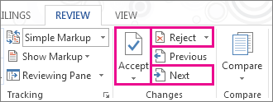

**Accept or delete all tracked changes**

1. Open your document.
2. On the **Review** tab, in the **Changes** group, do one of the following:
   * In the **Accept** list, choose **Accept All Changes**.

or

* + In the **Reject** list, choose **Reject All Changes**.

Word either [accepts the change](https://support.office.com/client/accepts-the-change-4838d24c-d5d1-4c6c-8e39-78b44bd2b4cc) or removes it, and then moves to the next change.

[View or delete comments](javascript:)

**View comments**

* Word shows a balloon where someone’s made a comment. To see a comment, choose the comment balloon.

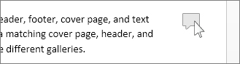

* To see the changes, click the line near the margin. That action switches Word into **All Markup** view.

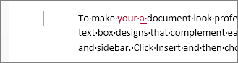

**Delete a single comment**

* Choose a comment, and on the **Review** tab, in the **Comments** group, choose **Delete**.

**Delete all comments**

* On the **Review** tab, in the **Comments** group, in the **Delete** list, choose **Delete All Comments in Document**.

**Tips:** Before you share the final version of your document, it’s a good idea to run Document Inspector. This tool checks for tracked changes and comments, hidden text, personal names in properties, and other information you might not want to share widely.

* On the **File** tab, choose **Info** > **Check for Issues** > **Inspect Document**.

To learn more about comments, see [Insert and delete comments](https://support.office.com/client/Insert-and-delete-comments-8d3f868a-867e-4df2-8c68-bf96671641e2).