Step1: Write OS to SD Card

Step2: Open “Boot” folder 🡪 New 🡪 Text Document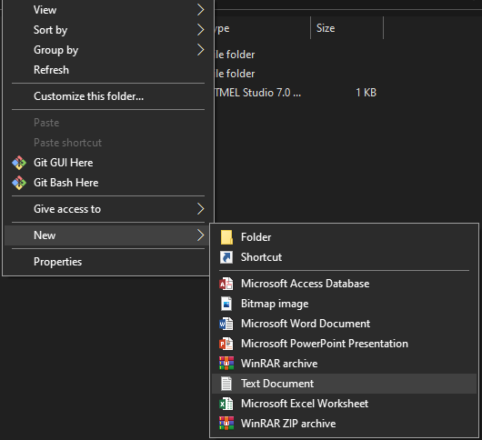

Naming: “ssh” without any extensions.

Click **Yes.**

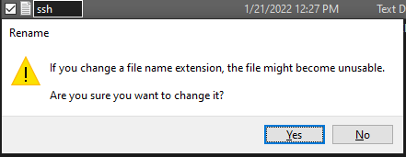

Step4: Attach SD Card to Raspberry Pi, power supply, Ethernet cable.

Step5: Sharing wifi from Laptop

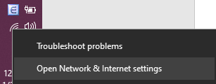

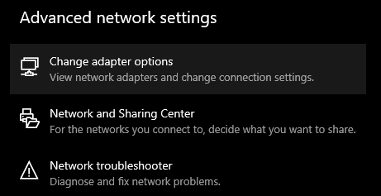

Right click “Wi-Fi” 🡪 **Properties 🡪** tab **Sharing** 🡪 Click “**Allow other network users to connect …” 🡪 OK**

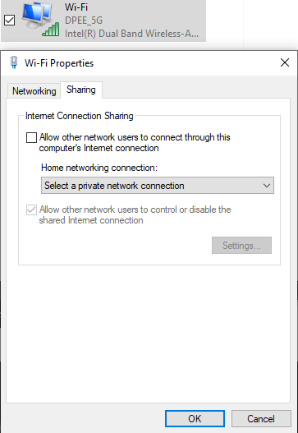

Step6: Scan IP for Raspberry

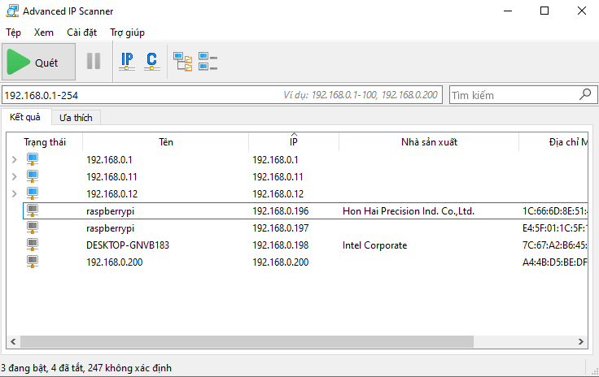

Step7: Open terminal on PC (Laptop). Type: ssh pi@{ip of raspberry}

Eg: 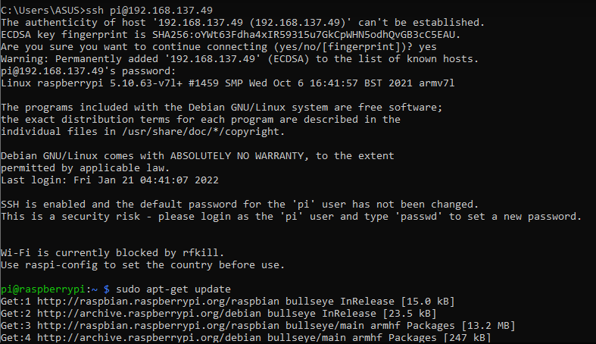

Step8: update raspberry: **“sudo apt-get update”**

Step9: Install XRDP: **“sudo apt-get install xrdp”**

Step10: Enable VNC: **“sudo raspi-config” 🡪 Enable VNC … 🡪 Sudo reboot**

After Step 10, user can remote desktop to raspberry **if using Raspberry Pi 3**

With **Raspberry Pi 4,** we have to config xorg.conf

Step11: SSH Raspberry via Terminal 🡪 “**cd /etc/X11/xrdp” 🡪 “sudo vi xorg.conf”**

Replace **Option “DRMDevice” “/dev/dri/renderD128”** to **Option “DRMDevice” “”**

🡪ESC 🡪 type **:wq** (write and quit) 🡪 **Sudo reboot**

