MSSV: SE192641
Name: Pham Thi Van Thanh

Hướng dẫn kiểm thử tự động
Selenium WebDriver với JUnit 5
By traltb@fe.edu.vn
PROJECT STRUCTURE:
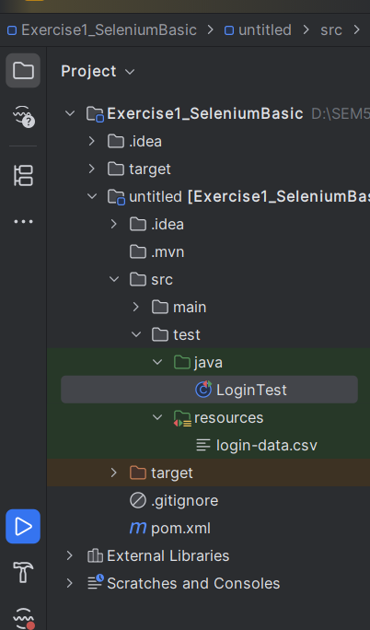
EXERCISE 1:
CODE:
import io.github.bonigarcia.wdm.WebDriverManager;
import org.junit.jupiter.api.*;
import org.junit.jupiter.params.ParameterizedTest;
import org.junit.jupiter.params.provider.CsvSource;
import org.openqa.selenium.By;
import org.openqa.selenium.WebDriver;
import org.openqa.selenium.WebElement;
import org.openqa.selenium.chrome.ChromeDriver;
import org.openqa.selenium.chrome.ChromeOptions;
import org.openqa.selenium.support.ui.ExpectedConditions;
import org.openqa.selenium.support.ui.WebDriverWait;
import java.time.Duration;
import java.util.HashMap;
import java.util.Map;
import static org.junit.jupiter.api.Assertions.assertTrue;
@TestMethodOrder(MethodOrderer.OrderAnnotation.class)
@DisplayName("Login Tests for the-internet.herokuapp.com")
public class LoginTest {
static WebDriver driver;
static WebDriverWait wait;
@BeforeAll
static void setUp() {
WebDriverManager.chromedriver().setup(); // Tự động tải và cấu hình
//disable JavaScript in Chrome
ChromeOptions options = new ChromeOptions();
Map<String, Object> prefs = new HashMap<>();
prefs.put("profile.managed_default_content_settings.javascript", 2); //1: Cho phép (default), 2: Chặn JavaScript
options.setExperimentalOption("prefs", prefs);
options.addArguments("--incognito"); // Ẩn danh
driver = new ChromeDriver(options);
wait = new WebDriverWait(driver, Duration.ofSeconds(10)); // Thêm WebDriverWait
driver.manage().window().maximize();
}
@Test
@Order(1)
@DisplayName("Should login successfully with valid credentials")
void testLoginSuccess() {
driver.get("https://the-internet.herokuapp.com/login");
driver.findElement(By.id("username")).sendKeys("tomsmith");
driver.findElement(By.id("password")).sendKeys("SuperSecretPassword!");
driver.findElement(By.cssSelector("button[type='submit']")).click();
// Chờ thông báo thành công hiển thị
WebElement successMsg = wait.until(
ExpectedConditions.visibilityOfElementLocated(By.cssSelector(".flash.success"))
);
//String successMsg = driver.findElement(By.cssSelector(".flash.success")).getText();
assertTrue(successMsg.getText().contains("You logged into a secure area!"));
}
@Test
@Order(2)
@DisplayName("Should display error when logging in with invalid credentials")
void testLoginFail() {
driver.get("https://the-internet.herokuapp.com/login");
driver.findElement(By.id("username")).sendKeys("invalid");
driver.findElement(By.id("password")).sendKeys("wrongpassword");
driver.findElement(By.cssSelector("button[type='submit']")).click();
// Chờ thông báo lỗi hiển thị
WebElement errorMsg = wait.until(
ExpectedConditions.visibilityOfElementLocated(By.cssSelector(".flash.error"))
);
assertTrue(errorMsg.getText().contains("Your username is invalid!"));
}
@AfterAll
static void tearDown() {
driver.quit();
}
@Order(3)
@ParameterizedTest(name = "Test Login - Username: {0}, Password: {1}")
@CsvSource({
"tomsmith, SuperSecretPassword!, success", // valid
"wronguser, SuperSecretPassword!, error", // invalid username
"tomsmith, wrongpassword, error", // invalid password
"'', '', error" // empty credentials
})
@DisplayName("Multiple login attempts using @CsvSource")
void testLoginWithMultipleParameters(String username, String password, String expectedResult) {
driver.get("https://the-internet.herokuapp.com/login");
driver.findElement(By.id("username")).sendKeys(username);
driver.findElement(By.id("password")).sendKeys(password);
driver.findElement(By.cssSelector("button[type='submit']")).click();
By messageLocator = expectedResult.equals("success")
? By.cssSelector(".flash.success")
: By.cssSelector(".flash.error");
WebElement message = wait.until(ExpectedConditions.visibilityOfElementLocated(messageLocator));
if (expectedResult.equals("success")) {
assertTrue(message.getText().contains("You logged into a secure area!"));
} else {
assertTrue(message.getText().toLowerCase().contains("invalid"));
}
}
}

RESULT:
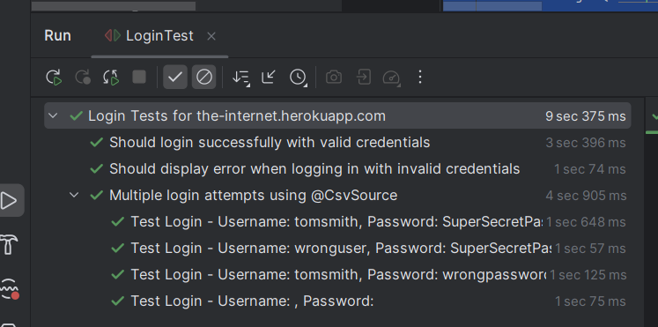

EXERCISE 2:
CODE:
@ParameterizedTest(name = "Test login with: {0} / {1}")
@CsvFileSource(resources = "/login-data.csv", numLinesToSkip = 1)
@DisplayName("Login with data from external CSV file")
void testLoginWithCSV(String username, String password, String expectedResult) {
driver.get("https://the-internet.herokuapp.com/login");
// Chuyển null thành chuỗi rỗng nếu cần
username = (username == null) ? "" : username.trim();
password = (password == null) ? "" : password.trim();
driver.findElement(By.id("username")).sendKeys(username);
driver.findElement(By.id("password")).sendKeys(password);
driver.findElement(By.cssSelector("button[type='submit']")).click();
By messageLocator = expectedResult.equals("success")
? By.cssSelector(".flash.success")
: By.cssSelector(".flash.error");
WebElement message = wait.until(ExpectedConditions.visibilityOfElementLocated(messageLocator));
if (expectedResult.equals("success")) {
assertTrue(message.getText().contains("You logged into a secure area!"));
} else {
assertTrue(message.getText().toLowerCase().contains("invalid"));
}
}

RESULT:
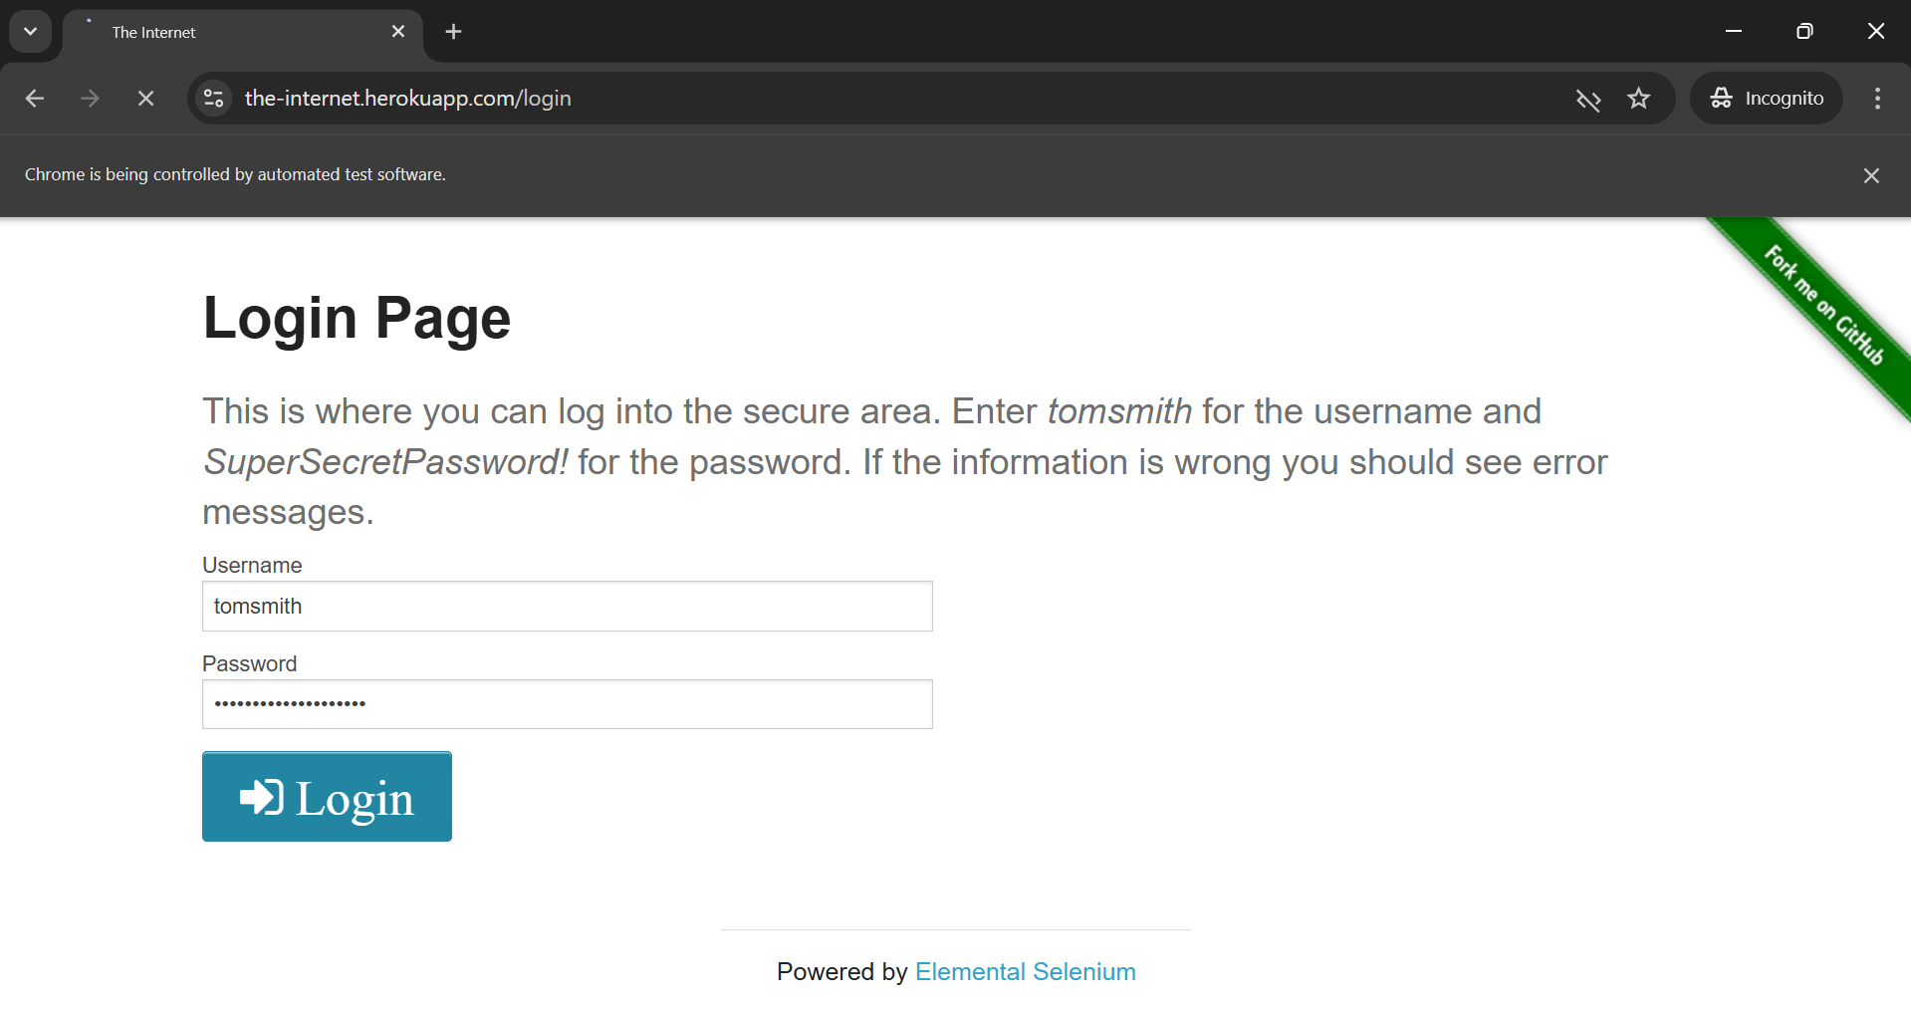
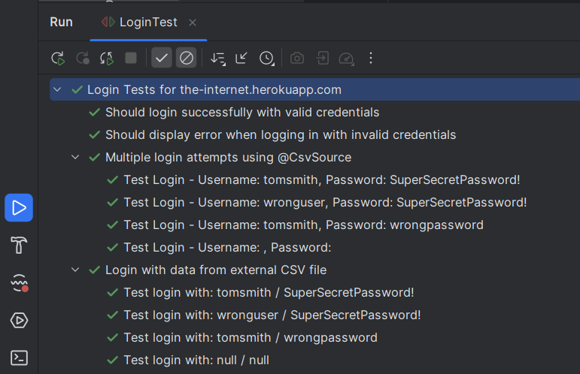
EXERCISE 3:
PROJECT STRUCTURE:
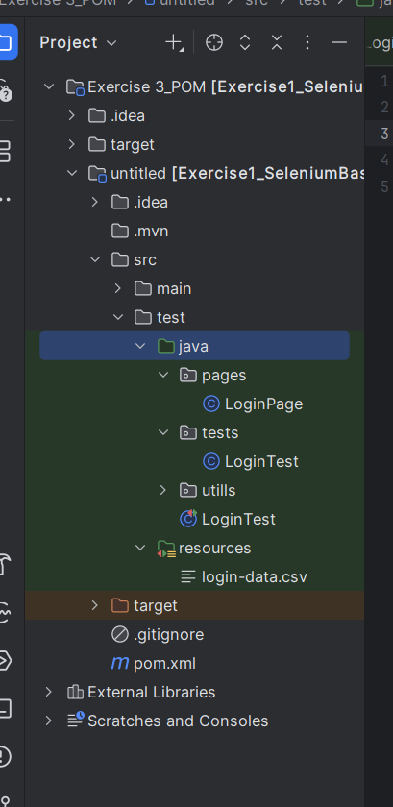
RESULT:
CODE:
package tests;
import org.junit.jupiter.api.*;
import org.junit.jupiter.params.ParameterizedTest;
import org.junit.jupiter.params.provider.CsvFileSource;
import org.junit.jupiter.params.provider.CsvSource;
import org.openqa.selenium.*;
import org.openqa.selenium.support.ui.*;
import pages.LoginPage;
import utils.DriverFactory;
import java.time.Duration;
import static org.junit.jupiter.api.Assertions.assertTrue;
@TestMethodOrder(MethodOrderer.OrderAnnotation.class)
@DisplayName("Login Tests using Page Object Model")
public class LoginTest {
static WebDriver driver;
static WebDriverWait wait;
static LoginPage loginPage;
@BeforeAll
static void setUp() {
driver = DriverFactory.createDriver();
wait = new WebDriverWait(driver, Duration.ofSeconds(10));
driver.manage().window().maximize();
loginPage = new LoginPage(driver);
}
@Test
@Order(1)
@DisplayName("Should login successfully with valid credentials")
void testLoginSuccess() {
loginPage.navigate();
loginPage.login("tomsmith", "SuperSecretPassword!");
WebElement success = wait.until(ExpectedConditions.visibilityOfElementLocated(loginPage.getSuccessLocator()));
assertTrue(success.getText().contains("You logged into a secure area!"));
}
@Test
@Order(2)
@DisplayName("Should show error for invalid credentials")
void testLoginFail() {
loginPage.navigate();
loginPage.login("wronguser", "wrongpassword");
WebElement error = wait.until(ExpectedConditions.visibilityOfElementLocated(loginPage.getErrorLocator()));
assertTrue(error.getText().toLowerCase().contains("invalid"));
}
@ParameterizedTest(name = "CSV Inline: {0} / {1}")
@Order(3)
@CsvSource({
"tomsmith, SuperSecretPassword!, success",
"wronguser, SuperSecretPassword!, error",
"tomsmith, wrongpassword, error",
"'', '', error"
})
void testLoginCsvInline(String username, String password, String expected) {
loginPage.navigate();
username = (username == null) ? "" : username.trim();
password = (password == null) ? "" : password.trim();
loginPage.login(username, password);
By resultLocator = expected.equals("success") ? loginPage.getSuccessLocator() : loginPage.getErrorLocator();
WebElement result = wait.until(ExpectedConditions.visibilityOfElementLocated(resultLocator));
if (expected.equals("success")) {
assertTrue(result.getText().contains("You logged into a secure area!"));
} else {
assertTrue(result.getText().toLowerCase().contains("invalid"));
}
}
@ParameterizedTest(name = "CSV File: {0} / {1}")
@Order(4)
@CsvFileSource(resources = "/login-data.csv", numLinesToSkip = 1)
void testLoginFromCSV(String username, String password, String expected) {
loginPage.navigate();
username = (username == null) ? "" : username.trim();
password = (password == null) ? "" : password.trim();
loginPage.login(username, password);
By resultLocator = expected.equals("success") ? loginPage.getSuccessLocator() : loginPage.getErrorLocator();
WebElement result = wait.until(ExpectedConditions.visibilityOfElementLocated(resultLocator));
if (expected.equals("success")) {
assertTrue(result.getText().contains("You logged into a secure area!"));
} else {
assertTrue(result.getText().toLowerCase().contains("invalid"));
}
}
@AfterAll
static void tearDown() {
driver.quit();
}
}

STEP 1:
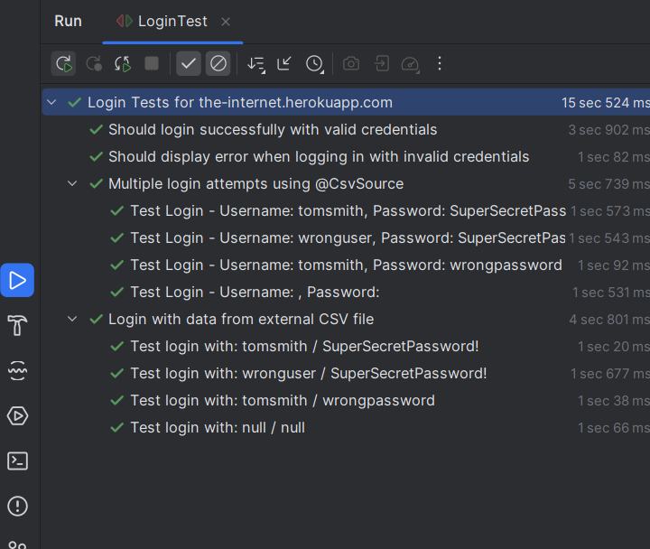
STEP 2:
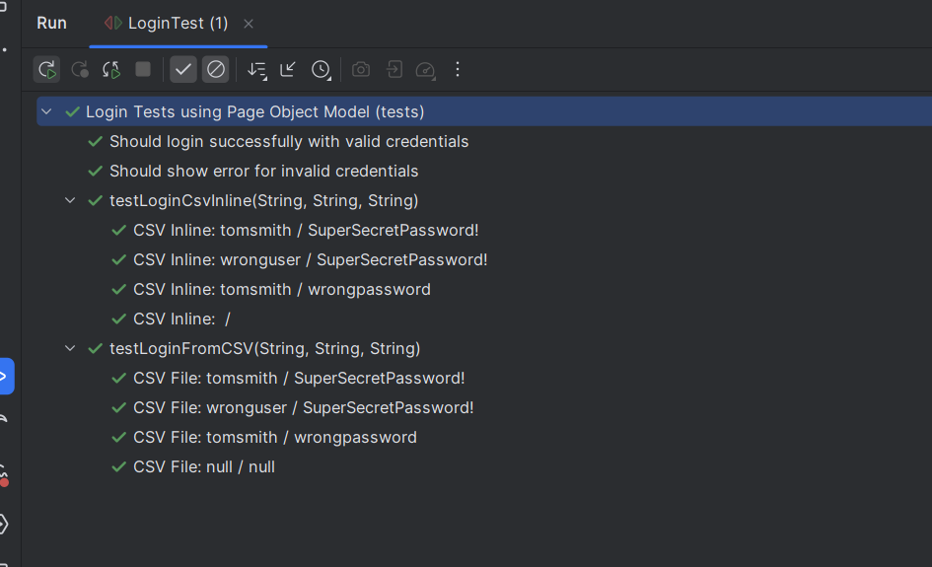

EXERCISE 4:
CODE:
package tests;
import org.junit.jupiter.api.*;
import org.junit.jupiter.params.ParameterizedTest;
import org.junit.jupiter.params.provider.CsvFileSource;
import org.junit.jupiter.params.provider.CsvSource;
import org.openqa.selenium.*;
import org.openqa.selenium.support.ui.*;
import pages.LoginPage;
import utils.DriverFactory;
import java.time.Duration;
import static org.junit.jupiter.api.Assertions.assertTrue;
@TestMethodOrder(MethodOrderer.OrderAnnotation.class)
@DisplayName("Login Tests using Page Object Model")
public class LoginTest extends BaseTest{
//static WebDriver driver;
static WebDriverWait wait;
static LoginPage loginPage;
@BeforeAll
static void initPage() {
loginPage = new LoginPage(driver);
wait = new WebDriverWait(driver, Duration.ofSeconds(10));
}
@Test
@Order(1)
@DisplayName("Should login successfully with valid credentials")
void testLoginSuccess() {
loginPage.navigate();
loginPage.login("tomsmith", "SuperSecretPassword!");
WebElement success = wait.until(ExpectedConditions.visibilityOfElementLocated(loginPage.getSuccessLocator()));
assertTrue(success.getText().contains("You logged into a secure area!"));
}
@Test
@Order(2)
@DisplayName("Should show error for invalid credentials")
void testLoginFail() {
loginPage.navigate();
loginPage.login("wronguser", "wrongpassword");
WebElement error = wait.until(ExpectedConditions.visibilityOfElementLocated(loginPage.getErrorLocator()));
assertTrue(error.getText().toLowerCase().contains("invalid"));
}
@ParameterizedTest(name = "CSV Inline: {0} / {1}")
@Order(3)
@CsvSource({
"tomsmith, SuperSecretPassword!, success",
"wronguser, SuperSecretPassword!, error",
"tomsmith, wrongpassword, error",
"'', '', error"
})
void testLoginCsvInline(String username, String password, String expected) {
loginPage.navigate();
username = (username == null) ? "" : username.trim();
password = (password == null) ? "" : password.trim();
loginPage.login(username, password);
By resultLocator = expected.equals("success") ? loginPage.getSuccessLocator() : loginPage.getErrorLocator();
WebElement result = wait.until(ExpectedConditions.visibilityOfElementLocated(resultLocator));
if (expected.equals("success")) {
assertTrue(result.getText().contains("You logged into a secure area!"));
} else {
assertTrue(result.getText().toLowerCase().contains("invalid"));
}
}
@ParameterizedTest(name = "CSV File: {0} / {1}")
@Order(4)
@CsvFileSource(resources = "/login-data.csv", numLinesToSkip = 1)
void testLoginFromCSV(String username, String password, String expected) {
loginPage.navigate();
username = (username == null) ? "" : username.trim();
password = (password == null) ? "" : password.trim();
loginPage.login(username, password);
By resultLocator = expected.equals("success") ? loginPage.getSuccessLocator() : loginPage.getErrorLocator();
WebElement result = wait.until(ExpectedConditions.visibilityOfElementLocated(resultLocator));
if (expected.equals("success")) {
assertTrue(result.getText().contains("You logged into a secure area!"));
} else {
assertTrue(result.getText().toLowerCase().contains("invalid"));
}
}
@AfterAll
static void tearDown() {
driver.quit();
}
}

RESULT
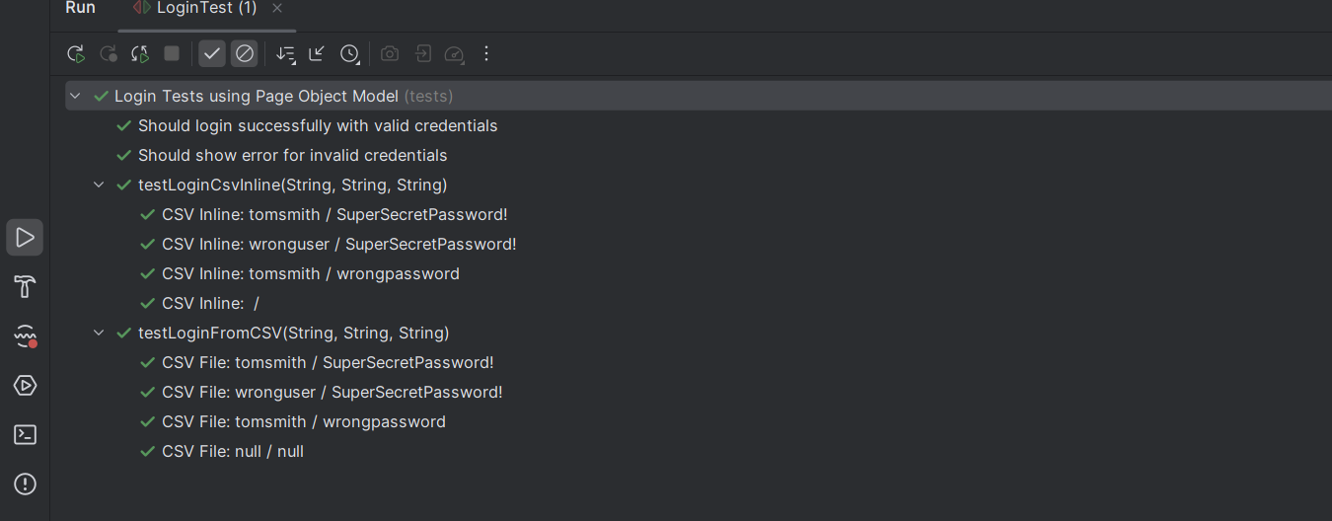
EXERCISE 5:
PROJECT STRUCTURE:
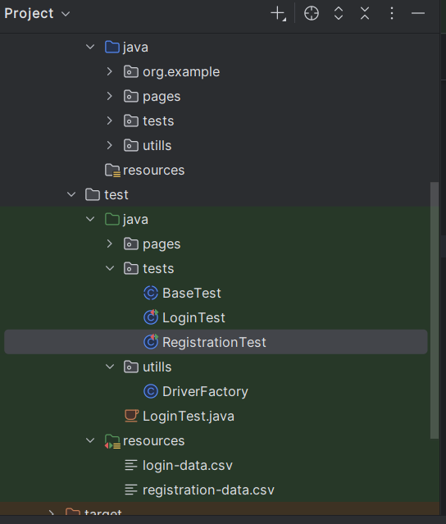
CODE:
package tests;
import org.junit.jupiter.api.DisplayName;
import org.junit.jupiter.api.Test;
import org.junit.jupiter.params.ParameterizedTest;
import org.junit.jupiter.params.provider.CsvFileSource;
import pages.RegistrationPage;
import static org.junit.jupiter.api.Assertions.assertEquals;
import static org.junit.jupiter.api.Assertions.assertTrue;
@DisplayName("DemoQA Registration Form Tests (POM)")
public class RegistrationTest extends BaseTest {
@Test
@DisplayName("Should submit registration form successfully (happy path)")
void testSubmitRegistration() {
RegistrationPage page = new RegistrationPage(driver);
String first = "John";
String last = "Doe";
String email = "john.doe@example.com";
String mobile = "9999999999";
page.navigate();
page
.setFirstName(first)
.setLastName(last)
.setEmail(email)
.selectGender("Male")
.setMobile(mobile)
.addSubject("Maths")
.selectHobby("Sports")
.setCurrentAddress("221B Baker Street")
.selectState("NCR")
.selectCity("Delhi");
page.submit();
assertTrue(page.isSubmissionModalVisible());
assertEquals(first + " " + last, page.getSubmittedValue("Student Name"));
assertEquals(email, page.getSubmittedValue("Student Email"));
assertEquals("Male", page.getSubmittedValue("Gender"));
assertEquals(mobile, page.getSubmittedValue("Mobile"));
}
@ParameterizedTest(name = "CSV: {0} {1}, {3}, {4}")
@CsvFileSource(resources = "/registration-data.csv", numLinesToSkip = 1)
@DisplayName("Submit registration form with CSV data")
void testRegistrationFromCSV(
String first,
String last,
String email,
String gender,
String mobile,
String subjects,
String hobbies,
String address,
String state,
String city) {
RegistrationPage page = new RegistrationPage(driver);
page.navigate();
page
.setFirstName(first)
.setLastName(last)
.setEmail(email)
.selectGender(gender)
.setMobile(mobile)
.setCurrentAddress(address)
.selectState(state)
.selectCity(city);
if (subjects != null && !subjects.isBlank()) {
for (String sub : subjects.split("\\|")) {
page.addSubject(sub.trim());
}
}
if (hobbies != null && !hobbies.isBlank()) {
for (String hobby : hobbies.split("\\|")) {
page.selectHobby(hobby.trim());
}
}
page.submit();
assertTrue(page.isSubmissionModalVisible());
assertEquals(first + " " + last, page.getSubmittedValue("Student Name"));
assertEquals(email, page.getSubmittedValue("Student Email"));
assertEquals(gender, page.getSubmittedValue("Gender"));
assertEquals(mobile, page.getSubmittedValue("Mobile"));
// Close modal to avoid overlay blocking next dataset
page.closeModal();
}
}

RESULT:
