**GitOps with Argo CD**

1. **Install Argo CD Server in Cluster**

kubectl create namespace argocd

kubectl apply -n argocd \\

-f <https://raw.githubusercontent.com/argoproj/argo-cd/stable/manifests/install.yaml>

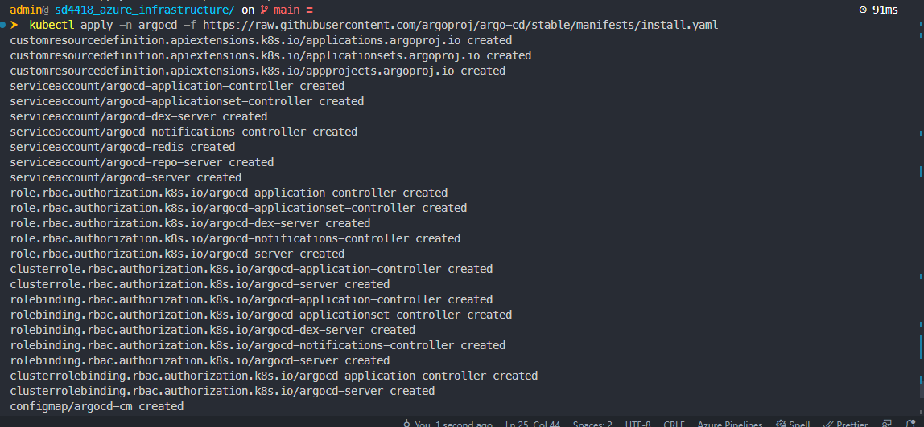

Check the status of kube pods

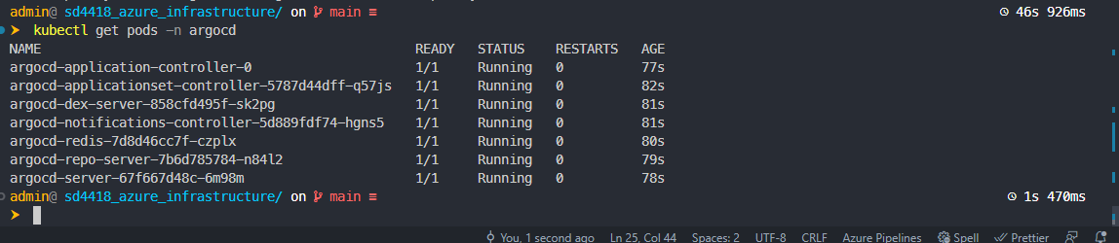

1. **Access The Argo CD API Server**

Exposing with a Service Type Load Balancer

kubectl patch svc argocd-server \\

-n argocd \\

-p '{"spec": {"type": "LoadBalancer"}}'

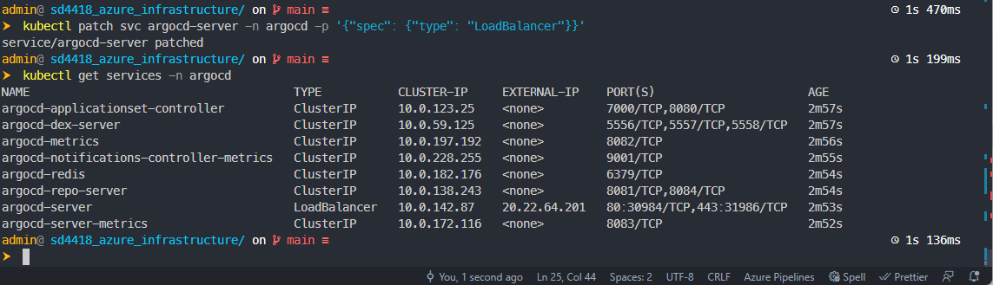

Retrieve the admin password.

argocd admin initial-password -n argocd

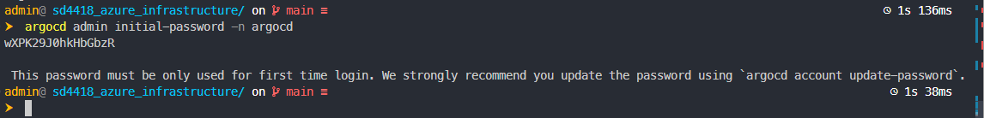

Login into ArgoCD Dashboard

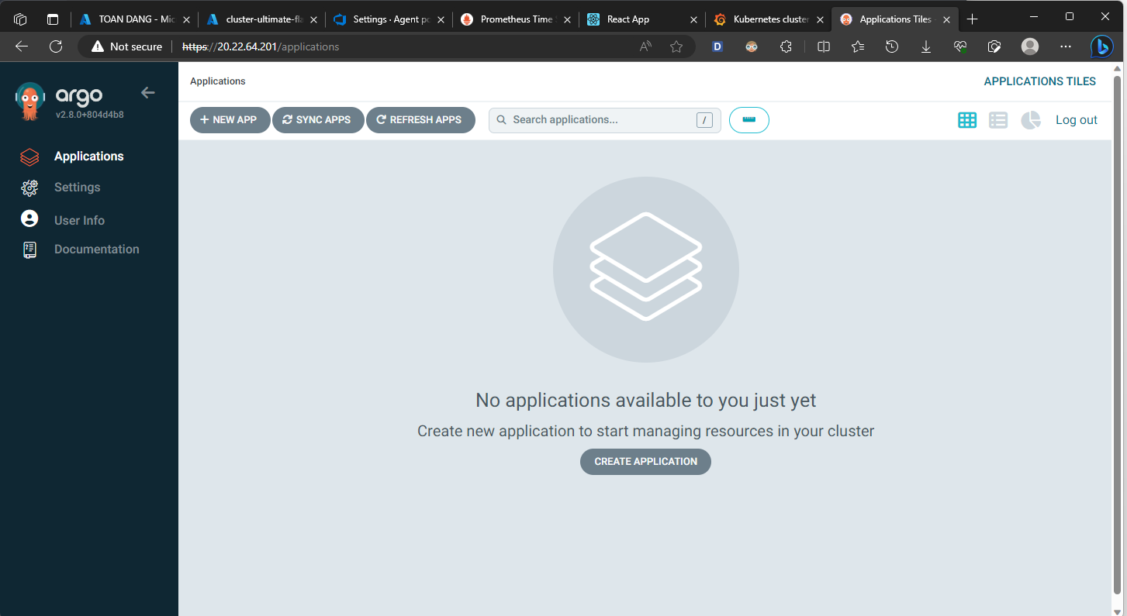

1. **Create An Application From A Git Repository**

Create namespace for application

kubectl create namespace app-argocd

Create a new project

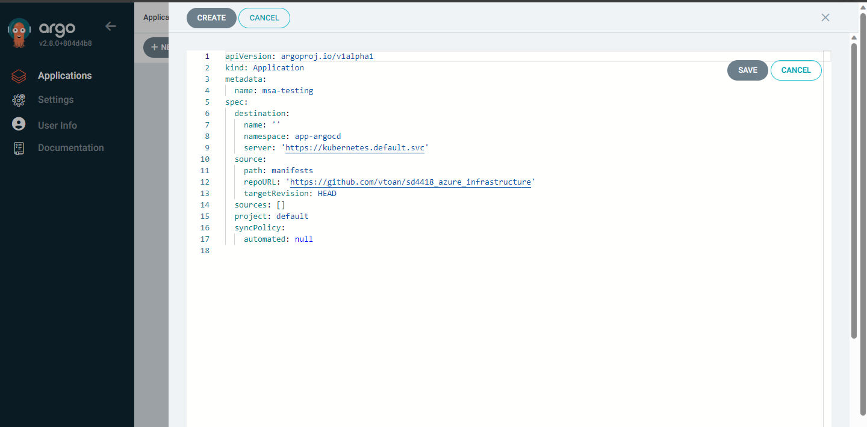

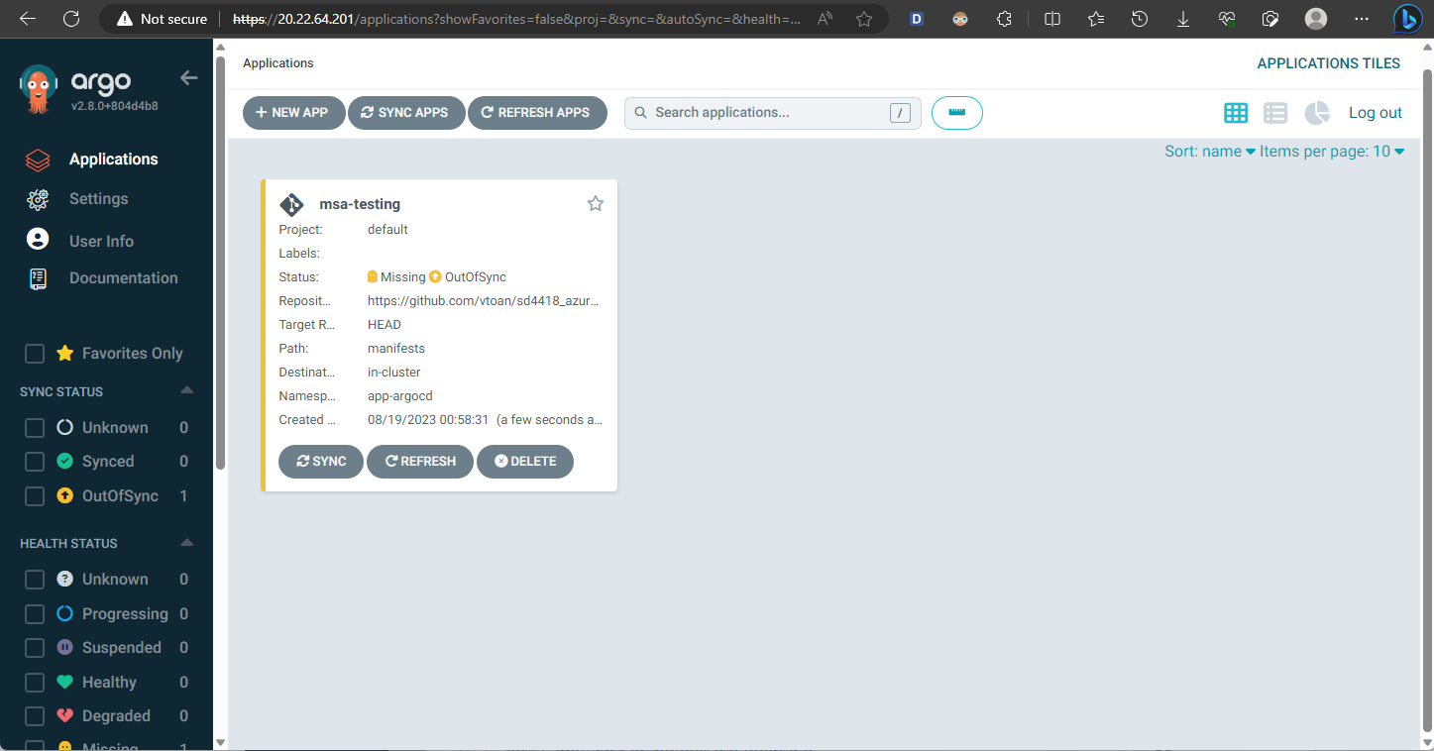

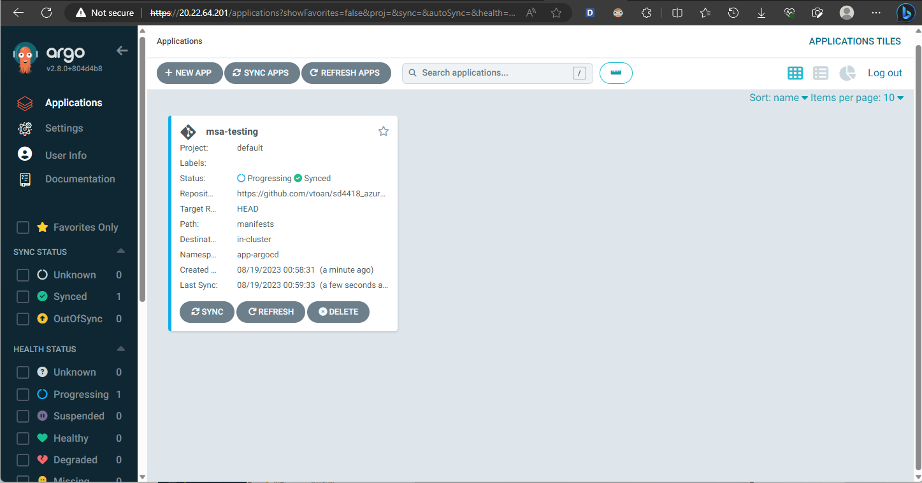

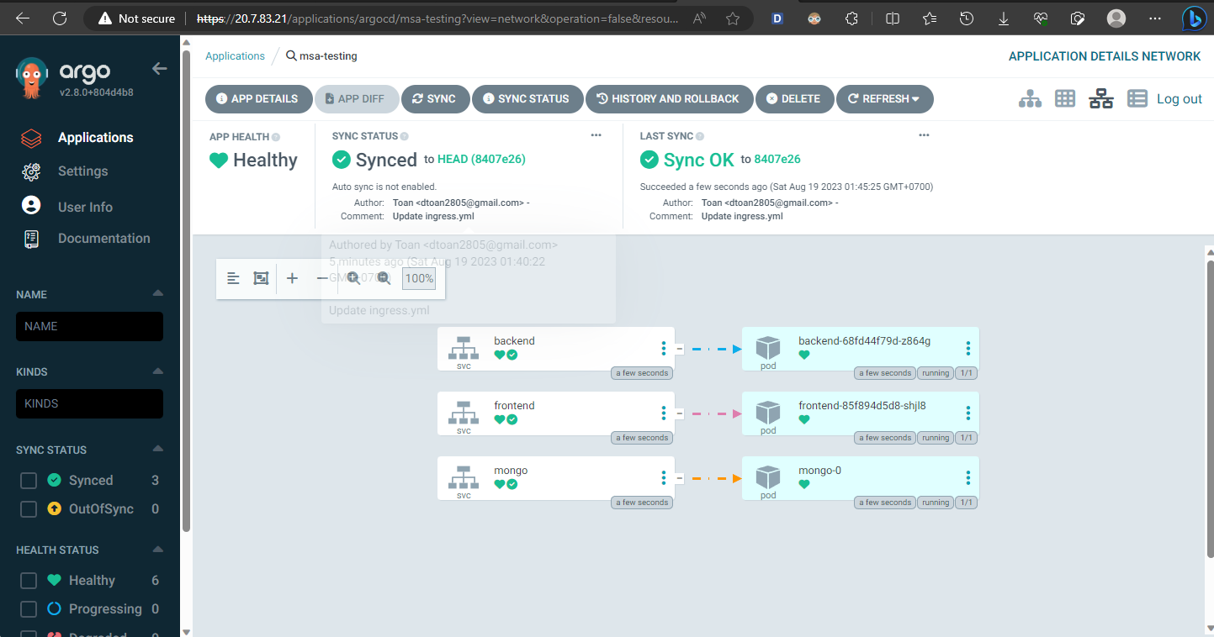

Check pods and services of app-argocd

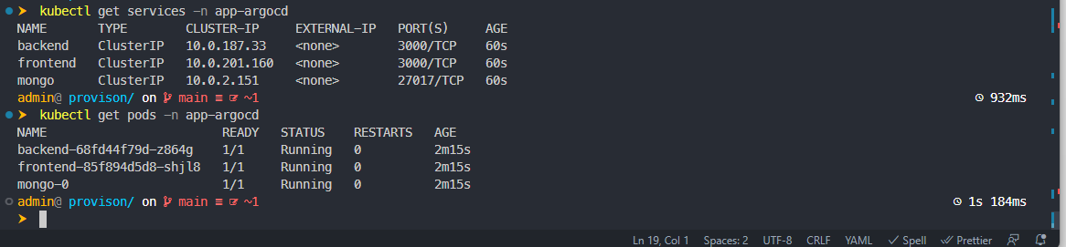

Run the application with modified

