**Industrial Internship Report on**

**” Traffic Viewer”**

**Prepared by**

**[Vikas Tripathi]**

|  |
| --- |
| *Executive Summary* |
| This report provides details of the Industrial Internship provided by upskill Campus and The IoT Academy in collaboration with Industrial Partner UniConverge Technologies Pvt Ltd (UCT).  This internship was focused on a project/problem statement “Forecasting of Smart city traffic patterns” provided by UCT. We had to finish the project including the report in 6 weeks’ time.  My project name is “Traffic Viewer”.  This internship gave me a very good opportunity to get exposure to Industrial problems and design/implement solution for that. It was an overall great experience to have this internship. |

**TABLE OF CONTENTS**

1 Preface 3

2 Introduction 4

2.1 About UniConverge Technologies Pvt Ltd 4

2.2 About upskill Campus 8

2.3 Objective 9

2.4 Reference 9

2.5 Glossary 10

3 Problem Statement 11

4 Existing and Proposed solution 12

5 Proposed Design/ Model 13

5.1 High Level Diagram (if applicable) 13

5.2 Low Level Diagram (if applicable) 13

5.3 Interfaces (if applicable) 13

6 Performance Test 14

6.1 Test Plan/ Test Cases 14

6.2 Test Procedure 14

6.3 Performance Outcome 14

7 My learnings 15

8 Future work scope 16

# Preface

**Summary of the whole 6 weeks’ work.**

In this 6th week internship, which focuses on forecasting smart city traffic patterns problem statement. Advanced technologies such as IoT and edge computing are utilized to collect real-time data on traffic, weather, and other relevant factors. Predictive analytics can help identify potential traffic hotspots and congestion points before they occur, enabling proactive measures to improve overall traffic flow and reduce congestion. This internship not only develops personal skills in machine learning and data analysis but also contributes to advancing the efficiency and development of new traffic problem solutions with significant societal relevance.

**About need of relevant Internship in career development**.

Relevant internships are essential for career development because they bridge the gap between education and the workplace, helping individuals acquire practical skills, industry knowledge, and professional connections. They are a pivotal step in building a successful and fulfilling career.

**Brief about Your project/problem statement.**

As an intern working on the forecasting of smart city traffic patterns, I was tasked with analysing data related to traffic patterns in the four junctions of the city. The objective was to understand the trends and patterns in traffic flow in order to make informed decisions about infrastructure planning and traffic management.

How Program was planned

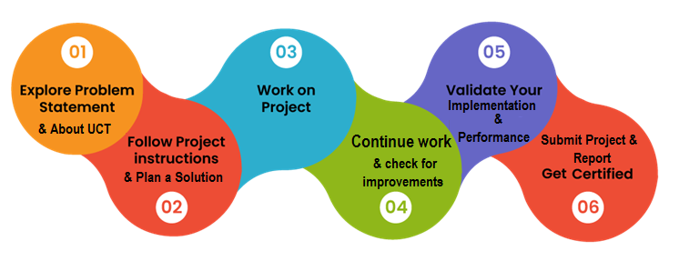

**Opportunity given by USC/UCT.**

In this internship I learned many practical knowledge for that I show my sincere gratitude to Uniconverge Technologies, Upskill Campus, Edunet Foundation, and our college Pacific School of Engineering for providing me with the invaluable opportunity to work on the project focused on Forecasting of Smart city traffic patterns in India using machine learning. This opportunity has allowed me to gain hands-on experience in data science, machine learning, and patterns formation domain knowledge.

I have developed essential skills in data collection, preprocessing, model development, and evaluation. Additionally, I have learned project management, communication, and collaboration skills that will be valuable in my future goals.

# Introduction

## About UniConverge Technologies Pvt Ltd

A company established in 2013 and working in Digital Transformation domain and providing Industrial solutions with prime focus on sustainability and RoI.

For developing its products and solutions it is leveraging various**Cutting Edge Technologies e.g. Internet of Things (IoT), Cyber Security, Cloud computing (AWS, Azure), Machine Learning, Communication Technologies (4G/5G/LoRaWAN), Java Full Stack, Python, Front end**etc.

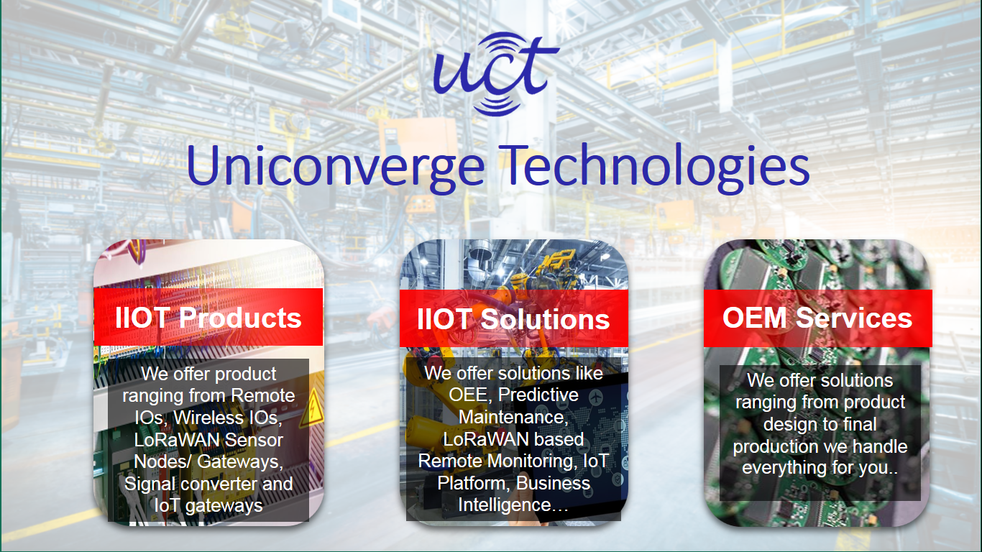

1. UCT IoT Platform **(****)**

**UCT Insight** is an IOT platform designed for quick deployment of IOT applications on the same time providing valuable “insight” for your process/business. It has been built in Java for backend and ReactJS for Front end. It has support for MySQL and various NoSql Databases.

* It enables device connectivity via industry standard IoT protocols - MQTT, CoAP, HTTP, Modbus TCP, OPC UA
* It supports both cloud and on-premises deployments.

It has features to  
• Build Your own dashboard  
• Analytics and Reporting  
• Alert and Notification  
• Integration with third party application(Power BI, SAP, ERP)  
• Rule Engine

 

1. **Smart Factory Platform (****)**

Factory watch is a platform for smart factory needs.

It provides Users/ Factory

* with a scalable solution for their Production and asset monitoring
* OEE and predictive maintenance solution scaling up to digital twin for your assets.
* to unleased the true potential of the data that their machines are generating and helps to identify the KPIs and also improve them.
* A modular architecture that allows users to choose the service that they what to start and then can scale to more complex solutions as per their demands.

Its unique SaaS model helps users to save time, cost and money.

 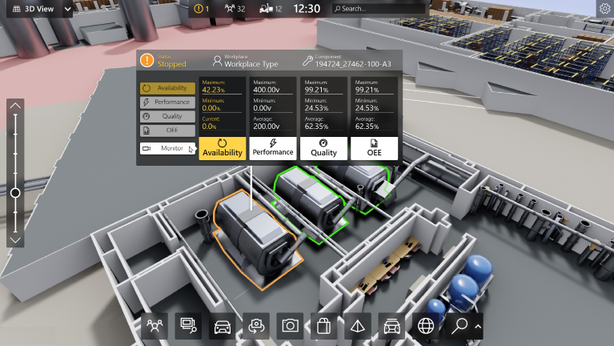

1.  based Solution

UCT is one of the early adopters of LoRAWAN teschnology and providing solution in Agritech, Smart cities, Industrial Monitoring, Smart Street Light, Smart Water/ Gas/ Electricity metering solutions etc.

1. Predictive Maintenance

UCT is providing Industrial Machine health monitoring and Predictive maintenance solution leveraging Embedded system, Industrial IoT and Machine Learning Technologies by finding Remaining useful life time of various Machines used in production process.



## About upskill Campus (USC)

upskill Campus along with The IoT Academy and in association with Uniconverge technologies has facilitated the smooth execution of the complete internship process.

USC is a career development platform that delivers **personalized executive coaching** in a more affordable, scalable and measurable way.



Seeing need of upskilling in self paced manner along-with additional support services e.g. Internship, projects, interaction with Industry experts, Career growth Services

<https://www.upskillcampus.com/>

upSkill Campus aiming to upskill 1 million learners in next 5 year

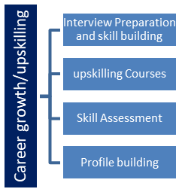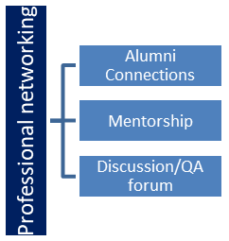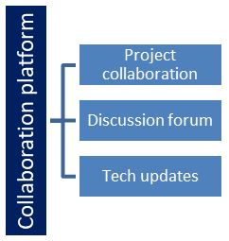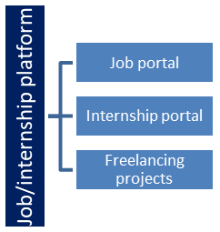

## The IoT Academy

The IoT academy is EdTech Division of UCT that is running long executive certification programs in collaboration with EICT Academy, IITK, IITR and IITG in multiple domains.

## Objectives of this Internship program

The objective for this internship program was to

 ☛ get practical experience of working in the industry.

 ☛ to solve real world problems.

 ☛ to have improved job prospects.

 ☛ to have Improved understanding of our field and its applications.

 ☛ to have Personal growth like better communication and problem solving.

## Reference

[1] Indian Traffic Survey to provide every vehicles quantity in specific Highways-- http://indiantrafficsurvey.com/

[2] Morth for data related --https://morth.nic.in/basic-road-statistics-india

[3] Knowledge of all Conventional Traffic Controls https://data.gov.in/keywords/Traffic%20control

# Problem Statement

When we talk about the inspiration behind this project is the critical role traffic problems plays in India, in this its vast population, and the challenges the taffic problems faces. The project seeks to address these challenges and provide solutions that can benefit a large number of people in the country. And help the environment and boost the efficiency of economy of our country.

The dataset used for this project contains information related to various aspects of timing with related to accidents and congestions in a roads and various regions in India, such as ID,cities ,timing , junction, vehicles, locations.

One of the key challenges in this project was dealing with the complexity of traffic patterns. There were many factors that influenced traffic flow, such as time of day, day of the week, weather conditions, and special events. I had to develop models that could capture these factors and provide accurate forecasts. And here the issue is that the model is depend on the data sets and analysed data sets if any data or analysing of data is not accurate then our model can be not accurate. And here the selection of machine learning algorithm is also important to train the model and to achieve the best result.

# Existing and Proposed solution

When we talk about the very basic Conventional Timer Traffic Signal then its drawbacks are very huge and that’s why timer traffic signals are not perfect because they do not account for changing traffic patterns and unexpected events such as accidents or road closures. They are programmed based on historical traffic data and do not adapt in real-time to current conditions.

And there is also have another option after timer traffic signal that is Sensor based Traffic signals but Sensor traffic signals are also not perfect because they can be affected by weather conditions such as rain or snow, which can interfere with the sensors' ability to detect vehicles. Additionally, sensor signals may not work properly if there are large vehicles or objects blocking the sensors. Finally, sensor signals may require regular maintenance and calibration to ensure they are functioning correctly, which can be costly and time-consuming.

Here we can say that in all aspects the machine learning based traffic signals is going to very helpful in this modern era. But in thing have a cons in here is that to maintenance of the system is required.

## Code submission (GitHub link):

[**My GitHub Link**](https://github.com/vtofficial/upskillcampus/tree/main/Codes)

## Report submission (GitHub link):

## [GitHub Repositories Link](https://github.com/vtofficial/upskillcampus.git)

# Proposed Design/ Model

1. Introduction: The Forecasting Traffic Signal system is an advanced software solution designed to revolutionize Traffic Controls by harnessing the power of machine learning and data science. The system is works by training a machine learning model on traffic data, the model can learn to predict when traffic congestion is likely to occur.
2. Working: when traffic congestion is likely to occur then the system or model runs and adjust the timing of traffic signals accordingly to reduce congestion and improve traffic flow. Basically, the system detects the vehicles counts and the density on the road if the vehicles count is zero then the timer will not be counting and gives the red light until any vehicles comes and open the green light for the other direction. Here if the vehicle count is one then the green light is open until the vehicle passes mean here after passing of vehicle system detect the vehicle count is zero then the timer stops and shows red light and open the green light to the other direction or ways.
3. Forecasting patterns: The use of machine learning in traffic signal prediction and optimization is becoming increasingly popular as cities look for ways to improve their transportation systems. By using real-time data and predictive analytics, traffic signals can be adjusted in real-time to respond to changing traffic conditions, resulting in a more efficient and safer transportation system for everyone.
4. Congestions Recommendation: Based on the analysis of traffic patterns and signal timings, the traffic signals predictor can provide recommendations for reducing congestion in high-traffic areas. These recommendations may include:

* Implementing dedicated turn lanes: By creating separate lanes for turning vehicles, the flow of traffic can be improved and delays reduced.
* Adjusting signal timings: The model can recommend adjustments to the duration of green lights and the length of time between signal changes to optimize traffic flow.
* Implementing roundabouts: Roundabouts can help to reduce congestion by eliminating the need for stoplights and allowing traffic to flow more smoothly.
* Encouraging alternative modes of transportation: The model can recommend strategies for promoting biking, walking, or public transportation to reduce the number of cars on the road and alleviate congestion.

1. Safety: The traffic signals predictor model can also improve safety on the roads by reducing the number of accidents caused by congestion and delays. By providing real-time information on traffic patterns, the model can help drivers to make more informed decisions about their routes, reducing the likelihood of accidents and improving overall road safety.
2. Accident Prediction: The traffic signals predictor model can also be used for accident prediction. By analyzing historical data on accidents and traffic patterns, the model can identify high-risk areas and provide recommendations for improving safety measures such as installing traffic lights, speed bumps, or pedestrian crossings. This can help to prevent accidents before they occur, saving lives and reducing the costs associated with emergency response and medical care.
3. Key Features:

* Real-time traffic analysis
* Predictive modeling for traffic patterns
* Optimization of traffic signal timing
* Identification of high-risk areas for accidents
* Recommendations for safety measures
* Improved emergency response times
* Reduction of costs associated with emergency response and medical care
* Potential to revolutionize transportation management
* Improved safety on the roads
* Creation of livable, sustainable, and safe urban environments.
* User-Friendly Interface: Our software boasts an intuitive and user-friendly interface, ensuring that even non-technical users can access its powerful capabilities.

1. Data Integration: The system seamlessly integrates with various data sources, including weather APIs, soil databases, and disease databases, to provide accurate and up-to-date recommendations.
2. Data Security: Robust security measures are in place to protect user data and ensure privacy.
3. In conclusion: Traffic prediction technology is a game changer in the transportation industry as it offers real-time analysis, predictive modeling, and optimization of traffic signal timing. This technology helps identify high-risk areas for accidents and recommends safety measures to improve emergency response times. With reduced costs associated with emergency response and medical care, it has the potential to revolutionize transportation management and create livable, sustainable, and safe urban environments.

# Performance Test

The work on traffic prediction technology is meant for real industries because it offers practical solutions to the challenges faced by the transportation industry. The technology provides real-time analysis and predictive modeling, which can be applied to optimize traffic signal timing and identify high-risk areas for accidents. This information is invaluable for transportation management, as it helps to reduce costs associated with emergency response and medical care, and improves the efficiency of transportation systems. Additionally, the technology has the potential to create livable, sustainable, and safe urban environments, which is a critical concern for real industries that operate in urban areas. Therefore, this work is not just an academic project but a practical tool that can be implemented by real industries to enhance safety on the roads and improve the efficiency of transportation systems.

**Constraints:**

1. Data Availability:

* Determine the availability and quality of historical traffic data. Constraints may arise if you have limited or incomplete data.
* Note any gaps or missing data points in your dataset that could affect the accuracy of your forecasts.

1. Computational Resources:

* The computational resources like models algorithm available for your project. Complex forecasting models may require substantial computational resources.

1. Time Constraints:

* Understanding your project's timeline is critical for selecting appropriate forecasting methods and allocating resources efficiently.

1. Budget Constraints:

* Project's budget limitation is another thing in the project in this project the cost of hardware’s play a costly role rather than algorithm’s.

1. Model Complexity:

* The complexity of the forecasting models used is also very important. Complex models may require more data and resources but can potentially yield more accurate predictions.

## Test Plan/ Test Cases

Creating a robust test plan and test cases is crucial for ensuring the quality and reliability of your traffic pattern forecasting project. Here are some important notes and considerations when developing a test plan and defining test cases:

1. **Objective and Scope:**
   * Objective: To validate the accuracy and reliability of the traffic pattern forecasting system.
   * Scope: Testing will cover all forecasting models and their integration with the data sources.
2. **Testing Types:**
   * Unit Testing: Validate individual components and algorithms.
   * Integration Testing: Ensured the seamless integration of data sources and forecasting models.
   * Regression Testing: Verified the new code changes do not break existing functionality.
3. Test Data: Use historical traffic data for a specific date and time, representing a typical peak hour scenario.
4. Preconditions: Ensure the availability of accurate historical traffic data.
5. Test Pass/Fail Criteria: Pass: Predicted traffic

## Performance Outcome

1. **Accuracy and Precision:**

* Performance Outcome: The forecasting model is achieved an MAE (Mean Absolute Error) of with very accurate result and an RMSE (Root Mean Square Error) or when comparing predicted traffic patterns to actual observed data.

1. **Real-Time Prediction Latency:**

* Performance Outcome: The system generate the real-time traffic forecasts within time limit to meet the project's real-time application requirements.

1. **Scalability:**

* Performance Outcome: The system can handle a 50% increase in data volume while maintaining response times within limits, ensuring scalability for future growth.

1. **Data Preprocessing:** The outcome should show that missing values and outliers have been handled appropriately, resulting in clean and reliable data for analysis.
2. **Feature Engineering:** The outcome should confirm that new, relevant variables have been generated, and they contribute positively to the model's performance.
3. **Model Training:** The outcome should demonstrate that the selected machine learning algorithms can be trained without errors and within a reasonable time frame.
4. **Robustness:** The outcome should show that the model remains stable and effective when exposed to noisy or outlier-prone data.
5. **User Interface:** If applicable, the outcome should verify that the user interface or dashboard functions smoothly, allowing users to input data and obtain predictions.
6. **Documentation:** The outcome should ensure that project documentation is comprehensive and user-friendly, with clear instructions for users.

# My learnings

1. **Data Handling Skills:**

* Gained hands-on experience in handling large datasets, including data cleaning, preprocessing, and transformation, which are essential skills in data-driven roles.

1. **Machine Learning and Forecasting Models:**

* Developed proficiency in machine learning techniques and forecasting models used in traffic pattern analysis, enhancing analytical and predictive abilities.

1. **Data Visualization:**

* Learned to create effective data visualizations and dashboards to communicate insights and findings, which is crucial for conveying complex information to stakeholders.

1. **Real-Time Data Processing:**

* Acquired knowledge of real-time data processing and its significance in dynamic traffic pattern analysis.

1. **Statistical Analysis:**

* Gained expertise in statistical analysis techniques for identifying trends, patterns, and anomalies in traffic data, improving decision-making capabilities.

1. **Python Programming:**

* Strengthened Python programming skills, particularly in data manipulation libraries (e.g., pandas), machine learning frameworks (e.g., scikit-learn), and data visualization tools (e.g., Matplotlib, Seaborn).

# Future work scope

1. **Pollution Prediction:**

* Work on systems that can also not only forecast traffic patterns but also detect and respond to pollution by the vehicles and take action according to that in real-time.

1. **Customizable Forecasting Solutions:**

* Develop forecasting systems with customizable parameters, allowing city planners and transportation authorities to fine-tune forecasts for their specific needs.

1. **Public Transportation Optimization:**

* Collaborate with public transportation authorities to optimize routes and schedules based on traffic pattern forecasts, improving the overall public transit experience.

1. **Traffic Pattern Forecasting for Emergency Response**:

* A system that provides real-time traffic pattern forecasts to support emergency response teams in reaching incidents more quickly during emergencies.

1. **Flexible with all weathers:**

* In which system can run in foggy or any other weathers or can also works in the Night time with perfectly.

1. **Human and Animal Detection:**

* Can also be a problem so for we have to also to insure to train the model about the animals and humans.