Queen Mary University of London

School of Economics and Finance

Online Assignment Submission

Student ID Number: 231073958

Name and Surname: TOPSIDIS VASILEIOS

Module Code: ECOM107

MSc Programme: Corporate Finance

Dissertation/Project Title: Puma Valuation

Supervisor Name: Panagiotis Kountroumpis

Online Dissertation submission:

By submitting my work online, I am confirming that my work is my own and I understand and have read the University’s rules regarding plagiarism.

Deleting as appropriate:

I do agree to allow my dissertation to be seen by future students.



Table of Contents

Αbbreviations 3

Abstract 4

Introduction 5

Company Overview 6

Management Team 6

Capital Structure 8

Dividend Policy 9

ESG Performance 10

Financials 12

Regional Sales 12

Business Areas 13

Recent Historic Collaborations 13

Market Overview 14

Methodology 17

Introduction to Valuation 17

Discounted Cash Flow Model (DCF) 17

Relative Valuation 18

Data sources 18

Empirical Analysis 19

Historical Financial Performance 19

Sales 20

Determining Key Performance Drivers 21

Free Cash Flow Projections 21

Cost of Goods Sold 21

Tax 22

Capex- Depreciations 23

Working Capital (W.C.) 24

Weighted Average Cost of Capital (WACC) 26

Cost of Debt 26

Cost of Equity 27

Risk Free Rate 27

Equity Beta (β) 27

Equity Risk Premium 27

Terminal Value (TV) 27

Enterprise Value 28

Equity Value 28

Equity Value per Share 29

Sensitivity Analysis 29

Enterprise Sensitivity Analysis 29

Equity Share Price Sensitivity Analysis 30

Scenario Analysis 31

Relative Valuation 33

P/E 33

EV/EBITDA 33

EV/REV 33

Conclusion 34

References 35

Table 1 4

Table 2 7

Table 3 8

Table 4 9

Table 5 12

Table 6 13

Table 7 17

Table 8 19

Table 9 22

Table 10 23

Table 11 24

Table 12 24

Table 13 27

Table 14 28

Table 15 28

Table 16 28

Table 17 29

Table 18 29

Table 19 30

Table 20 31

Table 21 32

Table 22 32

Table 23 32

Figure 1 9

Figure 2 10

Figure 3 18

Figure 4 18

Figure 5 18

Figure 6 21

Figure 7 22

Figure 8 23

Equation 1 15

Equation 2 17

Equation 3 25

Equation 4 25

Equation 5 26

Equation 6 26

Equation 7 27

Equation 8 27

Equation 9 27

# Αbbreviations

Table 1

|  |  |
| --- | --- |
| CAPM | Capital Asset Pricing Model |
| CapEx | Capital Expenditures |
| CAGR | Compound Annual Growth |
| COGS | Cost of Goods Sold |
| DCF | Discounted Cash Flow |
| EBIT | Earnings Before Interest and Taxes |
| EBITDA | Earnings Before Interest Taxes Depreciation and Amortization |
| EV | Enterprise Value |
| ERP | Equity Risk Premium |
| € | Euro |
| EMEA | Europe Middle East Asia |
| FY | Financial Year |
| FCF | Free Cash Flow to the Firm |
| TV | Terminal Value |

# Abstract

This report presents an investment recommendation report for PUMA SE, a leading global sportswear brand. The way to do that analysis is the Discounted Cash Flow (DCF) model.

The report also incorporates general analysis of Puma with multiples regarding financial and ESG performance for more holistic view. The last ten financial years were analyzed in the report with historical financial data from different sources such as Bloomberg Terminals, Yahoo Finance and Investors website. Also, the following five years are forecasted. To do the forecast, external value drivers for the sports industry in which Puma operates, were identified. Furthermore, internal value drivers related to Puma’s growth were established. The geopolitical and the economic outlook were extensively analyzed, as it is a positively correlated indicator of the overall industry’s performance. The DCF variables were forecasted, revealing an equity value of 8870 million € and P/L ratio as 37.96%.

A sensitivity analysis was also performed to depict how possible changes in the weighted average cost of capital and growth would affect the enterprise value and equity value per share. The report also conducts a scenario analysis with two opposite cases, a bullish case and a bearish case, and their effects on enterprise value and equity value.

Relative valuation was also carried out using financial multiples such as P/E, EV/EBITDA, and EV/REV, indicating whether Puma is undervalued or overvalued compared to its main competitors.

Based on the results from both the DCF and relative valuation analysis, the report concludes with a recommendation to BUY Puma’s stock.

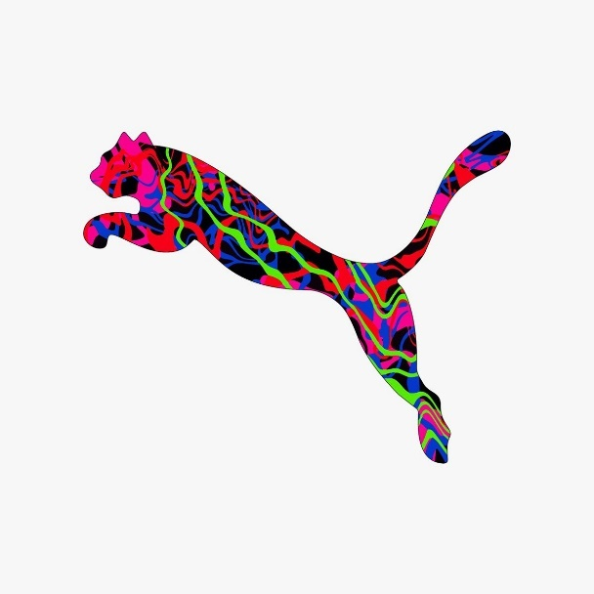

# Introduction

This thesis focuses on the valuation of Puma, a sports company based in Germany, identified by the Bloomberg ticker PUM GR EQUITY.

This will be achieved by using the DCF model for valuation which will present the perceived value of Puma relative to the discounted expected future cash flows of the 5 following financial years for the company. The forecasted free cash flows and the terminal value will be discounted using the WACC. Then, the sum of the discounted free cash flows and the terminal value will establish the enterprise value which is the basis for the DCF valuation. The next step is a sensitivity analysis and a scenario analysis. The sensitivity analysis will depict how potential changes in the growth rates and in WACC will affect either the equity share price or the enterprise value of Puma. In the scenario analysis two alternative cases are analyzed. A bullish case and a bearish case including their effects on Puma’s enterprise and equity value.

Additionally, a relative valuation will be conducted to enhance the DCF approach. This method uses financial multiples to derive Puma’s value by comparing it with similar firms, based on standardized metrics.

The thesis will conclude with an investment recommendation, suggesting whether to buy Puma’s stock based on the findings from both the DCF and relative valuation analysis.



# Company Overview[1]

Founded back in 1919 and currently based on Herzogenaurach in Germany, Puma nowadays in collaboration with its 11 subsidiaries in America, EMEA, Asia-Pacific engages in the development and sale of athletic footwear, apparel, and accessories all over the world. The firm provides sports lifestyle products for plenty of famous sports, such as football, handball, rugby, cricket, volleyball, track and field, motorsports, golf, and basketball. It issues licensees to independent partners to design, develop, manufacture, and sells watches, glasses, safety shoes, workwear, and gaming accessories. The company sells its products under the PUMA and Cobra Golf brands through retail stores, outlets, and online stores.

## Management Team[2]

Although The management team of Puma has a very low average age of 45 years, it is composed of highly experienced and diverse professionals since a third of board members are female, who drive the strategic direction and operational excellence of the company. The team includes Arne Freundt as Chief Executive Officer. Joining him are Huber Hinterseher, Chief Financial Officer, responsible for overseeing financial health, Maria Valdes as Chief Product Officer, Anne-Laure Descours as Chief Sourcing Officer and Heloise Temple-Boyer with the role of Supervisory Board. The management team has a crucial role to Puma success in the highly competitive sportswear industry.

The company has four different audit committees and three of them are independent reflecting the company’s commitment to strong corporate governance and enhances transparency and accountability at all levels of Puma. It is very interesting to mention that the audit committee has a meeting every three months with full attendance like the board meeting which are five during the whole year.

Below are the names and the position of management team of Puma.

Table 2

|  |  |
| --- | --- |
| Chief Executive Officer (CEO) | Arne Freundt |
| Chief Financial Officer (CFO) | Hubert Hinterseher |
| Chief Product Officer (CPO) | Maria Valdes |
| Chief Sourcing Officer (CSO) | Anne-Laure Descours |
| Chair Of the Supervisory Board | Héloïse Temple-Boyer |

The corporate values of Puma are workforce diversity, workplace inclusion, continuous accountability and community engagement, which has four key areas. Sports and health, protection of environment, equality & non-discrimination and education.

The management team is responsible for the whole of employees of the company to spread the values, to be sure that they are aligned, to avoid conflict of interests between management team, shareholders and employees. Moreover, the management team, despite flexible working conditions, want good survival salary for everyone with plenty of benefits and bonus system for employees to achieve well-being in their personal life with their families.

Puma for 2023 had a total number of employees equal to 21.164 from 134 nationalities in 1214 offices and stores and in 400 factories most of which located in Asian countries. Also, diversity exists in the central headquarters with 75 countries having employees, which is 44% of the workforce, the rest are German citizens.

On pie 3 it is presented how the employees have been allocated throughout the world, most of them are based in EMEA countries and in Asia.

Table 3

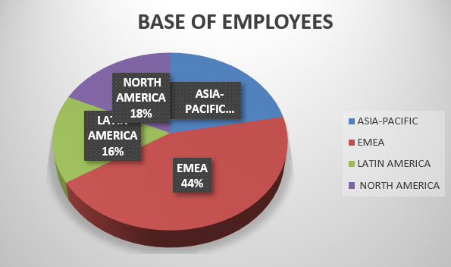

## Capital Structure

All companies to finance their investments use either equity or debt. Related data regarding total firms’ equity and total debt have been retrieved from three financial statements and Bloomberg terminal. On Table 4 the total capital structure is presented with debt ratios of Puma for the last 5 financial years.

Table 4

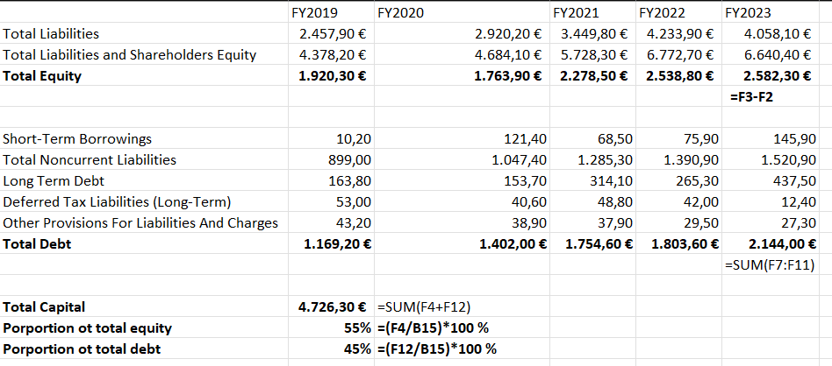

Puma is financed 55% with equity and 45% with debt.

On the following figure 1, the increase of the total debt is presented from 1920.30€ in 2019 to 2582.30€ in 2023. From the graph, Puma needs to borrow funds in order to finance it is CapEx, as internal finance was insufficient. Despite that increase, the Interest Coverage Ratio of Puma is 6.17, which is a high number as it means that Puma with its EBIT can cover its interest expenses six times. Moreover, the NET DEBT/EBITDA Puma’s ratio is equal to 2.56 and compared to 3 which is the benchmark, since it is lower, it provides ability for Puma to repay its debt obligations. The excellent performance on those two ratios enhances the solvency of Puma and its investment grade.

So, despite the high levels of debt, Puma can repay its obligations.

Figure 1

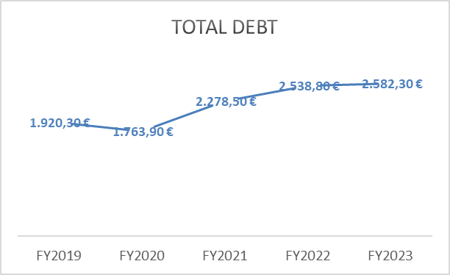

## Dividend Policy

Every business should reinvest its Net Earnings or distribute them as a dividend. Pumas’ choice is after annual general meeting to share 40.3% of its net income, which is the payout ratio of the company, as a dividend to shareholders

Graph 2 is a print screen from puma’s annual report website[3] which depicts the flow of EPS and dividends per share for the last five financial years.

Figure 2

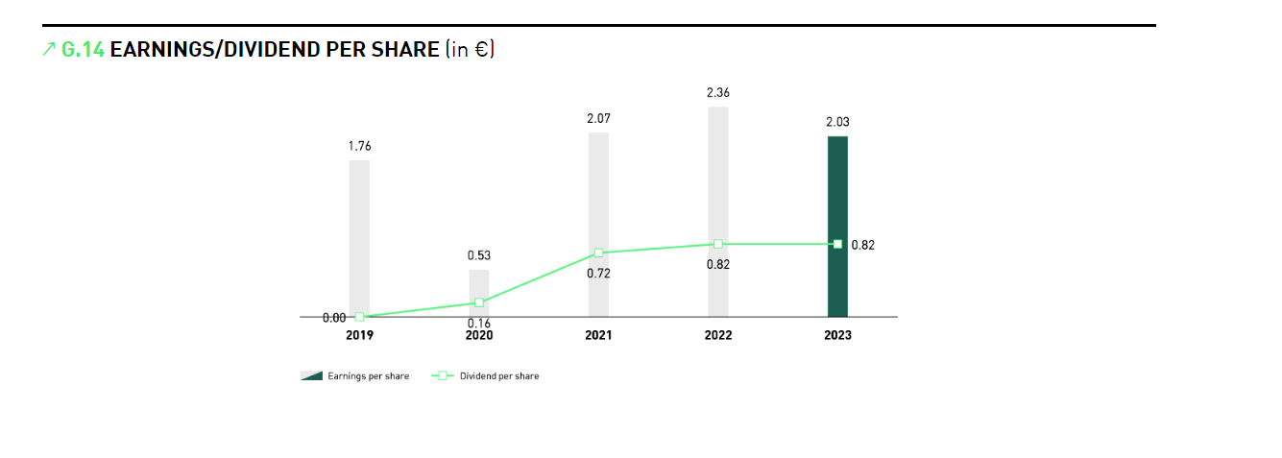

For the 2023 Puma share 0.82 dividends per share and from the cash flow from financing activities in the cash flow statement, Puma totally paid 122.80 € in dividend and 92.40 € for dividends outside to equity interests.

The Payout ratio is 40.3% for 2023 which is higher 6% than THE previous year. This means that Puma pays 40.3% of its net earnings as a dividend and the rest Is used for other operations such as reinvesting.

Puma has higher ROCE than WACC, so the management team creates value, and the shareholders require low dividend payout ratio since net earnings can be reinvested.

## ESG Performance

Puma, been actively enhancing its Environmental, Social, and Governance (ESG) performance in recent years. Bloomberg, which is the main source of data for that part, provides ESG data for Puma until FY2022. Puma has a total ESG score of 72.51 for the FY2022, which is a significant increase from the FY2014 when the score was 35.57. Nowadays it is very important for every company to incorporate ESG factors in their investment decisions with the long-term view for several reasons. By integrating ESG Puma can meet requirements under fiduciary duty or regulations and client demands, manage risks effectively, improve the quality of engagement and stewardship activities, enhance financial and non-financial returns, boost its reputation, attract investments and contribute to sustainable development.

Puma has shown significant progress in environmental sustainability from FY2014 to FY2022 since the environmental disclosure score in FY2022 was approximately double (33.52 to 62.22). Several are the reasons for that increase, but the most important is that Puma during that period started to adopt water reduction policy and biodiversity policy. Furthermore, Puma has never been fined for an environmental violation. The total energy consumption score of 98.65 for FY2022 is a positive sign since it is higher than THE previous financial years and it is very close to the benchmark which is 100. This indicates a well-performing consumption management and possibly utilizing renewable energy sources.

On the social front, the last Social Disclosure Score in 2022 was 3.94, which is close to the historical average of the company. Of the 21.164 employees, 1795 are temporary and 4109 are part-time, the rest are full-time with long-term contract, with AN average age OF 32 years old. For Puma humans are crucially important to the business and that’s why the company has adopted employee training programs and training policy for 160.481 total hours with total cost 4.187 million euros for FY2022. Furthermore, Puma tries to reduce the number of workforce accidents, which was 98 for FY2023 by incorporating health and safety policy over the last ten years.

Puma has maintained robust governance practices by emphasizing transparency, ethics, and stakeholder engagement, with total governance disclosure score of 96.18. In terms of Board Composition and Diversity, Puma’s board consists of a diverse group of 6 experienced professionals with an average board age of 55.67 years old (highest age: 80, lowest age: 45), ensuring a range of perspectives in decision-making. Since Puma is a multinational company, it has adopted global strategies (like in Tax) in every subsidiary to be sure that they follow the same corporate rules.

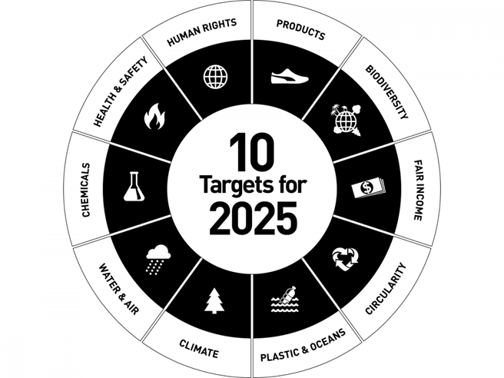

Although Social and Governance factors have historically been overlooked in valuation process, investment decisions and asset valuation were based exclusively on financial metrics and forecasts (which remains important). Nowadays, investors and valuation professionals have the knowledge that all ESG factors increasingly influence both asset long-term values and valuation practices, the Cash Flows and can enhance non-financial returns and boost profitability. That’s why transparency is crucially important in ESG data before integrating ESG into the valuation and investment decision-making process. Environmental sustainability, social responsibility, and robust governance are the root of success for every company and Puma has adopted both.

Diversity is one of the most important values of Puma and the company invests a lot to create the right environment for everyone and that’s the reason why the last four years Puma has been ranked as a diversity leader among European companies from the Financial Times.

## Financials

In FY2023, Puma had total revenue of 8601.70 million € a 1.61% increase from FY2023. Puma operates on a worldwide basis. Puma has a strong balance sheet with net cash position of 552.90 million € on 31 December 2023, which is higher than FY2022, but lower than the previous two financial years.

## Regional Sales

The EMEA and America accounted for 40% and 39% of Group Sales with strength in its main markets, namely USA, France and origin country Germany. The third biggest market, Asia, contributed 21% in total sales. In that case it must be considered that every region has different beliefs, and the consumer behavior varies in each country for every product.

Table 5 presents the regional sales of Puma for FY2023

Table 5

## Business Areas

The group operates in three segments: footwear, apparel and accessories. The largest revenue generating area of Puma is footwear, producing 4583,4 million € of revenue in 2023, which was more than half of total sales. Based on historical data from Bloomberg and Annual reports, accessories are always the category with lower contribution.

Table 6

## Recent Historic Collaborations [4]

During the FIFA World Cup in Germany in 2006, PUMA sponsored more than any other of its peers with 13 out of 32 teams. Italy won the final game and for the first time in the company’s history, a PUMA-sponsored team becomes the world champion. Moreover, Italy’s goalkeeper, Gianluigi Buffon, equipped with PUMA gloves, was awarded the Yashin Award for "Best Goalkeeper of the Tournament."

Puma used to provide Usain Bolt with sports equipment during his unique career. In 2009 he set a new 100 world record with a time of 9.58 seconds at the World Athletics Championships in Berlin.

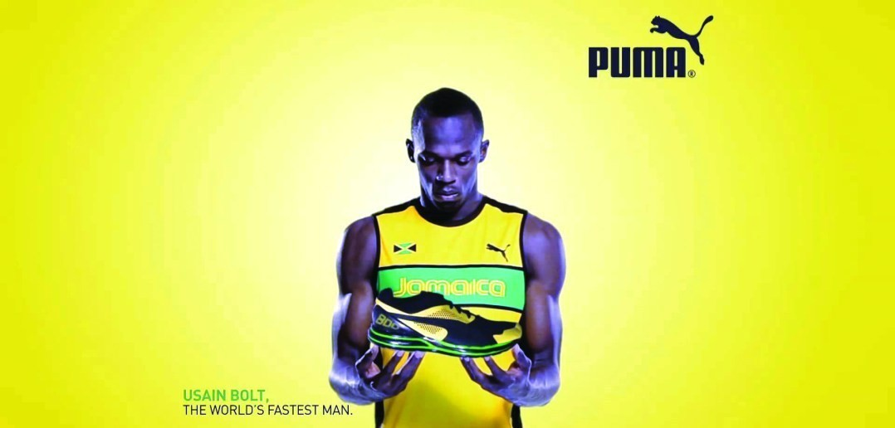

During 2012 PUMA added Borussia Dortmund (BVB) to its football portfolio in a long-term partnership until 2028. BVB makes it to the Champions League final in the first season of the partnership. Since 2014, PUMA has also been a shareholder of Borussia Dortmund.

In 2019 Puma and Manchester City signed the biggest deal in the history of Puma, since they signed a long-term partnership to provide all representative teams of British Club including men’s, women’s and youth football. Melbourne City FC, Mumbai City FC, Girona FC, AC Milan are teams among Puma’s portfolio.

# Market Overview

The sports market industry has shown significant growth and transformation, driven by several key trends and factors in the last decade. Digital transformation and technology integration, e-sports and virtual sports, sustainability and social responsibility, sponsorship and advertising have a significant impact on the companies that have business in that market.



2024 is a significant year in sports since three big events will be held in Europe and in Latin America. UEFA Euro in home country of Puma, Copa America and the most important athletic event, which takes place every four years, the Olympic games during August 2024 in Paris.

For these events, plenty of preparations and significant investments in infrastructure and technology are required with the goal of delivering a technologically advanced and sustainable event. It is important to mention that those events not only have a significant impact on the sports industry but also in other industries like media, watch, food and beverage, and hotel industry, since they ARE affected a lot by those events. For every competition, each sport brand must prepare plenty of different things, such as special equipment for the sponsorship teams (jerseys or balls) and create souvenirs of the games for fans.

Despite the opportunities there are significant challenges in the market which can cause several problems for the firms. Our era is characterized by economic uncertainty. Several global economic conditions including inflation and supply chain disruptions, posed challenges for the sports industry. However, the sector has shown resilience with continued investment and innovation. The last financial year was a transition year for sports industry. The market environment was challenging, characterized by various macroeconomic aspects such as geopolitical conflicts, the new war in Middle East and volatile currencies. Especially for Puma the extraordinary devaluation of the Argentinian Peso had a significant one-off accounting impact, otherwise Puma would have better financial results. Moreover, Covid-19 changed our life and sports events have also been influenced by that since in period after covid the way of organizing an event has changed since the health and safety measures at events have changed a lot.

In the pie chart below, the brands worn by each national team during the 2022 FIFA World Cup in Qatar are depicted. Nike was the leading brand, outfitting 13 of the 32 teams, including some of the most successful nations in the tournament such as France, England, and Brazil. Argentina, the 2022 champions, were represented by Adidas, along with other recent champions like Germany and Spain. Puma was the third most prominent brand, representing 6 teams, including the surprise team of the tournament, Morocco.

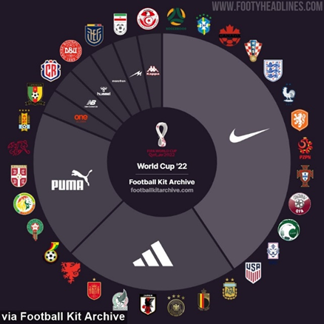

# Methodology

The second chapter will depict the models that are used in the valuation process. Starting with presenting an introduction to valuation, moving on what valuation is and then a description of the valuation models (DCF and Relative Valuation).

## Introduction to Valuation

Every asset has its own value, so every change or assumption in any component will be reflected in the valuation. For instance, if rf will increase 1 unit several effects occur in the DCF model. WACC, cost of equity and cost of debt will increase since rf is part of their calculation. As DCF calculates the enterprise value by discounting the projected free cash flows to their present value, a higher discount rate will have a result in a lower enterprise value. This means that the overall valuation of the company would decrease, so lower present value of those cash flows.

## Discounted Cash Flow Model (DCF)

DCF is a function of the expected cash flows of an asset. Assets with high and predictable cash flows have greater values than assets with lower or unpredictable cash flows. The value of an asset is estimated using the present value of the expected cash flow associated and can be calculated using the equation 1.

Equation 1

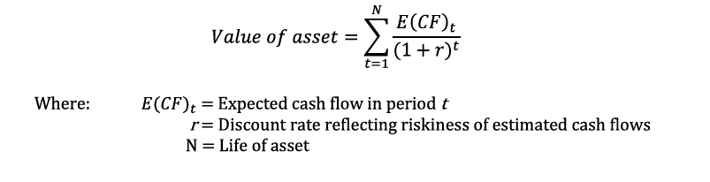

In a DCF, a company’s cash flows are usually forecasted for a five- or six-year period, but this depends on THE sector and the people who are doing it.

The forecasted free cash flows and the terminal value must be discounted using the WACC. The enterprise value, which is crucially important in the process of DCF valuation, is created by the sum of the discounted present value and the terminal value. It must be considered that there are limitations associated with DCF. Especially with growth rate, discount rate and β since they are unstable through the time. In that case, sensitivity analysis or scenario analysis can measure these changes and help the company to prepare for different scenarios, either positive or negative.

## Relative Valuation

Relative valuation is a method used to identify the value of an asset by comparing it to the values of similar assets. It is a practical tool for investors and analysts in all segments since it uses common variables and provides useful information. It is very important not only to focus on the number but on the fundamentals which are driving multiples, otherwise inaccurate conclusions will be examined. Thus, the use of appropriate multiples in each case with understanding the fundamentals will allow accurate conclusions. There are a lot of different categories of multiples such as price multiples, Enterprise Value, Equity, Revenue, Profit, Liquidity, Cash Flow and Book Value.

Price/Earnings (P/E) is one more ratio that compares a company's current share price to its per-share earnings (EPS). Higher P/E implies higher growth expectations. On the other hand, a lower P/E may indicate undervaluation or potential issues.

Price-to-Book Value (PBV) ratio compares a company's current share price to its book value per share. A higher P/B ratio suggests the stock is valued more highly by the market, this means it is overvalued, while a lower P/B may indicate undervaluation.

For this valuation P/E, EV/EBITDA and EV/REV are the selected multiples.

## Data sources

To do this valuation, data from Annual Reports, from Bloomberg and historical financial data from independent sources like Yahoo finance were utilized. Also notes from the QMUL courses ECOM143 (Cases in Corporate Finance) and ECOM208 (ESG investing) were used.

# Empirical Analysis

The aim of the 3rd section is to perform the valuation models introduced in Chapter 2 and present the findings. By executing this, we can find Puma’s perceived value, which will enable us to make an informed investment recommendation.

## Historical Financial Performance

Before doing valuation, it is crucially important to analyze historical financial reports from a valuation perspective. This should allow identification of key value drivers in investment and understand what Puma is doing for having future success.

The analyzed historical period for Puma was between FY2014 and FY2023. During the last ten years the group sales grew significantly in the three segments with average CAGR 11.5 %. The average CapEx was 162.48, which was lower than 188.21 showing depreciations over that period, which indicates underinvestment. The evolution of W.C., ratios and the relationship between CapEx and Depreciation are extensively analyzed later in that chapter.

Over the last decade, Puma's inventories have generally increased, rising from 571.50 in 2014 to 1,804.40 in 2023, reflecting the company's expansion and increase of operations. This happened due to expansion, increased production, or higher anticipated sales. There is a noticeable decrease of 19.6% from 2022 which was the peak year to 2023. Several factors can be the reason for that such as improved inventory management or decrease in production.

Current ratio and the quick ratio are two common ratios which are frequently used for identifying short-term liquidity risk.

Equation 2

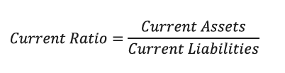

Table 7



From historical data it is proven that Puma has always current ratio which fluctuates but it is always slightly above 1. In the case that current ratio is below 1, the company does not have enough assets to meet its short-term obligations. For instance, a current ratio 2.05 for FY2014, means that Puma had approximately 2 times more current assets than its current liabilities to cover its short-term financial obligations like debts.

Since Pumas Current ratio was close to 1, especially in the last three years if this downtrend continues in the foreseeable future there are possibilities for the company to face liquidity problems.

Quick ratio is a current ratio excluding inventories and provides useful information about the short-term liquidity risk of a company. A good quick ratio is everything above 1, which means that the company has the same liquid assets as current liabilities. Quick ratio of Puma also has a downtrend like current ratio and since FY2016 is lower than one., which indicates an inadequate level of liquidity for Puma since it is not able to pay off current liabilities several times over.

## Sales

Regarding the evolution of sales in the three compounds the charts below demonstrate the historical progression of sales by business area for the last ten financial years. Both categories have an uptrend, but during THE Covid-19 period there was a dip in the total number of sales since most of the physical stores were closed for a long time.

Figure 3

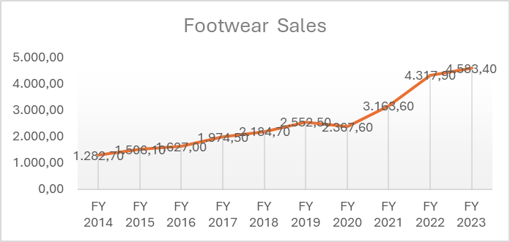

Figure 4

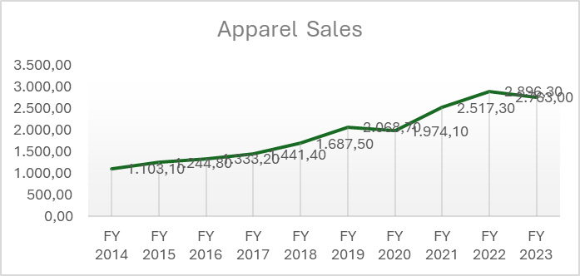

Figure 5

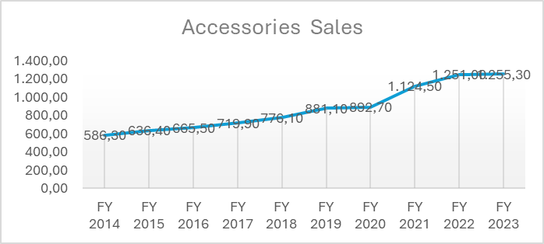

## Determining Key Performance Drivers

At the beginning of DCF, it is very important to understand the valued firm and the sector in which THEY have their business, allowing one to identify value creating or destructing determinants.

Puma recognizes its most important growth drivers as the following: product innovation, digital transformation, market expansion, brand strength and heritage, and athlete and celebrity endorsements.

## Free Cash Flow Projections

Forecast for sales were made in consideration of internal, strategic measures taken by Puma and external factors such as the political and economic climate of 4 regions (Europe, Asia, America, Africa).

## Cost of Goods Sold

Costs of Goods (COGS) for Puma was assumed to remain steady at 54% of total sales until FY2029. 54% is the average for the last four financial years of cost of sales. COGS for Puma was integrated from the historic data from Bloomberg and then used to benchmark against expected COGS calculations. Furthermore, Puma is a company having a stability in its business model, so it is accurate to base on historical data to predict the future, but we must consider that COGS are based on various factors such as raw material prices which can fluctuate due to inflation period and economic conditions

The results are presented in table 8.

Table 8

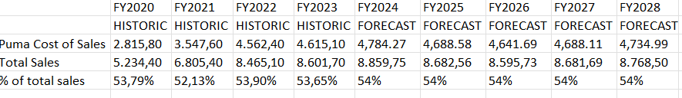

## Tax

Figure 6 depicts the cash expenses of Puma for the last ten financial years. The numbers are in millions of euros and although the first four years Puma had a decline in the cash paid compared it to FY2014, after FY2018 there was a significant increase in the total tax expenses. This is due to the increase of revenues and EBITDA, so in the case of those two going up, tax expenses also will go up. The tax rate for business now in Germany is 25%. The Group also reported that it anticipates their effective tax rate to remain at that level. For this reason, an effective tax rate of 25% was used for the forecasts. Since Puma is in Germany, it follows the International Financial Reporting Standards (IFRS) for their financial statements. Puma is a multinational company; this means that it has business in many countries. Each country has its own corporate tax rate. For instance, the U.S. which is one of the biggest markets for Puma has a corporate tax rate of 21%, while in European countries the corporate tax rate varies between 25% to 33%.

Figure 6

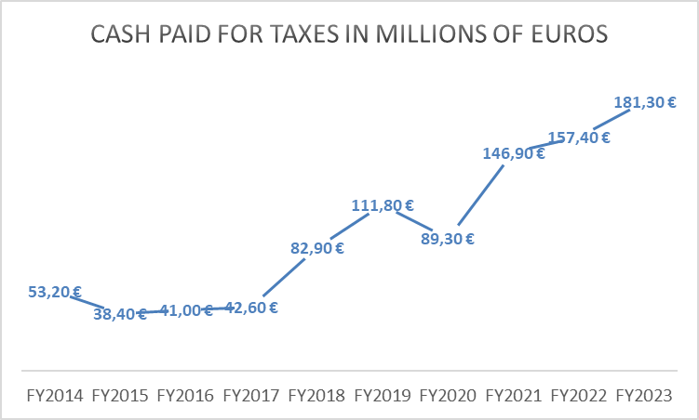

## Capex- Depreciations

To evaluate the investment policy of a Puma it is necessary to compare CapEx with Depreciations.

On Table 9 historical data is provided for Capital Expenditures and Depreciations for Puma from FY2014 until FY2023.

Table 9

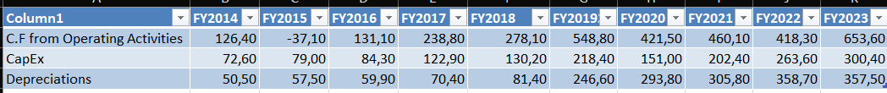

CapEx fluctuates throughout that period and Depreciations have an upward trend.

For the last five years, as the chart below depicts Capex was always lower than depreciations, this means that the company has not been investing in new assets.

Figure 7

In that case organic growth is limited and Puma has to find other ways to growth such as acquisitions, better marketing for achieving higher sales or creating new innovative products.

Regarding the future, both are expected to have a slight decrease 0,35% every year for the next four financial years, but still depreciations will be higher than CapEx. In the final year of DCF (2028), the two figures are set at the same value of 351, to ensure that Puma is not overvalued.

Table 10

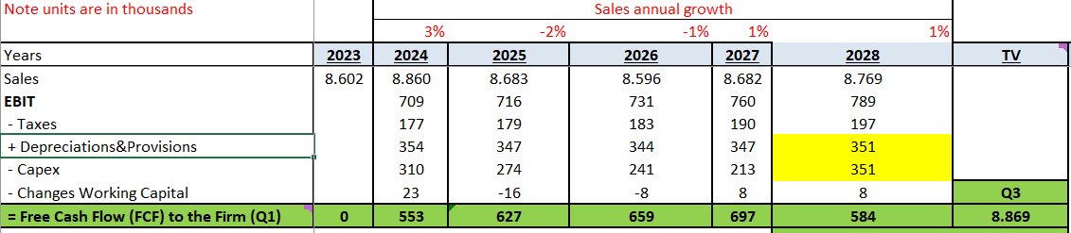

Figure 8 illustrates that although Investments and CapEx are growing at the same rate from 2019, Puma has high depreciations and that’s why future might be in danger since it has conditions of underinvestment

Figure 8

It is crucially important for every business to balance their Capex and their Depreciations to achieve sustainable operations and organic growth. But when valuing a company, we must consider that there might be strategic reasons for a firm to choose a specific investment policy.

## Working Capital (W.C.)

The difference between current assets and current liabilities is equal to working capital (<https://corporatefinanceinstitute.com/resources/financial-modeling/working-capital-formula/>), but this can be slightly modified depending on the purpose of valuation. Puma on its balance sheet as a current asset has its cash and equivalents, their inventories and receivables. W.C. represents the balance of the accounts related to the operating cycle and includes funds that the company owes to suppliers such as accounts payable current liabilities, short term borrowing, income taxes and provisions. Moreover, it includes sales that customers have not paid yet which are the customer receivables in balance sheet and inventories that the company has. The balance of the three items represents the actual amount of money associated with the operating cycle of the company

W.C has three important financial ratios. Days Sales Outstanding (D.S.O.) Days Inventories Outstanding (D.I.O.) and Days Payables Outstanding (D.P.O.)

On Table 11 the statistics and the average of those ratios are provided.

Table 11



Puma has 44.79 average of D.S.O, which means that it needs that number of days to receive payment for a sale, which is high since it is more than a month, so the company faces delays in receiving payment which can lead in a cash flow problem.

Puma in the last 10 years holds its inventories for 135.33 days (D.I.O.) before turning it into sales, which is also high, so they face the risk of inventory become obsolete.

Also, the D.P.O. which is 104.38 days approximately 3,5 months, refers to the average number of days that takes Puma to pay back all its suppliers. This means that Puma has good credit terms or that the company is unable to pay on time.

Below is provided the calculation of historical working capital for Puma.

Table 12

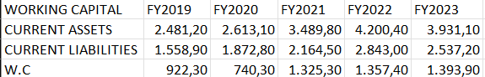

For every year the working capital is positive, which means that Puma has more current assets than current liabilities. This can be interpreted as a sign of financial health and stability through time. In addition, it implies liquidity for the company, and it is proof of being able to cover its short-term liabilities like debts or bills. Furthermore, it depicts efficient management in current assets, so since the working capital is positive, they can use it more effectively in investments for growing.

To conclude, growth of the business is a phenomenon related to an increase of the amount of W.C.

## Weighted Average Cost of Capital (WACC)

WACC is a method that is used as a discount rate to calculate the present value of the firm’s forecasted free cash flows and its terminal value. The cost of capital is the average rate of return equity holders and debt investors require to cover the opportunity cost of investing in the firm. There are two different ways to calculate the WACC.

The first is with equation 3.

Equation 3

 Equation 4 presents the second way to calculate the WACC.

Equation 4

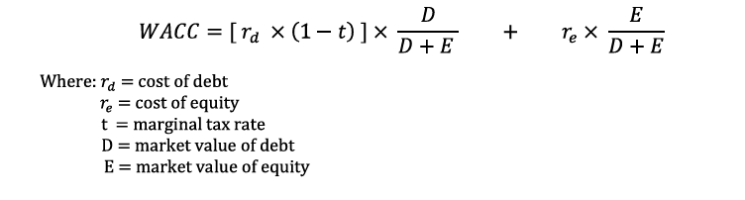

## Cost of Debt

Cost of debt is the effective rate that A business pays on its debt. It is a crucial component when valuing a company since it provides information about financing costs of business and has a major role in the total capital structure of a firm.

From Bloomberg the cost of debt of Puma is 3.68. Since Puma is a company with 45% proportion of debt in its capital structure, the cost of debt has a significant influence on its operations.

To understand the impact of debt we need to compare the cost of debt with WACC. In Puma’s case the cost of debt is lower than WACC, which means that the debt is not so expensive and does not increase the financial risk.

To evaluate whether the returns that are generated are profit taking into consideration the amount of debt, we need to compare the cost of debt with ROCE. Puma has ROCE equal to 25.10% which is higher than the cost of debt. This can be interpreted as the returns are sufficient to cover borrowing costs.

## Cost of Equity

There are 3 key variables that determine THE cost of equity. The risk-free rate, the market risk premium and β.

Below it’s the equation of Capital Asset Pricing Model (C.A.P.M.) which is used to calculate the cost of equity.

Equation 5



## Risk Free Rate

The risk-free rate is the theoretical return on an investment with no risk of financial loss, typically represented by the yield on government bonds, such as Germany or U.S. since they are considered bonds with high liquidity and lower credit risk than other countries.

## Equity Beta (β)

Beta is a measure of a stock's volatility relative to the overall market. It measures the systematic risk that every company cannot eliminate. Every company has its own beta, and it compares it with the market which has beta of 1. So, companies which have beta equal to 1 are expected to have the same return with the market. A beta lower than 1 indicates lower volatility than the market. On the other hand, those companies with beta greater than one, like Puma with 1.12, tend to have higher volatility than the market and they face more risk

## Equity Risk Premium

Equity Risk Premium is the difference between market return and risk-free rate. It is considered as the extra money you expect to earn by investing in stocks instead of safer investments like government bonds. So, it is the reward for taking higher risk on the stock market.

## Terminal Value (TV)

The TV depicts the potential-estimated future growth of a company. It takes into account the last forecasted free cash flows from DCF the CAGR and the WACC

TV can be calculated with equation 6

Equation 6

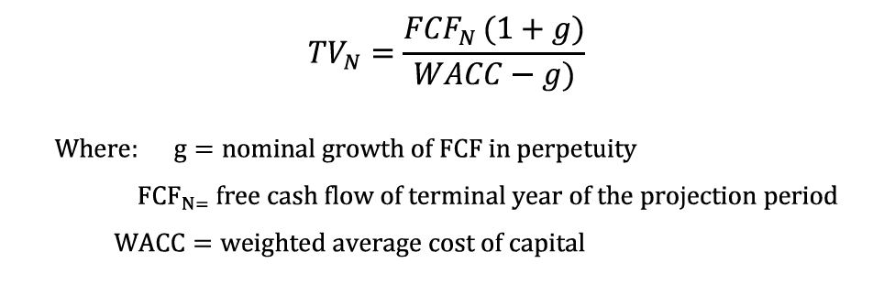

The final free cash flow for Puma is forecasted at 584 million with 1% CAGR and 7.65% was the WACC.

## Enterprise Value

A firm’s forecasted free cash flow and terminal value will allow for calculation of the enterprise value.

The enterprise value of a firm is the total sum of the net present value of the discounted forecasted free cash flows and the discounted terminal value as it is depicted below on equation 7.

Equation 7

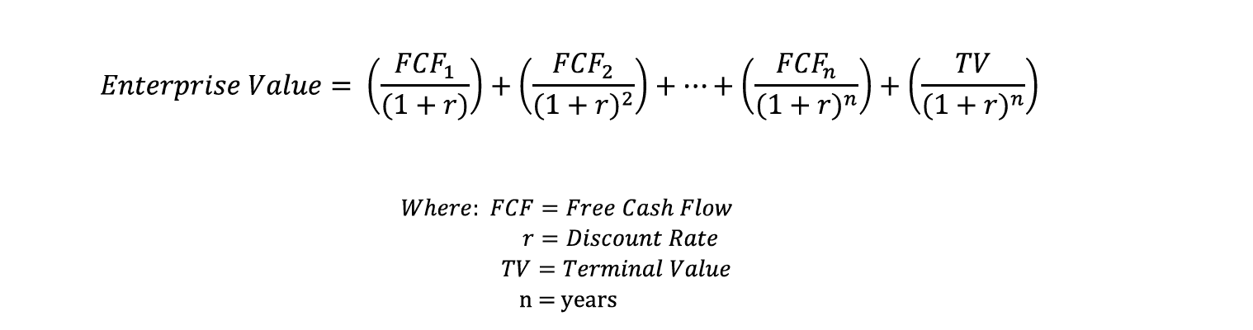

Pumas’ enterprise value calculated as 8748€ and terminal value as 8869€.

## Equity Value

Equity value or market capitalization represents the total value of a company's outstanding shares of stock.

It is calculated by the formula which is in equation 8.

Equation 8

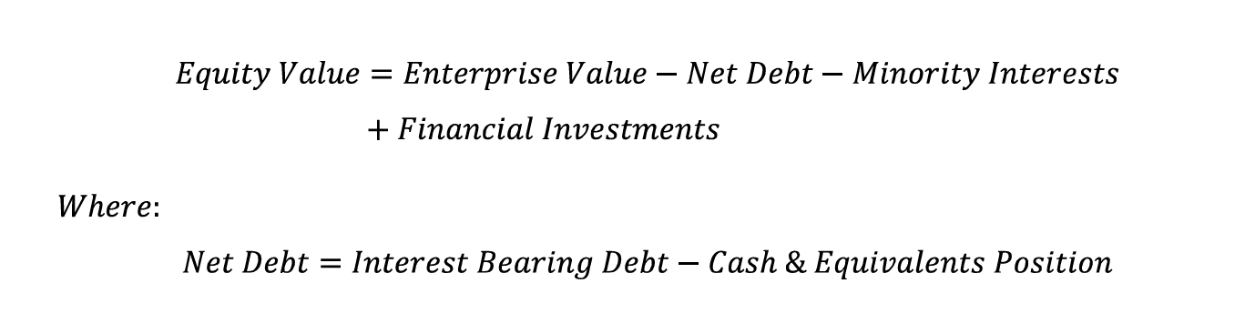

Using that formula, equity value was equal to 8.870€. Total debt was found by summing long-term borrowings from non-current liabilities and short-term liabilities from current liabilities which is the total debt, and the minus cash and equivalents.

Financial Investments is the sum of investing activities from cash flow statement and short-long term investments.

Table 13

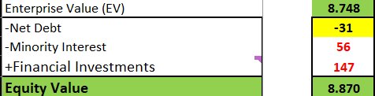

## Equity Value per Share

Equity value per share is calculated by the below formula.

Equation 9

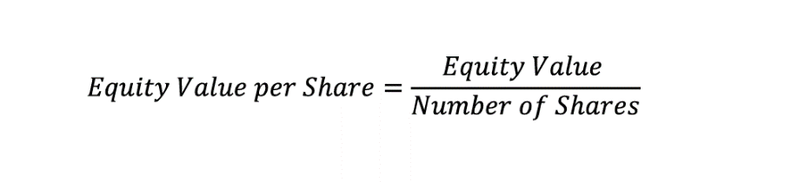

Equity value of Puma was 8.870 divided by 149.920 outstanding shares, which gives 59.53 value per share

Table 14

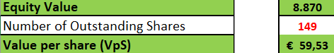

## Sensitivity Analysis

For doing this part, I used the produced data from the DCF, the WACC is 7.65% and the growth rate 1%, the E.V is 8748 million €.

### Enterprise Sensitivity Analysis

The two tables below represent the sensitivity analysis for the enterprise value of Puma. This type of analysis allows investors to determine how possible changes in values of WACC and growth rate WOULD affect the enterprise value.

In the table, the WACC fluctuates 0.5% up and down and the g remains unchanged. In the case that WACC decreases the E.V. of the company increases. This is because the EV formula incorporates T.V. which has WACC in the nominator. Since the nominator decreases the T.V would increase, and this leads to higher E.V. On the other hand, for the same reason, when WACC increases, the E.V will be lower.

Table 15

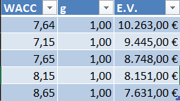

If the growth rate was to increase to 1.55 and WACC remained the same enterprise value would increase to 9322 million € as it is provided on the following table. In the opposite case E.V would be lower. This happens because the T.V value in the nominator despite the WACC has also the growth rate. WACC is higher than g, so in the case that g increases the sum of those two decreases and in the opposite case the sum increases.

Table 16

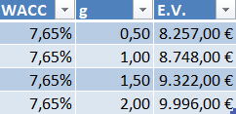

### Equity Share Price Sensitivity Analysis

Table 17 demonstrates how any changes in WACC and growth rates will impact equity share price. If WACC increases 0.25% per cent and growth remains steady, the sensitivity analysis provides that equity value share price would decrease. A higher WACC reduces the present value of future cash flows as it increases the discount rate. Since the equity value per share is based on the present value of future cash flows, a higher WACC can reduce this value. On the other hand, lower WACC means lower discount rate, so in the case of reducing WACC, the Equity value per share is going to increase.

Table 17

The value of equity share price is directly related with the present value of future cash flows, which are influenced by the growth rate. In the case that growth rate increases companies are expected to have higher cash flows. Thus, when WACC remains at 7.65% and growth rate increases from 1% to 1.05%, the equity share price would be higher, as table provides at 8925 million of euro. In contrast, in the case that growth rate is lower than 1%, the equity value per share will also be lower. Since the equity value per share based on the present value of future cash flows, a decrease in the growth rate will reduce the equity value per share.

Table 18

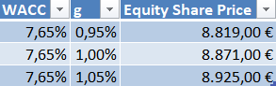

## Scenario Analysis

In Scenario Analysis section two different cases are presented. A bullish case which is an extremely aggressive scenario and a bearish-pessimistic case which is a conservative scenario.

Table 19 is a screenshot of Excel spreadsheet which presents A bearish case scenario. A hypothetical negative growth rate and a higher than the historical average WACC were used to find the effect on the enterprise value and equity value. Pumas’ TV, EV and equity value have significantly fallen. Especially Equity value per share dropped at 14.47 euros from 59.54 euros which was produced by DCF. Table 19

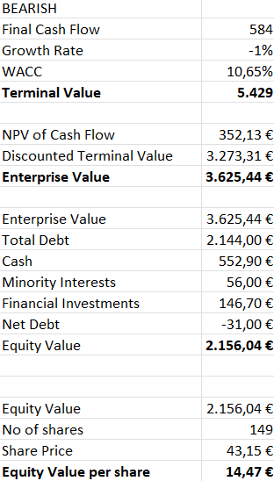

On the other scenario, the bullish case, 6% growth rate which is higher than the historical average and 3.65% for WACC were used to analyze this case. Table 20 presents the findings. In this case terminal value, enterprise value and equity value are higher. Since the growth rate is very high the company is expected to produce more revenue which influences the values.Table 20

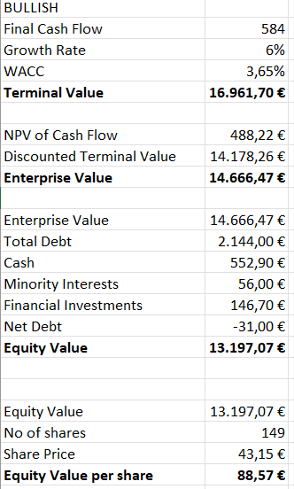

## Relative Valuation

Relative valuation is a method in which the current value of a company is compared with other similar businesses with the use of financial multiples such as P/E, EV/EBITDA, EV/REVENUE. In that case the ratios of competitors of Puma have been used to do the analysis, since there are companies on the same market.

### 

### P/E

The P/E Multiple for Puma for FY2023 was 23.43 Compared to the average of 22.62 of its competitive peers suggests that Puma is overvalued by 0.81 units.

Table 21

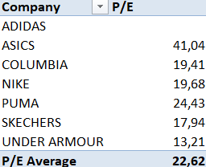

### 

### EV/EBITDA

The EV/EBITDA multiple is a financial valuation metric that compares a company's EV to its EBITDA.

The EV/EBITDA multiple for Puma was 13.72 in FY2023. This means Puma is undervalued by 3.46 units for that year.

Table 22

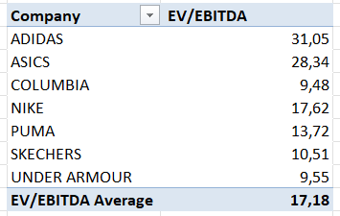

### 

### EV/REV

The enterprise value compared to Puma priced low, this implies that the Group has good projects to do in the foreseeable future. That multiple for Puma in FY2023 was equal to one, compared to the multiple of 1.67 of its peers.

Table 23

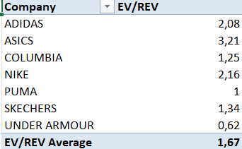

# Conclusion

This thesis was aimed at performing an equity valuation of Germany-based sports goods company Puma. Using DCF model to value the company and finding the equity and enterprise value.

Since Puma has limited capacity for organic growth, the company strategically focuses on innovative products, on sustainability, on brand image and high-profile collaborations, such as those with English champions Manchester City and with seven times European champions AC Milan, to achieve growth.

After identifying the value drivers, the next step involved making forecasts for the conducting of DCF. The DCF model revealed that Puma has an enterprise value of 8,748€ million and an equity value of 8,870 million €. The current share price is 43.15€, with 149,200 outstanding shares.

A sensitivity and scenario analysis were performed to check the forecasted assumptions. The sensitivity analysis showed how any fluctuations in growth rate and WACC influence the enterprise value of Puma. Moreover, a scenario analysis was done presenting 2 different extreme cases, a bullish case and a bearish case and the effects that the scenarios have on the enterprise value and equity value. The bearish case produced an enterprise value equal to 3.625,44 million € and equity value equal to 2.156,04 million €. The bullish case had higher results since the enterprise value was 14.666,47 million € and equity value was 13197,07 million €.

Following this, a relative valuation was performed using multiples such as P/E, EV/EBIT, EV/EBITDA, and EV/REV. This analysis suggested that Puma is undervalued compared to its peers, which supports the conclusions drawn from the DCF model.

Based on the results from both the DCF and the relative valuation methods, the recommendation is to BUY Puma's stock.

# References

* All the historical data (financial statements and ratios) for the last ten financial years received from Bloomberg terminal, Puma has “PUM GR EQUITY” for Bloomberg ticket
* Yahoo Finance: <https://finance.yahoo.com/quote/PUM.DE/>
* Investors Website: <https://about.puma.com/en/investor-relations>
* Pumas annual report 2023: <https://annual-report.puma.com/2023/en/>
* History of Puma: <https://about.puma.com/en/this-is-puma/history>
* Employees data: <https://about.puma.com/en/diversity-equity-inclusion>
* Dividend Policy: <https://annual-report.puma.com/2023/en/combined-management-report/dividends/index.html>
* Definitions of the ratios: Corporate Finance Institute

(<https://corporatefinanceinstitute.com/>)

1. <https://finance.yahoo.com/quote/PUM.DE/profile/>
2. <https://about.puma.com/en/diversity-equity-inclusion>

   Puma Annual Report 2023
3. <https://annual-report.puma.com/2023/en/combined-management-report/dividends/index.html>
4. <https://about.puma.com/en/this-is-puma/history>