Example:
Html:
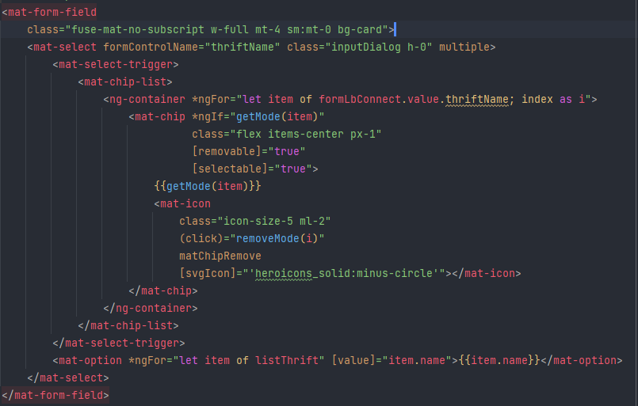
Ts:
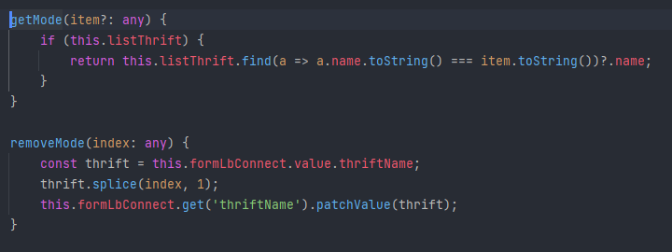
Link stackblitz: https://stackblitz.com/edit/angular-material-v9-mat-select-with-mat-chip-list?file=src%2Fapp%2Fselect-multiple-example.html
Search: mat select with mat chip list

