EEL 4742 - Embedded Systems
MSP430G2553-HW5-Capture The Flag

Overview:
In cyber security, capture the flag is an exercise where participants finds a hidden strings called “flag” in a purposefully-vulnerable program. Capture the flags can be used for both competitve or educational purposes. They come in different categories such as website vulnerabilty, crytography, binary exploit or pwned, digital forenic, and more.

Capture the Flag (CTF) is a competitive exercise commonly used in the fields of cybersecurity and computer science education. In a CTF competition, participants are presented with a series of challenges or puzzles that simulate real-world security scenarios. These challenges cover various domains such as cryptography, web security, forensics, and binary exploitation. The primary goal is to "capture flags"—specific pieces of data or tokens hidden within the challenges—that demonstrate successful completion of tasks or the discovery of vulnerabilities.
CTFs serve multiple purposes:
- Educational Tool: They provide hands-on experience, allowing participants to apply theoretical knowledge in practical situations.
- Skill Assessment: Organizations use CTFs to evaluate the technical skills of individuals or teams.
- Community Engagement: CTFs foster collaboration and knowledge sharing within the cybersecurity community.
Objective of This Binary Exploitation Challenge
The specific CTF challenge you worked on focuses on binary exploitation, a subfield of cybersecurity that involves analyzing and manipulating executable programs to discover and exploit vulnerabilities. Here's a breakdown of the challenge's objectives:
- Understanding the Provided Files:
  - binary.elf: An executable file designed for the MSP430G2553 microcontroller, containing the program code you need to analyze.
  - binary.hdr: ELF headers detailing the structure and memory layout of the executable, which helps in understanding how the program is organized in memory.
  - binary.dsm: A disassembled version of the binary, translating machine code into assembly language instructions for analysis.
  - binary.hex: An Intel HEX file that represents the binary in a format suitable for programming microcontrollers.
- Objective:
  - Flag Retrieval: Utilize various tools and techniques to analyze the program's code with the ultimate goal of printing "flags" to your serial terminal. Each flag represents a successful exploitation step.
  - Methodology Documentation: Explain the methods used to reverse engineer the binary, including the identification and exploitation of software bugs.
  - Testing and Inputs: Describe the testing strategies and specific inputs provided to the program to trigger the desired behavior and reveal the flags.
Grading Criteria:
  - First Flag - 75 points.
  - Second Flag - 25 points.
  - Third Flag - bonus 10 points.
In summary, this challenge is designed to test your ability to dissect and manipulate a compiled program to uncover hidden information, simulating real-world scenarios where understanding and exploiting software vulnerabilities is crucial.

Achieving Flag A.
Method 1 – Using strings command
started by using simple command-line tool called strings, which looks for readable tet within a program. This method is helpful when searching for clues embedded in a binary file. After running the command “strings binary.elf” on the provided binary.elf file, I found an interesting string “313373”. In capture the flag (CTF) community, “313373” or “1337” is a common reference to “elite”, which stem from hacker culture. I used “313373” as input to the progam and was able to retrieve Flag A

Method 2 – Decompling with Ghidra
To understand how the program worked, I used a tool called Ghidra, which translates the program’s machine code back into something more readable. After I succeeded reversed engineer the main function of the program, I found that the program was checking two strings in loop. One of these strings, when converted from its numeric form, matched “313373”. This helped me to confirmed that both methodds led to the same result, but using Ghidra allowed me to understand how the program internalley checked for the flag.

Flag B – Does this count?

NOTE: value to obtain flag A is 313373

Given hint:
Set break at 0xc372 and 0xc38c where the value compare occurred and observed it behavior.
Tried to use both the correct value obtained from flag A and incorrect value to observe the behavior of the program.
Notice how the function 0x210 is called, when it is called vs when it is not

0xc372: cmp #0, r12 ;r3 As==00
0xc374: jnz $+8 ;abs 0xc37c
0xc376: call &0x0210 ; ←----magic function

From given hint, I knew that 0xc372 compare the the value at R12 with 0, return 0 if input valid - so when I tested the value “313373”, r12 returned 0, next instruction jnz check if not equal zero it will jump to determined address at 0xc37c however; since I input the correct value for flag A I should go to next instruction at 0xc376 and call a magic function at &(absolute) address 0x0210
Set the breaks at target addresses eg 0xc372 and 0xc38c where the r12 compare with 0 to validate input
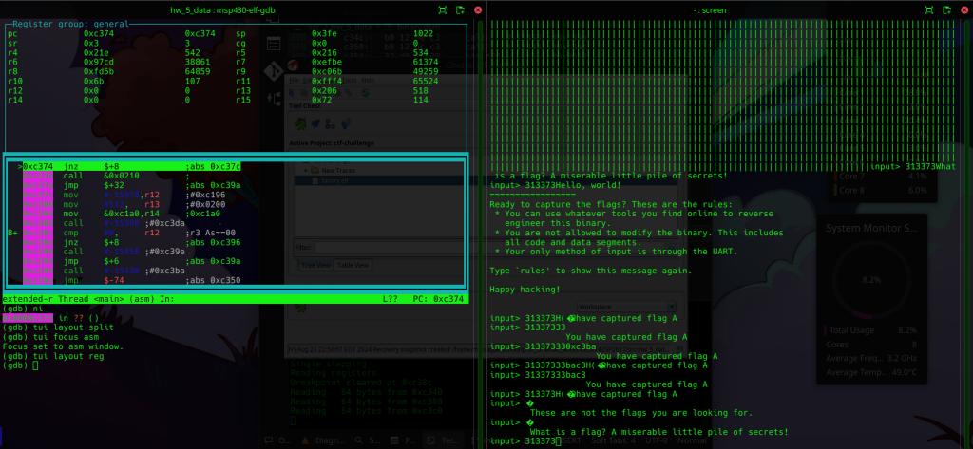
This function do something I dont know yet, but I know that this is an absolute address in the RAM as show in slau144k.pdf
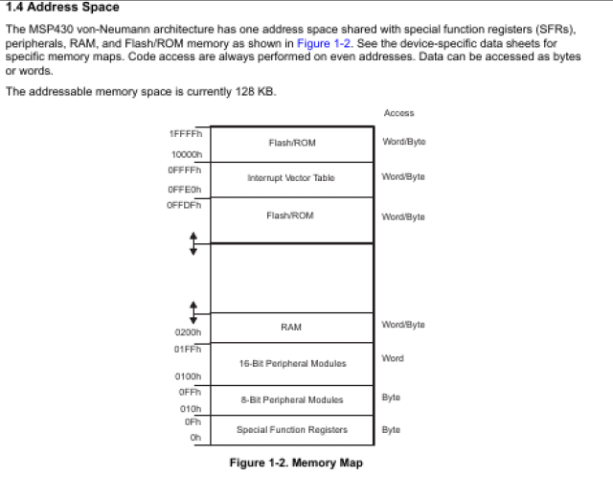

Then I wanted to observe $r12 value changes and its behavior, thus I used “ni” command of GDB to go to next instruction.
NOTE: TO GO TO NEXT INSTRUCTION USE: NI
As I went to next instruction, I noticed that the value of $r12 at one point equivalent to the ASCII value of character of flagA. Also, in the middle of the moving to next instruction, if I press “c” to continue to the next break point that I set, the program would print an incompleted string of flagA.
Then I was curious how the value in the RAM looked as I moved on to next instruction so I did a quick research and found out that to print the value of the RAM at 0x0200 I could you the following command
x/20x 0x0200 which will print the next 20 addresses, I believe. However, I want to see before the value at 0x0200 and after that so I played around and chose value 0x01f0 as my target.

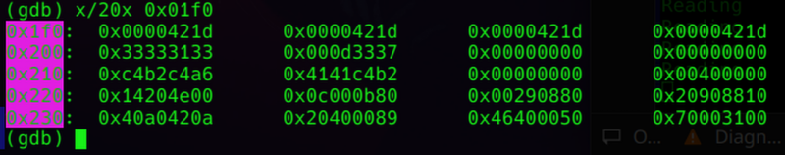
As we can see that the address contains the value that we input.
NOTE: this is msp430g2553 which has 16 bits
Thus each register hold 8 bits of data; therefore each column I could see above is 8 bits each.
Since the hint I got related to buffer overflow thus I tried to overflow the RAM to get to the address that contains strings of flag B (from ghidra)
From ghidra, I could see that the address where strings Flag A start at c290 and end at c2a7 while Flag B start at c2ae and end at c2c9.
So I tried to modified overflow the input with 313373330xc2ae and many more but all I got was as shown in picture below

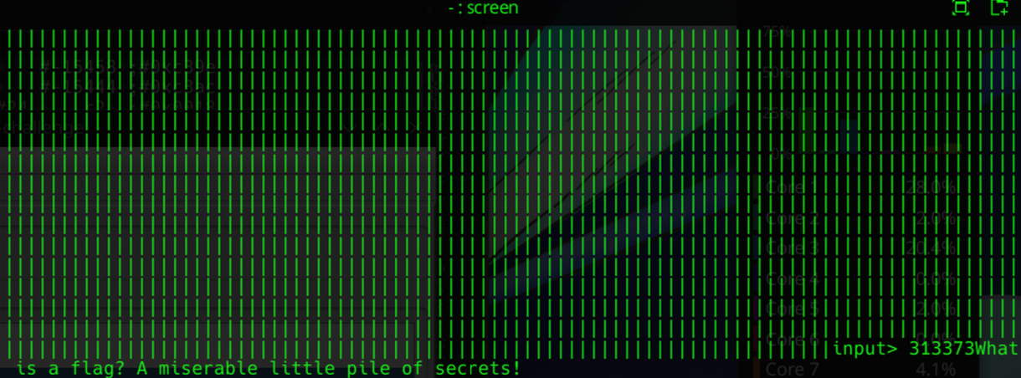
The reason for chosing 313373330xc2ae was because 313373 each register is 8bits and I counted the value of each character (ASCII value) 2 bits each, therefore, I created an 18 bits strings to overflow the RAM to different location but seemed like I broke the program.
Knowing &0x0210 was a magic function but ni commands kept stepping over the function so I looked for a solution to step into the function thus I found stepi or si.
TO GO “INTO" A FUNCTION USE: SI
When I step instruction “si” to get inside the function 0x0210 – the magic function - I could see that r12 and r13 stored the addressed of the begin and end of the flag’s strings respectively.
First, to ensure the function behave as I expected, I “si” slow over the function and observe the register value at the same time. Here I expected to see character of flag A’s string slowly loaded into the register and processed.
After I confirmed it, I started to modify the register value and observe the behavior. At first, everytime I modified the value GDB remote would failed and return E00 error which disrupted debugging process.
After a while of research, I remembered the mspdebug also user to set break point and change value of CPU register so I tried it out as shown in the picture.
After modified r12 and r13 value to the region of the RAM that stored the flag B string respectively, I set the program to run again and I saw flag B printed on the screen.
