Detail Techinal Report
Understanding the program
The program start with greeting and print the rules message to screen. It asking for the input, up on sending message, the program will display 3 differents messages and loop around. Beside that, I can type rules to prints out the rules again.
Achieving Flag A
Method 1 – Using strings command
Started by using simple command-line tool called strings, which looks for readable tet within a program. This method is helpful when searching for clues embedded in a binary file. After running the command “strings binary.elf” on the provided binary.elf file, I found an interesting string “313373”. In capture the flag (CTF) community, “313373” or “1337” is a common reference to “elite”, which stem from hacker culture. I used “313373” as input to the progam and was able to retrieve Flag A

Method 2 – Decompling with Ghidra
To understand how the program worked, I used a tool called Ghidra, which translates the program’s machine code back into something more readable. After I succeeded reversed engineer the main function of the program, I found that the program was checking two strings in loop. One of these strings, when converted from its numeric form, matched “313373”. This helped me to confirmed that both methodds led to the same result, but using Ghidra allowed me to understand how the program internalley checked for the flag.

Flag B:

Flag B is much more complex, which required player to have a great understanding of the program and the msp430 architecture.

MSP430 architecture background

MSP430x2xx family MCU is a 16 bits RISC CPU using von-Neumann computer model architecture, it consists of a single, shared memory for programs and data, a single bus for memory access, an arithmetic unit, and a program control unit.

MSP430 address memory

The figure show that from 0h to 01FFh is memory space for special function register and peripheral modules that controls [please explain here]. Then, from 0200h and below are the [please explain here].

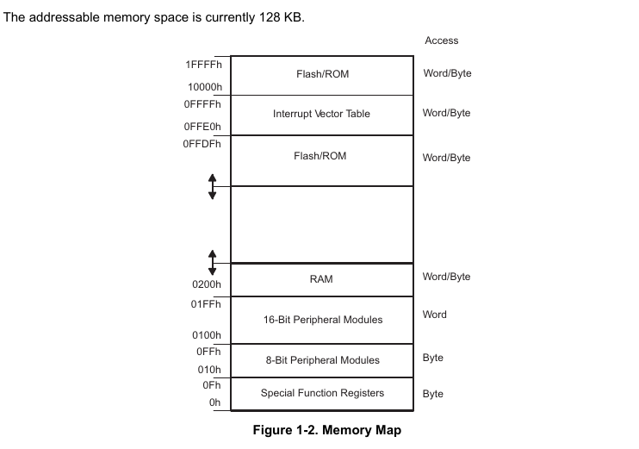
Static Analysis
To understand the program better let’s go back to Ghidra.
From what I have reversed engineer the program. I found the main function located at the address . The Interrupt service routine function that disable the CPU preventing it from getting me flag B and C.
Then there are other functions that calculate the address where to get the address and print UART.

So I know that the program always start at the address 0xc304 where the entry of the program is. Here it will do initialization for the register.

After quite amount of time doing reverse engineer, I have found the main function located at 0xc344 and the address where the program asking player to input strings are located at 0xc372 and 0xc38c.

To observe the behavior of the program, I tested with both the known flag which is 313373 and random strings such as AAAAAAAA.

Notice how the function 0x210 is called

0xc372: cmp #0, r12 ;r3 As==00
0xc374: jnz $+8 ;abs 0xc37c
0xc376: call &0x0210 ; ←----magic function

After I carefully observe the behavior of the program at these two breakpoints, I knew that 0xc372 compare the the value at R12 with 0, return 0 if input valid - so when I tested the value “313373”, r12 returned 0, next instruction jnz check if not equal zero it will jump to determined address at 0xc37c however; since I input the correct value for flag A I should go to next instruction at 0xc376 and call a magic function at &(absolute) address 0x0210. So the question was, whats at address 0x0210
Then I was curious how the value in the RAM looked as I moved on to next instruction so I did a quick research and found out that to print the value of the RAM at 0x0200 I could you the following command
x/20x 0x0200 which will print the next 20 addresses, I believe. However, I want to see before the value at 0x0200 and after that so I played around and chose value 0x01f0 as my target.

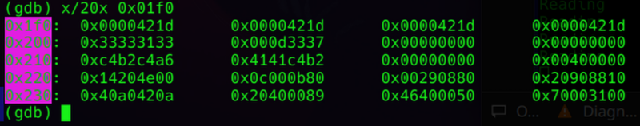
As we can see that the address contains the value that we input.
NOTE: this is msp430g2553 which has 16 bits
Thus each register hold 8 bits of data; therefore each column I could see above is 8 bits each.
Since the hint I got related to buffer overflow thus I tried to overflow the RAM to get to the address that contains strings of flag B (from ghidra)
From ghidra, I could see that the address where strings Flag A start at c290 and end at c2a7 while Flag B start at c2ae and end at c2c9.
So I tried to modified overflow the input with 313373330xc2ae and many more but all I got was as shown in picture below

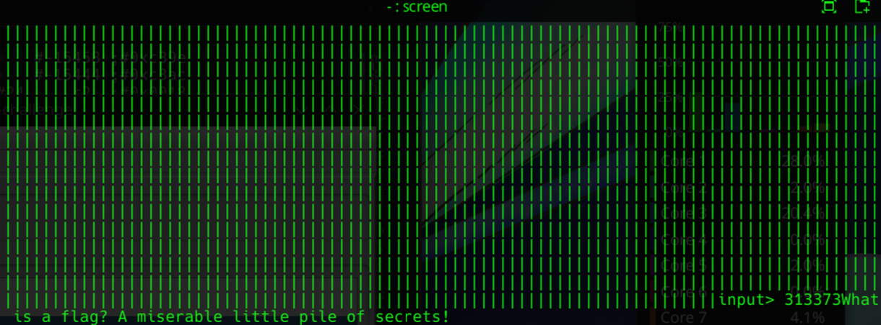
The reason for chosing 313373330xc2ae was because 313373 each register is 8bits and I counted the value of each character (ASCII value) 2 bits each, therefore, I created an 18 bits strings to overflow the RAM to different location but seemed like I broke the program.
Knowing &0x0210 was a magic function but ni commands kept stepping over the function so I looked for a solution to step into the function thus I found stepi or si.
TO GO “INTO" A FUNCTION USE: SI
When I step instruction “si” to get inside the function 0x0210 – the magic function - I could see that r12 and r13 stored the addressed of the begin and end of the flag’s strings respectively.
First, to ensure the function behave as I expected, I “si” slow over the function and observe the register value at the same time. Here I expected to see character of flag A’s string slowly loaded into the register and processed.
After I confirmed it, I started to modify the register value and observe the behavior. At first, everytime I modified the value GDB remote would failed and return E00 error which disrupted debugging process.
After a while of research, I remembered the mspdebug also user to set break point and change value of CPU register so I tried it out as shown in the picture.
After modified r12 and r13 value to the region of the RAM that stored the flag B string respectively, I set the program to run again and I saw flag B printed on the screen.

