Kubernetes

Developed by Google, In 2015, It was donated to the CNCF(Cloud Native Computing Foudation).

Is an Open Source Platform that Automates the mgmt, scaling, and the Deployment of containerized applications.

1)deploying applications.

2)rolling out changes

3) Scaling

4)Monitoring applications

5)Manging Service descovery

6)Incorporating Load Balancer

7)Tracking resource allocation

8)Checking the health of individual resources

9)Enabling applications to self heal

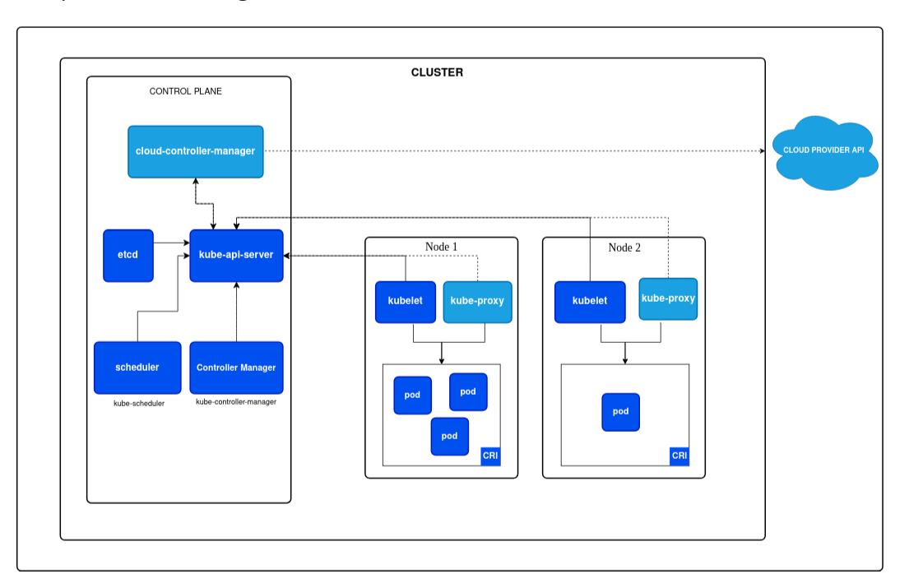

Controle Plane Components

-----------------------------------------

**a) Kube-api-server:**

Is the central mgmt entity that recieves all REST requests for modifications(to pods,services,replication set/controller and others)

Serving as frontend to the cluster, This is only component that communicates with etcd & agreement with Service details with deployed pods.

**b)etcd:** Distributed key value storage which is used to store the kubernetes cluster data( no.pods,their states,namespace)

**c)Kube-Controller-Manager:**

It match desired state

**d)Kube-Scheduler:** Help to schedule the pods.(replication=7): This scheduler must know the total resources available as well as resource allocated to existing workloads on the each.

Node1 (2pods) node2(2pods) Node3 (2pods ) node4(1pod) : Autoscaler

(2vCPU,4GB) (2vCPU,4GB) (2vCPU,4GB)

2pods 2 pods 2pods+2pods

Node(Worker Components)

--------------------------------------

**1)Kubelet:** Regularly taking in new or modified pod specification. Ensuring the pods and their containers are healthy & running in the desired state.

This component also reports to the control plane on the health of the host.

**2)Kube-Proxy:**

A proxy service that runs on each Worker Node to deal with individual host subnneting and Expose the services to the External World.

It performs request forwarding to th correct pods/Container across the various isolated networks in a cluster.

**Kubectl**: Command line tool that Interacts with Kube-apiserver & send commands to that control Plane.

Each command is converted into API call.

**POD**: Smallest unit in kebernetes object.

**Service**:Represents a logical set of pods & acts as a Gateway, Allowing pods to send requests to service without needing keeptrack of which physical pods actually make up the service.

**Namespace**: Logicall cluster(Sub-cluster).

**Volume**: