Customer Shopping Behavior Analysis
1. Project Overview
This project analyzes customer shopping behavior using transactional data from 350 purchases across various product categories. The goal is to uncover insights into spending patterns, customer segments, membership type, and satisfaction level to guide strategic business decisions.
2. Dataset Summary
- Rows: 350
- Columns: 11
- Key Features:
- Customer demographics (Age, Gender, City, Membership type, Satisfaction level)
- Purchase details (Item Purchased, Total spend)
- Shopping behavior (Discount Applied, Days Since Last Purchase, Average Rating)
- Missing Data: 2 values in Satisfaction Level
3. Exploratory Data Analysis using Python
We began with data preparation and cleaning in Python:
● Data Loading: Imported the dataset using pandas.
● Initial Exploration: Used df.info() to check structure and df.describe() for summary statistics.
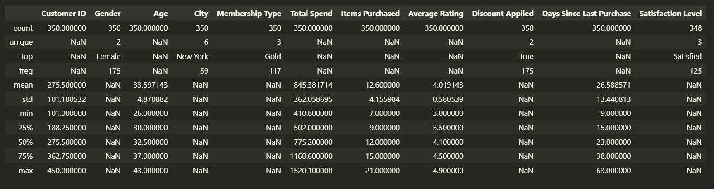
● Missing Data Handling: Checked for null values and found two missing values in satisfaction level column so removed two records.
● Column Standardization: Renamed columns to snake case for better readability and documentation.
● Database Integration: Connected Python script to PostgreSQL and loaded the cleaned Data Frame into the database for SQL analysis.

4. Data Analysis using SQL (Business Transactions)
We performed structured analysis in PostgreSQL to answer key business questions:
- Membership by highest Total Revenue – Compared total revenue for membership type (Gold, Silver, Bronze).

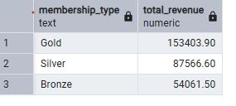

- Average order value by each city – Identified average order value for each city.

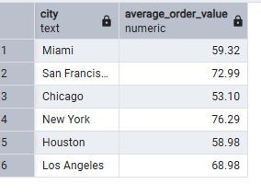

3. Are Bronze members significantly more "Unsatisfied" than gold members?
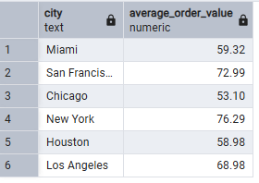
4.Average Satisfaction level - Identified highest average Satisfaction Level based on city. After Analysis San Francisco has highest average satisfaction level.
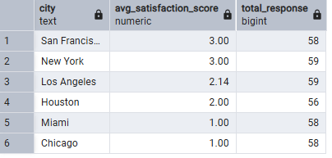
5. Gender preference based on membership types or cities- Segmented member counts and percentages by gender, city, and membership type to identify trends.
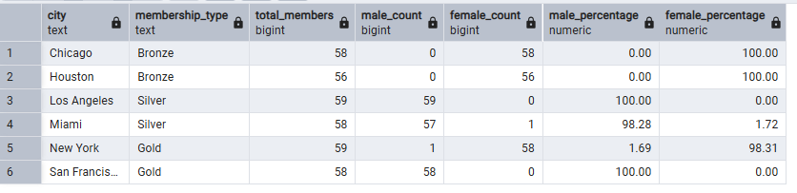

6. Discount Impact on Satisfaction – Determined that discounts do not increase sentiment, with 100% of unsatisfied customers receiving them as reactive compensation.
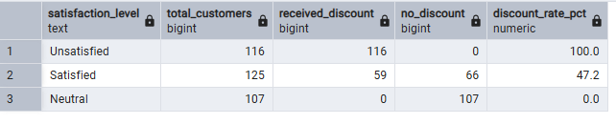
7. Spending and Volume by Age Group – Identified that the 30-39 age group dominates overall value, generating the highest total revenue ($192k+) and volume (2,725 items).
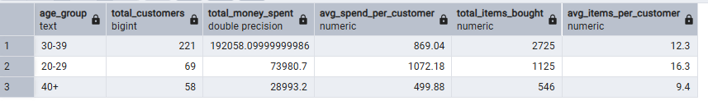
5. Dashboard in Power BI
Finally, we built an interactive dashboard in Power BI to present insights visually.
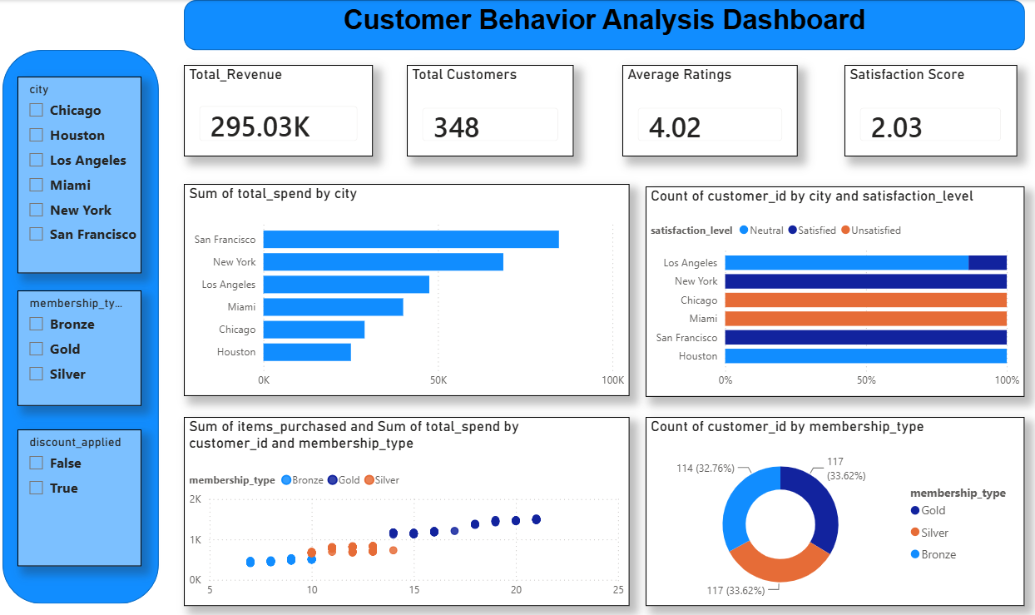

Optimized Business Recommendations
- Revamp the Discount Policy & Compensation Framework
  - The Data: Your SQL analysis reveals a striking 100% discount rate among "Unsatisfied" customers, while "Neutral" customers received zero discounts.
  - The Action: Stop using discounts as a reactive band-aid for poor experiences, as it isn't fixing sentiment. Shift your strategy from reactive compensation to proactive rewards (e.g., surprise loyalty perks for neutral/satisfied tiers). Investigate the root causes of the friction causing dissatisfaction in the first place.
- Introduce Gender-Tailored Regional Subscriptions
  - The Data: Your membership segmentation shows an absolute, extreme split by gender across cities. For example, Bronze memberships in Chicago and Houston are 100% Female, while Gold memberships in San Francisco and Silver in Los Angeles are 100% Male.
  - The Action: Tailor your subscription marketing campaigns based on these hyper-regional demographic splits. Target the female demographic in Chicago and Houston with upsell campaigns to move them from Bronze to Silver/Gold, and design male-centric campaigns for the West Coast markets.
- Differentiate Marketing Strategies Across Age Cohorts
  - The Data: The 30-39 age group is your clear volume engine, generating over $192k in revenue and buying 2,725 items. However, the 20-29 age group holds the highest individual value, with an impressive average spend of $1,072.18 per customer and 16.3 items per customer.
  - The Action: Treat these groups differently. Deploy volume-driven loyalty programs and cross-selling bundles for the 30-39 segment to maximize their footprint. For the 20-29 segment, focus on premium, high-ticket product positioning and premium tier memberships to leverage their high willingness to spend per capita.
- Replicate the San Francisco & New York Customer Service Model
  - The Data: San Francisco and New York boast the highest average satisfaction scores at 3.00, while Miami and Chicago lag severely behind with an average score of 1.00.
  - The Action: Conduct an internal audit of fulfillment, shipping speeds, and local product availability in San Francisco and New York. Document their best practices and replicate that operational model directly in Chicago and Miami to pull those lagging markets out of low-satisfaction traps.

