ECE 426 - Analog Electronics Laboratory
LAB 8: FLIGHT CONTROLLER AND POWER DISTRIBUTION BOARD DESIGN
by Molana Torabi
Student Handout
Week 8 | Due date available in the LMS
Design a portable KiCad flight-controller and power-distribution project. Select components and passive values, define power and signal nets, use the required ESC pins, choose compatible pins for other interfaces, and create a reviewable two-layer PCB. Lab 8 completes the design stage before the Lab 7 controller and flightboard are prepared for fabrication together.
WHAT TO SUBMIT
Note
Submit one file: Lab8_Flightboard_<YourStudentID>.zip. It must contain the completed KiCad project, project-specific symbol and footprint libraries, project library tables, and every nonstandard 3D model used. You do not submit this manual, a report, a schematic PDF, separate screenshots, Gerbers, or design notes. Grading is completion-based. Completion credit requires a complete, portable project with no ERC or DRC errors; review any remaining warnings and confirm they are intentional.

WHAT YOU RECEIVE
Item | What it contains | What you do
Week 8 handout | Design contract, functional-block guidance, PCB workflow, and submission test. | Follow the three parts in order and keep exact filenames and net names machine-readable.
Flightboard study images | Updated PCB/3D references and intentionally unconnected schematic study views. The schematic images do not supply a solved netlist. | Use them to identify functions and mechanics, not as a solved netlist or a manufacturing baseline.
Student starter ZIP | Native project, unconnected schematic, empty PCB, local component assets, and two pin-redacted firmware references. | Extract the entire Lab8_Flightboard_Student_Starter.zip and open its project. Keep the project and libraries together.
Component documentation | 15 offline PDFs, Datasheets/START_HERE.md, and source records. The ST LSM6DSO32 IC datasheet is online-only. | Use the exact device and breakout documentation. An included model or family guide does not establish the hardware revision.
AI context guides | Part1_Schematic_AI_Guide.md, Part2_PCB_AI_Guide.md, and Part3_Submission_AI_Guide.md. | Attach the matching guide, your project, and relevant documentation when asking a file-capable AI for help.
Week 8 lecture | System context for battery distribution, regulated rails, ESC control, IMU orientation, copper, and return paths. | Use it to organize the design; verify component-specific decisions in primary documentation.

Build note
• Start by extracting Lab8_Flightboard_Student_Starter.zip. Open Lab8_Flightboard_Starter.kicad_pro in the extracted folder; do not start from a routed instructor project.
• The starter has 66 symbols with no wires, labels, power symbols, or no-connect decisions; all 34 R/C/L values are TBD. Its two-layer, 1.6 mm PCB is empty. Complete the design yourself; starting ERC errors are expected.
• Use KiCad 10. Keep sym-lib-table, fp-lib-table, and libraries/ beside the project. Read libraries/README.md for the supplied footprint/model limitations.

SCHEMATIC EDITOR
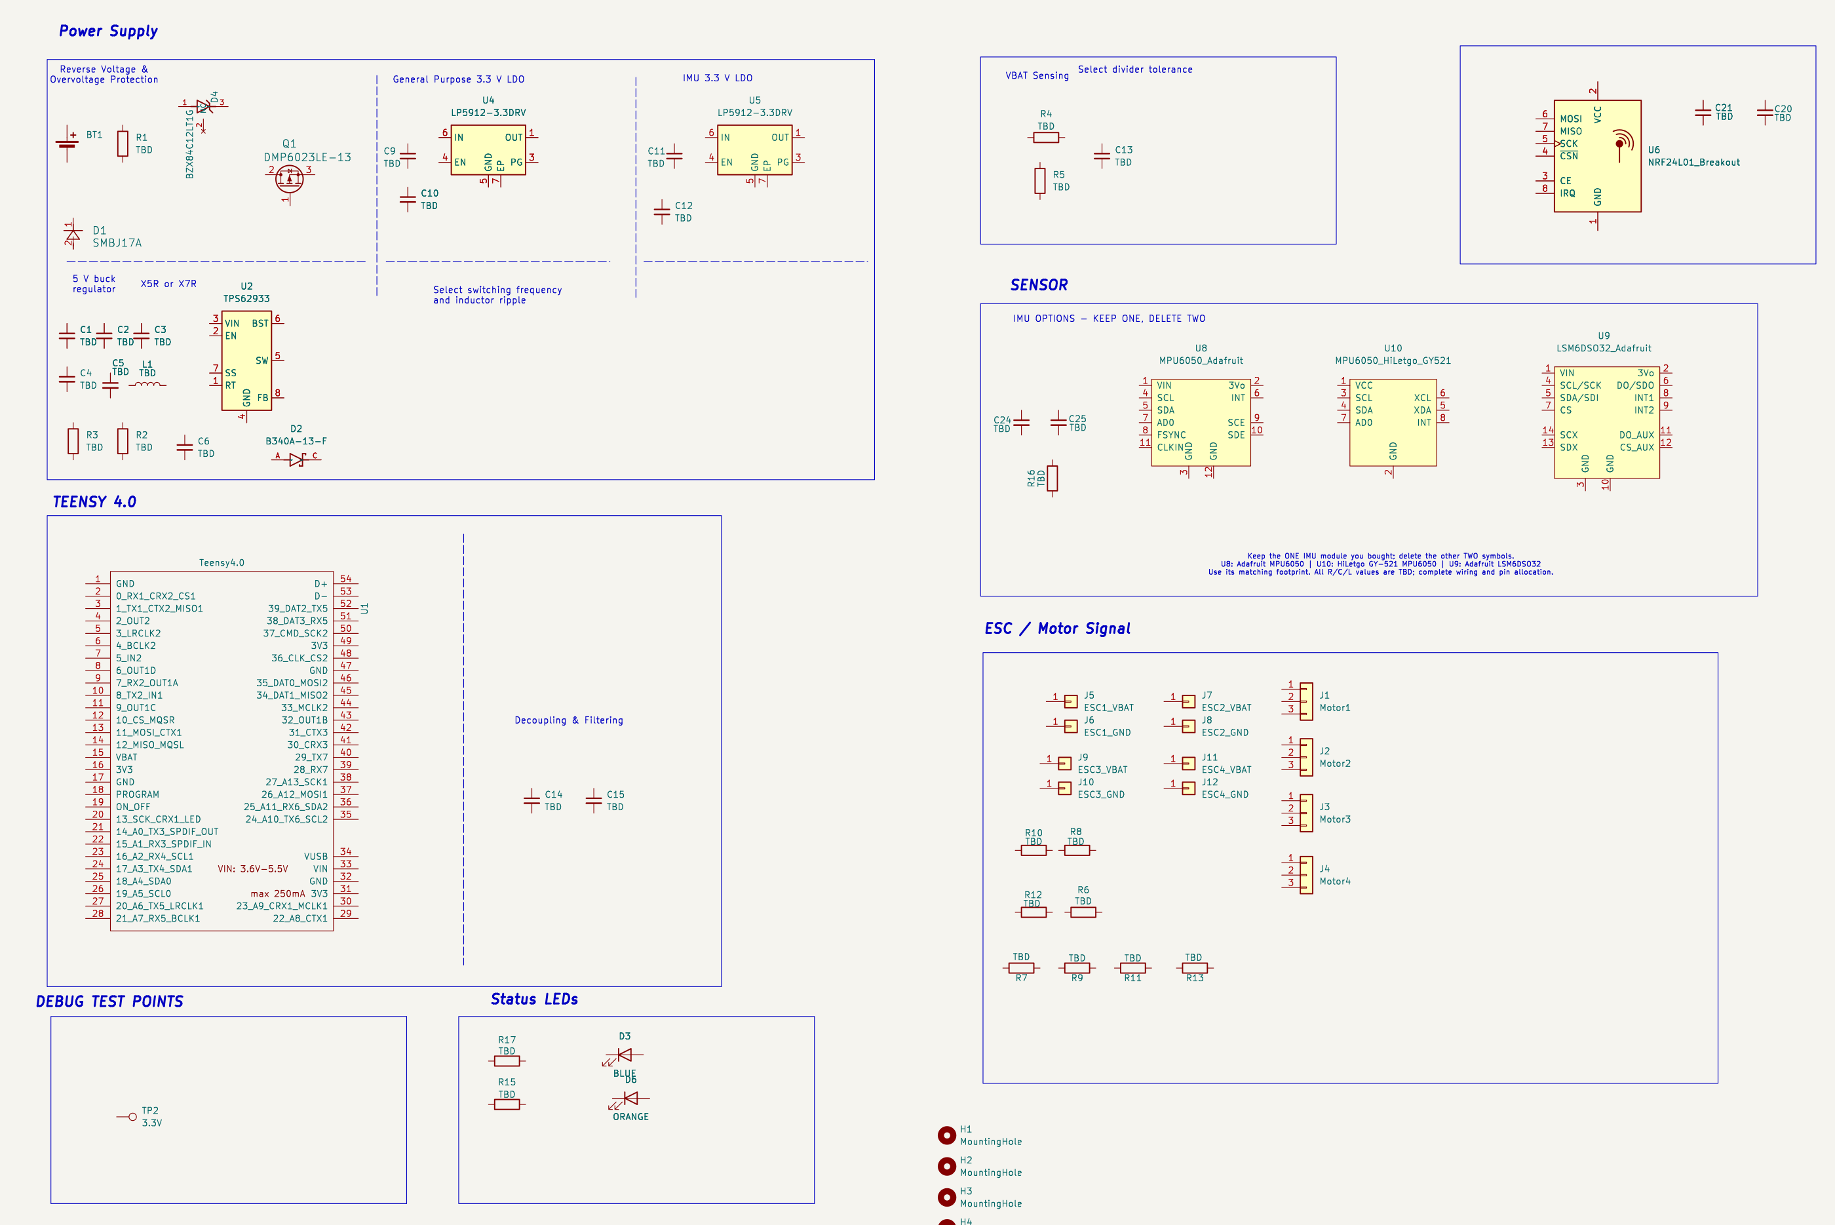
Current student-starter schematic: unconnected components, three IMU alternatives, and TBD passive values. Keep the module you bought, delete the other two IMUs, and complete the electrical design.
Part 1 | Design the flight controller schematic
Use the functional blocks as a design brief. Select appropriate component values, define the power and signal nets, use the required four ESC GPIOs, and choose compatible Teensy connections for the other functions. Verify those choices against device documentation and match each symbol pin to its footprint pad. Labs 6 and 7 established the KiCad mechanics; no separate explanation of your design reasoning is required.
Block | Contribution | Decision to resolve
Battery entry and protection | Accepts the LiPo supply and protects the downstream board from foreseeable input faults. | Connector/pad polarity, expected pack range, protection topology, and ratings.
5 V conversion | Creates the main regulated rail from SYS_VIN for the controller and downstream regulators. | Buck part, application circuit, passives, thermal/current limits, and layout.
3.3 V rails | Supplies logic/radio and a deliberately separated IMU rail in the reference architecture. | Loads, stability capacitors, rail naming, and whether separation remains justified.
Teensy 4.0 | Runs the flight-control firmware and coordinates sensors, radio, battery monitoring, and four motor commands. | Required ESC GPIOs; other pin capabilities, voltage domains, firmware mapping, decoupling, and access.
IMU | Measures motion for stabilization and must retain a known orientation relative to the frame. | Exact module, bus, address/configuration, supply, pull-ups, axes, and placement.
nRF24L01+ radio | Receives command and tuning data over a 3.3 V SPI/control interface. | Exact module, SPI/control pins, supply transients, decoupling, and antenna clearance.
Battery monitor | Scales battery voltage into a safe ADC range for monitoring and calibration. | Maximum pack voltage, divider/filter values, ADC pin, error, and firmware scale.
ESC power and control | Distributes battery power to four ESCs and supplies four logic-level motor commands with ground reference. | Power-pad mapping, signal connector mapping, channel order, and failsafe behavior.
Status, test, and mechanics | Provides inspection access, local status, board orientation, and mounting features. | Test-point access, LED meaning, hole geometry, silkscreen, and frame clearance.
Circuit
The instructor reference combines a LiPo battery input and protection, four ESC battery/ground branches, a 5 V buck supply, and 3.3 V logic/radio and IMU supplies. The Teensy exchanges data with the radio and one IMU, monitors battery voltage, and sends four motor commands. Treat these as functional targets, not supplied wiring or passive-value answers. Verify the intended pack range and each device rating before making connections.

Hints and formulas
• ESC battery power and motor-command signals serve different purposes. Map both interfaces explicitly; the motor-phase wires remain between each ESC and motor, not through the flight-controller signal connectors.
• Use the fully charged pack voltage when checking battery sensing and device limits. Choose either the LSM6DSO32 or the MPU6050—not both. Verify the chosen module's pin order and voltage requirements, and record its axes relative to the frame.

WHAT EACH BLOCK CONTRIBUTES
The excerpts below show the flight-controller blocks without connection wires or selected passive values. Each design idea suggests what to research. The fictional block-level Ask your AI examples demonstrate methods rather than supplying flightboard answers. The placement and project-review prompts in Part 2 invite inspection of your actual KiCad files. Supply relevant manufacturer documentation and verify the findings and final choices yourself.
1. Power input protection and regulated supplies
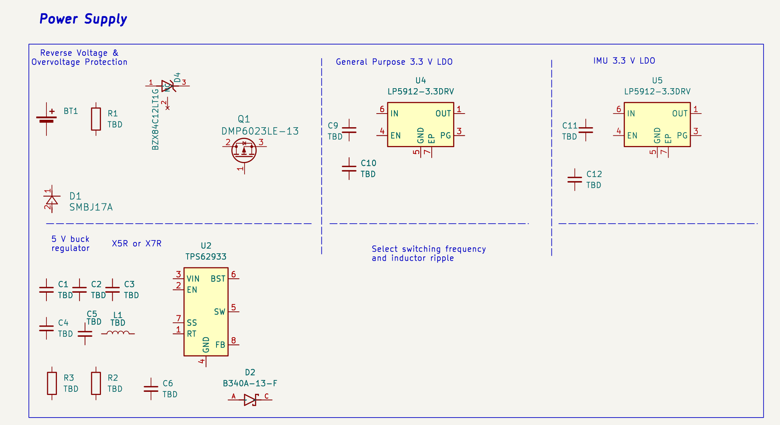
Battery protection, 5 V buck, and separate 3.3 V regulator blocks, before wiring.
The battery input establishes SYS_VIN and the common return. Protection devices must tolerate the intended pack voltage, polarity, current, and fault energy. The buck converter produces the main 5 V rail; the 3.3 V regulators supply logic and radio loads and the separate IMU rail. Treat the protection, conversion, and regulation stages as one power system with a defined source and load budget for every rail.
Research focus: Verify pack and connector ratings, protection topology, buck input range and feedback network, inductor and capacitor ratings, switching loops, LDO dropout and thermal limits, stability capacitors and ESR, rail names, sequencing, and whether a separate IMU supply is justified.
Ask your AI: “For an unrelated battery-powered data logger with a buck converter, a radio, and a precision sensor, show how to review input protection, regulated rails, load budgets, supporting parts, and layout from manufacturer documentation. Explain the checks without selecting my Lab 8 values or connections.”
2. Teensy 4.0 controller
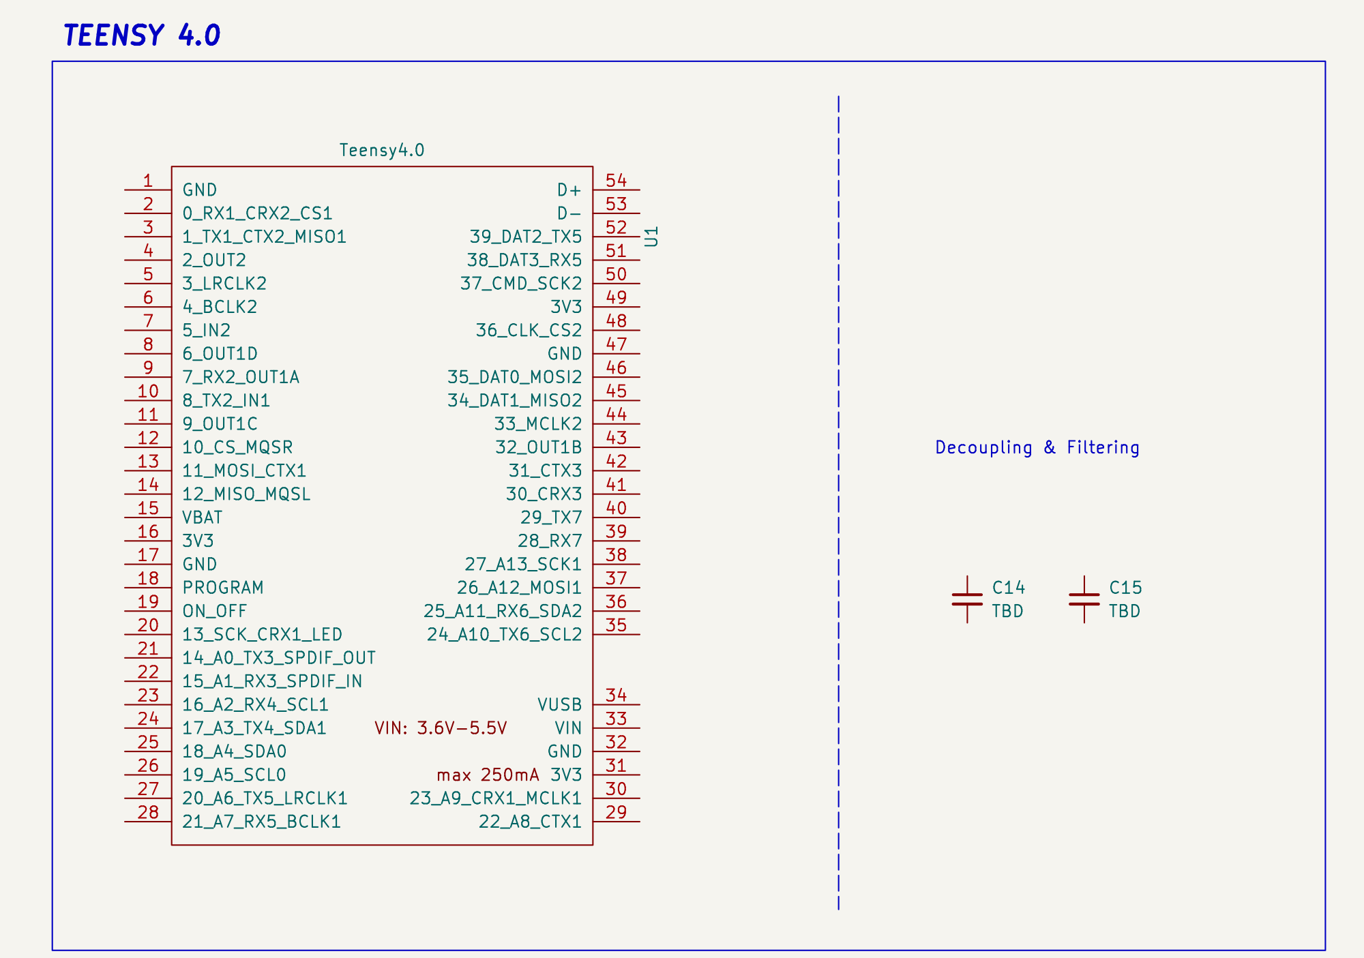
Teensy 4.0 power and signal pins with nearby decoupling parts.
The Teensy integrates the chosen peripheral functions. Every student must use D4, D8, D22, and D23 for the four ESC motor commands, one pin per command. The motor-to-pin order is your choice. Choose compatible pins for the IMU, radio, battery ADC, status output, and any optional functions. Teensy 4.0 I/O is 3.3 V and is not 5 V tolerant.
Interface | Required Teensy 4.0 GPIOs
Four ESC motor commands | D4, D8, D22, and D23 — use each once; choose your motor order.
These are Teensy GPIO labels, not symbol-pin or footprint-pad numbers. Resolve the physical mapping using the supplied symbol and PJRC pinout. No specific M1–M4 assignment is required; keep your chosen channel order consistent in the schematic, PCB, and later firmware. These pins carry ESC logic commands, not motor power.
Firmware_Reference/ in the starter ZIP provides LSM6DSO32 (SPI) and MPU6050 (I2C) receiver sketches with local headers. Use only the reference matching your chosen IMU; either MPU6050 breakout uses the MPU reference after exact-module checks. Other GPIOs and battery-divider values are intentionally unassigned. Read its README before use: deliberate compile guards remain, and inherited calibration, axes, tuning and bus settings need later hardware review. Compiling or flashing is not required in Lab 8.
Footprint limitation: the supplied Teensy40 footprint does not implement symbol pins 45–54 (GPIO 34–39, extra GND/3V3, and USB D−/D+ connections). Do not allocate required PCB connections to these pins without a verified footprint or physical-connection change; see libraries/README.md.
Research focus: Verify PWM-capable outputs, ADC capability and limits, SPI and I2C instances, interrupt requirements, boot/programming access, supply arrangement, and firmware pin definitions.
Ask your AI: “For an unrelated 3.3 V MCU controlling four servos, one SPI device, one I2C sensor, and one ADC input, demonstrate a pin-allocation review using the MCU pinout. Do not assign my Teensy pins.”
3. IMU sensing and orientation
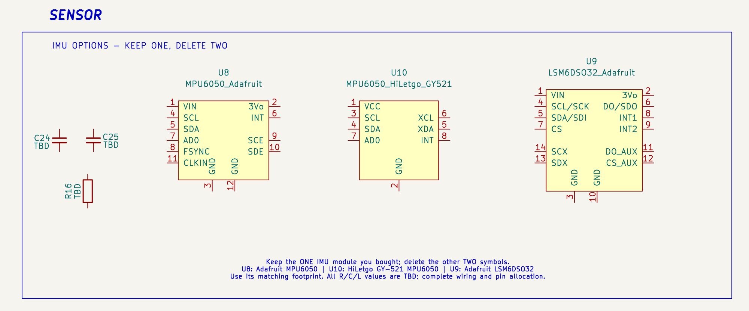
Three module alternatives: U8 Adafruit MPU6050, U10 HiLetgo/GY-521 MPU6050, U9 Adafruit LSM6DSO32. Keep ONE matching your purchased module; delete the other TWO.
Choose ONE IMU. The starter contains U9 (Adafruit LSM6DSO32), U8 (Adafruit MPU6050), and U10 (HiLetgo/GY-521 MPU6050). Keep one matching symbol/footprint pair and delete the other two symbols before updating the PCB. Do not populate both sensor types. The IMU supplies acceleration and rotation data to the control loop. Verify the chosen module's pin order, supply, bus configuration, pull-ups, footprint, and axes against its documentation and firmware.
Research focus: Identify the exact module, supported bus modes, supply and logic limits, address/configuration straps, interrupt options, axis directions, mounting height, and calibration implications.
Ask your AI: “For an unrelated robot using a breakout-board IMU, show how to verify I2C versus SPI wiring, address straps, pull-ups, axis orientation, and mounting from primary documentation.”
4. nRF24L01 plus radio
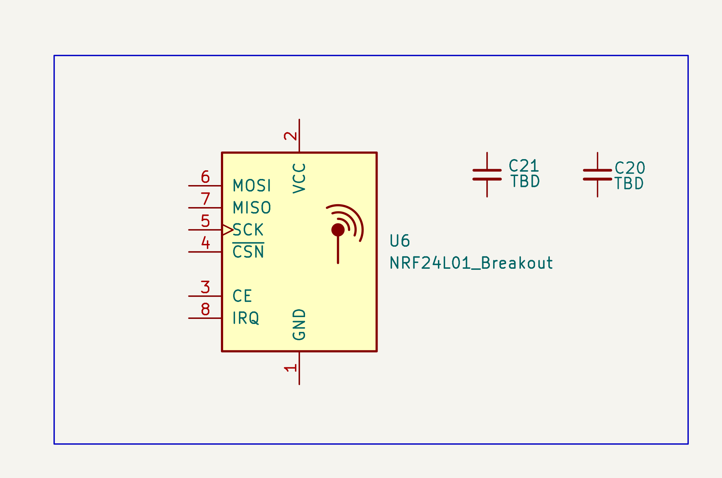
nRF24L01 radio module and nearby supply capacitors, before wiring.
The radio is a peripheral, not the flight-control processor. The MCU configures it, transfers packets over SPI, and controls CE/CSN. Stable 3.3 V power, local decoupling, compatible logic, and antenna clearance are part of the interface.
Research focus: Confirm the exact module pinout, current transients, supply limits, SPI/control roles, firmware settings, antenna geometry, keepout, and whether IRQ is required by the selected firmware.
Ask your AI: “For an unrelated 3.3 V SPI radio module, demonstrate how to check supply transients, decoupling, CE/CS/IRQ behavior, and antenna keepout. Do not choose pins or values for my board.”
5. Battery voltage monitoring
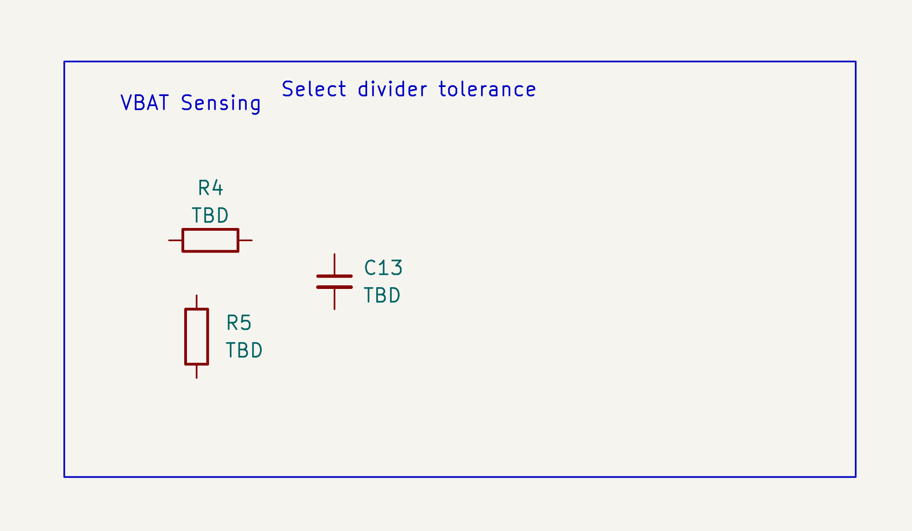
Battery-sense divider and filter parts, before wiring.
The divider and filter scale the maximum battery voltage into a safe Teensy ADC range. The measurement must remain safe at the fully charged pack voltage and useful after resistor tolerance, ADC reference error, input leakage, and filtering are considered.
Research focus: Choose a maximum input assumption, ADC pin and limit, divider current and ratio, filter corner, resistor tolerance, protection strategy, and firmware calibration method.
Ask your AI: “For an unrelated 18 V battery monitor feeding a 3.0 V ADC, demonstrate divider and filter selection, tolerance analysis, and calibration without using my battery or resistor values.”
6. Four ESC power branches and motor commands
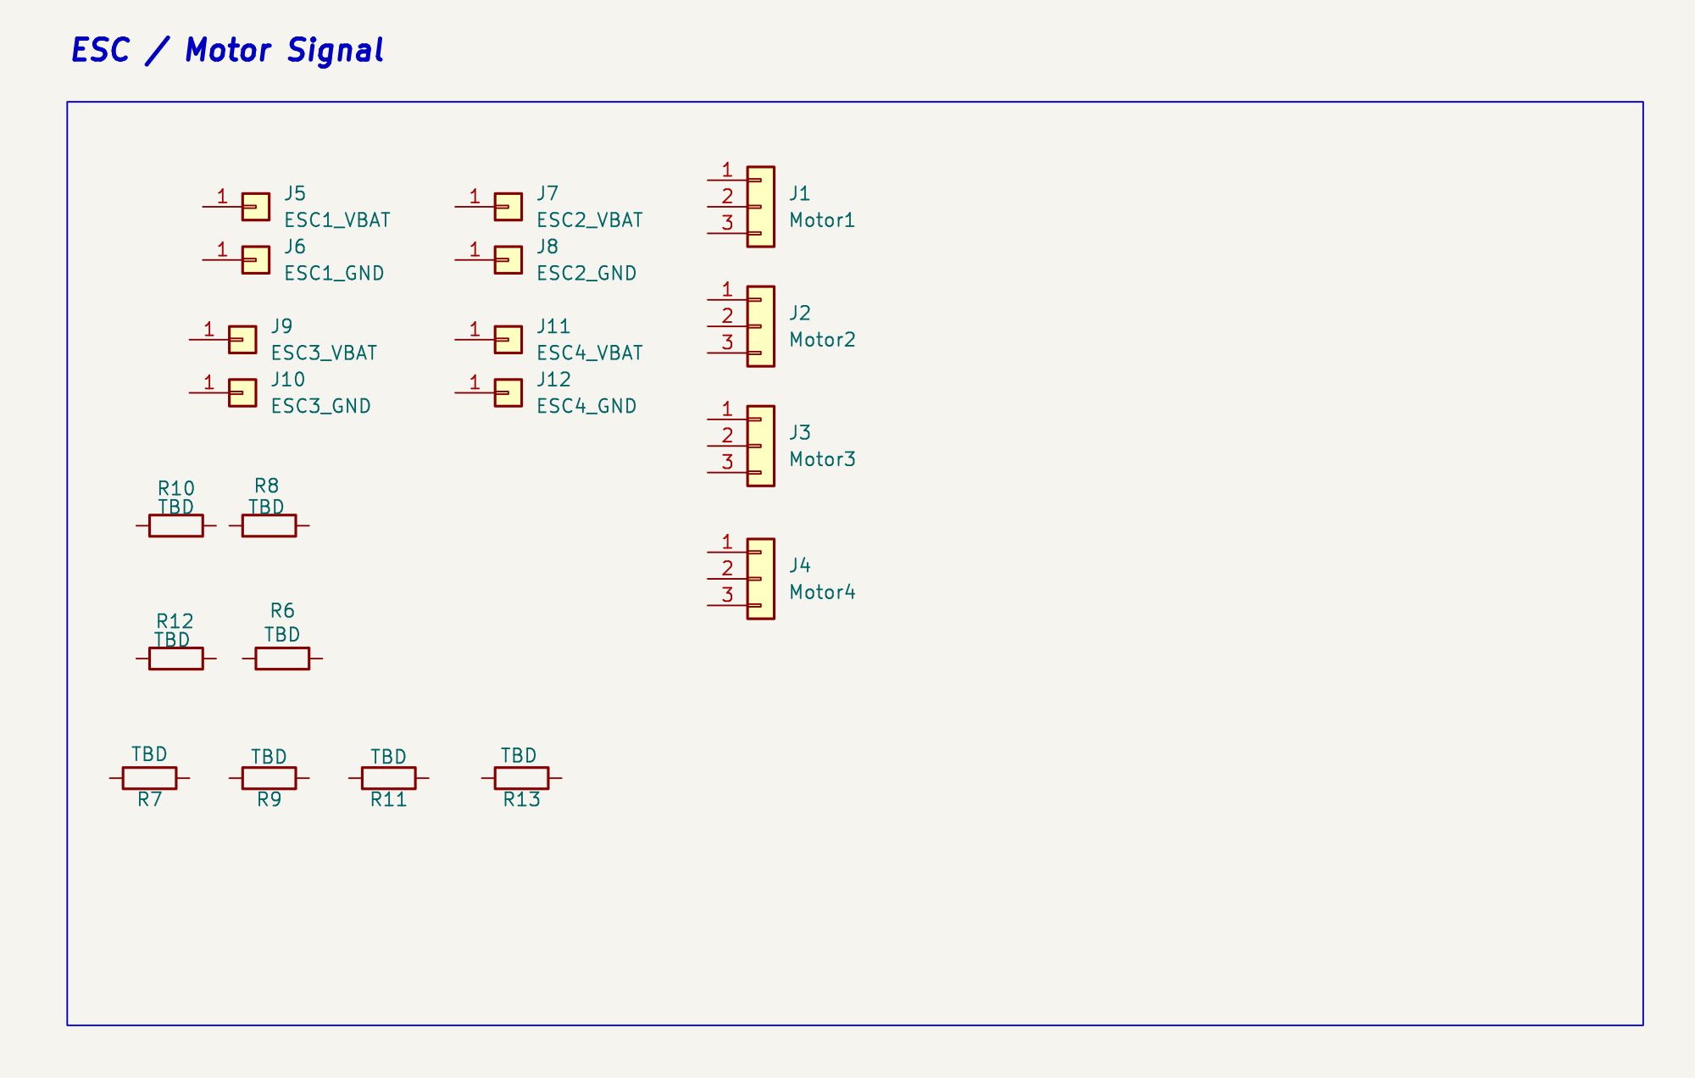
Four ESC battery/ground branches and separate command connectors. Required command GPIOs: D4, D8, D22, and D23; motor order is your choice.
The PDB distributes battery positive and ground to four ESCs. Separate low-power connectors carry four command signals and their reference ground. The three motor-phase wires remain between each ESC and motor; they do not pass through the flight-controller signal pins.
Research focus: Map battery pads, grounds, command channels, connector pin numbers, firmware channel order, signal voltage, default/pulldown behavior, current paths, and cable direction.
Ask your AI: “For an unrelated four-channel actuator board, demonstrate how to document a connector pin map and keep high-current power separate from logic commands. Do not specify my ESC wiring.”
7. Status indicators test points and mounting
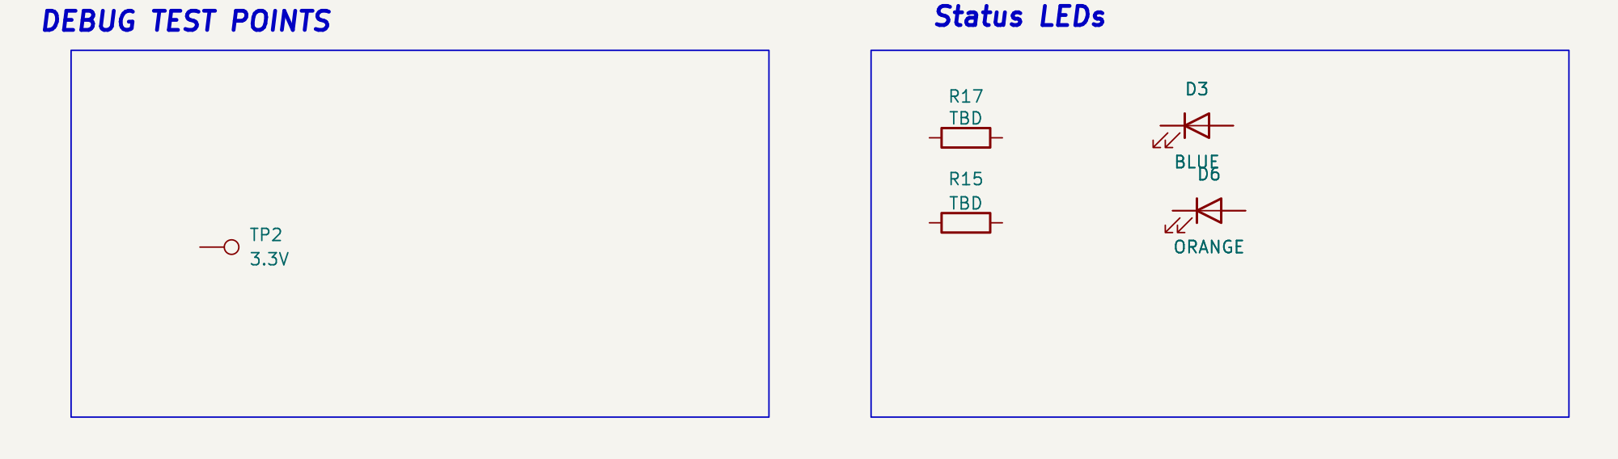
Status LEDs and test points for later observation and bring-up.
Status LEDs and test points make later bring-up observable; mounting holes and silkscreen make the board installable and understandable. A status LED indicates only the firmware condition assigned to it, not that the whole flight system is safe.
Research focus: Define indicator meaning and current, test-point nets and probe clearance, forward direction, mounting-hole diameter/keepout, screw-head space, and component/cable access.
Ask your AI: “For an unrelated 60 mm square controller board, propose a checklist for test-point access, indicator labels, mounting clearance, and board-orientation markings without laying out my flightboard.”
RESOLVE THE SCHEMATIC DECISIONS
Design task | Your schematic must resolve
Parts and values | Select exact devices and R/C/L values from application requirements and current primary documentation. Check voltage, current, power, tolerance, temperature, ESR/DCR, saturation, and package ratings as applicable.
Nets and interfaces | Define each rail source and load, battery/ESC paths, ground references, bus/control signals, connector pin maps, labels, and no-connect decisions.
MCU and firmware | Use D4, D8, D22, and D23 for the four ESC commands in your chosen motor order. Choose compatible pins for other functions; later firmware must match.
Physical mapping | Match every symbol pin to the intended footprint pad, pin 1, polarity, connector orientation, hole pattern, and exact module variant.
MCU pins and firmware. Use the exact set D4, D8, D22, and D23 for the four ESC motor commands, one per output. You choose which motor channel uses each pin; no specific M1–M4 assignment is required. All remaining pin assignments are yours to choose within the Teensy and peripheral capabilities. Keep the schematic, PCB and later firmware definitions consistent. The starter firmware references deliberately cannot compile/flash as supplied; compilation, flashing and powered testing are not Lab 8 deliverables. Remove omitted optional hardware and disable its firmware feature.

DESIGN REVIEW
Before PCB layout, inspect each value, rating, voltage domain, net name, pin capability, connector map, and symbol-to-footprint relationship. Run ERC, correct all errors, then review each remaining warning and confirm it is intentional. Do not suppress a warning merely to make the report shorter.
Before moving on, confirm:
☐ Every required function appears once with a defined source, destination, and ground reference.
☐ Maximum battery and rail voltages stay within every device, ADC, and I/O limit.
☐ Regulator application circuits and passive selections match the exact device documentation.
☐ The four ESC commands use D4, D8, D22, and D23 once each; chosen motor order is consistent and other pins support their functions.
☐ Connector pin numbers, symbol pins, footprint pads, polarity, and module variants agree.
☐ ERC has no errors; remaining warnings have been reviewed and are intentional.

PCB EDITOR
Part 2 | Design the PCB
Update the PCB from the completed schematic, then establish mechanics and component access before routing. The finalized instructor board is a physical reference only. Recreate a layout that is electrically suitable for your choices, manufacturable by the selected process, and inspectable during later integration.
COMPONENT CHOICES AND ASSEMBLY
The reference parts are not a fixed bill of materials. You may substitute suitable devices and choose different resistor, capacitor, and inductor packages after rechecking ratings, pin/pad mapping, stability requirements, clearance, and fit. Common imperial resistor/capacitor codes describe nominal body size: 0805 is about 2.0 x 1.25 mm, 1206 about 3.2 x 1.6 mm, and 1210 about 3.2 x 2.5 mm. Inductor package names are often manufacturer-specific; verify body, height, pad pattern, saturation current, RMS current, and DCR. Through-hole parts are allowed when they meet the electrical and mechanical requirements and are easier to assemble. Include every custom library used in the final ZIP.
REQUIRED AND OPTIONAL FUNCTIONS
The required design includes battery entry and protection, four ESC battery/ground branches, regulated 5 V and 3.3 V supplies, Teensy 4.0, exactly one IMU (your choice of LSM6DSO32 or MPU6050), the radio interface, four motor-command outputs with ground reference, battery sensing, status indication, test access, and suitable mechanical mounting features. The reference mounting-hole diameter and spacing are highly recommended, not mandatory. An OLED or additional telemetry hardware is optional unless the instructor assigns it separately. If you omit an optional function, remove its schematic parts, PCB footprints, nets, and firmware feature rather than leaving dangling hardware.
MECHANICAL REFERENCE
Reference feature | Recorded snapshot | Your check
Board envelope | 80 x 80 mm with 1 mm-radius corner fillets in the finalized V-Final reference. Board center: (40, 40) mm from the upper-left bounding corner. | 75 mm per side is the suggested minimum; neither width nor height may exceed 85 mm. The 80 x 80 mm outline is an example. Verify frame, edge and cable clearance.
Board stackup | Two copper layers (F.Cu and B.Cu), 1.6 mm board thickness in the finalized reference. | Confirm the ordered stackup, copper thickness, and clearances with the fabricator and frame hardware.
Recommended mounting pattern | Four 3.3 mm non-plated holes. Centers (mm): H1 (27.5, 27.5); H2 (52.5, 27.5); H3 (27.5, 52.5); H4 (52.5, 52.5). Origin: outline's upper-left bounding corner; X right, Y down. Center spacing: 25.0 x 25.0 mm. | The 3.3 mm holes and 25 x 25 mm center spacing are highly recommended, not mandatory. Confirm fastener clearance and frame fit; recenter the pattern for your board size.
Controller access | Teensy footprint centered with USB access planned at an edge. | Check actual header/module height, USB cable insertion, and orientation.
Battery and ESC pads | Four symmetric perimeter power and ground pad pairs mirror the Motor 2 edge offsets. | Check polarity, labeling, soldering access, conductor size, and mechanical strain.

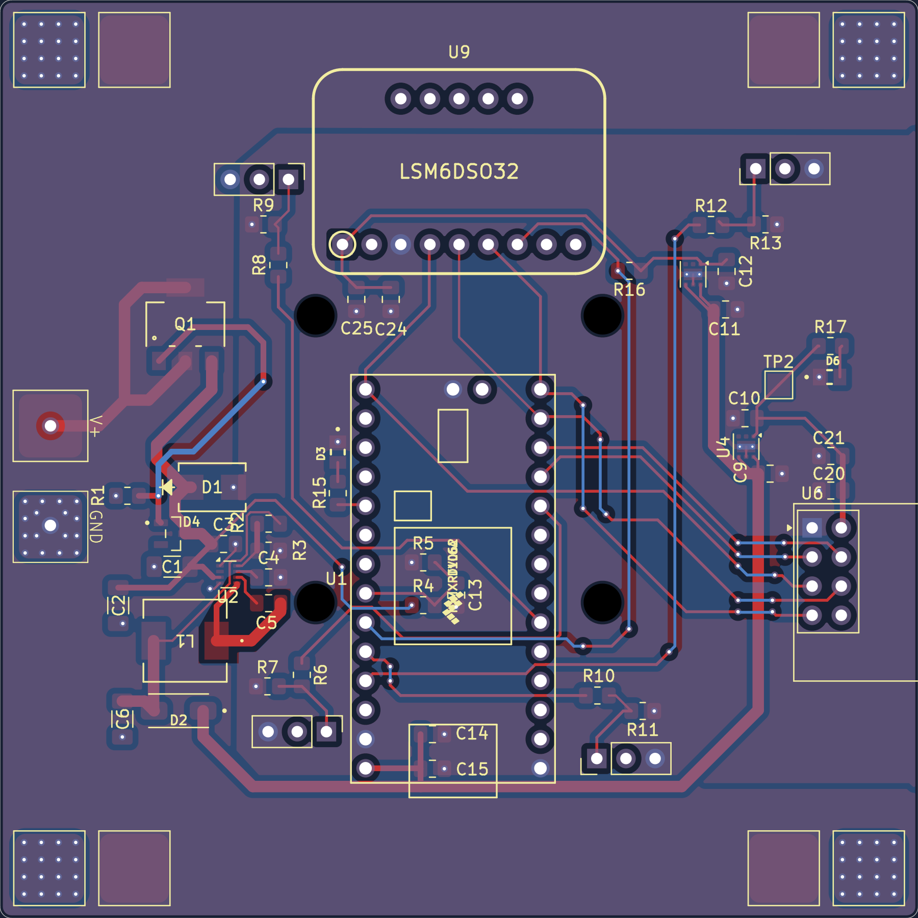
Updated instructor routed-PCB reference, including the corrected complete ESC pad footprints and GND via grids. Compare the 80 x 80 mm outline, symmetric ESC pads, component access, and copper approach with your own design. It is a design example, not a clean ERC/DRC or manufacturing baseline.
2.1 CREATE THE BOARD
Ask your AI: “Open my KiCad flight-controller/PDB project before I route. Suggest a component placement order and candidate groupings or orientations that make the board practical to assemble and route. Account for mounting holes, battery and ESC power paths, USB access, compact regulator loops, IMU axes and noise, radio antenna clearance, probing access, and return paths. Cite relevant datasheet layout guidance and state what you cannot verify from the files.”
1. Save the schematic and use Update PCB from Schematic. Read the change list; stop and repair missing footprints, duplicate references, or library failures before placement.
2. Draw one closed Edge.Cuts outline: 75 mm is the suggested minimum width and height; 85 mm is the maximum for either dimension. Verify frame fit, then place mounting features and keepouts before components.
3. Place battery and ESC power interfaces around the perimeter for short, direct cable paths and safe soldering access. Mark polarity visibly.
4. Place the Teensy for USB/programming access, then position the IMU with a recorded relationship between its axes and the drone's forward direction.
5. Group each regulator with the exact support parts required by its datasheet. Keep high-current and switching loops compact; reserve quiet space for the IMU and battery-sense path.
6. Place radio, status, and test features for antenna clearance, observation, probing, and assembly. Check module and connector bodies, not only their pads.
2.2 ROUTE AND REVIEW
Ask your AI: “On an unrelated two-layer board with a battery input, four load branches, one buck converter, and one motion sensor, explain how current paths and return paths influence copper, vias, planes, and placement. Describe what DRC cannot prove.”
1. Select JLCPCB or the instructor-approved manufacturer/process, then enter its current published capabilities in Board Setup. The instructor reference uses two copper layers and a 1.6 mm board thickness. Use this stackup unless the instructor approves a different stackup and its cost; verify the ordered copper thickness rather than assuming it.
Trace-width review. Choose copper geometry per net from expected current, copper thickness, path length, temperature rise, layer transitions, pad neck-downs, and signal requirements. Do not route every net with one default width and do not copy an arbitrary numeric table.
2. Route battery positive and the complete return path deliberately. Check the combined battery-input current and each ESC branch, including pads, thermals, neck-downs, and vias.
3. Keep the buck switch node and its high-di/dt loops compact. Follow the selected regulator's placement guidance and keep noisy copper away from the IMU, radio supply, and battery ADC route.
4. Route the IMU, radio, motor commands, and battery sense with their correct ground references. Preserve ground continuity and avoid creating isolated return-current detours.
5. Add and refill zones only after assigning each zone to the correct net. Inspect isolated islands, thermal connections, mounting-hole clearance, and unintentional rail contact.
6. Run DRC, correct every error, refill zones, and rerun it. Confirm zero unconnected items and schematic/PCB parity. Review any remaining warnings individually.
7. Open 3D Viewer and inspect polarity, pin 1, module orientation, USB and cable access, component height, screw heads/standoffs, silkscreen, and model alignment. A correct-looking model does not verify the electrical pin map.
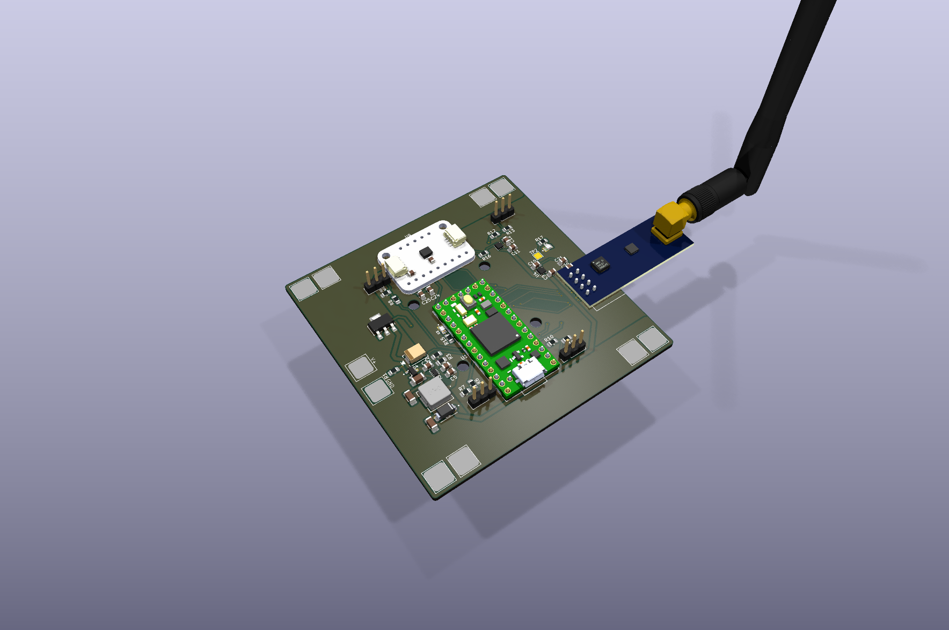
Updated flight-controller 3D reference from the left-oblique side. It uses the current board geometry and the supplied Teensy, LSM, and external-antenna nRF models. Check placement, height, and access; it is not electrical verification.
TROUBLESHOOTING
If you see | Check first
Missing symbol or footprint | Project library table, nickname, ${KIPRJMOD} path, copied library file/folder, and exact footprint assignment.
Model missing or displaced | Model path, origin, rotation, scale, and whether the model matches the exact module variant.
Unexpected airwire | Schematic net, connector pin/pad number, Update PCB from Schematic results, and whether the track reached the intended pad.
Power bottleneck | Smallest pad/neck/via/thermal, current assumption, copper thickness, path length, and return path.
Noisy sensor or ADC risk | Switching-node proximity, loop area, local decoupling, ground continuity, filtering, and physical orientation.
Rule-check warning | Underlying geometry or mapping first; exclusions only after the cause and intent are understood.

Before moving on, confirm:
☐ Neither board dimension exceeds 85 mm; 75 mm per side is the suggested minimum. Mounting features fit the verified frame and hardware.
☐ Battery, ESC, USB, radio, IMU, test points, and connectors remain physically accessible.
☐ Power copper and return paths have documented assumptions and no hidden neck-down bottleneck.
☐ Switching loops are compact; sensitive sensor and ADC paths avoid noisy regions.
☐ Zones are assigned and filled correctly with no unintended islands or rail connections.
☐ DRC has no errors or unconnected items; remaining warnings are reviewed and intentional.
☐ The 3D view has no known collision, polarity, model-alignment, or mounting conflict.

Design responsibility. You are responsible for confirming that your flight controller and PDB are electrically sound, manufacturable, and ready to order. With approximately 80 unique designs, TAs cannot perform a complete design audit or sign off on every board. Use manufacturer datasheets, application notes, KiCad ERC/DRC, the chosen fabricator's rules, and focused TA questions. AI can compare options and challenge assumptions, but verify every recommendation against primary evidence before fabrication or powered testing.
Project-level AI review. You may upload the complete KiCad folder or ZIP to a file-capable AI assistant such as Codex or Claude and ask it to inspect the actual schematic, PCB, libraries, and rule-check reports. This review is broader than the fictional research examples above and must remain evidence-based.
Ask your AI: “I have uploaded my complete KiCad flight-controller/PDB project. Open the schematic, PCB, project libraries, and the ERC/DRC reports I provide. Use the exact manufacturer documentation and fabrication rules I provide. Review the battery and protection path, regulator circuits and passive ratings, rail sources and loads, Teensy/IMU/radio voltage and pin compatibility, ESC power and command mapping, connector pinouts, footprint mappings, decoupling, switching loops, IMU orientation, antenna clearance, copper widths and neck-downs, return paths and zones, mounting geometry, and project portability. Rank suspected issues by severity, cite evidence, state what information or measurement would resolve uncertainty, and identify what you cannot verify. Do not claim the board is ready to manufacture or fly.”
Part 3 | Test the one-file submission
The ZIP must be portable. A design that opens on your computer but loses custom libraries or 3D models after extraction is incomplete. Lab 8 ends with the tested KiCad project ZIP, not Gerber submission or an order. After completing both design labs, prepare and order the RF-controller and flight-controller boards together using the instructor's ordering instructions.
Keep in the submitted folder | Reason
Completed .kicad_pro, .kicad_sch, and .kicad_pcb | Project settings, electrical design, and board layout.
Project sym-lib-table and fp-lib-table | Portable resolution of project-specific library nicknames.
Every custom .kicad_sym and .pretty folder used | Custom electrical symbols and physical footprints.
Every nonstandard 3D model referenced | Portable mechanical review in 3D Viewer.

1. Save the schematic and PCB, refill zones, close both editors, and exit KiCad so every project file finishes writing.
2. Remove temporary lock files, autosave debris, unrelated downloads, history repositories, fabrication outputs, and copied instructor solutions. Keep only dependencies needed to reopen your design.
3. Compress the whole project folder and name the archive Lab8_Flightboard_<YourStudentID>.zip.
4. Extract the ZIP into a different temporary folder. Open the copied .kicad_pro file rather than the original project.
5. Confirm that the schematic renders, symbols resolve, footprints load, the PCB opens, zones refill, 3D models appear, and ERC/DRC can be rerun without missing paths.
6. Submit the tested ZIP only. Keep the Lab 7 RF-controller ZIP available so both boards can be prepared and ordered together using the instructor's ordering instructions.
Before submission, confirm:
☐ The submitted filename is Lab8_Flightboard_<YourStudentID>.zip.
☐ The extracted copy opens independently and uses project-relative custom dependencies.
☐ The ZIP contains the completed project, schematic, PCB, libraries, tables, and needed models.
☐ The final schematic and PCB have no ERC/DRC errors or unconnected items; remaining warnings are intentional and reviewed.
☐ No report, schematic PDF, separate screenshots, Gerbers, history folder, lock file, or instructor solution is included.
☐ The RF-controller and flight-controller boards will be prepared and ordered together using the instructor's ordering instructions.

COMPONENT DOCUMENTATION
Start with Datasheets/START_HERE.md and the 15 bundled PDFs. The ST LSM6DSO32 IC datasheet is not bundled: use the official ST link below. Use manufacturer documentation for ratings, pins, application circuits, footprints, and layout. These are reference families, not a fixed bill of materials. If you substitute a device or module, use documentation for that exact variant. Keep only one of the three supplied IMU module alternatives.
Component family | Primary documentation to use
Teensy 4.0 | PJRC Teensy 4.0. Use the official pinout, electrical limits, power guidance, and technical information.
TPS62933 buck regulator | TI TPS62933. Use the datasheet application circuit, passive-selection, thermal, and layout sections.
LP5912 3.3 V LDO | TI LP5912. Check the selected output variant, capacitor/stability requirements, dropout, and layout.
Bourns SRP7028A or selected inductor | Bourns SRP7028A datasheet. Select the exact inductance and part from your regulator design. Check saturation/RMS current, DCR, dimensions, and footprint; a footprint nickname is not an electrical part number.
nRF24L01+ module | Nordic product specification. Also verify the exact breakout pinout, peak current, antenna geometry, and keepout. A chip datasheet does not establish the module variant.
IMU option: Adafruit LSM6DSO32 | Adafruit guide; breakout drawings; ST datasheet. Choose this OR MPU6050, not both. Verify the exact breakout revision, pins, straps, supply, dimensions, and axes.
IMU option: MPU6050 | TDK MPU-6000/6050 datasheet; Adafruit MPU6050 guide; breakout drawings. Choose this OR LSM6DSO32, not both. For a HiLetgo or other breakout, verify its own pinout and dimensions; the Adafruit guide describes only the Adafruit board.
DMP6023LE-13 MOSFET | Diodes DMP6023LE datasheet. Check polarity, maximum ratings, gate drive, RDS(on), package, and thermal limits.
SMBJ17A TVS | Littelfuse SMBJ datasheet. Check the exact manufacturer variant, standoff/breakdown/clamp ratings, polarity, and surge capability.
BZX84C12LT1G Zener | onsemi BZX84C family datasheet. Check the exact voltage variant, tolerance, power, polarity, and package.
B340A-13-F Schottky diode | Diodes B340A datasheet. Check voltage/current ratings, forward drop, polarity, thermal limits, and package.
Selected status LEDs | Dialight SMD LED selection guide. Use the exact selected LED datasheet for color, forward voltage, current, polarity, and package. A BLUE/ORANGE label or shared footprint alone does not establish the part; size its resistor for the GPIO limits.
Selected battery, ESCs, connectors, and frame | Use exact product drawings/specifications for pack voltage, current, BEC behavior, pinouts, conductor size, mounting, and clearances.
Fabrication process | JLCPCB capabilities. Check the current capabilities and chosen stackup. If using another approved fabricator, use its published rules instead.

