ECE 426 - Analog Electronics Laboratory
LAB 7: CUSTOM RF CONTROLLER PCB DESIGN
by Molana Torabi
Student Handout
Week 7 | Due October 8, 2026 at 11:59 PM
You will build an editable KiCad schematic and PCB for the handheld RF controller. The supplied project opens with components placed but no electrical connections. Use component documentation to decide how the controller should connect, then design the board so the joysticks, radio, power stage, and optional display can be assembled and inspected.
WHAT TO SUBMIT
Note
Submit one file: Lab7_RF_Controller_<YourStudentID>.zip. It must contain the completed KiCad project, project-specific symbol and footprint libraries, and supplied 3D models. You do not submit this manual, a report, a schematic PDF, or separate screenshots. Grading is completion-based. Completion credit requires a complete, portable project with no ERC or DRC errors; review any remaining warnings and confirm they are intentional.

WHAT YOU RECEIVE
Item | What it contains | What you do
Lab7_RF_Controller_Student_Starter.zip | KiCad project with a placed, intentionally unconnected schematic and an empty board file | Extract it, read README_START_HERE.md, then open RF Controller V-Final.kicad_pro
Project libraries | Project symbols, footprints, and 3D models, including the standard assets used by the starter | Keep them with the project and verify portable paths
Component datasheets | 11 PDF references and a START_HERE.md guide in Datasheets/ | Use them for component values, ratings, pin functions, and layout guidance
Part 1–3 AI guides (.md) | Part1_Schematic_AI_Guide.md, Part2_PCB_AI_Guide.md, and Part3_Submission_AI_Guide.md | Open the matching guide in the extracted project folder. Upload it with your KiCad project and relevant datasheets when asking a file-capable AI for design help.
Firmware reference | Pin-redacted transmitter sketch and README in Firmware_Reference/ | Read it to plan interfaces; it is not ready to compile or flash in Lab 7.
Controller 3D reference | Physical placement view in Part 2 | Use it for mechanical and access cues, not as a connection diagram
RF controller holder STL | 3D-printable holder matched by the reference outline and outer-hole pattern | Use it only if you choose the recommended holder-compatible geometry

Build note • The starter includes an empty .kicad_pcb board file, not a routed PCB. You will create the layout from your completed schematic. Its resistor, capacitor, and inductor values are marked TBD; determine those values from component documentation. The placed schematic has no wires, labels, power symbols, or no-connect markers. The starter was saved in KiCad 10.0; KiCad 10 is recommended because earlier versions may not open newer project files reliably.

SCHEMATIC EDITOR
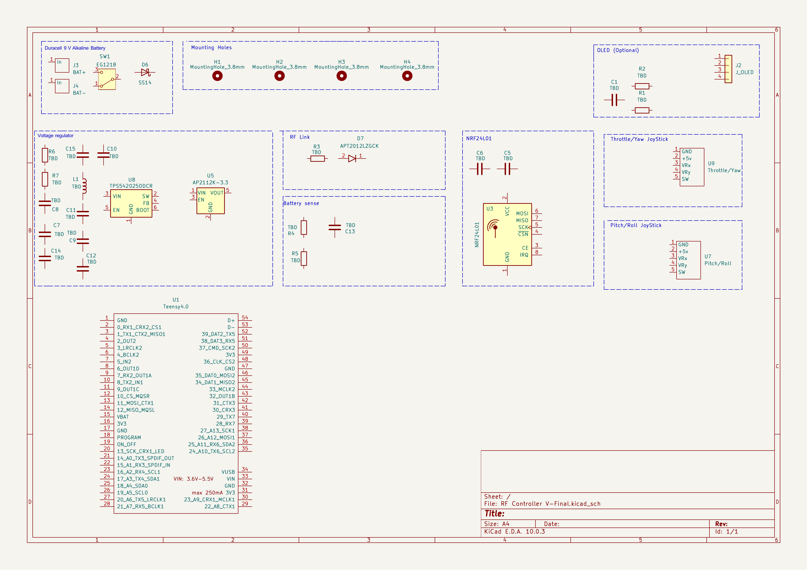
The issued schematic has placed components and pin labels without connection wires. Passive values are TBD. Open the KiCad file to inspect pins at readable zoom.
Part 1 | Design the controller schematic
Use the unconnected starter as a design brief. Your main schematic work is to select appropriate component values, define the nets that express the power and signal architecture, and choose the connections to the Teensy 4.0. Verify those choices against device documentation; you are not required to submit a separate explanation of your design reasoning.
Block | Role | Design question
Two joysticks | Each axis is a variable voltage that the Teensy measures with an analog input; switch presses provide digital input | Which pins are supply, ground, axis outputs, and switch contacts?
Teensy 4.0 | Reads controls, packages commands in firmware, and drives the radio interface | Which available pins support ADC, SPI, and any chosen controls?
nRF24L01+ | Transmits 2.4 GHz packets using SPI plus dedicated control signals | Which pins are power, ground, SPI, chip select, and radio enable?
Power stages | Create the controller supply and a clean radio rail from the intended battery source | What input range, regulator connections, decoupling, and thermal limits apply?
Optional OLED | Shows status or debugging information through its display interface | If included, what voltage and data interface does the actual module require?

Circuit
The instructor reference is based on a 9 V alkaline controller supply, a fixed 5 V buck stage, and a 3.3 V radio supply. Treat those as functional targets for this exercise. Verify the exact circuit against the relevant device documentation before making connections. A regulator IC's broad input rating does not make the whole controller safe for arbitrary battery voltages.

Hints and formulas
• Important symbol detail: the joystick symbol prints “+5v” beside its supply pin because that is the module pin label. It is not permission to drive a Teensy analog input above 3.3 V. Determine the joystick supply so its axis outputs remain inside the Teensy input range.
• The radio has a dedicated 3.3 V supply in the instructor architecture. Keep its decoupling close to the module and distinguish radio power from signal connections. The optional OLED may be omitted; if you omit it, remove its connector or document unused pins as intentional.

WHAT EACH BLOCK CONTRIBUTES
The excerpts below show the intentionally unconnected student starter. Each design idea suggests what to research, without supplying pin connections or passive values. The fictional circuits in the Ask your AI prompts demonstrate research methods rather than supplying controller answers. You may also upload your actual KiCad project, the matching Part 1-3 AI guide, and relevant PDFs in Datasheets/ to a file-capable AI. Ask it to locate datasheet equations and ratings, compare candidate values, or critique placement; verify cited evidence and final choices yourself.
1. Battery, switch, and protection
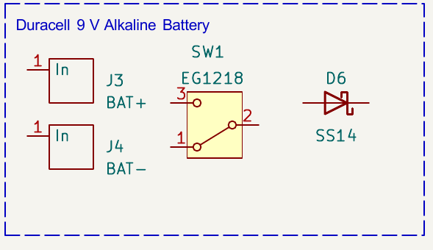
Battery input, switch, and series diode in the unconnected starter.
The battery makes the transmitter portable, and the slide switch gives the operator a physical on/off control. The series diode is intended to block a reversed battery before it reaches the regulators; this supply is for the controller, not the aircraft motors. The supplied reference choices are the EG1218 slide switch and an SS14 Schottky protection diode. Substitutes are allowed when their ratings, polarity, terminal mapping, and footprints are verified.
Research focus: Check battery polarity, switch contacts, diode direction and ratings, and the voltage the regulator will actually see.
Ask your AI: “On a fictional 9 V device, compare switch placement and reverse-polarity protection. What ratings and polarity checks would you make before wiring it?”
2. 9 V to 5 V to 3.3 V power conversion
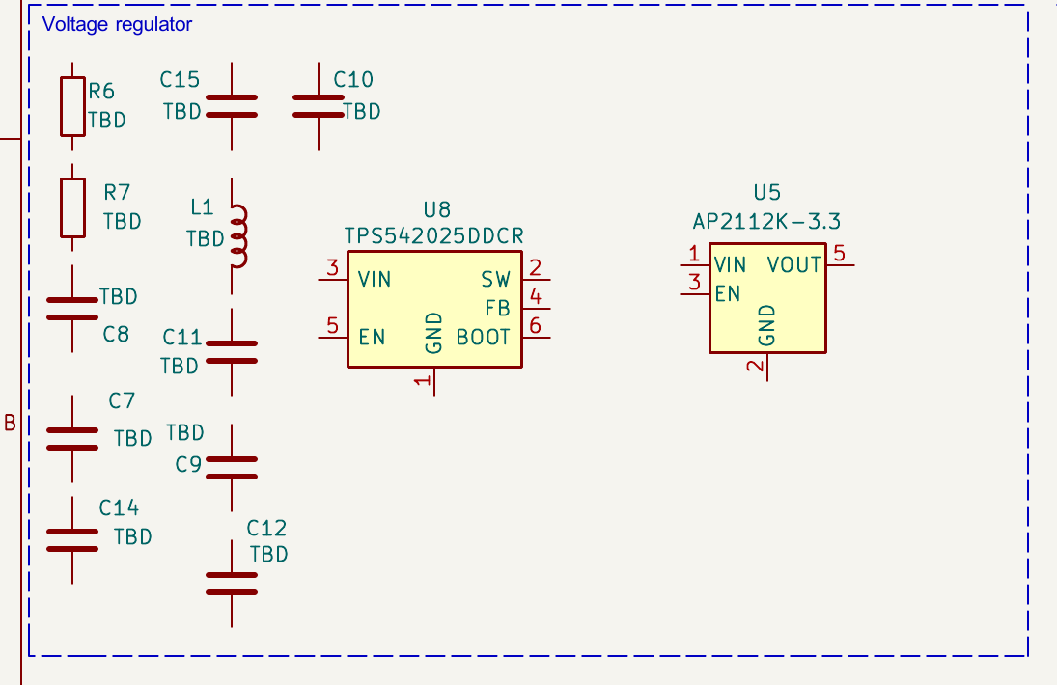
The unconnected buck and dedicated radio 3.3 V regulator.
The buck stage first reduces the 9 V battery supply to a 5 V rail for the controller. A second regulator then steps that 5 V rail down to a dedicated 3.3 V supply for the nRF radio. The supplied reference choices are TPS542025DDCR, AP2112K-3.3, and SRP5030HMCT-150M; the resistor, capacitor, and inductor values remain for you to determine from the exact device documentation.
Research focus: Use the regulator datasheets to determine the application circuit, allowed input range, enable behavior, passive values, and placement guidance.
Ask your AI: “For an unrelated 10 V-to-4.5 V-to-2.8 V supply, show how to read both regulator datasheets to choose passives and check current, heat, and stability.”
3. Two joystick inputs
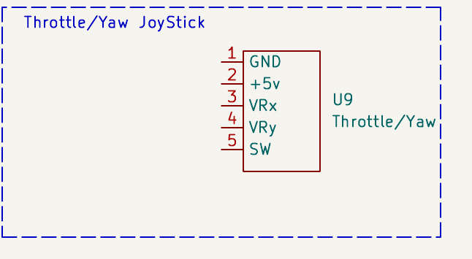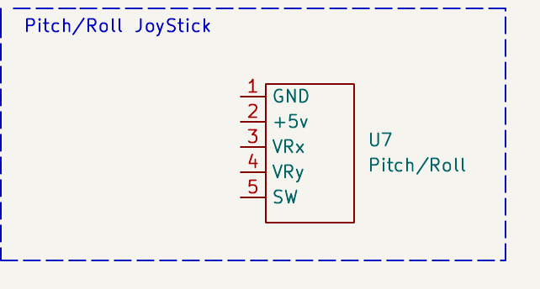
Left: throttle/yaw. Right: pitch/roll. Both are unconnected starter symbols.
Together, the two sticks provide four proportional controls: throttle and yaw on the left, pitch and roll on the right. Each stick also has a press switch for a deliberate controller action. The integrated footprint is based on the supplied KY-023-style joystick geometry, but module pin order must still be verified. Electrical axis names do not establish physical direction after mounting; calibration and command mapping are firmware functions.
Research focus: Confirm both modules' pin order, axis voltage range, switch behavior, and physical orientation.
Ask your AI: “For a generic two-axis sensor module, show how to verify connector pin order, signal range, switch behavior, and physical orientation from its documentation.”
4. nRF24L01 radio
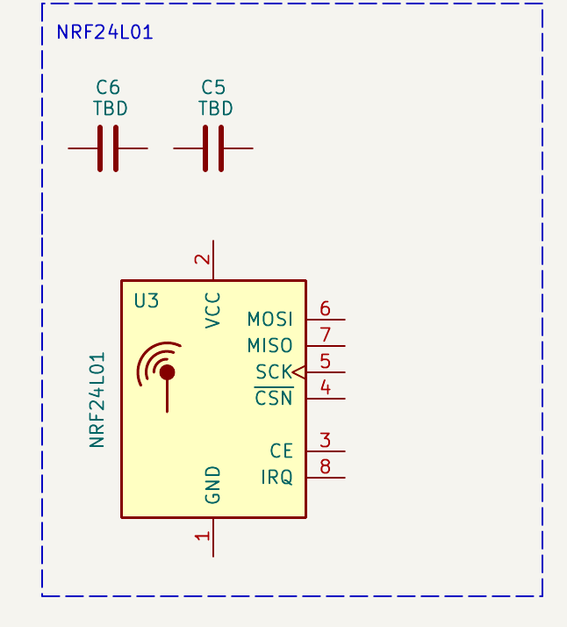
nRF24L01 module and nearby supply capacitors; its regulator appears in the power crop.
The nRF24L01+ module carries control data toward the aircraft. A standard module without a PA/LNA can generally use the Teensy 4.0's 3.3 V output if the total external load stays within PJRC's 250 mA recommendation and local decoupling is adequate. This controller instead has a dedicated 3.3 V radio regulator to leave power headroom for a future PA/LNA module, which may provide longer range. That is not a guarantee of drop-in compatibility: check the chosen module's peak current, voltage, pinout, antenna clearance, physical fit, and regulator thermal limits.
Research focus: Read the radio module's supply limits, digital interface and control-pin functions, decoupling advice, and antenna-clearance guidance.
Ask your AI: “For a fictional SPI radio module, show a checklist for supply, decoupling, control pins, and antenna clearance without assigning pins or nets for this controller.”
5. Optional RF link status LED
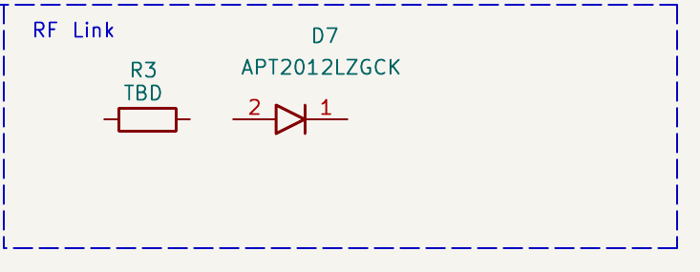
Status LED and current-limiting resistor, before wiring.
The optional supplied APT2012LZGCK status LED and its current-limiting resistor provide an immediate visual cue about radio status when the OLED or USB view is unavailable. A different LED may be used after checking its polarity, forward voltage, current, and footprint. The LED is a useful cue, not proof that every command reached the receiver.
Research focus: Check LED polarity, forward voltage and current, and how to size its series resistor for a Teensy output.
Ask your AI: “For an unrelated 2.8 V GPIO and indicator LED, demonstrate how to choose a series resistor from voltage, current, and pin-drive limits.”
6. Optional battery sensing
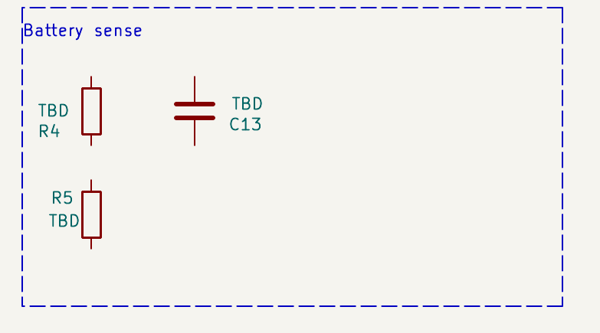
Battery-sense divider and filter parts, before wiring.
The optional divider and filter let the Teensy monitor battery level without applying full battery voltage to an analog input. That reading supports low-battery awareness while the controller is switched on. Omit the entire block if you do not plan to implement battery monitoring.
Research focus: Determine the analog-input voltage limit, a safe divider ratio, filtering needs, and how the reading should be calibrated.
Ask your AI: “For a fictional 10 V battery monitored by a 2.5 V ADC, demonstrate divider and filter selection and explain how software could calibrate the reading.”
7. Mechanical mounting features
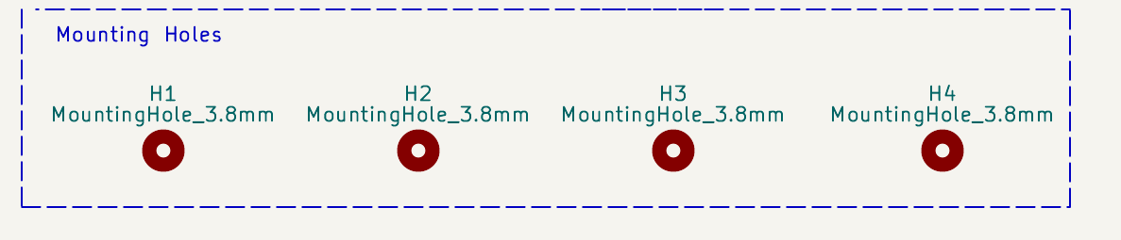
Only H1–H4 are standalone board mounting-hole symbols in the student starter.
These four holes secure the controller PCB in the printed holder. Each supplied integrated joystick footprint already contains its own four module mounting holes and five connector pads; the optional OLED footprint also contains its own mounting holes. Do not add separate schematic symbols for those footprint-integrated holes.
Research focus: Check the board outline and holder-hole fit, then inspect copper clearance around all footprint-integrated holes.
Ask your AI: “For a fictional 90 × 60 mm PCB with four board holes and module-integrated holes, show how to check fit, edge distance, and copper clearance.”
8. Optional OLED display
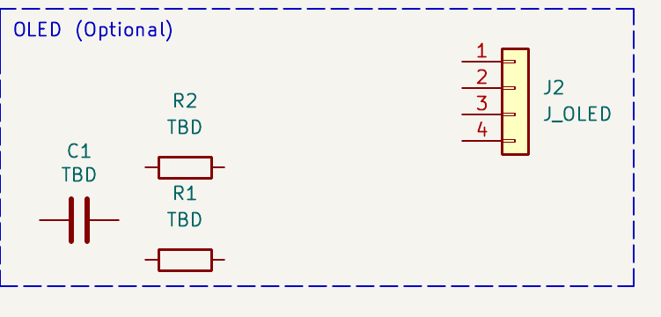
OLED connector and associated passive parts, before wiring.
The optional SSD1306 OLED module can show local controller status without a computer attached. Its small digital interface lets the Teensy send display information, while the controller's radio function remains independent of whether the screen is installed. Verify the exact supplied module's voltage, connector order, and pull-up arrangement because SSD1306 breakout boards are not all identical.
Research focus: Identify the exact display module's supply voltage, connector order, interface, and pull-up requirements.
Ask your AI: “For an unrelated display module, show how to verify supply voltage, connector pin order, interface type, and any required pull-ups before assigning nets.”
9. Teensy 4.0 controller
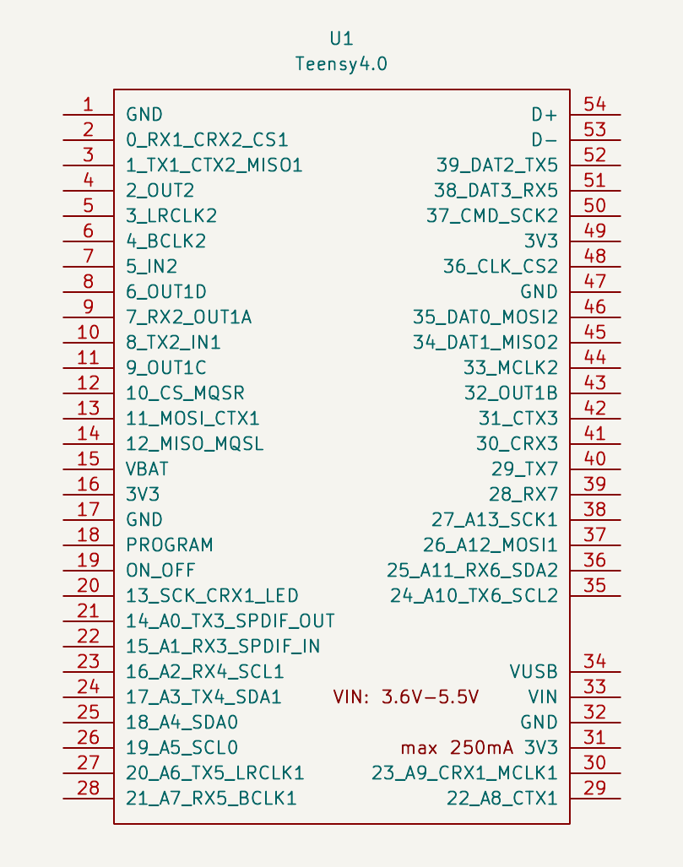
Teensy 4.0 symbol with its available power and signal pins.
The Teensy 4.0 is the programmable center of the transmitter. It interprets user inputs, forms commands, communicates with the radio and optional display, and monitors controller status; firmware determines how a stick motion becomes a transmitted action. Use the PJRC Teensy 4.0 pinout and electrical documentation for the exact pin functions and limits.
Research focus: Check the official pinout, voltage limits, analog-capable inputs, and the SPI and display-interface functions you need.
Ask your AI: “Using a fictional MCU with two analog sensors, an SPI device, a display, and an LED, demonstrate a pin-allocation checklist without choosing Teensy pins.”

The placed components are a starting point, not a completed circuit. Resolve these three design tasks in the schematic itself:
Schematic design task | What your design must resolve
1. Component values | Choose the resistor, capacitor, and inductor values left TBD in the starter. Check regulator application circuits, ratings, LED current limiting, battery-divider range, radio decoupling, and optional OLED pull-ups against device documentation.
2. Nets and connections | Define the battery, switched/protected input, 5 V, dedicated radio 3.3 V, controller 3.3 V, and ground nets. Name the joystick and radio signals, plus the status, battery-sense, and display signals only for the optional blocks you include.
3. MCU pin allocation | Choose Teensy pins for four analog axes, two switches, and radio SPI/control. If included, also choose pins for optional battery sensing, the status LED, and the OLED. Confirm pin functions, voltage limits, and any deliberately unused pins.
MCU pins and firmware. You may choose the Teensy pins that best fit your design. The ZIP includes a pin-redacted transmitter firmware reference so you can inspect the required interfaces now. It is not ready to compile or flash. Later, update its pin assignments to match your own schematic and PCB. If you omit battery sensing, the status LED, or the OLED, remove that block's schematic parts and PCB footprint(s), then remove or disable the corresponding firmware feature.
DESIGN REVIEW
Before PCB layout, inspect the chosen values, net names, voltage domains, MCU pin functions, and symbol-to-footprint pad mappings. Run ERC: resolve all errors, then review any remaining warnings and confirm they are intentional. The schematic should be clear and internally consistent; no separate design-reasoning report is required.
Before moving on, confirm:
☐ Every formerly TBD resistor, capacitor, and inductor has an appropriate selected value.
☐ Power and signal nets show the intended architecture and connections clearly.
☐ Teensy pin choices satisfy interface functions and 3.3 V signal limits.
☐ ERC has no errors; remaining warnings have been reviewed and are intentional, and physical symbols match their footprints.

PCB EDITOR
Part 2 | Design the PCB
The completed schematic drives the PCB ratsnest. Begin with mechanical fit and connector access; let those decisions guide placement before routing.
Component choices. The parts and functional blocks in the starter are design recommendations, not a fixed bill of materials. You may substitute parts, particularly the regulators, and omit blocks your controller does not need. Recheck the required functions, power architecture, connections, and component values after any change.
Required and optional functions. A working controller still needs a suitable power path, a Teensy, both joystick inputs, and an RF link. The exact regulators and protection implementation may be replaced. Battery sensing, the RF-status LED, and the OLED are optional and may be omitted when they do not serve your controller design.
Package and assembly choices. You may choose different resistor, capacitor, and inductor package sizes. Common imperial SMD resistor/capacitor codes describe nominal body dimensions: 0805 is about 2.0 x 1.25 mm, 1206 about 3.2 x 1.6 mm, and 1210 about 3.2 x 2.5 mm. These codes describe physical size, not resistance or capacitance; check whether a supplier uses imperial or metric codes.
Inductor package names are often manufacturer-specific: use the exact part datasheet to select its footprint and verify body dimensions, height, pad pattern, saturation current, RMS current rating, and DC resistance. For all three component types, choose a package that meets the electrical ratings, fits the board, and is practical to solder.
SMD parts are not required; through-hole (THT) parts are also acceptable if they are easier for you to solder. You may import your own footprint libraries, but verify pad mapping and physical fit, and include those libraries in your submitted ZIP. The supplied outline and holder-hole pattern are recommendations; use them if you want your PCB to fit the supplied RF controller holder STL.
Verified reference feature | How to use it
Recommended holder-compatible outline | To fit the supplied RF controller holder STL, use the reference Edge.Cuts outline: 132.0 mm by 67.5 mm, 1.6 mm board thickness, and 3.0 mm-radius rounded corners. Use four 3.8 mm non-plated holder holes. From the outline's upper-left bounding corner, their centers are (4.5, 4.0), (127.5, 4.0), (4.5, 63.5), and (127.5, 63.5) mm (X right, Y down). The centers are 123.0 mm apart horizontally and 59.5 mm vertically. These dimensions are recommendations unless you intend to use the supplied holder.
Component access | Keep joystick caps, switch, battery connection, radio module, optional OLED, and programming/USB access usable after assembly.

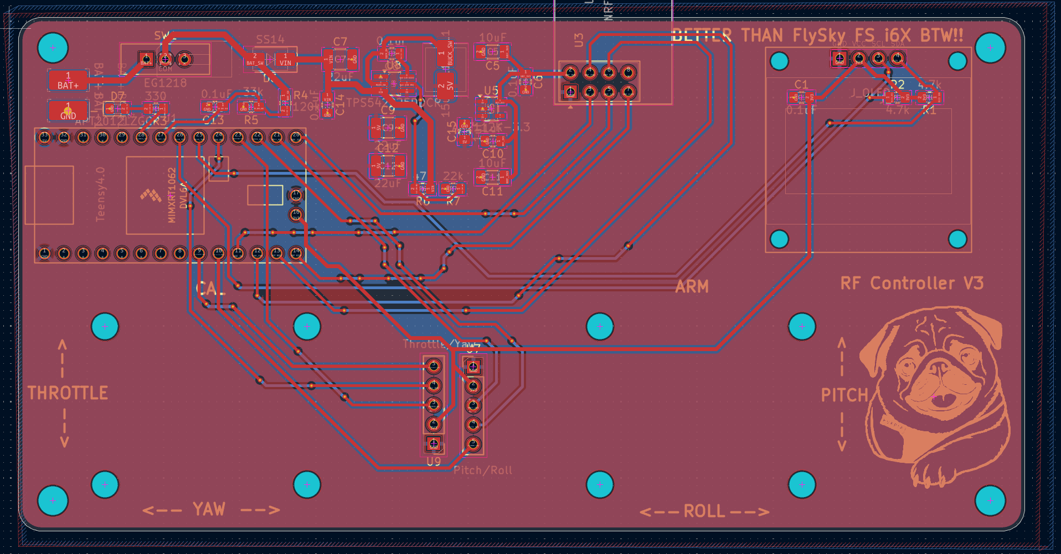
Instructor routed-PCB reference. Compare its board outline, mounting holes, component access, and copper-plane approach with your own design. Treat it as a design example, not a clean ERC/DRC or schematic-to-PCB verification baseline; validate your own project independently.
2.1 CREATE THE BOARD
Ask your AI: “Open my KiCad project and Part2_PCB_AI_Guide.md before I route. Suggest a component placement order and candidate groupings or orientations that make the board practical to assemble and route. Account for joystick movement, connector and USB access, a compact buck loop, radio antenna clearance, analog-signal noise, and return paths. Cite relevant datasheet layout guidance and say what you cannot verify from the files.”
1. Save the schematic and use Tools > Update PCB from Schematic. Stop and repair any missing footprint or library reference before placing parts.
2. Draw one closed Edge.Cuts outline. Check the reference envelope and planned clearance around joystick caps, mounting hardware, connector bodies, and enclosure edges.
3. Place the two supplied integrated joystick footprints first. Each includes the 1×5 connector and four module mounting holes; position and rotate each assembly for usable stick orientation and enclosure fit. Do not add separate joystick mounting-hole footprints. Then place the battery interface, switch, and Teensy for practical access.
4. Place the radio module so its antenna end remains clear of copper, tall parts, and nearby metal as required by its module guidance. Place decoupling close to the radio supply pins.
5. If you use the OLED, reserve readable viewing space and connector access. If omitted, do not leave a stranded footprint or unrouted display nets.
2.2 ROUTE AND REVIEW
Ask your AI: “On an unrelated low-current PCB with one buck converter and one analog sensor, explain how placement and return-current paths influence routing, and what DRC can and cannot verify. Do not prescribe tracks for my Lab 7 board.”
1. Inspect Board Setup and choose track widths, clearances, and vias for the actual circuit and JLCPCB's published capabilities. Use a two-layer board unless you intentionally accept the added fabrication cost of more layers; the instructor reference uses two copper layers and a 1.6 mm board thickness. Do not copy a generic screenshot's numbers.
Trace-width review. Do not route every net with the same default width. Choose widths for each net based on its expected current, copper thickness, allowable temperature rise, and any relevant signal-integrity needs; also check the board manufacturer's design rules. Consult datasheets, credible online references, or AI to evaluate your choices, then verify the final widths for your actual design before submission.
2. Keep the buck switch loop compact. Place its input bypass, bootstrap part, inductor, output capacitors, and ground return according to the regulator layout guidance; keep the switching node's copper area small.
3. Route power and ground deliberately, then sensitive joystick signals and the radio interface. Keep analog paths away from the buck's noisy switching region.
4. Use planes where practical: keep bottom GND continuous and consider top 5 V, as on the reference. Assign each zone's net, isolate other rails, respect the radio antenna keepout, then refill and check for islands and mounting-hole clearance.
5. Watch the ratsnest and status bar as you route. A track is complete only when KiCad recognizes the correct pad-to-net connection.
6. Run Design Rules Checker, fix the reported causes, refill zones, and rerun it. Open 3D Viewer to inspect hole alignment, connector reach, polarity, silkscreen, and model placement.
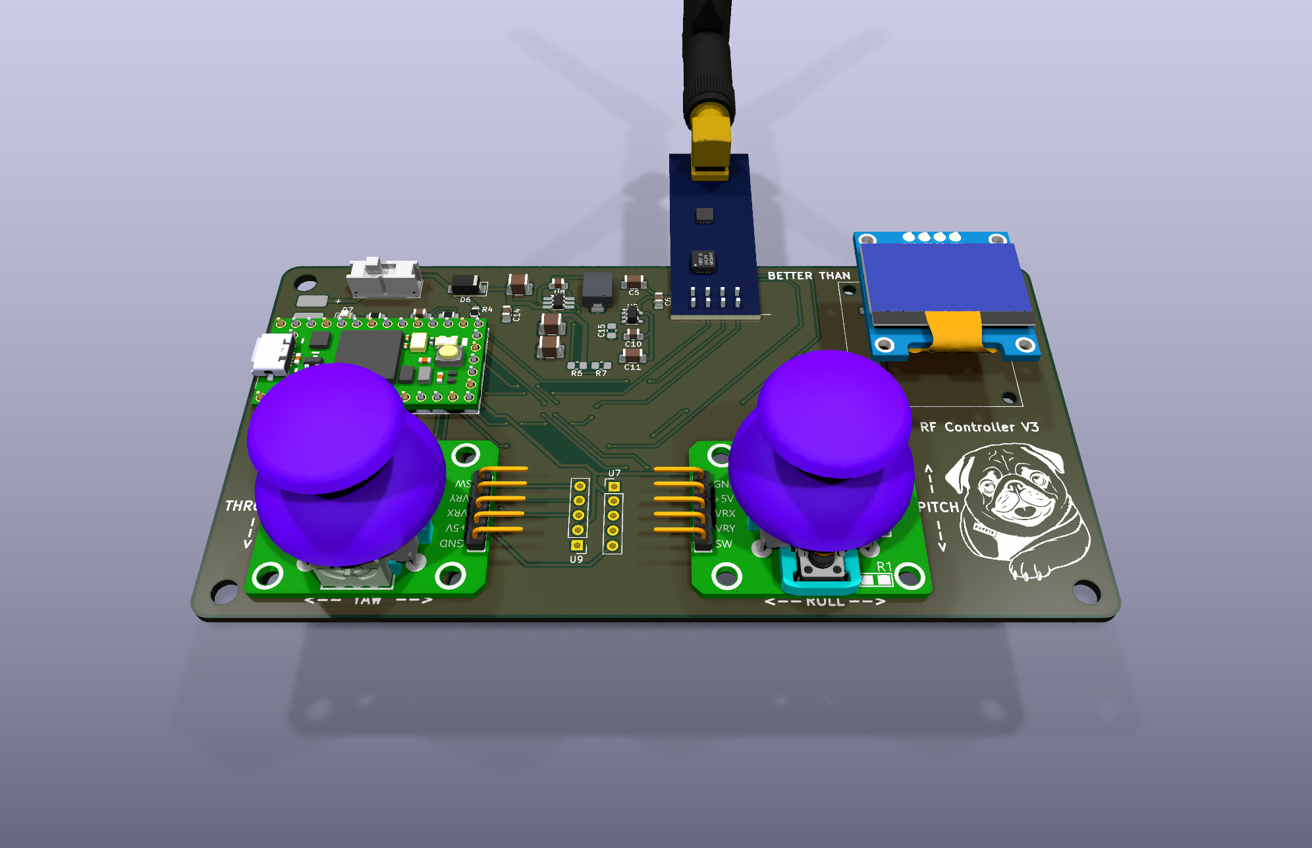
Controller 3D reference. Use this physical view for placement and access, not as a connection diagram.
If you see | First check
Missing custom footprint | Project footprint table, nickname, and ${KIPRJMOD} path
3D body absent or misplaced | Footprint 3D model path, orientation, scale, and origin
Unrouted ratsnest after a track | Track endpoint and pad net; zoom in and highlight the net
Many similar DRC findings | The first shared rule, footprint, zone, or board-outline cause
Clearance issue at joystick holes | Actual drill/NPTH geometry and copper-to-hole clearance after refilling zones

Before moving on, confirm:
☐ The board fits the reviewed mechanical envelope and both joysticks remain usable.
☐ Antenna, switch, battery, USB, and optional OLED have practical access.
☐ Zones have been refilled; no unintended unrouted connections remain.
☐ DRC has no errors; remaining warnings have been reviewed and are intentional, and the 3D view has no obvious collision.

Design responsibility. You are responsible for confirming that your custom RF controller is electrically sound, manufacturable, and ready to order. With approximately 80 unique designs, TAs cannot conduct a complete review or sign off on every board. Use manufacturer datasheets, application notes, KiCad ERC/DRC, and other reliable technical resources to check your choices. You are welcome to bring focused questions to the TAs, but should not expect them to validate the entire design. AI can help compare options, challenge assumptions, and identify possible errors; verify its recommendations against primary sources before finalizing your PCB.
Project-level AI review. You may upload your complete KiCad project folder or ZIP to a file-capable AI assistant (such as Codex or Claude) and ask it to open and inspect the actual schematic, PCB, and project libraries, not just screenshots. Supply relevant datasheets and fabrication rules where needed, and verify the AI's findings against primary sources before ordering.
Ask your AI: “I have uploaded my complete KiCad RF controller project. Open the project files and review the schematic, PCB layout, libraries, and any ERC/DRC reports I provide. Use the key datasheets and manufacturer rules I provide as a pre-order design reviewer. Check power rails and regulator circuits, component values and ratings, MCU and radio pin/voltage compatibility, connector pinouts, footprint mappings, decoupling, antenna keep-out, trace widths, return paths and planes, clearances, and holder fit. Rank suspected issues by severity, cite the evidence for each, and state what information or measurement would resolve uncertainty. Identify what you cannot verify from the materials; do not claim the board is ready to manufacture.”
Part 3 | Test the one-file submission
The ZIP must be portable. A design that opens on your computer but loses its custom libraries or 3D models after extraction is incomplete. Lab 7 ends with the tested KiCad project ZIP: do not order the RF controller PCB or submit Gerbers yet. After completing the Flight Controller PCB in Lab 8, prepare and order both boards together.
Keep in the submitted folder | Reason
Completed .kicad_pro, .kicad_sch, and .kicad_pcb | Project entry point, electrical design, and board layout
sym-lib-table and fp-lib-table | Project-specific library mappings
Supplied .kicad_sym and .pretty folders | Custom course symbols and physical footprints
Supplied 3D model files | Portable mechanical review

1. Save the schematic and PCB, refill zones, close both editors, and exit KiCad so the project files finish writing.
2. Remove temporary lock files and unrelated downloads from the project folder. Keep the supplied libraries, tables, and models.
3. Compress the whole Lab7_RF_Controller_Starter project folder and name the archive Lab7_RF_Controller_<YourStudentID>.zip.
4. Extract the archive into a different temporary folder. Open its copied .kicad_pro file.
5. Confirm that symbols render, footprints load, the PCB opens, zone fills rebuild, and supplied 3D models are found. Submit that tested ZIP only.
Before moving on, confirm:
☐ The archive contains the complete project folder and its .kicad_pro file.
☐ The extracted copy opens without absolute paths tied to your user profile, drive, or other absolute path.
☐ The schematic, PCB, project tables, custom libraries, and models are present.
☐ ERC and DRC have no errors; remaining warnings have been reviewed and are intentional.
COMPONENT DOCUMENTATION
Start with the PDFs in Datasheets/ and its START_HERE.md guide. Use current primary documentation for pin, rating, application-circuit, footprint, and layout decisions. The following parts are the supplied or instructor-reference choices, not mandatory substitutions; if you choose a different part or module, use documentation for that exact variant.
Component or module | Primary reference
Teensy 4.0 | PJRC pinout, electrical limits, and technical information: https://www.pjrc.com/store/teensy40.html
nRF24L01+ | Nordic nRF24L01+ Product Specification; verify the exact breakout module's connector order and antenna geometry.
TPS542025DDCR | TI TPS54202x datasheet and layout guidance: https://www.ti.com/product/TPS542025
AP2112K-3.3 | Diodes Incorporated AP2112 product page and datasheet: https://www.diodes.com/part/view/AP2112
SRP5030HMCT-150M | Bourns SRP5030HMCT product data: https://www.bourns.com/products/magnetic-products/product-detail/power-inductors-smd-high-current-shielded/srp5030hmct
SS14 / chosen protection diode | Use the selected diode manufacturer's datasheet; confirm polarity, repetitive reverse voltage, forward current, and footprint.
EG1218 slide switch | E-Switch EG1218 mechanical drawing and contact configuration; confirm the exact terminal numbering.
KY-023 joystick and SSD1306 OLED modules | Module pin order is not universal. Verify the exact supplied boards by their markings, documentation, and continuity checks.
APT2012LZGCK or chosen status LED | Use the selected LED datasheet for polarity, forward voltage, recommended current, and package orientation.

