1. Sanity test

1. Shell info



1. List available shells

1. Hello world bash test using variable

1. Basic admin tasks

1. Variables task

1. I/O Script

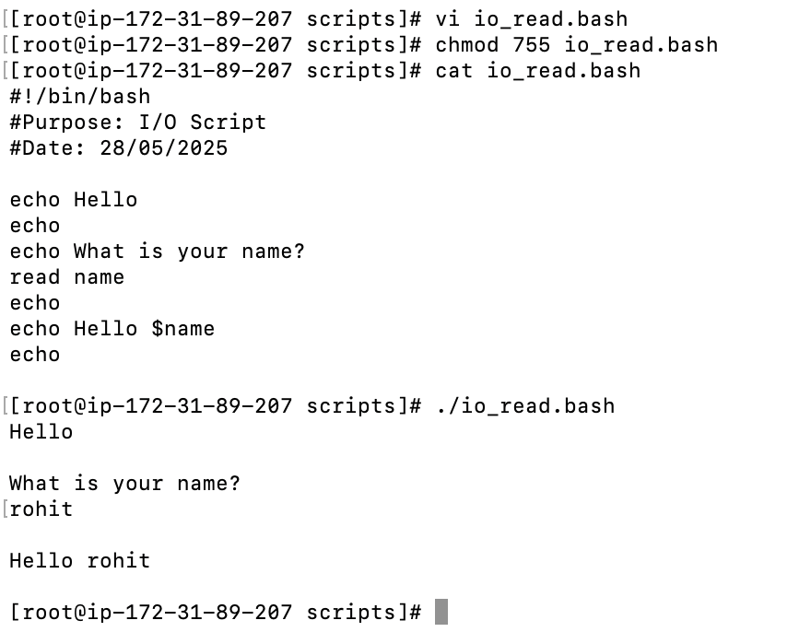

1. Command call in variable

Bash_examples_document

1. For loop using array

1. Case menuchoice A screenshot of a computer code

   AI-generated content may be incorrect.
2. Odd or even

