Launch one ec2 instance using amazon linux 2.

Install Docker



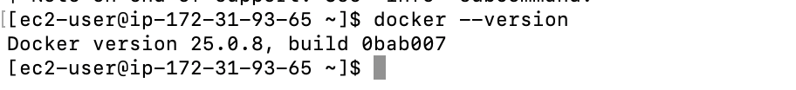

Install jenkins

Install apache

Install nginx

Install Apache Tomcat

