**Selecting a neighbourhood and**

**features of a new food venue in**

**Toron**

**to**

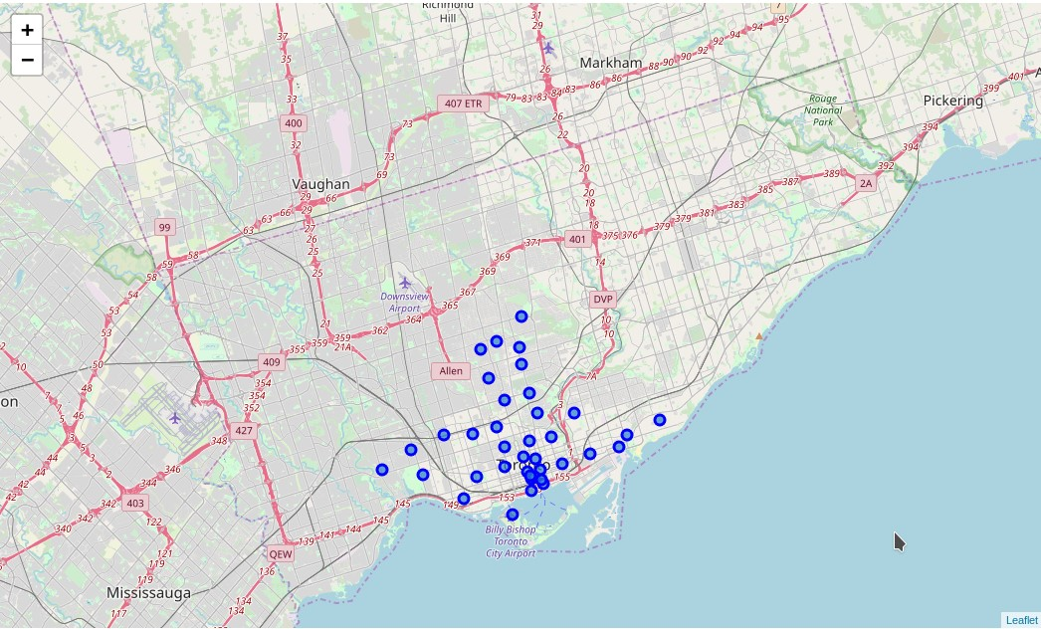

3

Selecting a location and features of a restaurant is challeging

Highly competitive

Dynamic market

Location is critical

What features to have to make it new and fresh

Ideal properties of a new restaurant

Located in the neighbourhood with the highest density of restaurants

▶ Maximum number of customers willing to pay

▶ The rent levels and associated costs can be covered by the revenue

Same cuisine as already offered in the neighbourhood

▶ Minimise any resistance to the unknown

Vary by one thing from the standard venue and use that as a marketing hook

2

Toronto postocdes from Wikipedia

Food venues from Foursquare

Food venues details from Foursquare

Postcode code data did not include unallocated postcodes

Data acquisition and cleaning

3

Generated a list of each neighbourhood and its

geographic centre



4

The top 5 neighbourhoods had over 40 food venues within 200m radius

|  |  |
| --- | --- |
| Neighbourhood | Number of food venues within 200m |
| Commerce Court and Victoria  Hotel | 50 |
| Central Bay Street | 48 |
| First Canadian Place and  Underground city | 48 |
| Chinatown, Grange Park and  Kensington Market | 46 |
| Harbourfront East, Toronto  Islands and Union Station | 42 |

5

Coffee shops were 25% of the food venues in

|  |  |
| --- | --- |
| Category | Number of food venues within 200m |
| Coffee shop | 12 |
| Restaurant | 5 |
| Fastfood Restaurant | 3 |

Commerce Court and Victoria Hotel

Each category of food venue was assessed according the 3 features

Price Tier (1 cheapest, 4 most expensive)

Outdoor seating

Wifi

7

Pricing alternatives were one below and one above the most common price tier

For example if the most common price tier was 2, the alternative price tiers were offered to be

▶ Price Tier 1 ▶ Price Tier 3

If the price tier was either the lowest or highest (i.e 1 or 4) then one alternative tier was offered

For example, if the price tier was 1, the offered alternative would be

▶ Price Tier 2

8

Outdoor seating and wifi alternatives were determined from their relative numbers

For each feature if both options were approximately the same it was considered that there was no underexploited niche in this neighbourhood for that features.

A threshold was set at the less common option was to be below 35% for the niche to be underexploited

For example:

Outdoor seating and indoor seating. Wifi is available at every venue,

niche

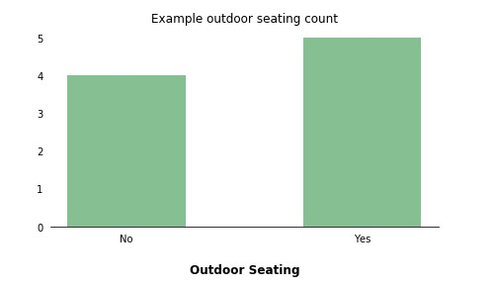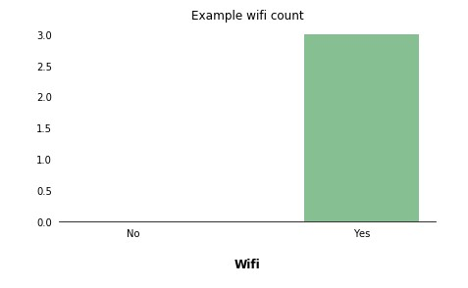

9

For the neighbourhood Commerce Court and Victoria Hotel, 7 options for a new food venue were identified

10

/

|  |  |  |  |  |
| --- | --- | --- | --- | --- |
| Category | Nickname | Price Tier | Outdoor seating | Wifi |
| Coffee Shop | Coffee anytime - even when it is raining | 1 | No | Yes |
| Coffee Shop | Upmarket coffee and treats | 2 | Yes | Yes |
| Restaurant | Cheap and cheerful in the fresh air | 1 | Yes | No |
| Restaurant | Good meals, done right | 3 | Yes | No |
| Fastfood Restaurant | Everything you expect AND wifi! | 1 | Yes | Yes |
| Fastfood Restaurant | We know two things: food and fast | 1 | No | No |
| Fastfood Restaurant | Fast food that is cut above the rest | 2 | Yes | No |