EECS 195 LAB 7: End-to-End Learning Using Neural Networks
By: Vy Tang
ID: 77659006

Classification results
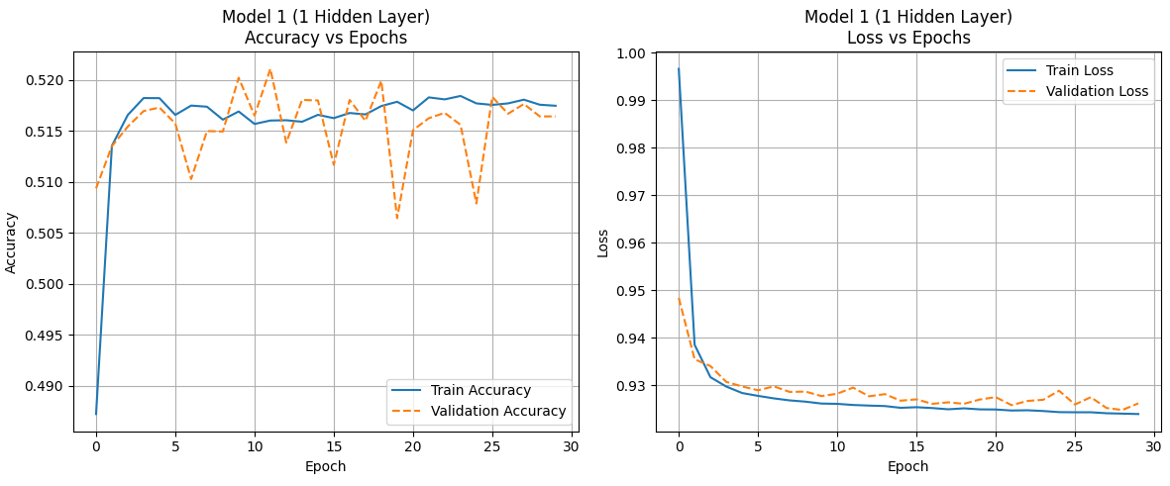

Figure 1. Model 1 Accuracy and Loss Plots
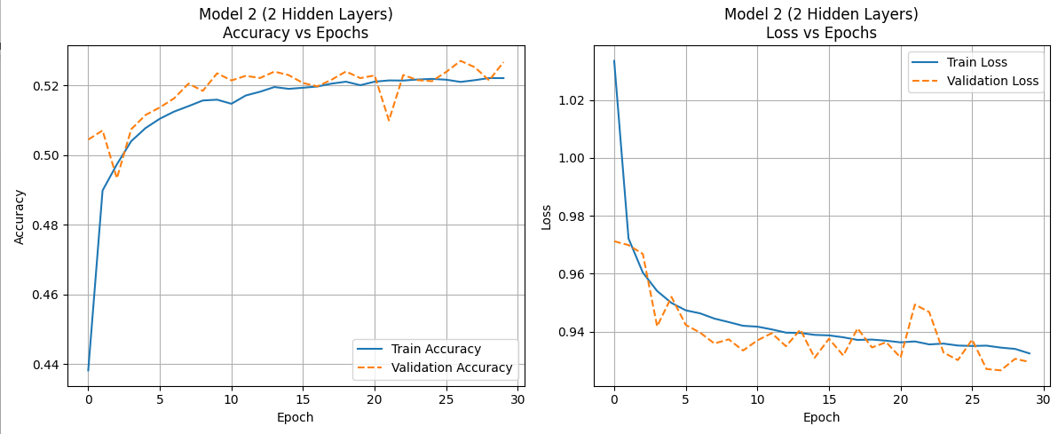

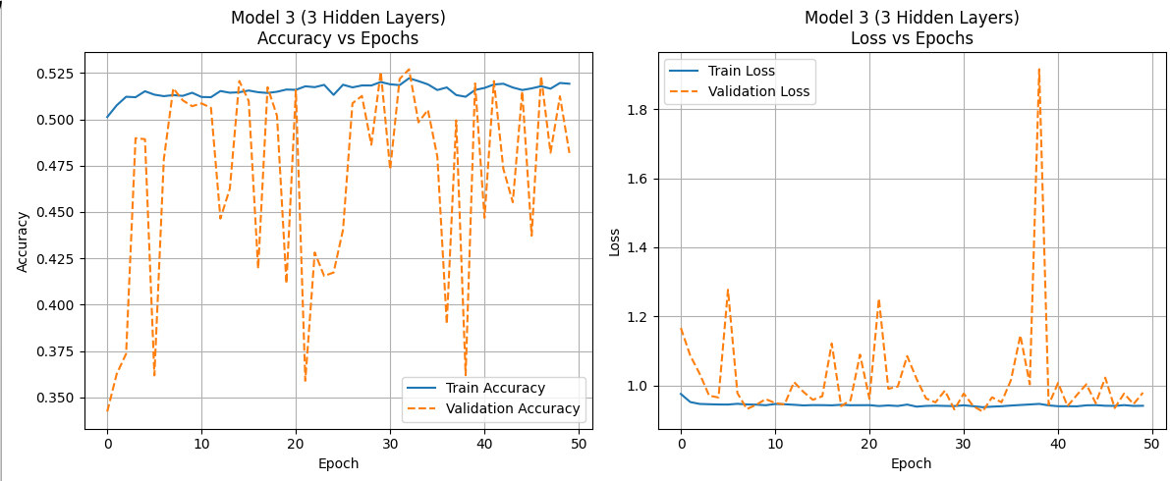
Figure 2. Model 2 Accuracy and Loss Plots

Figure 3. Model 3 Accuracy and Loss Plots

Analysis

Models | Accuracy | Loss
Model 1 | 0.5170 | 0.9261
Model 2 | 0.5232 | 0.9321
Model 3 | 0.4798 | 0.9786

Model 1 has 1 layer with 16 neurons where we use relu activation. For the optimizer we will use adam. For Model 2, it has 2 layers with the first hidden layer having 64 neurons and the second layer with 32 neurons where both of them uses tanh activation and uses rmsprop for optimization. The third model has a lot more neurons with 128 neurons in the first layer, 64 neurons in the second layer, and 32 in the third layer. For activation, we will go back to relu and use sgd with momentum to be the optimizer. For epoch, model 1 and 2 uses 30 and model 3 uses 50 epochs. From the graph and the table, model 2 performs the best with 0.52 accuracy with a loss of 0.9261 while model 3 performs the worst.

Regression results
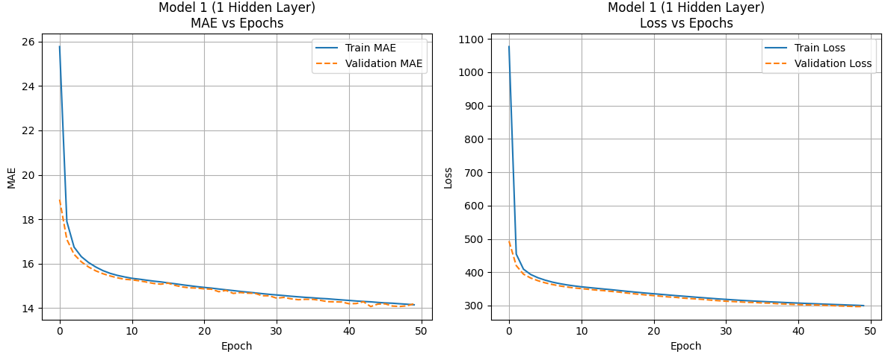

Figure 1. Model 1 MAE and Loss Plot
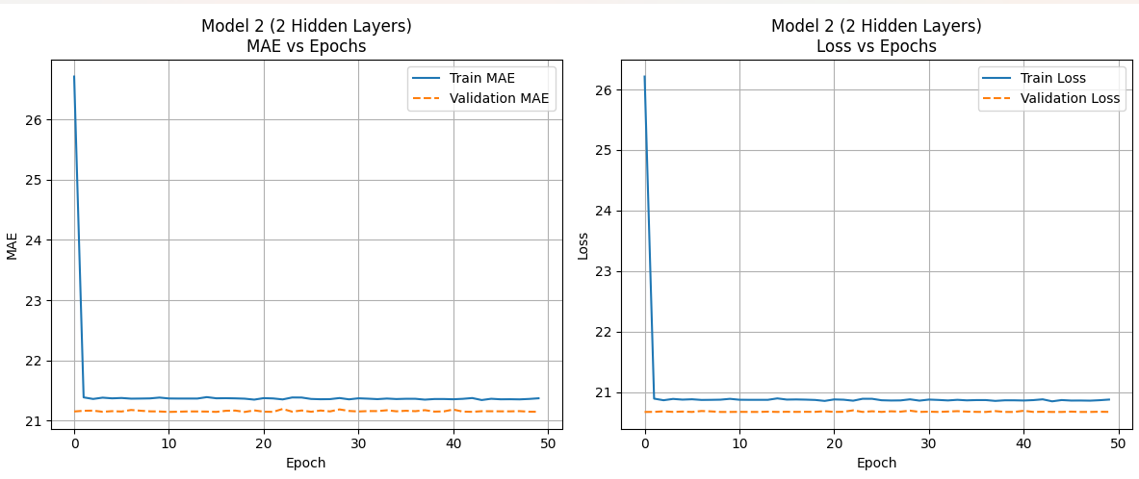

Figure 1. Model 2 MAE and Loss Plots
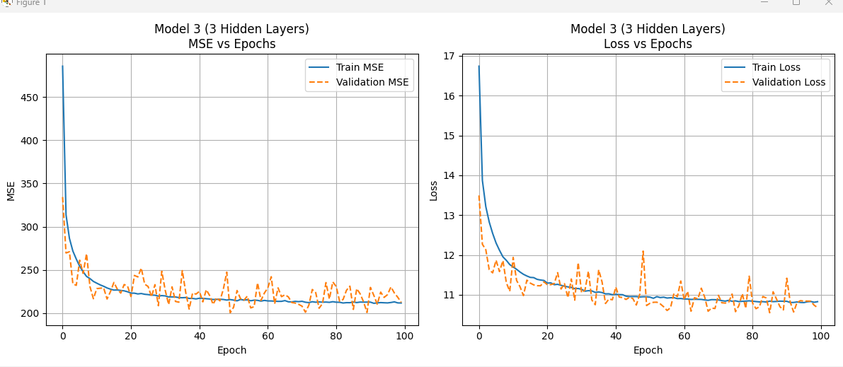

Figure 1. Model 3 MAE and Loss Plots

Analysis:
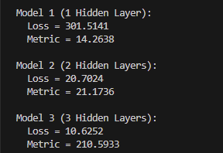

We can see that model 1 has a lower MAE but an extremely high Loss while Model 3 suffers from the opposite issue where Model 3 suffers from a high MSE while having the lowest loss rate. Model 2 comparatively, is the model that performs the best where both the loss is relatively moderate and the MAE is moderate compared to Models 1 and 2.

