EECS 195 LAB REPORT 5: Full Implementation of Motion Planning using ROS
By: Vy Tang
ID#: 77659006

Objective
The objective of this lab is to implement a complete motion planning system for TurtleBot3 in a simulated Gazebo environment using ROS. This involves integrating components from previous labs, including a Rapidly-exploring Random Tree (RRT) path planner, a motion planner, and a PID controller, to enable autonomous navigation from a start to a goal location.

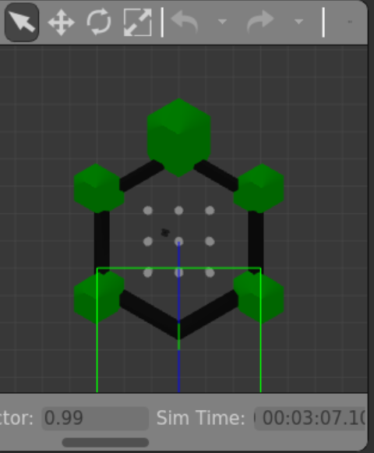
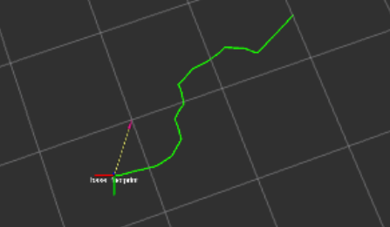

Test Point 1

Test point 1: End Goal = (0.5, 0.5)

- Start time Gazebo after running pid controller is 0:47

Test Point 2


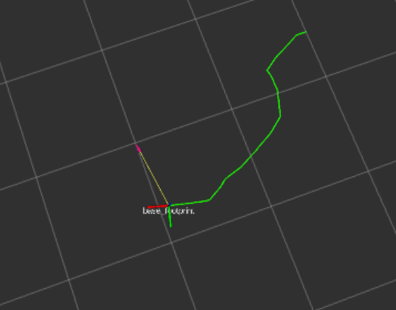

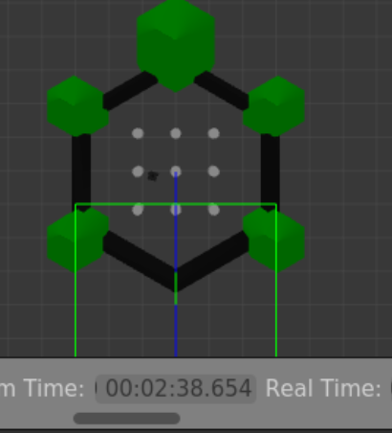

Test point 1: End Goal = (1, 1)
- Start time Gazebo after running pid controller is 0:38

