LAB 4: Motion Planning Using ROS pt.2
By: Vy Tang
ID: 77659006
5/5/25

Objective

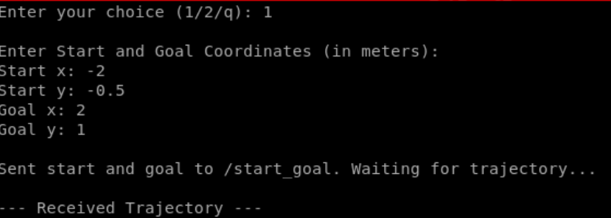
Test cases

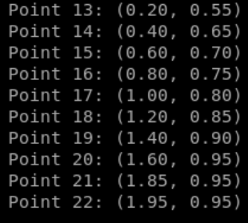
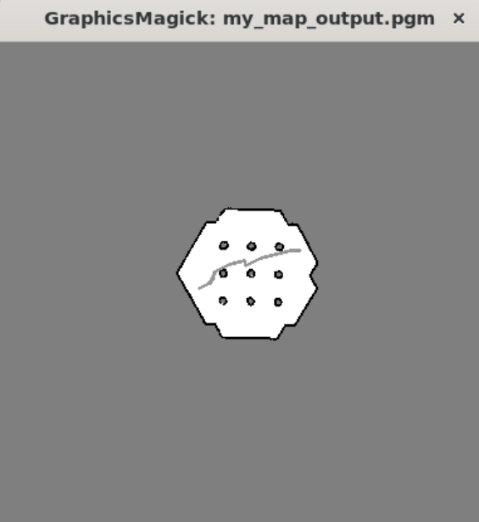

Test Case 1: The recommended starting test case where the goal is (2,1) and starting point is at (-2,-0.5)

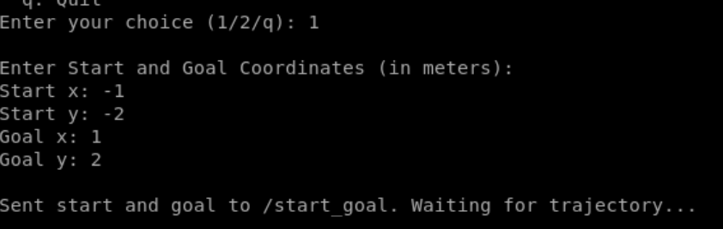

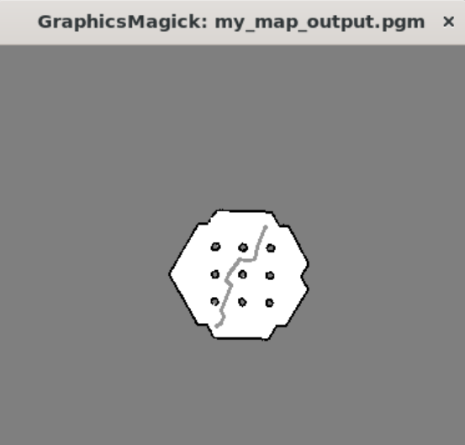
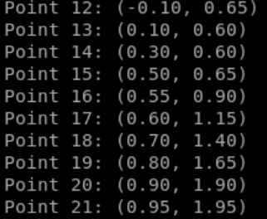

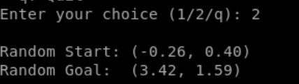
Test Case 2: User inputted starting point at (-1, -2) to goal point (1,2)
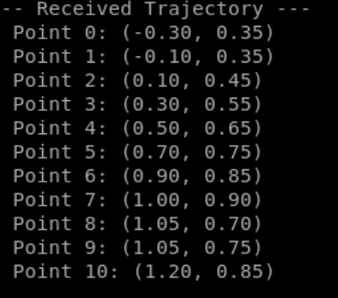
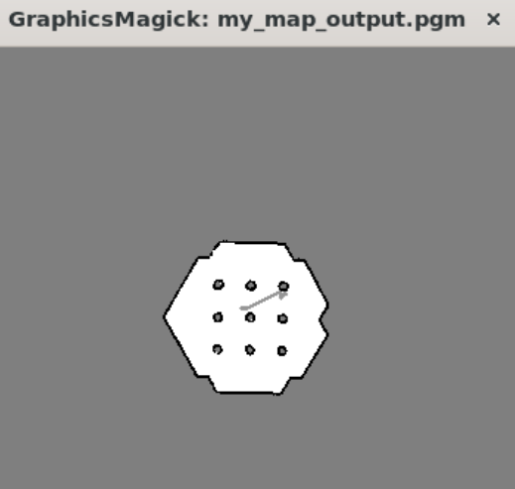
Test Case 3: Randomized start and goal points
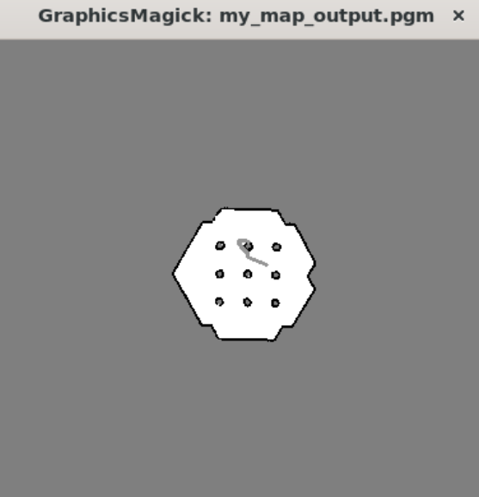
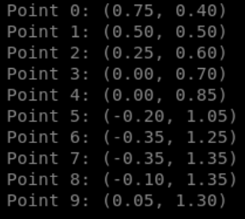
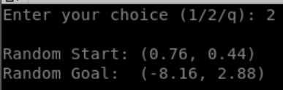
Test Case 4: Randomized start and goal points

Sdf

In total there are four test cases. The first test case is the goal and trajectory that was taken in the lab manual and the second test case is a user input test case. The latter two test cases are randomized.

Code Breakdown
rrt_node.py
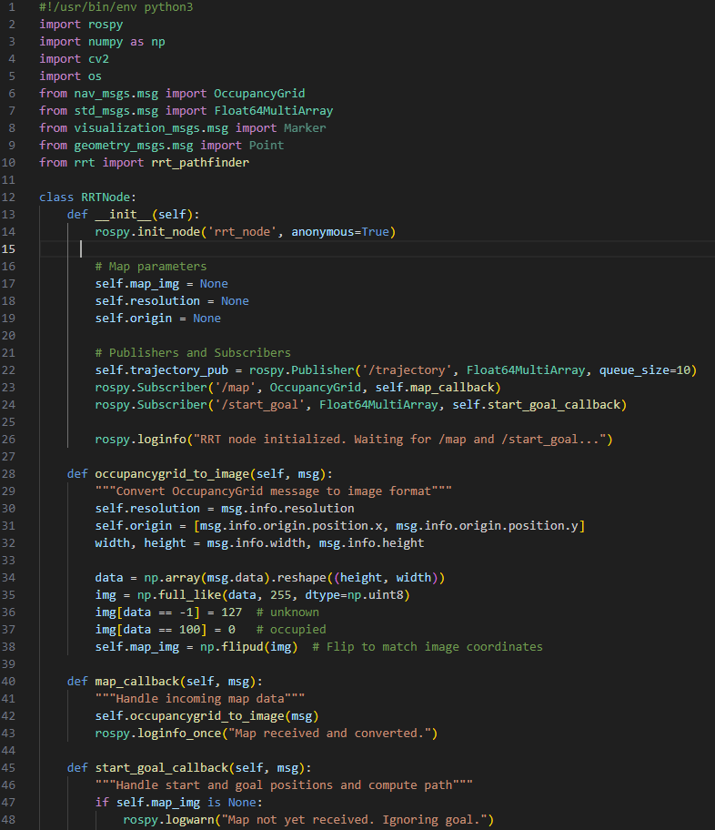

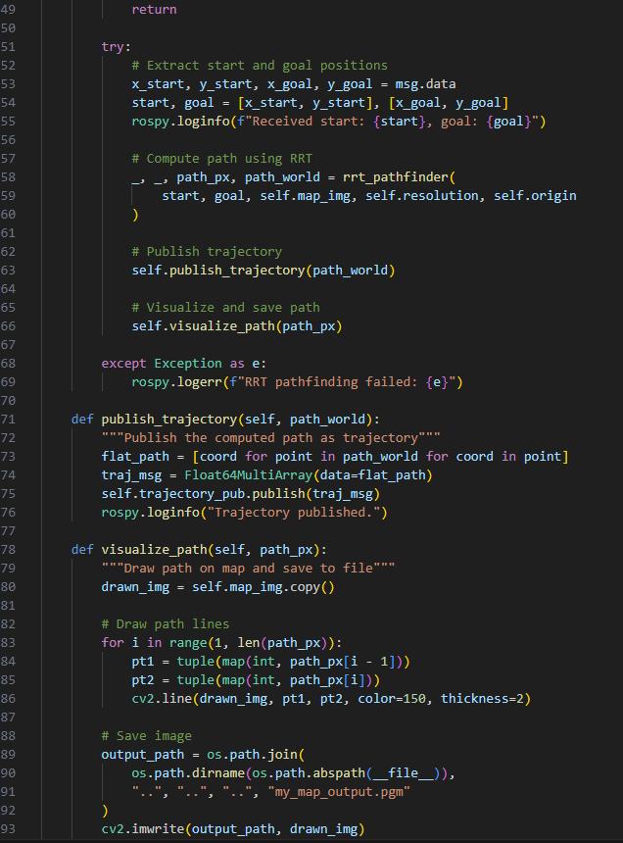
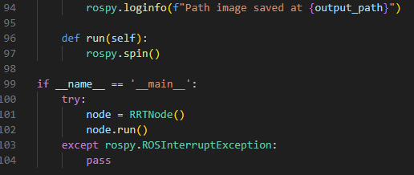

In this file, I started by initializing the rrtnode class that initializes the rrt node. The constructor in the init sets up map parameters i.e. map_img, resolution, and origin as well as creating publishers/subscribers for trajectory data, map data, and start/goal positions.
Next is about the map conversion and the function occupancygrid_to_image essentially converts ROS occupancy grid messages into a numpy image array where unknown areas are defined as gray at ‘127’, the occupied areas as black at ‘0’, and free space as white at ‘255’. There is also the map callback function to process new maps when it arrives via the /map topic using the occupancygrid_to_image function.
For the path planning, the start_goal_callback function will check for map availability and handle incoming start/goal positions. If there’s map availability, then it will call the RRT pathfinder. After receiving the path from the RRT, it will publish the coordinates as a trajectory and visualize the path on the map.
Now, after receiving the path, the program will publish the trajectory by converting the path into a ROS Float64MultiArray message and publish it to the /trajectory topic. The visualize_path function will then be responsible for actually drawing out the mapped path indicated by the gray lines shown in the test cases above. The last block is to execute the program.

Motion_planner.py
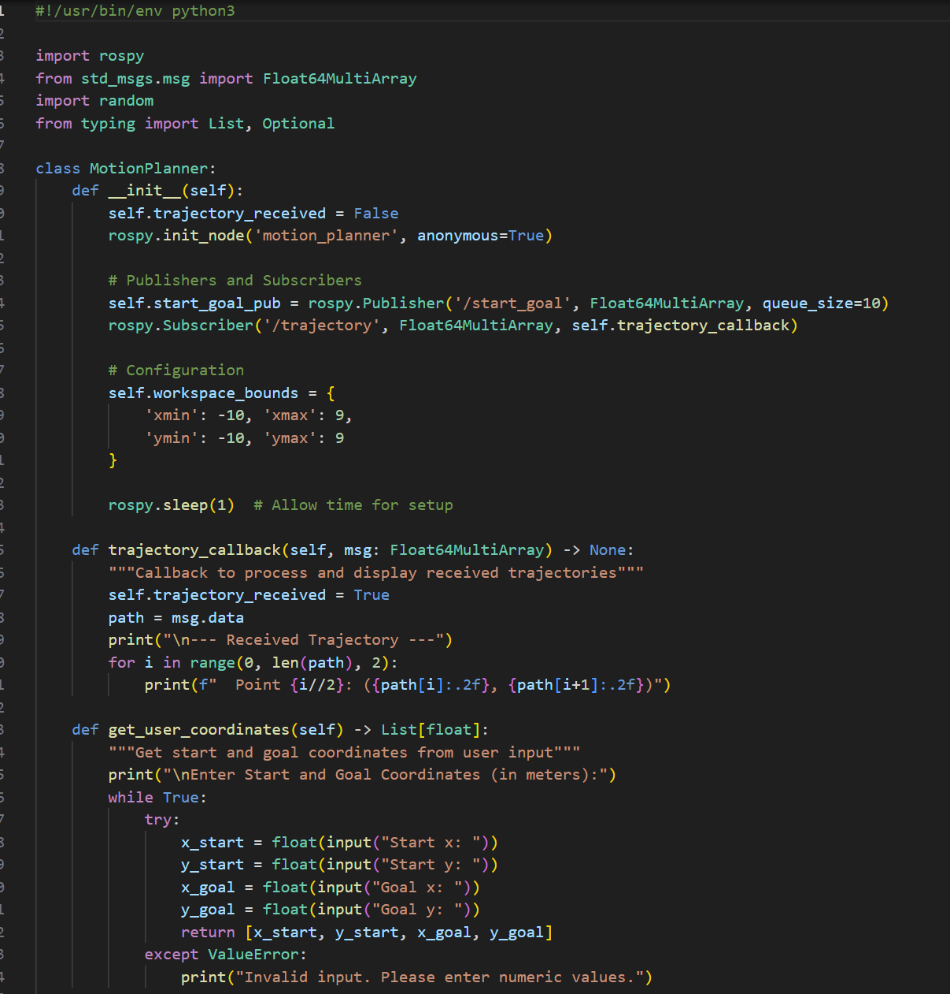
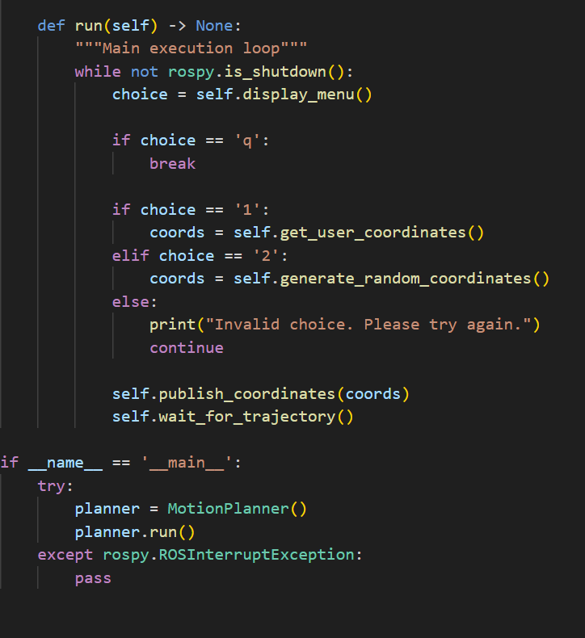
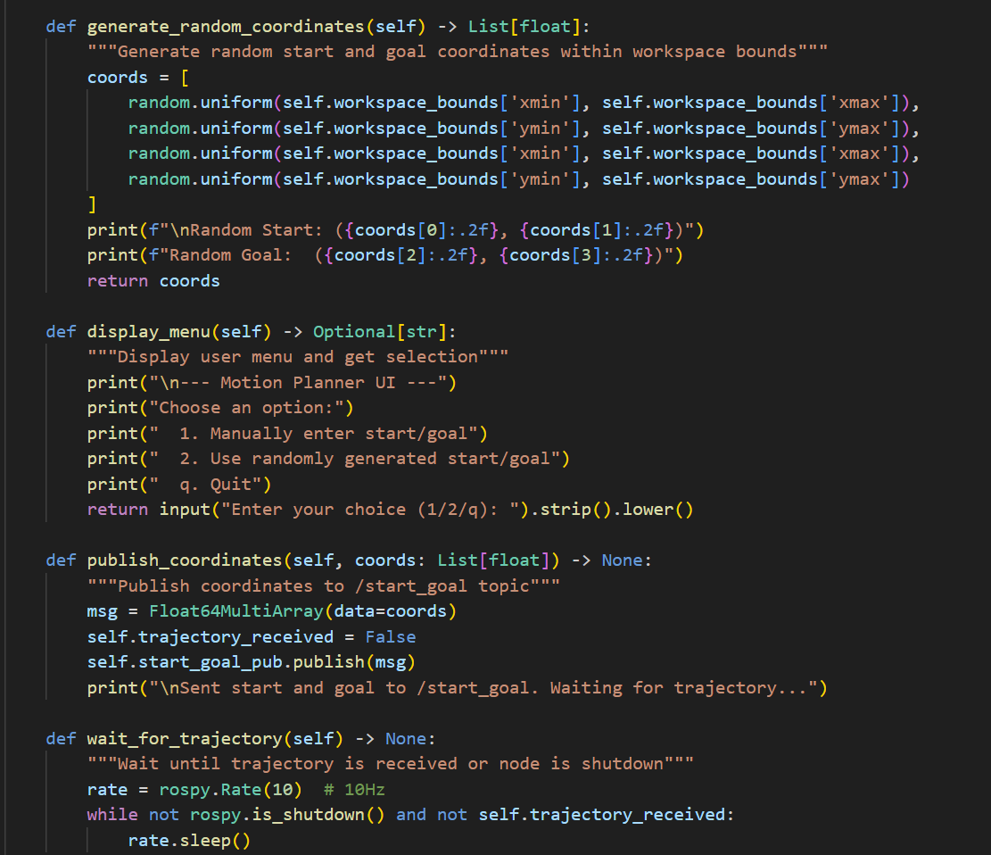

In my motion planner, similar to the rrt_node file, I initialized a motion_planner node and created a publisher sending start/goal coordinates and a subscriber to receive the trajectories ultimately, setting up the communication channels. Then there is workspace configurations where I defined the acceptable boundaries for coordinate generation.
The next function deals with trajectory handling where it will process incoming data and prints each point out within the configuration bounds. The first function deals with receiving user inputs for the start and end goal positions and it will also handle any errors that the user inputs that is not valid. The next function deals with the randomization option where the user could choose to randomize their start and end goal points instead of manually entering them. To tie this all up, there will be a menu interface for the user to select their option with ‘1’ being user generated coordinate points or ‘2’ being randomly generated points or ‘q’ to quit the program.
After receiving the coordinates, the program will take these coordinates into a ROS message and send them to the path planner where the ROS will have wait until the path data arrives. In the main execution loop, it will continuously display the menu and process user inputs until the program is shutdown.

