EECS 195 LAB 6: Navigation – Localization and Mapping

By: Vy Tang

ID: 77659006

Objective
The objective of this lab is to perform autonomous navigation and mapping using Hector SLAM in a simulated TurtleBot3 environment within Gazebo. The lab involves setting up the required ROS packages, launching the autonomous SLAM package, defining an exploration region using RVIZ, and enabling the robot to map its environment autonomously. The final goal is to generate and save an accurate 2D occupancy grid map of the environment, properly aligned for navigation tasks.

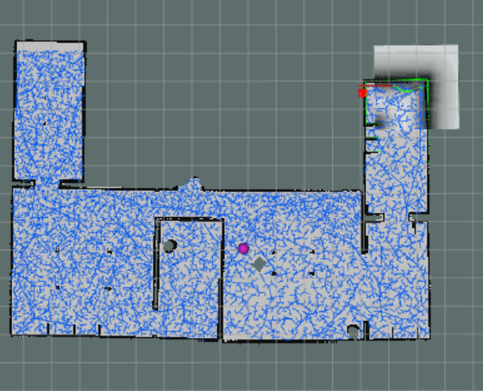
My_map.pgm

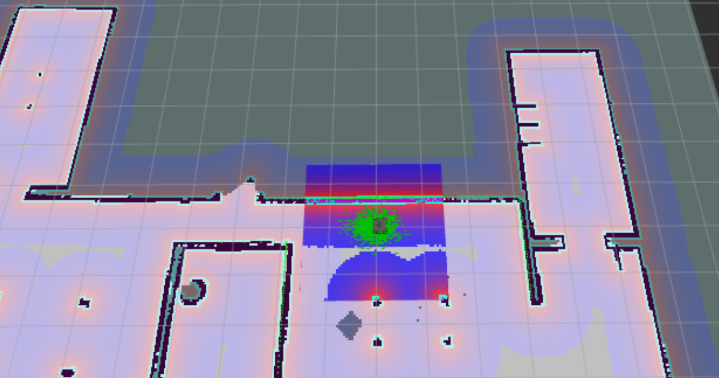
Aligned Mapping

Origin is set to: [-8.100000, -10.5000000, 0.000000]

