LAB 3: Motion Planning using ROS
By: Vy Tang
ID: 77659006

Objective
The objective of this lab report is to design and implement a PID controller to navigate the robot from an initial pose to the target poser from the user input. In the PID controller files, the PID gains were tuned to minimize errors and variations. The Gazebo software was used to simulate the differential drive robot to check the trajectory of the robot after user input.

Results
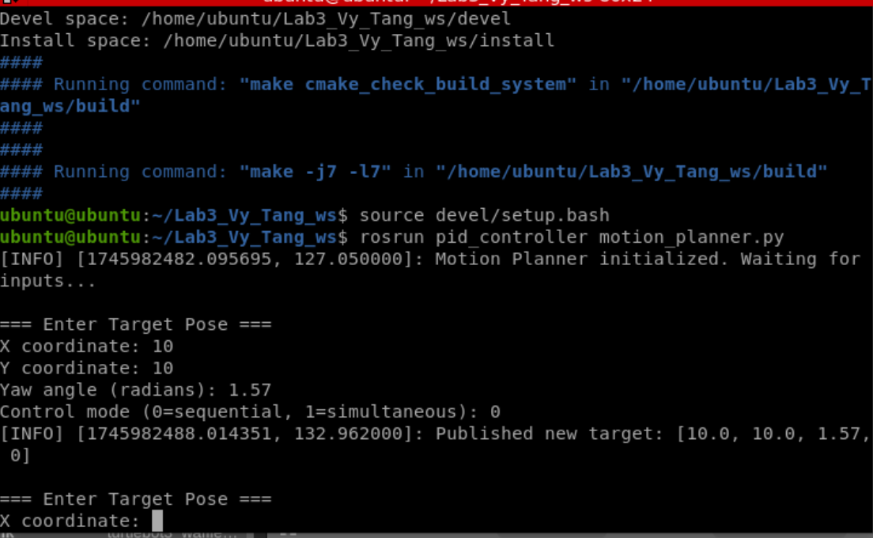
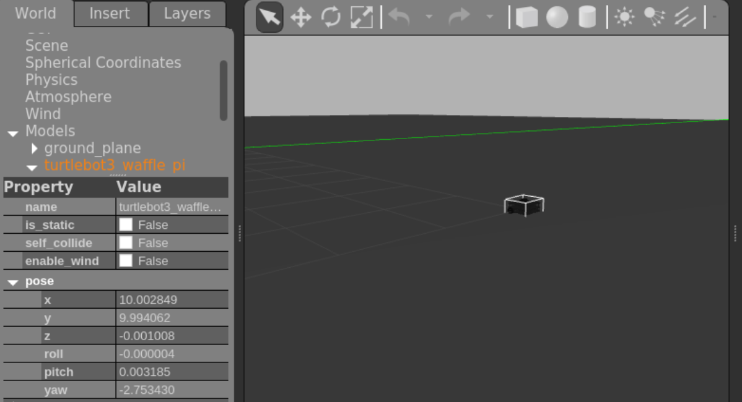

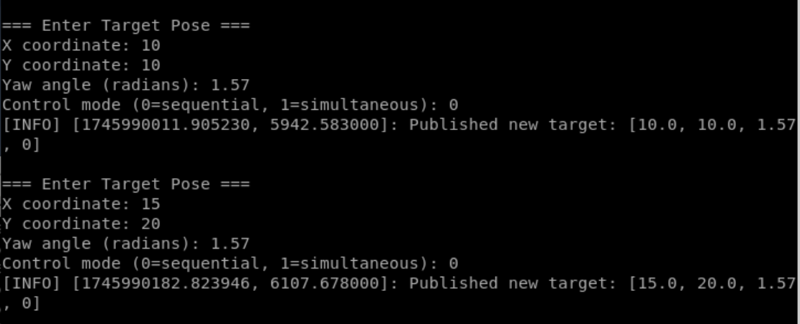
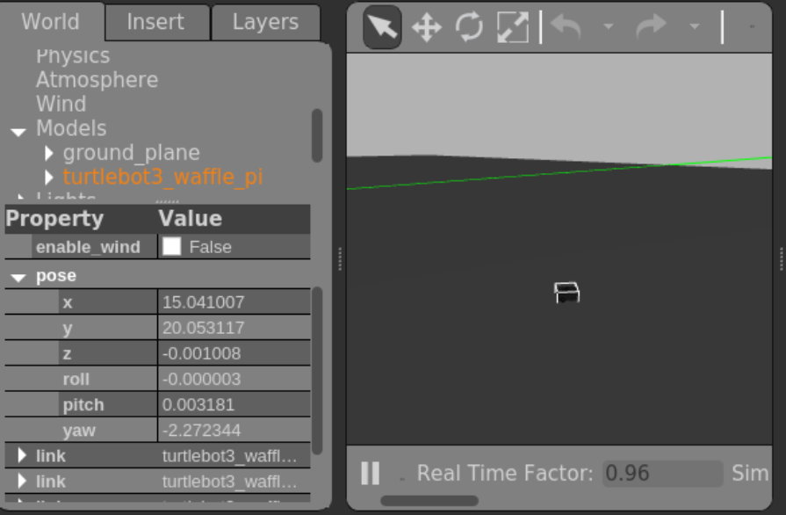

Fig 1. User input mode 0
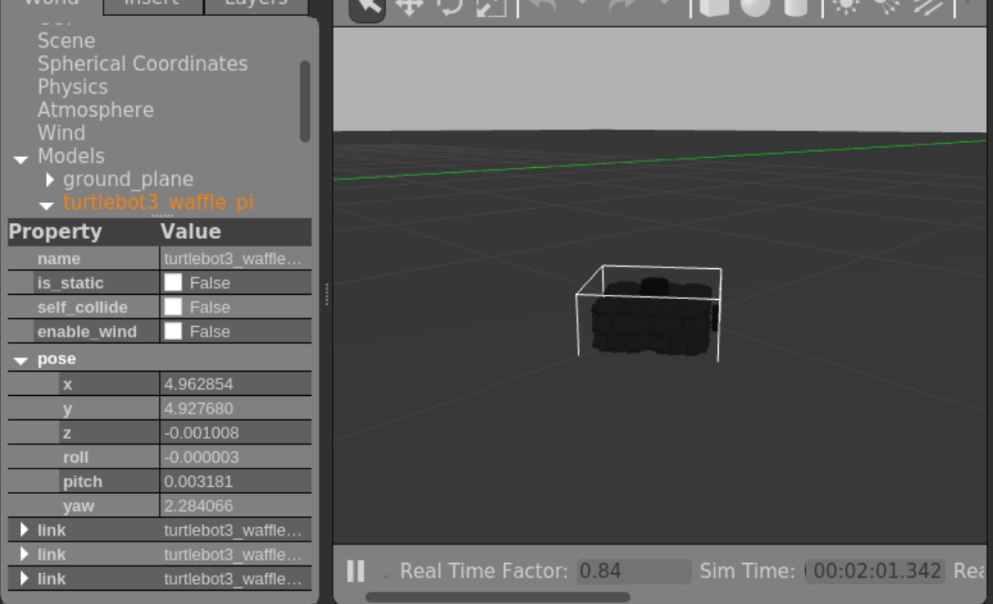
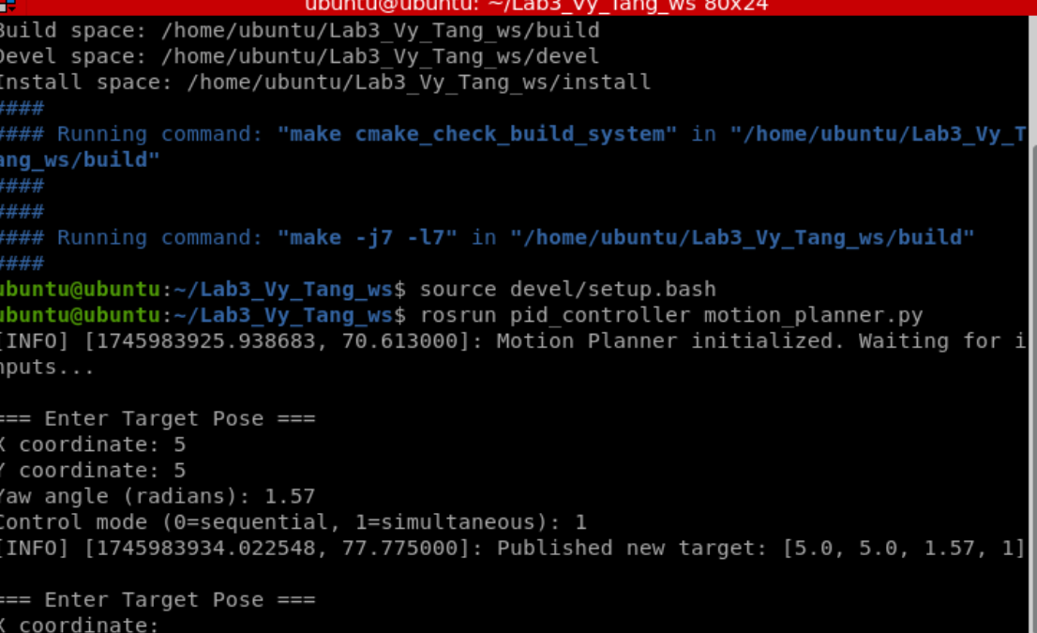

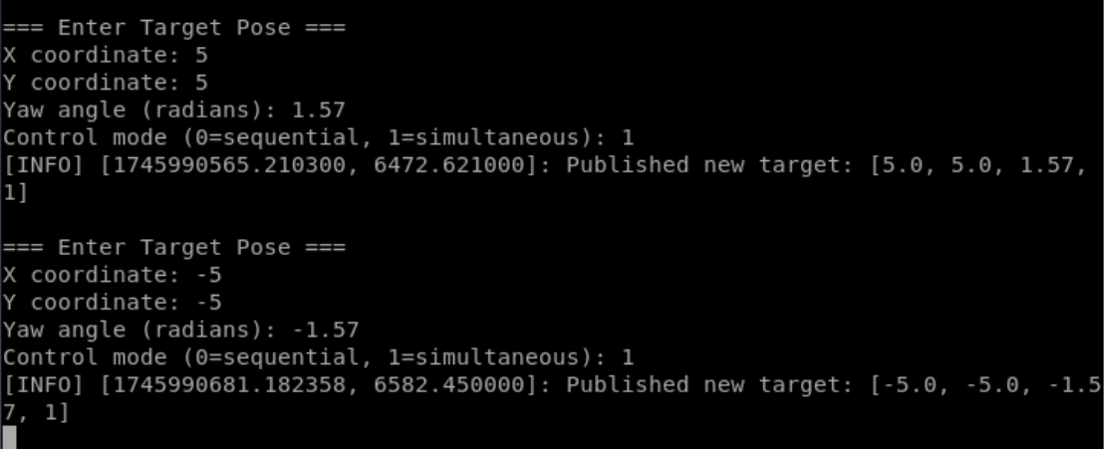
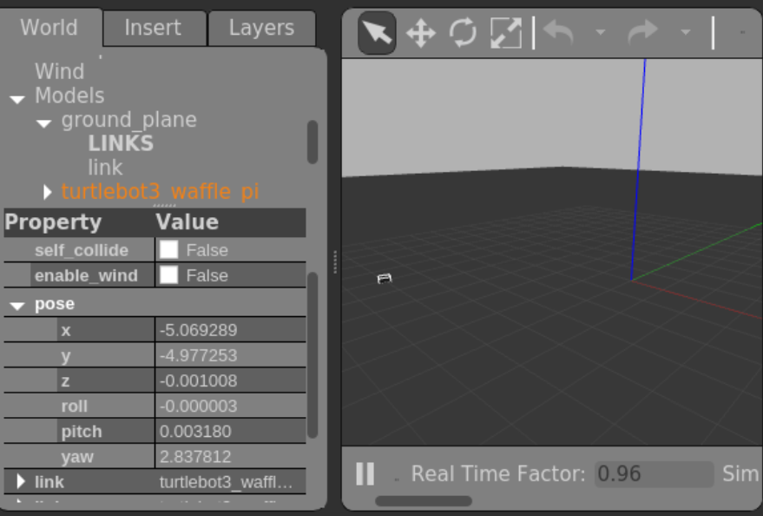

Fig 2. User input with mode 2

Code explanation
Pid_controller.py
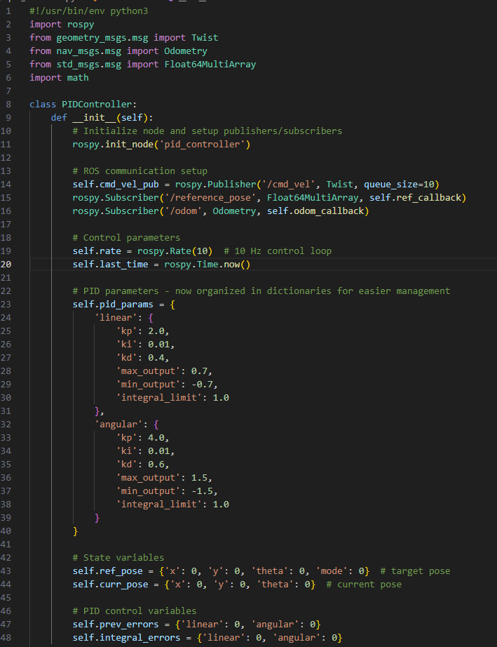

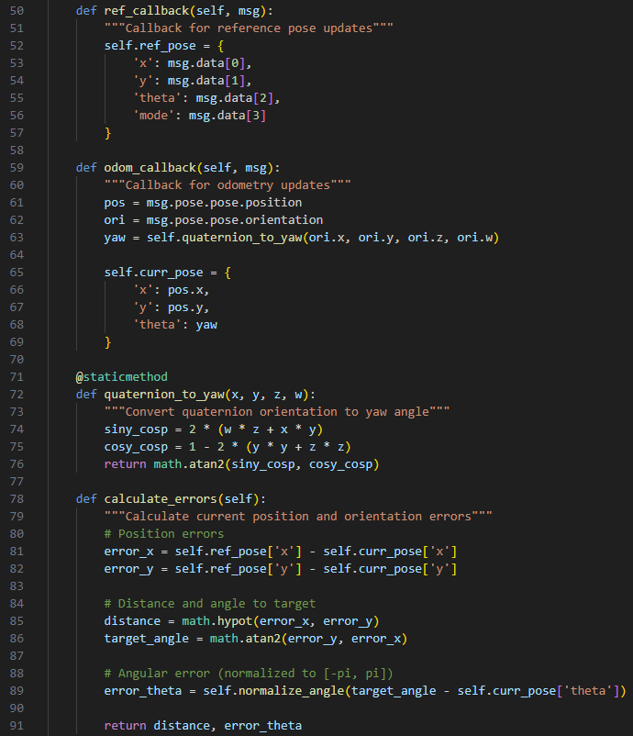
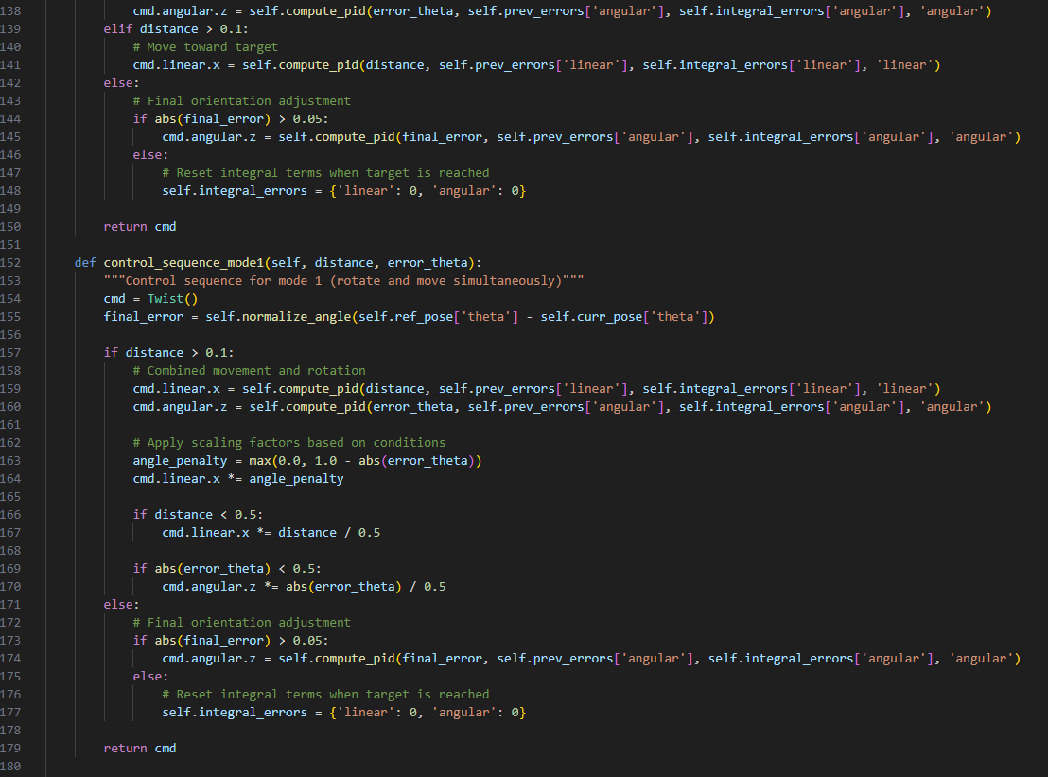
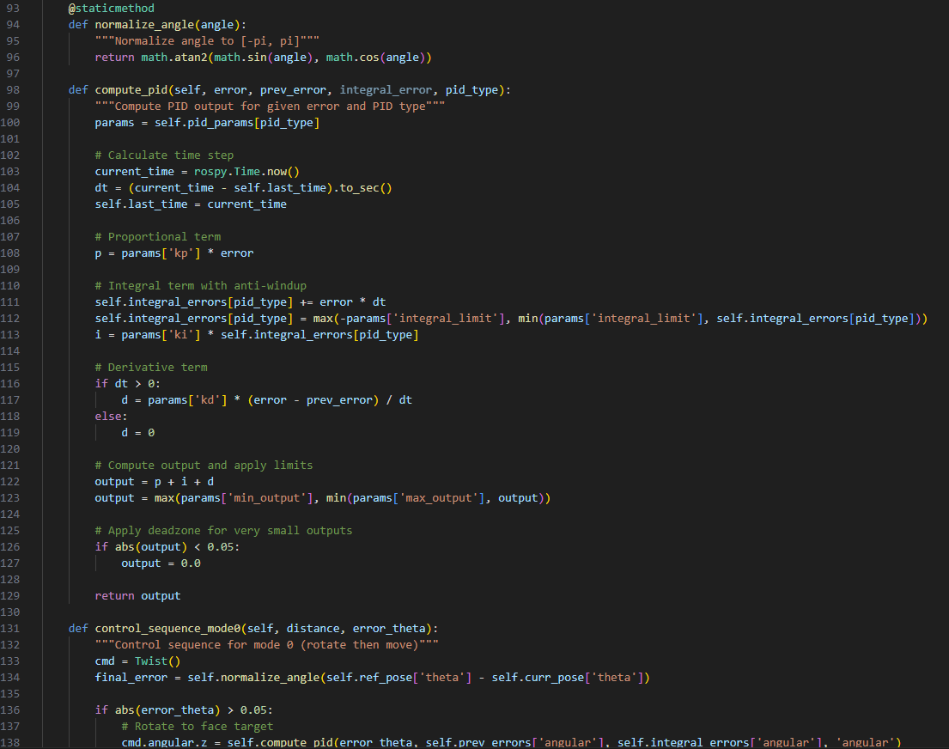

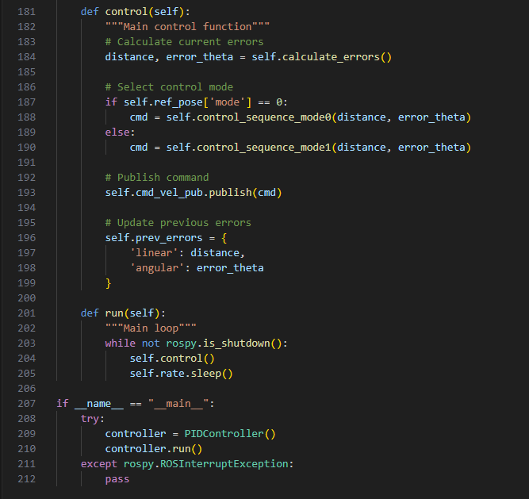

Firstly, we initialize the ROS node named pid_controller with velocity command publisher and subscribers i.e. reference_node and odometry. Then we will also initialize the PID gains for linear/angular control and initialize variables for target pose and current pose.
Then, there are the callback functions where the reference callback will update target pose, and the odometry callback will convert odometry quarternions (vector) into yaw and updates current pose. Next, I will compute the distance and angle errors to target using hypot() and atan2(). After that, I will normalize angular errors.
The next function is the PID mathematical logic under the compute_pid function. In this function, each term p, i, d is computed separately and then added together in the end using output variable. I also set a limit where if the output is not to a certain threshold of 0.05, the output will be automatically set to zero.
After this, there will be a function that controls the modes. The sequential mode, mode 0, will rotate the robot to face the target and will start moving towards that direction. It will then adjust orientation and repeat. For simultaneous mode (mode 1), the robot will move and turn at the same time.
The main loop will then execute all these functions where it will calculate errors, selects the control mode, and publishes the Twist command as well as provides updates and error history for the robot to fix its trajectory to its goal node.

Motion_planner.py
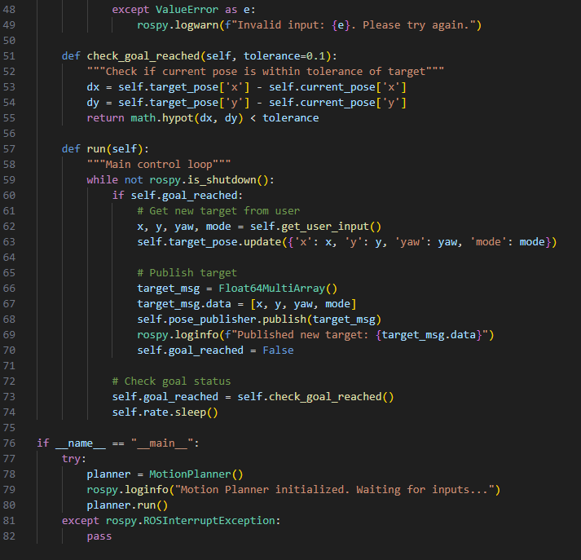
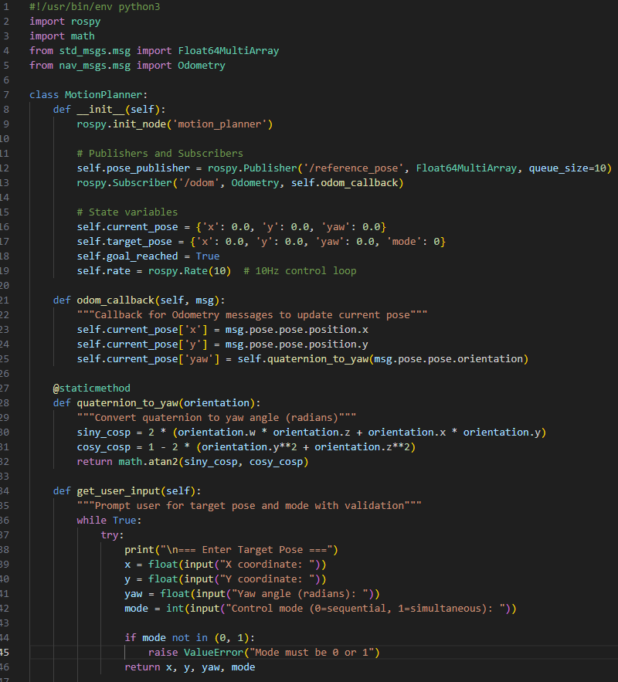

The first part is initializing the node motion_planner with a publisher for reference_pose and a subscriber to odometry. There also variables that track current and target poses and goal status.
Then, the odometry callback function will extract the (x,y) position and converts the robot’s orientation to yaw using quarternion math. Then, there will be a function that prompts the user to get (x, y) coordinates, yaw angle, and control mode.
After getting the user input, it will check if the robot have reached that goal using the Euclidean distance to target and returns true if the robot is within 0.1 units away from the user input target. When the goal is finally reached, the program will prompt another user input and the whole program will be reran again.

