Project 4: 4-bit synchronous binary up/down counter
Vy Tang
3/8/26

Introduction
The objective of this report is to design a 4-bit synchronous up/down counter and verify it using transient response simulations. To implement this counter, I needed to build several building blocks by creating a schematic capture and layout design of a 3-input NAND gate, 2-input NAND gate, and an inverter to build my Master-Slave J-K Flip Flop. To verify the layout design, I ran a DRC and LVS to check the layout design and extracted its capacitance to compare the performance of the ideal J-K Flip-Flop and a parasitic one. After building the flip-flop, I made an AND and XOR gates by simply inverting my XNOR and NAND gates to build the 4-bit synchronous up/down counter.

Theory
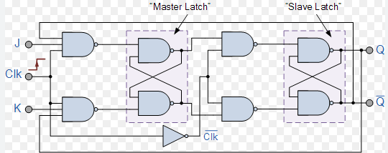
To design the 4-bit counter, I first needed to make a J-K Flip Flop. In this J-K Flip Flop the design incorporates a master latch and a slave latch. The master latch receives inputs J and K and is active when the clock is high. In this state, it captures and stores input conditions. Here, the slave flip-flop receives the inverse clock, so it stays inactive when the clock for the master flip-flop is high. When the clock turns low, the master stops accepting inputs and the slave latch becomes active and copies the master’s stored state to the output.

Fig 1. J-K Flip-Flop circuit diagram
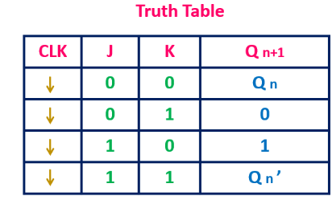
Because of this behavior, we can observe from the truth table below that the state only changes on the falling edge of the clock. When the inputs are both set to ‘0’ and the clock is high, the output state doesn’t change. However, if both inputs are set to ‘1’ while the clock is high, the flip-flop will toggle to the next state.
Fig 2. J-K Flip-Flop truth table

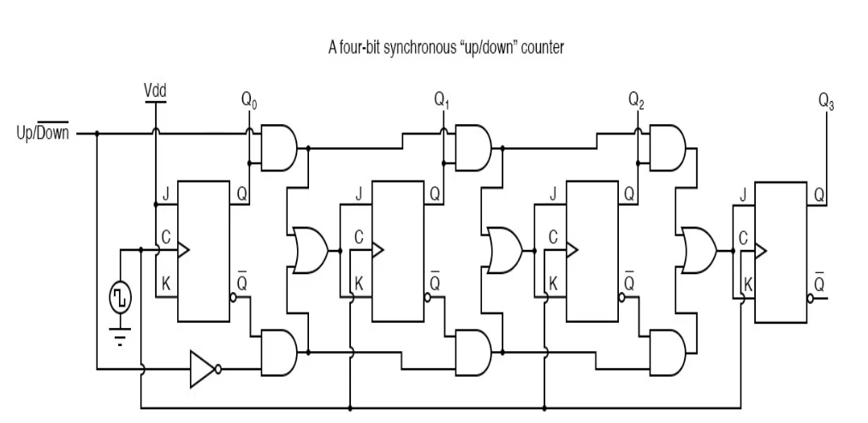
Now that I have a flip-flop, I can now construct a four-bit synchronous up/down counter as shown below.
Fig 3. 4-bit synchronous counter
To construct the 4-bit synchronous counter, we cascade four J-K Flip Flops in series and for the first flip-flop stage, we tie the V_{DD} to J and K inputs so that the Flip-Flop would toggle every clock cycle, creating the least significant bit of the counter. In the circuit, the control mode ‘M’ determines whether the flip flop is counting up or down with ‘1’ corresponding to counting up and ‘0’ to counting down. In this design, the flip flop shares the same clock therefore all the bits will update on the falling edge of the clock, making it synchronous.

Design and Layout

3 Input NAND gate
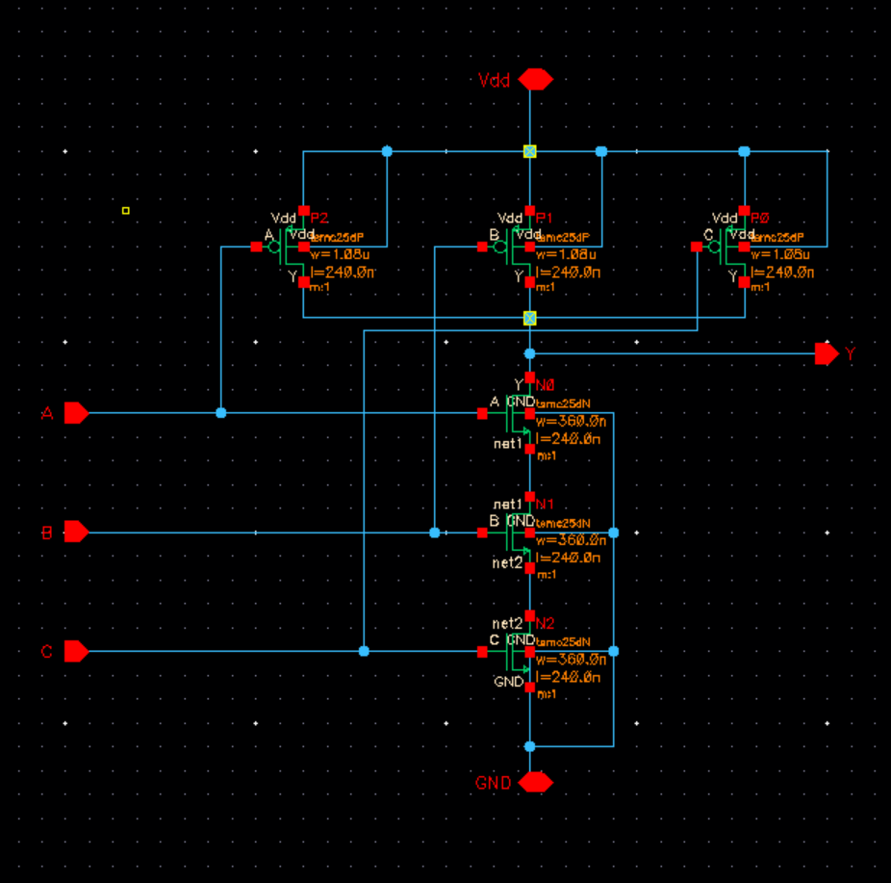
Schematic

Fig 4. 3-input NAND gate schematic
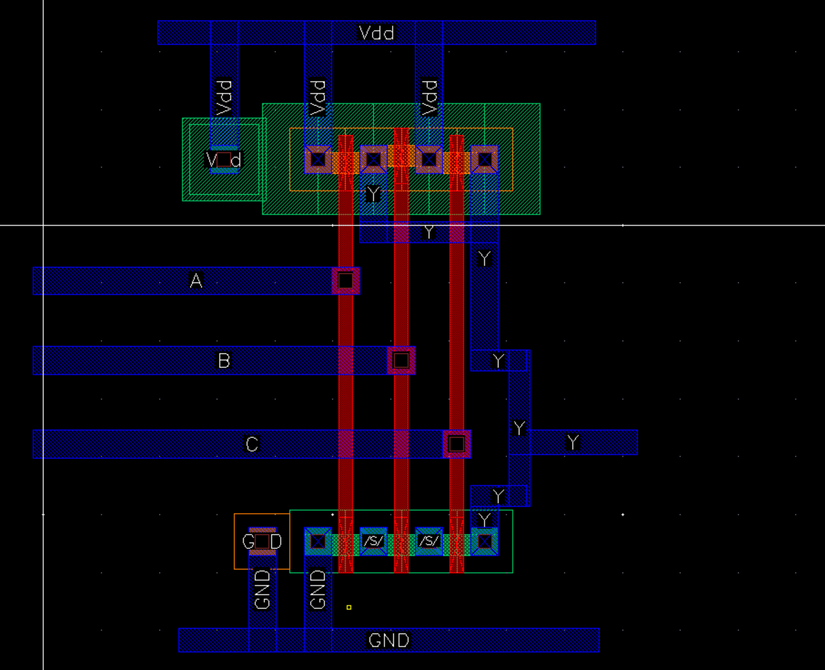
Layout

Fig 5. 3 input NAND gate layout

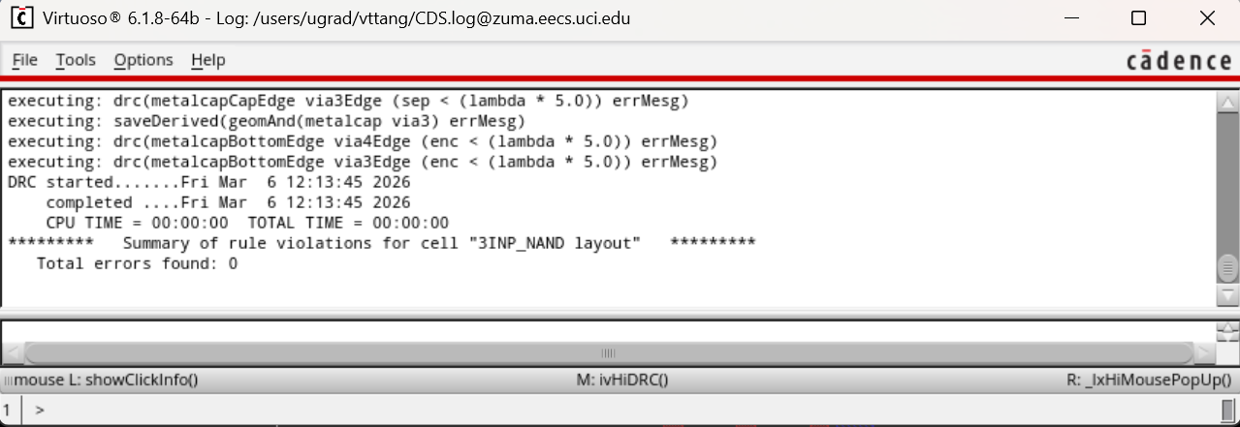
DRC

Fig 6. 3 input NAND gate DRC
LVS
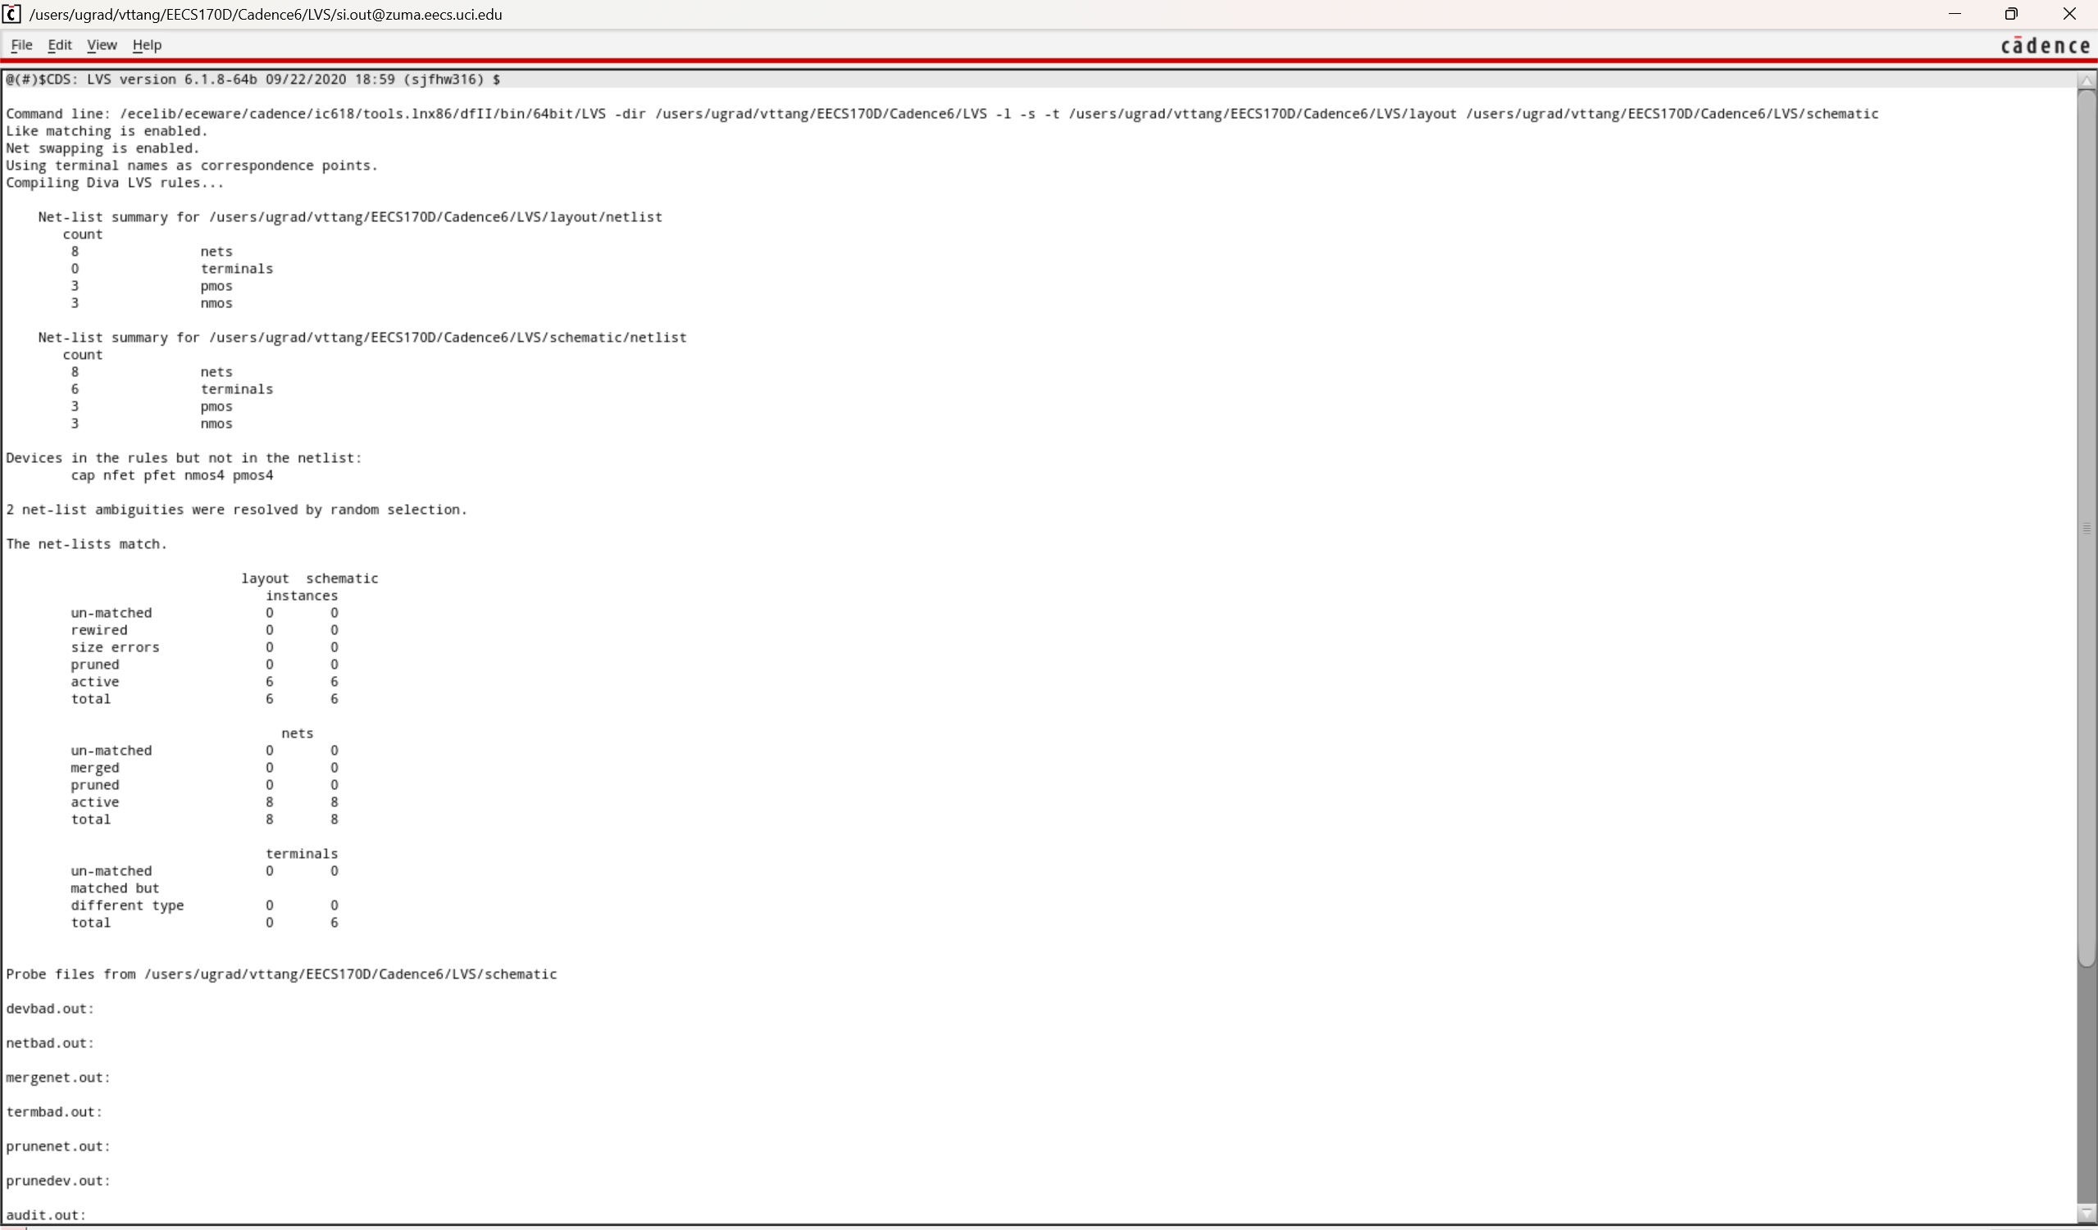
Fig 7. 3 input NAND gate LVS check

JK-Flip Flop
Schematic
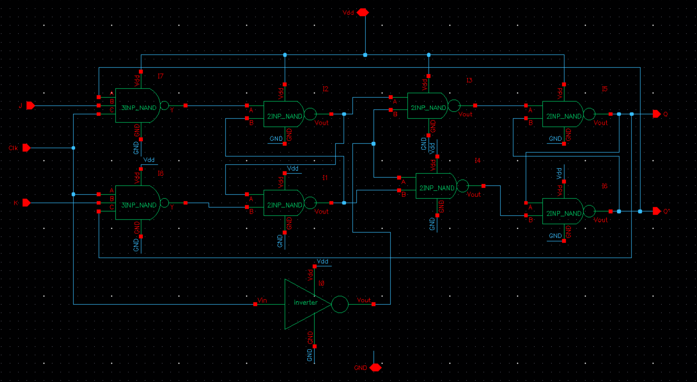
Fig 8. JK-Flip-Flop schematic

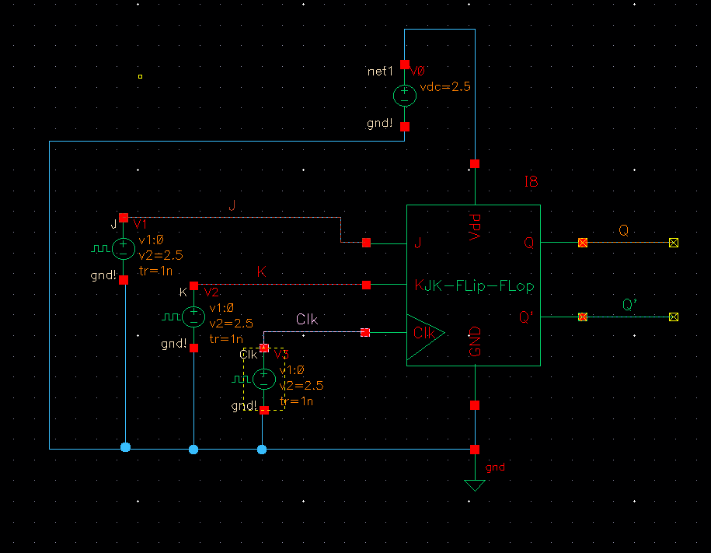
J-K Flip-Flop Testbench

Fig 9. JK-Flip-Flop testbench schematic
Waveform
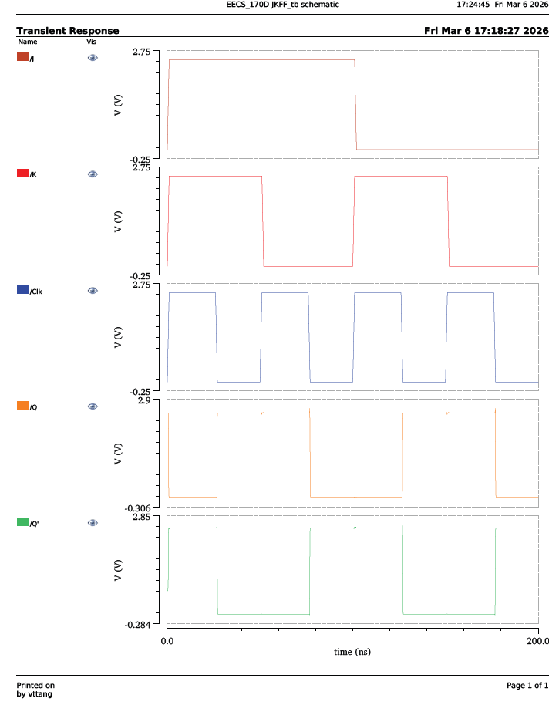
Fig 10. J-K-Flip-Flop output waveform
As can be seen here in the waveform, the J-K Flip Flop behavior matches the truth table. When J and K are high, at the falling edge of the clock, Q state and Q’ updates.
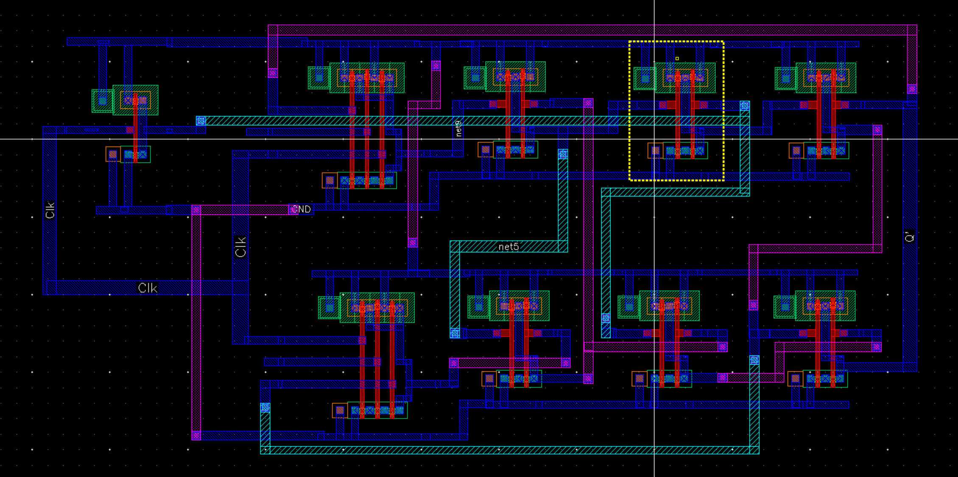
Layout

Fig 11. JK-Flip-Flop layout
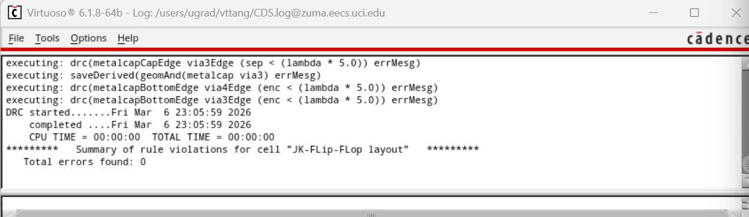
DRC

Fig 12. JK-Flip-Flop DRC
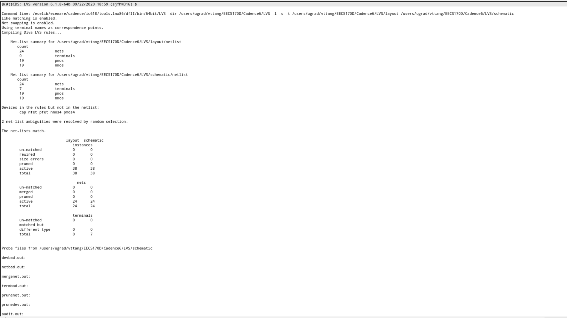
LVS
Fig 13. JK-Flip-Flop LVS check
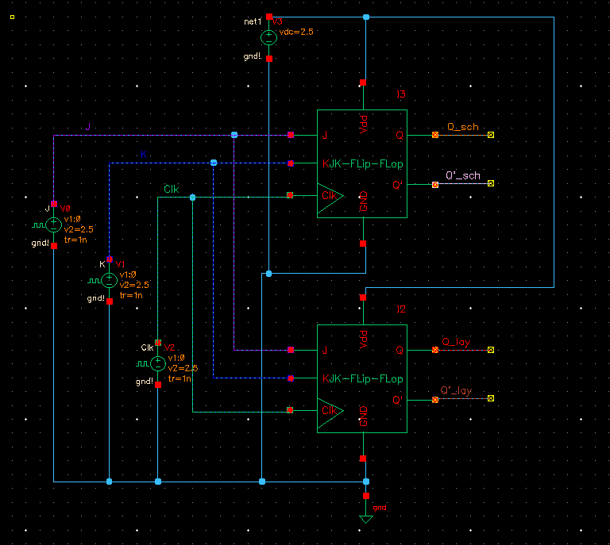
Fig 14. JK-Flip-Flop schematic vs layout testbench

In this schematic I₀ Flip-Flop is ideal and I₈ is the one with parasitic capacitance.
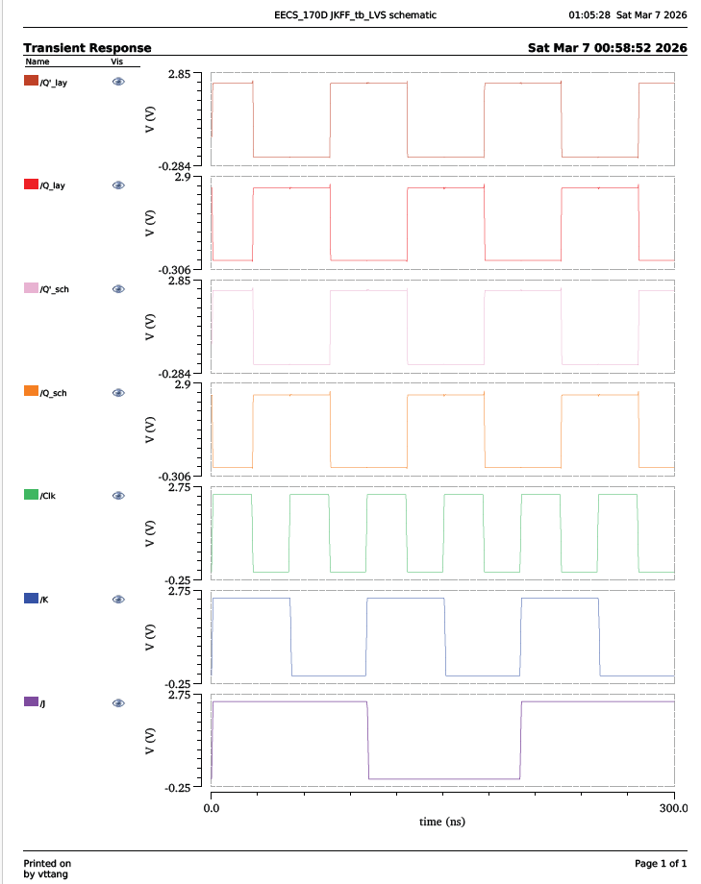
Fig 15. JK-Flip-Flop schematic vs layout waveform
Fig 14. JK-Flip-Flop schematic testbench
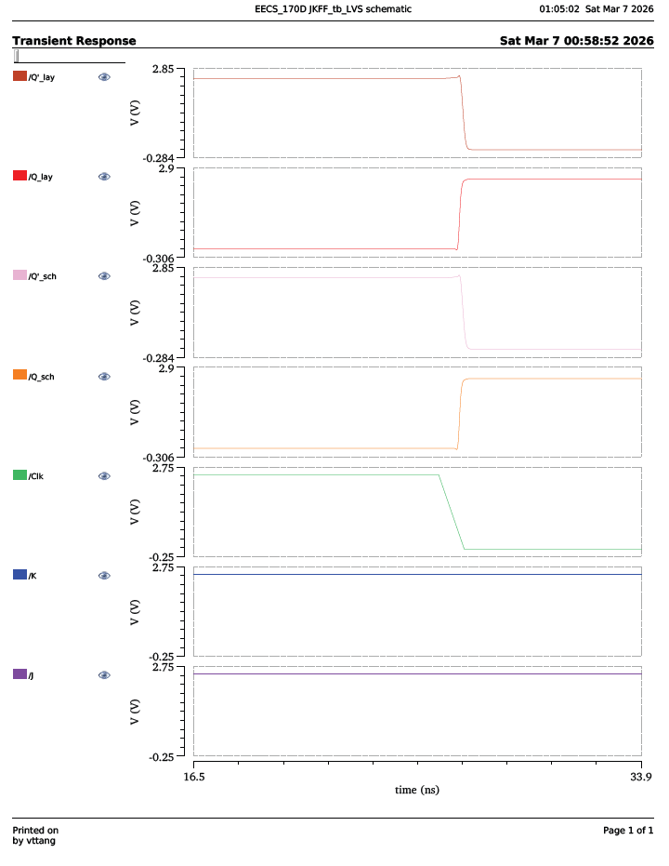
Fig 16. JK-Flip-Flop schematic vs layout waveform closeup

As seen in figure 16, the layout and the schematic transient responses at the output node are quite similar. However, if zoomed in, we can see that there is a slight delay in the rise and fall time between the ideal CMOS logic gate and the parasitic one. The reason for this delay is because with parasitic capacitance, it often takes longer to charge and discharge, thus contributing to the delay in the rise and fall time of the output node voltage.

4-bit sync up-down counter

XOR gate
XOR schematic
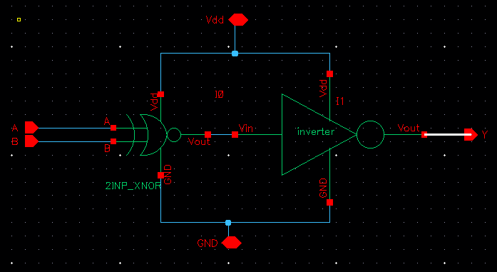
Fig 17. XOR gate schematic

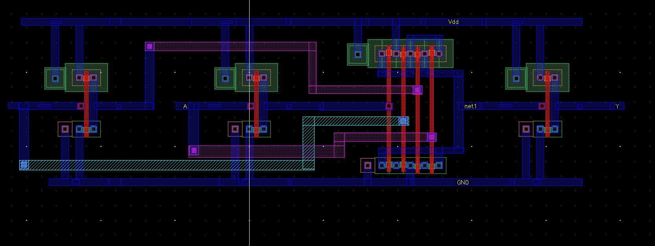
Layout

Fig 18. XOR gate layout
DRC
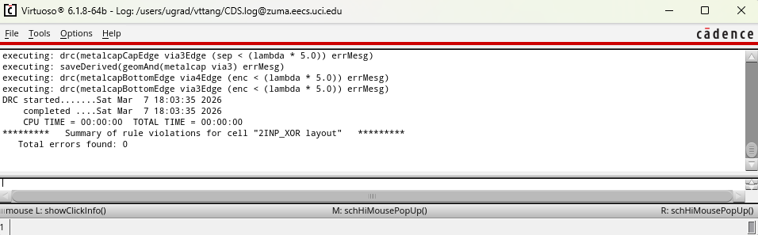
Fig 19. XOR DRC

LVS
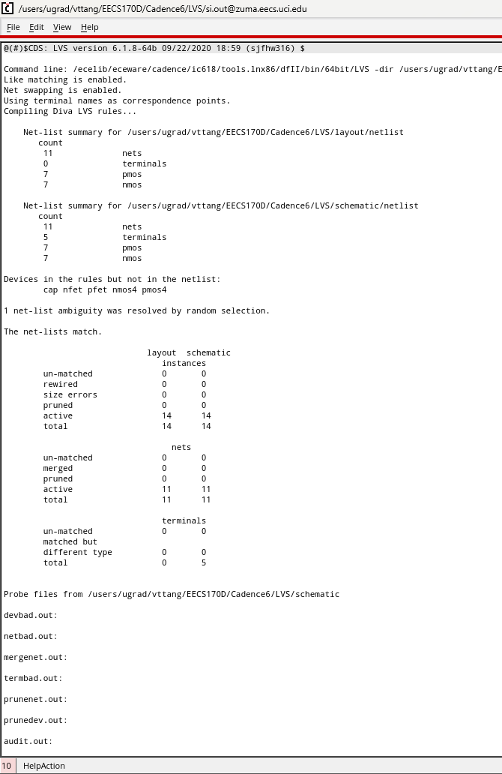
Fig 20. XOR LVS check

AND gate
Schematic
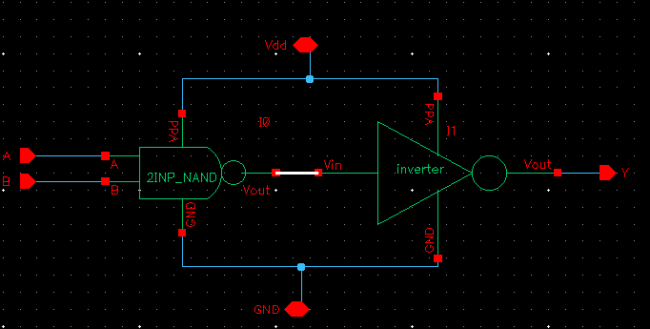
Fig 21. AND gate schematic
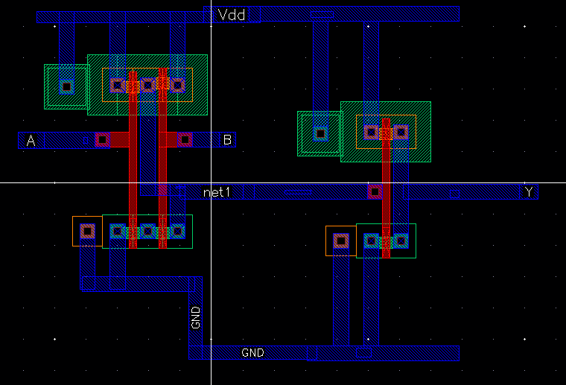
Layout

Fig 22. AND gate layout
DRC


Fig 23. AND gate DRC

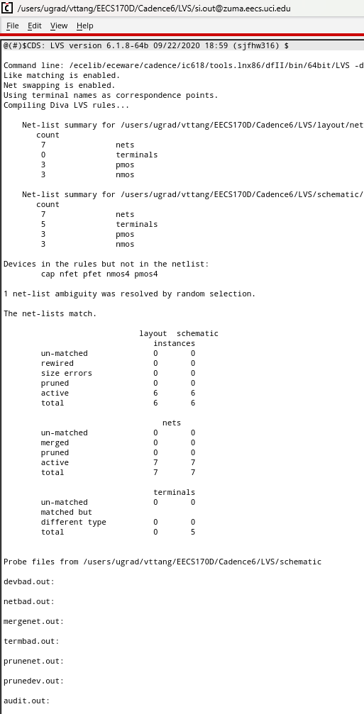
LVS

Fig 24. AND gate LVS check
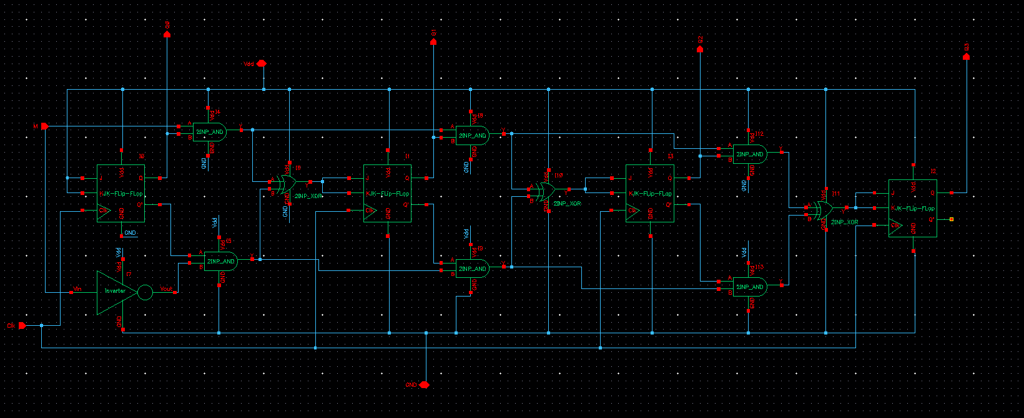
4-bit up/down counter schematic

Fig 25. 4-bit synchronous counter schematic
Layout
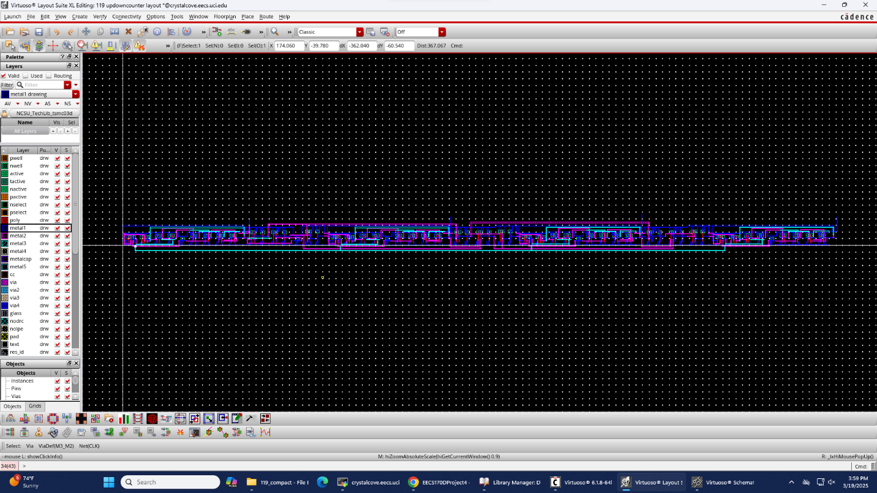

Testbench
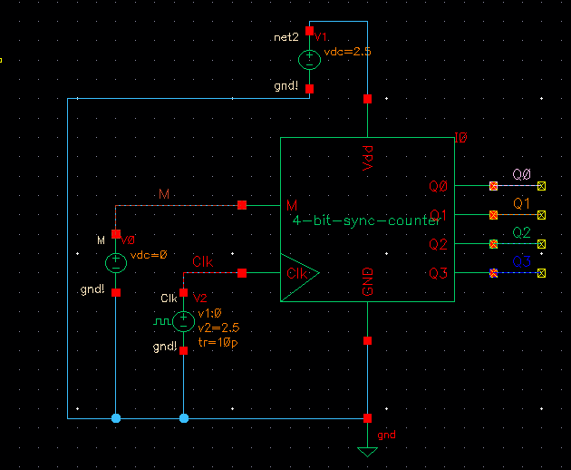
Fig 26. 4-bit synchronous counter testbench schematic
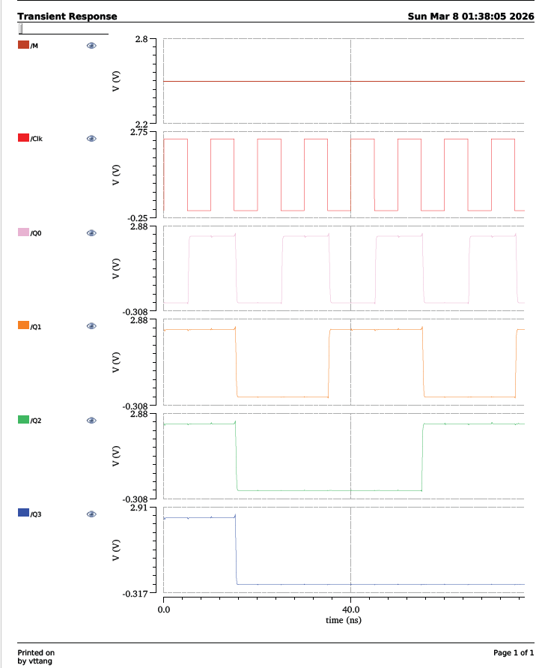
Fig 27. Counting up waveform

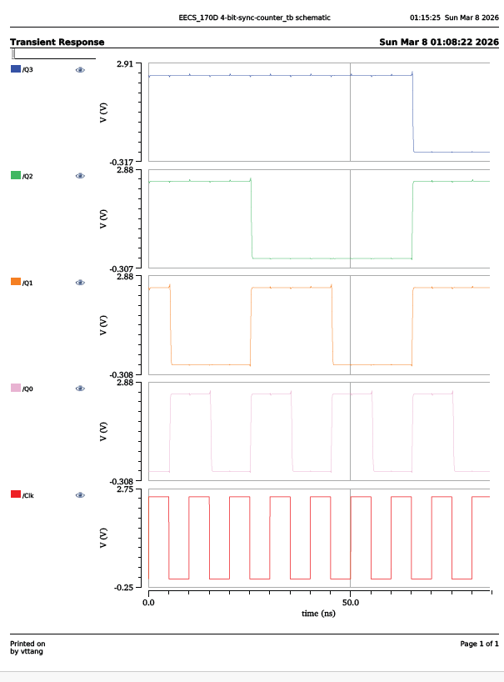
Fig 28. Counting down waveform
In the counting up waveform in figure 27, as I set the Vdc to 2.5V to make the counter count up, we can see that the counter does count up by one. In the initial state, it is at ‘1110’ and at the falling edge of the clock, the counter increases to ‘1111’ and we see that at each falling edge, the counter increases by 1,
On the other hand, in the counting down waveform in figure 28, the counter was able to countdown properly as expected. In the initial state, the counter is at “1110” and at the falling edge of the clock, the counter decreases by 1 and it transitions from “1111” to “1101”.

Conclusion
In conclusion, I was able to implement a 4-bit synchronous counter using building blocks like 3-input NAND gate, 2-input NAND gate and inverter to create a Master-Slave J-K Flip Flop. During the process, I also created the layout, ran DRC and LVS checks, and was able to verify its operation using transient response. I also extracted the parasitic capacitance and was able to plot the waveform between an ideal Flip-Flop and one with parasitic capacitance. After creating the J-K Flip-Flop, I was able to create a 4-bit synchronous up/down counter in the schematic and verify its properties by outputting waveforms that counts up and down.

Bibliography
- Admin. (2022, July 20). JK flip-flop explained: Race around condition in JK flip-flop: JK Flip-flop truth table, excitation table and timing diagram. ALL ABOUT ELECTRONICS. https://www.allaboutelectronics.org/jk-flip-flop-explained-race-around-condition-in-jk-flip-flop-jk-flip-flop-truth-table-excitation-table-and-timing-diagram/
- Storr, W. (2022, August 3). JK Flip Flop and the master-slave JK flip flop tutorial. Basic Electronics Tutorials. https://www.electronics-tutorials.ws/sequential/seq_2.html
- Synchronous counters | Sequential Circuits | Electronics textbook. Synchronous Counters. (n.d.). https://www.allaboutcircuits.com/textbook/digital/chpt-11/synchronous-counters /
- EECS 170D lecture slides

