**ESP32 MODULE**

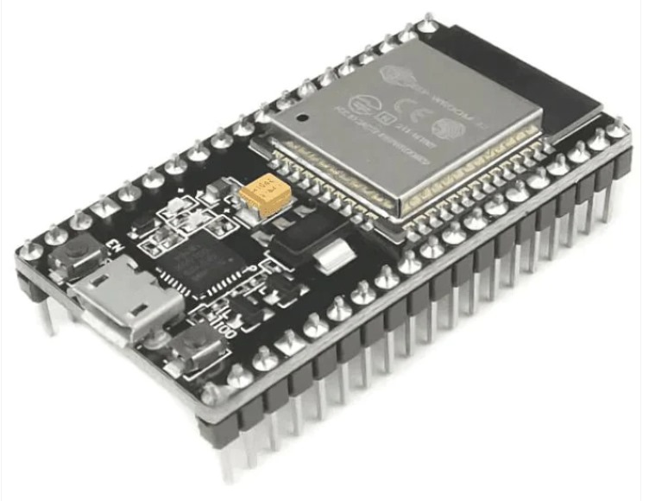

The ESP32 Development Module is a popular, low-cost, low-power system-on a-chip (SoC) series created by Espressif Systems. It’s primarily used for Wi-Fi and Bluetooth-enabled Internet of Things (IoT) applications. The ESP32 is an upgrade over its predecessor, the ESP8266, offering a more powerful CPU, better Wi-Fi, and Bluetooth capabilities, more GPIOs, and other enhanced features.

**SPECIFICATIONS:**

Processor: Tensilica LX6 Dual-Core

Wi-Fi: 802.11 b/g/n standards.

Flash Memory: 4 MB

SRAM: 512 KB

Clock Speed: 240 MHz

**MQ-02 GAS SENSOR**

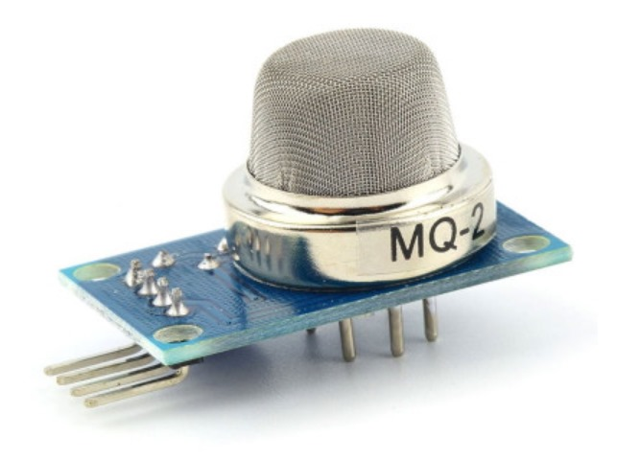

MQ2 gas sensor is an electronic sensor used for sensing the concentration of gases in the air.MQ2 gas sensor is also known as chemiresistor. It contains a sensing material whose resistance changes when it comes in contact with the gas. This change in the value of resistance is used for the detection of gas.

**SPECIFICATIONS:**

Operating Voltage: Commonly around 5V.

Input Voltage is 5V DC

Range:200 to 1000ppm

Heating Power: 800mW to 1W.

**BUZZER**

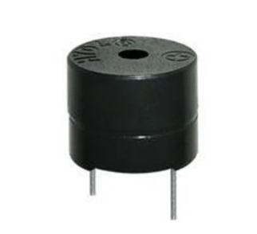

A Buzzer is a simple audio signaling device that can be used in a wide range of applications. Buzzers are commonly found in alarm devices, timers, confirmation of user input (like in keypads), and other electronic devices where generating sound is required.

**SPECIFICATIONS:**

Operation Voltage: 3-24V DC.

Current: ¡ 15mA.

Frequency: 2 kHz to 4 kHz

**LED**

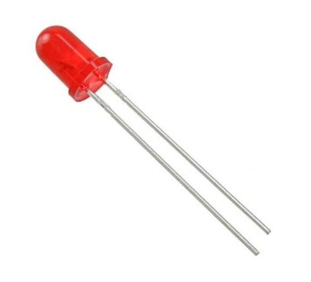

A Light Emitting Diode (LED) is a semiconductor light source that emits light when current flows through it. LEDs are used extensively in a wide range of applications due to their efficiency, long life, and the diverse array of colors they can produce.  
**SPECIFICATIONS:**  
Voltage : 5V or 3.3V.

Maximum current : 50 mA.

Vin pin : 7-20V.