


Vel Tech Rangarajan Dr. Sagunthala R&D Institute of Science and Technology
(Deemed to be University Estd. u/s 3 of UGC Act, 1956)

WEEKLY LESSON PLAN

Department: Computer Science and Engineering
Year / Semester: 2025-26 / Winter
Course Code / Course Name: 10213CS224 / Full Stack Application Development

Unit I: Database Management and Web Development basics
Course Outcome: • Understand and use database queries and web technologies to build interactive applications.

Week | Session | Topics to be Covered | Problems to Practice (Hands-On) | Resources
Week 1 | Session 1 | Git | - Practice basic Git Commands  - Upload single document to github using bash.  - Upload and update a folder in github.  - Create branch and push/commit one folder in Eclipse.  - Create branch and push/commit one folder in VS Code. | https://youtu.be/vA5TTz6BXhY
 | Session 2 | SQL | Install SQL tool, MySQL and VS Code.  1. Create a database.  2. Create at least two tables:  * Student (VTU Number, Name, Email, Phone, Department)  * Course (Course Code, Course Name, Faculty Id, Student ID, Faculty Email)  3. Insert minimum 5 records into each table.  4. Select records using different CLAUSE. | https://www.programiz.com/sql/online-compiler  https://www.w3schools.com
 | Session 3 | SQL | 1. Write SELECT queries to display all records.  2. Write queries using aggregate functions.  3. Sort data and display based in ascending/descending order of the VTU number.  4. Display student records belonging to a particular department.  5. Map VTU no. with course name and faculty using joins. | https://www.w3schools.com/
 | Session 4 | SQL | - Select set of students based on course and count the number of students.  - Select set of courses a faculty is handling and insert into the new table.  - Select top 5 students from same department and update their phone no. with country code. | https://youtu.be/EQbhKjBmW88
 | Session 5 | SQL | - Initiate and commit a transaction.  - Set a savepoint, perform transactions and rollback to the save point.  - Create a user-defined function to perform simple mathematical calculations.  - Create a user-defined function to execute a select query to return a value. | https://www.w3schools.com/mysql/default.asp

Session 1:

Prerequisites
- Install Git for Windows: https://git-scm.com/download/win
- Install VS Code: https://code.visualstudio.com/
- Restart VS Code after installing Git
Part 1: First Time Setup
Open VS Code and Configure Git
- Open VS Code Terminal
  - Press Ctrl+` (backtick key, usually above Tab)
  - Or: View → Terminal
- Configure Git (one-time setup)
bash
git config --global user.name "VTU#####"
git config --global user.email "your.email@example.com"

# Verify
git config --list

Part 2: Create Your First Git Project
Method 1: Using VS Code UI (Beginner Friendly)
Step 1: Create Project Folder
- File → Open Folder
- Navigate to: C:\Users\YourName\Documents
- Click "New Folder" button
- Name it: my-first-git-project
- Click "Select Folder"
Step 2: Initialize Git
- Click Source Control icon (left sidebar) - looks like branches
  - Or press Ctrl+Shift+G
- Click "Initialize Repository" button
- Done! You now have a Git repository
Step 3: Create a File
- Click Explorer icon (top of left sidebar)
- Click "New File" icon
- Name it: README.md
- Add content:
markdown
# My First Git Project

This is my first project using Git and VS Code!
- Save: Ctrl+S
Step 4: Commit Your First File
- Go to Source Control (Ctrl+Shift+G)
- You'll see README.md under "Changes"
- Hover over the file and click "+" (Stage Changes)
- File moves to "Staged Changes"
- In the message box at top, type: Initial commit
- Click ✓ checkmark or press Ctrl+Enter
- First commit done!
Step 5: Create a Branch
- Look at bottom-left corner of VS Code
- You'll see a branch icon with "main" (or "master")
- Click on it
- Select: "Create new branch..."
- Type: feature/my-new-feature
- Press Enter
- You're now on the new branch!
Step 6: Add More Files to Your Branch
- Create a new folder: Right-click in Explorer → New Folder → src
- Inside src, create: app.js
- Add code:
javascript
console.log("Hello from my branch!");
- Save the file
Step 7: Commit Changes on Branch
- Go to Source Control (Ctrl+Shift+G)
- Stage the new files (click "+" on each, or "+" on "Changes" to stage all)
- Commit message: Add src folder with app.js
- Click ✓ checkmark

Part 3: Connect to GitHub and Push
Create GitHub Repository
- Go to: https://github.com
- Click "+" (top-right) → New repository
- Name: my-first-git-project
- Do NOT check "Initialize with README"
- Click "Create repository"
Connect VS Code to GitHub
Using VS Code UI:
- In Source Control panel, click "..." (three dots menu)
- Select: "Remote" → "Add Remote"
- Paste your GitHub URL:
https://github.com/yourusername/my-first-git-project.git
- Name it: origin
- Press Enter
Or using Terminal:
bash
git remote add origin https://github.com/yourusername/my-first-git-project.git
Push to GitHub
Using VS Code UI:
- Click "..." menu in Source Control
- Select: "Push"
- If asked to publish branch, click "OK"
- VS Code may ask for GitHub authentication - follow the prompts
Or using Terminal:
bash
# Push main branch
git push -u origin main

# Push feature branch
git checkout feature/my-new-feature
git push -u origin feature/my-new-feature

Part 4: Daily Git Workflow in VS Code
Working on Your Project
1. Open VS Code
2. Open your project folder
3. Check current branch (bottom-left corner)
4. Make changes to files
5. Go to Source Control (Ctrl+Shift+G)
6. Stage changes (click +)
7. Write commit message
8. Commit (click ✓)
9. Push (click ... → Push)
Switch Between Branches
- Click branch name (bottom-left)
- Select branch from list
- Or create new branch
Useful Keyboard Shortcuts
Action | Shortcut
Open Terminal | Ctrl+`
Source Control | Ctrl+Shift+G
Save File | Ctrl+S
Save All | Ctrl+K S
Command Palette | Ctrl+Shift+P
Find | Ctrl+F
New File | Ctrl+N

Part 5: Common Tasks in VS Code
See What Changed
Visual Diff:
- In Source Control, click on any changed file
- VS Code shows side-by-side comparison
- Red = removed, Green = added
Undo Changes
Before Committing:
- Right-click file in Source Control
- Select "Discard Changes"
After Committing:
- Use terminal: git reset --soft HEAD~1
View Commit History
Install GitLens Extension (Recommended):
- Click Extensions icon (left sidebar)
- Search: "GitLens"
- Click "Install"
- Now you can see commit history, blame, and more!
Without Extension:
- Terminal: git log --oneline

Part 6: Real Example - Complete Workflow
Scenario: Add a New Feature
bash
# In VS Code Terminal (Ctrl+`)

# 1. Make sure you're on main branch
git checkout main

# 2. Pull latest changes
git pull origin main

# 3. Create feature branch
git checkout -b feature/add-login-page

# Now in VS Code:
# 4. Create new files:
# - src/login.html
# - src/login.css
# - src/login.js

# 5. Go to Source Control (Ctrl+Shift+G)
# 6. Stage all files (click + on "Changes")
# 7. Commit message: "Add login page with styling and validation"
# 8. Click ✓ to commit

# 9. Push to GitHub
git push -u origin feature/add-login-page

# 10. Go to GitHub and create Pull Request

Session 2:
Install SQL tool, MySQL and VS Code.
- Create a database.
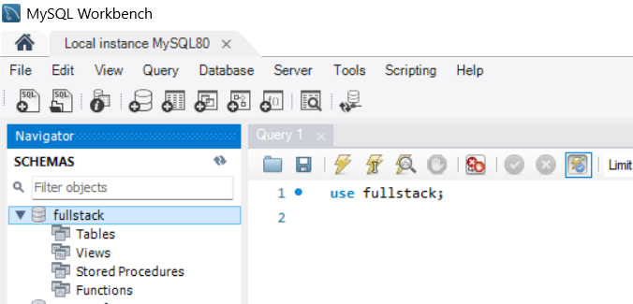
CREATE DATABASE fullstack;
USE fullstack;

2. Create at least two tables:
Table 1: Student (VTU Number, Name, Email, Phone, Department)
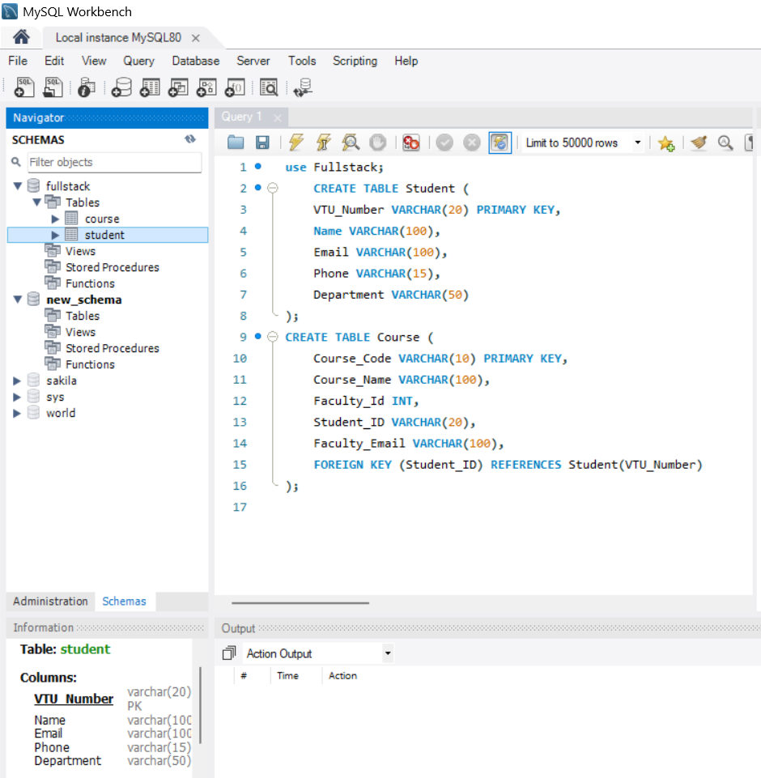

CREATE TABLE Student (
VTU_Number VARCHAR(20) PRIMARY KEY,
Name VARCHAR(100),
Email VARCHAR(100),
Phone VARCHAR(15),
Department VARCHAR(50)
);

Table 2: Course (Course Code, Course Name, Faculty Id, Student ID, Faculty Email)
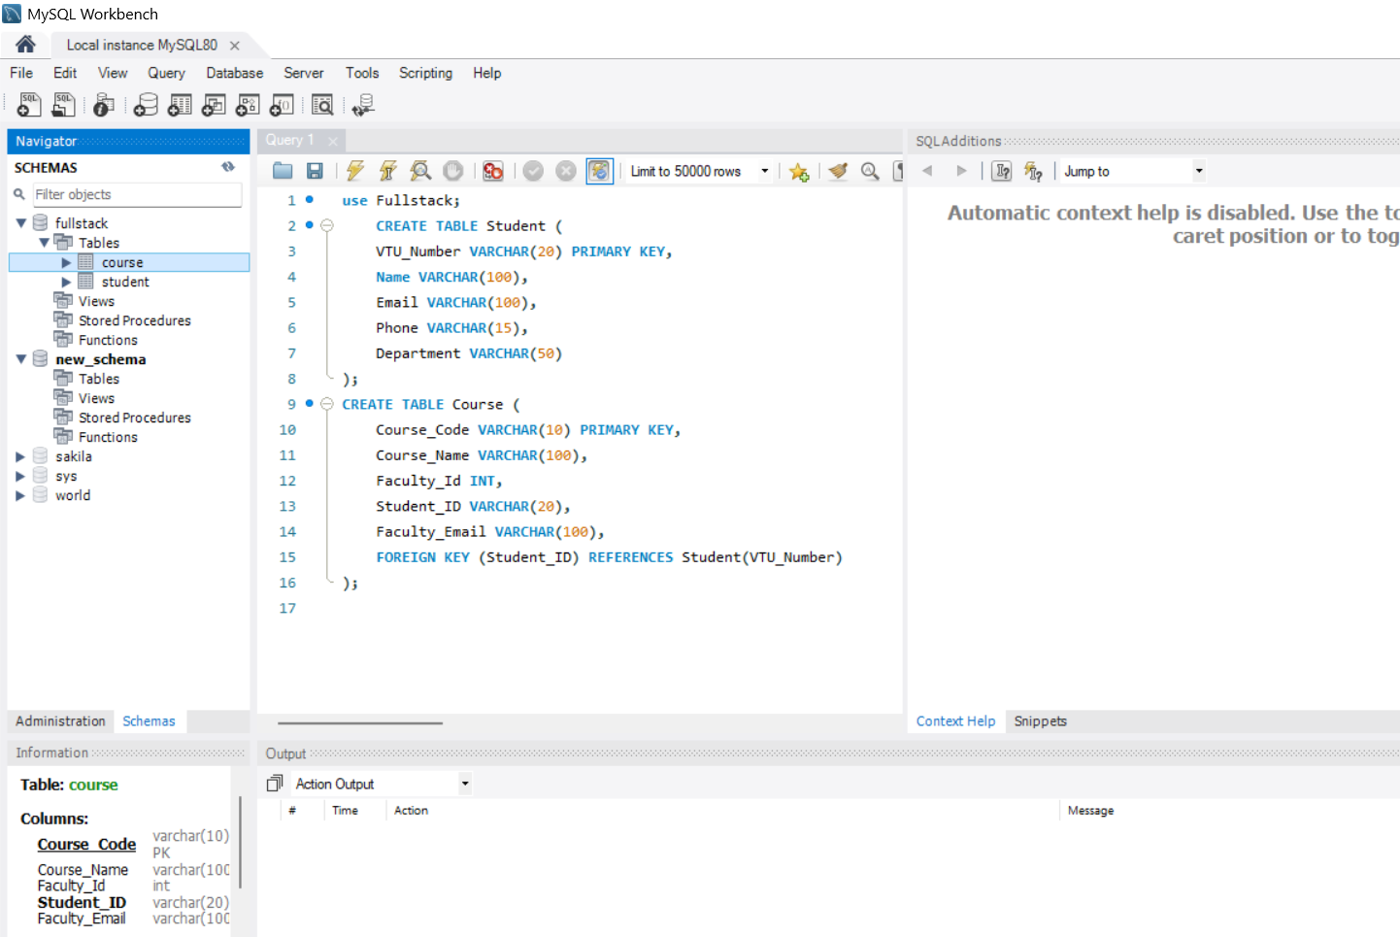
CREATE TABLE Course (
Course_Code VARCHAR(10) PRIMARY KEY,
Course_Name VARCHAR(100),
Faculty_Id INT,
Student_ID VARCHAR(20),
Faculty_Email VARCHAR(100),
FOREIGN KEY (Student_ID) REFERENCES Student(VTU_Number)
);
- Insert minimum 5 records into each table.
-- Inserting into Student Table
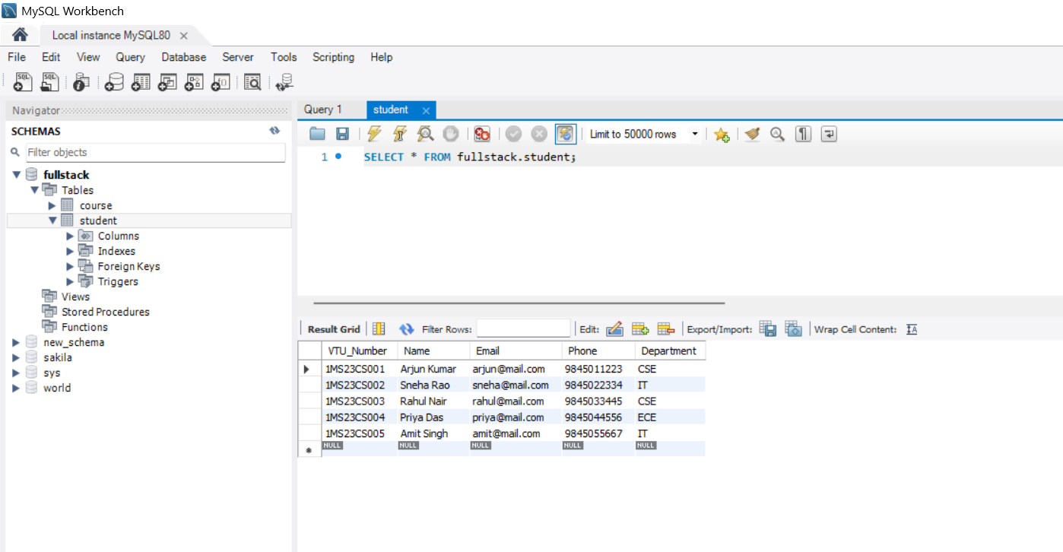
INSERT INTO Student VALUES
('1MS23CS001','Arjun Kumar','arjun@mail.com','9845011223','CSE'),
('1MS23CS002','Sneha Rao','sneha@mail.com','9845022334','IT'),
('1MS23CS003','Rahul Nair','rahul@mail.com','9845033445','CSE'),
('1MS23CS004','Priya Das','priya@mail.com','9845044556','ECE'),
('1MS23CS005','Amit Singh','amit@mail.com','9845055667','IT');
-- Inserting into Course Table 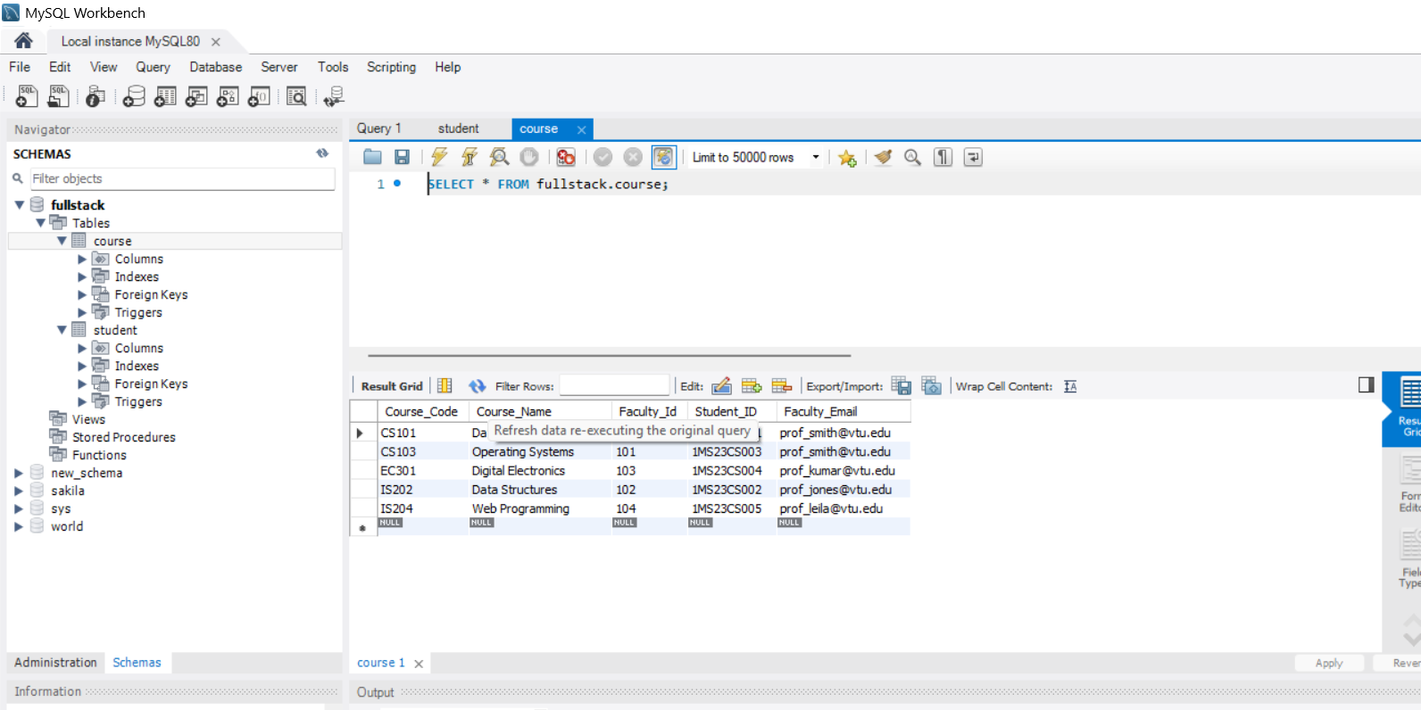

INSERT INTO Course VALUES
('CS101', 'Database Management', 101, '1MS23CS001', 'prof_smith@vtu.edu'),
('IS202', 'Data Structures', 102, '1MS23CS002', 'prof_jones@vtu.edu'),
('CS103', 'Operating Systems', 101, '1MS23CS003', 'prof_smith@vtu.edu'),
('EC301', 'Digital Electronics', 103, '1MS23CS004', 'prof_kumar@vtu.edu'),
('IS204', 'Web Programming', 104, '1MS23CS005', 'prof_leila@vtu.edu');
- Select records using different CLAUSE.
- WHERE clause:

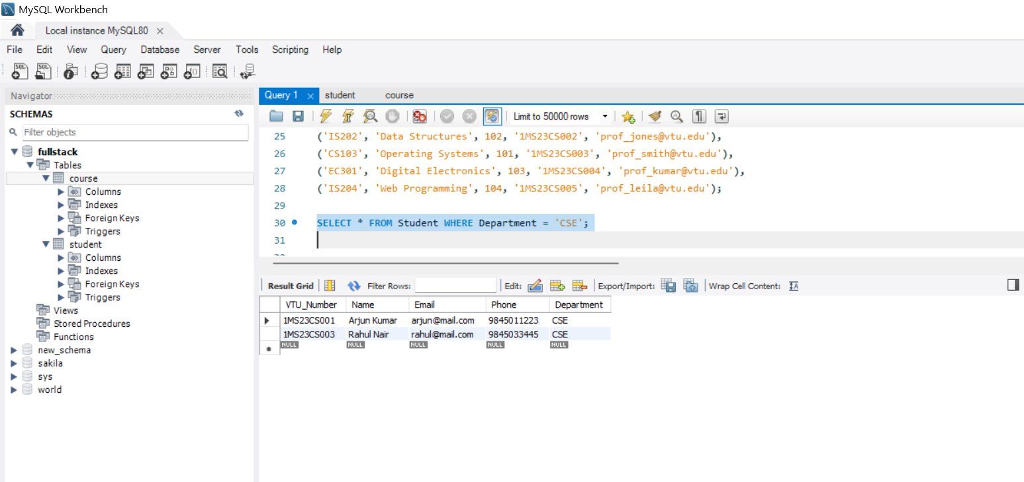
SELECT * FROM Student WHERE Department = 'CSE';
- ORDER BY Clause (Sorting):
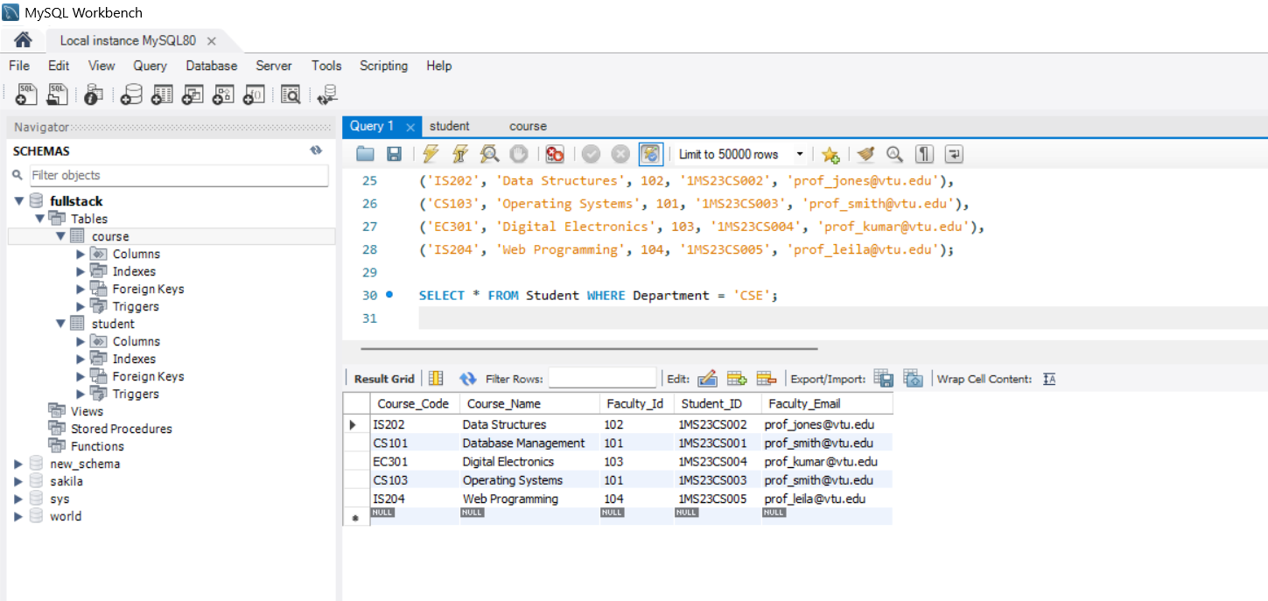
SELECT * FROM Course ORDER BY Course_Name ASC;
- LIKE Clause (Pattern Matching):
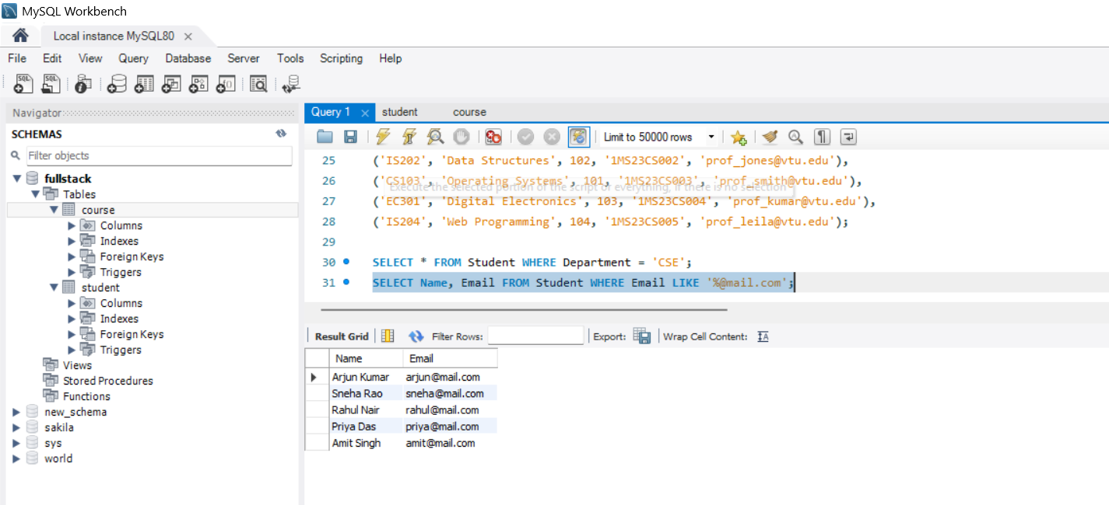
SELECT Name, Email FROM Student WHERE Email LIKE '%@mail.com';
- LIMIT Clause (Restricting Results):
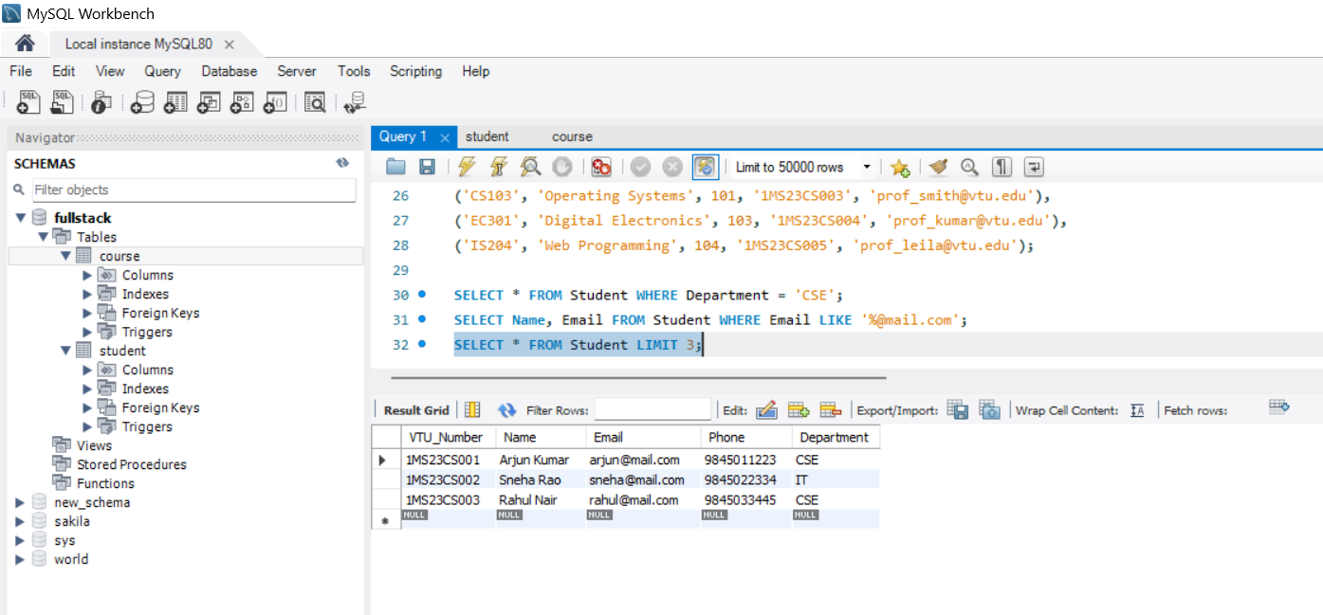
SELECT * FROM Student LIMIT 3;

- GROUP BY & HAVING Clause (Aggregating):
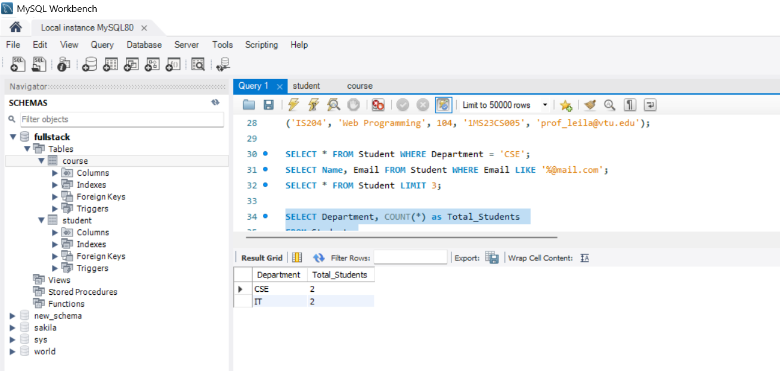
SELECT Department, COUNT(*) as Total_Students
FROM Student
GROUP BY Department
HAVING COUNT(*) > 1;

Session 3:
- Write SELECT queries to display all records.
-- Display all students
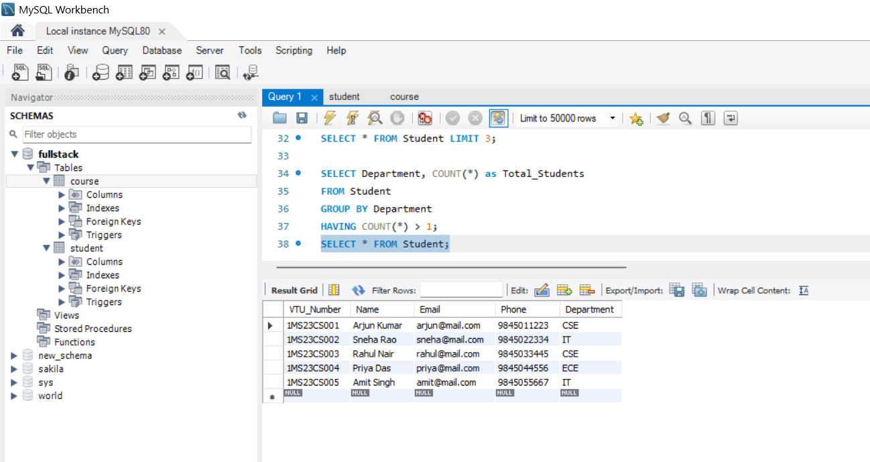
SELECT * FROM Student;
-- Display all courses
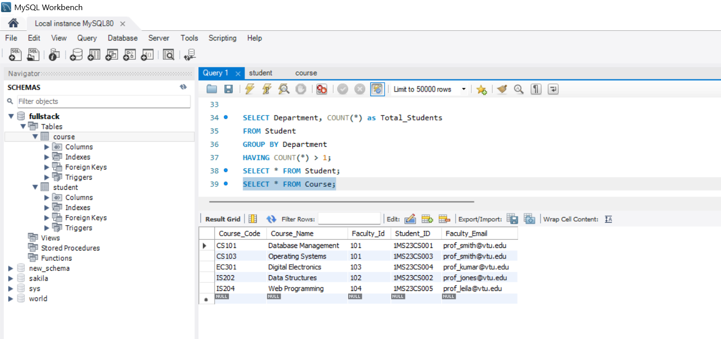
SELECT * FROM Course;

- Write queries using aggregate functions.
-- Count total number of students
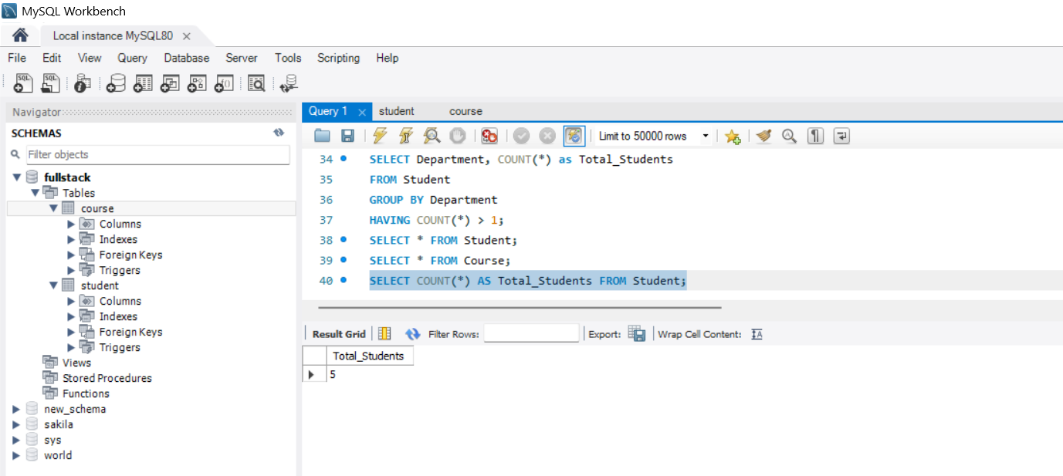

SELECT COUNT(*) AS Total_Students FROM Student;
-- Count unique departments
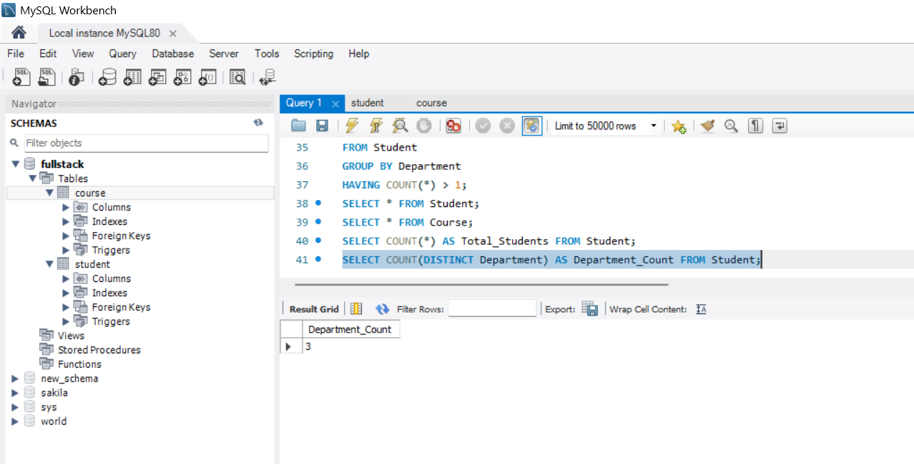
SELECT COUNT(DISTINCT Department) AS Department_Count FROM Student;
-- Find the highest Faculty ID assigned
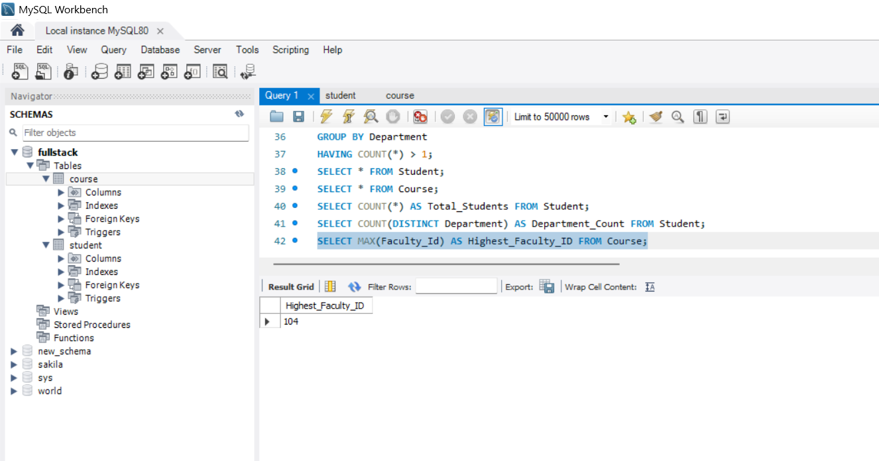
SELECT MAX(Faculty_Id) AS Highest_Faculty_ID FROM Course;

- Sort data and display based in ascending/descending order of the VTU number.
-- Sort - Ascending order (Default)
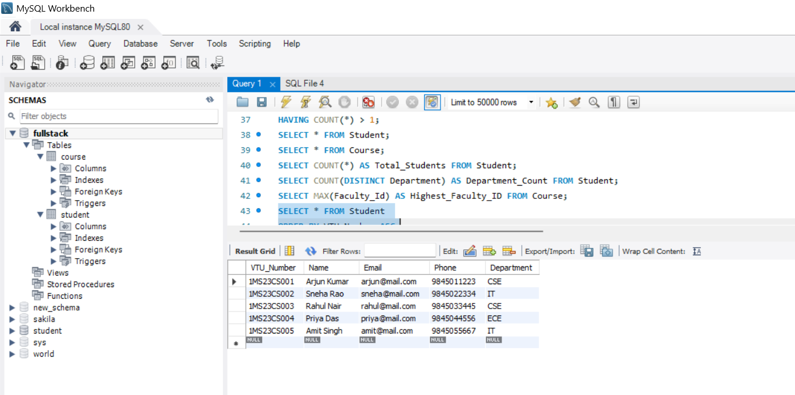
SELECT * FROM Student
ORDER BY VTU_Number ASC;
-- Sort - in Descending order
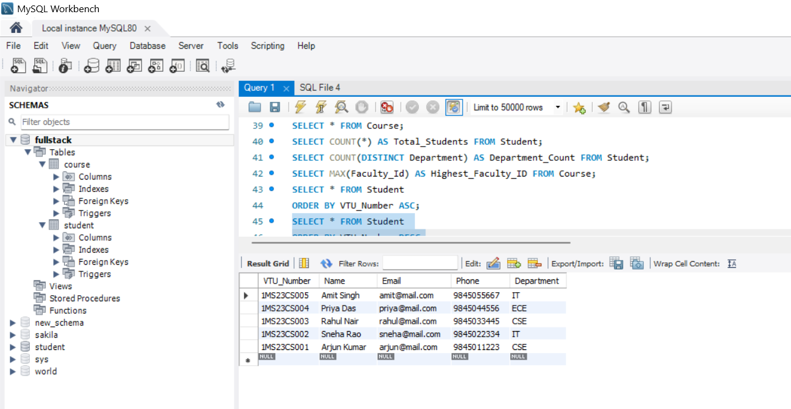
SELECT * FROM Student
ORDER BY VTU_Number DESC;

- Display student records belonging to a particular department.
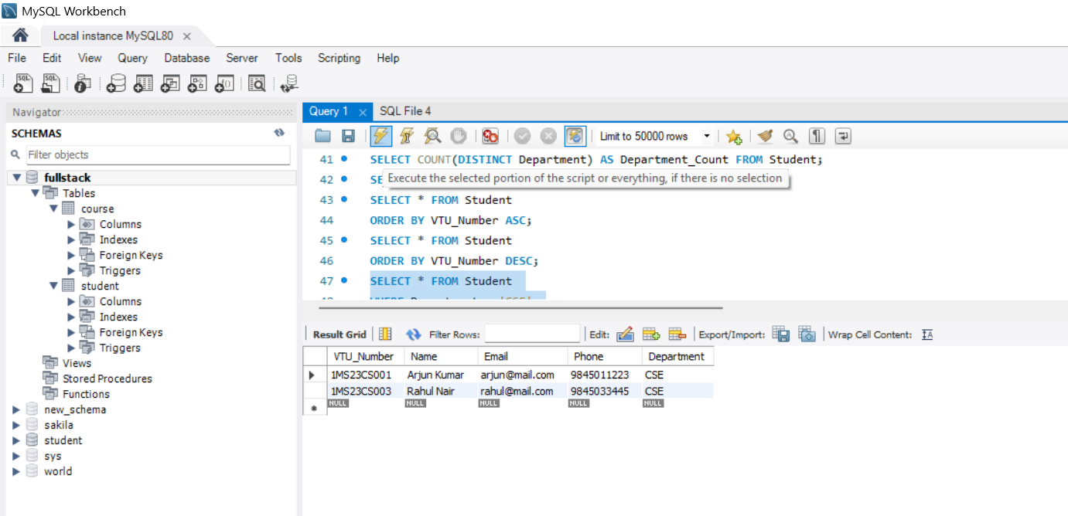
SELECT * FROM Student
WHERE Department = 'CSE';

- Map VTU no. with course name and faculty using joins.
Joins Summary:
Join Type | Records Included
Inner | Only matches found in both tables.
Left | Everything from Left + matches from Right.
Right | Everything from Right + matches from Left.
Full | Everything from both tables.
Cross | Every possible combination of both tables.

Inner Join:
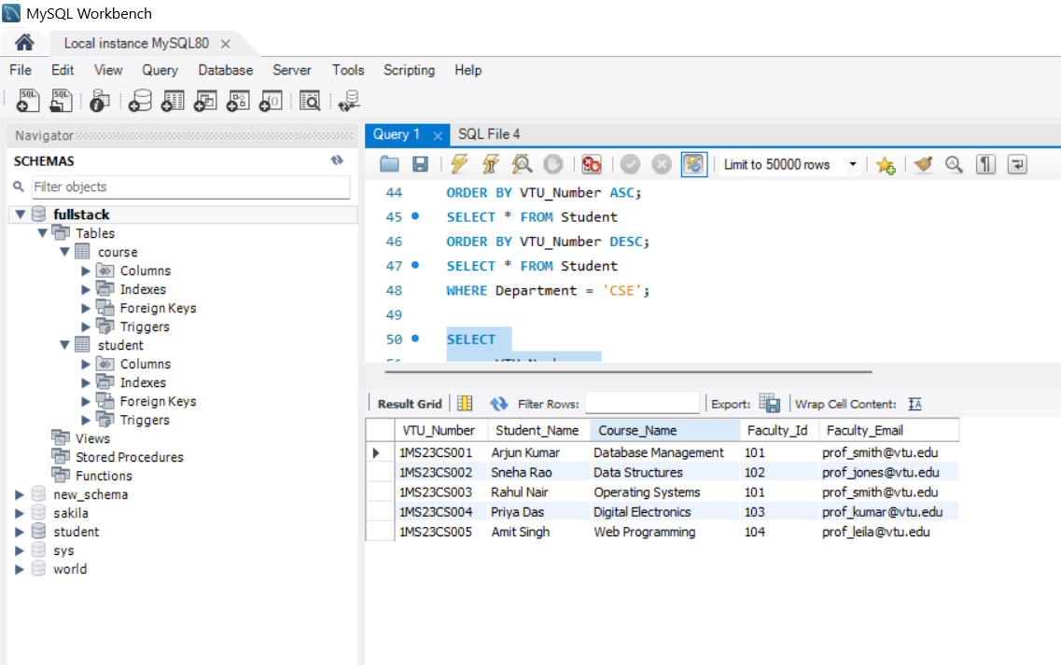
SELECT
s.VTU_Number,
s.Name AS Student_Name,
c.Course_Name,
c.Faculty_Id,
c.Faculty_Email
FROM Student s
INNER JOIN Course c ON s.VTU_Number = c.Student_ID;

Left Join:
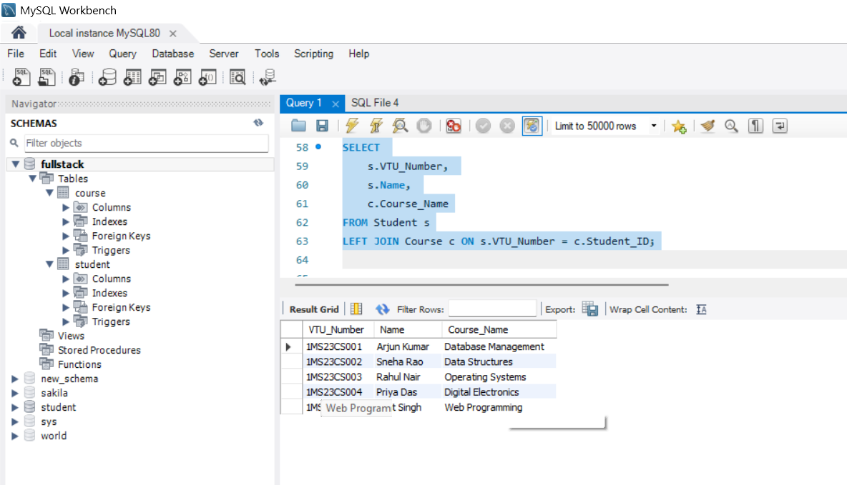
SELECT
s.VTU_Number,
s.Name,
c.Course_Name
FROM Student s
LEFT JOIN Course c ON s.VTU_Number = c.Student_ID;

Right Join:
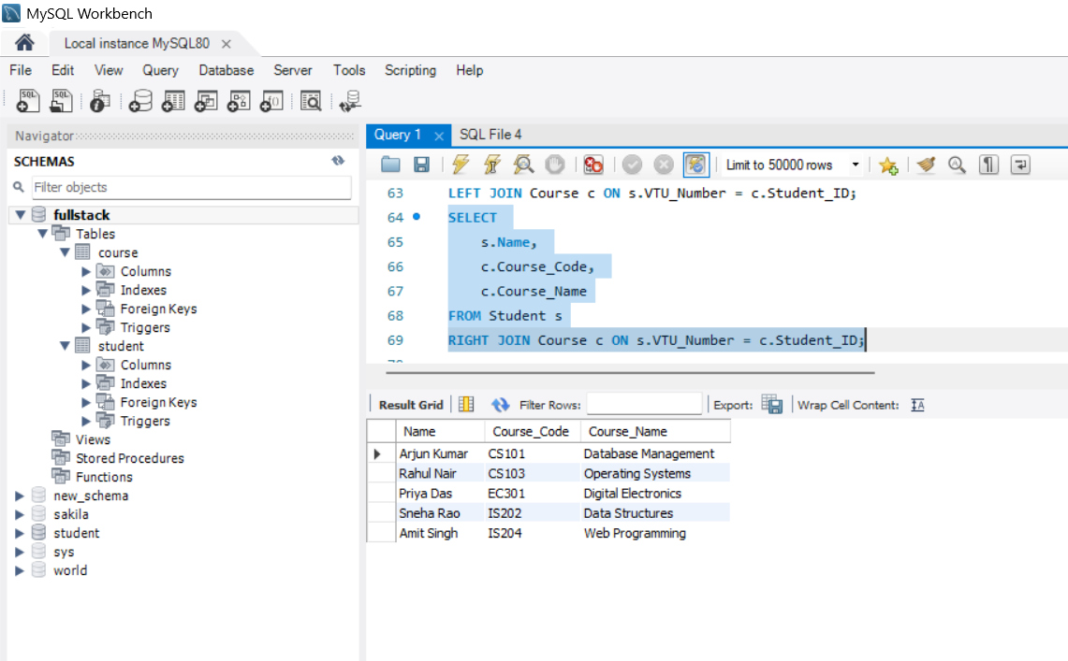
SELECT
s.Name,
c.Course_Code,
c.Course_Name
FROM Student s
RIGHT JOIN Course c ON s.VTU_Number = c.Student_ID;

FULL JOIN (Full Outer Join):
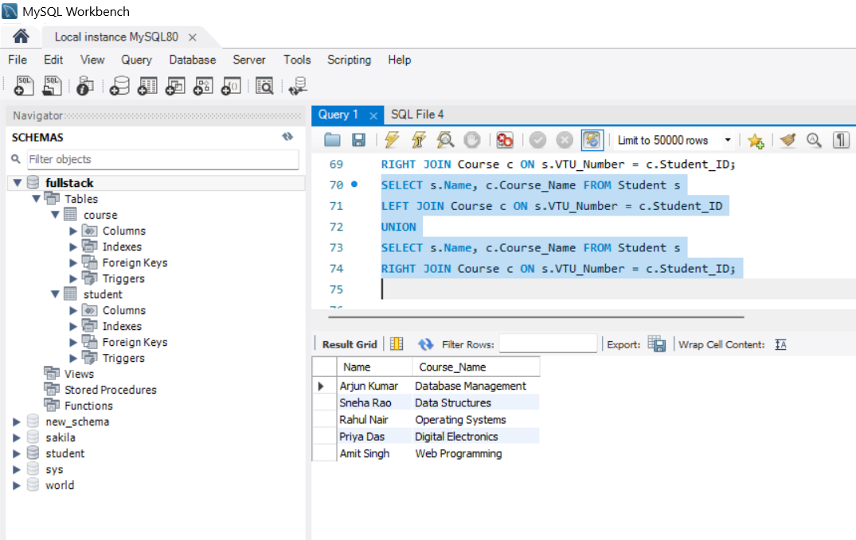
SELECT s.Name, c.Course_Name FROM Student s
LEFT JOIN Course c ON s.VTU_Number = c.Student_ID
UNION
SELECT s.Name, c.Course_Name FROM Student s
RIGHT JOIN Course c ON s.VTU_Number = c.Student_ID;

Cross Join(Cartesian Product):
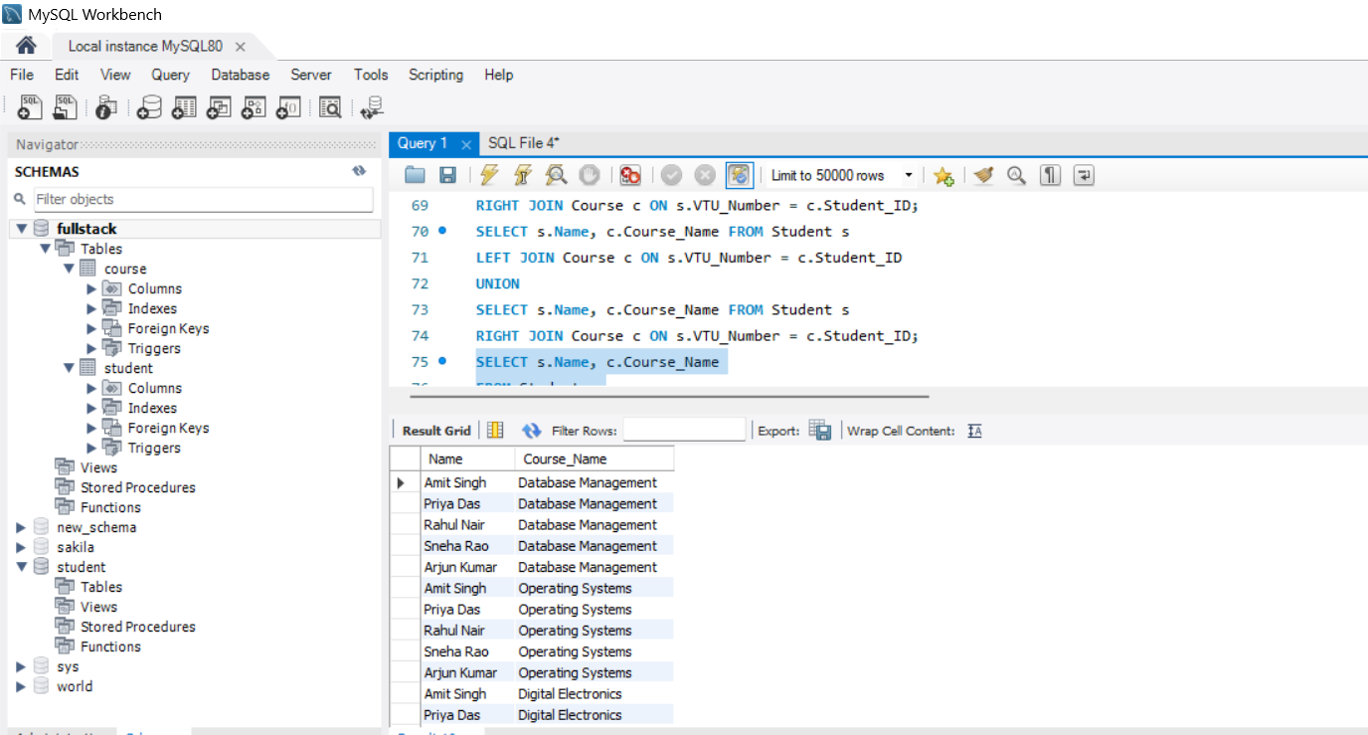
SELECT s.Name, c.Course_Name
FROM Student s
CROSS JOIN Course c;

