Car-Dealership

Table creation:

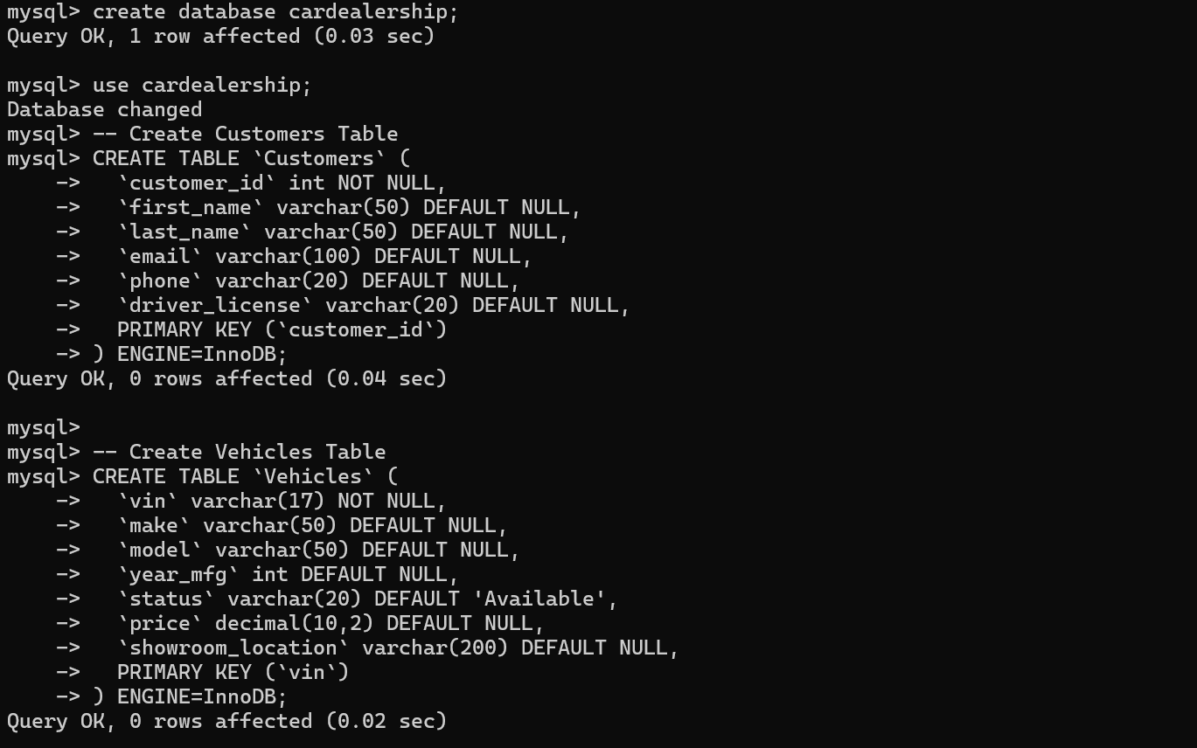
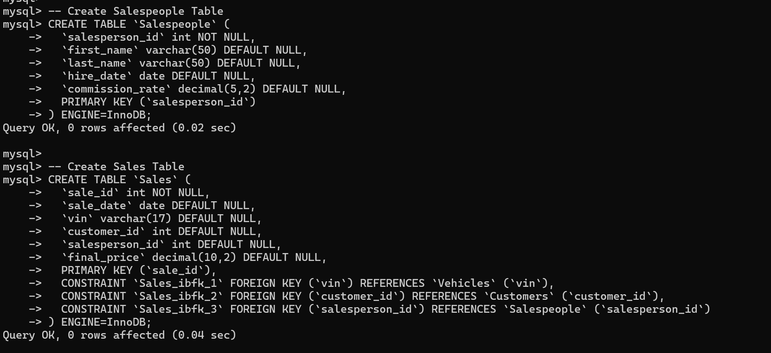

Insertion of values:
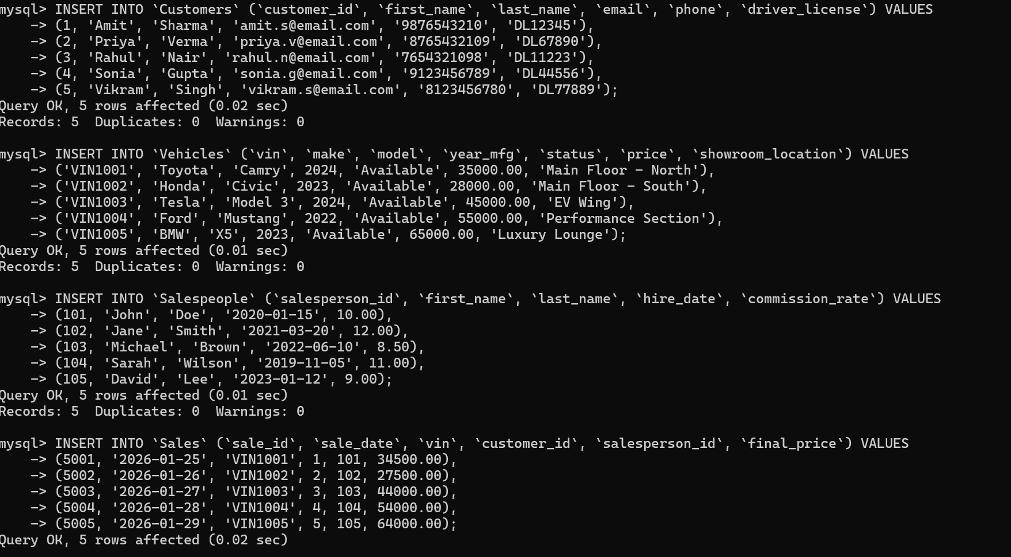
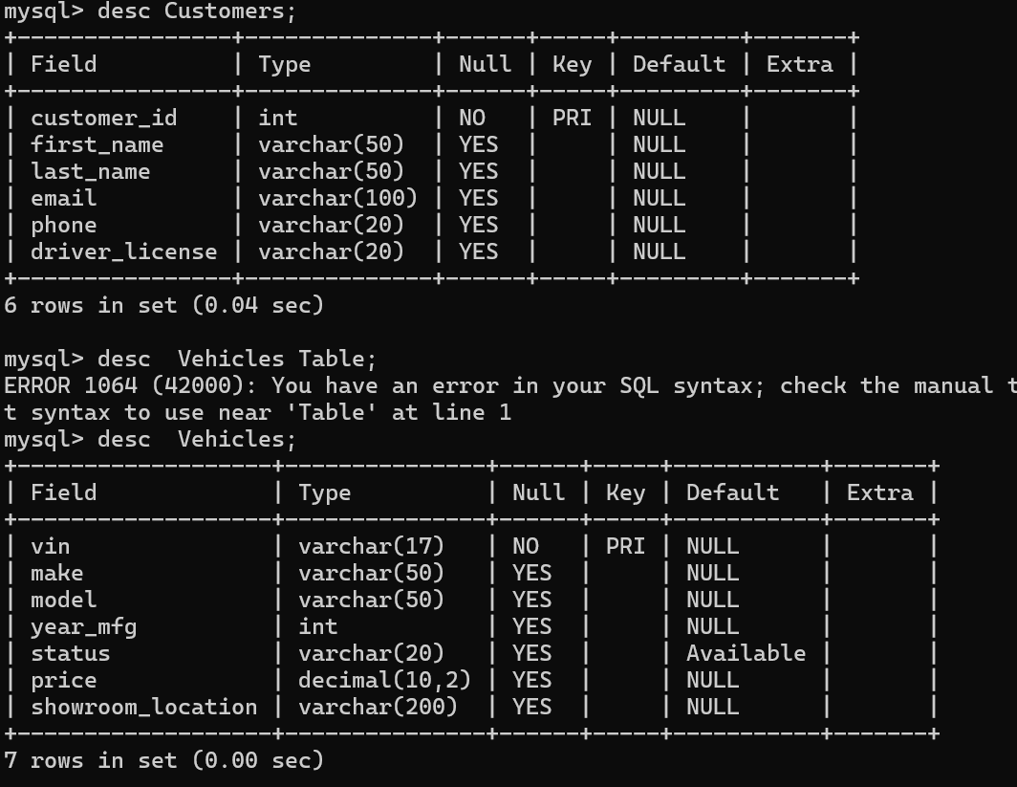

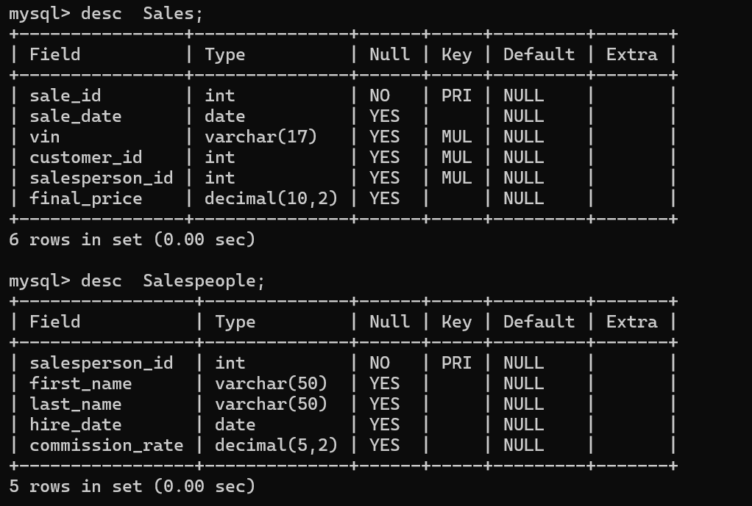

Joins :
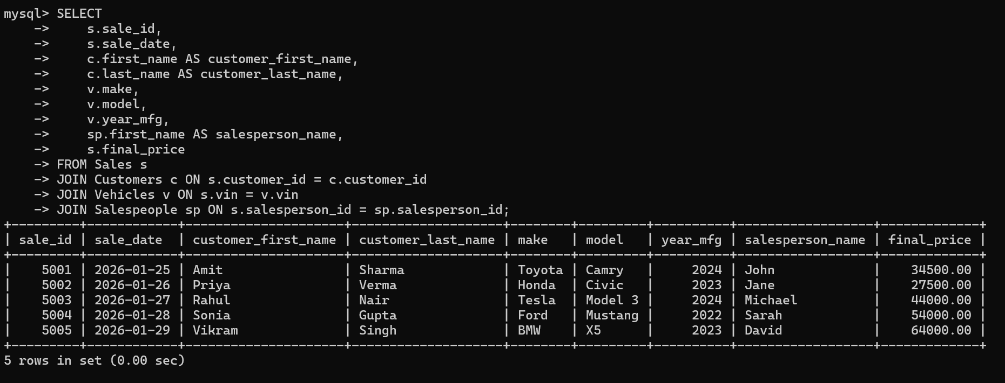

Views:
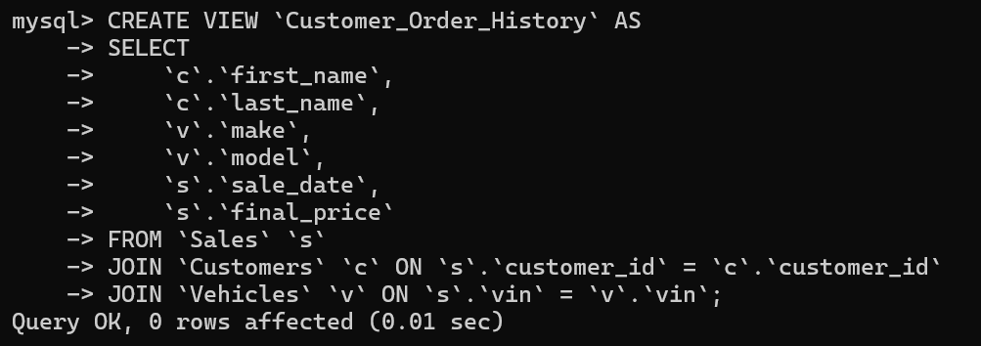
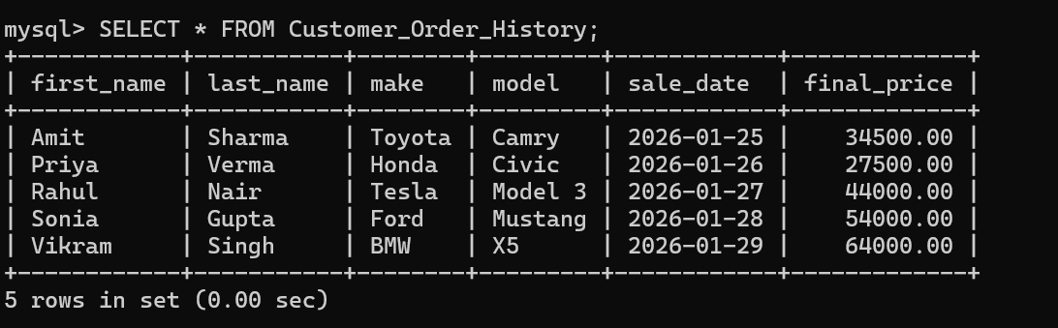

Triggers:
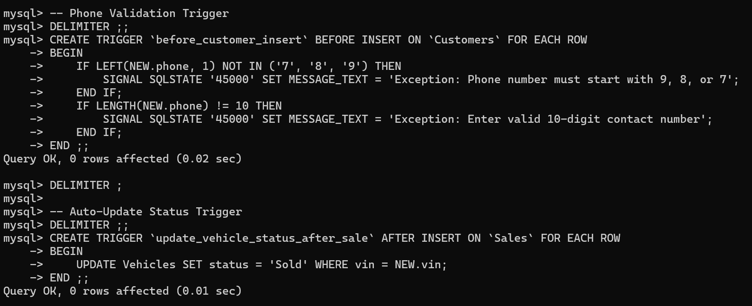

User defined function:
DELIMITER ;;

CREATE FUNCTION `CalculateTax`(price DECIMAL(10,2))
RETURNS decimal(10,2)
DETERMINISTIC
BEGIN
DECLARE tax_amount DECIMAL(10,2);
SET tax_amount = price * 0.10;
RETURN tax_amount;
END ;;

DELIMITER ;
