CREATE TABLE users (
-> id INT AUTO_INCREMENT PRIMARY KEY,
-> username VARCHAR(50),
-> email VARCHAR(100),
-> password VARCHAR(255),
-> created_at TIMESTAMP DEFAULT CURRENT_TIMESTAMP
-> );
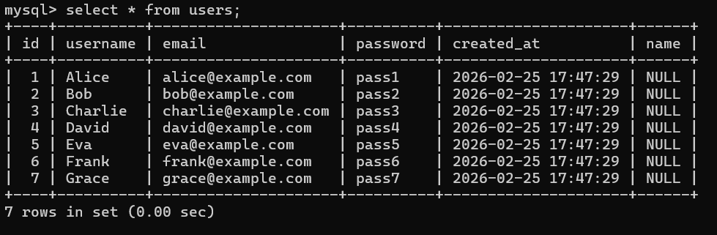

CREATE TABLE tasks (
-> id INT AUTO_INCREMENT PRIMARY KEY,
-> title VARCHAR(255),
-> description TEXT,
-> status ENUM('TODO','DOING','DONE'),
-> priority ENUM('LOW','MEDIUM','HIGH'),
-> due_date DATE,
-> created_by INT,
-> assigned_to INT,
-> created_at TIMESTAMP DEFAULT CURRENT_TIMESTAMP,
-> updated_at TIMESTAMP DEFAULT CURRENT_TIMESTAMP ON UPDATE CURRENT_TIMESTAMP
-> );
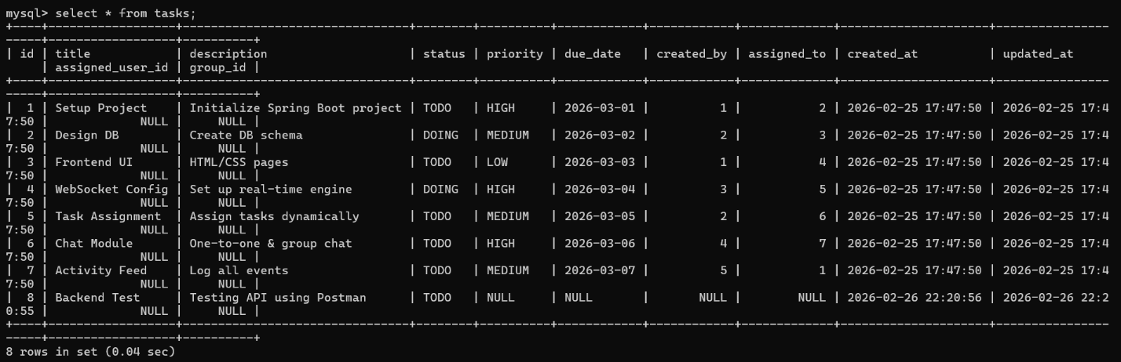

CREATE TABLE chat (
-> id INT AUTO_INCREMENT PRIMARY KEY,
-> sender_id INT,
-> receiver_id INT NULL,
-> group_id INT NULL,
-> message TEXT,
-> created_at TIMESTAMP DEFAULT CURRENT_TIMESTAMP
-> );
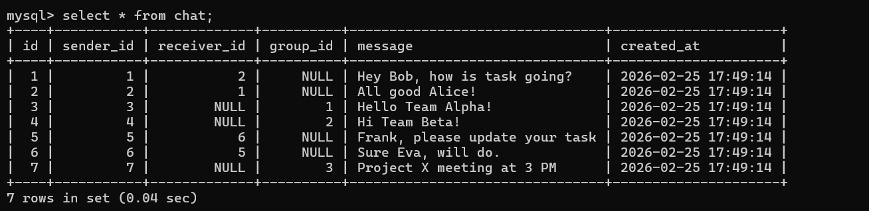

CREATE TABLE activity_feed (
-> id INT AUTO_INCREMENT PRIMARY KEY,
-> user_id INT,
-> action VARCHAR(255),
-> target_id INT NULL,
-> created_at TIMESTAMP DEFAULT CURRENT_TIMESTAMP
-> );
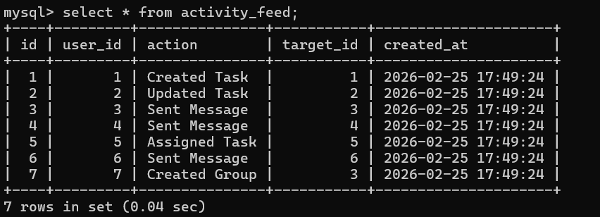

CREATE TABLE chat_groups (
-> id INT AUTO_INCREMENT PRIMARY KEY,
-> name VARCHAR(100),
-> created_by INT,
-> created_at TIMESTAMP DEFAULT CURRENT_TIMESTAMP
-> );
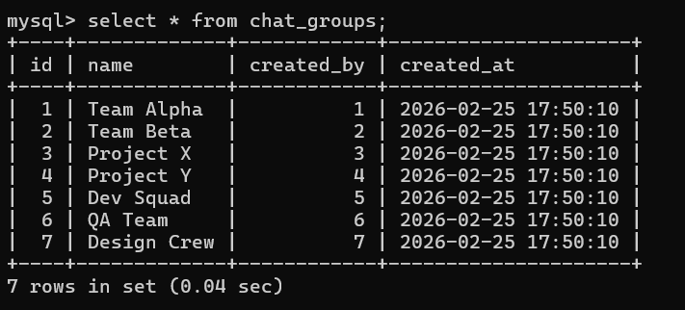

CREATE TABLE events (
-> id INT AUTO_INCREMENT PRIMARY KEY,
-> type VARCHAR(50),
-> details TEXT,
-> created_at TIMESTAMP DEFAULT CURRENT_TIMESTAMP
-> );
