Week-1
Database creation and table creation:

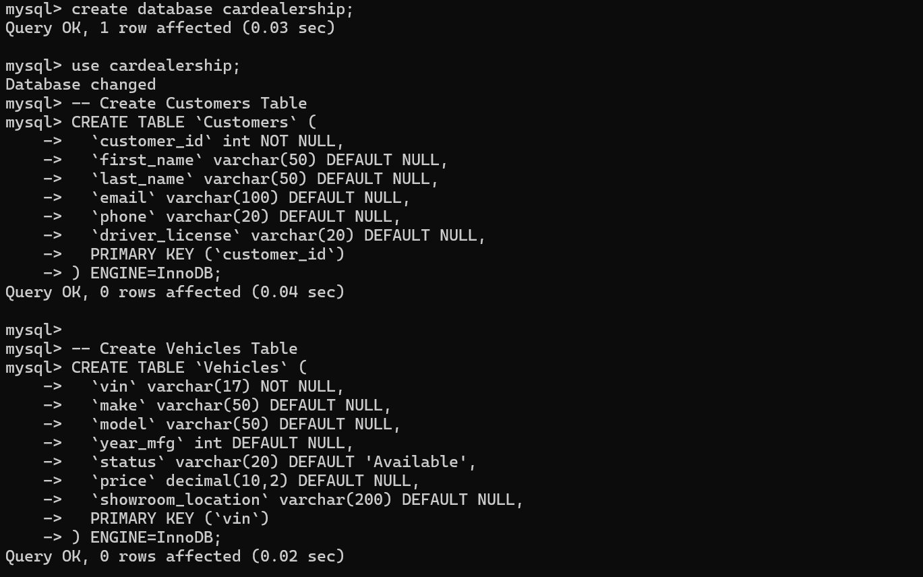
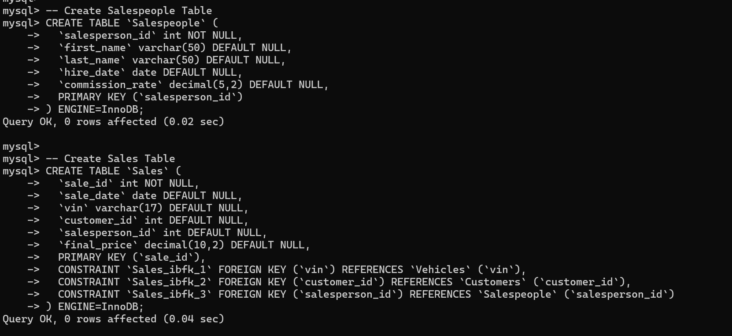

Insertion of values:
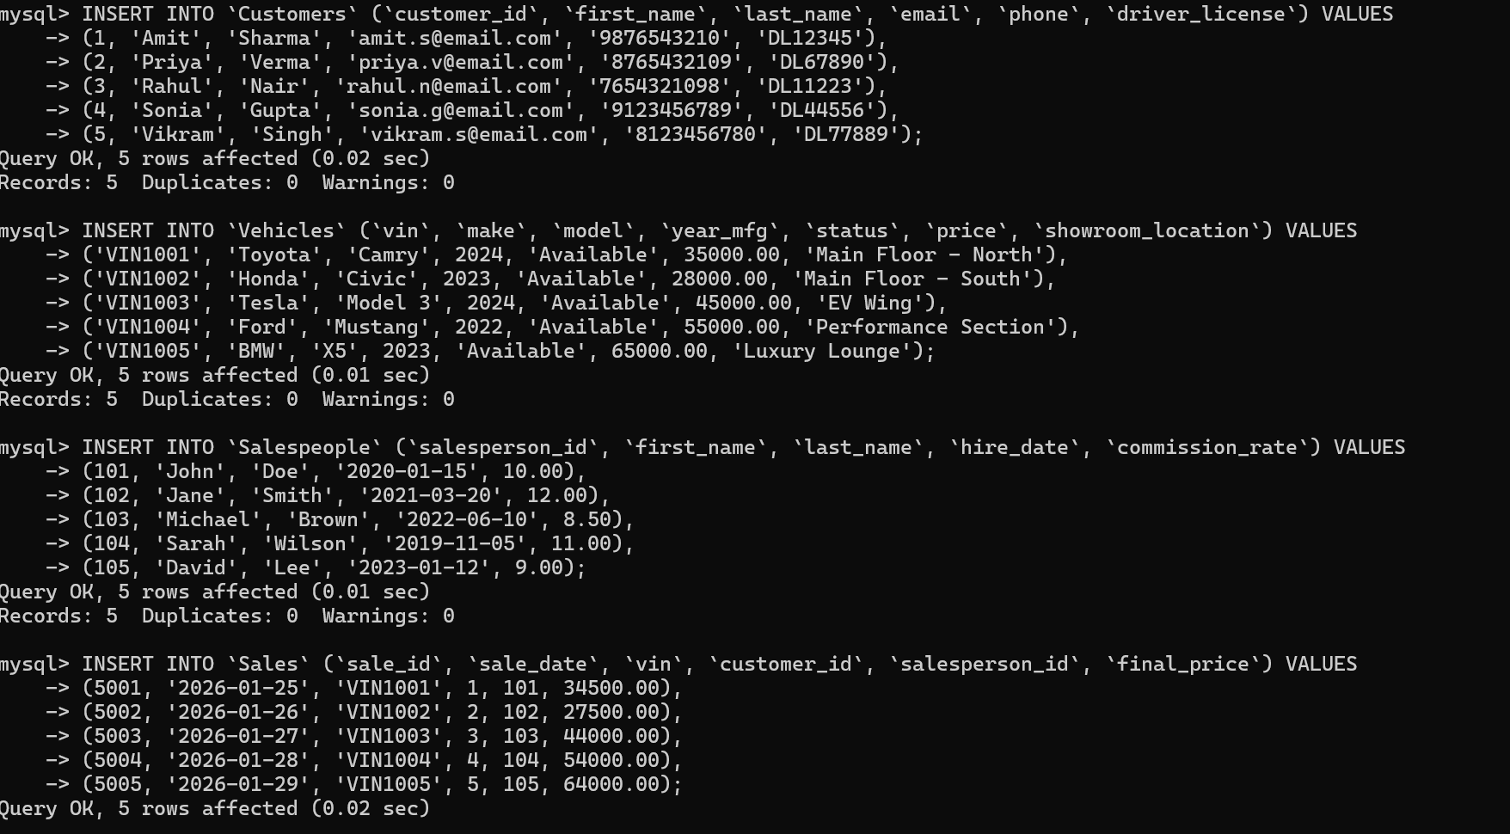
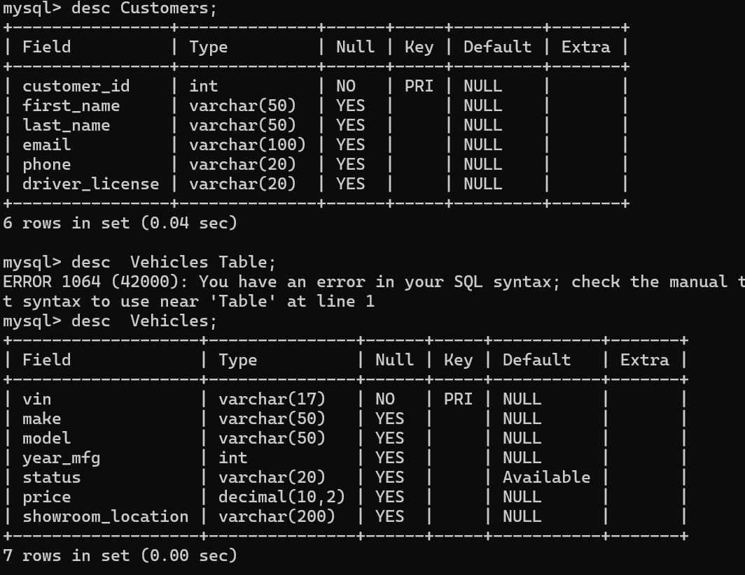

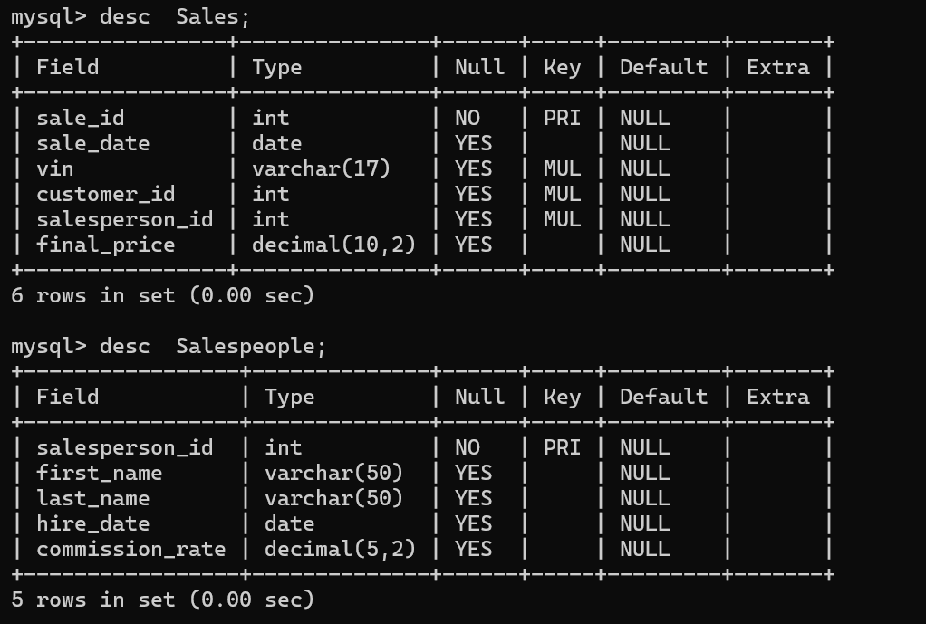

Joins :
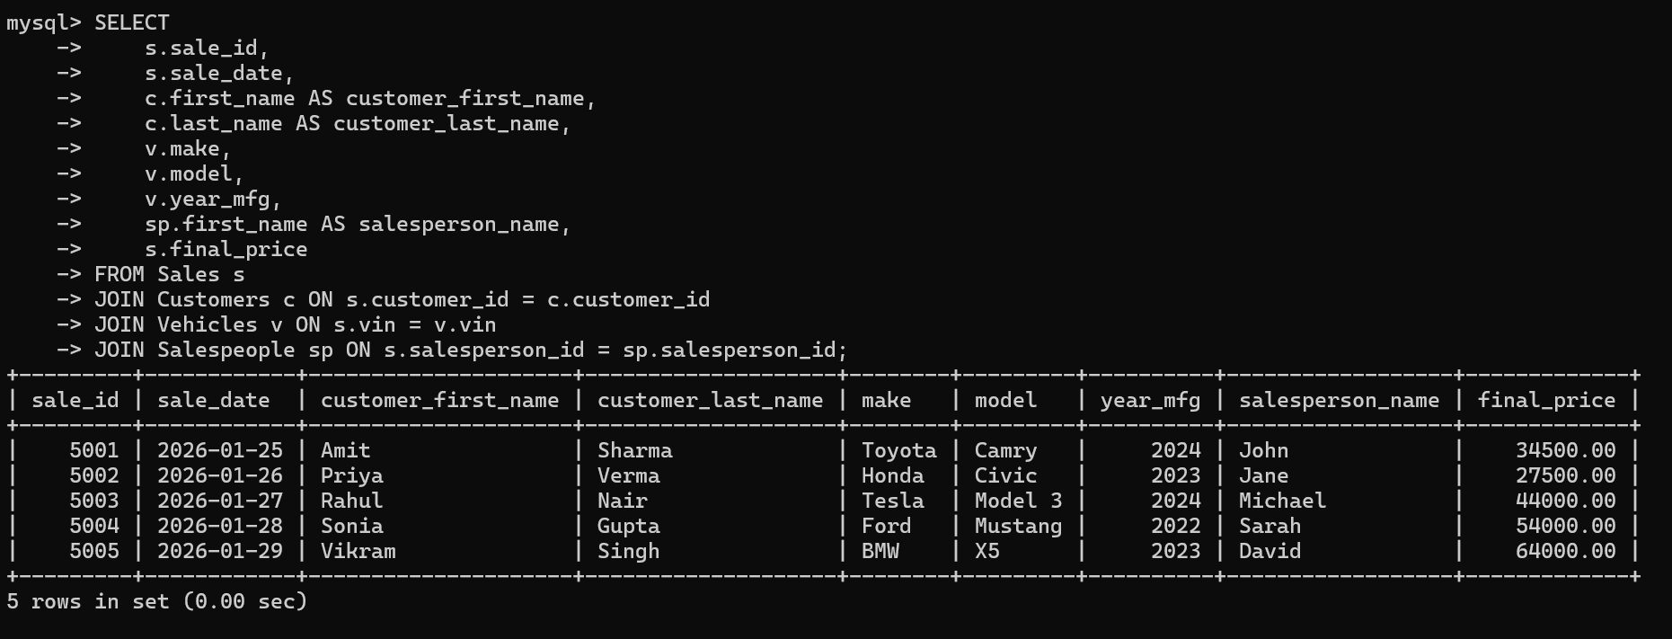

View:
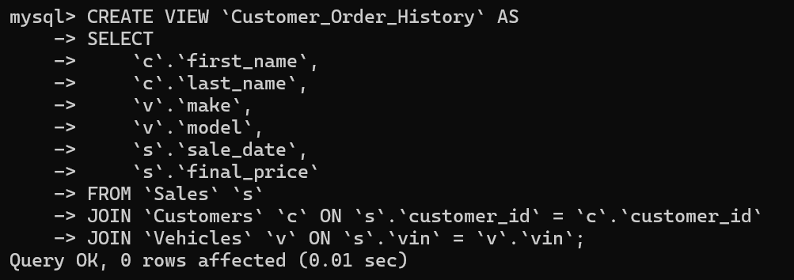
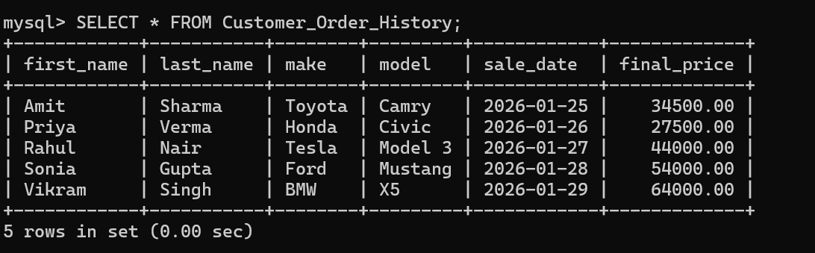

Trigger:
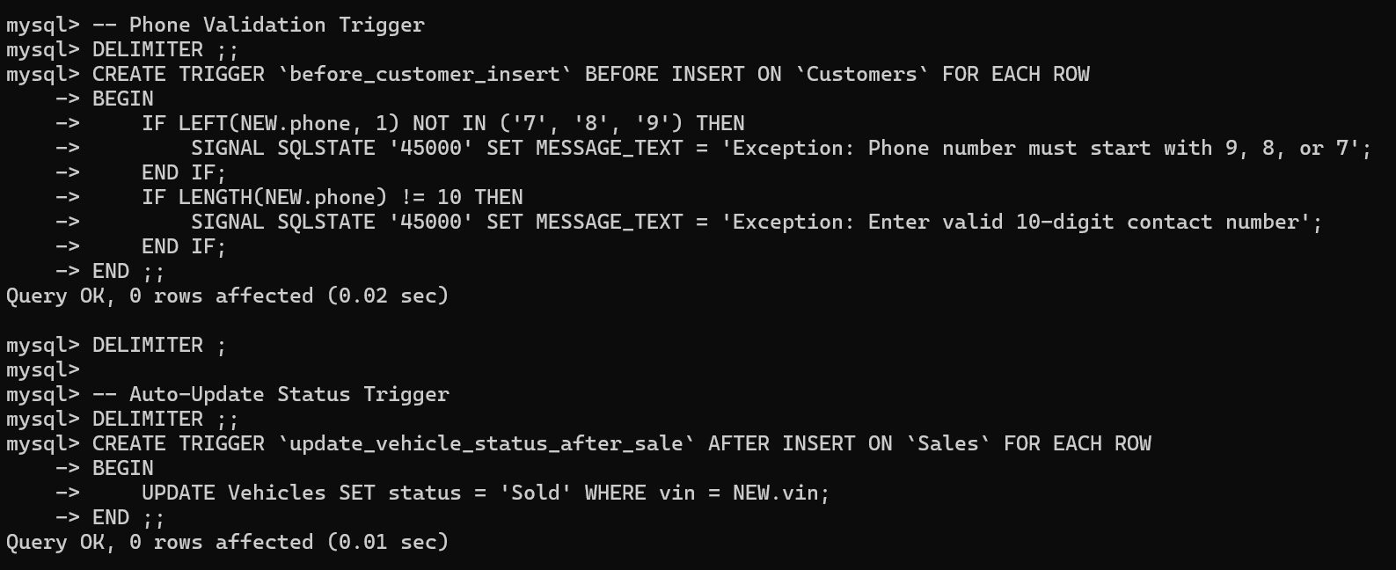

User defined function:
DELIMITER ;;

CREATE FUNCTION `CalculateTax`(price DECIMAL(10,2))
RETURNS decimal(10,2)
DETERMINISTIC
BEGIN
DECLARE tax_amount DECIMAL(10,2);
SET tax_amount = price * 0.10;
RETURN tax_amount;
END ;;

DELIMITER ;
