Task 2: Data Retrieval & Sorting Dashboard
Aim : To develop a dashboard for retrieving and displaying student records with sorting, filtering, and aggregation features.

Algorithm:
Step 1: Start
Step 2: Connect to MySQL database using PHP
Step 3: Retrieve filter (department) and sort (name/DOB) inputs from user
Step 4: Initialize SQL query to fetch student records
Step 5: If department is selected
Add WHERE condition to filter records
Step 6: If sorting option is selected
Add ORDER BY clause (name or DOB)
Step 7: Execute the SQL query
Step 8: Display the retrieved student records in table format
Step 9: Execute another query using GROUP BY department
to count number of students in each department
Step 10: Display department-wise student count
Step 11: Stop

Program:
(index.html)
<!DOCTYPE html>
<html>
<head>
<title>Student Registration</title>
<style>
body {
font-family: Arial;
background: linear-gradient(120deg, #f6f9fc, #e9f2ff);
}
.card {
width: 380px;
margin: 70px auto;
padding: 25px;
background: #fff;
border-radius: 12px;
box-shadow: 0 5px 15px rgba(0,0,0,0.15);
}
h2 {
text-align: center;
color: #333;
}
input, select {
width: 100%;
padding: 10px;
margin: 8px 0;
border-radius: 6px;
border: 1px solid #ccc;
}
input:focus, select:focus {
border-color: #4a90e2;
}
button {
width: 100%;
padding: 10px;
background: #4a90e2;
color: white;
border: none;
border-radius: 6px;
cursor: pointer;
}
button:hover {
background: #357bd8;
}
</style>
</head>

<body>

<div class="card">
<h2>Student Registration</h2>

<form action="insert.php" method="POST">
<input type="text" name="name" placeholder="Full Name" required>

<input type="email" name="email" placeholder="Email Address" required>

<input type="date" name="dob" required>

<select name="dept" required>
<option value="">Select Department</option>
<option value="CSE">CSE</option>
<option value="ECE">ECE</option>
<option value="IT">IT</option>
<option value="MECH">MECH</option>
</select>

<input type="text" name="phone" placeholder="Phone Number" required>

<button type="submit">Register</button>
</form>
</div>

</body>
</html>

(insert.php)
<?php
$conn = new mysqli("localhost", "root", "", "student_db");

if ($conn->connect_error) {
die("Connection Failed: " . $conn->connect_error);
}

// Get form data
$name = $_POST['name'];
$email = $_POST['email'];
$dob = $_POST['dob'];
$department = $_POST['department'];
$phone = $_POST['phone'];

// Insert query
$sql = "INSERT INTO students (name, email, dob, department, phone)
VALUES ('$name', '$email', '$dob', '$department', '$phone')";

if ($conn->query($sql) === TRUE) {
echo "<script>
alert('Student Registered Successfully!');
window.location.href='display.php';
</script>";
} else {
echo "Error: " . $conn->error;
}

$conn->close();
?>

(display.php)
<?php
$conn = new mysqli("localhost", "root", "", "student_system");

if ($conn->connect_error) {
die("Connection Failed");
}

$result = $conn->query("SELECT * FROM students_info");

echo "<h2 style='text-align:center;'>Student Records</h2>";

echo "<table border='1' align='center' cellpadding='10'>
<tr style='background:#4a90e2; color:white;'>
<th>ID</th>
<th>Name</th>
<th>Email</th>
<th>DOB</th>
<th>Department</th>
<th>Phone</th>
</tr>";

while($row = $result->fetch_assoc()) {
echo "<tr>
<td>{$row['id']}</td>
<td>{$row['name']}</td>
<td>{$row['email']}</td>
<td>{$row['dob']}</td>
<td>{$row['dept']}</td>
<td>{$row['phone']}</td>
</tr>";
}

echo "</table>";

$conn->close();
?>

(SQL)
CREATE TABLE students (
id INT AUTO_INCREMENT PRIMARY KEY,
name VARCHAR(100),
email VARCHAR(100),
dob DATE,
department VARCHAR(50),
phone VARCHAR(15)
);
Implementations:
Using Xampp server and creating project file and program text files
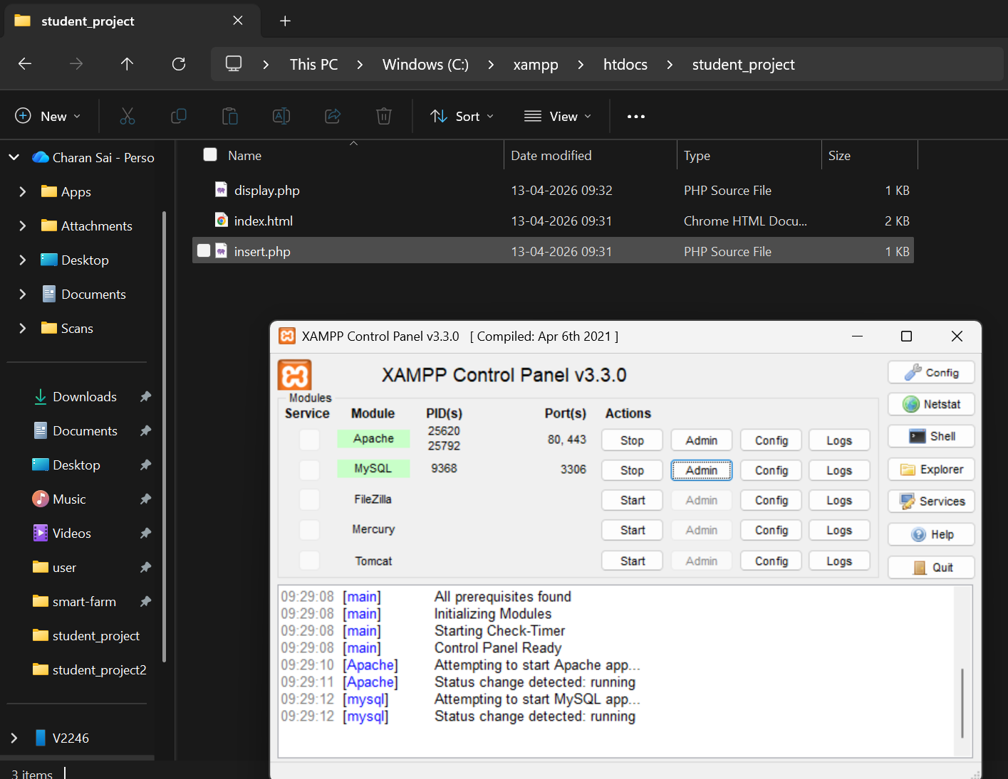
OUTPUT:
Registration page
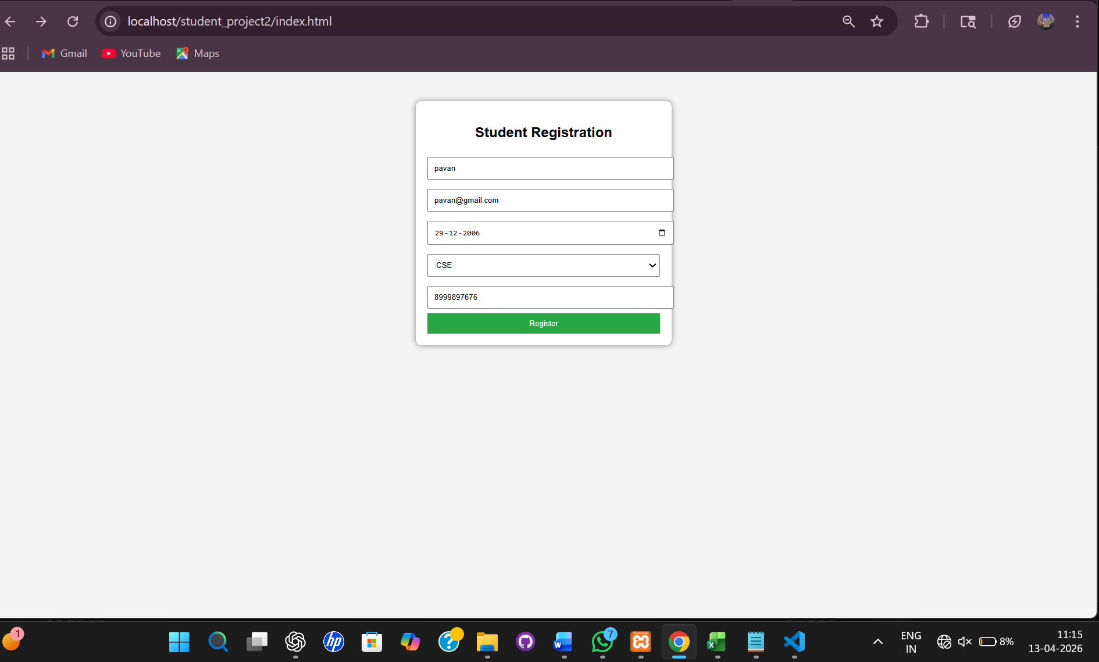

Output page
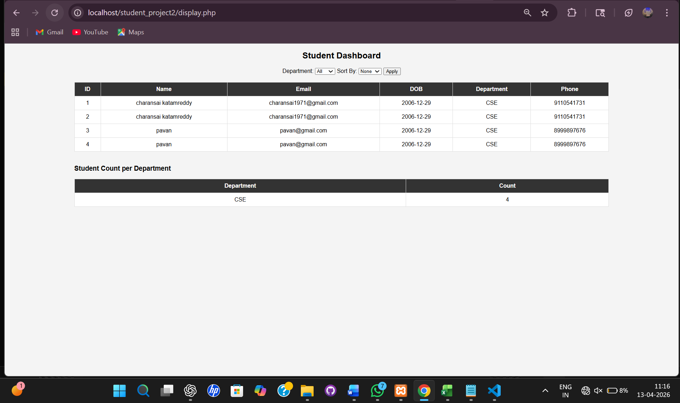

Result:
The student dashboard was successfully implemented. The system displays all student records with options to sort by name and date of birth, filter by department, and view the count of students in each department. The application works correctly and efficiently retrieves data from the database.

