Task 1: Student Registration & Data Storage
Aim:
To design and implement a Student Registration Form using HTML5 and CSS3, store the entered student details into a database, and retrieve the stored records using SQL SELECT query.
Algorithm:
- Start the process
- Create an HTML form to collect student details such as Name, Email, Date of Birth, Department, and Phone Number
- Apply CSS3 styling to enhance the user interface of the form
- On form submission, send the data to a PHP file using the POST method
- Establish a connection between PHP and MySQL database
- Create a database named student system
- Create a table students info with required fields
- Insert the submitted data into the table using SQL INSERT statement
- Execute an SQL SELECT query to fetch all stored records
- Display the retrieved data in a structured table format on the browser
- Stop the process

Program:
(Index.html)

<!DOCTYPE html>
<html>
<head>
<title>Student Registration</title>
<style>
body {
font-family: Arial;
background: linear-gradient(120deg, #f6f9fc, #e9f2ff);
}
.card {
width: 380px;
margin: 70px auto;
padding: 25px;
background: #fff;
border-radius: 12px;
box-shadow: 0 5px 15px rgba(0,0,0,0.15);
}
h2 {
text-align: center;
color: #333;
}
input, select {
width: 100%;
padding: 10px;
margin: 8px 0;
border-radius: 6px;
border: 1px solid #ccc;
}
input:focus, select:focus {
border-color: #4a90e2;
}
button {
width: 100%;
padding: 10px;
background: #4a90e2;
color: white;
border: none;
border-radius: 6px;
cursor: pointer;
}
button:hover {
background: #357bd8;
}
</style>
</head>

<body>

<div class="card">
<h2>Student Registration</h2>

<form action="insert.php" method="POST">
<input type="text" name="name" placeholder="Full Name" required>

<input type="email" name="email" placeholder="Email Address" required>

<input type="date" name="dob" required>

<select name="dept" required>
<option value="">Select Department</option>
<option value="CSE">CSE</option>
<option value="ECE">ECE</option>
<option value="IT">IT</option>
<option value="MECH">MECH</option>
</select>

<input type="text" name="phone" placeholder="Phone Number" required>

<button type="submit">Register</button>
</form>
</div>

</body>
</html>

(Insert.php)
<?php
// Database connection
$conn = new mysqli("localhost", "root", "", "student_system");

// Check connection
if ($conn->connect_error) {
die("Connection Failed: " . $conn->connect_error);
}

// Get form data
$name = $_POST['name'];
$email = $_POST['email'];
$dob = $_POST['dob'];
$dept = $_POST['dept'];
$phone = $_POST['phone'];

// Insert query
$sql = "INSERT INTO students_info (name, email, dob, dept, phone)
VALUES ('$name', '$email', '$dob', '$dept', '$phone')";

if ($conn->query($sql) === TRUE) {
echo "<h3>✅ Data Inserted Successfully</h3>";
echo "<a href='display.php'>View Records</a>";
} else {
echo "Error: " . $conn->error;
}

$conn->close();
?>

(display.php)
<?php
$conn = new mysqli("localhost", "root", "", "student_system");

if ($conn->connect_error) {
die("Connection Failed");
}

$result = $conn->query("SELECT * FROM students_info");

echo "<h2 style='text-align:center;'>Student Records</h2>";

echo "<table border='1' align='center' cellpadding='10'>
<tr style='background:#4a90e2; color:white;'>
<th>ID</th>
<th>Name</th>
<th>Email</th>
<th>DOB</th>
<th>Department</th>
<th>Phone</th>
</tr>";

while($row = $result->fetch_assoc()) {
echo "<tr>
<td>{$row['id']}</td>
<td>{$row['name']}</td>
<td>{$row['email']}</td>
<td>{$row['dob']}</td>
<td>{$row['dept']}</td>
<td>{$row['phone']}</td>
</tr>";
}

echo "</table>";

$conn->close();
?>

(SQL)
CREATE DATABASE student_system;

USE student_system;

CREATE TABLE students_info (
id INT AUTO_INCREMENT PRIMARY KEY,
name VARCHAR(100),
email VARCHAR(100),
dob DATE,
dept VARCHAR(50),
phone VARCHAR(15)
);

Implementations:
We are using xampp server
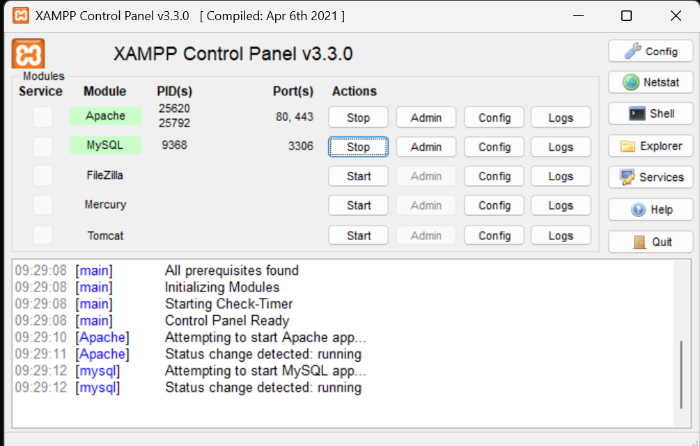

Creating a project folder structures like this.

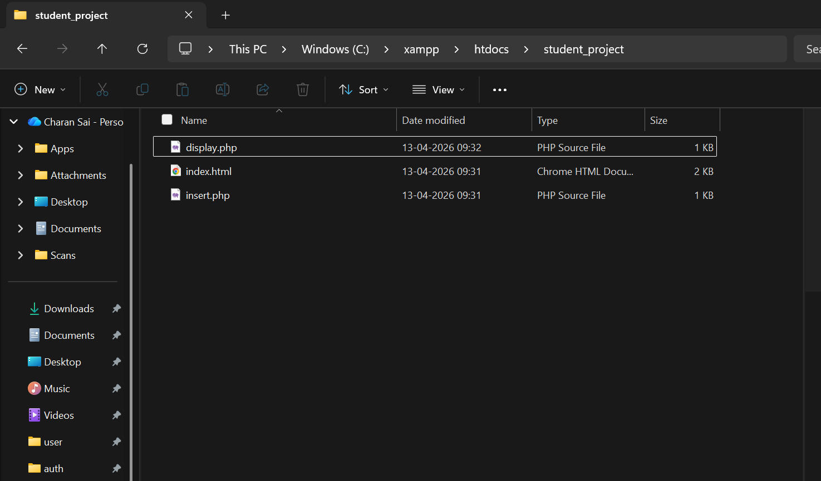

Use php my admin SQL for database
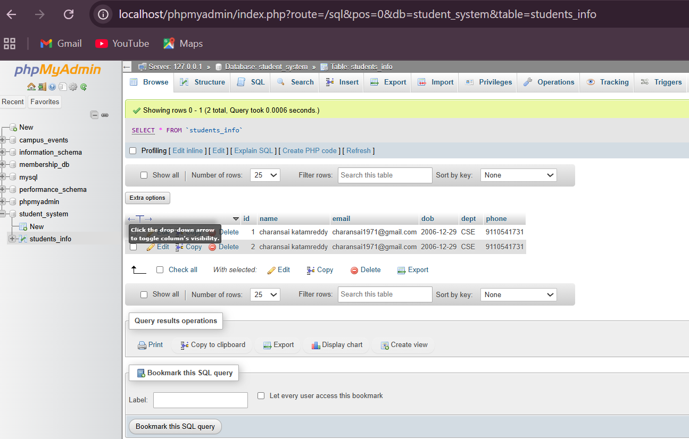

Output:
WEB INTERFACE
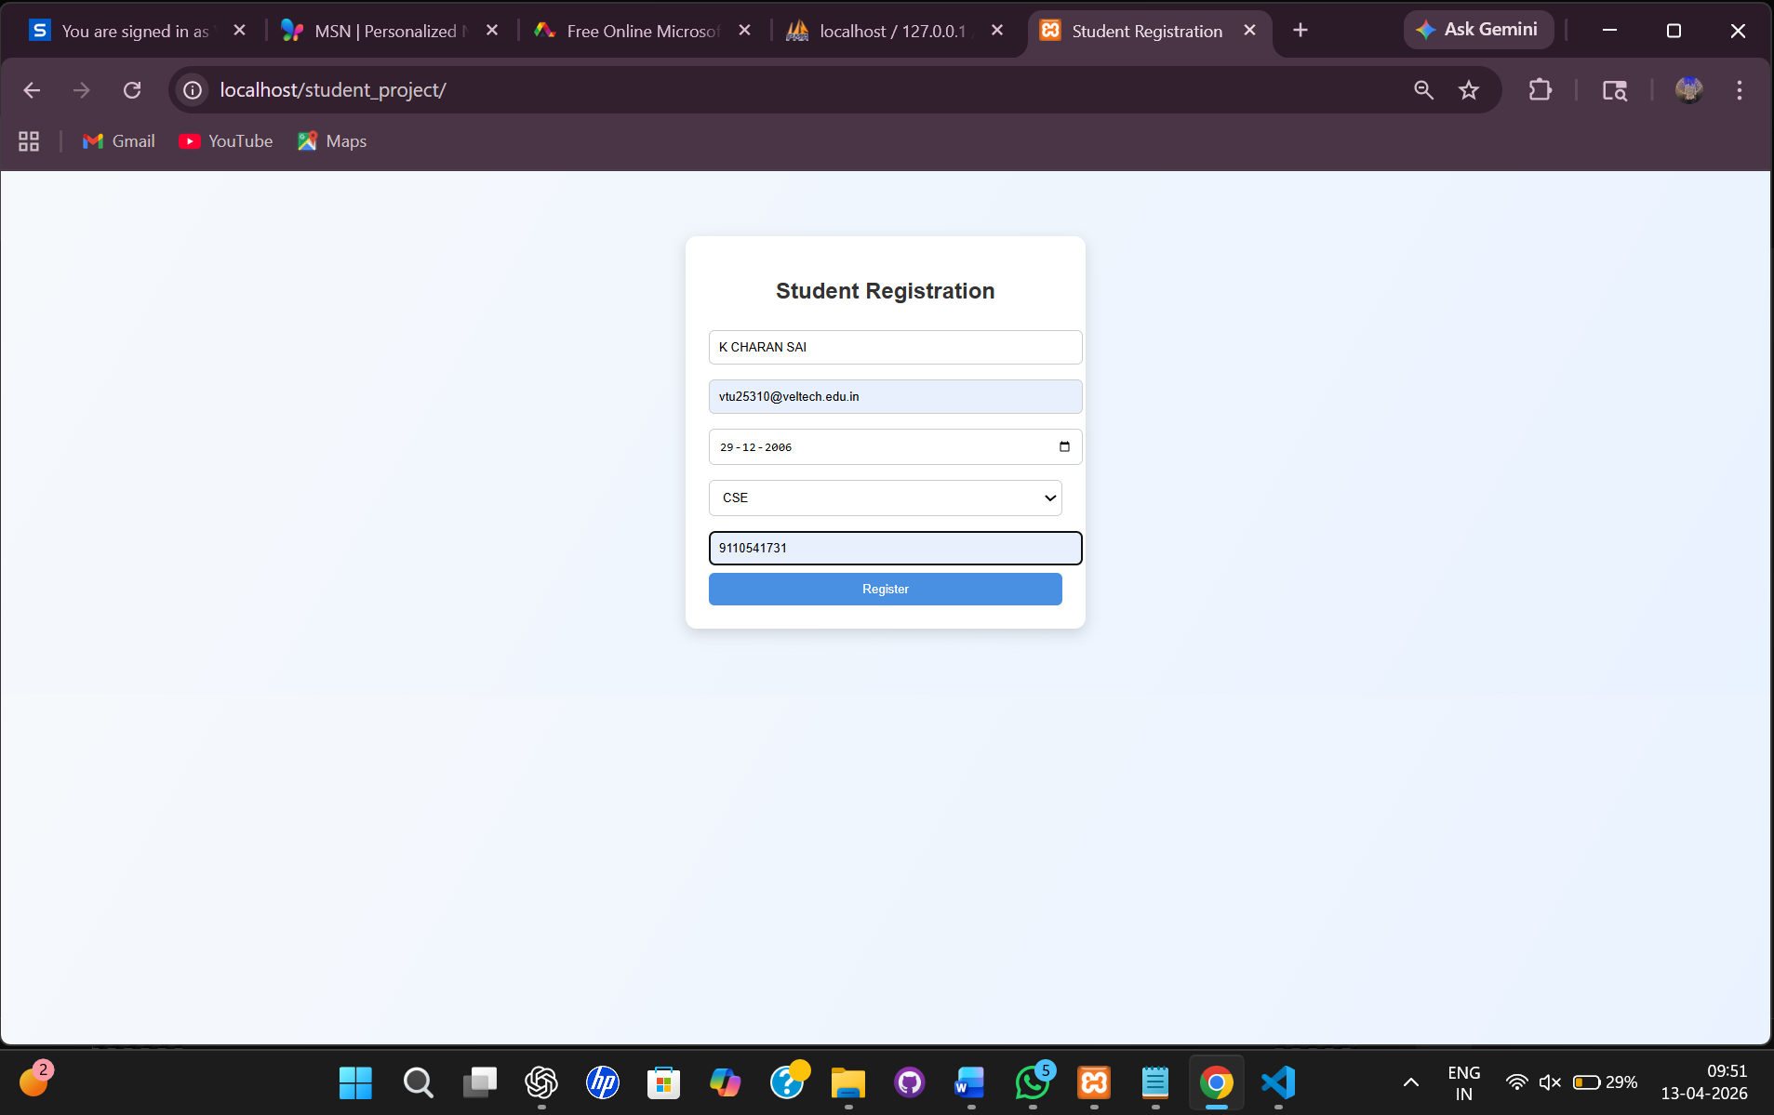

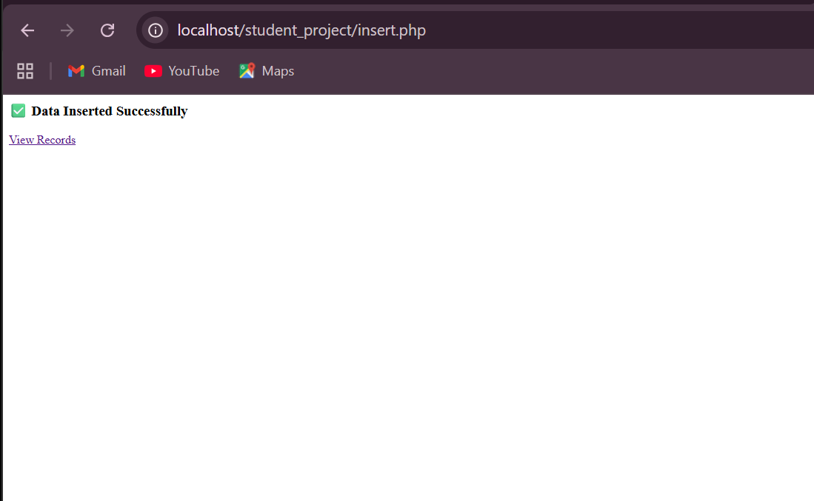

Records will be stored
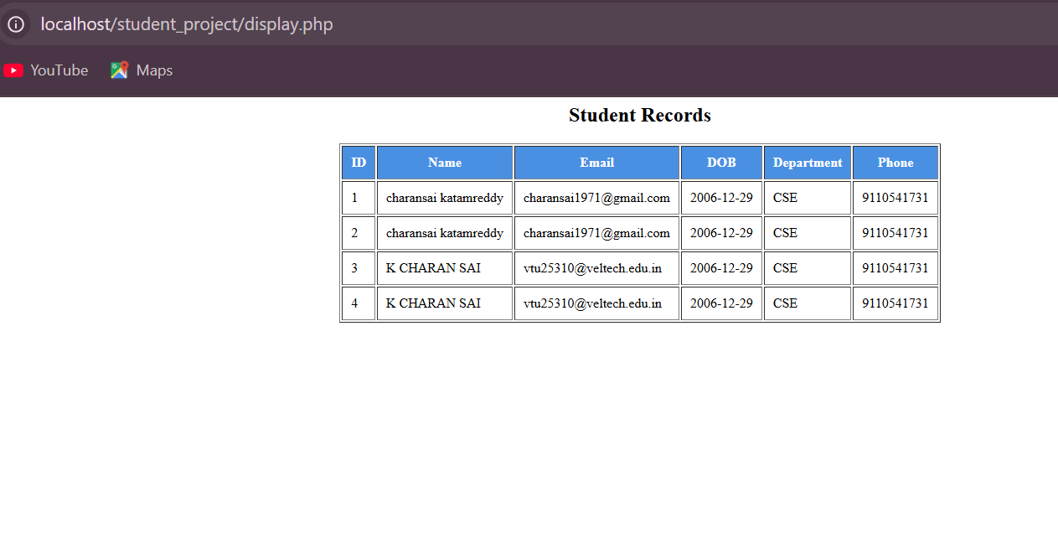

Result:
The student registration system was successfully implemented. The user inputs are collected through an HTML form, stored in the MySQL database using PHP, and retrieved using the SQL SELECT query. The data is displayed correctly in a tabular format.

