VEL TECH RANGARAJAN DR. SAGUNTHALA R&D INSTITUTE OF SCIENCE AND TECHNOLOGY
Department: Computer Science and Engineering
Course: Full Stack Application Development
Topic: SQL Commands Implementation using XAMPP (phpMyAdmin)

1. DATABASE OVERVIEW
Database Name: fsad_lab
Description:
This database is created using XAMPP MySQL through phpMyAdmin to demonstrate SQL concepts such as triggers, date functions, indexes, built-in functions, and user-defined functions.
Tables Used:
- employees
- orders
- employee_audit
- users
SQL Commands Used:
CREATE DATABASE fsad_lab;
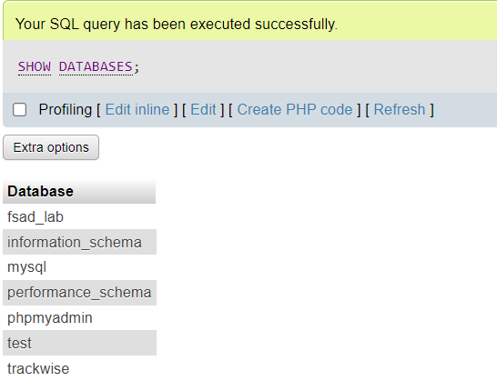

2. TABLE CREATION
Purpose: Create required tables to store employee, order, and user data.
Implementation:
CREATE TABLE employees (
id INT AUTO_INCREMENT PRIMARY KEY,
name VARCHAR(50),
salary DECIMAL(10,2),
department VARCHAR(50),
experience INT,
created_at TIMESTAMP
);
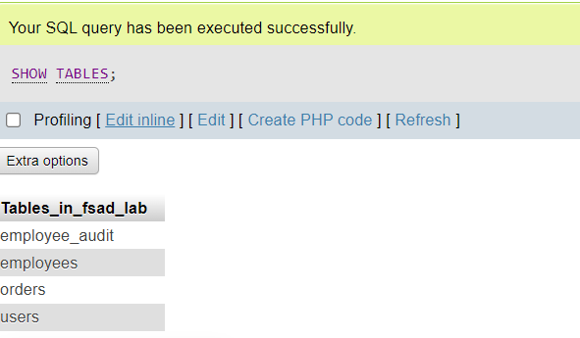

3. TRIGGERS

3.1 Prevent Negative Salary
Purpose: Prevent inserting employees with negative salary.
DELIMITER $$
CREATE TRIGGER check_salary
BEFORE INSERT ON employees
FOR EACH ROW
BEGIN
IF NEW.salary < 0 THEN
SIGNAL SQLSTATE '45000'
SET MESSAGE_TEXT = 'Salary cannot be negative';
END IF;
END$$
DELIMITER ;
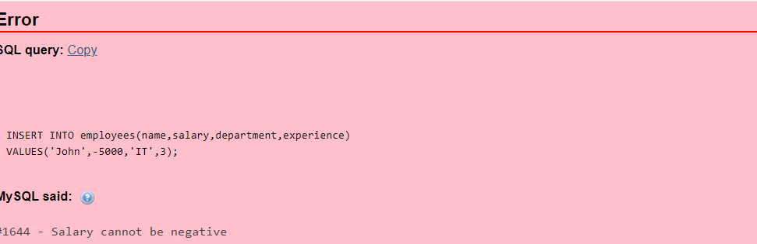

3.2 Automatic Timestamp
Purpose: Automatically insert current timestamp when employee record is added.
DELIMITER $$
CREATE TRIGGER set_timestamp
BEFORE INSERT ON employees
FOR EACH ROW
BEGIN
SET NEW.created_at = NOW();
END$$
DELIMITER ;
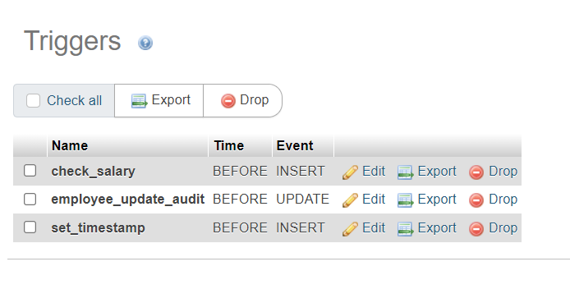

3.3 Employee Audit Log
Purpose: Store old employee data when an update occurs.
DELIMITER $$
CREATE TRIGGER employee_update_audit
BEFORE UPDATE ON employees
FOR EACH ROW
BEGIN
INSERT INTO employee_audit(emp_id, old_name, old_salary)
VALUES (OLD.id, OLD.name, OLD.salary);
END$$
DELIMITER ;
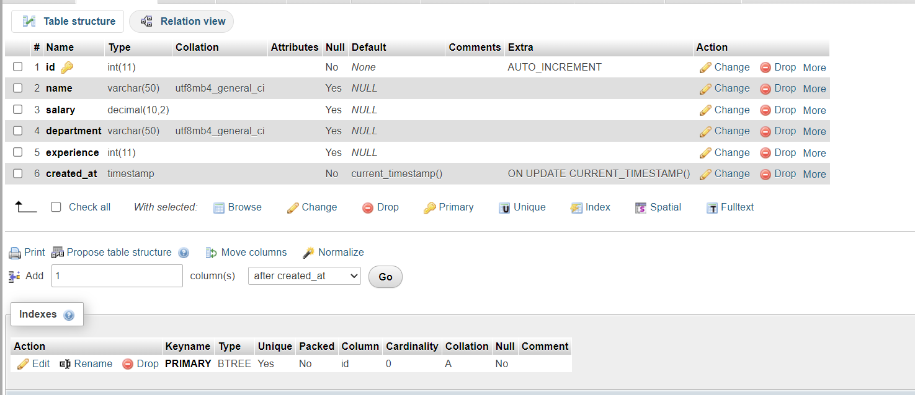

4. SQL DATE FUNCTIONS
Purpose: Perform operations using SQL date functions.
SELECT DATEDIFF('2026-03-10','2026-03-01') AS days_between;
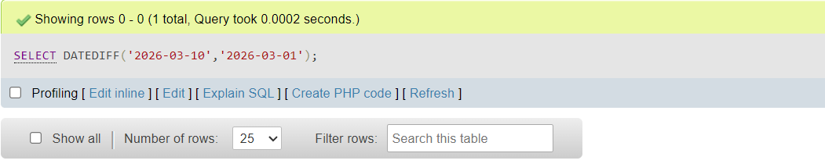
SELECT MONTHNAME(STR_TO_DATE('15-08-2025','%d-%m-%Y'));
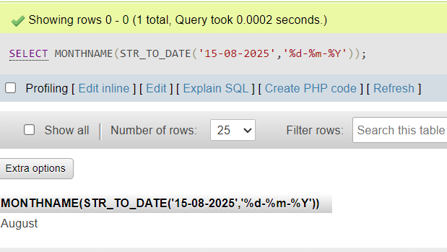
SELECT DATE_ADD(CURDATE(), INTERVAL 30 DAY);
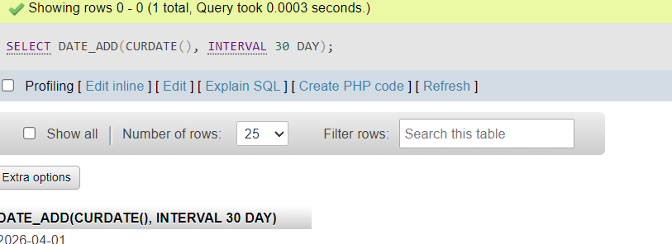

SELECT DATE_SUB(CURDATE(), INTERVAL 7 DAY);
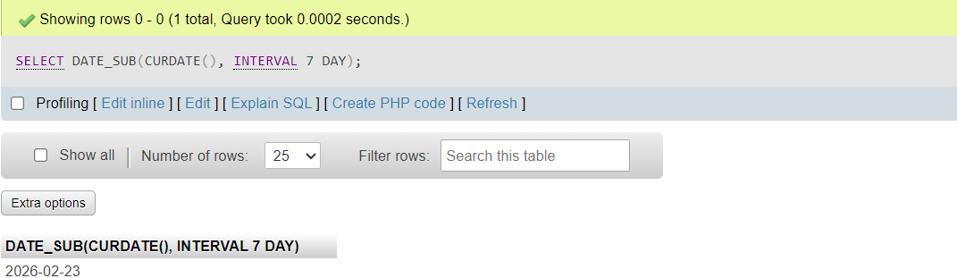

SELECT MONTHNAME(STR_TO_DATE('15-08-2025','%d-%m-%Y'));

5. INDEXES
Purpose: Improve search performance using indexes.
CREATE INDEX idx_email
ON users(email);
CREATE UNIQUE INDEX unique_username
ON users(username);
CREATE INDEX idx_aadhar
ON users(aadhar);
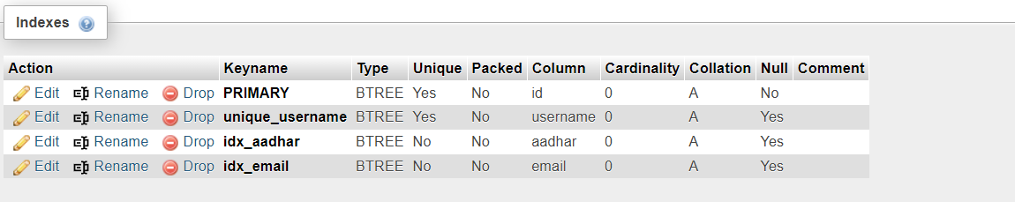

6. SQL BUILT-IN FUNCTIONS
Purpose: Use built-in SQL functions for string and aggregation operations.
SELECT CONCAT(SUBSTRING_INDEX(email,'@',1),'123')
FROM users;
SELECT department, AVG(experience)
FROM employees
GROUP BY department;
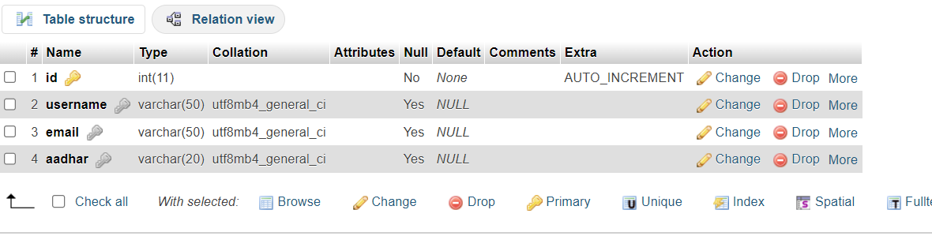

7. USER DEFINED FUNCTIONS

7.1 Net Salary Function
DELIMITER $$
CREATE FUNCTION net_salary(salary DECIMAL(10,2))
RETURNS DECIMAL(10,2)
DETERMINISTIC
BEGIN
RETURN salary - (salary * 0.10);
END$$
DELIMITER ;
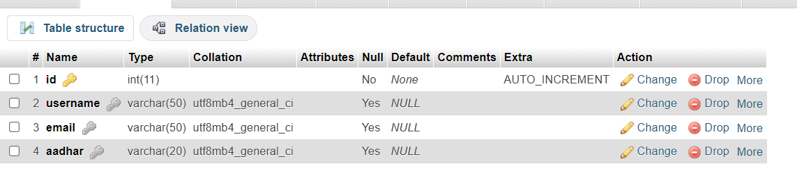

7.2 Experience Category Function
DELIMITER $$
CREATE FUNCTION experience_category(exp INT)
RETURNS VARCHAR(20)
DETERMINISTIC
BEGIN
IF exp < 2 THEN
RETURN 'Fresher';
ELSEIF exp BETWEEN 2 AND 5 THEN
RETURN 'Junior';
ELSEIF exp BETWEEN 6 AND 10 THEN
RETURN 'Mid';
ELSE
RETURN 'Senior';
END IF;
END$$
DELIMITER ;
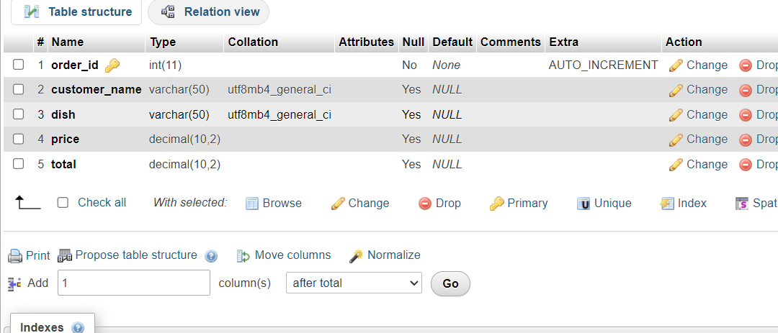

8. CONCLUSION
All SQL tasks including triggers, date functions, indexes, built-in functions, and user-defined functions were successfully executed using XAMPP MySQL and phpMyAdmin.

