Task 1:Create a Basic Servlet-based Spring boot web application.
• Create a Spring Boot project with spring-boot-starter-web and
Springboot Dev tools dependency.
• Run the embedded Tomcat servlet container
• Verify the application startup and default servlet behavior.
• Configure the port number in application.properties.

Step 1: Set Up Spring Boot Project in Eclipse
- Open Eclipse IDE.
- Go to File → New → Spring Starter Project.
- Fill in project details:
  - Name: BasicServletApp
  - Type: Maven Project
  - Packaging: Jar
  - Java Version: 17
  - Group: com.example
  - Artifact: basicservletapp
- Click Next.
Step 2: Add Dependencies
Spring Web → Provides spring-boot-starter-web (for servlet & REST support).
Spring Boot DevTools → Enables hot reload for faster development.

Step 3: Verify pom.xml
<?xml version="1.0" encoding="UTF-8"?>
<project xmlns="http://maven.apache.org/POM/4.0.0" xmlns:xsi="http://www.w3.org/2001/XMLSchema-instance"
xsi:schemaLocation="http://maven.apache.org/POM/4.0.0 https://maven.apache.org/xsd/maven-4.0.0.xsd">
<modelVersion>4.0.0</modelVersion>
<parent>
<groupId>org.springframework.boot</groupId>
<artifactId>spring-boot-starter-parent</artifactId>
<version>4.0.3</version>
<relativePath/> <!-- lookup parent from repository -->
</parent>
<groupId>com.example</groupId>
<artifactId>basicservletapp</artifactId>
<version>0.0.1-SNAPSHOT</version>
<name>BasicServletApp</name>
<description>Demo project for Spring Boot</description>
<url/>
<licenses>
<license/>
</licenses>
<developers>
<developer/>
</developers>
<scm>
<connection/>
<developerConnection/>
<tag/>
<url/>
</scm>
<properties>
<java.version>17</java.version>
</properties>
<dependencies>
<dependency>
<groupId>org.springframework.boot</groupId>
<artifactId>spring-boot-starter-webmvc</artifactId>
</dependency>
<dependency>
<groupId>org.springframework.boot</groupId>
<artifactId>spring-boot-devtools</artifactId>
<scope>runtime</scope>
<optional>true</optional>
</dependency>
<dependency>
<groupId>org.springframework.boot</groupId>
<artifactId>spring-boot-starter-webmvc-test</artifactId>
<scope>test</scope>
</dependency>
</dependencies>

<build>
<plugins>
<plugin>
<groupId>org.springframework.boot</groupId>
<artifactId>spring-boot-maven-plugin</artifactId>
</plugin>
</plugins>
</build>
</project>

Step 4: Create the Main Application Class
Inside src/main/java/com/example/demo, creating BasicServletAppApplication.java:
package com.example.demo;
import org.springframework.boot.SpringApplication;
import org.springframework.boot.autoconfigure.SpringBootApplication;

@SpringBootApplication
public class BasicServletAppApplication {

public static void main(String[] args) {
SpringApplication.run(BasicServletAppApplication.class, args);
}
}
Step 5: Create a Basic Servlet
Create a package com.example.demo.servlet.
Create a servlet class HelloServlet.java:
package com.example.demo.servlet;
import java.io.IOException;
import jakarta.servlet.ServletException;
import jakarta.servlet.annotation.WebServlet;
import jakarta.servlet.http.HttpServlet;
import jakarta.servlet.http.HttpServletRequest;
import jakarta.servlet.http.HttpServletResponse;
@WebServlet("/hello")
public class HelloServlet extends HttpServlet {
private static final long serialVersionUID = 1L;
@Override
protected void doGet(HttpServletRequest req, HttpServletResponse resp)
throws ServletException, IOException {
resp.getWriter().write("Hello from Servlet!");
}
}
Register the Servlet with Spring Boot
package com.example.demo;
import org.springframework.boot.SpringApplication;
import org.springframework.boot.autoconfigure.SpringBootApplication;

import org.springframework.boot.web.servlet.ServletRegistrationBean;
import org.springframework.context.annotation.Bean;
import com.example.demo.servlet.HelloServlet;
@SpringBootApplication
public class BasicServletAppApplication {
public static void main(String[] args) {
SpringApplication.run(BasicServletAppApplication.class, args);
}
@Bean
Public ServletRegistrationBean<HelloServlet> servletRegistrationBean() {
return new ServletRegistrationBean<>(new HelloServlet(), "/hello");
}
}

Step 6: Configure Port in application.properties
Create src/main/resources/application.properties and set a custom port (optional, default is 8080):
spring.application.name=BasicServletApp
server.port=9090

Step 7: Run the Application in Eclipse
- Right-click on BasicServletAppApplication.java.
- Select Run As → Java Application.

Step 8: Verify Servlet
http://localhost:9090/hello

Output:
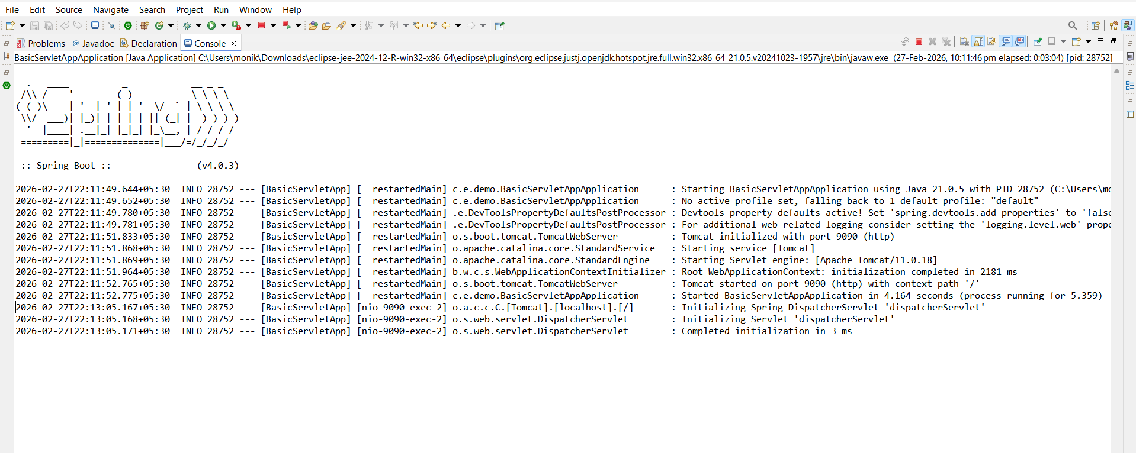

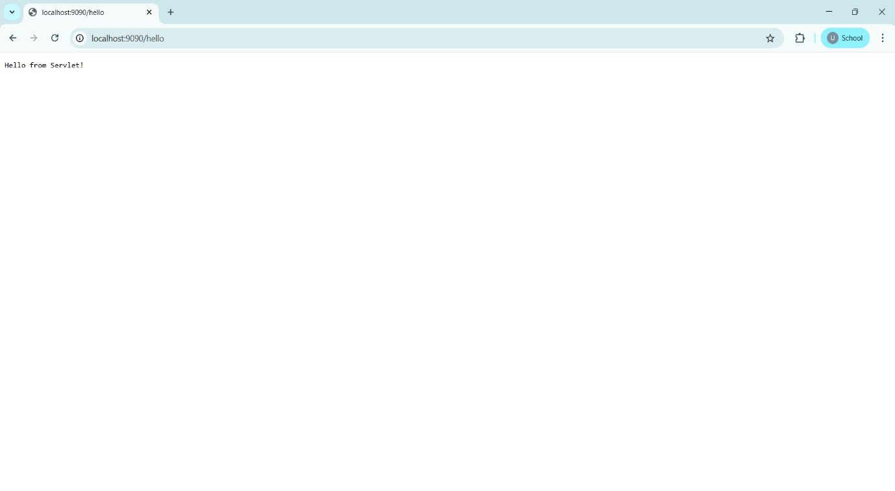
Project Structure Image:
