Task 1. Given a list of integers, find the second highest number in the list using stream API. If there is no second highest number (all elements same or only one element), print -1.
Input Format:
First line: An integer N - the number of integers in the list.
Second line: N space-separated integers - the elements of the list.
Output Format:
Print a single integer - the second highest number. Print -1 if it does not exist.
Sample Input 1:
5
4 2 8 1 5
Sample Output 1:
5
Sample Input 2:
3
5 5 5
Sample Output 2:
-1
Program:
import java.util.*;
import java.util.stream.*;

public class Task1
{
public static void main(String[] args) {
Scanner sc = new Scanner(System.in);
// Read number of elements
System.out.print("Enter number of elements: ");
int n = sc.nextInt();
System.out.println("Enter elements:");
List<Integer> list = new ArrayList<>();
for (int i = 0; i < n; i++) {
list.add(sc.nextInt());
}
// Use Stream API to get distinct elements sorted in descending order
List<Integer> sortedDesc = list.stream()
.distinct()
.sorted(Comparator.reverseOrder())
.collect(Collectors.toList());
if (sortedDesc.size() < 2) {
System.out.println(-1);
} else {
System.out.println(sortedDesc.get(1)); // second highest
}
sc.close();
}
}

Output: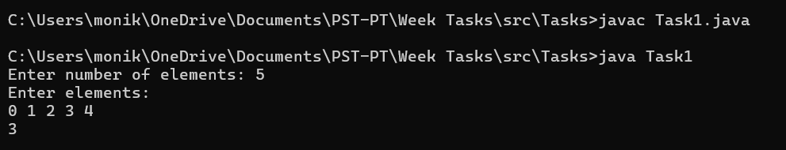

Task 2. Write the following methods that return a lambda expression performing a specified action:
- PerformOperation isOdd(): The lambda expression must return true if a number is odd or false if it is even.
- PerformOperation isPrime(): The lambda expression must return true if a number is prime or false if it is composite.
- PerformOperation isPalindrome(): The lambda expression must return true if a number is a palindrome or false if it is not.
Input Format
The first line contains an integer, (the number of test cases).
The subsequent lines each describe a test case in the form of space-separated integers:
The first integer specifies the condition to check for (for Odd/Even, for Prime, or for Palindrome). The second integer denotes the number to be checked.
Sample Input:
5
1 4
2 5
3 898
1 3
2 12
Sample Output
EVEN
PRIME
PALINDROME
ODD
COMPOSITE
Program:
import java.util.*;
import java.util.function.*;

interface PerformOperation {
boolean check(int n);
}
public class Task2
{
// Lambda for checking odd
public static PerformOperation isOdd() {
return n -> n % 2 != 0;
}
// Lambda for checking prime
public static PerformOperation isPrime() {
return n -> {
if (n <= 1) return false;
for (int i = 2; i <= Math.sqrt(n); i++) {
if (n % i == 0) return false;
}
return true;
};
}
// Lambda for checking palindrome
public static PerformOperation isPalindrome() {
return n -> {
String s = String.valueOf(n);
String rev = new StringBuilder(s).reverse().toString();
return s.equals(rev);
};
}
public static void main(String[] args) {
Scanner sc = new Scanner(System.in);
System.out.print("Enter number of test cases: ");
int t = sc.nextInt();
for (int i = 0; i < t; i++) {
int choice = sc.nextInt();
int num = sc.nextInt();
PerformOperation op;
String result = "";
switch (choice) {
case 1: // Odd/Even
op = isOdd();
result = op.check(num) ? "ODD" : "EVEN";
break;
case 2: // Prime
op = isPrime();
result = op.check(num) ? "PRIME" : "COMPOSITE";
break;
case 3: // Palindrome
op = isPalindrome();
result = op.check(num) ? "PALINDROME" : "NOT PALINDROME";
break;
default:
result = "INVALID CHOICE";
}
System.out.println(result);
}
sc.close();
}
}

Output:
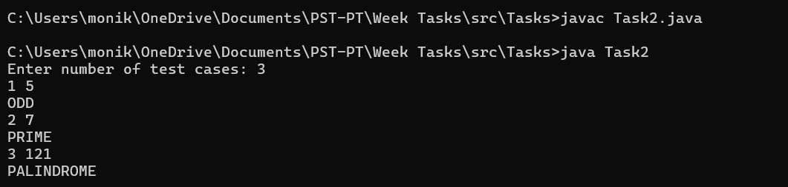

Task 3. Given a list of persons, each with a name (String) and age (integer).Sort the persons alphabetically by name using method references. Filter the persons older than a given age limit using a static method reference. Convert all names to uppercase using an instance method reference.
Input Format
The first line contains an integer n — the number of persons.
The next n lines each contain a string name and an integer age separated by a space.
The last line contains an integer ageLimit — the age threshold for filtering.
Output Format
First line: sorted names (alphabetically), space-separated.
Second line: names of persons older than ageLimit, space-separated, in the order they appear in the input.
Third line: all names in uppercase, space-separated, in the original order.
Name contains only uppercase and lowercase English letters
Sample Input-1:
3
Alice 23
Bob 30
Charlie 25
24
Sample Output-1:
Alice Bob Charlie
Bob Charlie
ALICE BOB CHARLIE
Program:
import java.util.*;
import java.util.stream.*;

// Person class
class Person {
String name;
int age;
Person(String name, int age) {
this.name = name;
this.age = age;
}
// Instance method to convert name to uppercase
public String getNameUpperCase() {
return name.toUpperCase();
}
// Static method to filter by age
public static boolean isOlderThan(Person p, int ageLimit) {
return p.age > ageLimit;
}
}
public class Task3 {
public static void main(String[] args) {
Scanner sc = new Scanner(System.in);
// Read number of persons
int n = sc.nextInt();
sc.nextLine(); // consume newline
List<Person> persons = new ArrayList<>();
// Read person data
for (int i = 0; i < n; i++) {
String[] parts = sc.nextLine().split(" ");
String name = parts[0];
int age = Integer.parseInt(parts[1]);
persons.add(new Person(name, age));
}
// Read age limit
int ageLimit = sc.nextInt();
// 1. Sorted names alphabetically
List<String> sortedNames = persons.stream()
.sorted(Comparator.comparing(p -> p.name)) // method reference can also be Comparator.comparing(Person::getName)
.map(p -> p.name)
.collect(Collectors.toList());
System.out.println(String.join(" ", sortedNames));
// 2. Names of persons older than ageLimit
List<String> filteredNames = persons.stream()
.filter(p -> Person.isOlderThan(p, ageLimit)) // static method reference via lambda
.map(p -> p.name)
.collect(Collectors.toList());
System.out.println(String.join(" ", filteredNames));
// 3. Names in uppercase using instance method reference
List<String> upperCaseNames = persons.stream()
.map(Person::getNameUpperCase)
.collect(Collectors.toList());
System.out.println(String.join(" ", upperCaseNames));
sc.close();
}
}

Output:
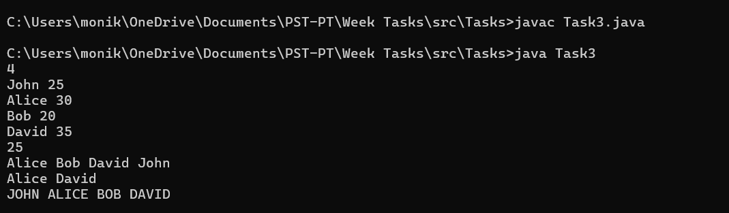

Task 4. A list of events is given, each with a unique name and a date in the format yyyy-MM-dd. The goal is to process this list using Java’s Date and Time API (java.time) to perform the following operations: first, sort all events chronologically by date; second, determine the earliest and latest events in the list; and third, given a month number, identify all events that occur in that specific month. The solution should handle parsing dates, sorting them, and filtering based on the month efficiently using the Date and Time API.
Sample Input-1:
5
EventA 2025-12-17
EventB 2024-01-10
EventC 2025-06-05
EventD 2024-12-31
EventE 2025-12-01
12
Sample Output-1:
EventB EventD EventC EventE EventA
EventB
EventA
EventE EventA
Program:
import java.time.LocalDate;
import java.time.format.DateTimeFormatter;
import java.util.*;
import java.util.stream.*;

class Event {
String name;
LocalDate date;
Event(String name, String dateStr) {
this.name = name;
// Parse date from yyyy-MM-dd
this.date = LocalDate.parse(dateStr, DateTimeFormatter.ISO_LOCAL_DATE);
}
}
public class Task4 {
public static void main(String[] args) {
Scanner sc = new Scanner(System.in);
// Read number of events
int n = sc.nextInt();
sc.nextLine(); // consume newline
List<Event> events = new ArrayList<>();
// Read events
for (int i = 0; i < n; i++) {
String line = sc.nextLine();
String[] parts = line.split(" ");
String name = parts[0];
String dateStr = parts[1];
events.add(new Event(name, dateStr));
}
// Read month number for filtering
int monthFilter = sc.nextInt();
// 1. Sort events chronologically
List<Event> sortedEvents = events.stream()
.sorted(Comparator.comparing(e -> e.date))
.collect(Collectors.toList());
System.out.println(sortedEvents.stream()
.map(e -> e.name)
.collect(Collectors.joining(" ")));
// 2. Earliest and latest events
Event earliest = sortedEvents.get(0);
Event latest = sortedEvents.get(sortedEvents.size() - 1);
System.out.println(earliest.name);
System.out.println(latest.name);
// 3. Events in the given month
List<String> eventsInMonth = events.stream()
.filter(e -> e.date.getMonthValue() == monthFilter)
.map(e -> e.name)
.collect(Collectors.toList());
System.out.println(String.join(" ", eventsInMonth));
sc.close();
}
}

Output:
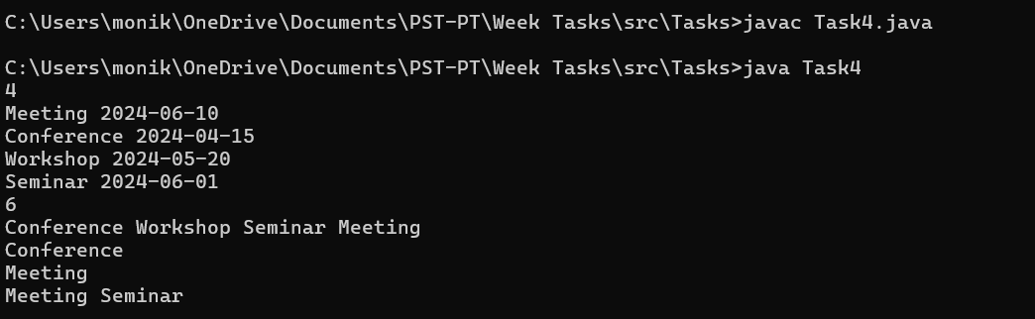

Task 5. A list of students is given, where each student has a name and total marks. The task is to sort students based on marks in descending order. If two students have the same marks, they must be sorted alphabetically by name. Finally, collect the top K students using Java Streams and Collectors API.

Input Format
The first line contains an integer N, the number of students.
The next N lines contain student details in the format: name marks
The last line contains an integer K, representing the number of top students to display.

Output Format:
Print the names of the top K students in sorted order, separated by space.

Sample Input-1:
6
Arun 85
Bala 92
Charan 85
Divya 95
Esha 92
Farhan 88
3

Sample Output-1:
Divya Bala Esha

Program:
import java.util.*;
import java.util.stream.*;

class Student {
String name;
int marks;
Student(String name, int marks) {
this.name = name;
this.marks = marks;
}
}
public class Task5 {
public static void main(String[] args) {
Scanner sc = new Scanner(System.in);
int n = sc.nextInt();
List<Student> students = new ArrayList<>();
for (int i = 0; i < n; i++) {
String name = sc.next();
int marks = sc.nextInt();
students.add(new Student(name, marks));
}
int k = sc.nextInt();
List<Student> topK = students.stream()
.sorted(Comparator
.comparingInt((Student s) -> s.marks).reversed()
.thenComparing(s -> s.name))
.limit(k)
.collect(Collectors.toList());
topK.forEach(s -> System.out.print(s.name + " "));
}
}

Output:
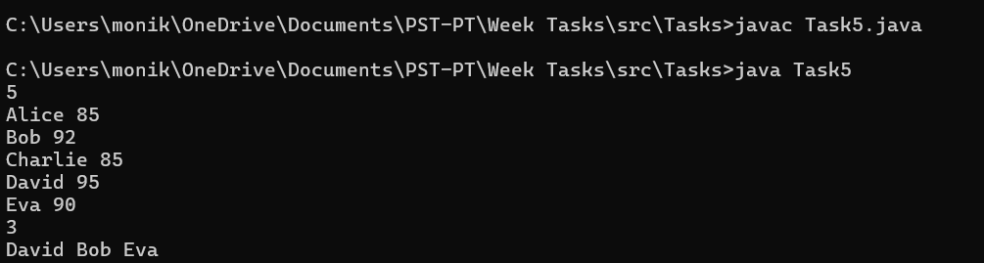

Task 6.A list of sales records is given, where each record contains a category name, item name, and sales amount. The task is to calculate the total sales for each category and also identify the item that contributed the maximum sales amount within that category.

Input Format
The first line contains an integer N, representing the number of sales records.
The next N lines contain sales details in the format:
category itemName amount

Output Format
For each category, print the category name, total sales amount, and the item name with the highest sales in that category.Categories should be printed in the order of first appearance.
Sample Input-1:
7
Electronics TV 50000
Electronics Mobile 40000
Furniture Sofa 30000
Electronics Laptop 70000
Furniture Chair 15000
Furniture Table 20000
Electronics Headphones 10000

Sample Output-1:
Electronics 170000 Laptop
Furniture 65000 Sofa
Program:
import java.util.*;

class SalesRecord {
String category;
String itemName;
int amount;
SalesRecord(String category, String itemName, int amount) {
this.category = category;
this.itemName = itemName;
this.amount = amount;
}
}
public class Task6 {
public static void main(String[] args) {
Scanner sc = new Scanner(System.in);
// Read number of sales records
int n = sc.nextInt();
sc.nextLine(); // consume newline
List<SalesRecord> records = new ArrayList<>();
LinkedHashMap<String, Integer> totalSalesMap = new LinkedHashMap<>();
LinkedHashMap<String, SalesRecord> maxItemMap = new LinkedHashMap<>();
// Read sales records
for (int i = 0; i < n; i++) {
String[] parts = sc.nextLine().split(" ");
String category = parts[0];
String item = parts[1];
int amount = Integer.parseInt(parts[2]);
SalesRecord record = new SalesRecord(category, item, amount);
records.add(record);
// Update total sales
totalSalesMap.put(category, totalSalesMap.getOrDefault(category, 0) + amount);
// Update max item for category
if (!maxItemMap.containsKey(category) || amount > maxItemMap.get(category).amount) {
maxItemMap.put(category, record);
}
}
// Print results in order of first appearance
for (String category : totalSalesMap.keySet()) {
int total = totalSalesMap.get(category);
String maxItem = maxItemMap.get(category).itemName;
System.out.println(category + " " + total + " " + maxItem);
}
sc.close();
}
}

Output:
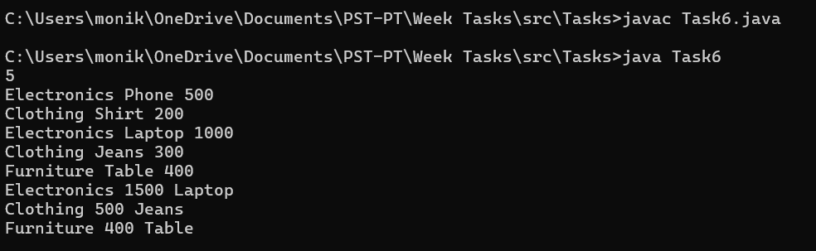

Task 7.Given an array arr[], Find the prefix sum of the array. A prefix sum array is another array prefixSum[] of the same size, such that prefixSum[i] is arr[0] + arr[1] + arr[2] . . . arr[i].

Sample Input-1:
5
10 20 10 5 15

Sample Output-1:
10 30 40 45 60
Explanation: For each index i, add all the elements from 0 to I
Program:
import java.util.*;

public class Task7 {
public static void main(String[] args) {
Scanner sc = new Scanner(System.in);
// Read number of elements
System.out.print("Enter number of elements: ");
int n = sc.nextInt();
int[] arr = new int[n];
int[] prefixSum = new int[n];
System.out.println("Enter array elements:");
for (int i = 0; i < n; i++) {
arr[i] = sc.nextInt();
}
// Compute prefix sum
prefixSum[0] = arr[0];
for (int i = 1; i < n; i++) {
prefixSum[i] = prefixSum[i - 1] + arr[i];
}
// Print prefix sum array
for (int i = 0; i < n; i++) {
System.out.print(prefixSum[i] + " ");
}
sc.close();
}
}

Output:
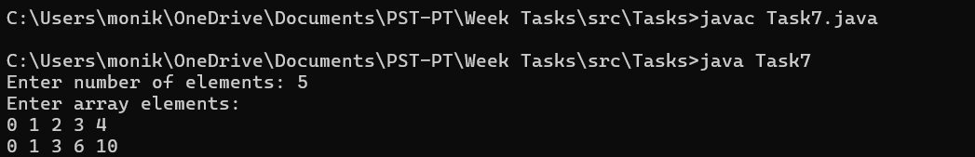

Task 8.You are given an array of integers nums, there is a sliding window of size k which is moving from the very left of the array to the very right. You can only see the k numbers in the window. Each time the sliding window moves right by one position. Return the max sliding window.

Sample Input 1: nums = [1,3,-1,-3,5,3,6,7], k = 3

Sample Output 1: [3,3,5,5,6,7]
Explanation:
Window position Max
--------------- -----
[1 3 -1] -3 5 3 6 7 3
1 [3 -1 -3] 5 3 6 7 3
1 3 [-1 -3 5] 3 6 7 5
1 3 -1 [-3 5 3] 6 7 5
1 3 -1 -3 [5 3 6] 7 6
1 3 -1 -3 5 [3 6 7] 7

Sample Input-2:
nums = [1], k = 1
Sample Output-2: [1]
Program:
import java.util.*;

public class Task8 {
public static int[] maxSlidingWindow(int[] nums, int k) {
if (nums == null || k <= 0) return new int[0];
int n = nums.length;
int[] result = new int[n - k + 1];
Deque<Integer> deque = new LinkedList<>(); // stores indices
for (int i = 0; i < n; i++) {
// Remove indices out of window
while (!deque.isEmpty() && deque.peekFirst() < i - k + 1) {
deque.pollFirst();
}
// Remove indices whose values are less than current element
while (!deque.isEmpty() && nums[deque.peekLast()] < nums[i]) {
deque.pollLast();
}
// Add current index
deque.offerLast(i);
// Add max to result starting from i >= k - 1
if (i >= k - 1) {
result[i - k + 1] = nums[deque.peekFirst()];
}
}
return result;
}
public static void main(String[] args) {
Scanner sc = new Scanner(System.in);
// Read number of elements
System.out.print("Enter number of elements: ");
int n = sc.nextInt();
int[] nums = new int[n];
System.out.println("Enter array elements:");
for (int i = 0; i < n; i++) {
nums[i] = sc.nextInt();
}
// Read k
System.out.print("Enter window size k: ");
int k = sc.nextInt();
int[] maxWindow = maxSlidingWindow(nums, k)
// Print output
for (int num : maxWindow) {
System.out.print(num + " ");
}
sc.close();
}
}

Output:
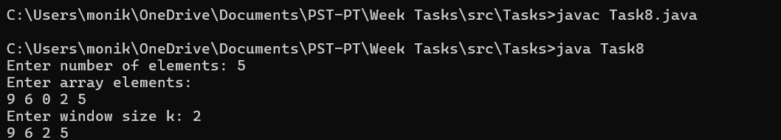

Task 9. Given an integer array nums sorted in non-decreasing order, remove the duplicates in-place such that each unique element appears only once. The relative order of the elements should be kept the same.
Consider the number of unique elements in nums to be k. After removing duplicates, return the number of unique elements k.
The first k elements of nums should contain the unique numbers in sorted order. The remaining elements beyond index k - 1 can be ignored.
Sample input 1:
nums = [1,1,2]
Sample Output: 2, nums = [1,2]
Explanation: Your function should return k = 2, with the first two elements of nums being 1 and 2 respectively.
Sample input 2:
nums = [0,0,1,1,1,2,2,3,3,4]
Sample Output -2: 5, nums = [0,1,2,3,4]
Explanation: Your function should return k = 5, with the first five elements of nums being 0, 1, 2, 3, and 4 respectively.
Program:
import java.util.*;

public class Task9 {
// Function to remove duplicates in-place
public static int removeDuplicates(int[] nums) {
if (nums.length == 0) return 0;
int k = 1; // pointer for unique elements
for (int i = 1; i < nums.length; i++) {
if (nums[i] != nums[k - 1]) {
nums[k] = nums[i];
k++;
}
}
return k;
}
public static void main(String[] args) {
Scanner sc = new Scanner(System.in);
// Read number of elements
System.out.print("Enter number of elements: ");
int n = sc.nextInt();
int[] nums = new int[n];
System.out.println("Enter sorted array elements:");
for (int i = 0; i < n; i++) {
nums[i] = sc.nextInt();
}
// Remove duplicates
int k = removeDuplicates(nums);
// Print results
System.out.println("Number of unique elements: " + k);
System.out.print("Modified array: ");
for (int i = 0; i < k; i++) {
System.out.print(nums[i] + " ");
}
sc.close();
}
}

Output:
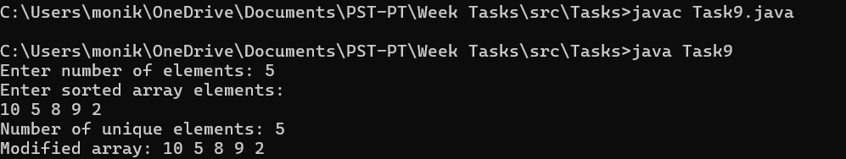

Task 10. Given a word pattern and a string text consisting of lowercase characters, the task is to return the count of substrings in text which are anagrams of the pattern.

Sample Input-1: text = "forxxorfxdofr", pattern = "for"
Sample Output-1: 3
Explanation: Anagrams present are for, orf and ofr. Each appears in the text once and hence the count is 3.

Sample Input-2: text = "aabaabaa", pattern = "aaba"
Sample Output-2: 4
Explanation : Anagrams present are aaba and abaa. Each appears twice in the text and hence the count is 4.
Program:
import java.util.*;

public class Task10 {
public static int countAnagrams(String text, String pattern) {
int n = text.length();
int k = pattern.length();
if (k > n) return 0;
int count = 0;
int[] patternFreq = new int[26];
int[] windowFreq = new int[26];
// Fill frequency for pattern and first window
for (int i = 0; i < k; i++) {
patternFreq[pattern.charAt(i) - 'a']++;
windowFreq[text.charAt(i) - 'a']++;
}
// Check first window
if (Arrays.equals(patternFreq, windowFreq)) {
count++;
}
// Sliding window
for (int i = k; i < n; i++) {
windowFreq[text.charAt(i) - 'a']++;
windowFreq[text.charAt(i - k) - 'a']--;
if (Arrays.equals(patternFreq, windowFreq)) {
count++;
}
}
return count;
}
public static void main(String[] args) {
Scanner sc = new Scanner(System.in);
// Taking input from user
System.out.print("Enter text: ");
String text = sc.nextLine();
System.out.print("Enter pattern: ");
String pattern = sc.nextLine();
int result = countAnagrams(text, pattern);
System.out.println("Count of anagram substrings: " + result);
sc.close();
}
}

Output:
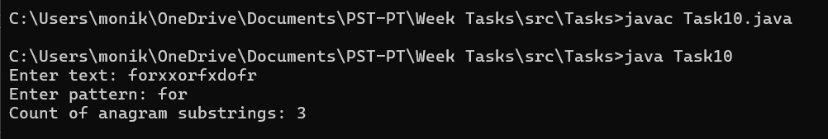
Task 11. You are given N integers. Find the count of numbers divisible by K.
Input Format
The input begins with two positive integers N,K. The next N lines contain one positive integer each denoted by Ai. Output a single number denoting how many integers are divisible by K.
Sample Input 1:
7 3
1
51
966369
7
9
999996
11
Sample Output-1:
4
Program:
import java.util.*;

public class Task11 {
public static void main(String[] args) {
Scanner sc = new Scanner(System.in);
// Read N and K
System.out.print("Enter N and K: ");
int N = sc.nextInt();
int K = sc.nextInt();
int count = 0;
System.out.println("Enter " + N + " numbers:");
// Read N numbers
for (int i = 0; i < N; i++) {
int num = sc.nextInt();
if (num % K == 0) {
count++;
}
}
// Output result
System.out.println("Count of numbers divisible by " + K + ": " + count);
sc.close();
}
}

Output:
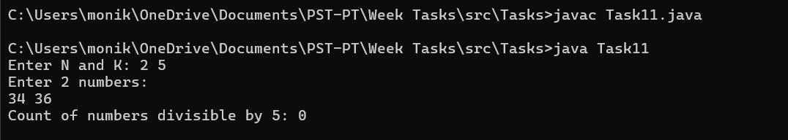

Task 12. Given a lowercase English string s of length n, encrypt it as follows:
Replace each contiguous group of the same character with the character followed by the lowercase hexadecimal representation of its length.
Reverse the entire modified string.
Return the encrypted string.
Note: All Hexadecimal letters should be converted to Lowercase letters.

Sample Input - 1: s = "aaaaaaaaaaa"
Sample Output - 1: ba
Explanation: Count consecutive characters: "aaaaaaaaaaa" → "a11".
Convert frequency to hexadecimal: "a11" → "ab".
Reverse the string: "ab" → "ba".

Sample Input 2: s = "abc"
Sample Output 2: 1c1b1a
Explanation: Convert to character-frequency format: "abc" → "a1b1c1".
Convert counts to hexadecimal (no change as 1 remains 1).
Reverse the string: "a1b1c1" → "1c1b1a".
Program:
import java.util.*;

public class Task12 {
public static String encrypt(String s) {
StringBuilder result = new StringBuilder();
int n = s.length();
int count = 1;
// Step 1: Count consecutive characters
for (int i = 1; i <= n; i++)
if (i < n && s.charAt(i) == s.charAt(i - 1)) {
count++;
} else {
// Convert count to hexadecimal
String hex = Integer.toHexString(count);
// Append character + hex value
result.append(s.charAt(i - 1));
result.append(hex);
count = 1; // reset count
}
}
// Step 2: Reverse the string
return result.reverse().toString();
}
public static void main(String[] args) {
Scanner sc = new Scanner(System.in);
// User input
System.out.print("Enter string: ");
String s = sc.nextLine();
String encrypted = encrypt(s);
// Output
System.out.println("Encrypted string: " + encrypted);
sc.close();
}
}

Output:
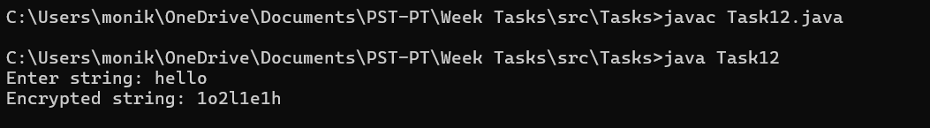

Task 13. Design a simple EntityRecord system to store and display information about multiple entities. Each EntityRecord has the following attributes:

Enrollment_ID (integer, unique identifier)
Student (string, name of the entity or person)
Course (string, type or classification of the entity)
Instructor (string, person responsible or associated with the entity)
startDate (string in YYYY-MM-DD format, representing creation or start date)
duration (integer, representing duration in appropriate units, e.g., weeks or months)

The task is to implement a program that reads multiple records, stores them, and displays the details of all records in the order they were added.
Sample Input-1:
3
101 Alice JavaBasics John 2025-12-20 6
102 Bob PythonAdvanced Mary 2025-12-22 8
103 Charlie DataScience Mike 2026-01-05 10
Sample Output-1:
Enrollment_ID: 101, Student: Alice, Course: JavaBasics, Instructor: John, Start Date: 2025-12-20, Duration: 6 weeks
Enrollment_ID: 102, Student: Bob, Course: PythonAdvanced, Instructor: Mary, Start Date: 2025-12-22, Duration: 8 weeks
Enrollment_ID: 103, Student: Charlie, Course: DataScience, Instructor: Mike, Start Date: 2026-01-05, Duration: 10 weeks
Program:
import java.util.*;

class EntityRecord {
int enrollmentId;
String student;
String course;
String instructor;
String startDate;
int duration;
// Constructor
public EntityRecord(int enrollmentId, String student, String course,
String instructor, String startDate, int duration) {
this.enrollmentId = enrollmentId;
this.student = student;
this.course = course;
this.instructor = instructor;
this.startDate = startDate;
this.duration = duration;
}
// Method to display record
public void display() {
System.out.println("Enrollment_ID: " + enrollmentId +
", Student: " + student +
", Course: " + course +
", Instructor: " + instructor +
", Start Date: " + startDate +
", Duration: " + duration + " weeks");
}
}
public class Task13 {
public static void main(String[] args) {
Scanner sc = new Scanner(System.in);
// Number of records
System.out.print("Enter number of records: ");
int n = sc.nextInt();
// List to store records
List<EntityRecord> records = new ArrayList<>();
System.out.println("Enter details (Enrollment_ID Student Course Instructor StartDate Duration):");
// Input records
for (int i = 0; i < n; i++) {
int id = sc.nextInt();
String student = sc.next();
String course = sc.next();
String instructor = sc.next();
String startDate = sc.next();
int duration = sc.nextInt();
records.add(new EntityRecord(id, student, course, instructor, startDate, duration));
}
// Display records
System.out.println("\nStored Records:");
for (EntityRecord record : records) {
record.display();
}
sc.close();
}
}

Output:
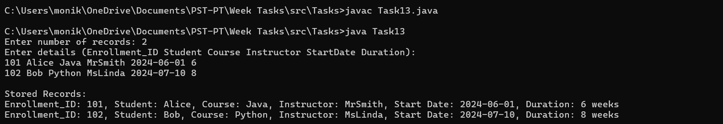

Task 14. Design a simple vehicle rental system using inheritance.There is a base class Vehicle with the following attributes:
vehicleId (integer, unique ID)
modelName (string)
baseRent (double)

There are two subclasses that inherit from Vehicle:

Car: has an additional attribute seats (integer).
The total rent for a car is calculated as baseRent + (seats * 100).

Bike: has an additional attribute engineCapacity (integer, in cc).
The total rent for a bike is calculated as baseRent + (engineCapacity * 2).

The task is to implement these classes and write a program that reads multiple vehicle records (Car or Bike), stores them, calculates the total rent for each vehicle, and then displays the vehicle details along with the total rent.

Sample Input-1:
3
C 101 HondaCivic 2000 5
B 102 YamahaR15 500 150
C 103 ToyotaCorolla 2500 4

Sample Output-1:
Vehicle ID: 101, Model: HondaCivic, Total Rent: 2500.0
Vehicle ID: 102, Model: YamahaR15, Total Rent: 800.0
Vehicle ID: 103, Model: ToyotaCorolla, Total Rent: 2900.0
Program:
import java.util.*;

// Base class
class Vehicle {
int vehicleId;
String modelName;
double baseRent;
public Vehicle(int vehicleId, String modelName, double baseRent) {
this.vehicleId = vehicleId;
this.modelName = modelName;
this.baseRent = baseRent;
}
// Method to calculate rent (to be overridden)
public double calculateRent() {
return baseRent;
}
// Display method
public void display() {
System.out.println("Vehicle ID: " + vehicleId +
", Model: " + modelName +
", Total Rent: " + calculateRent());
}
}
// Subclass Car
class Car extends Vehicle {
int seats;
public Car(int vehicleId, String modelName, double baseRent, int seats) {
super(vehicleId, modelName, baseRent);
this.seats = seats;
}
@Override
public double calculateRent() {
return baseRent + (seats * 100);
}
}
// Subclass Bike
class Bike extends Vehicle {
int engineCapacity;
public Bike(int vehicleId, String modelName, double baseRent, int engineCapacity) {
super(vehicleId, modelName, baseRent);
this.engineCapacity = engineCapacity;
}
@Override
public double calculateRent() {
return baseRent + (engineCapacity * 2);
}
}
// Main class
public class Task14 {
public static void main(String[] args) {
Scanner sc = new Scanner(System.in);
System.out.print("Enter number of vehicles: ");
int n = sc.nextInt();
List<Vehicle> vehicles = new ArrayList<>();
System.out.println("Enter vehicle details:");
for (int i = 0; i < n; i++) {
char type = sc.next().charAt(0);
int id = sc.nextInt();
String model = sc.next();
double baseRent = sc.nextDouble();
if (type == 'C') {
int seats = sc.nextInt();
vehicles.add(new Car(id, model, baseRent, seats));
} else if (type == 'B') {
int engine = sc.nextInt();
vehicles.add(new Bike(id, model, baseRent, engine));
}
}
// Display all vehicles
System.out.println("\nVehicle Details:");
for (Vehicle v : vehicles) {
v.display();
}
sc.close();
}
}

Output:
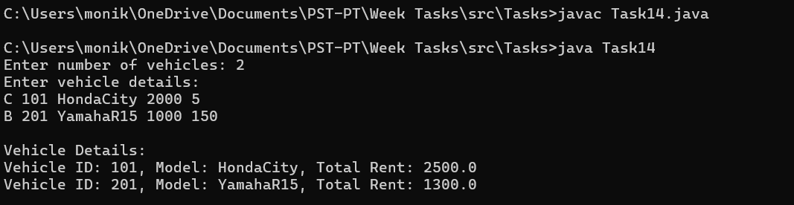

Task 15. Design a payment processing system for an e-commerce platform using polymorphism.
There is a base class Payment with a method processPayment(double amount) which returns a confirmation message.

There are multiple subclasses that inherit from Payment:
CreditCardPayment:
Charges a 2% processing fee on the amount.
PayPalPayment: Charges a flat fee of $1.50 per transaction.
UPIPayment: No extra fee.

The task is to implement these classes and a program that reads multiple payment instructions, creates the appropriate payment objects, and prints the result of processPayment() for each payment. Use polymorphism so that the main program can call processPayment() on a Payment reference without knowing the specific payment type.

Sample Input-1:
4
C 100
P 50
U 200
C 250

Sample Output-1:
Processed CreditCard payment: Total Amount = 102.00
Processed PayPal payment: Total Amount = 51.50
Processed UPI payment: Total Amount = 200.00
Processed CreditCard payment: Total Amount = 255.00
Program:
import java.util.*;

// Base class
class Payment {
public String processPayment(double amount) {
return "Processed Payment: " + amount;
}
}
// Credit Card Payment
class CreditCardPayment extends Payment {
@Override
public String processPayment(double amount) {
double total = amount + (amount * 0.02); // 2% fee
return String.format("Processed CreditCard payment: Total Amount = %.2f", total);
}
}
// PayPal Payment
class PayPalPayment extends Payment {
@Override
public String processPayment(double amount) {
double total = amount + 1.50; // flat fee
return String.format("Processed PayPal payment: Total Amount = %.2f", total);
}
}
// UPI Payment
class UPIPayment extends Payment {
@Override
public String processPayment(double amount) {
double total = amount; // no fee
return String.format("Processed UPI payment: Total Amount = %.2f", total);
}
}
// Main class
public class Task15 {
public static void main(String[] args) {
Scanner sc = new Scanner(System.in);
System.out.print("Enter number of payments: ");
int n = sc.nextInt();
List<Payment> payments = new ArrayList<>();
System.out.println("Enter payment details:");
for (int i = 0; i < n; i++) {
char type = sc.next().charAt(0);
double amount = sc.nextDouble();
Payment p;
if (type == 'C') {
p = new CreditCardPayment();
} else if (type == 'P') {
p = new PayPalPayment();
} else {
p = new UPIPayment();
}
payments.add(p);
// Process immediately (or you can store & process later)
System.out.println(p.processPayment(amount));

sc.close();
}
}

Output:
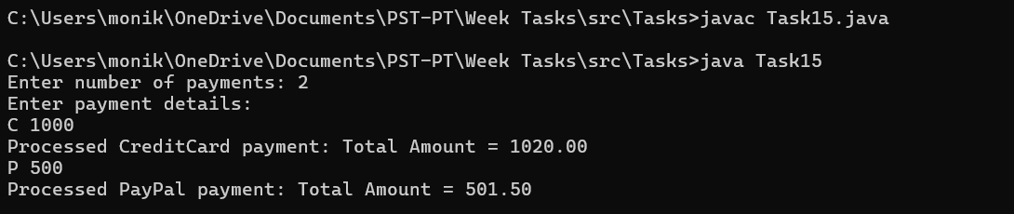
Task 16.Design a notification system for a web application using interface-based design to ensure extensibility.There is an interface Notification with a method:
void sendNotification(String message);

There are multiple implementations of this interface:
EmailNotification – sends the message via email.
SMSNotification – sends the message via SMS.
PushNotification – sends the message as a push notification.

The main program reads multiple notification requests, creates the appropriate Notification objects, and calls sendNotification() on them.
Goal: Use an interface so that new types of notifications (like WhatsAppNotification, SlackNotification) can be added in the future without modifying existing code.
Sample Input-1:
4
E Welcome_to_our_platform
S Your_OTP_is_1234
P New_offer_available
E Password_changed_successfully

Sample Output-1:
Sent Email notification: Welcome_to_our_platform
Sent SMS notification: Your_OTP_is_1234
Sent Push notification: New_offer_available
Sent Email notification: Password_changed_successfully
Program:
import java.util.*;

// Interface
interface Notification {
void sendNotification(String message);
}
// Email Notification
class EmailNotification implements Notification {
@Override
public void sendNotification(String message) {
System.out.println("Sent Email notification: " + message);
}
}
// SMS Notification
class SMSNotification implements Notification {
@Override
public void sendNotification(String message) {
System.out.println("Sent SMS notification: " + message);
}
}
// Push Notification
class PushNotification implements Notification {
@Override
public void sendNotification(String message) {
System.out.println("Sent Push notification: " + message);
}
}
// Main Class
public class Task16 {
public static void main(String[] args) {
Scanner sc = new Scanner(System.in);
System.out.print("Enter number of notifications: ");
int n = sc.nextInt();
sc.nextLine(); // consume newline
System.out.println("Enter notifications (Type Message):");
for (int i = 0; i < n; i++) {
String input = sc.nextLine();
String[] parts = input.split(" ", 2); // split type and message
char type = parts[0].charAt(0);
String message = parts[1];
Notification notification;
switch (type) {
case 'E':
notification = new EmailNotification();
break;
case 'S':
notification = new SMSNotification();
break;
case 'P':
notification = new PushNotification();
break;
default:
System.out.println("Invalid notification type: " + type);
continue;
}
notification.sendNotification(message);
}
sc.close();
}
}

Output:
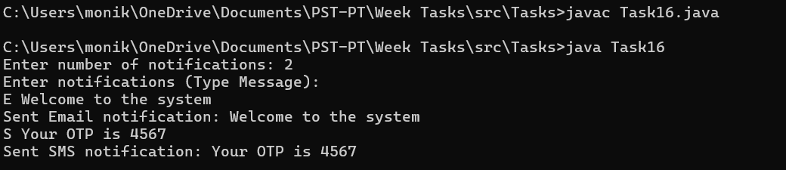

Task 17. Design an online order processing system where certain operations may fail and should be handled using exception-driven flow control.
Each Order has the following attributes:
orderId (integer, unique ID)
productName (string)
quantity (integer)
availableStock (integer)

The main program reads multiple orders and attempts to process each order.

If the quantity requested is greater than availableStock, an exception should be thrown and caught to display:
Order <orderId> failed: Insufficient stock
If the order is valid, print:
Order <orderId> processed successfully
The program must continue processing the remaining orders even if some orders fail.

Sample Input-1:
5
101 Laptop 2 5
102 Mouse 10 8
103 Keyboard 3 3
104 Monitor 1 0
105 Speaker 5 10

Sample Output-1:
Order 101 processed successfully
Order 102 failed: Insufficient stock
Order 103 processed successfully
Order 104 failed: Insufficient stock
Order 105 processed successfully
Program:
import java.util.*;

// Custom exception for insufficient stock
class InsufficientStockException extends Exception {
public InsufficientStockException(String message) {
super(message);
}
}
// Order class
class Order {
int orderId;
String productName;
int quantity;
int availableStock;
public Order(int orderId, String productName, int quantity, int availableStock) {
this.orderId = orderId;
this.productName = productName;
this.quantity = quantity;
this.availableStock = availableStock;
}
// Process the order
public void processOrder() throws InsufficientStockException {
if (quantity > availableStock) {
throw new InsufficientStockException("Order " + orderId + " failed: Insufficient stock");
} else {
System.out.println("Order " + orderId + " processed successfully");
}
}
}
// Main class
public class Task17
{
public static void main(String[] args) {
Scanner sc = new Scanner(System.in);
System.out.print("Enter number of orders: ");
int n = sc.nextInt();
List<Order> orders = new ArrayList<>();
System.out.println("Enter orders (orderId productName quantity availableStock):");
for (int i = 0; i < n; i++) {
int id = sc.nextInt();
String product = sc.next();
int qty = sc.nextInt();
int stock = sc.nextInt();
orders.add(new Order(id, product, qty, stock));
}
// Process each order with exception handling
for (Order order : orders) {
try {
order.processOrder();
} catch (InsufficientStockException e) {
System.out.println(e.getMessage());
}
}
sc.close();
}
}

Output:
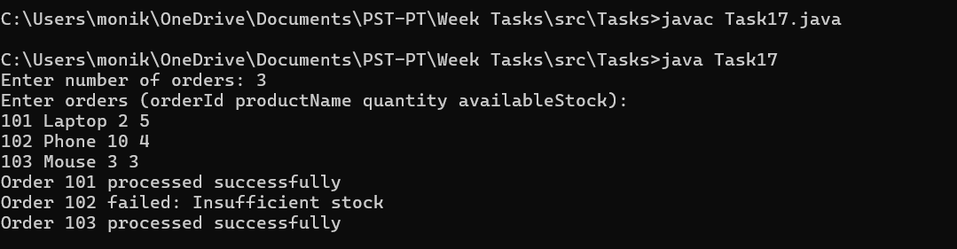

Task 18:Design a simple banking system where each account has a unique account number, an account holder name, and a balance.
Implement a class Account to store this information.
Create another class Bank that manages multiple accounts and provides the following operations:
depositing money into an account,
withdrawing money from an account,
and transferring money between accounts.

The Bank class should interact with Account objects to perform these operations safely, ensuring that withdrawals or transfers do not exceed the available balance and that accounts exist before performing any operation.

Your task is to implement these classes and write a program that can process a sequence of banking operations and produce the appropriate output for each operation.
Sample Input-1:
2
101 Alice 1000
102 Bob 500
5
DEPOSIT 101 200
WITHDRAW 102 100
TRANSFER 101 102 300
WITHDRAW 102 1000
TRANSFER 101 103 50
Sample Output-1:
Deposited 200 to Alice
Withdrawn 100 from Bob
Transferred 300 from Alice to Bob
Insufficient balance
Account not found
Program:
import java.util.*;

// Account class
class Account {
int accountNumber;
String holderName;
double balance;
public Account(int accountNumber, String holderName, double balance) {
this.accountNumber = accountNumber;
this.holderName = holderName;
this.balance = balance;
}
public void deposit(double amount) {
balance += amount;
System.out.println("Deposited " + (int)amount + " to " + holderName);
}
public boolean withdraw(double amount) {
if (amount <= balance) {
balance -= amount;
System.out.println("Withdrawn " + (int)amount + " from " + holderName);
return true;
} else {
System.out.println("Insufficient balance");
return false;
}
}
}
// Bank class
class Bank {
Map<Integer, Account> accounts = new HashMap<>();
public void addAccount(Account account) {
accounts.put(account.accountNumber, account);
}
public Account getAccount(int accountNumber) {
return accounts.get(accountNumber);
}
public void deposit(int accountNumber, double amount) {
Account acc = getAccount(accountNumber);
if (acc != null) {
acc.deposit(amount);
} else {
System.out.println("Account not found");
}
}
public void withdraw(int accountNumber, double amount) {
Account acc = getAccount(accountNumber);
if (acc != null) {
acc.withdraw(amount);
} else {
System.out.println("Account not found");
}
}
public void transfer(int fromAccNum, int toAccNum, double amount) {
Account fromAcc = getAccount(fromAccNum);
Account toAcc = getAccount(toAccNum);
if (fromAcc == null || toAcc == null) {
System.out.println("Account not found");
return;
}
if (fromAcc.withdraw(amount)) {
toAcc.deposit(amount);
System.out.println("Transferred " + (int)amount + " from " + fromAcc.holderName + " to " + toAcc.holderName);
}
}
}
// Main class
public class Task18 {
public static void main(String[] args) {
Scanner sc = new Scanner(System.in);
Bank bank = new Bank();
// Read accounts
System.out.print("Enter number of accounts: ");
int n = sc.nextInt();
System.out.println("Enter accounts (accountNumber holderName balance):");
for (int i = 0; i < n; i++) {
int accNum = sc.nextInt();
String name = sc.next();
double balance = sc.nextDouble();
bank.addAccount(new Account(accNum, name, balance));
}
// Read operations
System.out.print("Enter number of operations: ");
int m = sc.nextInt();
sc.nextLine(); // consume newline
System.out.println("Enter operations:");
for (int i = 0; i < m; i++) {
String line = sc.nextLine();
String[] parts = line.split(" ");
String op = parts[0];
switch (op) {
case "DEPOSIT":
int accNum = Integer.parseInt(parts[1]);
double amt = Double.parseDouble(parts[2]);
bank.deposit(accNum, amt);
break;
case "WITHDRAW":
accNum = Integer.parseInt(parts[1]);
amt = Double.parseDouble(parts[2]);
bank.withdraw(accNum, amt);
break;
case "TRANSFER":
int fromAcc = Integer.parseInt(parts[1]);
int toAcc = Integer.parseInt(parts[2]);
amt = Double.parseDouble(parts[3]);
bank.transfer(fromAcc, toAcc, amt);
break;
default:
System.out.println("Invalid operation");
}
}
sc.close();
}
}

Output:
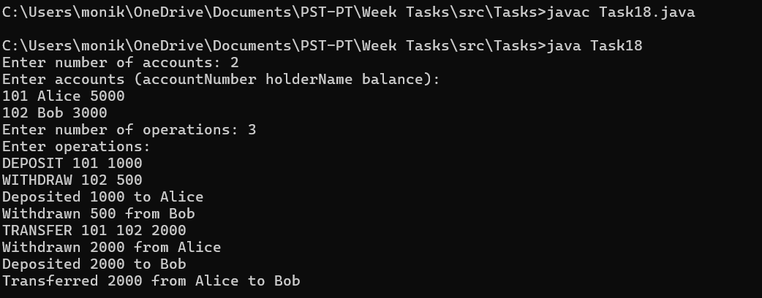

Task 19. Given an integer array nums and an integer k, return the k most frequent elements. You may return the answer in any order.

Sample Input 1:
nums = [1,1,1,2,2,3], k = 2
Sample Output-1: [1,2]

Sample Input 2:
nums = [1], k = 1

Sample Output-2: [1]

Sample Input -3:
nums = [1,2,1,2,1,2,3,1,3,2], k = 2

Sample Output- 3: [1,2]
Program:
import java.util.*;

public class Task19 {
public static List<Integer> topKFrequent(int[] nums, int k) {
// Count frequency of each number
Map<Integer, Integer> freqMap = new HashMap<>();
for (int num : nums) {
freqMap.put(num, freqMap.getOrDefault(num, 0) + 1);
}
// Max heap based on frequency
PriorityQueue<Integer> maxHeap = new PriorityQueue<>(
(a, b) -> freqMap.get(b) - freqMap.get(a)
);
maxHeap.addAll(freqMap.keySet());
// Get top k frequent elements
List<Integer> result = new ArrayList<>();
for (int i = 0; i < k; i++) {
result.add(maxHeap.poll());
}
return result;
}
public static void main(String[] args) {
Scanner sc = new Scanner(System.in);
// Read array size
System.out.print("Enter number of elements in array: ");
int n = sc.nextInt();
int[] nums = new int[n];
System.out.println("Enter array elements:");
for (int i = 0; i < n; i++) {
nums[i] = sc.nextInt();
}
// Read k
System.out.print("Enter value of k: ");
int k = sc.nextInt();
// Get top k frequent elements
List<Integer> topK = topKFrequent(nums, k);
System.out.println("Top " + k + " frequent elements: " + topK);
sc.close();
}
}

Output:
