Exercise 1: Control Structures
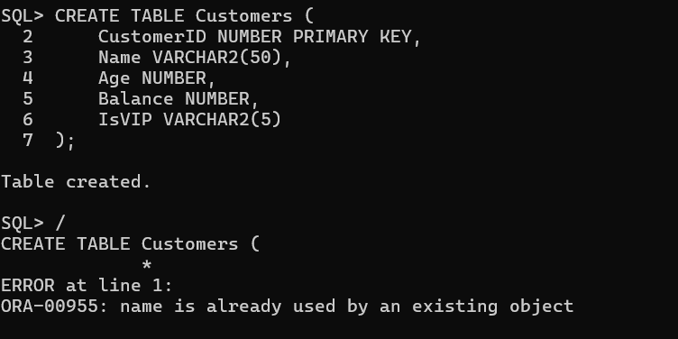
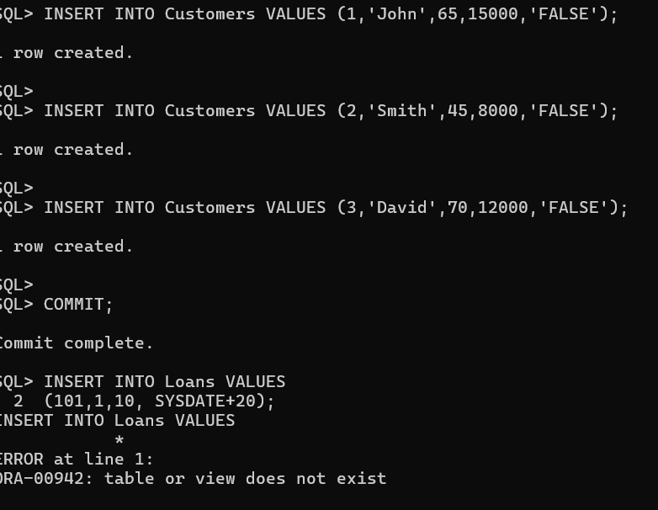
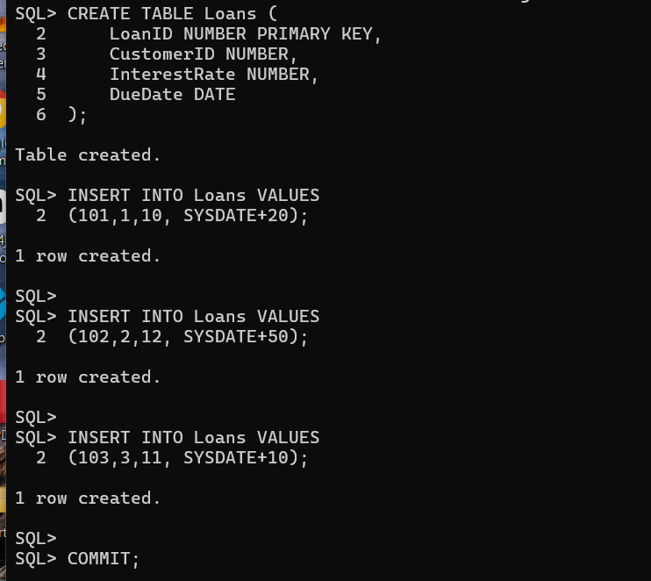
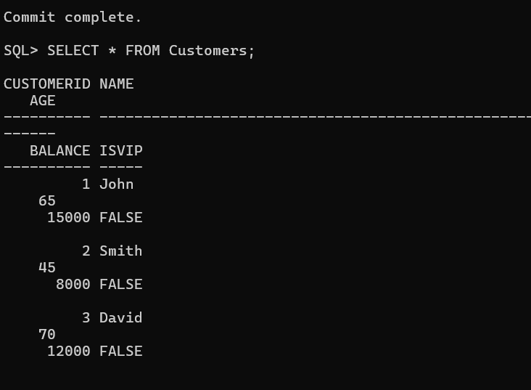
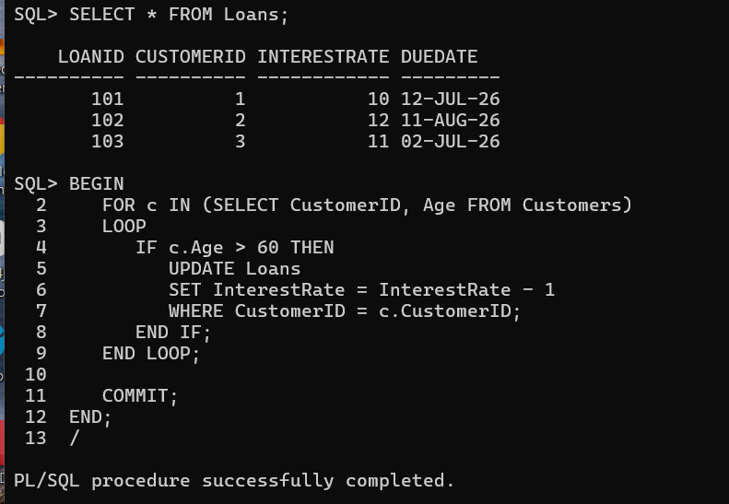
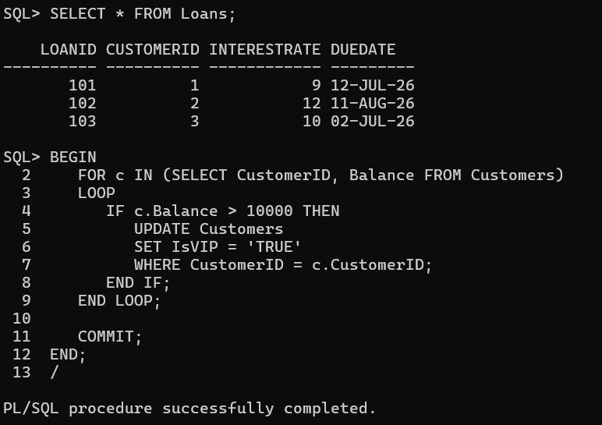
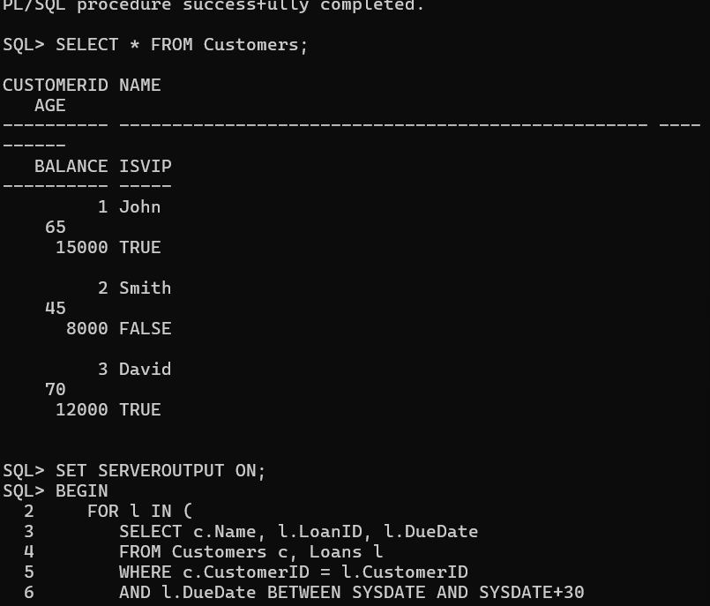
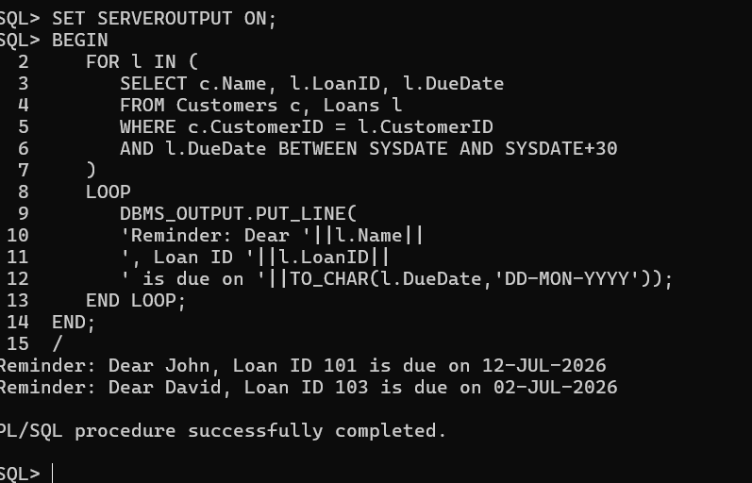
Exercise 3: Stored Procedures
SQL*Plus: Release 21.0.0.0.0 - Production on Mon Jun 22 14:40:04 2026
Version 21.3.0.0.0

Copyright (c) 1982, 2021, Oracle. All rights reserved.

Enter user-name: system
Enter password:
ERROR:
ORA-28002: the password will expire within 6 days

Last Successful login time: Mon Jun 22 2026 14:21:01 +05:30

Connected to:
Oracle Database 21c Express Edition Release 21.0.0.0.0 - Production
Version 21.3.0.0.0

SQL> CREATE TABLE Accounts3 (
2 AccountID NUMBER PRIMARY KEY,
3 AccountType VARCHAR2(20),
4 Balance NUMBER
5 );

Table created.

SQL> /
CREATE TABLE Accounts3 (
*
ERROR at line 1:
ORA-00955: name is already used by an existing object

SQL> INSERT INTO Accounts3 VALUES (101,'Savings',10000);

1 row created.

SQL>
SQL> INSERT INTO Accounts3 VALUES (102,'Current',5000);

1 row created.

SQL>
SQL> INSERT INTO Accounts3 VALUES (103,'Savings',20000);

1 row created.

SQL>
SQL> COMMIT;

Commit complete.

SQL> SELECT * FROM Accounts3;

ACCOUNTID ACCOUNTTYPE BALANCE
---------- -------------------- ----------
101 Savings 10000
102 Current 5000
103 Savings 20000

SQL> CREATE OR REPLACE PROCEDURE ProcessMonthlyInterest
2 IS
3 BEGIN
4 UPDATE Accounts3
5 SET Balance = Balance + (Balance * 0.01)
6 WHERE AccountType = 'Savings';
7
8 COMMIT;
9 END;
10 /

Procedure created.

SQL> SHOW ERRORS;
No errors.
SQL> EXEC ProcessMonthlyInterest;

PL/SQL procedure successfully completed.

SQL> SELECT * FROM Accounts3;

ACCOUNTID ACCOUNTTYPE BALANCE
---------- -------------------- ----------
101 Savings 10100
102 Current 5000
103 Savings 20200

SQL> CREATE TABLE Employees3 (
2 EmployeeID NUMBER PRIMARY KEY,
3 EmployeeName VARCHAR2(50),
4 Department VARCHAR2(20),
5 Salary NUMBER
6 );

Table created.

SQL> INSERT INTO Employees3 VALUES (101,'John','IT',50000);

1 row created.

SQL> INSERT INTO Employees3 VALUES (102,'Smith','HR',45000);

1 row created.

SQL> INSERT INTO Employees3 VALUES (103,'David','IT',60000);

1 row created.

SQL>
SQL> COMMIT;

Commit complete.

SQL> SELECT * FROM Employees3;

EMPLOYEEID EMPLOYEENAME
---------- --------------------------------------------------
DEPARTMENT SALARY
-------------------- ----------
101 John
IT 50000

102 Smith
HR 45000

103 David
IT 60000

SQL> CREATE OR REPLACE PROCEDURE UpdateEmployeeBonus(
2 p_department IN VARCHAR2,
3 p_bonus_percent IN NUMBER
4 )
5 IS
6 BEGIN
7 UPDATE Employees3
8 SET Salary = Salary + (Salary * p_bonus_percent / 100)
9 WHERE Department = p_department;
10
11 COMMIT;
12 END;
13 /

Procedure created.

SQL> SHOW ERRORS;
No errors.
SQL> EXEC UpdateEmployeeBonus('IT',10);

PL/SQL procedure successfully completed.

SQL> SELECT * FROM Employees3;

EMPLOYEEID EMPLOYEENAME
---------- --------------------------------------------------
DEPARTMENT SALARY
-------------------- ----------
101 John
IT 55000

102 Smith
HR 45000

103 David
IT 66000

SQL> CREATE TABLE Accounts4 (
2 AccountID NUMBER PRIMARY KEY,
3 Balance NUMBER
4 );

Table created.

SQL> INSERT INTO Accounts4 VALUES (101,10000);

1 row created.

SQL> INSERT INTO Accounts4 VALUES (102,5000);

1 row created.

SQL>
SQL> COMMIT;

Commit complete.

SQL> SELECT * FROM Accounts4;

ACCOUNTID BALANCE
---------- ----------
101 10000
102 5000

SQL> SET SERVEROUTPUT ON;
SQL> CREATE OR REPLACE PROCEDURE TransferFunds(
2 p_source_acc IN NUMBER,
3 p_dest_acc IN NUMBER,
4 p_amount IN NUMBER
5 )
6 IS
7 v_balance NUMBER;
8 BEGIN
9 SELECT Balance
10 INTO v_balance
11 FROM Accounts4
12 WHERE AccountID = p_source_acc;
13
14 IF v_balance >= p_amount THEN
15
16 UPDATE Accounts4
17 SET Balance = Balance - p_amount
18 WHERE AccountID = p_source_acc;
19
20 UPDATE Accounts4
21 SET Balance = Balance + p_amount
22 WHERE AccountID = p_dest_acc;
23
24 COMMIT;
25
26 DBMS_OUTPUT.PUT_LINE('Transfer Successful');
27
28 ELSE
29
30 DBMS_OUTPUT.PUT_LINE('Insufficient Balance');
31
32 END IF;
33
34 END;
35 /

Procedure created.

SQL> SHOW ERRORS;
No errors.
SQL> EXEC TransferFunds(101,102,3000);
Transfer Successful

PL/SQL procedure successfully completed.

SQL> SELECT * FROM Accounts4;

ACCOUNTID BALANCE
---------- ----------
101 7000
102 8000

SQL>

