1.Inventrory management system
Code:
InventoryManagementSystem.java
import java.util.HashMap;

public class InventoryManagementSystem {

HashMap<Integer, Product> inventory =
new HashMap<>();

public void addProduct(Product p) {
inventory.put(p.productId, p);
System.out.println("Product Added");
}

public void updateProduct(int id, int qty) {

if (inventory.containsKey(id)) {
inventory.get(id).quantity = qty;
System.out.println("Product Updated");
}
}

public void deleteProduct(int id) {

if (inventory.containsKey(id)) {
inventory.remove(id);
System.out.println("Product Deleted");
}
}

public void displayProducts() {

for (Product p : inventory.values()) {
System.out.println(p);
}
}

public static void main(String[] args) {

InventoryManagementSystem ims =
new InventoryManagementSystem();

ims.addProduct(
new Product(101, "Laptop",
10, 50000));

ims.addProduct(
new Product(102, "Mouse",
50, 500));

System.out.println("\nProducts:");

ims.displayProducts();

ims.updateProduct(101, 15);

ims.deleteProduct(102);

System.out.println("\nAfter Update:");

ims.displayProducts();
}
}
Product.java
public class Product {

int productId;
String productName;
int quantity;
double price;

Product(int productId, String productName,
int quantity, double price) {

this.productId = productId;
this.productName = productName;
this.quantity = quantity;
this.price = price;
}

@Override
public String toString() {
return "ID: " + productId +
", Name: " + productName +
", Quantity: " + quantity +
", Price: " + price;
}
}
Output:
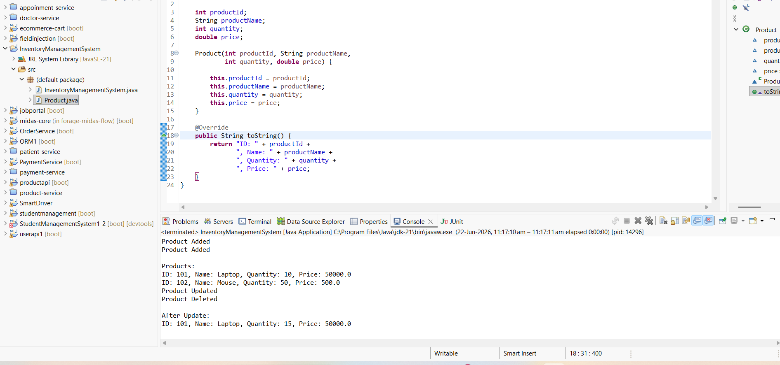
2. E-commerce Platform Search Function
Main.java
Code:
package com.ecommerce;

public class Main {

public static void main(String[] args) {

Product[] products = {
new Product(101, "Laptop", "Electronics"),
new Product(102, "Mobile", "Electronics"),
new Product(103, "Shoes", "Fashion"),
new Product(104, "Watch", "Accessories"),
new Product(105, "Headphones", "Electronics")
};

// Linear Search
Product result1 = SearchOperations.linearSearch(products, 104);

if (result1 != null) {
System.out.println("Linear Search:");
System.out.println("Product ID: " + result1.productId);
System.out.println("Product Name: " + result1.productName);
System.out.println("Category: " + result1.category);
} else {
System.out.println("Product not found.");
}

// Binary Search
Product result2 = SearchOperations.binarySearch(products, 104);

if (result2 != null) {

System.out.println("\nBinary Search:");
System.out.println("Product ID: " + result2.productId);
System.out.println("Product Name: " + result2.productName);
System.out.println("Category: " + result2.category);
}

}

}
Product.java
Code:
package com.ecommerce;
public class Product {

int productId;
String productName;
String category;

public Product(int productId, String productName, String category) {
this.productId = productId;
this.productName = productName;
this.category = category;
}

public void display() {
System.out.println(productId + " "
+ productName + " "
+ category);
}
}
SearchOperations.java
Code:
package com.ecommerce;

public class SearchOperations {

// Linear Search
public static Product linearSearch(Product[] products, int id) {

for (int i = 0; i < products.length; i++) {

if (products[i].productId == id) {
return products[i];
}

}

return null;
}

// Binary Search
public static Product binarySearch(Product[] products, int id) {

int low = 0;
int high = products.length - 1;

while (low <= high) {

int mid = (low + high) / 2;

if (products[mid].productId == id) {
return products[mid];
}

if (products[mid].productId < id) {
low = mid + 1;
} else {
high = mid - 1;
}
}

return null;
}

}
Output:
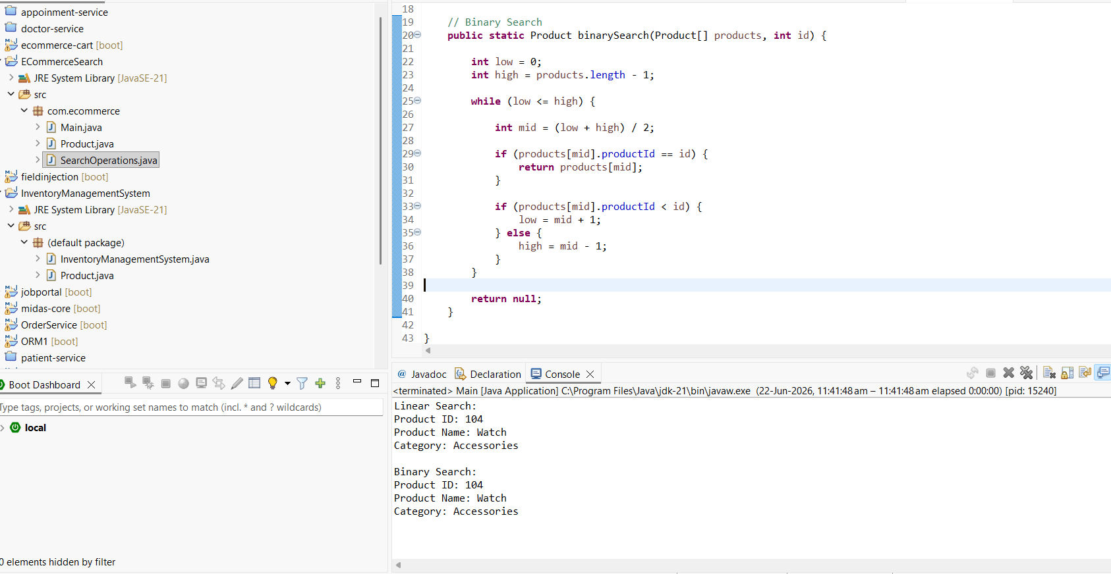
3. Sorting Customer Orders
Main.java
package com.ecommerce;

public class Main {

public static void main(String[] args) {

Order[] orders = {

new Order(101, "Rahul", 5000),
new Order(102, "Priya", 12000),
new Order(103, "Arjun", 8000),
new Order(104, "Sneha", 3000)

};

System.out.println("Before Sorting");

for (Order order : orders) {

System.out.println(order.orderId + " "
+ order.customerName + " "
+ order.totalPrice);
}

SortOperations.bubbleSort(orders);

System.out.println("\nAfter Bubble Sort");

for (Order order : orders) {

System.out.println(order.orderId + " "
+ order.customerName + " "
+ order.totalPrice);
}

SortOperations.quickSort(orders, 0, orders.length - 1);

System.out.println("\nAfter Quick Sort");

for (Order order : orders) {

System.out.println(order.orderId + " "
+ order.customerName + " "
+ order.totalPrice);
}

}
}
Order.java

package com.ecommerce;

public class Order {

int orderId;
String customerName;
double totalPrice;

public Order(int orderId, String customerName, double totalPrice) {

this.orderId = orderId;
this.customerName = customerName;
this.totalPrice = totalPrice;
}
}
sortOperations.java
package com.ecommerce;

public class SortOperations {

// Bubble Sort
public static void bubbleSort(Order[] orders) {

int n = orders.length;

for (int i = 0; i < n - 1; i++) {

for (int j = 0; j < n - i - 1; j++) {

if (orders[j].totalPrice > orders[j + 1].totalPrice) {

Order temp = orders[j];
orders[j] = orders[j + 1];
orders[j + 1] = temp;
}
}
}
}

// Quick Sort
public static void quickSort(Order[] orders, int low, int high) {

if (low < high) {

int pi = partition(orders, low, high);

quickSort(orders, low, pi - 1);
quickSort(orders, pi + 1, high);
}
}

public static int partition(Order[] orders, int low, int high) {

double pivot = orders[high].totalPrice;

int i = low - 1;

for (int j = low; j < high; j++) {

if (orders[j].totalPrice <= pivot) {

i++;

Order temp = orders[i];
orders[i] = orders[j];
orders[j] = temp;
}
}

Order temp = orders[i + 1];
orders[i + 1] = orders[high];
orders[high] = temp;

return i + 1;
}
}
Output:
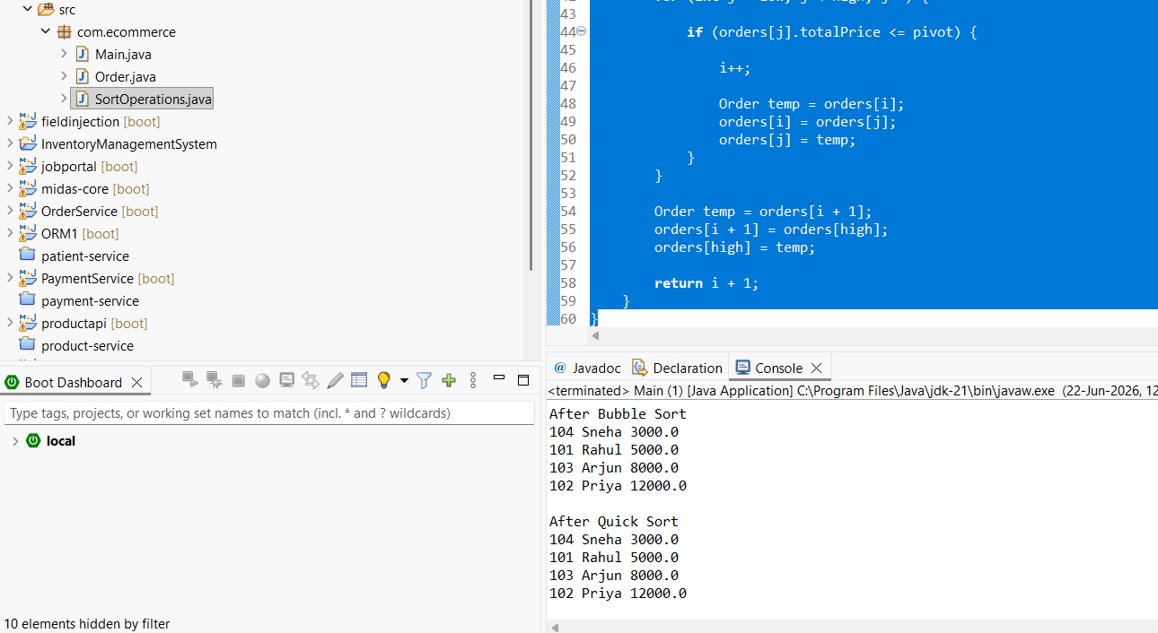
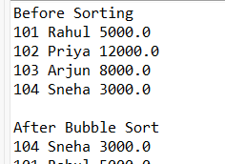
4.Employee Management System
Employee.java
package com.employee;

public class Employee {

int employeeId;
String name;
String position;
double salary;

public Employee(int employeeId, String name, String position, double salary) {

this.employeeId = employeeId;
this.name = name;
this.position = position;
this.salary = salary;
}
}
EmployeeOperations:
package com.employee;

public class EmployeeOperations {

Employee[] employees = new Employee[10];
int count = 0;

// Add Employee
public void addEmployee(Employee employee) {

if (count < employees.length) {

employees[count] = employee;
count++;

System.out.println("Employee Added");
}
}

// Search Employee
public Employee searchEmployee(int id) {

for (int i = 0; i < count; i++) {

if (employees[i].employeeId == id) {

return employees[i];
}
}

return null;
}

// Traverse Employees
public void traverseEmployees() {

for (int i = 0; i < count; i++) {

System.out.println(employees[i].employeeId + " "
+ employees[i].name + " "
+ employees[i].position + " "
+ employees[i].salary);
}
}

// Delete Employee
public void deleteEmployee(int id) {

for (int i = 0; i < count; i++) {

if (employees[i].employeeId == id) {

for (int j = i; j < count - 1; j++) {

employees[j] = employees[j + 1];
}

employees[count - 1] = null;
count--;

System.out.println("Employee Deleted");
return;
}
}

System.out.println("Employee Not Found");
}
}
Main:
package com.employee;

public class Main {

public static void main(String[] args) {

EmployeeOperations emp = new EmployeeOperations();

// Add employees
emp.addEmployee(new Employee(101, "Rahul", "Manager", 50000));
emp.addEmployee(new Employee(102, "Priya", "Developer", 45000));
emp.addEmployee(new Employee(103, "Arjun", "Tester", 40000));

System.out.println("\nEmployees:");

emp.traverseEmployees();

// Search
Employee e = emp.searchEmployee(102);

if (e != null) {

System.out.println("\nEmployee Found");

System.out.println(e.employeeId + " "
+ e.name + " "
+ e.position + " "
+ e.salary);
}

// Delete
emp.deleteEmployee(102);

System.out.println("\nAfter Deletion:");

emp.traverseEmployees();

}
}
Output:
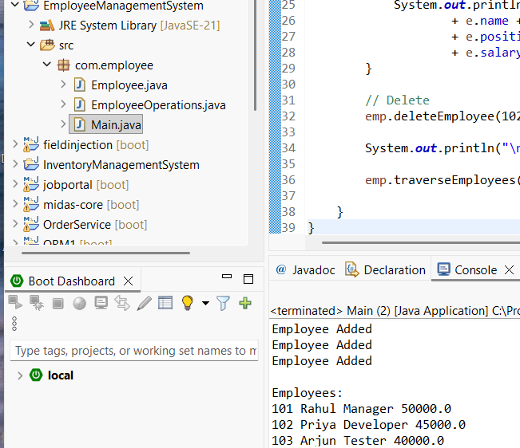
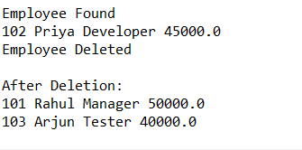
5.Task Management System
Task:
package com.task;

public class Task {

int taskId;
String taskName;
String status;
Task next;

public Task(int taskId, String taskName, String status) {

this.taskId = taskId;
this.taskName = taskName;
this.status = status;
this.next = null;
}

}
TaskLinkedList:
package com.task;

public class TaskLinkedList {

Task head = null;

// Add Task
public void addTask(int id, String name, String status) {

Task newTask = new Task(id, name, status);

if (head == null) {

head = newTask;
}

else {

Task temp = head;

while (temp.next != null) {

temp = temp.next;
}

temp.next = newTask;
}

System.out.println("Task Added");
}

// Search Task
public void searchTask(int id) {

Task temp = head;

while (temp != null) {

if (temp.taskId == id) {

System.out.println("Task Found");
System.out.println(temp.taskId + " "
+ temp.taskName + " "
+ temp.status);

return;
}

temp = temp.next;
}

System.out.println("Task Not Found");
}

// Traverse Tasks
public void traverseTasks() {

Task temp = head;

while (temp != null) {

System.out.println(temp.taskId + " "
+ temp.taskName + " "
+ temp.status);

temp = temp.next;
}
}

// Delete Task
public void deleteTask(int id) {

if (head == null) {

return;
}

if (head.taskId == id) {

head = head.next;

System.out.println("Task Deleted");

return;
}

Task temp = head;

while (temp.next != null && temp.next.taskId != id) {

temp = temp.next;
}

if (temp.next != null) {

temp.next = temp.next.next;

System.out.println("Task Deleted");
}

else {

System.out.println("Task Not Found");
}

}

}
Main:
package com.task;

public class Main {

public static void main(String[] args) {

TaskLinkedList list = new TaskLinkedList();

// Add Tasks
list.addTask(101, "Coding", "Pending");
list.addTask(102, "Testing", "Completed");
list.addTask(103, "Documentation", "Pending");

System.out.println("\nTasks:");

list.traverseTasks();

System.out.println("\nSearching Task 102");

list.searchTask(102);

System.out.println("\nDeleting Task 102");

list.deleteTask(102);

System.out.println("\nTasks after deletion:");

list.traverseTasks();

}

}
Output:
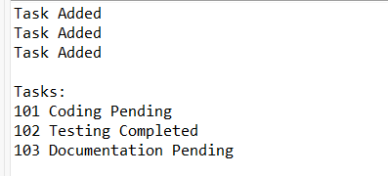
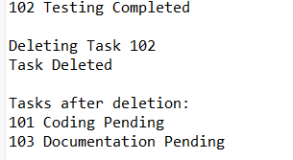
6. Library Management System
Book:
package com.library;

public class Book {

int bookId;
String title;
String author;

public Book(int bookId, String title, String author) {

this.bookId = bookId;
this.title = title;
this.author = author;
}
}
LibraryOperations:
package com.library;

public class LibraryOperations {

// Linear Search
public static Book linearSearch(Book[] books, String title) {

for (Book book : books) {

if (book.title.equalsIgnoreCase(title)) {
return book;
}
}

return null;
}

public static Book binarySearch(Book[] books, String title) {

int low = 0;
int high = books.length - 1;

while (low <= high) {

int mid = (low + high) / 2;

int result = books[mid].title.compareToIgnoreCase(title);

if (result == 0) {
return books[mid];
}

else if (result < 0) {
low = mid + 1;
}

else {
high = mid - 1;
}
}

return null;
}
}
Main:
package com.library;

public class Main {

public static void main(String[] args) {

// Sorted by title
Book[] books = {

new Book(101, "C Programming", "Dennis Ritchie"),
new Book(102, "Data Structures", "Mark Allen"),
new Book(103, "Java Programming", "James Gosling"),
new Book(104, "Python Basics", "Guido Van Rossum"),
new Book(105, "Web Development", "John Duckett")
};

// Linear Search
Book b1 = LibraryOperations.linearSearch(books, "Python Basics");

if (b1 != null) {

System.out.println("Book Found using Linear Search");

System.out.println("Book ID : " + b1.bookId);
System.out.println("Title : " + b1.title);
System.out.println("Author : " + b1.author);
}

// Binary Search
Book b2 = LibraryOperations.binarySearch(books, "Python Basics");

if (b2 != null) {

System.out.println("\nBook Found using Binary Search");

System.out.println("Book ID : " + b2.bookId);
System.out.println("Title : " + b2.title);
System.out.println("Author : " + b2.author);
}

}
}
Output:
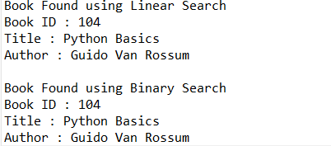
7. Financial Forecasting
Forecast.java
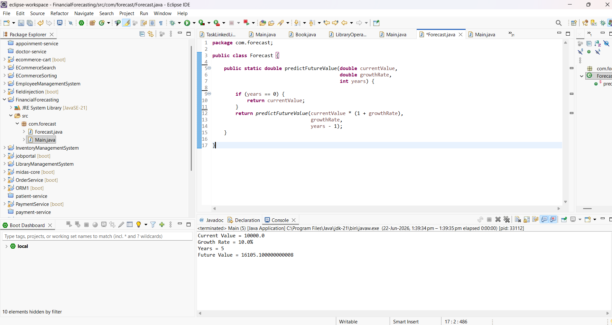
Main.java
