
School of Computing
Department of Computer Science and Engineering ACADEMIC YEAR: 2025-26
(WINTER SEMESTER)

LAB RECORD

10211CS224 - Full Stack Application Development

NAME : VENNA MAMITHA
VTU.NO : VTU25796
REG.NO : 23UECS0603
BRANCH : CSE

YEAR/SEM : 3rd/6th

SLOT : E2

10211CS224 - Full Stack Application Development
TABLE OF CONTENTS

Task No | Date | Experiment Title
1. | 05-01-2026 | Student Registration System with Database Storage and Retrieval
2. | 22-01-2026 | Data Retrieval, Sorting, and Filtering Dashboard
3. | 29-01-2026 | Login System with Input Validation and Authentication
4. | 02-02-2026 | Order Management Using SQL Joins and Subqueries
5. | 05-02-2026 | Transaction-Based Payment Simulation Using COMMIT and ROLLBACK
6. | 09-02-2026 | Automated Logging Using Database Triggers and Views
7. | 12-02-2026 | Interactive Web Form Using JavaScript Events and Functions
8. | 16-02-2026 | Employee Management Using Spring Core and Dependency Injection
9. | 19-02-2026 | Spring MVC Application Using Annotation-Based Configuration
10. | 23-02-2026 | Student CRUD Operations Using Spring Boot and JPA
11. | 26-02-2026 | Data Access Using Spring Data JPA with Sorting and Pagination
12. | 02-03-2026 | RESTful API for Product Management Using Spring Boot
13. | 05-03-2026 | Exception Handling and Validation in RESTful Applications
14. | 09-03-2026 | Microservices Architecture with Service Decomposition
15. | 16-03-2026 | Service Registry and Discovery Using Eureka
16. | 28-03-2026 | API Gateway with Load Balancing for Microservices
17. | 30-03-2026 | Inter-Service Communication Using REST APIs
18. | 02-04-2026 | Unit Testing for Microservices Applications
19. | 06-04-2026 | Version Control Using Git and Remote Repositories
20. | 08-04-2026 | Git Branching, Merging, and Conflict Resolution
21. | 13-04-2026 | CI/CD Pipeline for Automated Build and Deployment
22. | 16-04-2026 | Cloud Service Providers Comparison and Pricing Models
23. | 20-04-2026 | Prompt Engineering for Code Generation Using Generative AI
24. | 27-04-2026 | Cloud-Based Application Using Vibe Coding and Generative AI
25. | 30-04-2026 | Use Cases

Task-1: Student Registration & Data Storage System

AIM: To develop a Student Registration System that allows users to enter, store, and manage student details efficiently using a web interface and a MySQL database.

ALGORITHM:
Step 1: Start
Step 2: Open the web application (index page)
Step 3: Display home page with option to go to registration page
Step 4: User navigates to the registration form
Step 5: User enters student details (like name, ID, course, etc.) Step 6: Validate input fields
- Check if fields are empty
- Ensure correct data format
Step 7: Submit the form data to the server Step 8: Server receives the data using Node.js
Step 9: Establish connection with MySQL database
- If connection fails → display error
- Else → proceed
Step 10: Insert student data into database table Step 11: Confirm successful storage of data Step 12: Display success message to user
Step 13: Allow user to view/manage stored data (if implemented)
Step 14: Stop PROGRAM: INDEX.HTML:
<!DOCTYPE html>

<html>
<head>
<title>Student Portal</title>
<link rel="stylesheet" href="style.css">
</head>
<body>
<div class="home-container">
<h1>Welcome to Student Portal</h1>
<p>Register and manage student information easily.</p>
<a href="registration.html" class="start-btn">Go to Registration</a>
</div>
</body>
</html>

REGISTRATION.HTML:
<!DOCTYPE html>
<html>
<head>
<title>Student Registration</title>
<link rel="stylesheet" href="style.css">
</head>
<body>
<div class="container">
<h1>Student Registration</h1>
<button onclick="goHome()" class="home-btn">Home</button>
<form id="studentForm">
<label>Name</label>

<input type="text" id="name" placeholder="Enter your name" required>
<label>Email</label>
<input type="email" id="email" placeholder="Enter your email" required>
<label>Date of Birth</label>
<input type="date" id="dob" required>
<label>Department</label>
<select id="department" required>
<option value="">Select Department</option>
<option>CSE</option>
<option>IT</option>
<option>ECE</option>
<option>MECH</option>
</select>
<label>Phone</label>
<input type="text" id="phone" placeholder="Enter phone number" required>
<button type="submit">Register</button>
</form>
</div>
<script src="script.js"></script>
</body>
</html>

STYLE.CSS:
body{
font-family: 'Segoe UI', sans-serif;
background: linear-gradient(135deg,#0f2027,#203a43,#2c5364); height:100vh;

display:flex;
justify-content:center; align-items:center; margin:0;
}
.container{ width:420px;
padding:35px; background:rgba(255,255,255,0.08); border-radius:18px;
backdrop-filter: blur(10px);
box-shadow:0 10px 35px rgba(0,0,0,0.6);
}
h1{
text-align:center; color:white;
margin-bottom:25px;
}
h2{
text-align:center; color:white; margin-top:30px;
}
form{ display:flex;
flex-direction:column;

}
label{ color:#ddd; font-size:14px;
margin-bottom:5px; margin-top:10px;
}
input,select{ width:100%;
padding:12px; border:none; border-radius:8px;
background:#27496d;
color:white; font-size:14px; outline:none;
margin-bottom:5px;

}
input:focus,select:focus{ box-shadow:0 0 8px #00eaff; background:#2c5d8a;
}
button{
margin-top:15px; padding:12px;
border:none;

border-radius:10px;
background:linear-gradient(45deg,#ff4b2b,#ff416c); color:white;
font-size:16px;
font-weight:bold; cursor:pointer;
transition:0.3s;

}
button:hover{ transform:scale(1.05);
box-shadow:0 0 15px #ff416c;
}
#studentList{
margin-top:15px; text-align:center; color:white;
font-size:15px;
}
.home-container{
text-align:center;
color:white; background:rgba(255,255,255,0.08); padding:50px;
border-radius:20px; backdrop-filter: blur(10px);
box-shadow:0 10px 35px rgba(0,0,0,0.6);

width:420px;
}
.home-container h1{ font-size:32px;
margin-bottom:15px;

}
.home-container p{ margin-bottom:30px; color:#ddd;
}
.start-btn{
text-decoration:none; padding:12px 25px; border-radius:10px;
background:linear-gradient(45deg,#ff4b2b,#ff416c);
color:white;
font-weight:bold; transition:0.3s;
}
.start-btn:hover{ transform:scale(1.05);
box-shadow:0 0 15px #ff416c;
}

SCRIPT.JS:
const form = document.getElementById("studentForm")

form.addEventListener("submit", async (e) => {
e.preventDefault()
const student = {
name: document.getElementById("name").value, email: document.getElementById("email").value,
dob: document.getElementById("dob").value,
department: document.getElementById("department").value, phone: document.getElementById("phone").value
}
try{
const res = await fetch("http://localhost:3000/addStudent",{ method:"POST",
headers:{
"Content-Type":"application/json"
},
body:JSON.stringify(student)
})
const data = await res.text() alert(data)
// clear form
form.reset()
}catch(error){
console.log("Error:",error)

}
})
function goHome(){

window.location.href="index.html"
}

SERVER.JS:
const express = require("express") const cors = require("cors")
const path = require("path")
const db = require("./db") const app = express() app.use(cors()) app.use(express.json())
// Serve static files (HTML, CSS, JS) app.use(express.static( dirname))
// Redirect root link to index.html app.get("/", (req, res) => {
res.sendFile(path.join(dirname, "index.html"))
})
// Insert student data app.post("/addStudent", (req, res) => {
const {name,email,dob,department,phone} = req.body
const sql = "INSERT INTO students(name,email,dob,department,phone) VALUES (?,?,?,?,?)"
db.query(sql,[name,email,dob,department,phone],(err,result)=>{
if(err){ res.send(err)
}else{
res.send("Student Added Successfully")

}
})

})
// Get student data app.get("/students",(req,res)=>{
db.query("SELECT * FROM students",(err,result)=>{
if(err){ res.send(err)
}else{
res.json(result)
}
})

})
// Start server app.listen(3000,()=>{
console.log("Server running at: http://localhost:3000")
})

DB.JS:
const mysql = require("mysql") const db = mysql.createConnection({ host: "localhost",
user: "root", password: "fahi",

database: "studentdb"
})
db.connect((err)=>{ if(err){
console.log("Database Error:", err)
}else{
console.log("MySQL Connected Successfully")
}
})
module.exports = db

OUTPUTS:
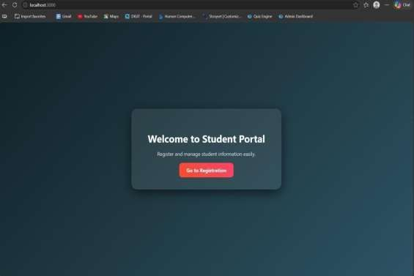

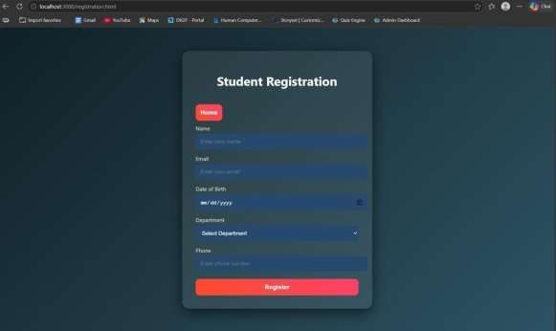

RESULT: The student registration system was successfully developed to store and manage student data using a web interface and MySQL database.

TASK2: Data Retrieval & Sorting Dashboard
AIM: To develop a web-based dashboard that allows users to store, retrieve, and display student dataefficiently from a database, and present it in a structured format for easy access and management.

ALGORITHM:
- Start the application
- Initialize the server using Express framework
- Establish database connection using MySQL
- Load frontend pages (HTML, CSS, JS) in browser
➤ Data Insertion Process:
- User enters student details (Name, Email, DOB, Department, Phone)
- Send data to backend using POST request (/addStudent)
- Execute SQL query to insert data into database
- Display success message after insertion
➤ Data Retrieval Process:
- Send GET request to server (/students)
- Fetch all student records from database
- Convert data into JSON format
- Display data dynamically in dashboard table.
- Arrange data in structured format (table/grid)
- Allow better readability and management
- Stop.

PROGRAM: INDEX.HTML:
<!DOCTYPE html>
<html>

<head>
<title>Student Portal</title>
<link rel="stylesheet" href="style.css">
</head>
<body>
<div class="home-container">
<h1>Welcome to Student Portal</h1>
<p>Register and manage student information easily.</p>
<a href="registration.html" class="start-btn">Go to Registration</a>
<a href="dashboard.html" class="start-btn">View Dashboard</a>
</div>
</body>
</html>

REGISTRATION.HTML:
<!DOCTYPE html>
<html>
<head>
<title>Student Registration</title>
<link rel="stylesheet" href="style.css">
</head>
<body>
<div class="container">
<h1>Student Registration</h1>
<button onclick="goHome()" class="home-btn">Home</button>
<form id="studentForm">

<label>Name</label>
<input type="text" id="name" placeholder="Enter your name" required>
<label>Email</label>
<input type="email" id="email" placeholder="Enter your email" required>
<label>Date of Birth</label>
<input type="date" id="dob" required>
<label>Department</label>
<select id="department" required>
<option value="">Select Department</option>
<option>CSE</option>
<option>IT</option>
<option>ECE</option>
<option>MECH</option>
</select>
<label>Phone</label>
<input type="text" id="phone" placeholder="Enter phone number" required>
<button type="submit">Register</button>
</form>
</div>
<script src="script.js"></script>
</body>
</html>

DASHBOARD.HTML:
<!DOCTYPE html>
<html>

<head>
<title>Student Dashboard</title>
<link rel="stylesheet" href="dashboard.css">
</head>
<body>
<div class="container">
<button onclick="goHome()" class="home-btn">Home</button>
<h1>Student Dashboard</h1>
<div class="controls">
<select id="sortSelect">
<option value="">Sort By</option>
<option value="name">Name</option>
<option value="dob">Date of Birth</option>
</select>
<select id="departmentFilter">
<option value="">Filter by Department</option>
<option value="CSE">CSE</option>
<option value="IT">IT</option>
<option value="ECE">ECE</option>
<option value="MECH">MECH</option>
</select>
<button onclick="loadStudents()">Apply</button>
</div>
<table>
<thead>
<tr>

<th>ID</th>
<th>Name</th>
<th>Email</th>
<th>DOB</th>
<th>Department</th>
<th>Phone</th>
</tr>
</thead>
<tbody id="studentTable"></tbody>
</table>
<h2>Department Count</h2>
<div id="deptCount"></div>
</div>
<script src="dashboard.js"></script>
<script>
function goHome(){ window.location.href = "index.html"
}
</script>
</body>
</html>

STYLE.CSS:
body{
font-family: 'Segoe UI', sans-serif;
background: linear-gradient(135deg,#0f2027,#203a43,#2c5364);

height:100vh; display:flex;
justify-content:center;
align-items:center; margin:0;
}

.container{ width:420px; padding:35px;
background:rgba(255,255,255,0.08); border-radius:18px;
backdrop-filter: blur(10px);
box-shadow:0 10px 35px rgba(0,0,0,0.6);
}

h1{
text-align:center; color:white;
margin-bottom:25px;
}

h2{
text-align:center; color:white;
margin-top:30px;

}

form{ display:flex;
flex-direction:column;
}

label{ color:#ddd; font-size:14px;
margin-bottom:5px; margin-top:10px;
}

input,select{ width:100%; padding:12px; border:none; border-radius:8px;
background:#27496d; color:white;
font-size:14px;
outline:none; margin-bottom:5px;
}

input:focus,select:focus{
box-shadow:0 0 8px #00eaff;
background:#2c5d8a;
}

button{
margin-top:15px; padding:12px; border:none; border-radius:10px;
background:linear-gradient(45deg,#ff4b2b,#ff416c); color:white;
font-size:16px;
font-weight:bold; cursor:pointer;
transition:0.3s;
}

button:hover{ transform:scale(1.05);
box-shadow:0 0 15px #ff416c;
}

#studentList{ margin-top:15px;
text-align:center;

color:white; font-size:15px;
}
.home-container{ text-align:center; color:white;
background:rgba(255,255,255,0.08); padding:50px;
border-radius:20px; backdrop-filter: blur(10px);
box-shadow:0 10px 35px rgba(0,0,0,0.6);
width:420px;
}

.home-container h1{ font-size:32px; margin-bottom:15px;
}

.home-container p{ margin-bottom:30px; color:#ddd;
}

.start-btn{
text-decoration:none;

padding:12px 25px; border-radius:10px;
background:linear-gradient(45deg,#ff4b2b,#ff416c);
color:white;
font-weight:bold; transition:0.3s;
}

.start-btn:hover{ transform:scale(1.05);
box-shadow:0 0 15px #ff416c;
}

DASHBOARD.CSS:
body{
font-family:Segoe UI;
background:linear-gradient(135deg,#0f2027,#203a43,#2c5364); margin:0;
padding:0;
display:flex;

justify-content:center;
}

.container{ width:900px; margin-top:40px;

background:rgba(255,255,255,0.08);
padding:30px;
border-radius:15px; backdrop-filter:blur(10px); color:white;
}

h1{
text-align:center; margin-bottom:20px;
}

.controls{ display:flex; gap:10px;
margin-bottom:20px;
}

select,button{ padding:10px; border:none; border-radius:6px;
}

button{ background:#ff416c;

color:white; cursor:pointer;
}

table{ width:100%;
border-collapse:collapse; background:rgba(255,255,255,0.1);
}

th,td{ padding:10px; text-align:center;
}

th{ background:#1f4068;
}

tr:nth-child(even){ background:rgba(255,255,255,0.05);
}

#deptCount{ margin-top:15px; font-size:16px;

}
.home-btn{ padding:8px 16px; border:none;
border-radius:6px; background:#00c6ff; color:white; cursor:pointer;
margin-bottom:10px;
}

SCRIPT.JS:
const form = document.getElementById("studentForm") form.addEventListener("submit", async (e) => { e.preventDefault()
const student = {
name: document.getElementById("name").value, email: document.getElementById("email").value, dob: document.getElementById("dob").value,
department: document.getElementById("department").value,
phone: document.getElementById("phone").value
}
try{
const res = await fetch("http://localhost:3000/addStudent",{ method:"POST",
headers:{

"Content-Type":"application/json"
},
body:JSON.stringify(student)
})
const data = await res.text() alert(data)
// clear form
form.reset()
}catch(error){ console.log("Error:",error)
}
})
function goHome(){ window.location.href="index.html"
}

SERVER.JS:
const express = require("express") const cors = require("cors")
const path = require("path") const db = require("./db") const app = express() app.use(cors()) app.use(express.json())
// Serve static files (HTML, CSS, JS) app.use(express.static( dirname))

// Redirect root link to index.html app.get("/", (req, res) => {
res.sendFile(path.join(dirname, "index.html"))
})
// Insert student data app.post("/addStudent", (req, res) => {
const {name,email,dob,department,phone} = req.body
const sql = "INSERT INTO students(name,email,dob,department,phone) VALUES (?,?,?,?,?)" db.query(sql,[name,email,dob,department,phone],(err,result)=>{
if(err){ res.send(err)
}else{
res.send("Student Added Successfully")
}
})

})
// Get student data app.get("/students",(req,res)=>{
db.query("SELECT * FROM students",(err,result)=>{
if(err){
res.send(err)
}else{ res.json(result)
}
})

})
// Start server app.listen(3000,()=>{
console.log("Server running at: http://localhost:3000")
})

DB.JS:
const mysql = require("mysql") const db = mysql.createConnection({ host: "localhost",
user: "root", password: "fahi", database: "studentdb"
})
db.connect((err)=>{ if(err){
console.log("Database Error:", err)
}else{
console.log("MySQL Connected Successfully")
}
})
module.exports = db

OUTPUTS:
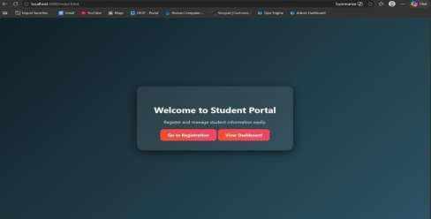
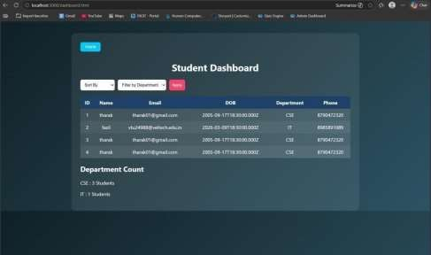

RESULT: The system successfully stores, retrieves, and displays student data efficiently through a user-friendly dashboard.

TASK3: : Login System with Validation

AIM: To develop a secure login system that validates user credentials (username and password) and allows access only to authorized users.

ALGORITHM:
- Start the application
- Display login form (Username & Password fields)
- User enters login credentials
- Perform input validation:
  - Check if fields are empty
  - Validate email format (if applicable)
  - Ensure password meets required criteria
- Send login data to backend server
- Server receives request and processes input
- Compare entered credentials with database records
- If credentials match:
  - Grant access and redirect to dashboard
- Else:
  - Display error message (“Invalid Username/Password”)
- End process

PROGRAM: INDEX.HTML:
<!DOCTYPE html>
<html>

<head>
<title>Student Portal</title>
<link rel="stylesheet" href="style.css">
</head>
<body>
<div class="home-container">
<h1>Welcome to Student Portal</h1>
<p>Register and manage student information easily.</p>
<a href="registration.html" class="start-btn">Go to Registration</a>
<a href="dashboard.html" class="start-btn">View Dashboard</a>
</div>
</body>
</html>

DASHBOARD.HTML:
<!DOCTYPE html>
<html>
<head>
<title>Student Dashboard</title>
<link rel="stylesheet" href="dashboard.css">
</head>
<body>
<div class="container">
<button onclick="goHome()" class="home-btn">Home</button>
<h1>Student Dashboard</h1>
<div class="controls">

<select id="sortSelect">
<option value="">Sort By</option>
<option value="name">Name</option>
<option value="dob">Date of Birth</option>
</select>
<select id="departmentFilter">
<option value="">Filter by Department</option>
<option value="CSE">CSE</option>
<option value="IT">IT</option>
<option value="ECE">ECE</option>
<option value="MECH">MECH</option>
</select>
<button onclick="loadStudents()">Apply</button>
</div>
<table>
<thead>
<tr>
<th>ID</th>
<th>Name</th>
<th>Email</th>
<th>DOB</th>
<th>Department</th>
<th>Phone</th>
</tr>
</thead>
<tbody id="studentTable"></tbody>

</table>
<h2>Department Count</h2>
<div id="deptCount"></div>
</div>
<script src="dashboard.js"></script>
<script>
function goHome(){ window.location.href = "index.html"
}
</script>
</body>
</html>

LOGIN.HTML:
<!DOCTYPE html>
<html>
<head>
<title>Login</title>
<link rel="stylesheet" href="login.css">
</head>
<body>
<div class="login-container">
<h1>Login</h1>
<form id="loginForm">
<label>Username</label>
<input type="text" id="username">

<label>Password</label>
<input type="password" id="password">
<p id="errorMsg"></p>
<button type="submit">Login</button>
</form>
</div>
<script src="login.js"></script>
</body>
</html>

REGISTRATION.HTML:
<!DOCTYPE html>
<html>
<head>
<title>Student Registration</title>
<link rel="stylesheet" href="style.css">
</head>
<body>
<div class="container">
<h1>Student Registration</h1>
<button onclick="goHome()" class="home-btn">Home</button>
<form id="studentForm">
<label>Name</label>
<input type="text" id="name" placeholder="Enter your name" required>
<label>Email</label>
<input type="email" id="email" placeholder="Enter your email" required>

<label>Date of Birth</label>
<input type="date" id="dob" required>
<label>Department</label>
<select id="department" required>
<option value="">Select Department</option>
<option>CSE</option>
<option>IT</option>
<option>ECE</option>
<option>MECH</option>
</select>
<label>Phone</label>
<input type="text" id="phone" placeholder="Enter phone number" required>
<button type="submit">Register</button>
</form>
</div>
<script src="script.js"></script>
</body>
</html>

STYLE.CSS:
body{
font-family: 'Segoe UI', sans-serif;
background: linear-gradient(135deg,#0f2027,#203a43,#2c5364); height:100vh;
display:flex;
justify-content:center;

align-items:center; margin:0;
}

.container{ width:420px; padding:35px;
background:rgba(255,255,255,0.08); border-radius:18px;
backdrop-filter: blur(10px);
box-shadow:0 10px 35px rgba(0,0,0,0.6);
}

h1{
text-align:center; color:white;
margin-bottom:25px;
}

h2{
text-align:center; color:white; margin-top:30px;
}

form{

display:flex;
flex-direction:column;
}

label{ color:#ddd; font-size:14px;
margin-bottom:5px; margin-top:10px;
}

input,select{ width:100%; padding:12px; border:none; border-radius:8px;
background:#27496d; color:white;
font-size:14px; outline:none; margin-bottom:5px;
}

input:focus,select:focus{ box-shadow:0 0 8px #00eaff; background:#2c5d8a;

}

button{
margin-top:15px; padding:12px; border:none;
border-radius:10px;
background:linear-gradient(45deg,#ff4b2b,#ff416c);
color:white;
font-size:16px; font-weight:bold;
cursor:pointer; transition:0.3s;
}

button:hover{ transform:scale(1.05);
box-shadow:0 0 15px #ff416c;
}

#studentList{ margin-top:15px; text-align:center; color:white;
font-size:15px;
}

.home-container{ text-align:center; color:white;
background:rgba(255,255,255,0.08); padding:50px;
border-radius:20px;
backdrop-filter: blur(10px);
box-shadow:0 10px 35px rgba(0,0,0,0.6); width:420px;
}

.home-container h1{ font-size:32px; margin-bottom:15px;
}

.home-container p{ margin-bottom:30px; color:#ddd;
}

.start-btn{
text-decoration:none; padding:12px 25px; border-radius:10px;
background:linear-gradient(45deg,#ff4b2b,#ff416c);

color:white;
font-weight:bold; transition:0.3s;
}

.start-btn:hover{ transform:scale(1.05);
box-shadow:0 0 15px #ff416c;
}

SERVER.JS:
const express = require("express")
const cors = require("cors")
const path = require("path") const db = require("./db") const app = express()
app.use(cors()) app.use(express.json())
app.use(express.urlencoded({ extended: true }))
// Disable default index.html loading app.use(express.static( dirname, { index: false }))
// ==========================
// OPEN LOGIN PAGE FIRST
// ==========================
app.get("/", (req, res) => { res.sendFile(path.join( dirname, "login.html"))

})
// ==========================
// LOGIN SYSTEM
// ==========================
app.post("/login",(req,res)=>{
const {username,password} = req.body
const sql = "SELECT * FROM users WHERE username=? AND password=?" db.query(sql,[username,password],(err,result)=>{
if(err){ res.send("error") return
}
if(result.length > 0){ res.send("success")
}else{
res.send("fail")
}
})
})
// ==========================
// STUDENT REGISTRATION
// ==========================
app.post("/addStudent",(req,res)=>{
const {name,email,dob,department,phone} = req.body
const sql = "INSERT INTO students(name,email,dob,department,phone) VALUES (?,?,?,?,?)" db.query(sql,[name,email,dob,department,phone],(err,result)=>{

if(err){ res.send(err)
}else{
res.send("Student Added Successfully")
}

})

})
// ==========================
// GET STUDENTS (Dashboard)
// ==========================

app.get("/students",(req,res)=>{

db.query("SELECT * FROM students",(err,result)=>{

if(err){ res.send(err)
}else{ res.json(result)
}

})

})

// ==========================
// START SERVER
// ==========================
app.listen(3000,()=>{
console.log("Server running at: http://localhost:3000")
})

OUTPUTS:
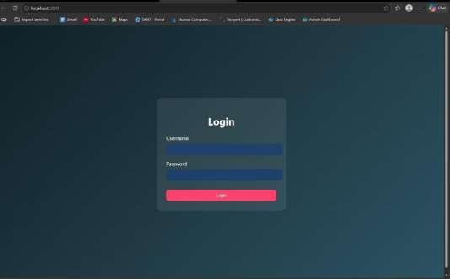

RESULT: The system successfully validates user credentials and grants access only to authorized
users while preventing invalid logins.

TASK4: Order Management using Joins

AIM: To design and implement an order management system using SQL joins and subqueries to efficiently retrieve and analyze customer, product, and order data.

ALGORITHM:
- Start the process
- Create database tables:
  - Customers (CustomerID, Name, etc.)
  - Products (ProductID, ProductName, Price)
  - Orders (OrderID, CustomerID, ProductID, Quantity, TotalAmount)
- Insert sample data into all tables
➤ Data Retrieval using Joins:
- Use SQL JOIN queries to combine data from Customers, Orders, and Products
- Display customer order history with details (Name, Product, Quantity, Total Amount)
➤ Subquery for Analysis:
- Use subquery to find the highest value order
- Use subquery with GROUP BY to find the most active customer (maximum number of orders)
➤ Sorting:
- Apply ORDER BY clause to sort results (e.g., highest order value first)
- Display results in structured format (table/UI with CSS if frontend used)
- Stop

PROGRAM:
INDEX.HTML:
<!DOCTYPE html>
<html>
<head>
<title>Login</title>
<link rel="stylesheet" href="style.css">
</head>
<body>
<div class="login">
<h2>Admin Login</h2>
<input type="text" id="username" placeholder="Username">
<input type="password" id="password" placeholder="Password">
<button onclick="login()">Login</button>
</div>
<script src="script.js"></script>
</body>
</html>

ADMINDASHBOARD.HTML:

<!DOCTYPE html>
<html>
<head>
<title>Order Dashboard</title>
<link rel="stylesheet" href="style.css">

</head>
<body>
<!-- NAVBAR -->
<div class="navbar">
<h2>Order Management</h2>
<a href="index.html">
<button class="logout-btn">Logout</button>
</a>
</div>
<h1>Order Management Dashboard</h1>
<!-- CARDS SECTION -->
<div class="grid">
<!-- Add Customer -->
<div class="card">
<h3>Add Customer</h3>
<input id="cname" placeholder="Customer Name">
<input id="cemail" placeholder="Email">
<button onclick="addCustomer()">Add Customer</button>
</div>
<!-- Add Product -->
<div class="card">
<h3>Add Product</h3>
<input id="pname" placeholder="Product Name">
<input id="pprice" placeholder="Price">
<button onclick="addProduct()">Add Product</button>
</div>

<!-- Place Order -->
<div class="card">
<h3>Place Order</h3>
<select id="customerSelect">
<option value="">Select Customer</option>
</select>
<select id="productSelect">
<option value="">Select Product</option>
</select>
<input id="qty" placeholder="Quantity">
<button onclick="placeOrder()">Place Order</button>
</div>
</div>
<!-- ACTION BUTTONS -->
<div class="actions">
<button onclick="loadOrders()">Order History</button>
<button onclick="highestOrder()">Highest Order</button>
<button onclick="activeCustomer()">Most Active Customer</button>
</div>
<!-- RESULT AREA -->
<div id="result"></div>
<script src="script.js"></script>
</body>
</html>

STYLE.CSS:

*{ margin:0; padding:0;
box-sizing:border-box;
font-family: 'Segoe UI', Tahoma, Geneva, Verdana, sans-serif;
}

body{
background: linear-gradient(135deg,#5f6caf,#9a6bff); min-height:100vh;
display:flex;
flex-direction:column; align-items:center;
}

/* LOGIN PAGE */

.login{ width:350px; padding:40px; margin-top:120px; background:white; border-radius:15px;
box-shadow:0 10px 25px rgba(0,0,0,0.2); text-align:center;
}

.login h2{
margin-bottom:20px;
color:#333;
}

.login input{ width:100%; padding:12px; margin:10px 0; border:1px solid #ccc; border-radius:8px; outline:none;
}

.login button{ width:100%; padding:12px; border:none; background:#5f6caf; color:white;
font-weight:bold; border-radius:8px; cursor:pointer; transition:0.3s;
}

.login button:hover{ background:#7c4dff;
}

/* DASHBOARD TITLE */

h1{
margin-top:30px; margin-bottom:25px;
color:white;

}

/* CARD GRID */

.grid{ display:flex; gap:25px;
flex-wrap:wrap; justify-content:center; margin-bottom:20px;
}

/* CARDS */

.card{

width:260px; padding:22px; border-radius:15px;
box-shadow:0 8px 20px rgba(0,0,0,0.2); text-align:center;
transition:0.3s; color:white;
}

/* Different card colors */

.card:nth-child(1){
background:linear-gradient(135deg,#ff7a18,#ffb347);
}

.card:nth-child(2){
background:linear-gradient(135deg,#00c6ff,#0072ff);
}

.card:nth-child(3){
background:linear-gradient(135deg,#43e97b,#38f9d7);
color:#222;
}

.card:hover{ transform:translateY(-6px);

}

.card h3{
margin-bottom:10px;
}

/* INPUTS */

.card input{ width:90%; padding:10px; margin:6px; border-radius:6px; border:none;
}

/* CARD BUTTON */

.card button{ padding:10px 15px; border:none; background:white; color:#333;
border-radius:6px; cursor:pointer; font-weight:bold;

transition:0.3s;
}

.card button:hover{ background:#f1f1f1;
}

/* ACTION BUTTONS */

button{ margin:10px; padding:12px 18px; border:none; border-radius:6px; background:#ffffff; color:#333;
font-weight:bold; cursor:pointer; transition:0.3s;
}

button:hover{
background:#eaeaea;

}

/* TABLE */

table{ width:85%;
margin:auto; margin-top:30px;
border-collapse:collapse; background:white; border-radius:12px;
overflow:hidden;

box-shadow:0 5px 15px rgba(0,0,0,0.2);
}

th{ background:#5f6caf; color:white; padding:14px;
font-size:18px;
}

td{ padding:12px; text-align:center;
border-bottom:1px solid #ddd; color:#222;
font-weight:500;
}

tr:nth-child(even){ background:#f7f7f7;
}

tr:hover{
background:#eef1ff;

}

/* RESULT TEXT */

#result{
margin-top:20px;
color:white;
font-size:18px; text-align:center;
}
/* NAVBAR */

.navbar{

width:100%; display:flex;
justify-content:space-between;
align-items:center; padding:15px 40px;

background:#2c2f5c; color:white;
box-shadow:0 4px 10px rgba(0,0,0,0.2);

}

.navbar h2{
font-weight:600;
}

.logout-btn{

background:#ff5252; color:white; border:none; padding:10px 16px; border-radius:6px; cursor:pointer;
font-weight:bold;

}

.logout-btn:hover{

background:#ff1744;

}
.actions{

display:flex;
justify-content:center; gap:20px;
margin-top:30px; flex-wrap:wrap;

}
.actions button{ padding:12px 20px;
font-size:16px; border:none; border-radius:8px; background:#5f6caf; color:white; cursor:pointer; transition:0.3s;
}
.actions button:hover{ background:#7c4dff;
transform:scale(1.05);

}

SCRIPT.JS:
// LOGIN FUNCTION

function login(){

const username=document.getElementById("username").value const password=document.getElementById("password").value

fetch("/login",{

method:"POST",
headers:{"Content-Type":"application/json"},

body:JSON.stringify({username,password})

})

.then(res=>res.json())

.then(data=>{

if(data.success){

window.location="admindashboard.html"
}else{
alert("Invalid login")

}
})

}
// ADD CUSTOMER

function addCustomer(){

fetch("/add-customer",{

method:"POST",
headers:{"Content-Type":"application/json"},

body:JSON.stringify({

name:document.getElementById("cname").value, email:document.getElementById("cemail").value

})

})

.then(res=>res.text())
.then(alert)

}

// ADD PRODUCT

function addProduct(){

fetch("/add-product",{

method:"POST",
headers:{"Content-Type":"application/json"},

body:JSON.stringify({

product:document.getElementById("pname").value,
price:document.getElementById("pprice").value

})

})

.then(res=>res.text())
.then(alert)

}

// LOAD CUSTOMERS INTO DROPDOWN

async function loadCustomers(){

const res = await fetch("/customers") const data = await res.json()

let select=document.getElementById("customerSelect")

if(!select) return

select.innerHTML='<option value="">Select Customer</option>'

data.forEach(c=>{

select.innerHTML+=`<option value="${c.id}">${c.name}</option>`

})

}

// LOAD PRODUCTS INTO DROPDOWN

async function loadProducts(){

const res = await fetch("/products")

const data = await res.json()

let select=document.getElementById("productSelect")

if(!select) return

select.innerHTML='<option value="">Select Product</option>'

data.forEach(p=>{

select.innerHTML+=`<option value="${p.id}">${p.product_name}</option>`

})

}

// PLACE ORDER

function placeOrder(){

fetch("/place-order",{

method:"POST",
headers:{"Content-Type":"application/json"},

body:JSON.stringify({

customer_id:document.getElementById("customerSelect").value, product_id:document.getElementById("productSelect").value, quantity:document.getElementById("qty").value

})

})

.then(res=>res.text())
.then(alert)

}

// ORDER HISTORY (JOIN)

async function loadOrders(){

const res=await fetch("/orders") const data=await res.json()

let html="<table><tr><th>Customer</th><th>Product</th><th>Price</th><th>Qty</th><th>Total<
/th></tr>"

data.forEach(o=>{

html+=`

<tr>

<td>${o.name}</td>
<td>${o.product_name}</td>
<td>${o.price}</td>
<td>${o.quantity}</td>
<td>${o.total}</td>

</tr>

`

})

html+="</table>"

document.getElementById("result").innerHTML=html

}

// HIGHEST ORDER (SUBQUERY)

async function highestOrder(){

const res=await fetch("/highest-order") const data=await res.json()

document.getElementById("result").innerHTML=

`<h2>Highest Order</h2>

${data[0].name} - ₹${data[0].total}`

}

// MOST ACTIVE CUSTOMER

async function activeCustomer(){

const res=await fetch("/active-customer") const data=await res.json()

document.getElementById("result").innerHTML=

`<h2>Most Active Customer</h2>

${data[0].name} (${data[0].total_orders} orders)`

}

// AUTO LOAD DROPDOWNS WHEN PAGE LOADS

window.onload=function(){

loadCustomers() loadProducts()

}

SERVER.JS:
const express=require("express") const db=require("./db")

const app=express()

app.use(express.json()) app.use(express.static( dirname))

// LOGIN

app.post("/login",(req,res)=>{

const {username,password}=req.body

const sql="SELECT * FROM users WHERE username=? AND password=?"

db.query(sql,[username,password],(err,result)=>{

if(err) throw err

if(result.length>0){ res.json({success:true})
}else{ res.json({success:false})
}

})

})

// ADD CUSTOMER

app.post("/add-customer",(req,res)=>{

const {name,email}=req.body

const sql="INSERT INTO customers(name,email) VALUES(?,?)" db.query(sql,[name,email],(err)=>{
if(err) throw err

res.send("Customer Added Successfully")

})

})

// ADD PRODUCT

app.post("/add-product",(req,res)=>{

const {product,price}=req.body

const sql="INSERT INTO products(product_name,price) VALUES(?,?)"

db.query(sql,[product,price],(err)=>{

if(err) throw err

res.send("Product Added Successfully")

})

})

// GET CUSTOMERS (for dropdown) app.get("/customers",(req,res)=>{ const sql="SELECT * FROM customers"
db.query(sql,(err,result)=>{

if(err) throw err

res.json(result)

})

})

// GET PRODUCTS (for dropdown)

app.get("/products",(req,res)=>{

const sql="SELECT * FROM products" db.query(sql,(err,result)=>{
if(err) throw err

res.json(result)

})

})

// PLACE ORDER

app.post("/place-order",(req,res)=>{

const {customer_id,product_id,quantity}=req.body

const sql="INSERT INTO orders(customer_id,product_id,quantity) VALUES(?,?,?)"

db.query(sql,[customer_id,product_id,quantity],(err)=>{

if(err) throw err

res.send("Order Placed Successfully")

})

})
// ORDER HISTORY (JOIN)

app.get("/orders",(req,res)=>{

const sql=`

SELECT customers.name, products.product_name, products.price,
orders.quantity,

(products.price * orders.quantity) AS total

FROM orders

JOIN customers
ON orders.customer_id = customers.id

JOIN products
ON orders.product_id = products.id

ORDER BY orders.order_date DESC

`

db.query(sql,(err,result)=>{ if(err) throw err
res.json(result)

})

})

// HIGHEST VALUE ORDER (SUBQUERY)

app.get("/highest-order",(req,res)=>{

const sql=`

SELECT customers.name,
(products.price * orders.quantity) AS total

FROM orders

JOIN customers
ON orders.customer_id = customers.id

JOIN products
ON orders.product_id = products.id

WHERE (products.price * orders.quantity) =

(
SELECT MAX(products.price * orders.quantity) FROM orders
JOIN products
ON orders.product_id = products.id
)

` db.query(sql,(err,result)=>{
if(err) throw err

res.json(result)

})

})

// MOST ACTIVE CUSTOMER

app.get("/active-customer",(req,res)=>{

const sql=`

SELECT customers.name, COUNT(orders.id) AS total_orders

FROM customers

JOIN orders
ON customers.id = orders.customer_id GROUP BY customers.id
ORDER BY total_orders DESC

LIMIT 1

` db.query(sql,(err,result)=>{
if(err) throw err

res.json(result)

})

})

// START SERVER

app.listen(3000,()=>{

console.log("Server running at http://localhost:3000")

})

OUTPUTS:
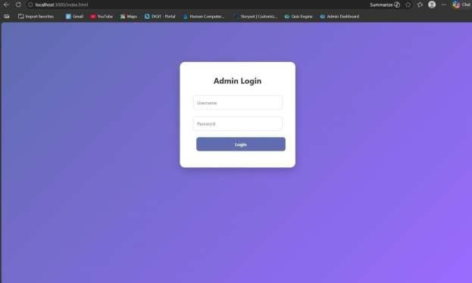

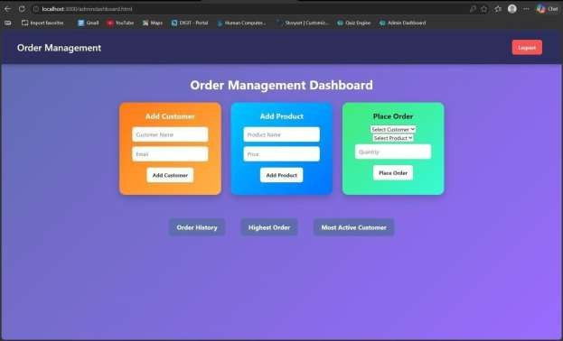

RESULT: The system successfully retrieves and analyzes customer order data using joins and subqueries, displaying meaningful insights like highest order value and most active customer.

TASK5: Transaction-Based Payment Simulation

AIM: To simulate an online payment system using database transactions that ensures safe and reliable fund transfer between user and merchant accounts using COMMIT and ROLLBACK operations.

ALGORITHM:
- Start the process
- Create database tables:
  - User Account (UserID, Balance)
  - Merchant Account (MerchantID, Balance)
- Insert initial balance values for user and merchant
➤ Transaction Process:
- Begin transaction (START TRANSACTION)
- Deduct amount from user account
- Add amount to merchant account
➤ Validation:
- Check if user has sufficient balance
  - If yes → proceed
  - If no → go to rollback
➤ Commit / Rollback:
- If all operations are successful → COMMIT transaction
- If any error occurs → ROLLBACK transaction
- Display transaction status (Success / Failed)
- Stop

PROGRAM:
INDEX.HTML:
<!DOCTYPE html>
<html>
<head>
<title>Payment Simulation</title>
<link rel="stylesheet" href="style.css">
</head>
<body>
<div class="container">
<h2>Online Payment</h2>
<select id="user" onchange="updateBalances()"></select>
<select id="merchant" onchange="updateBalances()"></select>
<input type="number" id="amount" placeholder="Enter amount">
<button onclick="pay()">Pay</button>
<h3 id="userBalance"></h3>
<h3 id="merchantBalance"></h3>
<p id="result"></p>
</div>
<script src="script.js"></script>
</body>
</html>

STYLE.CSS:
body{
font-family: Arial;

background: linear-gradient(135deg,#dfe9f3,#ffffff); display:flex;
justify-content:center;
align-items:center; height:100vh;
}

.container{ background:white; padding:30px; border-radius:15px;
box-shadow:0 10px 25px rgba(0,0,0,0.2); text-align:center;
width:400px;
}

select, input{ padding:10px; margin:10px; width:90%; border-radius:5px;
border:1px solid #ccc;
}

button{ padding:10px;

width:95%; background:green; color:white; border:none;
border-radius:5px; cursor:pointer; font-size:16px;
}

button:hover{ background:darkgreen;
}

h3{ margin:5px; color:#333;
}

SCRIPT.JS:
let usersData = []
let merchantsData = []
function loadData(){
fetch("/balances")

.then(res=>res.json())
.then(data=>{ usersData = data.users

merchantsData = data.merchants
let userSelect = document.getElementById("user")
let merchantSelect = document.getElementById("merchant") userSelect.innerHTML=""
merchantSelect.innerHTML=""
// fill users usersData.forEach(u=>{
userSelect.innerHTML += `<option value="${u.id}">${u.name}</option>`
})
window.onload = loadData
// fill merchants merchantsData.forEach(m=>{
merchantSelect.innerHTML += `<option value="${m.id}">${m.name}</option>`
})
// show initial balances updateBalances()
})
}
function updateBalances(){
let userId = document.getElementById("user").value
let merchantId = document.getElementById("merchant").value
let user = usersData.find(u=>u.id == userId)
let merchant = merchantsData.find(m=>m.id == merchantId) document.getElementById("userBalance").innerText = "User Balance: ₹" + user.balance document.getElementById("merchantBalance").innerText =

"Shop Balance: ₹" + merchant.balance
}
function pay(){
let userId = document.getElementById("user").value
let merchantId = document.getElementById("merchant").value let amount = document.getElementById("amount").value
fetch("/pay",{ method:"POST", headers:{
"Content-Type":"application/json"
},
body:JSON.stringify({ userId:userId, merchantId:merchantId, amount:amount
})
})
.then(res=>res.json())
.then(data=>{
document.getElementById("result").innerText = data.message loadData()
})
}
window.onload = loadData

SERVER.JS:
const express = require("express") const db = require("./db")
const app = express()
app.use(express.json()) app.use(express.static( dirname)) app.get("/", (req, res) => {
res.sendFile( dirname + "/index.html")
})
app.post("/pay", (req, res) => {
const { userId, merchantId, amount } = req.body const amt = parseInt(amount)
if (!amt || amt <= 0) {
return res.json({ message: "Enter valid amount" })
}
db.beginTransaction(err => {
if (err) return res.status(500).send("Transaction error")
// 1. Get user balance
db.query("SELECT balance FROM users WHERE id=?", [userId], (err, result) => { if (err || result.length === 0) {
return db.rollback(() => res.send("User not found"))
}
let balance = result[0].balance if (balance < amt) {
return db.rollback(() => {
res.json({ message: "Insufficient Balance" })

})
}

// 2. Deduct from user db.query(
"UPDATE users SET balance = balance - ? WHERE id=?", [amt, userId],
(err) => {

if (err) {
return db.rollback(() => res.send("Deduction failed"))
}

// 3. Add to merchant db.query(
"UPDATE merchants SET balance = balance + ? WHERE id=?",
[amt, merchantId], (err) => {

if (err) {
return db.rollback(() => res.send("Merchant update failed"))
}
// 4. Commit db.commit(err => {

if (err) {

return db.rollback(() => res.send("Commit failed"))
}

res.json({ message: "Payment Successful " })
})
}
)
}
)
})
})
})
app.get("/balances", (req, res) => {

db.query("SELECT * FROM users", (err, users) => {

if (err) return res.send("Error fetching users")

db.query("SELECT * FROM merchants", (err, merchants) => {

if (err) return res.send("Error fetching merchants")

res.json({ users: users,
merchants: merchants
})

})
})
})
app.listen(3000, () => {
console.log("Server running on http://localhost:3000")
})

OUTPUTS:
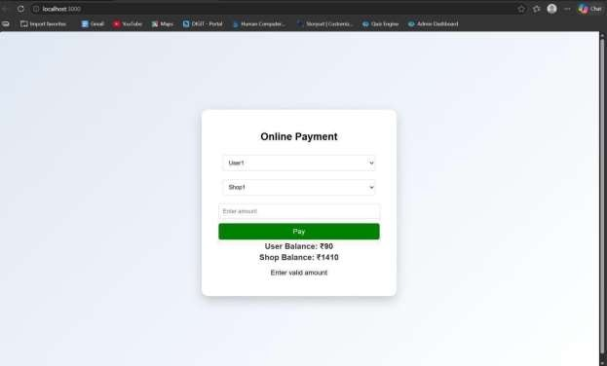
RESULT: The system successfully performs secure payment transactions by updating balances accurately using COMMIT on success and ROLLBACK on failure.

TASK6: Automated Logging using Triggers & Views
AIM: To develop a web-based application for automated logging of database activities using MySQL triggers and views, integrated with a Node.js backend and frontend interface, in order to track INSERT and UPDATE operations and generate daily activity reports.

ALGORITHM:
- Start the program
- Create database and required tables
- Create triggers for INSERT and UPDATE operations
- Store actions in log table automatically
- Create a view for daily activity report
- Develop backend using Node.js and Express
- Connect backend with MySQL database
- Create APIs for add, update, logs, and report
- Design frontend using HTML, CSS, and JavaScript
- Run the application and display results
- Stop the program

PROGRAM:
INDEX.HTML:
<!DOCTYPE html>
<html>
<head>
<title>Employee Audit System</title>
<link rel="stylesheet" href="style.css">
</head>
<body>

<h2>Employee Management</h2>
<div class="form">
<input type="number" id="emp_id" placeholder="Employee ID">
<input type="text" id="name" placeholder="Name">
<input type="number" id="salary" placeholder="Salary">
<button onclick="addEmployee()">Add</button>
</div>
<div class="form">
<input type="number" id="update_id" placeholder="Employee ID">
<input type="number" id="new_salary" placeholder="New Salary">
<button onclick="updateEmployee()">Update</button>
</div>
<button onclick="loadLogs()">View Logs</button>
<button onclick="loadReport()">View Daily Report</button>
<h3>Output</h3>
<pre id="output"></pre>
<script src="script.js"></script>
</body>
</html>

STYLE.CSS:
body {
font-family: Arial; text-align: center;
background: #f4f4f4;

}

.form {
margin: 15px;
}
input {
padding: 8px; margin: 5px;
}
button{
padding: 8px 15px; background: blue; color: white;
border: none; cursor: pointer;
}
button:hover { background: darkblue;
}
pre {
background: white; padding: 10px;
width: 60%;
margin: auto;

text-align: left;
}

SCRIPT.JS:
const BASE_URL = "http://localhost:3000";

// Add Employee
function addEmployee() {
const data = {
emp_id: document.getElementById("emp_id").value, name: document.getElementById("name").value,
salary: document.getElementById("salary").value
};
fetch(`${BASE_URL}/add`, { method: "POST",
headers: { "Content-Type": "application/json" },
body: JSON.stringify(data)

})
.then(res => res.text())
.then(data => alert(data));
}
// Update Employee function updateEmployee() {
const id = document.getElementById("update_id").value; const salary = document.getElementById("new_salary").value;

fetch(`${BASE_URL}/update/${id}`, {
method: "PUT",
headers: { "Content-Type": "application/json" }, body: JSON.stringify({ salary })
})
.then(res => res.text())

.then(data => alert(data));
}
// Load Logs function loadLogs() {
fetch(`${BASE_URL}/logs`)
.then(res => res.json())
.then(data => { document.getElementById("output").innerText =
JSON.stringify(data, null, 2);
});
}
// Load Report function loadReport() {
fetch(`${BASE_URL}/report`)
.then(res => res.json())
.then(data => { document.getElementById("output").innerText =
JSON.stringify(data, null, 2);
});
}

DB.JS:
const mysql = require('mysql2');
const db = mysql.createConnection({ host: 'localhost',
user: 'root',
password: 'fahi',

database: 'audit_db'
});
db.connect((err) => { if (err) {
console.error('DB Connection Failed:', err);
} else {
console.log('Connected to MySQL');
}
});
module.exports = db;

OUTPUTS:
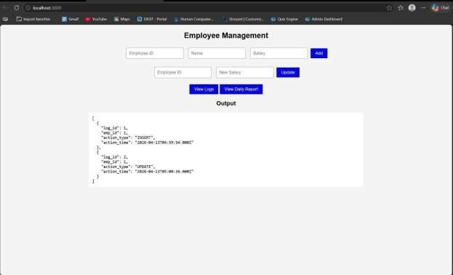

RESULT: The system successfully logs all INSERT and UPDATE operations automatically using triggers and displays daily activity reports through a web interface.

TASK7: Interactive Web Form with Events & Functions

AIM: To develop an interactive web-based feedback form with real-time validation, UI effects, and backend data storage using HTML, CSS, JavaScript, and Node.js.

ALGORITHM:
- Start the program
- Create project files (HTML, CSS, JS, server.js, db.js)
- Design feedback form with input fields (name, email, message)
- Apply CSS styling for layout and visual effects
- Define reusable validation functions in JavaScript
- Capture user input using DOM elements
- Apply keyup event for real-time validation
- Add hover effect to highlight input fields
- Implement double-click event on submit button
- Validate all fields before submission
- Send data to server using fetch API (POST request)
- Store data in database module and display success message

PROGRAM:
INDEX.HTML:
<!DOCTYPE html>
<html lang="en">
<head>
<title>Feedback Form</title>
<link rel="stylesheet" href="style.css">
</head>

<body>
<div class="container">
<h2> Customer Feedback</h2>
<form id="feedbackForm">
<input type="text" id="name" placeholder="Your Name" required>
<span class="error" id="nameError"></span>
<input type="email" id="email" placeholder="Your Email" required>
<span class="error" id="emailError"></span>
<textarea id="message" placeholder="Your Feedback" required></textarea>
<span class="error" id="msgError"></span>
<button type="button" id="submitBtn">Submit</button>
</form>
<p id="successMsg"></p>
</div>
<script src="script.js"></script>
</body>
</html>

STYLE.CSS:
body {
font-family: 'Segoe UI', sans-serif;
background: linear-gradient(135deg, #1f1c2c, #928dab);
display: flex;
justify-content: center; align-items: center; height: 100vh;
color: white;

}
.container {
background: rgba(255, 255, 255, 0.1); padding: 25px;
border-radius: 15px; backdrop-filter: blur(10px); width: 320px;
box-shadow: 0 10px 25px rgba(0,0,0,0.3);
}
h2 {
text-align: center;
}
input, textarea { width: 100%; padding: 10px;
margin: 8px 0; border-radius: 8px; border: none; outline: none; transition: 0.3s;
}
input:hover, textarea:hover {
transform: scale(1.05);
box-shadow: 0 0 8px #00f7ff;
}
button{

width: 100%; padding: 10px; background: #00c6ff; border: none;
border-radius: 10px; color: white;
font-weight: bold; cursor: pointer;
}
button:hover { background: #0072ff;
}
.error {
color: #ff6b6b;
font-size: 12px;
}
#successMsg {
text-align: center; margin-top: 10px;
color: #00ffae;

}

SCRIPT.JS:
const nameInput = document.getElementById("name"); const emailInput = document.getElementById("email");
const messageInput = document.getElementById("message");
const submitBtn = document.getElementById("submitBtn");

function validateName() {
if (nameInput.value.length < 3) { document.getElementById("nameError").innerText = "Min 3 characters"; return false;
}
document.getElementById("nameError").innerText = ""; return true;
}
function validateEmail() {
let pattern = /^[^ ]+@[^ ]+\.[a-z]{2,3}$/; if (!emailInput.value.match(pattern)) {
document.getElementById("emailError").innerText = "Invalid email";
return false;
}
document.getElementById("emailError").innerText = ""; return true;
}
function validateMessage() {
if (messageInput.value.length < 5) { document.getElementById("msgError").innerText = "Too short"; return false;
}
document.getElementById("msgError").innerText = ""; return true;
}
nameInput.addEventListener("keyup", validateName);

emailInput.addEventListener("keyup", validateEmail); messageInput.addEventListener("keyup", validateMessage); submitBtn.addEventListener("dblclick", () => {
if (validateName() && validateEmail() && validateMessage()) { sendData();
} else {
alert("Fix errors before submitting!");
}
});
function sendData() { fetch("http://localhost:3000/submit", {
method: "POST", headers: {
"Content-Type": "application/json"
},
body: JSON.stringify({ name: nameInput.value,
email: emailInput.value,

message: messageInput.value
})
})
.then(res => res.json())
.then(data => {
document.getElementById("successMsg").innerText = " Feedback Submitted!";
});
}

SERVER.JS:
const express = require("express"); const cors = require("cors");
const bodyParser = require("body-parser");
const path = require("path");
const db = require("./db"); const app = express(); app.use(cors()); app.use(bodyParser.json());
app.use(express.static( dirname)); app.get("/", (req, res) => {
res.sendFile(path.join(dirname, "index.html"));
});
app.post("/submit", (req, res) => {
const { name, email, message } = req.body; db.saveFeedback({ name, email, message }); res.json({ status: "success" });
});
app.listen(3000, () => {
console.log("Server running on http://localhost:3000");
});

DB.JS:
let feedbacks = [];
function saveFeedback(data) { feedbacks.push(data);
console.log("Saved:", data);

}
module.exports = { saveFeedback
};

OUTPUT:
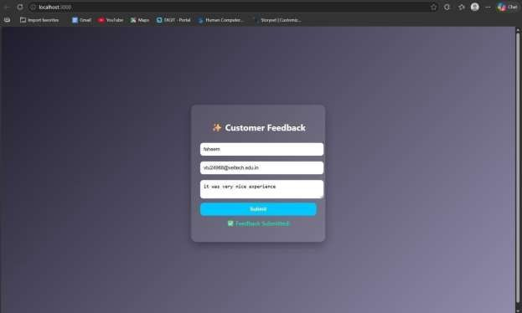

RESULT: The interactive feedback form was successfully implemented with real-time validation, enhanced UI effects, and backend data handling.

TASK8: Employee Management

AIM: To develop a simple Employee Management system using HTML, CSS, JavaScript, and Node.js for adding and displaying employee data.

ALGORITHM:
- Start the program
- Create project files (HTML, CSS, JS, server.js, db.js)
- Design the user interface with input fields (name, role)
- Apply CSS styling for layout and centering
- Capture user input using JavaScript
- Create function to add employee data
- Send data to server using fetch API (POST request)
- Create backend using Node.js and Express
- Receive and store employee data in memory (db.js)
- Create API to fetch all employee records (GET request)
- Display employee list dynamically on the webpage
- Stop the program

PROGRAM:
INDEX.HTML:
<!DOCTYPE html>
<html>
<head>
<title>Employee Management</title>
<link rel="stylesheet" href="style.css">
</head>

<body>
<div class="container">
<h2>Employee Management</h2>
<input id="name" placeholder="Name">
<input id="role" placeholder="Role">
<button onclick="addEmployee()">Add</button>
<ul id="list"></ul>
</div>
<script src="script.js"></script>
</body>
</html>

STYLE.CSS:
body {
font-family: Arial; background: #1e1e2f;
color: white;

display: flex;
justify-content: center; align-items: center; height: 100vh; margin: 0;
}
.container {
text-align: center;
}

input {
padding: 10px; margin: 5px; border-radius: 5px;
border: none;

}
button { padding: 10px;
background: #00c6ff; border: none; border-radius: 5px; cursor: pointer;
}

SCRIPT.JS:
function addEmployee() {
const name = document.getElementById("name").value; const role = document.getElementById("role").value; fetch("http://localhost:3000/add", {
method: "POST",
headers: {
"Content-Type": "application/json"
},
body: JSON.stringify({ name, role })
})
.then(res => res.json())

.then(() => loadEmployees());
}
function loadEmployees() { fetch("http://localhost:3000/all")
.then(res => res.json())
.then(data => {
let list = document.getElementById("list"); list.innerHTML = "";

data.forEach(emp => {
let li = document.createElement("li"); li.innerText = emp.name + " - " + emp.role; list.appendChild(li);
});
});
}
loadEmployees();

SERVER.JS:
const express = require("express"); const cors = require("cors");
const path = require("path"); const db = require("./db"); const app = express();
app.use(cors()); app.use(express.json());
app.use(express.static(dirname));

app.get("/", (req, res) => { res.sendFile(path.join(dirname, "index.html"));
});
app.post("/add", (req, res) => { db.addEmployee(req.body); res.json({ msg: "Added" });
});
app.get("/all", (req, res) => { res.json(db.getEmployees());
});
app.listen(3000, () => {
console.log("• Server running at: http://localhost:3000");
});

DB.JS:
let employees = [];
function addEmployee(emp) { employees.push(emp);
}
function getEmployees() { return employees;
}
module.exports = { addEmployee, getEmployees };

OUTPUT:
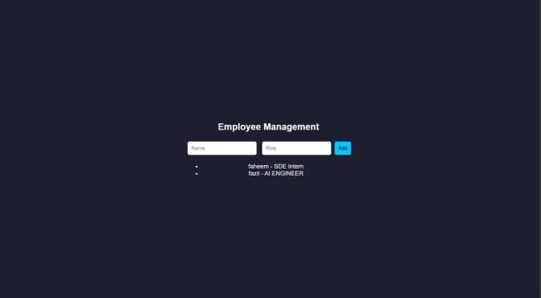

RESULT: The Employee Management system was successfully implemented with a user- friendly interface and dynamic data handling using Node.js backend.

TASK9: Employee MVC APP

AIM: To develop a basic MVC-based Employee application using HTML, CSS, JavaScript, and Node.js to handle user requests and display employee details.

ALGORITHM:
- Start the program
- Create project files (HTML, CSS, JS, server.js, db.js)
- Design UI form to accept employee details
- Apply CSS styling for better user interface
- Capture user input using JavaScript
- Send request to server using fetch API
- Create controller logic in server.js
- Define routes to handle requests (/add, /all)
- Store employee data in memory using db.js
- Retrieve employee data from database module
- Send response back to frontend (view)
- Display employee details dynamically and stop

PROGRAM:
INDEX.HTML:
<!DOCTYPE html>
<html>
<head>
<title>Employee MVC</title>
<link rel="stylesheet" href="style.css">
</head>
<body>

<div class="container">
<h2>Employee Details</h2>
<input id="name" placeholder="Name">
<input id="role" placeholder="Role">
<button onclick="addEmployee()">Add</button>
<ul id="list"></ul>
</div>
<script src="script.js"></script>
</body>
</html>

STYLE.CSS:
* {
margin: 0;
padding: 0;
box-sizing: border-box;
}
body {
font-family: 'Segoe UI', sans-serif;
background: linear-gradient(135deg, #1f1c2c, #928dab); height: 100vh;

display: flex;
justify-content: center; align-items: center;

color: white;

}
.container {
background: rgba(255, 255, 255, 0.1); padding: 30px;
border-radius: 15px; backdrop-filter: blur(10px); width: 320px;
text-align: center;

box-shadow: 0 10px 25px rgba(0,0,0,0.4);
}
h2 {
margin-bottom: 15px;
}
input {
width: 100%; padding: 10px;
margin: 8px 0;

border: none; border-radius: 8px; outline: none;

transition: 0.3s;
}
input:hover,

input:focus {
transform: scale(1.05);
box-shadow: 0 0 8px #00f7ff;
}
button{
width: 100%; padding: 10px; margin-top: 10px;

background: #00c6ff; border: none; border-radius: 10px;

color: white;
font-weight: bold; cursor: pointer;

transition: 0.3s;
}
button:hover { background: #0072ff; transform: scale(1.05);
}
ul {
list-style: none; margin-top: 15px;

}
li {
background: rgba(255,255,255,0.15); padding: 8px;
margin: 5px 0;
border-radius: 6px;

transition: 0.3s;
}
li:hover {
background: rgba(255,255,255,0.3);
}

SCRIPT.JS:
function addEmployee() {
const name = document.getElementById("name").value; const role = document.getElementById("role").value; fetch("/add", {
method: "POST",
headers: { "Content-Type": "application/json" }, body: JSON.stringify({ name, role })
})
.then(() => loadEmployees());
}
function loadEmployees() { fetch("/all")
.then(res => res.json())

.then(data => {
let list = document.getElementById("list"); list.innerHTML = "";
data.forEach(emp => {
let li = document.createElement("li"); li.innerText = emp.name + " - " + emp.role;
list.appendChild(li);
});
});
}
loadEmployees();

SERVER.JS:
const express = require("express");
const cors = require("cors");
const path = require("path"); const db = require("./db"); const app = express();
app.use(cors()); app.use(express.json()); app.use(express.static( dirname)); app.post("/add", (req, res) => {
db.addEmployee(req.body); res.json({ msg: "Employee Added" });
});
app.get("/all", (req, res) => { res.json(db.getEmployees());

});
app.listen(3000, () => { console.log("http://localhost:3000");
});

DB.JS:
let employees = [];
function addEmployee(emp) { employees.push(emp);
}
function getEmployees() { return employees;
}
module.exports = { addEmployee, getEmployees };

OUTPUT:
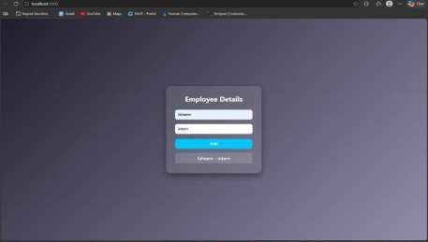
RESULT: The MVC-based Employee application was successfully implemented using Node.js, where user requests were processed and employee details were displayed dynamically.

TASK10: Student Crud App
AIM: To develop a Student CRUD application using HTML, CSS, JavaScript, and Node.js to
perform create, read, update, and delete operations.

ALGORITHM:
- Start the program
- Create project files (HTML, CSS, JS, server.js, db.js)
- Design UI for student input (id, name, course)
- Apply CSS for styling and layout
- Capture user input using JavaScript
- Send data to server using fetch API
- Create backend using Node.js and Express
- Implement Create operation (POST request)
- Implement Read operation (GET request)
- Implement Update operation (PUT request)
- Implement Delete operation (DELETE request)
- Display updated student data dynamically and stop

PROGRAM:
INDEX.HTML:
<!DOCTYPE html>
<html>
<head>
<title>Student CRUD</title>
<link rel="stylesheet" href="style.css">
</head>
<body>
<div class="container">

<h2>Student CRUD</h2>
<input id="id" placeholder="ID">
<input id="name" placeholder="Name">
<input id="course" placeholder="Course">
<button onclick="addStudent()">Add</button>
<button onclick="updateStudent()">Update</button>
<ul id="list"></ul>
</div>
<script src="script.js"></script>
</body>
</html>

STYLE.CSS:
body {
font-family: 'Segoe UI';
background: linear-gradient(135deg,#1f1c2c,#928dab); height: 100vh;
display:flex;
justify-content:center; align-items:center;
color:white;

}
.container {
background: rgba(255,255,255,0.1); padding:20px;
border-radius:10px; text-align:center;

}
input {
display:block; margin:8px auto;
padding:8px;

}
button { margin:5px; padding:8px;
background:#00c6ff; border:none; color:white;
}

SCRIPT.JS:
function addStudent() { let data = getInput();
fetch("/add", {

method: "POST",
headers: {"Content-Type":"application/json"}, body: JSON.stringify(data)
}).then(loadStudents);
}
function loadStudents() { fetch("/all")
.then(res => res.json())
.then(data => {

let list = document.getElementById("list");
list.innerHTML = "";
data.forEach(s => {
let li = document.createElement("li"); li.innerHTML = `
${s.id} - ${s.name} (${s.course})
<button onclick="deleteStudent(${s.id})"> </button>
`; list.appendChild(li);
});
});
}
function updateStudent() {
let data = getInput(); fetch("/update", {
method: "PUT",
headers: {"Content-Type":"application/json"}, body: JSON.stringify(data)
}).then(loadStudents);
}
function deleteStudent(id) { fetch(`/delete/${id}`, { method: "DELETE" })
.then(loadStudents);
}
function getInput() { return {

id: document.getElementById("id").value,
name: document.getElementById("name").value, course: document.getElementById("course").value
};
}
loadStudents();

SERVER.JS:
const express = require("express"); const cors = require("cors");
const db = require("./db"); const app = express(); app.use(cors()); app.use(express.json());
app.use(express.static(dirname));
// CREATE
app.post("/add", (req, res) => { db.add(req.body); res.json({msg:"Added"});
});
// READ
app.get("/all", (req, res) => {
res.json(db.getAll());
});
// UPDATE
app.put("/update", (req, res) => { db.update(req.body);

res.json({msg:"Updated"});
});
// DELETE
app.delete("/delete/:id", (req, res) => { db.remove(req.params.id); res.json({msg:"Deleted"});
});
app.listen(3000, () => console.log("http://localhost:3000"));

DB.JS:
let students = []; function add(s) {
students.push(s);
}
function getAll() { returnstudents;
}
function update(updated) { students = students.map(s =>
s.id == updated.id ? updated : s
);
}
function remove(id) {
students = students.filter(s => s.id != id);
}
module.exports = { add, getAll, update, remove };

OUTPUT:
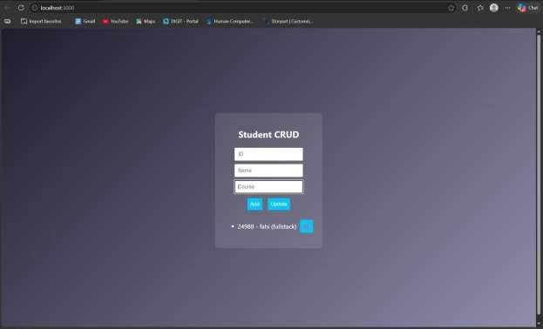
RESULT: The Student CRUD application was successfully implemented with full create, read, update, and delete operations using Node.js and a dynamic web interface.

TASK11: Student Data Layer

AIM: To implement a data access layer for managing student records with filtering, sorting, and pagination using HTML, CSS, JavaScript, and Node.js.

ALGORITHM:
- Start the program
- Create project files (HTML, CSS, JS, server.js, db.js)
- Design UI for student details (id, name, age, department)
- Apply CSS styling for layout and UI
- Capture input using JavaScript
- Send data to backend using fetch API
- Create Node.js server using Express
- Store student data in memory (db.js)
- Implement filtering (by department/age)
- Implement sorting (by name/age)
- Implement pagination (limit & page number)
- Display filtered, sorted, paginated data

PROGRAM:
INDEX.HTML:
<!DOCTYPE html>
<html>
<head>
<title>Student Data Layer</title>
<link rel="stylesheet" href="style.css">
</head>
<body>

<div class="container">
<h2>Student Data</h2>
<input id="name" placeholder="Name">
<input id="age" placeholder="Age">
<input id="dept" placeholder="Department">
<button onclick="addStudent()">Add</button>
<hr>
<input id="filterDept" placeholder="Filter Dept">
<input id="sortBy" placeholder="Sort (name/age)">
<input id="page" placeholder="Page No">
<button onclick="loadStudents()">Search</button>
<ul id="list"></ul>
</div>
<script src="script.js"></script>
</body>
</html>

STYLE.CSS:
body {
font-family: Arial; background: #1e1e2f;
color: white;
display:flex;
justify-content:center; align-items:center; height:100vh;
}

.container {
text-align:center;
}
input {
display:block; margin:5px;
padding:8px;

} SCRIPT.JS:
function addStudent() { const data = {
name: val("name"),
age: val("age"),
dept: val("dept")
};
fetch("/add", { method: "POST",
headers: {"Content-Type":"application/json"},
body: JSON.stringify(data)

}).then(loadStudents);
}
function loadStudents() {
const dept = val("filterDept"); const sort = val("sortBy");
const page = val("page");

fetch(`/students?dept=${dept}&sort=${sort}&page=${page}`)
.then(res => res.json())
.then(data => {
let list = document.getElementById("list"); list.innerHTML = "";
data.forEach(s => {
let li = document.createElement("li"); li.innerText = `${s.name} (${s.age}) - ${s.dept}`; list.appendChild(li);
});
});
}
function val(id){
return document.getElementById(id).value;
}
loadStudents();

SERVER.JS:
const express = require("express"); const cors = require("cors");
const db = require("./db"); const app = express();
app.use(cors());
app.use(express.json());

app.use(express.static(dirname));
// Add student app.post("/add", (req, res) => {

db.add(req.body); res.json({msg:"Added"});
});
// Filter + Sort + Pagination app.get("/students", (req, res) => {
let { dept, sort, page } = req.query; let data = db.getAll();
// FILTER
if (dept) {
data = data.filter(s => s.dept === dept);
}
// SORT
if (sort === "name") { data.sort((a,b)=>a.name.localeCompare(b.name));
} else if (sort === "age") {
data.sort((a,b)=>a.age - b.age);
}
// PAGINATION
let limit = 3;
page = parseInt(page) || 1; let start = (page - 1) * limit;
let paginated = data.slice(start, start + limit);
res.json(paginated);
});
app.listen(3000, () => console.log("http://localhost:3000"));

DB.JS:
let students = []; function add(s) {
students.push(s);
}
function getAll() { returnstudents;
}
module.exports = { add, getAll };

OUTPUT:
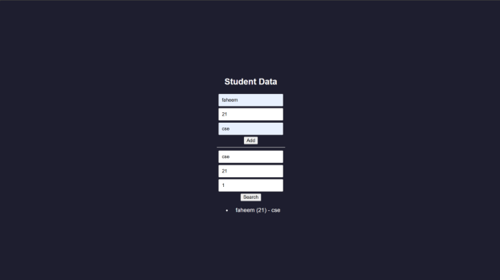

RESULT: The data access layer was successfully implemented with filtering, sorting, and pagination using Node.js and dynamic frontend interaction.

TASK12: Product Api
AIM: To design and develop a RESTful API for Product Management using Node.js that supports
GET, POST, PUT, and DELETE operations with JSON responses.

ALGORITHM:
- Start the program
- Create project files (server.js, db.js, HTML, CSS, JS)
- Design product structure (id, name, price)
- Create Node.js server using Express
- Enable JSON parsing using middleware
- Implement POST method to add products
- Implement GET method to fetch all products
- Implement PUT method to update product details
- Implement DELETE method to remove a product
- Store product data in memory using db.js
- Send JSON responses for all API requests
- Test APIs using browser or REST client

PROGRAM: INDEX.HTML:
<!DOCTYPE html>
<html>
<head>
<title>Product API</title>
</head>
<body>
<h2>Product API Test</h2>
<input id="id" placeholder="ID">

<input id="name" placeholder="Name">
<input id="price" placeholder="Price">
<button onclick="add()">Add</button>
<button onclick="get()">Get All</button>
<ul id="list"></ul>
<script src="script.js"></script>
</body>
</html>

STYLE.CSS:
/* Reset */
* {
margin: 0;
padding: 0;
box-sizing: border-box;
}
/* Background */ body {
font-family: 'Segoe UI', sans-serif;
background: linear-gradient(135deg, #141e30, #243b55); height: 100vh;
display: flex;
justify-content: center;
align-items: center; color: white;
}
/* Container */

.container {
background: rgba(255, 255, 255, 0.1); padding: 25px;
border-radius: 15px; backdrop-filter: blur(10px);

width: 350px; text-align: center;
box-shadow: 0 10px 25px rgba(0,0,0,0.4);
}
/* Heading */ h2 {
margin-bottom: 15px;
}
/* Inputs */ input {
width: 100%;
padding: 10px; margin: 8px 0; border: none; border-radius: 8px; outline: none; transition: 0.3s;
}
/* Hover + focus effect */ input:hover,

input:focus {
transform: scale(1.05);
box-shadow: 0 0 8px #00f7ff;
}
/* Buttons */ button {
width: 100%;
padding: 10px; margin-top: 8px; background: #00c6ff; border: none; border-radius: 10px; color: white;
font-weight: bold; cursor: pointer; transition: 0.3s;
}
/* Button hover */ button:hover {
background: #0072ff; transform: scale(1.05);
}
/* Product List */ ul {
list-style: none; margin-top: 15px;

}
/* List items */ li {
background: rgba(255,255,255,0.15);
padding: 10px;
margin: 6px 0; border-radius: 8px; display: flex;
justify-content: space-between;
align-items: center;

transition: 0.3s;
}
/* Hover effect */
li:hover {
background: rgba(255,255,255,0.3);
}
/* Optional delete button inside list */ li button {
width: auto; padding: 5px 8px; font-size: 12px; background: #ff4b5c;
}
li button:hover { background: #ff1e38;
}

SCRIPT.JS:
function add() { fetch("/products", {
method: "POST",
headers: {"Content-Type":"application/json"}, body: JSON.stringify(getData())
}).then(get);
}
function get() { fetch("/products")
.then(res => res.json())
.then(data => {
let list = document.getElementById("list");
list.innerHTML = "";
data.forEach(p => {
let li = document.createElement("li"); li.innerText = `${p.id} - ${p.name} - ₹${p.price}`; list.appendChild(li);
});
});
}
function getData() { return {
id: document.getElementById("id").value,
name: document.getElementById("name").value, price: document.getElementById("price").value

};
}

SERVER.JS:
const express = require("express"); const cors = require("cors");
const db = require("./db");
const app = express(); app.use(cors()); app.use(express.json());
// GET all products app.get("/products", (req, res) => {
res.json(db.getAll());
});
// POST add product app.post("/products", (req, res) => {
db.add(req.body);
res.json({ message: "Product added" });
});
// PUT update product app.put("/products/:id", (req, res) => {
db.update(req.params.id, req.body);
res.json({ message: "Product updated" });
});
// DELETE product app.delete("/products/:id", (req, res) => {

db.remove(req.params.id);
res.json({ message: "Product deleted" });
});
// Server start app.listen(3000, () => {
console.log("• API running at http://localhost:3000/products");
});

DB.JS:
let products = []; function getAll() {
return products;
}
function add(p) { products.push(p);
}
function update(id, newData) { products = products.map(p =>
p.id == id ? { ...p, ...newData } : p
);
}
function remove(id) {
products = products.filter(p => p.id != id);
}
module.exports = { getAll, add, update, remove };

OUTPUT:
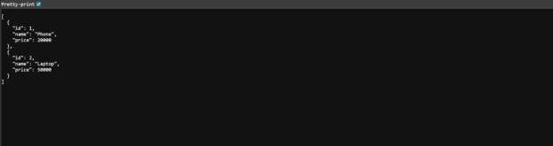

RESULT: The RESTful API for Product Management was successfully implemented with GET, POST, PUT, and DELETE methods returning JSON responses.

TASK13: PRODUCT-API
AIM: To design and develop a RESTful API for Product Management using Node.js that supports
GET, POST, PUT, and DELETE operations with JSON responses.

ALGORITHM:
- Start the program
- Create project files (server.js, db.js, HTML, CSS, JS)
- Design product structure (id, name, price)
- Create Node.js server using Express
- Enable JSON parsing using middleware
- Implement POST method to add products
- Implement GET method to fetch all products
- Implement PUT method to update product details
- Implement DELETE method to remove a product
- Store product data in memory using db.js
- Send JSON responses for all API requests
- Test APIs using browser or REST client

PROGRAM: INDEX.HTML:
<!DOCTYPE html>
<html>
<head>
<title>Product API</title>
</head>
<body>
<h2>Product API Test</h2>
<input id="id" placeholder="ID">

<input id="name" placeholder="Name">
<input id="price" placeholder="Price">
<button onclick="add()">Add</button>
<button onclick="get()">Get All</button>
<ul id="list"></ul>
<script src="script.js"></script>
</body>
</html>

STYLE.CSS:
/* Reset */
* {
margin: 0;
padding: 0;
box-sizing: border-box;
}
/* Background */ body {
font-family: 'Segoe UI', sans-serif;
background: linear-gradient(135deg, #141e30, #243b55); height: 100vh;
display: flex;
justify-content: center;
align-items: center; color: white;
}
/* Container */

.container {
background: rgba(255, 255, 255, 0.1); padding: 25px;
border-radius: 15px; backdrop-filter: blur(10px);

width: 350px; text-align: center;
box-shadow: 0 10px 25px rgba(0,0,0,0.4);
}
/* Heading */ h2 {
margin-bottom: 15px;
}
/* Inputs */ input {
width: 100%;
padding: 10px; margin: 8px 0; border: none; border-radius: 8px; outline: none; transition: 0.3s;
}
/* Hover + focus effect */ input:hover,

input:focus {
transform: scale(1.05);
box-shadow: 0 0 8px #00f7ff;
}
/* Buttons */ button {
width: 100%;
padding: 10px; margin-top: 8px; background: #00c6ff; border: none; border-radius: 10px; color: white;
font-weight: bold; cursor: pointer; transition: 0.3s;
}
/* Button hover */ button:hover {
background: #0072ff; transform: scale(1.05);
}
/* Product List */ ul {
list-style: none; margin-top: 15px;

}
/* List items */ li {
background: rgba(255,255,255,0.15);
padding: 10px;
margin: 6px 0; border-radius: 8px; display: flex;
justify-content: space-between;
align-items: center;

transition: 0.3s;
}
/* Hover effect */
li:hover {
background: rgba(255,255,255,0.3);
}
/* Optional delete button inside list */ li button {
width: auto; padding: 5px 8px; font-size: 12px; background: #ff4b5c;
}
li button:hover { background: #ff1e38;
}

SCRIPT.JS:
function add() { fetch("/products", {
method: "POST",
headers: {"Content-Type":"application/json"}, body: JSON.stringify(getData())
}).then(get);
}
function get() { fetch("/products")
.then(res => res.json())
.then(data => {
let list = document.getElementById("list");
list.innerHTML = "";
data.forEach(p => {
let li = document.createElement("li"); li.innerText = `${p.id} - ${p.name} - ₹${p.price}`; list.appendChild(li);
});
});
}
function getData() { return {
id: document.getElementById("id").value,
name: document.getElementById("name").value, price: document.getElementById("price").value

};
}

SERVER.JS:
const express = require("express"); const cors = require("cors");
const db = require("./db");
const app = express(); app.use(cors()); app.use(express.json());
// GET all products app.get("/products", (req, res) => {
res.json(db.getAll());
});
// POST add product app.post("/products", (req, res) => {
db.add(req.body);
res.json({ message: "Product added" });
});
// PUT update product app.put("/products/:id", (req, res) => {
db.update(req.params.id, req.body);
res.json({ message: "Product updated" });
});
// DELETE product app.delete("/products/:id", (req, res) => {

db.remove(req.params.id);
res.json({ message: "Product deleted" });
});
// Server start app.listen(3000, () => {
console.log("• API running at http://localhost:3000/products");
});

DB.JS:
let products = []; function getAll() {
return products;
}
function add(p) { products.push(p);
}
function update(id, newData) { products = products.map(p =>
p.id == id ? { ...p, ...newData } : p
);
}
function remove(id) {
products = products.filter(p => p.id != id);
}
module.exports = { getAll, add, update, remove };

OUTPUT:
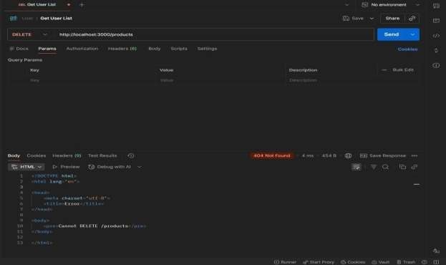

RESULT: The RESTful API for Product Management was successfully implemented with GET, POST, PUT, and DELETE methods returning JSON responses.

TASK14: MICROSERVICES APP
AIM: To design a simple microservices-based system by splitting a monolithic application into
independent services with loose coupling and single responsibility.

ALGORITHM:
- Start the program
- Identify modules in monolithic system
- Split system into independent services
- Create separate folders for each service
- Implement Service 1 (Product Service)
- Implement Service 2 (Order Service)
- Use separate databases (db.js) for each service
- Assign differentports for each service
- Enable communication via REST APIs
- Keep services loosely coupled
- Deploy and run services independently
- Access services and verify functionality

PROGRAM:
INDEX.HTML:
<!DOCTYPE html>
<html>
<head>
<title>Microservices App</title>
<link rel="stylesheet" href="style.css">
</head>
<body>
<div class="container">

<h2>Microservices Demo</h2>
<input id="pname" placeholder="Product Name">
<button onclick="addProduct()">Add Product</button>
<input id="order" placeholder="Order Item">
<button onclick="addOrder()">Place Order</button>
</div>
<script src="script.js"></script>
</body>
</html>

STYLE.CSS:
body {
font-family: Arial; background: #1e1e2f;
color: white; display:flex;
justify-content:center; align-items:center; height:100vh;
}
.container {
text-align:center;
}
input {
margin: 5px; padding: 8px;
}

button { padding: 8px; margin: 5px;
background: #00c6ff; border: none;
}

SCRIPT.JS:
function addProduct() { fetch("http://localhost:3001/products", {
method: "POST",
headers: { "Content-Type": "application/json" }, body: JSON.stringify({ name: val("pname") })
});
}
function addOrder() { fetch("http://localhost:3002/orders", {
method: "POST",
headers: { "Content-Type": "application/json" }, body: JSON.stringify({ item: val("order") })
});
}
function val(id) {
return document.getElementById(id).value;
}

SERVER.JS:
const express = require("express");

const cors = require("cors"); const db = require("./db"); const app = express(); app.use(cors());
app.use(express.json());
// GET products app.get("/products", (req, res) => {
res.json(db.getAll());
});
// ADD product app.post("/products", (req, res) => {
db.add(req.body);
res.json({ msg: "Product added" });
});
app.listen(3001, () => {
console.log("Product Service running at http://localhost:3001");
});

DB.JS:
let products = []; function add(p) {
products.push(p);
}
function getAll() { returnproducts;
}
module.exports = { add, getAll };

OUTPUT:
- GET : http://localhost:3001/products
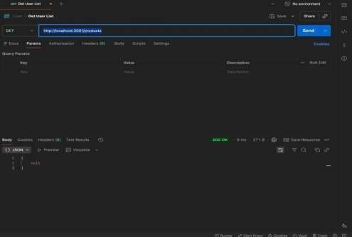
- POST: http://localhost:3001/products
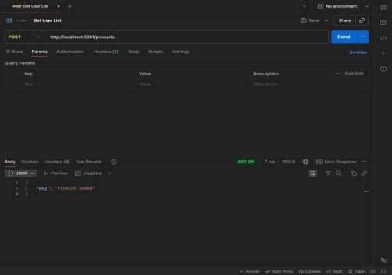
RESULTS: The application was successfully divided into independent microservices with separate responsibilities and communication via REST APIs

TASK15: Service Registry App

Aim: To implement service registry and discovery using Node.js by dynamically registering and discovering microservices without hard-coded URLs.

ALGORITHM:
- Start the program
- Create a registry server
- Store service name and URL in memory
- Start Product Service
- Register Product Service to registry
- Start Order Service
- Register Order Service to registry
- Maintain service list in registry
- Client requests service from registry
- Fetch service URL dynamically
- Call the discovered service API
- Stop the program

PROGRAM:
SERVER.JS:
const express = require("express"); const app = express(); app.use(express.json());
let services = {}; app.post("/register", (req, res) => {
const { name, url } = req.body;
services[name] = url;

console.log(`${name} registered at ${url}`); res.json({ msg: "Registered" });
});
app.get("/service/:name", (req, res) => { const service = services[req.params.name]; if (!service) {
return res.status(404).json({ error: "Service not found" }) res.json({ url: service });
});
app.listen(4000, () => {
console.log("Registry running at http://localhost:4000");
});

OUTPUT

RESULT: The microservices-based system was successfully implemented with service registry and discovery, enabling dynamic communication between independent services without hard- coded URLs.

TASK16: API GATEWAY API

AIM: To configure an API Gateway that routes client requests to microservices and performs basic load balancing across multiple service instances.

ALGORITHM:
- Start the program
- Create API Gateway server
- Define routes for microservices
- Create multiple instances of a service
- Store service URLs in an array
- Implement round-robin load balancing
- Receive client request at gateway
- Select service instance dynamically
- Forward request to selected instance
- Get response from service
- Send response back to client
- Stop the program

PROGRAM:
SERVER.JS:
const express = require("express"); const axios = require("axios"); const app = express();
const services = [ "http://localhost:3001", "http://localhost:3002"
];

let index = 0;
app.get("/products", async (req, res) => { try {
const service = services[index];
index = (index + 1) % services.length;
const response = await axios.get(service + "/products"); res.json(response.data);

} catch (err) {
res.status(500).json({ error: "Service unavailable" });
}
});
app.listen(5000, () => {
console.log("API Gateway → http://localhost:5000/products");
});

OUTPUT:
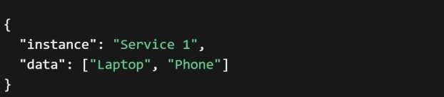
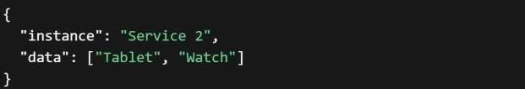

RESULT: The API Gateway was successfully implemented to route requests and distribute load across multiple service instances using round-robin load balancing.

TASK17: Inter Service App
AIM: To enable inter-service communication where one microservice consumes another
service’s REST API and handles responses and failures gracefully.

ALGORITHM:
- Start the program
- Create Product Service (provider)
- Create Order Service (consumer)
- Implement REST API in Product Service
- Store product data in memory
- Implement Order Service API
- Use axios/fetch to call Product Service
- Receive response from Product Service
- Process and store order data
- Handle errors using try-catch
- Send proper success/error response
- Stop the program

FOLDER STRUCTURE:
inter-service-app/
│
├── product-service/
│ └── server.js
│
├── order-service/
│ └── server.js

PROGRAM:
PRODUCT-SERVICE:SERVER.JS:
const express = require("express"); const app = express();
let products = [
{ id: 1, name: "Laptop" },
{ id: 2, name: "Phone" }
];
app.get("/products", (req, res) => { res.json(products);
});
app.listen(3001, () => {
console.log("Product Service → http://localhost:3001/products");
});

ORDER-SERVICE:SERVER.JS:
const express = require("express"); const axios = require("axios"); const app = express(); app.use(express.json());
let orders = [];
app.post("/orders", async (req, res) => {
try {
const response = await axios.get("http://localhost:3001/products"); const products = response.data;
const order = { id: Date.now(),

products: products
};
orders.push(order); res.json({
message: "Order created successfully",
order: order
});
} catch (error) { res.status(500).json({
error: "Failed to fetch products from Product Service"
});
}
});
app.get("/orders", (req, res) => { res.json(orders);
});
app.listen(3002, () => {
console.log("Order Service → http://localhost:3002/orders");
});

OUTPUT:
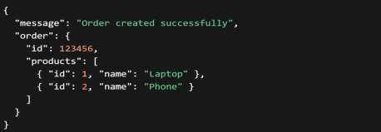

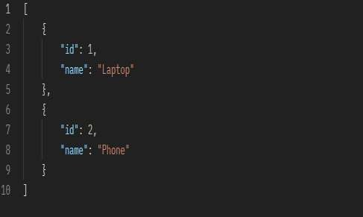

RESULT: Inter-service communication was successfully implemented using REST APIs, with proper handling of responses and failures between microservices.

TASK18: Microservice Test
AIM: To write unit test cases for microservices to validate service logic, REST APIs, and data
handling using a testing framework. ALGORITHM:
- Start the program
- Install testing framework (Jest, Supertest)
- Configure test script in package.json
- Create test folder/files
- Import service modules
- Write test cases for service logic
- Write test cases for REST APIs
- Mock external dependencies if needed
- Execute test cases using Jest
- Verify expected outputs
- Handle edge cases and errors
- Stop the program

PROGRAM:

app.js:
const express = require("express"); const app = express(); app.use(express.json());
let products = [];
// API
app.get("/products", (req, res) => { res.json(products);
});

app.post("/products", (req, res) => { products.push(req.body); res.json({ msg: "Product added" });
});
module.exports = app;

SERVER.JS:
const app = require("./app"); app.listen(3001, () => {
console.log("Product Service running");
});

Product.Test.js:
const request = require("supertest");
const app = require("../product-service/app"); describe("Product API Tests", () => {
test("GET /products should return empty array", async () => {
const res = await request(app).get("/products"); expect(res.statusCode).toBe(200); expect(res.body).toEqual([]);
});
test("POST /products should add product", async () => { const res = await request(app)
.post("/products")
.send({ name: "Laptop" }); expect(res.statusCode).toBe(200); expect(res.body.msg).toBe("Product added");
});
test("GET /products should return data", async () => {

DB.JS:
let commits = []; let version = 1;
function save(data) { commits.push({
version: version++,
message: data.message, content: data.content,
time: new Date()

});
}
function getAll() {
returncommits;
}
module.exports = { save, getAll };

OUTPUT:
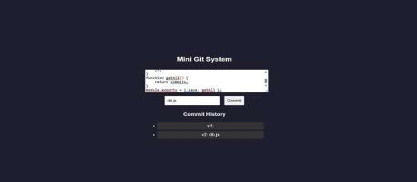
RESULT: A mini Git-like system was successfully developed to track versions, store commits, and display history through a web interface.

Task 19: Create a Git repository for a sample project and demonstrate basic Git operations such as initializing a repository, staging files, committing changes, and maintaining version history. Push the repository to GitHub and manage it using remote repositories.
Aim
To create a Git repository for a sample project and demonstrate:
- Repository initialization
- Staging files
- Committing changes
- Maintaining version history
- Connecting to remote repository
- Pushing project to GitHub

Tools Required
- Git
- GitHub
- VS Code / Terminal

Algorithm / Procedure
- Create a project folder
- Create HTML, CSS, JS files
- Initialize Git repository
- Add files to staging area
- Commit files
- Create repository in GitHub
- Connect local repo to GitHub
- Push files to remote repository
- Verify output in GitHub

Program (Code)
index.html
<!DOCTYPE html>
<html>
<head>

<title>Color Palette App</title>
<link rel="stylesheet" href="style.css">
</head>
<body>

<div class="container">
<h2>Color Palette App</h2>

<input type="text" id="colorInput" placeholder="Enter color">

<br><br>

<button onclick="changeBackground()">Background</button>
<button onclick="changeText()">Text Color</button>

<p id="text">Welcome Students</p>
</div>

<script src="script.js"></script>

</body>
</html>

style.css
body {
font-family: Arial; background-color: #f4f7fb; text-align: center;
}

.container {
margin-top: 100px;
}

button { padding: 10px; margin: 5px;
background-color: #2563eb; color: white;
border: none;
}

#text {
margin-top: 20px; font-size: 20px;
background-color: #e0f2fe;

padding: 10px;
}

script.js
function changeBackground() {
let color = document.getElementById("colorInput").value; document.getElementById("text").style.backgroundColor = color;
}

function changeText() {
let color = document.getElementById("colorInput").value;
document.getElementById("text").style.color = color;
}

Git Commands Used
cd D:\VSCode_Projects\Unit-IV
mkdir ColorPallette
cd ColorPallette

git init git status git add
git commit -m "Initial commit - Color Palette App"

git branch -M main
git remote add origin https://github.com/Dr-Hemamalini/FSAD.git git pull origin main --allow-unrelated-histories
git push -u origin main

Output Screenshots

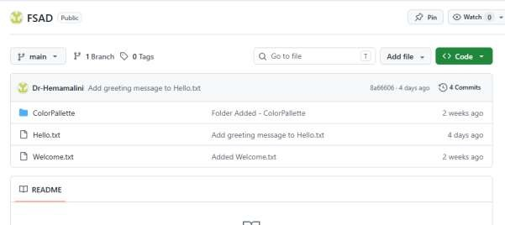
Git Output
- git init → repository created
- git status → files shown
- git add → staged files
- git commit → snapshot created
- git push → uploaded to GitHub
Result
Thus, a Git repository was successfully created for a sample project.
Basic Git operations such as initialization, staging, committing, and version history were performed. The project was successfully pushed to GitHub using remote repository.
Task_20: Implement branching strategies in Git by creating feature branches. Perform merging and rebasing
operations, and intentionally create merge conflicts to understand and resolve them effectively.
Git Branching Strategy
Aim
To create feature branches in Git, perform merge and rebase operations, and intentionally create merge
conflicts to understand conflict resolution.
Scenario
A simple arithmetic calculator file is used. Branches:
main feature-add feature-sub feature-mul
Procedure
Step 1: Create Repository

mkdir git_branch_demo cd git_branch_demo
git init
Step 2: Create Base File
echo Basic Calculator > calc.txt git add calc.txt
git commit -m "Initial commit"
Step 3: Create Addition Branch
git checkout -b feature-add
echo Addition: 10+5=15 >> calc.txt git add calc.txt
git commit -m "Added addition feature"
Step 4: Create Subtraction Branch
git checkout main
git checkout -b feature-sub
echo Subtraction: 10-5=5 >> calc.txt git add calc.txt
git commit -m "Added subtraction feature"

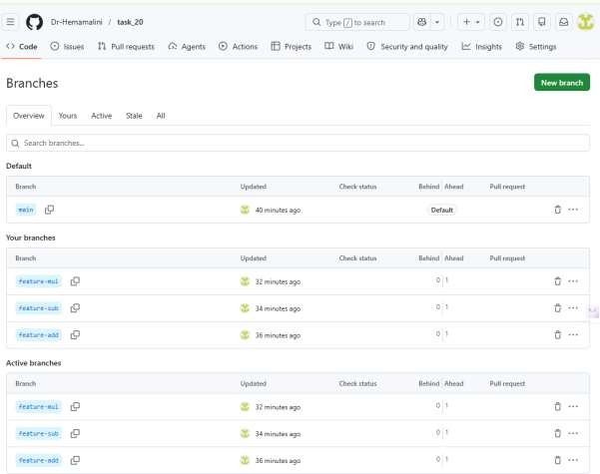

Now Go to GitHub
Open your repo → Click: Insights → Network Graph
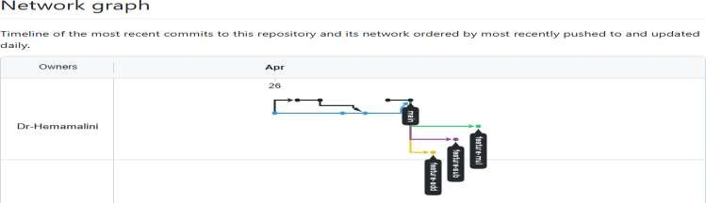
Step 5: Merge Addition Branch
git checkout main
git merge feature-add
Expected file:

Basic Calculator Addition: 10+5=15
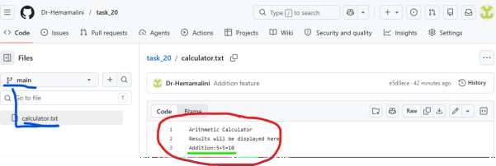
Step 6: Rebase Subtraction Branch
git checkout feature-sub git rebase main
If conflict comes, edit calc.txt, then: git add calc.txt
git rebase --continue

Step 7: Merge Subtraction Branch
git checkout main
git merge feature-sub Expected file:
Basic Calculator Addition: 10+5=15
Subtraction: 10-5=5

Create Merge Conflict
Step 8: Create Multiplication Branch
git checkout -b feature-mul
echo Result: Multiplication 10*5=50 > result.txt git add result.txt
git commit -m "Added multiplication result"

Step 9: Modify Same File in Main
git checkout main
echo Result: Division 10/5=2 > result.txt

git add result.txt
git commit -m "Added division result"

Step 10: Merge and Create Conflict
git merge feature-mul Expected conflict:
CONFLICT (content): Merge conflict in result.txt Automatic merge failed

Step 11: Resolve Conflict
Open result.txt. You may see:
<<<<<<< HEAD
Result: Division 10/5=2
=======
Result: Multiplication 10*5=50
>>>>>>> feature-mul
Replace with:
Result: Division 10/5=2 Result: Multiplication 10*5=50
Then commit:
git add result.txt
git commit -m "Resolved merge conflict"

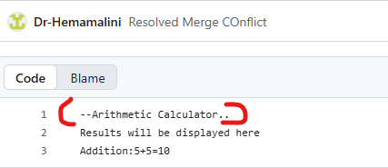
Result
Thus, Git branching strategies were implemented successfully. Feature branches were created, merge and rebase operations were performed, and merge conflicts were intentionally created and resolved manually.

Task 21: Implement a CI/CD pipeline using Jenkins, GitHub Actions, or GitLab CI/CD. Automate code checkout, build, test, and deployment steps, and demonstrate continuous integration and continuous deployment for the application

Implementation of CI/CD Pipeline using Jenkins
Aim
To implement a Continuous Integration and Continuous Deployment (CI/CD) pipeline using Jenkins to automate code checkout, build, testing, and deployment of a Node.js application.
Tools Required
- Jenkins
- GitHub
- Node.js
- Git
- VS Code
Project Description
A simple Node.js application is created to perform arithmetic addition and validate it using a test script.
Procedure
Step 1: Create Project
mkdir jenkins-cicd-demo cd jenkins-cicd-demo npm init -y
Step 2: Create Application File (app.js)
function add(a, b) { return a + b;
}

console.log("Application running successfully");
console.log("Addition:", add(5, 3));

module.exports = add;
Step 3: Create Test File (app.test.js)
const add = require("./app");

if (add(5, 3) === 8) {
console.log("Test Passed"); process.exit(0);
} else {
console.log("Test Failed");

process.exit(1);
}
Step 4: Update package.json
{
"name": "jenkins-cicd-demo", "version": "1.0.0",
"main": "app.js", "scripts": {
"test": "node app.test.js",
"build": "echo Build completed successfully"
}
}
Step 5: Push Code to GitHub
git init git add .
git commit -m "Initial commit" git branch -M main
git remote add origin https://github.com/Dr-Hemamalini/cicd-demo.git git push -u origin main
Step 6: Create GitHub Token
- Go to GitHub → Settings → Developer Settings
- Select Personal Access Token
- Generate token with repo access
- Copy the token
Step 7: Configure Credentials in Jenkins
- Open Jenkins Dashboard
- Go to Manage Jenkins → Manage Credentials
- Add credentials:
  - Kind: Username & Password
  - Username: GitHub username
  - Password: Personal Access Token
  - ID: github-token
Step 8: Create Jenkins Pipeline Job
- Click New Item
- Enter name: CICD-Demo
- Select Pipeline → Click OK

Step 9: Create Jenkinsfile
pipeline {
agent any

stages {
stage('Checkout Code') { steps {
checkout([
$class: 'GitSCM',
branches: [[name: '*/main']], userRemoteConfigs: [[
url: 'https://github.com/Dr-Hemamalini/cicd-demo.git', credentialsId: 'github-token'
]]
])
}
}

stage('Install Dependencies') { steps {
bat 'npm install'
}
}

stage('Build Application') {
steps {
bat 'npm run build'
}
}

stage('Run Tests') { steps {
bat 'npm test'
}
}

stage('Deploy Application') {
steps {
bat 'echo Application deployed successfully'
}
}
}
}

Step 10: Push Jenkinsfile

git add Jenkinsfile
git commit -m "Added Jenkins pipeline" git push
Step 11: Run Pipeline
- Open Jenkins Job
- Click Build Now
- View Console Output
Expected Output
Checkout Code → Success
Install Dependencies → Success Build → Build completed successfully Test → Test Passed
Deploy → Application deployed successfully

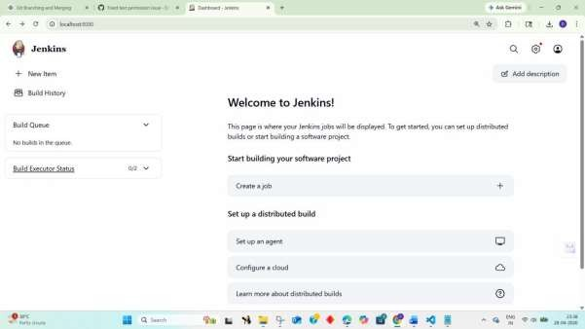

New Item

£'ipeline
Bullo, test, and de play using oioelines Supports stages, parallel work. and running on multiple agents.

followed by post-build steps like archiving artifacts and sending email 'notifications.

p êdulti-configuration proje<t
SGabeMroo]emtacneedalagenumbeŒdWeenconfguœnons,suchasœsfingonmunpe
env œ n meMts, p laform-*pecITIc bu ilds, Mc.
w n x c + c Æ + G o Æ# c n e I ••-

x ChockouiCodo 1s

- InstaII Dependenôes 10s

w BuibAppGœflon 072s

Yñndows8atch5cüp e'• t••t
C:\PcogrsœDete;Jenkins\.jsnkinslworkspsce;CîCD-oemo›nPm tQit

6 Application running successfuily

o % O

0.61s Z

555.0

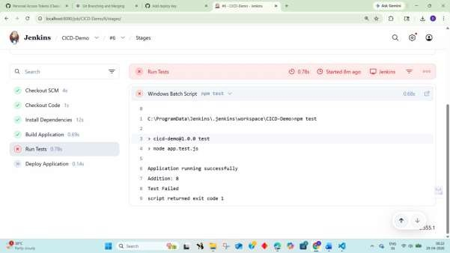
Result
Thus, a CI/CD pipeline was successfully implemented using Jenkins. The pipeline automated code checkout,
dependency installation, build process, testing, and deployment of the Node.js application.

Task 22: Explore major cloud service providers such as AWS, Google Cloud, and Microsoft Azure. Identify and compare their core services related to compute, storage, databases, and networking, along with the pay-as-you-use pricing model.

COMPARISON OF CLOUD SERVICES: AWS, GOOGLEC CLOUD, MICROSOFT AZURE
AIM: To develop a cloud comparison application that displays and compares services and pricing models of AWS, GCP, and Azure
ALGORITHM:
- Start the program
- Create project files (HTML, CSS, JS, server.js, db.js)
- Design user interface with dropdown for cloud providers
- Initialize cloud service data (AWS, GCP, Azure) in database module
- Capture selected provider using JavaScript
- Send request to server to fetch service details
- Display compute, storage, database, and networking services
- Accept user input for compute hours and storage usage
- Send input data to server for cost calculation

- Calculate cost based on pay-as-you-use pricing model
- Display total cost dynamically on UI
- Stop the program
PROGRAM:
INDEX.HTML:
<!DOCTYPE html>
<html>
<head>
<title>Cloud Comparison</title>
<link rel="stylesheet" href="style.css">
</head>
<body>
<div class="container">
<h2>Cloud Service Comparison</h2>
<select id="provider" onchange="loadData()">
<option value="aws">AWS</option>
<option value="gcp">GCP</option>
<option value="azure">Azure</option>
</select>
<h3>Services</h3>
<ul id="services"></ul>
<h3>Pricing Calculator</h3>
<input id="hours" placeholder="Compute Hours">
<input id="storage" placeholder="Storage (GB)">
<button onclick="calculate()">Calculate Cost</button>
<h3 id="result"></h3>
</div>
<script src="script.js"></script>
</body>
</html>
STYLE.CSS:

body {
font-family: Arial;
background: #1e1e2f; color: white; display:flex; justify-content:center; align-items:center; height:100vh;
}
.container {
text-align:center; width: 350px;
}
input, select, button { margin: 5px; padding: 8px;
}
li {
background: #333; margin: 5px; padding: 5px;
}
SCRIPT.JS:
function loadData() {
const provider = document.getElementById("provider").value; fetch(`/services/${provider}`)
.then(res => res.json())
.then(data => {
let list = document.getElementById("services"); list.innerHTML = ""; Object.entries(data).forEach(([key, value]) => { let li = document.createElement("li"); li.innerText = `${key}: ${value}`; list.appendChild(li);
});
});
}
function calculate() {
const provider = document.getElementById("provider").value; const hours = document.getElementById("hours").value; const storage = document.getElementById("storage").value; fetch("/cost", {
method: "POST",
headers: {"Content-Type":"application/json"}, body: JSON.stringify({ provider, hours, storage })
})

.then(res => res.json())
.then(data => {
document.getElementById("result").innerText = "Cost: $" + data.cost;
});
}
loadData();
SERVER.JS:
const express = require("express"); const db = require("./db"); const app = express(); app.use(express.json());
app.use(express.static( dirname)); app.get("/services/:provider", (req, res) => { res.json(db.getServices(req.params.provider));
});
app.post("/cost", (req, res) => {
const { provider, hours, storage } = req.body;
const cost = db.calculate(provider, hours, storage); res.json({ cost });
});
app.listen(3000, () => {
console.log("http://localhost:3000");
});
DB.JS:
const services = { aws: {
Compute: "EC2", Storage: "S3", Database: "RDS", Network: "VPC"
},
gcp: {
Compute: "Compute Engine", Storage: "Cloud Storage", Database: "Cloud SQL", Network: "VPC"
},
azure: {
Compute: "Virtual Machines", Storage: "Blob Storage",

Database: "SQL Database", Network: "VNet"
}
};
const pricing = {
aws: { compute: 0.1, storage: 0.02 }, gcp: { compute: 0.09, storage: 0.025 }, azure: { compute: 0.11, storage:
0.018 }
};
function getServices(provider) { return services[provider];
}
function calculate(provider, hours, storage) { const p = pricing[provider];
return (hours * p.compute + storage * p.storage).toFixed(2);
}
module.exports = { getServices, calculate };
OUTPUT:
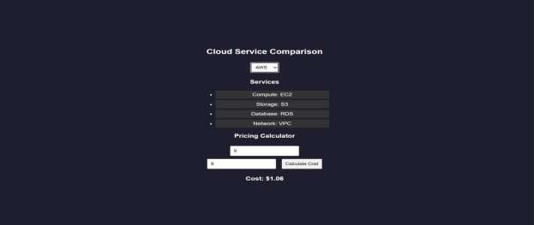

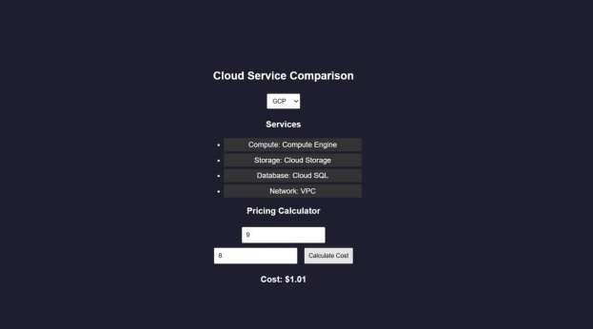
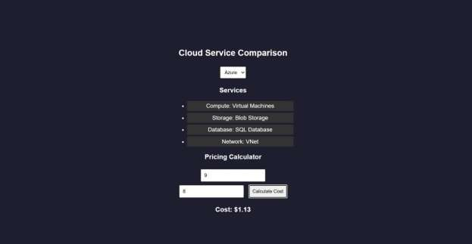

RESULTS: A cloud comparison application was successfully developed to display services and simulate pay-as- you-use pricing across AWS, GCP, and Azure.

Task 23: Apply Vibe Coding and Prompt Engineering techniques using a Generative AI tool. Design effective prompts to generate code snippets, cloud configuration templates, or application logic, and evaluate the quality and efficiency of the generated outputs for real-world business applications.
AI PROMPT APP USING VIBE CODING
AIM: To develop an application that demonstrates prompt engineering by generating and evaluating code or cloud configurations based on user input.
ALGORITHM:
- Start the program
- Create project files (HTML, CSS, JS, server.js, db.js)
- Design UI with input field for user prompt
- Capture user prompt using JavaScript
- Send prompt to server using fetch API
- Receive prompt data in backend (server.js)
- Process prompt using predefined logic (db.js)
- Generate output (code / cloud config / response)
- Evaluate output quality and assign score
- Send generated output and score to frontend
- Display output and score on UI
- Stop the program PROGRAM: INDEX.HTML:
<!DOCTYPE html>
<html>
<head>
<title>AI Prompt App</title>
<link rel="stylesheet" href="style.css">
</head>
<body>

<div class="container">
<h2>Prompt Engineering Tool</h2>
<textarea id="prompt" placeholder="Enter your prompt..."></textarea>
<button onclick="generate()">Generate Output</button>
<h3>Generated Output</h3>
<pre id="output"></pre>
<h3>Quality Score</h3>
<p id="score"></p>
</div>
<script src="script.js"></script>
</body>
</html>
STYLE.CSS:
body {
font-family: Arial;
background: #202038; color: white;
display:flex;
justify-content:center; align-items:center; height:100vh;
}
.container { width: 400px; text-align: center;
}
textarea { width: 100%; height: 100px; margin: 5px;
}
button { padding: 10px; margin: 10px; background: #00c6ff; border: none; color: white;
}
pre {
background: #333; padding: 10px;

}
SCRIPT.JS:
function generate() {
const prompt = document.getElementById("prompt").value; fetch("/generate", { method: "POST",
headers: {"Content-Type":"application/json"}, body: JSON.stringify({ prompt })
})
.then(res => res.json())
.then(data => {
document.getElementById("output").innerText = data.output; document.getElementById("score").innerText
= data.score + "/10";
});
}
SERVER.JS:
const express = require("express"); const db = require("./db"); const app = express();
// Middleware app.use(express.json());
app.use(express.static( dirname)); // serve HTML
// Home route (optional but useful) app.get("/", (req, res) => { res.sendFile( dirname + "/index.html");
});
// Generate output app.post("/generate", (req, res) => {
const result = db.processPrompt(req.body.prompt); res.json(result);
});
// START SERVER WITH LINK
app.listen(3000, () => {
console.log(" • Server running at:"); console.log(" http://localhost:3000");
});

DB.JS:
function processPrompt(prompt) { let output = ""; let score = 5;
if (prompt.toLowerCase().includes("code")) { output = `function greet() { console.log("Hello from AI!");
}`;
score = 9;
}
else if (prompt.toLowerCase().includes("cloud")) { output = `AWS EC2 Config:
- Instance: t2.micro
- Region: us-east-1`; score = 8;
}
else {
output = "Basic AI response generated."; score = 5;
}
return { output, score };
}
module.exports = { processPrompt };
OUTPUT:

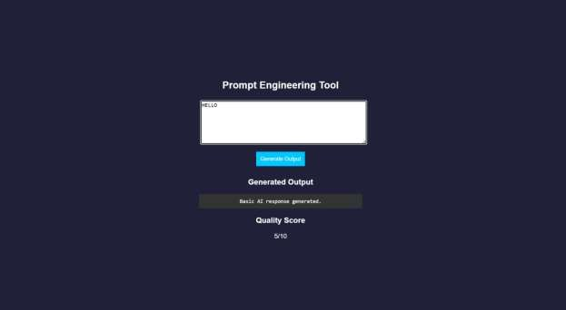

RESULT: A prompt engineering application was successfully developed to generate and evaluate AI-based outputs for code and cloud configurations.

Task 24: Use Vibe Coding to build a complete cloud-based feature using Generative AI. Write iterative prompts to generate a REST API, cloud deployment steps, and security configurations. Refine the prompts based on the output quality, document prompt versions, and evaluate how prompt engineering improves code accuracy, scalability, and real-world usability.

Vibe Cloud App
AIM: To develop an application that uses iterative prompt engineering to generate and evaluate REST APIs, cloud deployment steps, and security configurations.
ALGORITHM:
- Start the program
- Create project files (HTML, CSS, JS, server.js, db.js)
- Design UI to accept user prompts
- Capture prompt input using JavaScript
- Send prompt to backend using fetch API
- Receive prompt in server and forward to processing module
- Store prompt in history for version tracking
- Analyze prompt type (REST API / Cloud / Security)
- Generate corresponding output based on prompt
- Evaluate output quality and assign score
- Return output and score to frontend and display results
- Stop the program
PROGRAM:
INDEX.HTML:
<!DOCTYPE html>
<html>
<head>
<title>Vibe Coding App</title>
<link rel="stylesheet" href="style.css">
</head>
<body>
<div class="container">
<h2>Vibe Coding Cloud Generator</h2>

<textarea id="prompt" placeholder="Enter prompt..."></textarea>
<button onclick="generate()">Generate</button>
<h3>Output</h3>
<pre id="output"></pre>
<h3>Score</h3>
<p id="score"></p>
<h3>Prompt Versions</h3>
<ul id="history"></ul>
</div>
<script src="script.js"></script>
</body>
</html>
STYLE.CSS:
body {
font-family: Arial;
background: #b98bdb; color: white;
display:flex;
justify-content:center; align-items:center; height:100vh;
}
.container { width: 400px; text-align: center;
}
textarea { width: 100%; height: 100px;
}
button { padding: 10px; margin: 10px; background: #00c6ff; border: none;
}
pre {
background: #333; padding: 10px;
}

li {
background: #444; margin: 5px; padding: 5px;
}

SCRIPT.JS:
function generate() {
const prompt = document.getElementById("prompt").value; fetch("/generate", { method: "POST",
headers: {"Content-Type":"application/json"}, body: JSON.stringify({ prompt })
})
.then(res => res.json())
.then(data => {
document.getElementById("output").innerText = data.output; document.getElementById("score").innerText
= data.score + "/10"; loadHistory();
});
}
function loadHistory() { fetch("/history")
.then(res => res.json())
.then(data => {
let list = document.getElementById("history"); list.innerHTML = ""; data.forEach((p, i) => {
let li = document.createElement("li"); li.innerText = `v${i+1}: ${p.prompt}`; list.appendChild(li);
});
});
}
loadHistory();
SERVER.JS:
const express = require("express"); const db = require("./db");

const app = express(); app.use(express.json());
app.use(express.static( dirname)); app.post("/generate", (req, res) => { const result = db.process(req.body.prompt); res.json(result);
});
app.get("/history", (req, res) => { res.json(db.getHistory());
});
app.listen(3000, () => {
console.log(" • http://localhost:3000");
});
DB.JS:
let history = [];
function process(prompt) { let output = ""; let score = 5;
history.push({ prompt });
if (prompt.includes("REST")) {
output = `app.get('/api', (req,res)=>res.send('API running'));`; score = 7;
}
else if (prompt.includes("cloud")) { output = `Deploy using AWS EC2:
- Launch instance
- Install Node.js
- Run app`;
score = 8;
}
else if (prompt.includes("security")) {
output = `Use HTTPS, JWT authentication, and firewall rules`; score = 9;
}
score += Math.min(history.length, 2); return { output, score };
}
function getHistory() { return history;
}
module.exports = { process, getHistory };

OUTPUT:
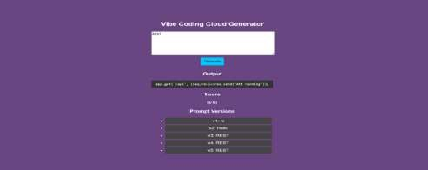

RESULT: A Vibe Coding application was successfully developed to generate and refine cloud-based
features using iterative prompt engineering.

