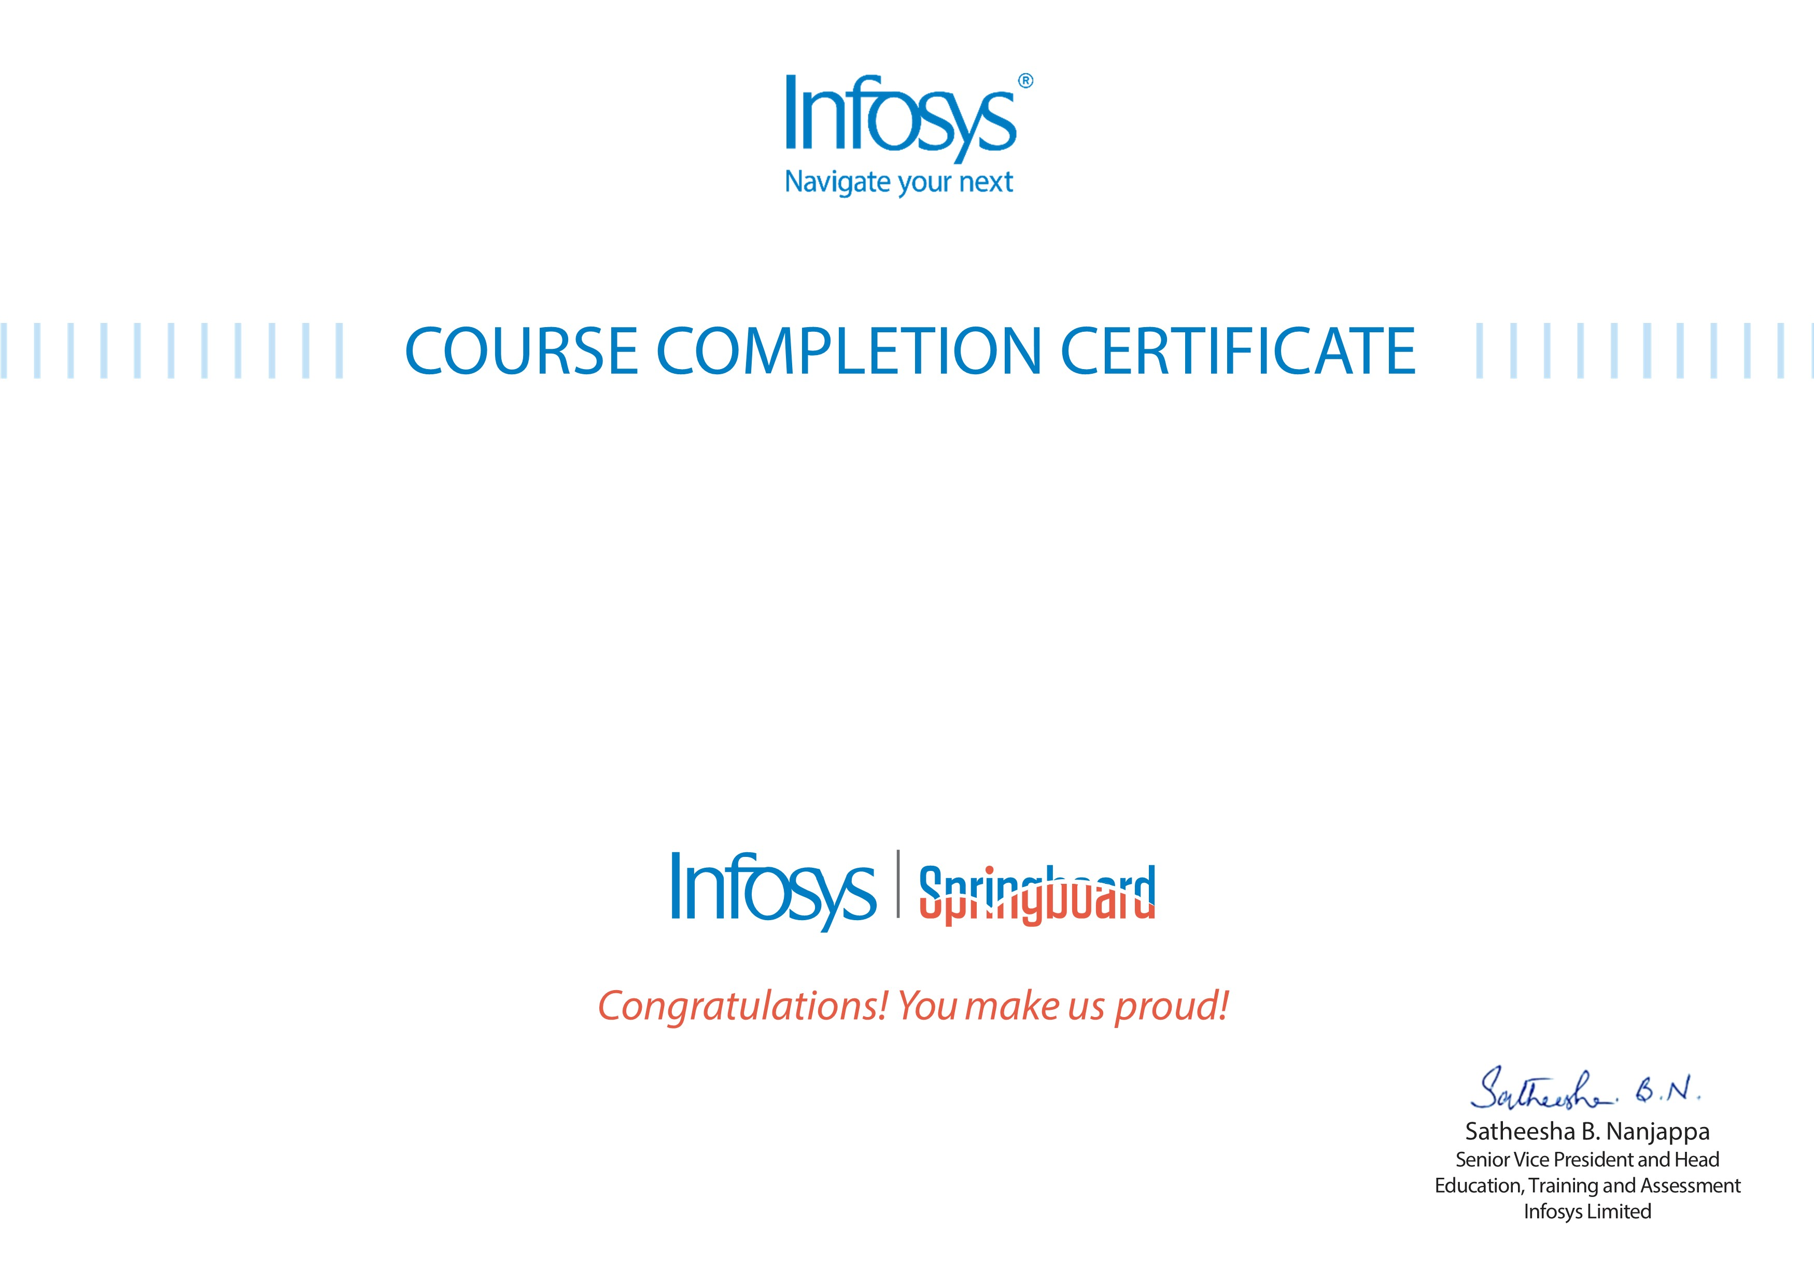
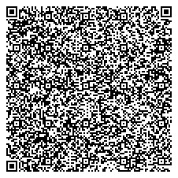
VENNA MAMITHA,CSE 2023 VENNA MAMITHA,CSE 2023

Ruby Full Stack Development: Introduction
The certificate is awarded to
for successfully completing the course
on February 22, 2026
Issued on:
Thursday, February 26, 2026
To verify, scan the QR code at
htt
ps://verif
y
.onwin
g
span.co
m

