Task 19: Create a Git repository for a sample project and demonstrate basic Git operations such as initializing a repository, staging files, committing changes, and maintaining version history. Push the repository to GitHub and manage it using remote repositories.
Aim
To create a Git repository for a sample project and demonstrate:
- Repository initialization
- Staging files
- Committing changes
- Maintaining version history
- Connecting to remote repository
- Pushing project to GitHub

Tools Required
- Git
- GitHub
- VS Code / Terminal

Algorithm / Procedure
- Create a project folder
- Create HTML, CSS, JS files
- Initialize Git repository
- Add files to staging area
- Commit files
- Create repository in GitHub
- Connect local repo to GitHub
- Push files to remote repository
- Verify output in GitHub

Program (Code)
index.html
<!DOCTYPE html>
<html>
<head>
<title>Color Palette App</title>
<link rel="stylesheet" href="style.css">
</head>
<body>
<div class="container">
<h2>Color Palette App</h2>
<input type="text" id="colorInput" placeholder="Enter color">
<br><br>
<button onclick="changeBackground()">Background</button>
<button onclick="changeText()">Text Color</button>
<p id="text">Welcome Students</p>
</div>
<script src="script.js"></script>
</body>
</html>

style.css
body {
font-family: Arial;
background-color: #f4f7fb;
text-align: center;
}
.container {
margin-top: 100px;
}
button {
padding: 10px;
margin: 5px;
background-color: #2563eb;
color: white;
border: none;
}
#text {
margin-top: 20px;
font-size: 20px;
background-color: #e0f2fe;
padding: 10px;
}

script.js
function changeBackground() {
let color = document.getElementById("colorInput").value;
document.getElementById("text").style.backgroundColor = color;
}
function changeText() {
let color = document.getElementById("colorInput").value;
document.getElementById("text").style.color = color;
}

Git Commands Used
cd D:\VSCode_Projects\Unit-IV
mkdir ColorPallette
cd ColorPallette
git init
git status
git add
git commit -m "Initial commit - Color Palette App"
git branch -M main
git remote add origin https://github.com/Dr-Hemamalini/FSAD.git
git pull origin main --allow-unrelated-histories
git push -u origin main

Output Screenshots

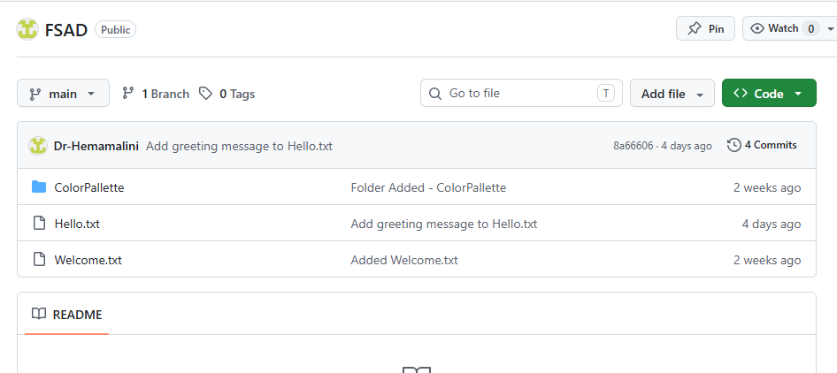
Git Output
- git init → repository created
- git status → files shown
- git add → staged files
- git commit → snapshot created
- git push → uploaded to GitHub
Result
Thus, a Git repository was successfully created for a sample project.
Basic Git operations such as initialization, staging, committing, and version history were performed.
The project was successfully pushed to GitHub using remote repository.
Task_20: Implement branching strategies in Git by creating feature branches. Perform merging and rebasing operations, and intentionally create merge conflicts to understand and resolve them effectively.
Git Branching Strategy
Aim
To create feature branches in Git, perform merge and rebase operations, and intentionally create merge conflicts to understand conflict resolution.
Scenario
A simple arithmetic calculator file is used.
Branches:
main
feature-add
feature-sub
feature-mul
Procedure
Step 1: Create Repository
mkdir git_branch_demo
cd git_branch_demo
git init
Step 2: Create Base File
echo Basic Calculator > calc.txt
git add calc.txt
git commit -m "Initial commit"
Step 3: Create Addition Branch
git checkout -b feature-add
echo Addition: 10+5=15 >> calc.txt
git add calc.txt
git commit -m "Added addition feature"
Step 4: Create Subtraction Branch
git checkout main
git checkout -b feature-sub
echo Subtraction: 10-5=5 >> calc.txt
git add calc.txt
git commit -m "Added subtraction feature"

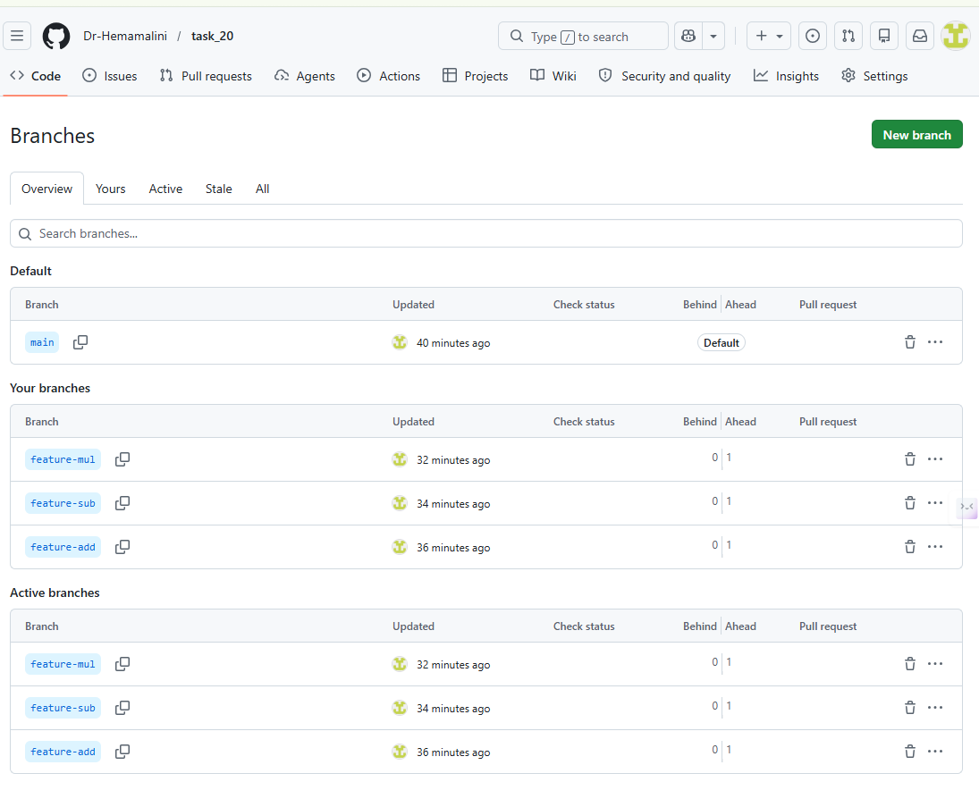
Now Go to GitHub
Open your repo → Click: Insights → Network Graph
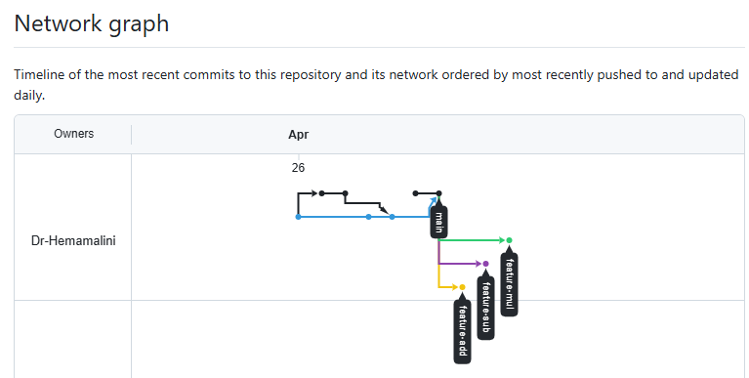
Step 5: Merge Addition Branch
git checkout main
git merge feature-add
Expected file:
Basic Calculator
Addition: 10+5=15
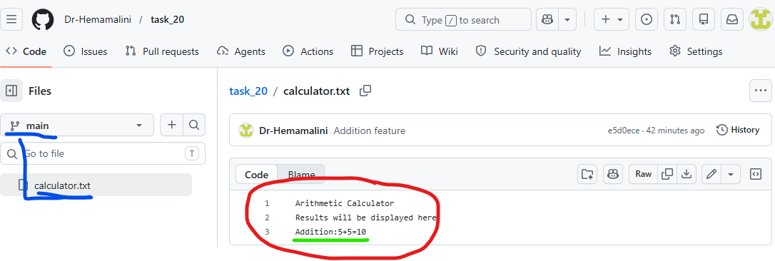
Step 6: Rebase Subtraction Branch
git checkout feature-sub
git rebase main
If conflict comes, edit calc.txt, then:
git add calc.txt
git rebase --continue

Step 7: Merge Subtraction Branch
git checkout main
git merge feature-sub
Expected file:
Basic Calculator
Addition: 10+5=15
Subtraction: 10-5=5

Create Merge Conflict
Step 8: Create Multiplication Branch
git checkout -b feature-mul
echo Result: Multiplication 10*5=50 > result.txt
git add result.txt
git commit -m "Added multiplication result"

Step 9: Modify Same File in Main
git checkout main
echo Result: Division 10/5=2 > result.txt
git add result.txt
git commit -m "Added division result"

Step 10: Merge and Create Conflict
git merge feature-mul
Expected conflict:
CONFLICT (content): Merge conflict in result.txt
Automatic merge failed

Step 11: Resolve Conflict
Open result.txt.
You may see:
<<<<<<< HEAD
Result: Division 10/5=2
=======
Result: Multiplication 10*5=50
>>>>>>> feature-mul
Replace with:
Result: Division 10/5=2
Result: Multiplication 10*5=50
Then commit:
git add result.txt
git commit -m "Resolved merge conflict"

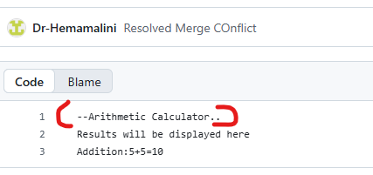
Result
Thus, Git branching strategies were implemented successfully. Feature branches were created, merge and rebase operations were performed, and merge conflicts were intentionally created and resolved manually.

Task 21: Implement a CI/CD pipeline using Jenkins, GitHub Actions, or GitLab CI/CD. Automate code checkout, build, test, and deployment steps, and demonstrate continuous integration and continuous deployment for the application

Implementation of CI/CD Pipeline using Jenkins
Aim
To implement a Continuous Integration and Continuous Deployment (CI/CD) pipeline using Jenkins to automate code checkout, build, testing, and deployment of a Node.js application.
Tools Required
- Jenkins
- GitHub
- Node.js
- Git
- VS Code
Project Description
A simple Node.js application is created to perform arithmetic addition and validate it using a test script.
Procedure
Step 1: Create Project
mkdir jenkins-cicd-demo
cd jenkins-cicd-demo
npm init -y
Step 2: Create Application File (app.js)
function add(a, b) {
return a + b;
}
console.log("Application running successfully");
console.log("Addition:", add(5, 3));
module.exports = add;
Step 3: Create Test File (app.test.js)
const add = require("./app");
if (add(5, 3) === 8) {
console.log("Test Passed");
process.exit(0);
} else {
console.log("Test Failed");
process.exit(1);
}
Step 4: Update package.json
{
"name": "jenkins-cicd-demo",
"version": "1.0.0",
"main": "app.js",
"scripts": {
"test": "node app.test.js",
"build": "echo Build completed successfully"
}
}
Step 5: Push Code to GitHub
git init
git add .
git commit -m "Initial commit"
git branch -M main
git remote add origin https://github.com/Dr-Hemamalini/cicd-demo.git
git push -u origin main
Step 6: Create GitHub Token
- Go to GitHub → Settings → Developer Settings
- Select Personal Access Token
- Generate token with repo access
- Copy the token
Step 7: Configure Credentials in Jenkins
- Open Jenkins Dashboard
- Go to Manage Jenkins → Manage Credentials
- Add credentials:
  - Kind: Username & Password
  - Username: GitHub username
  - Password: Personal Access Token
  - ID: github-token
Step 8: Create Jenkins Pipeline Job
- Click New Item
- Enter name: CICD-Demo
- Select Pipeline → Click OK
Step 9: Create Jenkinsfile
pipeline {
agent any
stages {
stage('Checkout Code') {
steps {
checkout([
$class: 'GitSCM',
branches: [[name: '*/main']],
userRemoteConfigs: [[
url: 'https://github.com/Dr-Hemamalini/cicd-demo.git',
credentialsId: 'github-token'
]]
])
}
}
stage('Install Dependencies') {
steps {
bat 'npm install'
}
}
stage('Build Application') {
steps {
bat 'npm run build'
}
}
stage('Run Tests') {
steps {
bat 'npm test'
}
}
stage('Deploy Application') {
steps {
bat 'echo Application deployed successfully'
}
}
}
}

Step 10: Push Jenkinsfile
git add Jenkinsfile
git commit -m "Added Jenkins pipeline"
git push
Step 11: Run Pipeline
- Open Jenkins Job
- Click Build Now
- View Console Output
Expected Output
Checkout Code → Success
Install Dependencies → Success
Build → Build completed successfully
Test → Test Passed
Deploy → Application deployed successfully

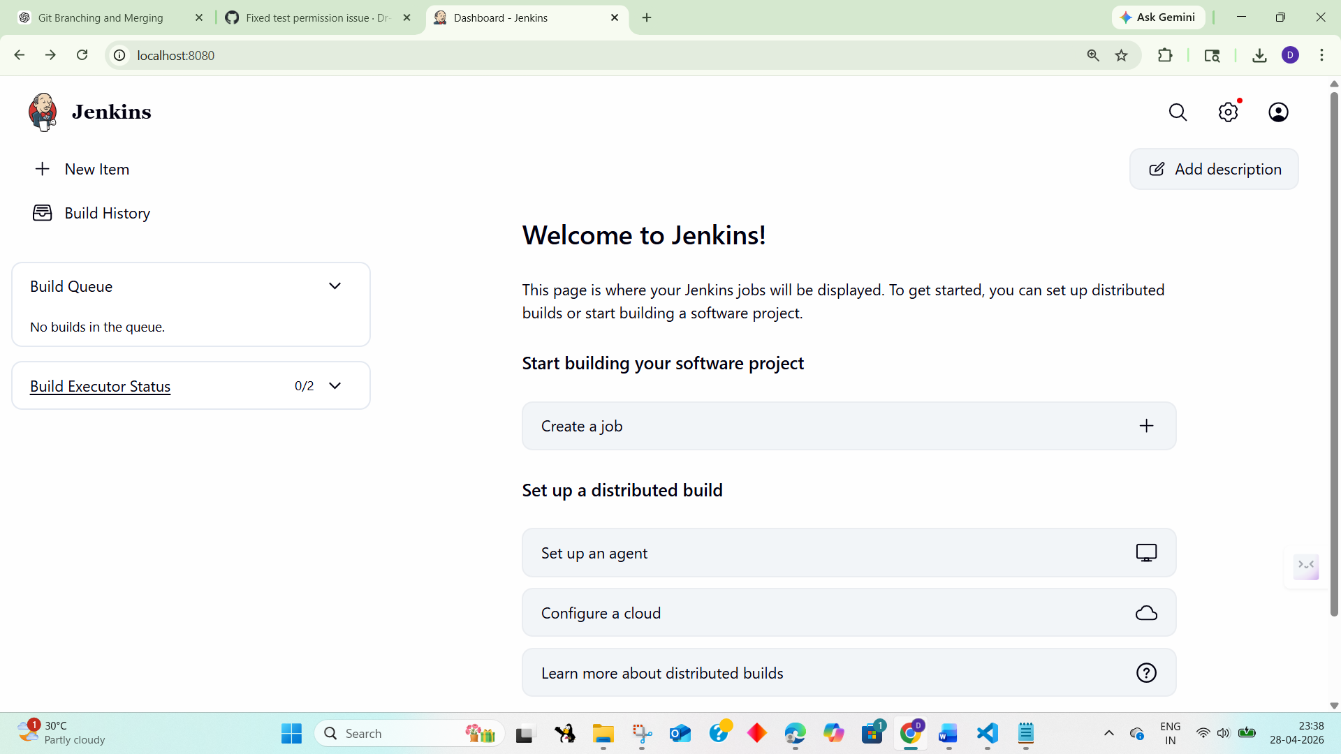

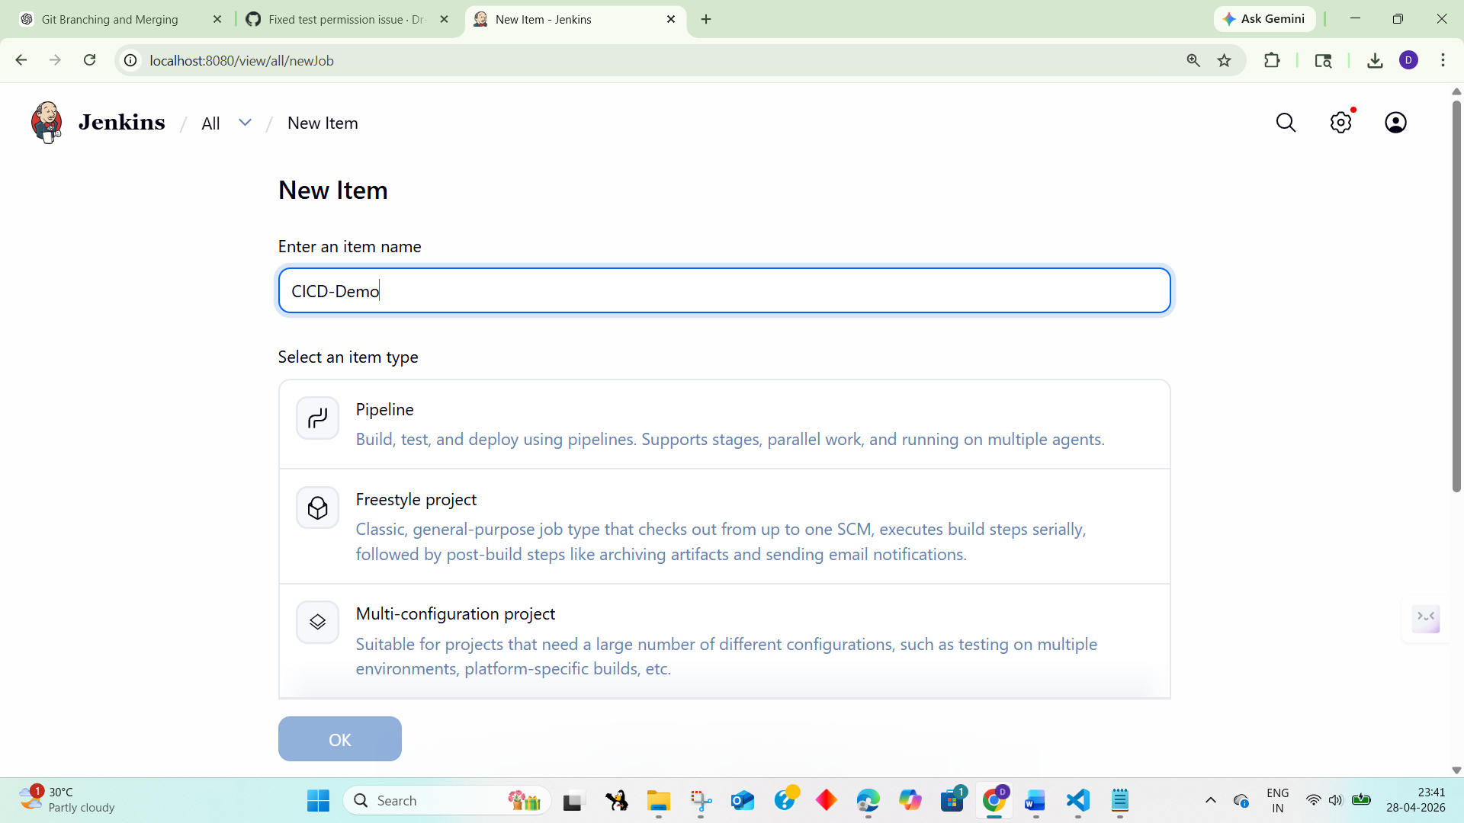

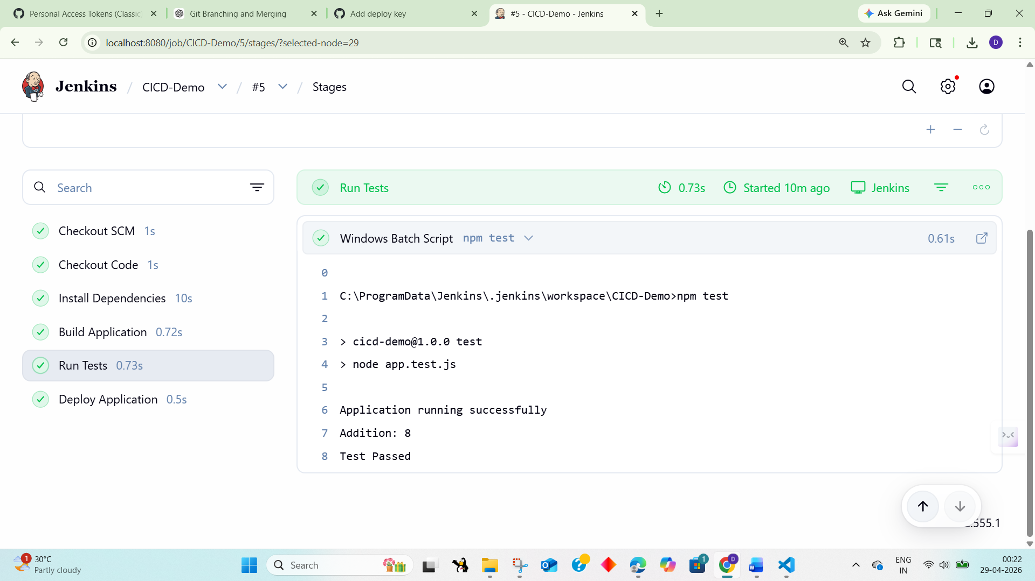

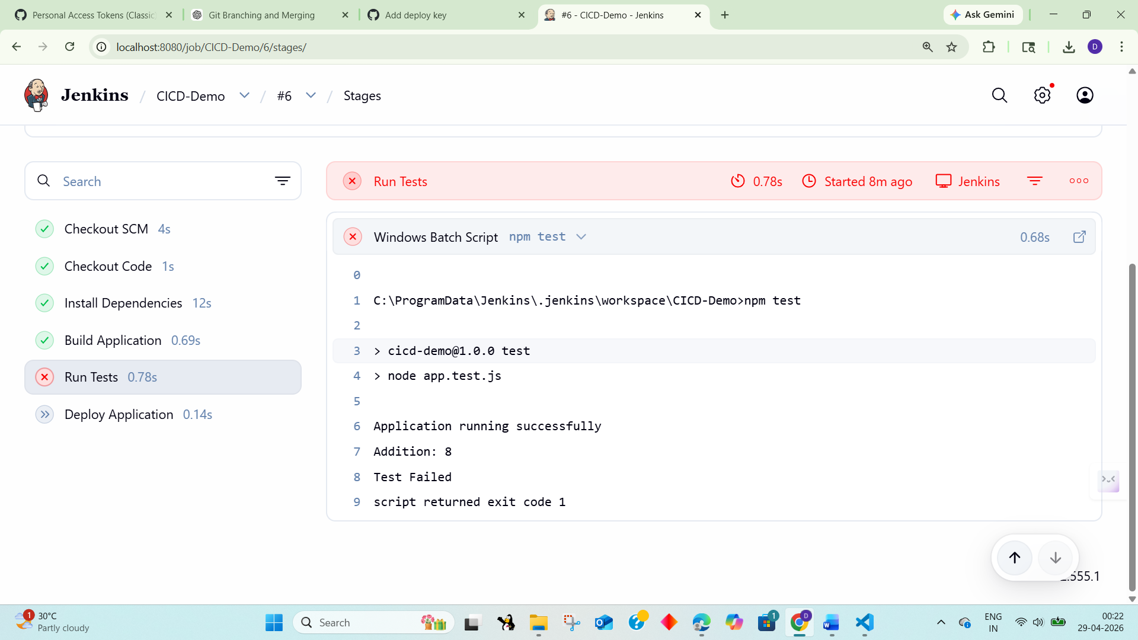
Result
Thus, a CI/CD pipeline was successfully implemented using Jenkins. The pipeline automated code checkout, dependency installation, build process, testing, and deployment of the Node.js application.

Task 22: Explore major cloud service providers such as AWS, Google Cloud, and Microsoft Azure. Identify and compare their core services related to compute, storage, databases, and networking, along with the pay-as-you-use pricing model.

COMPARISON OF CLOUD SERVICES: AWS, GOOGLEC CLOUD, MICROSOFT AZURE
AIM: To develop a cloud comparison application that displays and compares services and pricing models of AWS, GCP, and Azure
ALGORITHM:
- Start the program
- Create project files (HTML, CSS, JS, server.js, db.js)
- Design user interface with dropdown for cloud providers
- Initialize cloud service data (AWS, GCP, Azure) in database module
- Capture selected provider using JavaScript
- Send request to server to fetch service details
- Display compute, storage, database, and networking services
- Accept user input for compute hours and storage usage
- Send input data to server for cost calculation
- Calculate cost based on pay-as-you-use pricing model
- Display total cost dynamically on UI
- Stop the program
PROGRAM:
INDEX.HTML:
<!DOCTYPE html>
<html>
<head>
<title>Cloud Comparison</title>
<link rel="stylesheet" href="style.css">
</head>
<body>
<div class="container">
<h2>Cloud Service Comparison</h2>
<select id="provider" onchange="loadData()">
<option value="aws">AWS</option>
<option value="gcp">GCP</option>
<option value="azure">Azure</option>
</select>
<h3>Services</h3>
<ul id="services"></ul>
<h3>Pricing Calculator</h3>
<input id="hours" placeholder="Compute Hours">
<input id="storage" placeholder="Storage (GB)">
<button onclick="calculate()">Calculate Cost</button>
<h3 id="result"></h3>
</div>
<script src="script.js"></script>
</body>
</html>
STYLE.CSS:
body {
font-family: Arial;
background: #1e1e2f; color: white; display:flex;
justify-content:center; align-items:center;
height:100vh;
}
.container {
text-align:center; width: 350px;
}
input, select, button { margin: 5px; padding: 8px;
}
li {
background: #333; margin: 5px; padding: 5px;
}
SCRIPT.JS:
function loadData() {
const provider = document.getElementById("provider").value; fetch(`/services/${provider}`)
.then(res => res.json())
.then(data => {
let list = document.getElementById("services"); list.innerHTML = "";
Object.entries(data).forEach(([key, value]) => { let li = document.createElement("li");
li.innerText = `${key}: ${value}`; list.appendChild(li);
});
});
}
function calculate() {
const provider = document.getElementById("provider").value; const hours = document.getElementById("hours").value; const storage = document.getElementById("storage").value; fetch("/cost", {
method: "POST",
headers: {"Content-Type":"application/json"}, body: JSON.stringify({ provider, hours, storage })
})
.then(res => res.json())
.then(data => {
document.getElementById("result").innerText = "Cost: $" + data.cost;
});
}
loadData();
SERVER.JS:
const express = require("express"); const db = require("./db");
const app = express(); app.use(express.json());
app.use(express.static( dirname)); app.get("/services/:provider", (req, res) => {
res.json(db.getServices(req.params.provider));
});
app.post("/cost", (req, res) => {
const { provider, hours, storage } = req.body;
const cost = db.calculate(provider, hours, storage); res.json({ cost });
});
app.listen(3000, () => {
console.log("http://localhost:3000");
});
DB.JS:
const services = { aws: {
Compute: "EC2", Storage: "S3", Database: "RDS", Network: "VPC"
},
gcp: {
Compute: "Compute Engine", Storage: "Cloud Storage", Database: "Cloud SQL", Network: "VPC"
},
azure: {
Compute: "Virtual Machines", Storage: "Blob Storage",

Database: "SQL Database", Network: "VNet"
}
};
const pricing = {
aws: { compute: 0.1, storage: 0.02 }, gcp: { compute: 0.09, storage: 0.025 }, azure: { compute: 0.11, storage: 0.018 }
};
function getServices(provider) { return services[provider];
}
function calculate(provider, hours, storage) { const p = pricing[provider];
return (hours * p.compute + storage * p.storage).toFixed(2);
}
module.exports = { getServices, calculate };
OUTPUT:
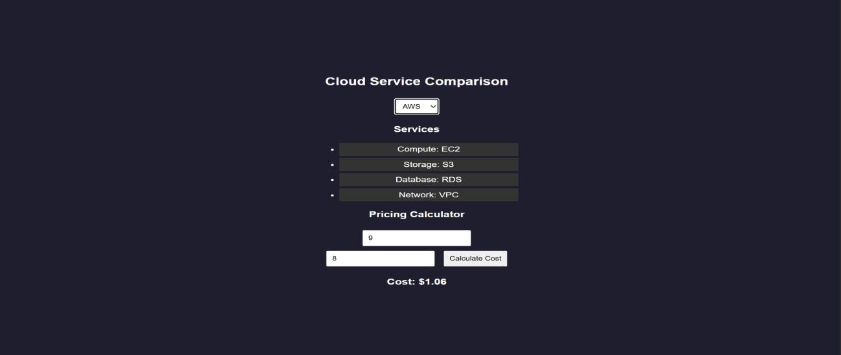

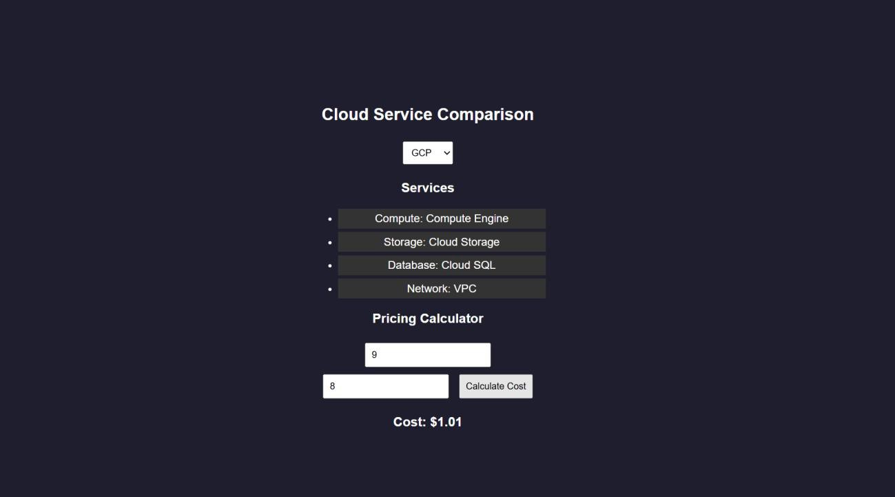
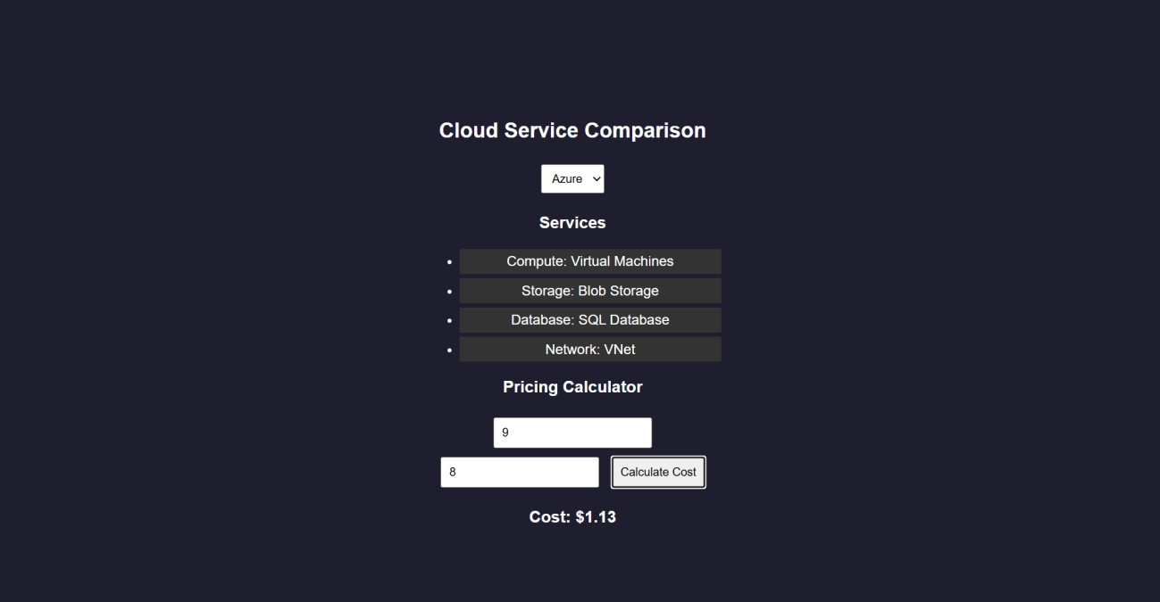
RESULTS: A cloud comparison application was successfully developed to display services and simulate pay-as-you-use pricing across AWS, GCP, and Azure.

Task 23: Apply Vibe Coding and Prompt Engineering techniques using a Generative AI tool. Design effective prompts to generate code snippets, cloud configuration templates, or application logic, and evaluate the quality and efficiency of the generated outputs for real-world business applications.
AI PROMPT APP USING VIBE CODING
AIM: To develop an application that demonstrates prompt engineering by generating and evaluating code or cloud configurations based on user input.
ALGORITHM:
- Start the program
- Create project files (HTML, CSS, JS, server.js, db.js)
- Design UI with input field for user prompt
- Capture user prompt using JavaScript
- Send prompt to server using fetch API
- Receive prompt data in backend (server.js)
- Process prompt using predefined logic (db.js)
- Generate output (code / cloud config / response)
- Evaluate output quality and assign score
- Send generated output and score to frontend
- Display output and score on UI
- Stop the program
PROGRAM:
INDEX.HTML:
<!DOCTYPE html>
<html>
<head>
<title>AI Prompt App</title>
<link rel="stylesheet" href="style.css">
</head>
<body>

<div class="container">
<h2>Prompt Engineering Tool</h2>
<textarea id="prompt" placeholder="Enter your prompt..."></textarea>
<button onclick="generate()">Generate Output</button>
<h3>Generated Output</h3>
<pre id="output"></pre>
<h3>Quality Score</h3>
<p id="score"></p>
</div>
<script src="script.js"></script>
</body>
</html>
STYLE.CSS:
body {
font-family: Arial;
background: #202038; color: white;
display:flex;
justify-content:center; align-items:center;
height:100vh;
}
.container { width: 400px;
text-align: center;
}
textarea { width: 100%; height: 100px; margin: 5px;
}
button { padding: 10px; margin: 10px;
background: #00c6ff; border: none;
color: white;
}
pre {
background: #333; padding: 10px;
}
SCRIPT.JS:
function generate() {
const prompt = document.getElementById("prompt").value; fetch("/generate", {
method: "POST",
headers: {"Content-Type":"application/json"}, body: JSON.stringify({ prompt })
})
.then(res => res.json())
.then(data => {
document.getElementById("output").innerText = data.output; document.getElementById("score").innerText = data.score + "/10";
});
}
SERVER.JS:
const express = require("express"); const db = require("./db");
const app = express();
// Middleware
app.use(express.json());
app.use(express.static( dirname)); // serve HTML
// Home route (optional but useful) app.get("/", (req, res) => {
res.sendFile( dirname + "/index.html");
});
// Generate output app.post("/generate", (req, res) => {
const result = db.processPrompt(req.body.prompt); res.json(result);
});
// START SERVER WITH LINK
app.listen(3000, () => {
console.log(" • Server running at:");
console.log(" http://localhost:3000");
});

DB.JS:
function processPrompt(prompt) { let output = "";
let score = 5;
if (prompt.toLowerCase().includes("code")) { output = `function greet() {
console.log("Hello from AI!");
}`;
score = 9;
}
else if (prompt.toLowerCase().includes("cloud")) { output = `AWS EC2 Config:
- Instance: t2.micro
- Region: us-east-1`; score = 8;
}
else {
output = "Basic AI response generated."; score = 5;
}
return { output, score };
}
module.exports = { processPrompt };
OUTPUT:
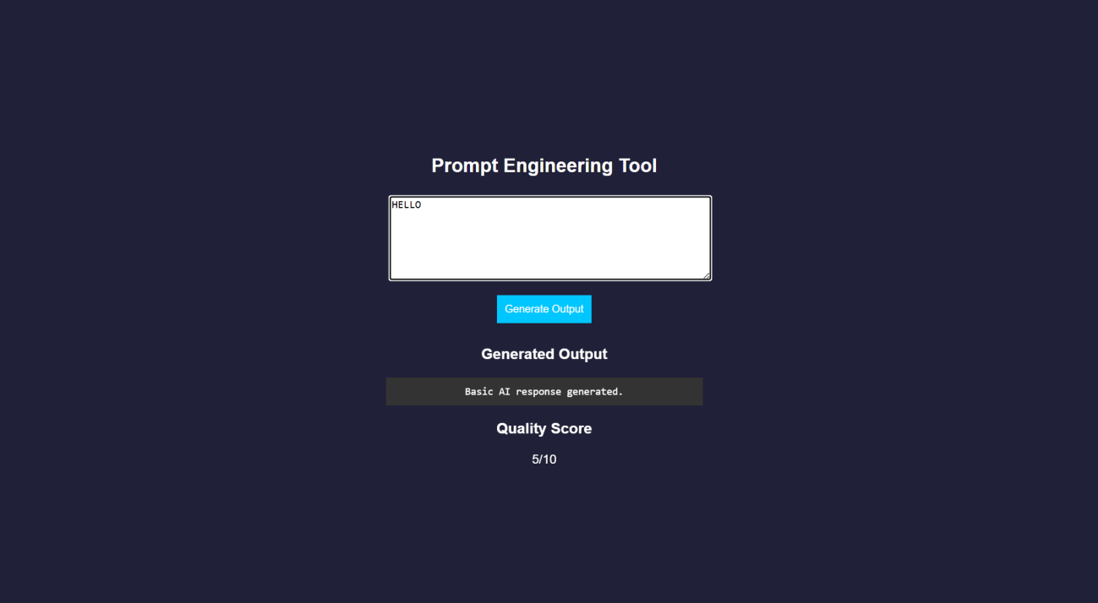
RESULT: A prompt engineering application was successfully developed to generate and evaluate AI-based outputs for code and cloud configurations.

Task 24: Use Vibe Coding to build a complete cloud-based feature using Generative AI. Write iterative prompts to generate a REST API, cloud deployment steps, and security configurations. Refine the prompts based on the output quality, document prompt versions, and evaluate how prompt engineering improves code accuracy, scalability, and real-world usability.

Vibe Cloud App
AIM: To develop an application that uses iterative prompt engineering to generate and evaluate REST APIs, cloud deployment steps, and security configurations.
ALGORITHM:
- Start the program
- Create project files (HTML, CSS, JS, server.js, db.js)
- Design UI to accept user prompts
- Capture prompt input using JavaScript
- Send prompt to backend using fetch API
- Receive prompt in server and forward to processing module
- Store prompt in history for version tracking
- Analyze prompt type (REST API / Cloud / Security)
- Generate corresponding output based on prompt
- Evaluate output quality and assign score
- Return output and score to frontend and display results
- Stop the program
PROGRAM:
INDEX.HTML:
<!DOCTYPE html>
<html>
<head>
<title>Vibe Coding App</title>
<link rel="stylesheet" href="style.css">
</head>
<body>
<div class="container">
<h2>Vibe Coding Cloud Generator</h2>

<textarea id="prompt" placeholder="Enter prompt..."></textarea>
<button onclick="generate()">Generate</button>
<h3>Output</h3>
<pre id="output"></pre>
<h3>Score</h3>
<p id="score"></p>
<h3>Prompt Versions</h3>
<ul id="history"></ul>
</div>
<script src="script.js"></script>
</body>
</html>
STYLE.CSS:
body {
font-family: Arial;
background: #b98bdb; color: white;
display:flex;
justify-content:center; align-items:center;
height:100vh;
}
.container { width: 400px;
text-align: center;
}
textarea { width: 100%; height: 100px;
}
button { padding: 10px; margin: 10px;
background: #00c6ff; border: none;
}
pre {
background: #333; padding: 10px;
}
li {
background: #444; margin: 5px; padding: 5px;
}

SCRIPT.JS:
function generate() {
const prompt = document.getElementById("prompt").value; fetch("/generate", {
method: "POST",
headers: {"Content-Type":"application/json"},
body: JSON.stringify({ prompt })
})
.then(res => res.json())
.then(data => {
document.getElementById("output").innerText = data.output; document.getElementById("score").innerText = data.score + "/10"; loadHistory();
});
}
function loadHistory() { fetch("/history")
.then(res => res.json())
.then(data => {
let list = document.getElementById("history"); list.innerHTML = "";
data.forEach((p, i) => {
let li = document.createElement("li"); li.innerText = `v${i+1}: ${p.prompt}`; list.appendChild(li);
});
});
}
loadHistory();
SERVER.JS:
const express = require("express"); const db = require("./db");

const app = express(); app.use(express.json());
app.use(express.static( dirname)); app.post("/generate", (req, res) => {
const result = db.process(req.body.prompt); res.json(result);
});
app.get("/history", (req, res) => { res.json(db.getHistory());
});
app.listen(3000, () => {
console.log(" • http://localhost:3000");
});
DB.JS:
let history = [];
function process(prompt) { let output = "";
let score = 5;
history.push({ prompt });
if (prompt.includes("REST")) {
output = `app.get('/api', (req,res)=>res.send('API running'));`; score = 7;
}
else if (prompt.includes("cloud")) { output = `Deploy using AWS EC2:
- Launch instance
- Install Node.js
- Run app`;
score = 8;
}
else if (prompt.includes("security")) {
output = `Use HTTPS, JWT authentication, and firewall rules`; score = 9;
}
score += Math.min(history.length, 2); return { output, score };
}
function getHistory() { return history;
}
module.exports = { process, getHistory };
OUTPUT:
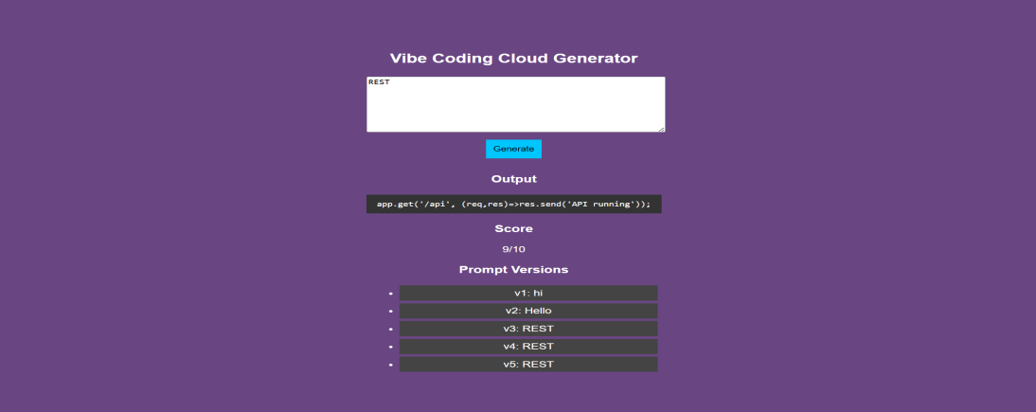
RESULT: A Vibe Coding application was successfully developed to generate and refine cloud-based features using iterative prompt engineering.

