Blockchain Technology Lab Manual – Task 1

**Title:** Creating MetaMask Wallet and Crypto Transactions

**Tool Used:** MetaMask

This lab guides students through the process of creating a MetaMask wallet, securing it, and viewing the dashboard.

## Step 1

Step 1: Creating MetaMask Password  
This step involves creating a secure password to unlock your MetaMask wallet locally on your device.

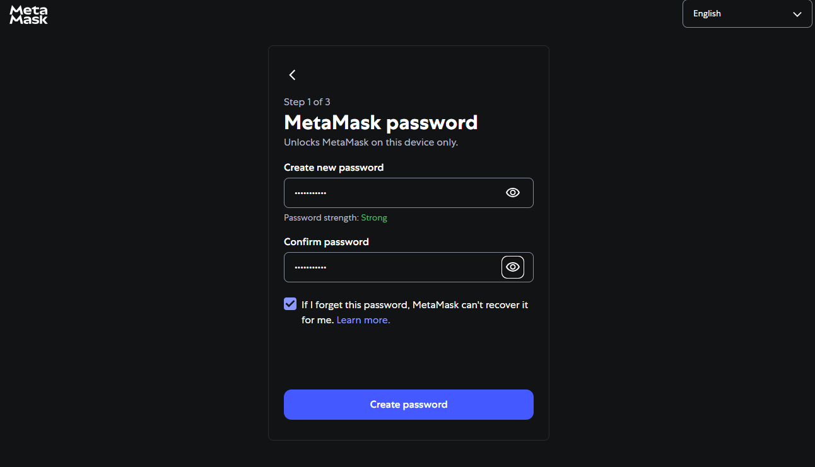

## Step 2

Step 2: Securing the Wallet  
MetaMask prompts you to secure your wallet using a Secret Recovery Phrase. This is critical for backup and recovery.

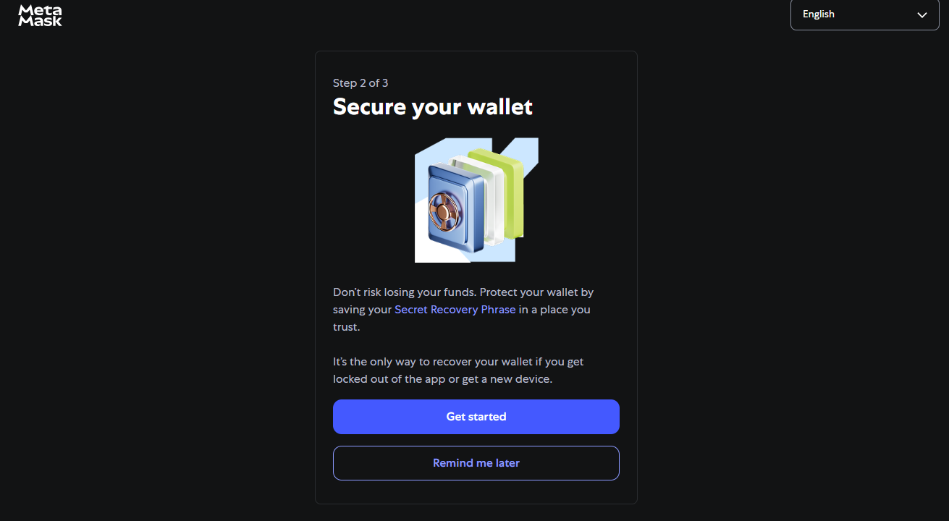

## Step 3

Step 3: Viewing the Secret Recovery Phrase  
Tap to reveal the recovery phrase and note it down in the correct order and store it securely.

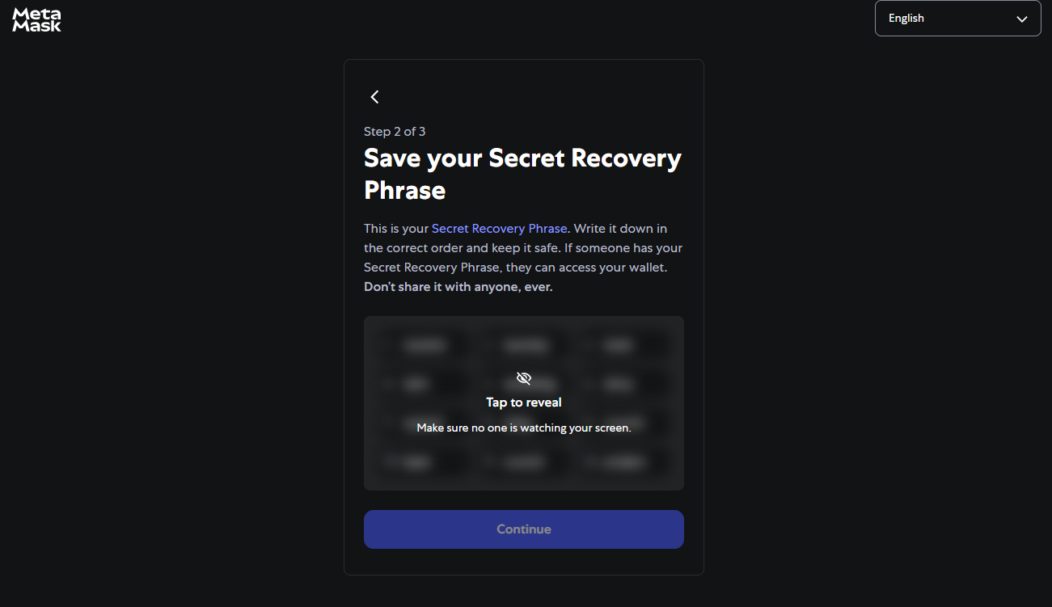

## Step 4

Step 4: Full Secret Phrase Displayed  
MetaMask shows the 12-word recovery phrase. This must be recorded in the exact order.

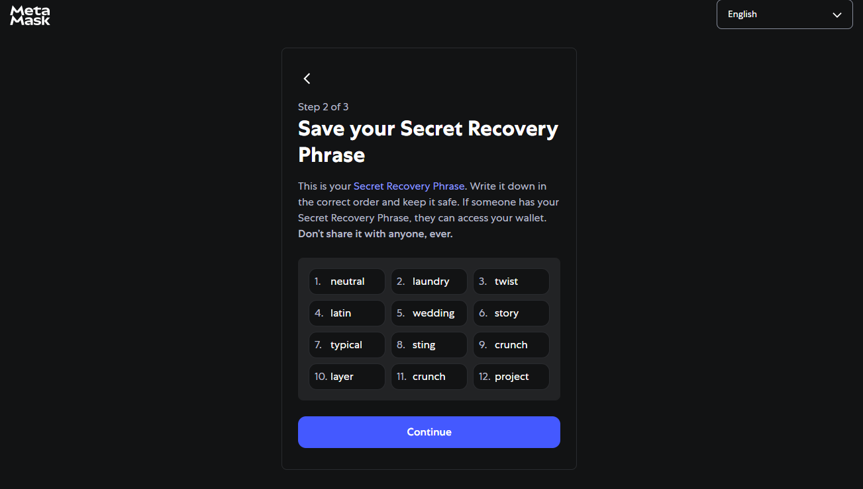

## Step 5

Step 5: Confirming Secret Phrase  
Here you confirm the recovery phrase to verify you’ve stored it correctly.

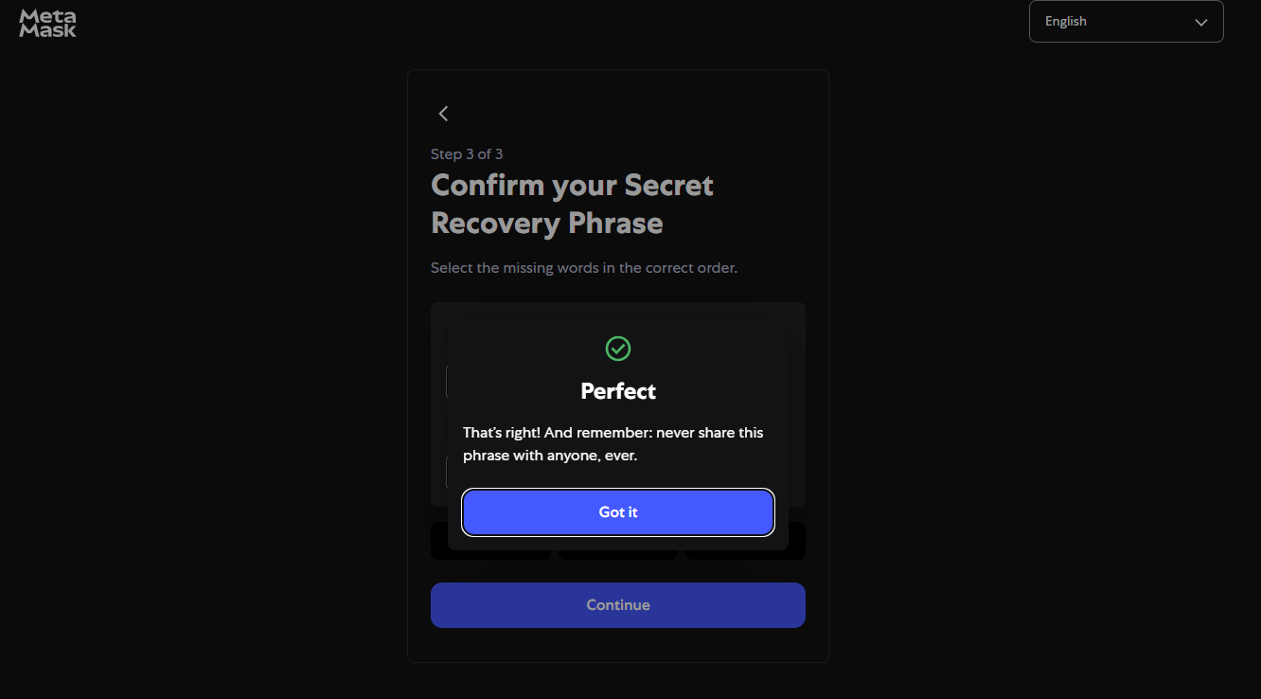

## Step 6

Step 6: MetaMask Confirmation  
After correct confirmation, a success message is displayed. The wallet is now ready to use.

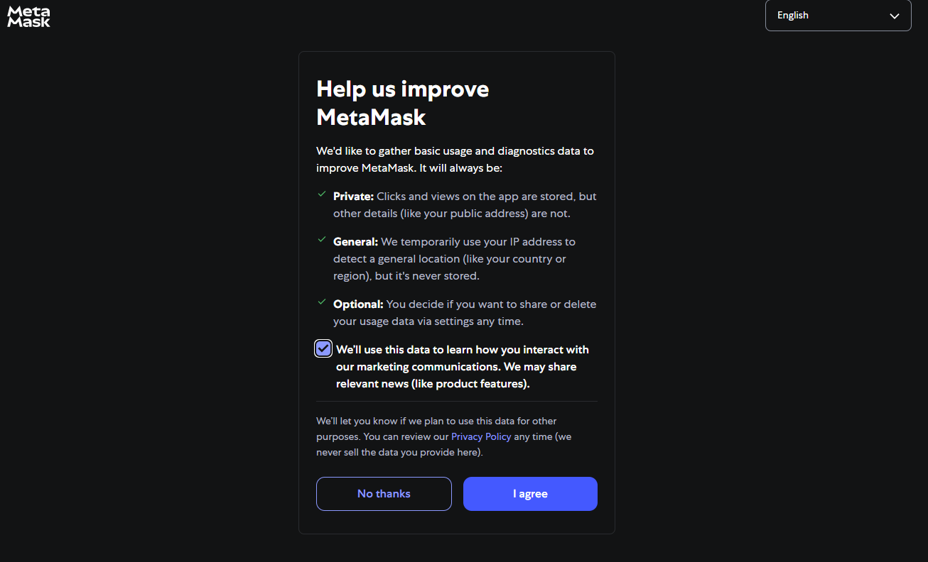

## Step 7

Step 7: MetaMask Optional Preferences  
MetaMask asks for optional permissions to help improve the app through usage data.

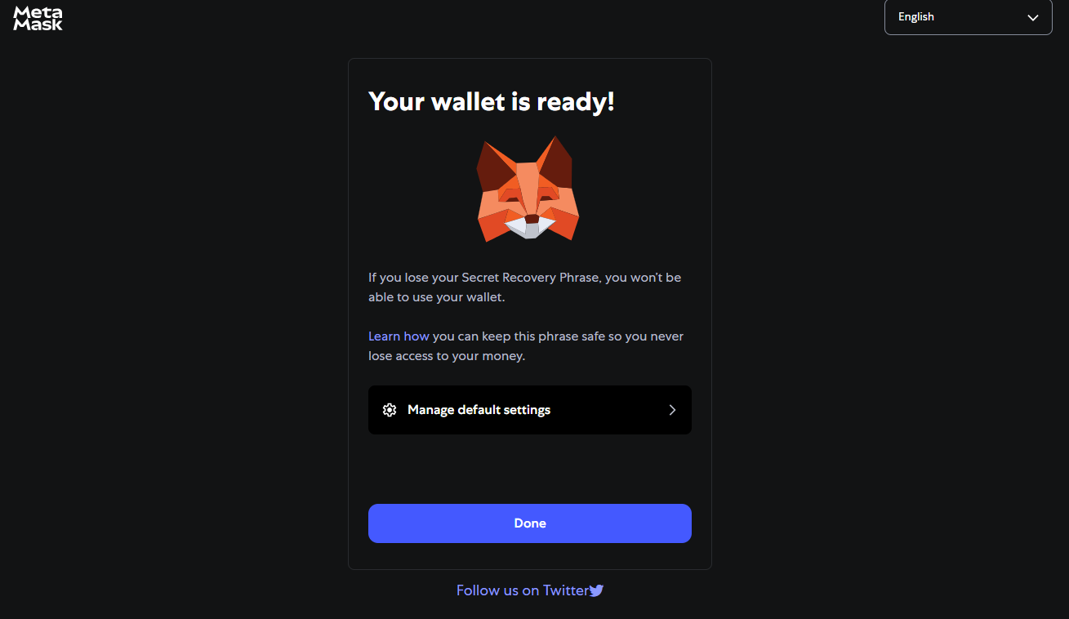

## Step 8

Step 8: Wallet Ready Screen  
The final setup screen confirms that your wallet is successfully created and ready to use.

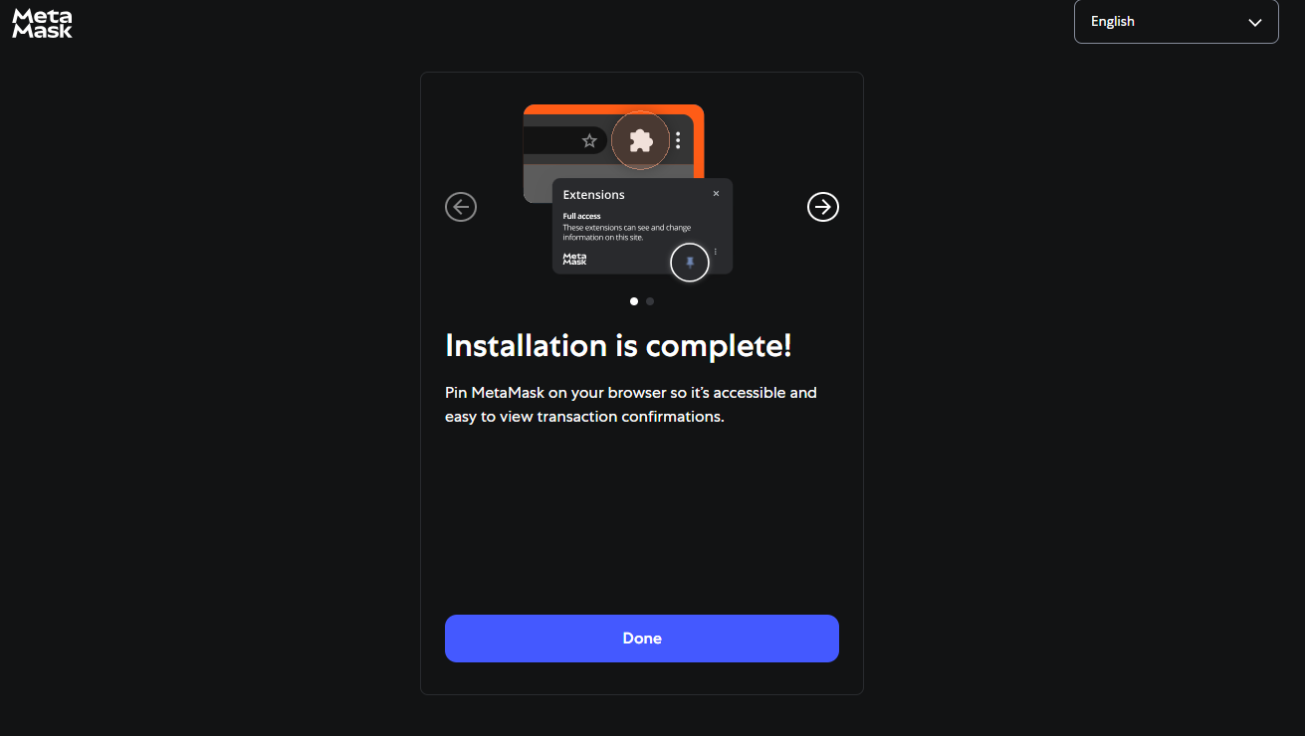

## Step 9

Step 9: MetaMask Dashboard  
This is the home screen of MetaMask showing your ETH balance, networks, and wallet functions like Buy, Send, and Swap.

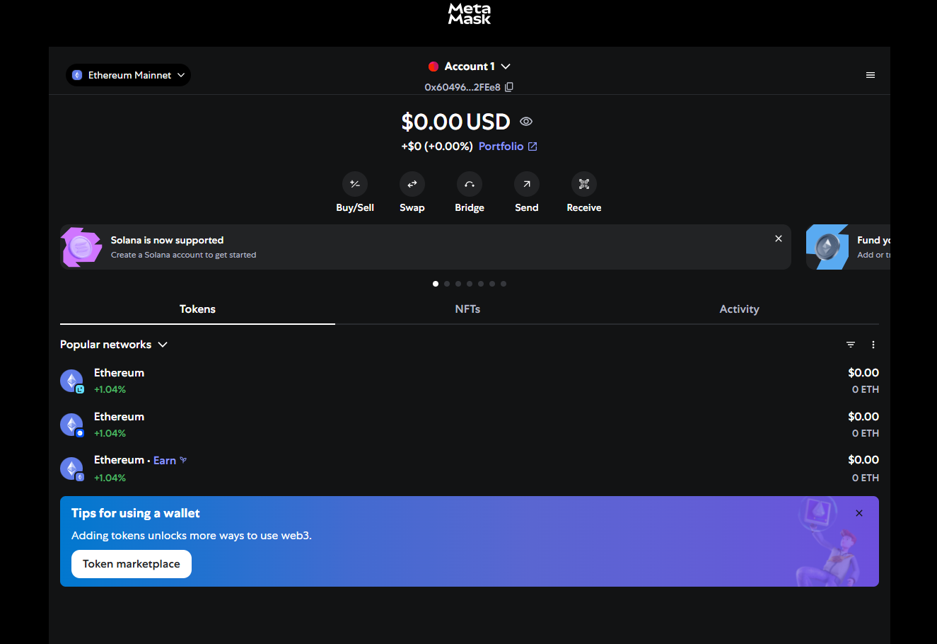

0x60496C20329A1D94AA5d9657b920C71E69f2FEe8