Task 6
Write a program to implement the Gaussian mixture model. Compute the accuracy of the classifier, considering few test data sets.

Algorithm
- Initialize the mean μk, the covariance matrix μk, and the mixing coefficients μk by some random variables.
- Compute the μk
- Again, estimate all the parameters using the current μk values
- Compute log-likelihood function.
- Put some convergence criterion
- If the log-likelihood value converges to some value (or if all the parameters converge to some values) then stop, else return to Step 2.

Python Code
import numpy as np
import pandas as pd
import matplotlib.pyplot as plt
from pandas import DataFrame
from sklearn import datasets
from sklearn.mixture import GaussianMixture
# load the iris dataset
iris = datasets.load_iris()
# select first two columns
X = iris.data[:, :2]
# turn it into a dataframe
d = pd.DataFrame(X)
# plot the data
plt.scatter(d[0], d[1])
gmm = GaussianMixture(n_components = 3)
# Fit the GMM model for the dataset
# which expresses the dataset as a
# mixture of 3 Gaussian Distribution
gmm.fit(d)
# Assign a label to each sample
labels = gmm.predict(d)
d['labels']= labels
d0 = d[d['labels']== 0]
d1 = d[d['labels']== 1]
d2 = d[d['labels']== 2]
plt.show()
# plot three clusters in same plot
plt.scatter(d0[0], d0[1], c ='r')
plt.scatter(d1[0], d1[1], c ='yellow')
plt.scatter(d2[0], d2[1], c ='g')
plt.show()
# print the converged log-likelihood value
print("The mean:",gmm.means_)
print('\n')
print("The covariance matrix:",gmm.covariances_)
print("The converged log-likelihood value:",gmm.lower_bound_)
# print the number of iterations needed
# for the log-likelihood value to converge
print("The number of iterations needed for the log-likelihood value to converge:",gmm.n_iter_)

Output:
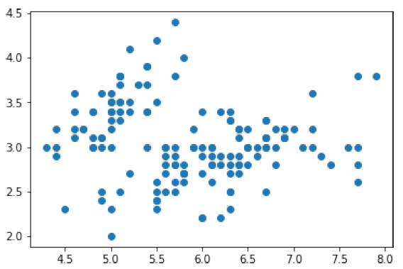
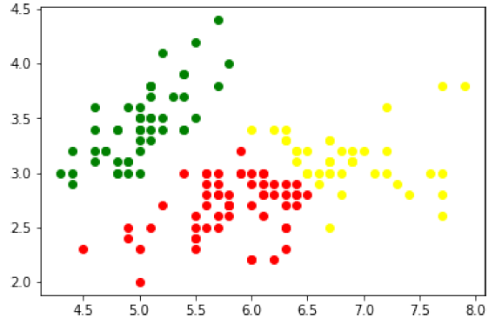

The mean:
[[5.9009976 2.74387546]
[6.68055626 3.02849627]
[5.01507898 3.4514463 ]]

The covariance matrix:
[[[0.27671149 0.08897036]
[0.08897036 0.09389206]]

[[0.36153508 0.05159664]
[0.05159664 0.08927917]]

[[0.11944714 0.08835648]
[0.08835648 0.11893388]]]
The converged log-likelihood value: -1.4987505566235166
The number of iterations needed for the log-likelihood value to converge: 8

