Task-1:
class Solution {
public boolean halvesAreAlike(String s) {
int n = s.length();
int mid = n / 2;

int countA = 0;
int countB = 0;

for (int i = 0; i < mid; i++) {
if (isVowel(s.charAt(i))) {
countA++;
}
}

for (int i = mid; i < n; i++) {
if (isVowel(s.charAt(i))) {
countB++;
}
}

return countA == countB;
}

private boolean isVowel(char c) {
return c == 'a' || c == 'e' || c == 'i' || c == 'o' || c == 'u' ||
c == 'A' || c == 'E' || c == 'I' || c == 'O' || c == 'U';
}
}
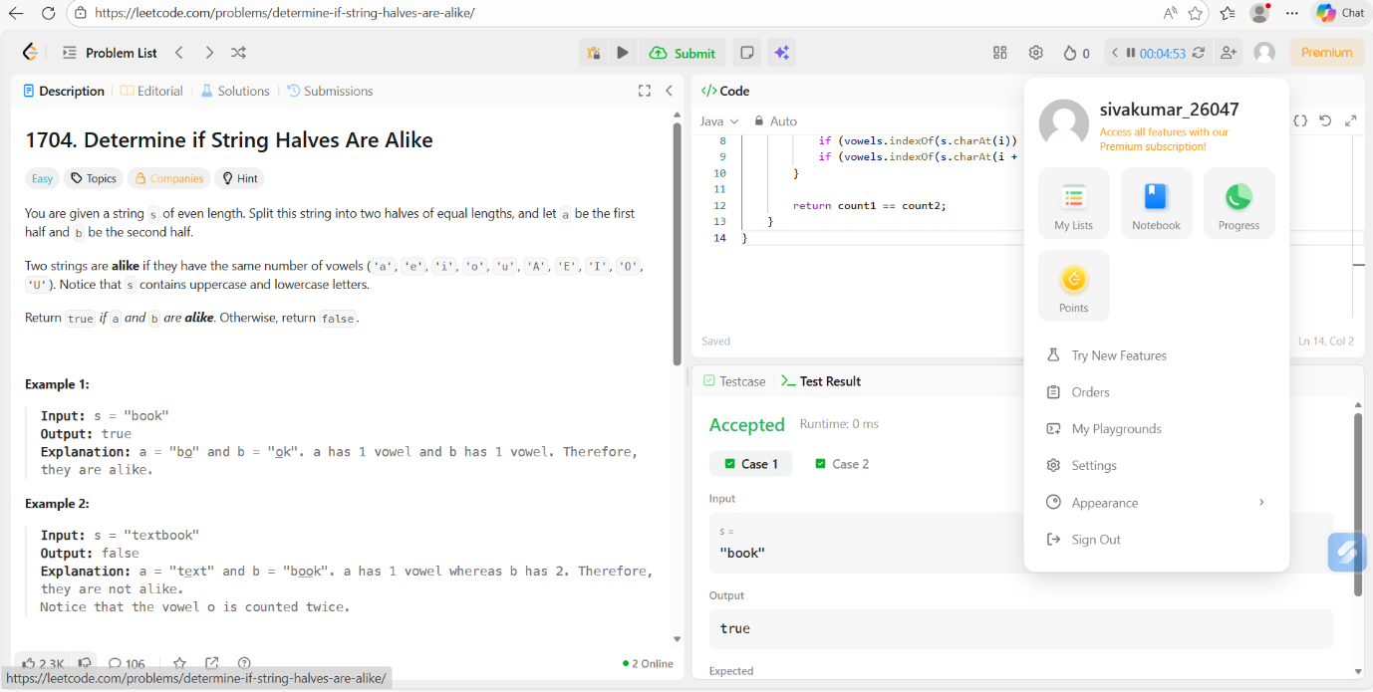
Task-2:

import java.util.Scanner;

public class Main {

public static boolean isLapindrome(String s) {
int n = s.length();

String left, right;

// Split string
if (n % 2 == 0) {
left = s.substring(0, n / 2);
right = s.substring(n / 2);
} else {
left = s.substring(0, n / 2);
right = s.substring(n / 2 + 1);
}

// Frequency arrays
int[] freqLeft = new int[26];
int[] freqRight = new int[26];

// Count frequency for left half
for (char c : left.toCharArray()) {
freqLeft[c - 'a']++;
}

// Count frequency for right half
for (char c : right.toCharArray()) {
freqRight[c - 'a']++;
}

// Compare frequencies
for (int i = 0; i < 26; i++) {
if (freqLeft[i] != freqRight[i]) {
return false;
}
}

return true;
}

public static void main(String[] args) {
Scanner sc = new Scanner(System.in);

int T = sc.nextInt();
sc.nextLine(); // consume newline

while (T-- > 0) {
String s = sc.nextLine();

if (isLapindrome(s)) {
System.out.println("YES");
} else {
System.out.println("NO");
}
}

sc.close();
}
}
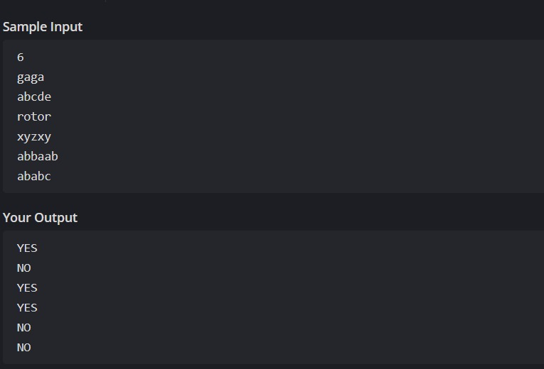
Task-3:
import java.io.*;
import java.util.*;
import java.util.stream.*;
import static java.util.stream.Collectors.joining;
import static java.util.stream.Collectors.toList;

class Result {

public static List<Integer> compareTriplets(List<Integer> a, List<Integer> b) {

int aliceScore = 0;
int bobScore = 0;

for (int i = 0; i < a.size(); i++) {
if (a.get(i) > b.get(i)) {
aliceScore++;
} else if (a.get(i) < b.get(i)) {
bobScore++;
}
}

List<Integer> result = new ArrayList<>();
result.add(aliceScore);
result.add(bobScore);

return result;
}
}

public class Solution {
public static void main(String[] args) throws IOException {

BufferedReader bufferedReader = new BufferedReader(new InputStreamReader(System.in));
BufferedWriter bufferedWriter = new BufferedWriter(new OutputStreamWriter(System.out));

List<Integer> a = Stream.of(bufferedReader.readLine().trim().split(" "))
.map(Integer::parseInt)
.collect(toList());

List<Integer> b = Stream.of(bufferedReader.readLine().trim().split(" "))
.map(Integer::parseInt)
.collect(toList());

List<Integer> result = Result.compareTriplets(a, b);

bufferedWriter.write(
result.stream()
.map(Object::toString)
.collect(joining(" "))
);

bufferedWriter.newLine();

bufferedReader.close();
bufferedWriter.close();
}
}
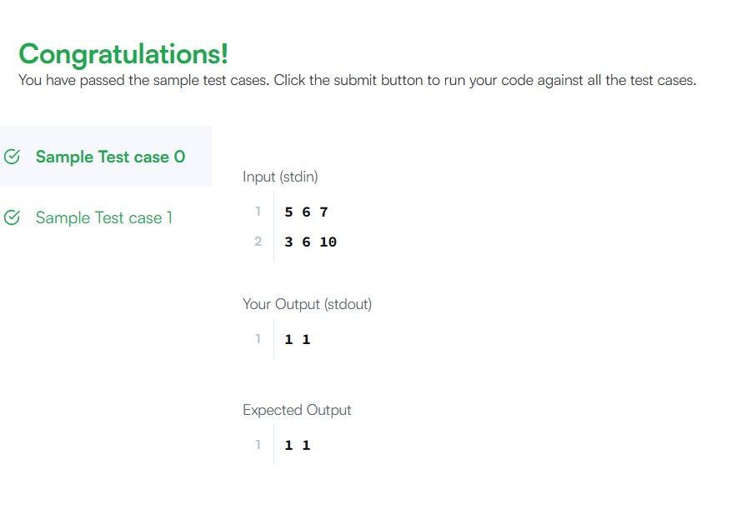
Task-4:
import java.util.*;

class Solution {
public boolean containsDuplicate(int[] nums) {

HashSet<Integer> set = new HashSet<>();

for (int num : nums) {
if (set.contains(num)) {
return true;
}
set.add(num);
}

return false;
}

// For testing
public static void main(String[] args) {
Solution obj = new Solution();

int[] nums1 = {1, 2, 3, 1};
System.out.println(obj.containsDuplicate(nums1)); // true

int[] nums2 = {1, 2, 3, 4};
System.out.println(obj.containsDuplicate(nums2)); // false

int[] nums3 = {1,1,1,3,3,4,3,2,4,2};
System.out.println(obj.containsDuplicate(nums3)); // true
}
}
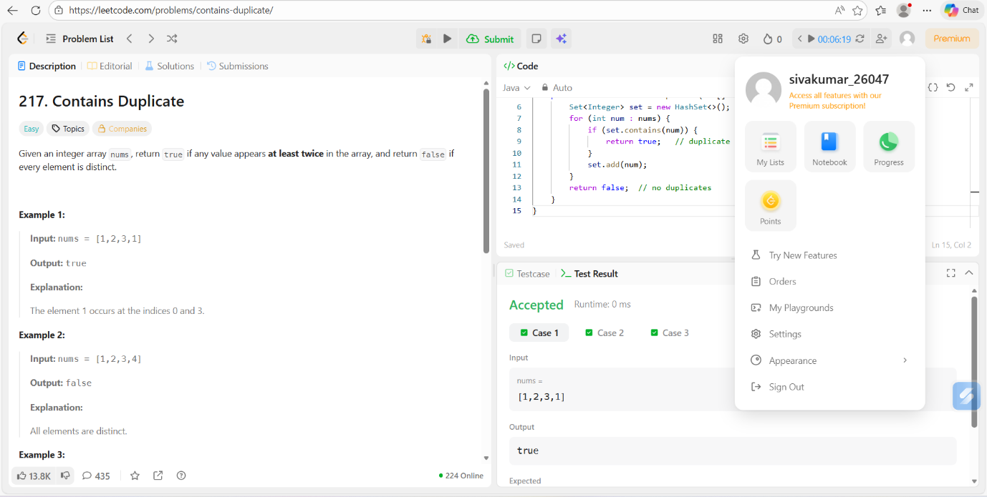

Task-5:
import java.io.*;
import java.util.*;

class Result {

/*
* Complete the 'timeConversion' function below.
* The function converts 12-hour format to 24-hour format.
*/

public static String timeConversion(String s) {

String period = s.substring(s.length() - 2); // AM or PM
String[] parts = s.substring(0, s.length() - 2).split(":");

int hour = Integer.parseInt(parts[0]);
String minute = parts[1];
String second = parts[2];

if (period.equals("AM")) {
if (hour == 12) {
hour = 0;
}
} else { // PM
if (hour != 12) {
hour += 12;
}
}

return String.format("%02d:%s:%s", hour, minute, second);
}
}

public class Solution {
public static void main(String[] args) throws IOException {

BufferedReader bufferedReader = new BufferedReader(new InputStreamReader(System.in));
BufferedWriter bufferedWriter = new BufferedWriter(new OutputStreamWriter(System.out));

String s = bufferedReader.readLine();

String result = Result.timeConversion(s);

bufferedWriter.write(result);
bufferedWriter.newLine();

bufferedReader.close();
bufferedWriter.close();
}
}

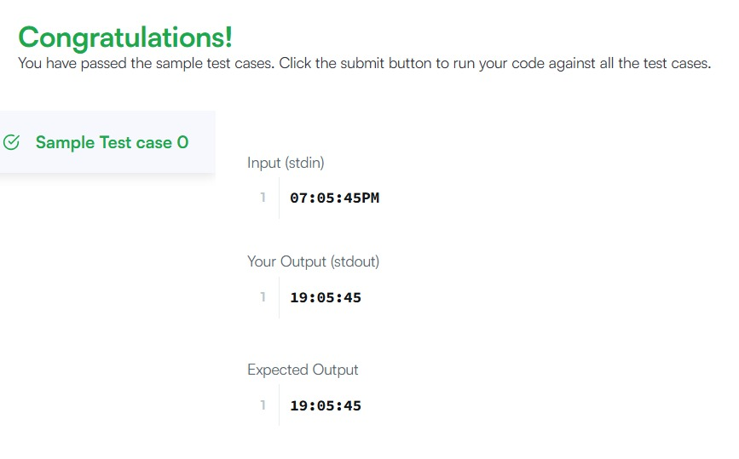
Task-6:
class Solution {
public void moveZeroes(int[] nums) {
int k = 0; // index to place next non-zero element

// Move all non-zero elements to the front
for (int i = 0; i < nums.length; i++) {
if (nums[i] != 0) {
nums[k] = nums[i];
k++;
}
}

// Fill remaining positions with zero
while (k < nums.length) {
nums[k] = 0;
k++;
}
}
}
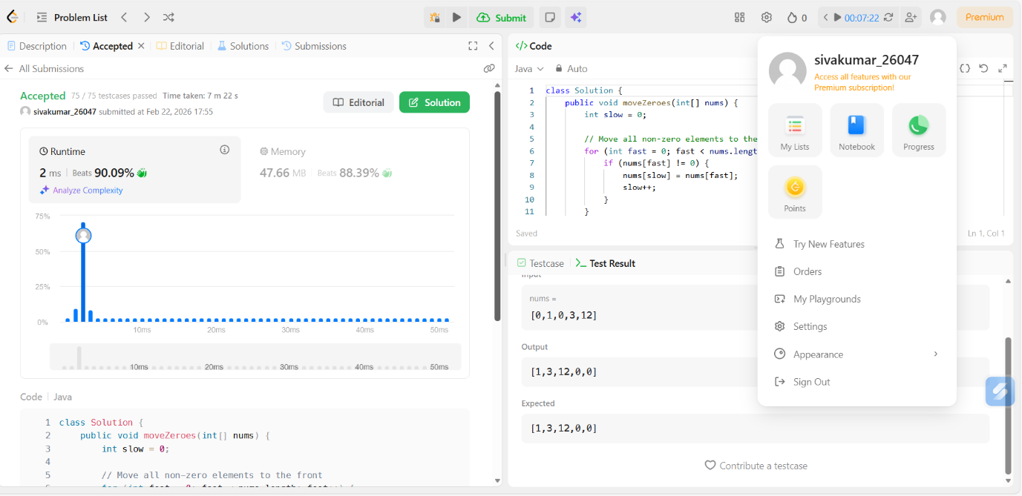
Task-7:
import java.io.*;
import java.util.*;
import java.util.stream.*;
import static java.util.stream.Collectors.toList;

class Result {

/*
* Complete the 'diagonalDifference' function below.
* The function is expected to return an INTEGER.
* The function accepts 2D_INTEGER_ARRAY arr as parameter.
*/

public static int diagonalDifference(List<List<Integer>> arr) {

int n = arr.size();
int primarySum = 0;
int secondarySum = 0;

for (int i = 0; i < n; i++) {
primarySum += arr.get(i).get(i);
secondarySum += arr.get(i).get(n - 1 - i);
}

return Math.abs(primarySum - secondarySum);
}
}

public class Solution {
public static void main(String[] args) throws IOException {

BufferedReader bufferedReader = new BufferedReader(new InputStreamReader(System.in));
BufferedWriter bufferedWriter = new BufferedWriter(new OutputStreamWriter(System.out));

int n = Integer.parseInt(bufferedReader.readLine().trim());

List<List<Integer>> arr = new ArrayList<>();

IntStream.range(0, n).forEach(i -> {
try {
arr.add(
Stream.of(bufferedReader.readLine().trim().split(" "))
.map(Integer::parseInt)
.collect(toList())
);
} catch (IOException ex) {
throw new RuntimeException(ex);
}
});

int result = Result.diagonalDifference(arr);

bufferedWriter.write(String.valueOf(result));
bufferedWriter.newLine();

bufferedReader.close();
bufferedWriter.close();
}
}

Task-8:
class Solution {
public int[][] transpose(int[][] matrix) {
int m = matrix.length; // number of rows
int n = matrix[0].length; // number of columns

// create new matrix with swapped dimensions
int[][] result = new int[n][m];

// swap rows and columns
for (int i = 0; i < m; i++) {
for (int j = 0; j < n; j++) {
result[j][i] = matrix[i][j];
}
}

return result;
}
}
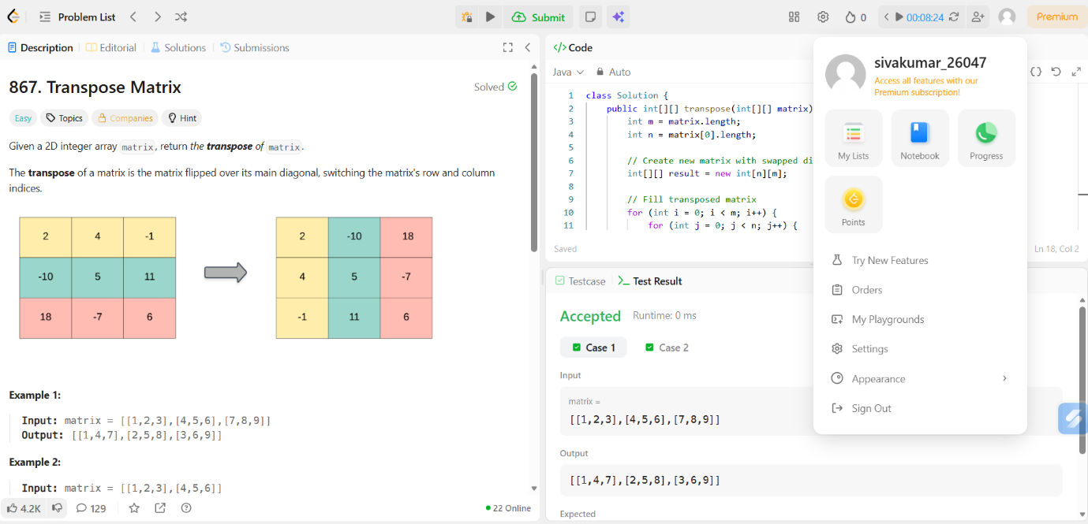

Task-9:
class Solution {
public int[][] matrixBlockSum(int[][] mat, int k) {
int m = mat.length;
int n = mat[0].length;

// Step 1: Create prefix sum matrix
int[][] prefix = new int[m + 1][n + 1];

for (int i = 1; i <= m; i++) {
for (int j = 1; j <= n; j++) {
prefix[i][j] = mat[i - 1][j - 1]
+ prefix[i - 1][j]
+ prefix[i][j - 1]
- prefix[i - 1][j - 1];
}
}

// Step 2: Calculate block sum for each cell
int[][] answer = new int[m][n];

for (int i = 0; i < m; i++) {
for (int j = 0; j < n; j++) {

int r1 = Math.max(0, i - k);
int c1 = Math.max(0, j - k);
int r2 = Math.min(m - 1, i + k);
int c2 = Math.min(n - 1, j + k);

// Convert to prefix index
r1++;
c1++;
r2++;
c2++;

answer[i][j] = prefix[r2][c2]
- prefix[r1 - 1][c2]
- prefix[r2][c1 - 1]
+ prefix[r1 - 1][c1 - 1];
}
}

return answer;
}
}
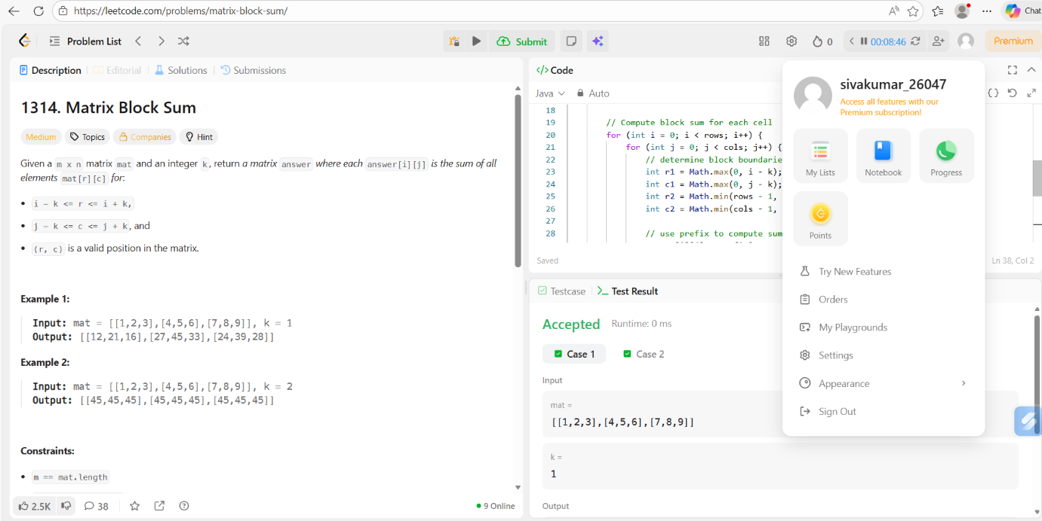
Task-10:
import java.io.*;
import java.util.*;
import java.util.stream.*;
import static java.util.stream.Collectors.toList;

class Result {

public static void matrixRotation(List<List<Integer>> matrix, int r) {

int m = matrix.size();
int n = matrix.get(0).size();
int layers = Math.min(m, n) / 2;

int[][] result = new int[m][n];

for (int layer = 0; layer < layers; layer++) {

List<Integer> elements = new ArrayList<>();

int top = layer;
int bottom = m - 1 - layer;
int left = layer;
int right = n - 1 - layer;

// extract layer
for (int j = left; j <= right; j++)
elements.add(matrix.get(top).get(j));

for (int i = top + 1; i < bottom; i++)
elements.add(matrix.get(i).get(right));

for (int j = right; j >= left; j--)
elements.add(matrix.get(bottom).get(j));

for (int i = bottom - 1; i > top; i--)
elements.add(matrix.get(i).get(left));

// rotate
int size = elements.size();
int rot = r % size;

List<Integer> rotated = new ArrayList<>();
rotated.addAll(elements.subList(rot, size));
rotated.addAll(elements.subList(0, rot));

// put back
int idx = 0;

for (int j = left; j <= right; j++)
result[top][j] = rotated.get(idx++);

for (int i = top + 1; i < bottom; i++)
result[i][right] = rotated.get(idx++);

for (int j = right; j >= left; j--)
result[bottom][j] = rotated.get(idx++);

for (int i = bottom - 1; i > top; i--)
result[i][left] = rotated.get(idx++);
}

// print output
for (int i = 0; i < m; i++) {
for (int j = 0; j < n; j++) {
System.out.print(result[i][j]);
if (j < n - 1) System.out.print(" ");
}
System.out.println();
}
}
}

public class Solution {
public static void main(String[] args) throws IOException {

BufferedReader bufferedReader = new BufferedReader(new InputStreamReader(System.in));

String[] first = bufferedReader.readLine().split(" ");

int m = Integer.parseInt(first[0]);
int n = Integer.parseInt(first[1]);
int r = Integer.parseInt(first[2]);

List<List<Integer>> matrix = new ArrayList<>();

for (int i = 0; i < m; i++) {
matrix.add(
Stream.of(bufferedReader.readLine().split(" "))
.map(Integer::parseInt)
.collect(toList())
);
}

Result.matrixRotation(matrix, r);

bufferedReader.close();
}
}
