Database Management and Web Development basics

Triggers:
- Create a simple trigger BEFORE INSERT or update or delete trigger using the CREATE TRIGGER statement for driver schema assuming the otp for entry.
Table:
CREATE TABLE driver (
driver_id INT PRIMARY KEY,
otp INT
);
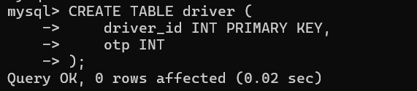

Trigger (OTP must be exactly 4 digits):
DELIMITER //

CREATE TRIGGER otp_validation
BEFORE INSERT ON driver
FOR EACH ROW
BEGIN
IF NEW.otp < 1000 OR NEW.otp > 9999 THEN
SIGNAL SQLSTATE '45000'
SET MESSAGE_TEXT = 'OTP must be exactly 4 digits';
END IF;
END //

DELIMITER ;
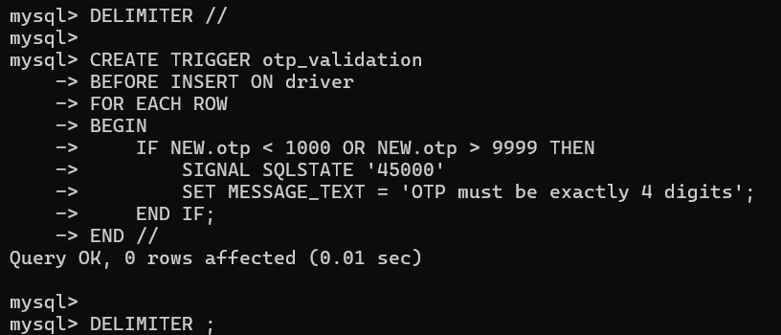
- Create a simple trigger AFTER INSERT When a customer adds a dish to their order, the system must automatically calculate the price and add it to the order's running total.
Table:
CREATE TABLE orders (
order_id INT PRIMARY KEY,
total_amount INT DEFAULT 0
);

CREATE TABLE order_items (
item_id INT PRIMARY KEY,
order_id INT,
price INT
);
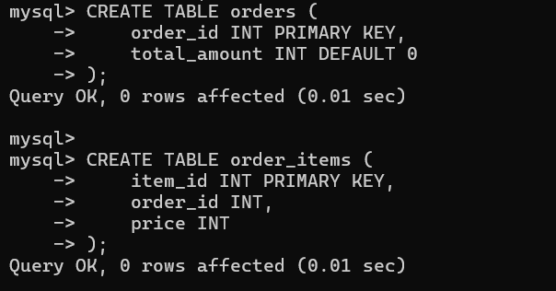

Trigger:
DELIMITER //

CREATE TRIGGER update_order_total
AFTER INSERT ON order_items
FOR EACH ROW
BEGIN
UPDATE orders
SET total_amount = total_amount + NEW.price
WHERE order_id = NEW.order_id;
END //

DELIMITER ;
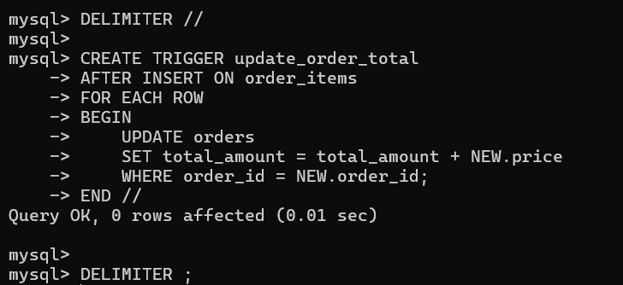

- Automatically set created_at timestamp.
Table:
CREATE TABLE users (
user_id INT PRIMARY KEY,
name VARCHAR(30),
created_at DATETIME
);
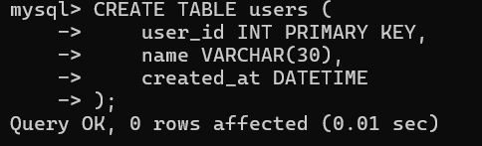

Trigger:
DELIMITER //

CREATE TRIGGER set_created_at
BEFORE INSERT ON users
FOR EACH ROW
BEGIN
SET NEW.created_at = NOW();
END //

DELIMITER ;
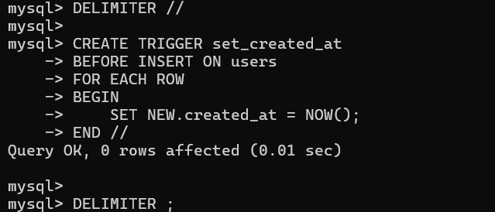

- Prevent negative salary entry by Stop inserting or updating an employee record if salary < 0.
Table:
CREATE TABLE employee (
emp_id INT PRIMARY KEY,
name VARCHAR(30),
salary INT
);
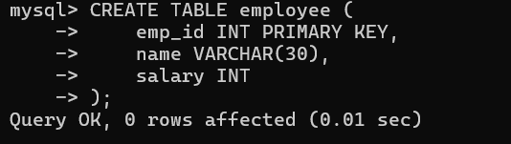

Trigger:
DELIMITER //

CREATE TRIGGER salary_check
BEFORE INSERT ON employee
FOR EACH ROW
BEGIN
IF NEW.salary < 0 THEN
SIGNAL SQLSTATE '45000'
SET MESSAGE_TEXT = 'Salary cannot be negative';
END IF;
END //

DELIMITER ;
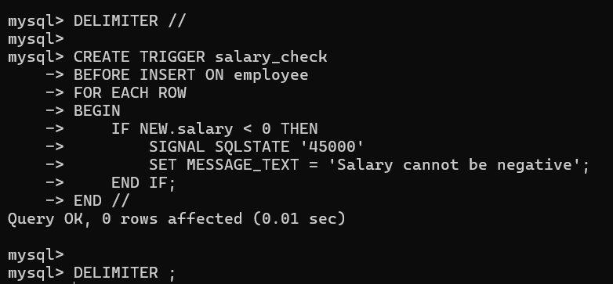

Same rule for UPDATE:
DELIMITER //

CREATE TRIGGER salary_update_check
BEFORE UPDATE ON employee
FOR EACH ROW
BEGIN
IF NEW.salary < 0 THEN
SIGNAL SQLSTATE '45000'
SET MESSAGE_TEXT = 'Salary cannot be negative';
END IF;
END //

DELIMITER ;
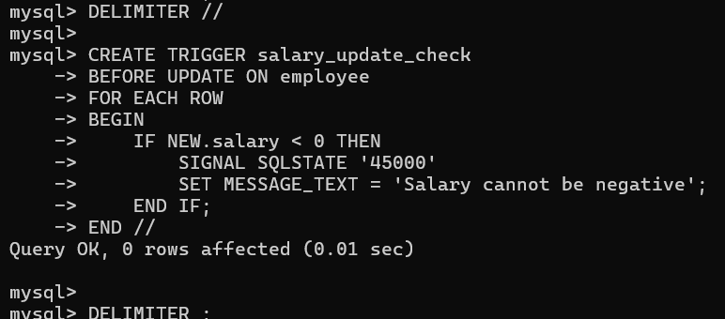

- Maintain audit log table: Whenever an employee record is updated, store old values in an employee_audit table.
Table:
CREATE TABLE employee_audit (
emp_id INT,
old_salary INT,
changed_at DATETIME
);
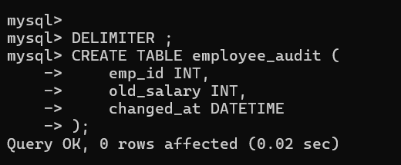

Trigger:
DELIMITER //

CREATE TRIGGER employee_audit_log
BEFORE UPDATE ON employee
FOR EACH ROW
BEGIN
INSERT INTO employee_audit
VALUES (OLD.emp_id, OLD.salary, NOW());
END //

DELIMITER ;
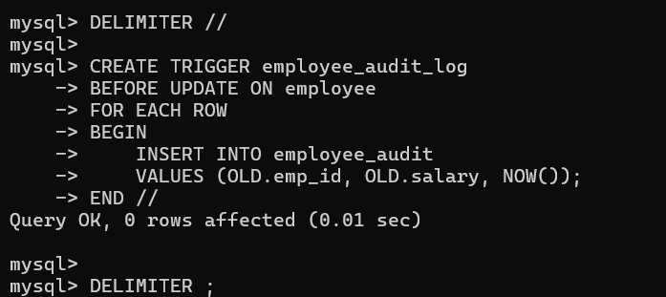
Working with Date:
- Find number of days between start_date and end_date.
SELECT DATEDIFF(end_date, start_date) AS no_of_days
FROM project;
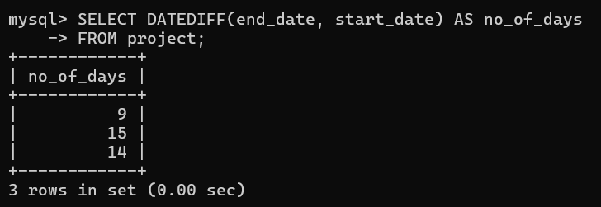

- Find the expiry date after 30 days.
SELECT DATE_ADD(start_date, INTERVAL 30 DAY) AS expiry_date
FROM subscription;
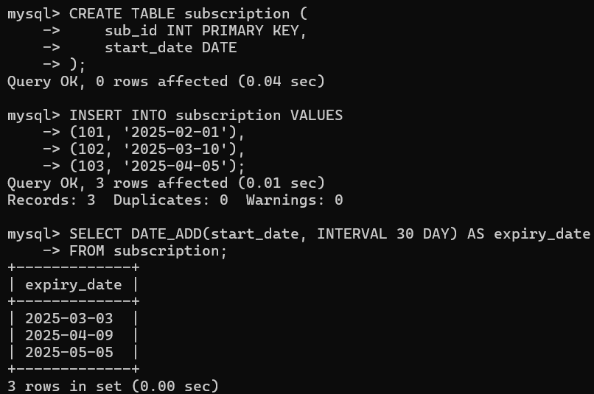

- Get Date before seven days from today.
SELECT DATE_SUB(CURDATE(), INTERVAL 7 DAY) AS date_before_7_days;
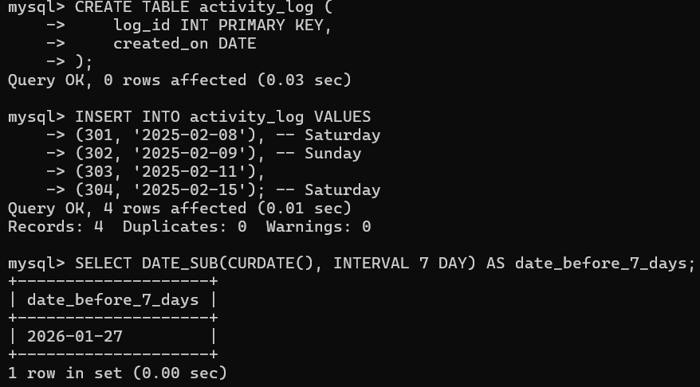
- Get the records created on weekend dates.
SELECT *
FROM activity_log
WHERE DAYOFWEEK(created_on) IN (1, 7);
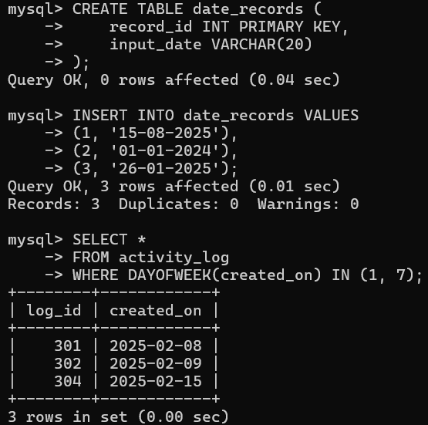

- Read input date as string then convert to date format ‘DD-MM-YYYY’ then display the month name from the date given.
SELECT record_id,
input_date,
MONTHNAME(
STR_TO_DATE(input_date, '%d-%m-%Y')
) AS month_name
FROM date_records;
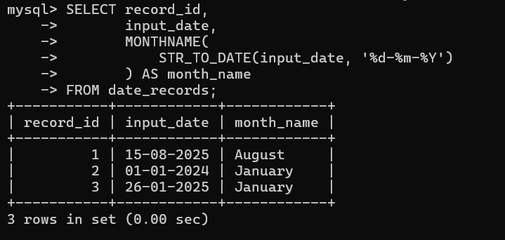

Indexes and Views:

- Improve search performance on email column using CREATE INDEX.
CREATE INDEX idx_email
ON users_account(email);
SELECT * FROM users_account WHERE email = 'arun@gmail.com';
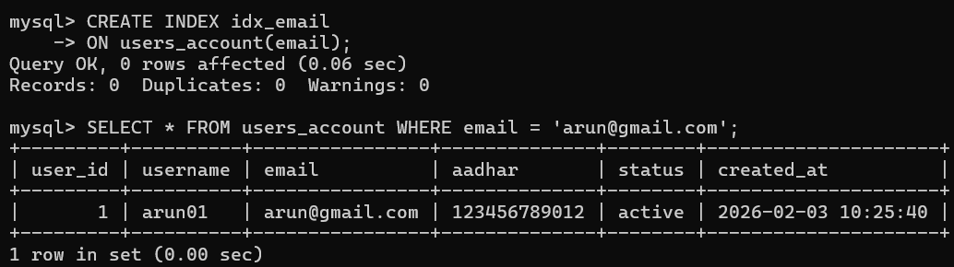

- Create UNIQUE INDEX to ensure no duplicate values in username.
CREATE UNIQUE INDEX idx_username_unique
ON users_account(username);
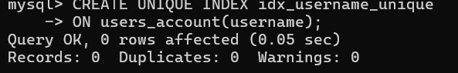

- Find and remove the unused index from the table using DROP INDEX.
View indexes:
SHOW INDEX FROM users_account;
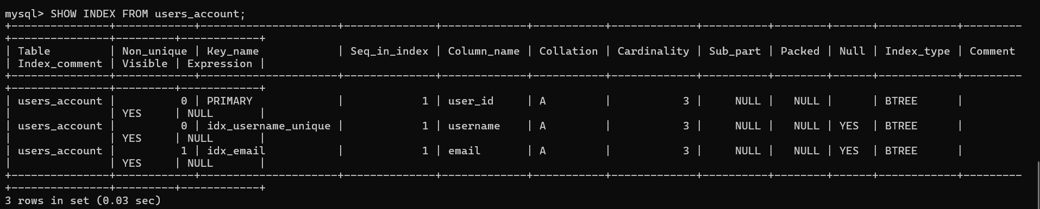

Drop unused index:
DROP INDEX idx_email ON users_account;
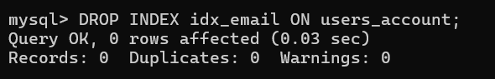

- A SELECT query using WHERE aadhar= ? is slow. Fix it using index.
CREATE INDEX idx_aadhar
ON users_account(aadhar);

SELECT * FROM users_account WHERE aadhar = '123456789012';
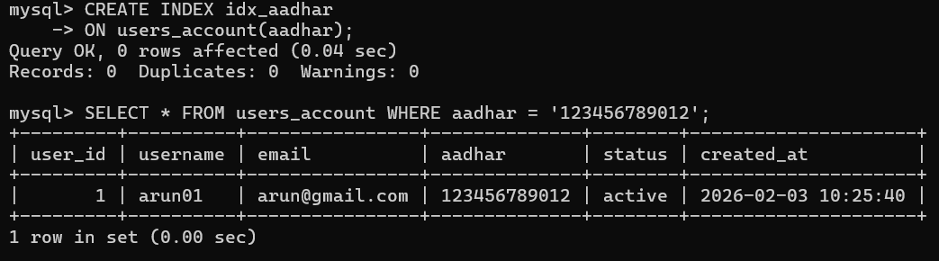

- Create a composite index: (status, created_at) to query filters by status and sorts by created_at.
CREATE INDEX idx_status_created
ON users_account(status, created_at);

SELECT *
FROM users_account
WHERE status = 'active'
ORDER BY created_at;
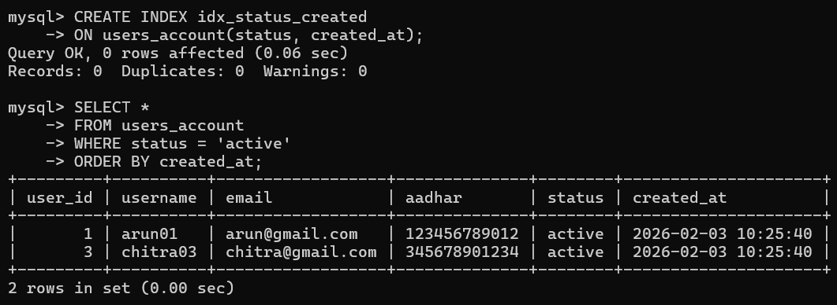

SQL BUILT-IN FUNCTIONS:

- Extract the letters before @ from the username and append 123 at the end to create a default password.
SELECT email,
CONCAT(
SUBSTRING_INDEX(email, '@', 1),
'123'
) AS default_password
FROM user_account;
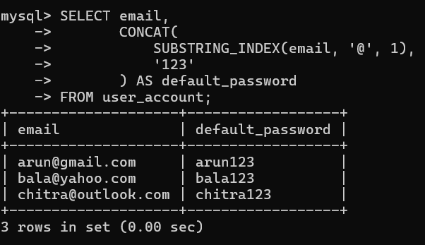

- Correct the invalid contact numbers which contains spaces, dashes or any other symbols. Keep only numbers to make the contact valid.
SELECT contact,
REGEXP_REPLACE(contact, '[^0-9]', '') AS valid_contact
FROM user_account;
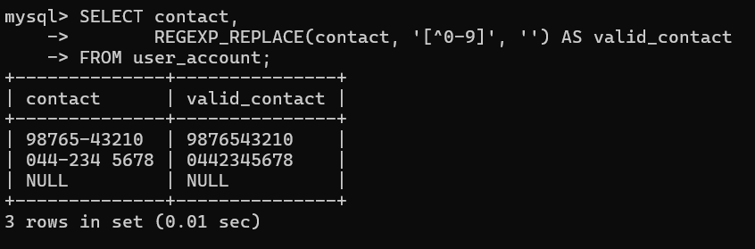

- Normalise the employee names given in mixed case using UPPER(), LOWER(), SUBSTRING(), CONCAT() functions.
SELECT emp_name,
CONCAT(
UPPER(SUBSTRING(emp_name,1,1)),
LOWER(SUBSTRING(emp_name,2))
) AS normalized_name
FROM employee_details;
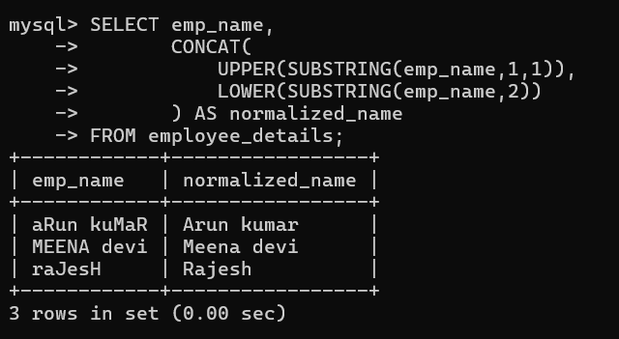

- Handle multiple fallback columns in the use table with the priority of contact details as Mobile→Phone→email.
SELECT username,
COALESCE(mobile, phone, email) AS preferred_contact
FROM user_account;
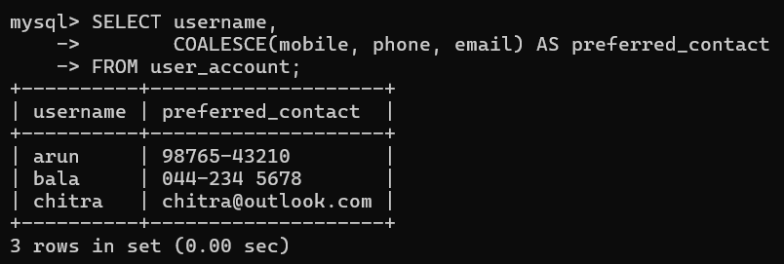

- Find average experience per department using the functions AVG(), TIMESTAMPDIFF(), GROUP BY.

SELECT department,
AVG(
TIMESTAMPDIFF(YEAR, join_date, CURDATE())
) AS avg_experience_years
FROM employee_details
GROUP BY department;
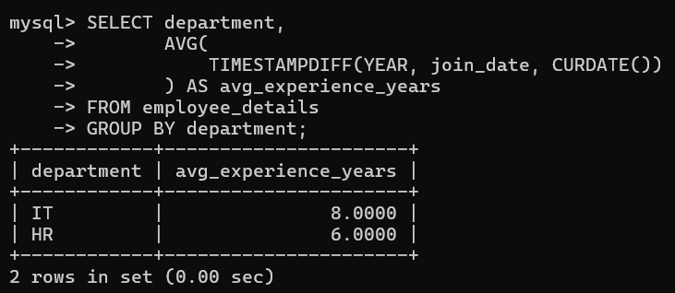

User-Defined Functions:

- Create a function to calculate net salary after 10% tax deduction.
DELIMITER //
CREATE FUNCTION net_salary(salary DECIMAL(10,2))
RETURNS DECIMAL(10,2)
DETERMINISTIC
BEGIN
RETURN salary - (salary * 0.10);
END //
DELIMITER ;

SELECT emp_id, salary, net_salary(salary) AS net_salary
FROM emp_salary;
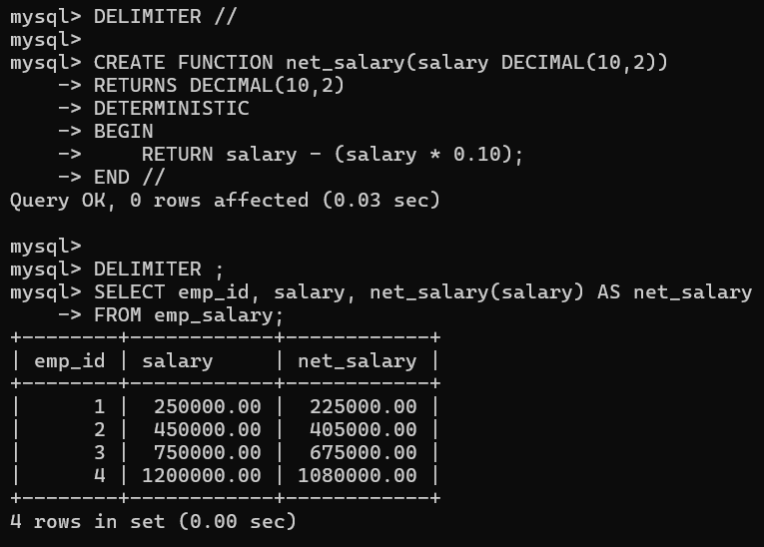
- Create a function to check activity of the user. Return Active if last login within 30 days, else Inactive.
DELIMITER //

CREATE FUNCTION user_status(last_login DATE)
RETURNS VARCHAR(20)
DETERMINISTIC
BEGIN
IF DATEDIFF(CURDATE(), last_login) <= 30 THEN
RETURN 'Active';
ELSE
RETURN 'Inactive';
END IF;
END //

DELIMITER ;

SELECT user_id, user_status(last_login) AS status
FROM user_activity;
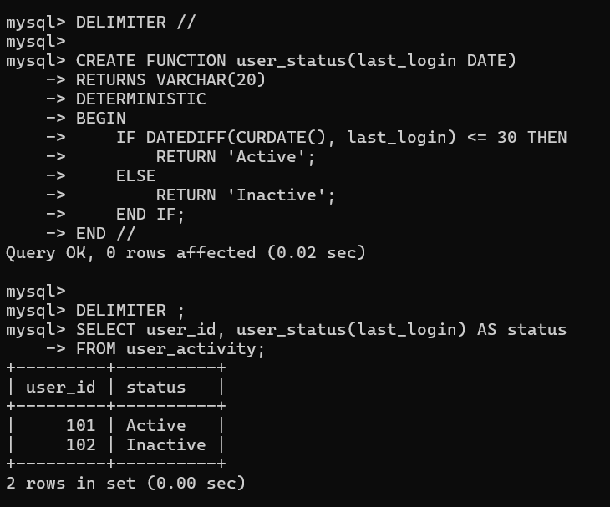

- Create a function to perform dynamic tax slab calculation based on the following categories:
DELIMITER //

CREATE FUNCTION calculate_tax(salary DECIMAL(10,2))
RETURNS DECIMAL(10,2)
DETERMINISTIC
BEGIN
IF salary <= 300000 THEN
RETURN 0;
ELSEIF salary <= 600000 THEN
RETURN salary * 0.10;
ELSEIF salary <= 1000000 THEN
RETURN salary * 0.20;
ELSE
RETURN salary * 0.30;
END IF;
END //

DELIMITER ;

SELECT emp_id, salary, calculate_tax(salary) AS tax_amount
FROM emp_salary;
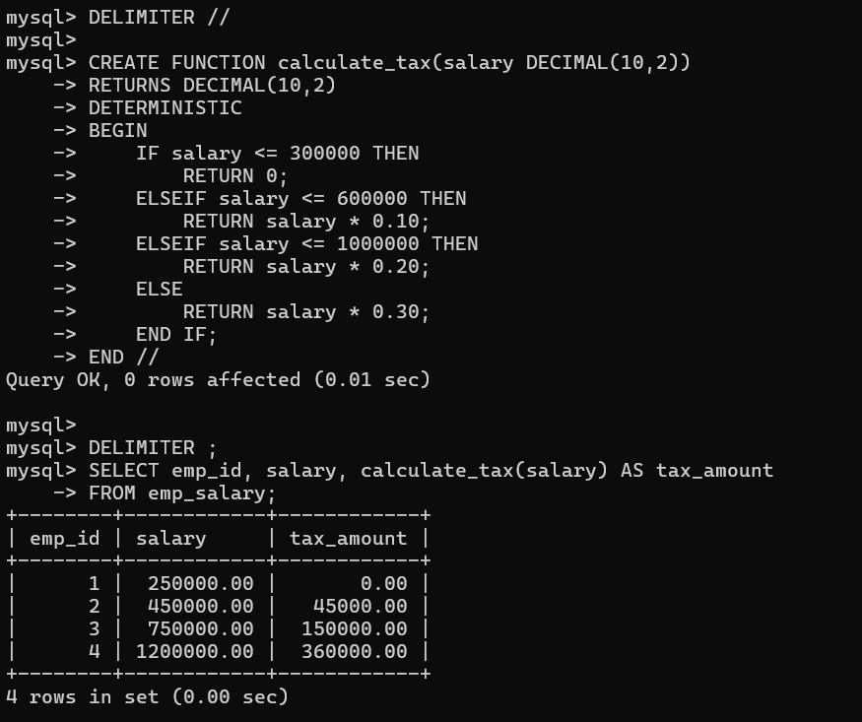
- Create a function to categorize the employees based on the years of experience:
DELIMITER //

CREATE FUNCTION experience_category(join_date DATE)
RETURNS VARCHAR(20)
DETERMINISTIC
BEGIN
DECLARE years INT;
SET years = TIMESTAMPDIFF(YEAR, join_date, CURDATE());

IF years < 2 THEN
RETURN 'Fresher';
ELSEIF years BETWEEN 2 AND 5 THEN
RETURN 'Junior';
ELSEIF years BETWEEN 6 AND 10 THEN
RETURN 'Mid';
ELSE
RETURN 'Senior';
END IF;
END //

DELIMITER ;

SELECT emp_id, experience_category(join_date) AS category
FROM emp_salary;
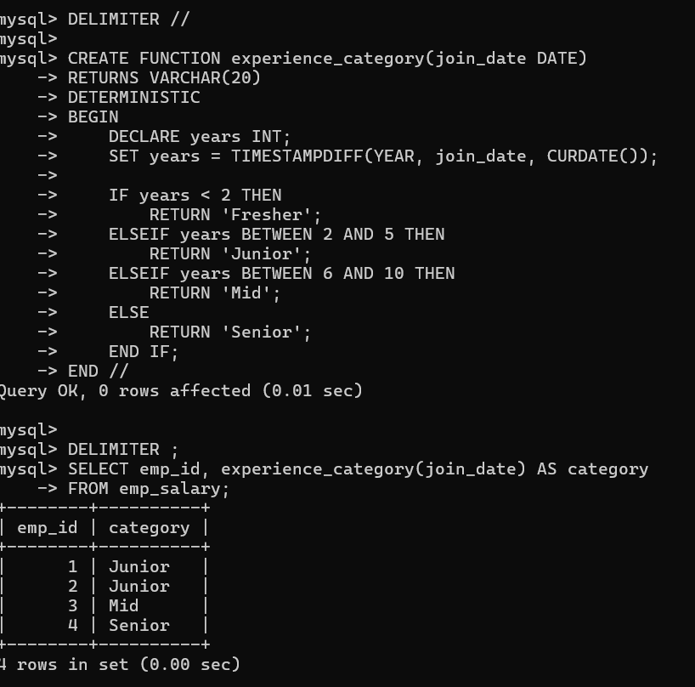
- Create a late fee calculator using function where late fee of ₹50/day is applicable after due date limited to as maximum amount of ₹1000.

DELIMITER //

CREATE FUNCTION calculate_late_fee(due DATE, returned DATE)
RETURNS INT
DETERMINISTIC
BEGIN
DECLARE days INT;
DECLARE fee INT;

IF returned <= due THEN
RETURN 0;
END IF;

SET days = DATEDIFF(returned, due);
SET fee = days * 50;

IF fee > 1000 THEN
SET fee = 1000;
END IF;

RETURN fee;
END //

DELIMITER ;

SELECT record_id,
calculate_late_fee(due_date, return_date) AS late_fee
FROM fee_details;

