Aim:
To find the minimum number of adjacent swaps required to make k ones appear consecutively in a given binary array.
Algorithm:
1 Read the array nums and integer k
2 Store the indices of all elements equal to one in a list
3 If k equals one then return zero because one element is already consecutive
4 Use a sliding window of size k on the list of one indices
5 For each window compute the median index position
6 Calculate the total number of swaps required to bring all ones in that window together around the median
7 Adjust the cost by subtracting the natural positions offset for consecutive placement
8 Keep track of the minimum cost over all windows
9 Output the minimum value
Procedure:
1 Start the program
2 Input the binary array nums and integer k
3 Create a list to store the positions of all ones
4 Slide a window of size k across this list
5 For each group of k ones determine the middle position
6 Compute how many adjacent swaps are needed to move those ones into consecutive locations
7 Compare with the previously stored minimum and update if smaller
8 Display the minimum number of swaps
9 Stop the program
Program:
public class Solution {
public boolean halvesAreAlike(String s) {
Set<Character> vowels = new HashSet<>();
vowels.add('a'); vowels.add('e'); vowels.add('i'); vowels.add('o'); vowels.add('u');
vowels.add('A'); vowels.add('E'); vowels.add('I'); vowels.add('O'); vowels.add('U');

int length = s.length();
int midPoint = length / 2;

String firstHalf = s.substring(0, midPoint);
String secondHalf = s.substring(midPoint);

return countVowels(firstHalf, vowels) == countVowels(secondHalf, vowels);
}

private int countVowels(String str, Set<Character> vowels) {
int count = 0;
for (char c : str.toCharArray()) {
if (vowels.contains(c)) {
count++;
}
}
return count;
}
}

Output:
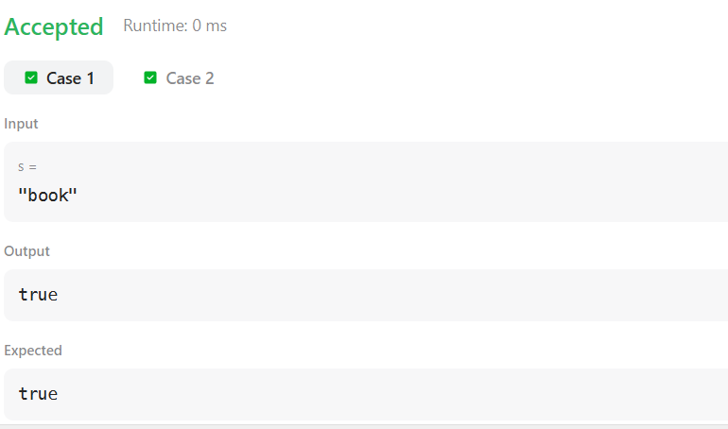

Result:
The program successfully calculates the minimum number of adjacent swaps required to make k ones consecutive in the array and outputs the smallest possible value for the given input.

Aim:
To write a program that checks whether a given string is a Lapindrome that is a string whose two halves contain the same characters with the same frequency after ignoring the middle character when the length is odd.
Algorithm:
1 Read the integer T which represents the number of test cases
2 For each test case read the string S
3 Find the length N of the string
4 If N is even then take the first N by 2 characters as the left half and the remaining characters as the right half
5 If N is odd then take the first N by 2 characters as the left half ignore the middle character and take the remaining characters as the right half
6 Convert both halves into character arrays
7 Sort both arrays
8 Compare the two sorted arrays
9 If they are equal print YES otherwise print NO
Procedure:
1 Start the program
2 Accept the input value T
3 For each test case input the string
4 Compute the length of the string
5 Divide the string into two halves based on whether the length is even or odd
6 Sort both halves
7 Compare the two halves
8 Display the result
9 Stop the program
Program:
import java.util.*;

class Main {
public static void main(String[] args) {
Scanner sc = new Scanner(System.in);

int T = sc.nextInt();

while (T-- > 0) {
String s = sc.next();
int n = s.length();

String left, right;

// Split into halves
if (n % 2 == 0) {
left = s.substring(0, n / 2);
right = s.substring(n / 2);
} else {
left = s.substring(0, n / 2);
right = s.substring(n / 2 + 1);
}

char[] a = left.toCharArray();
char[] b = right.toCharArray();

Arrays.sort(a);
Arrays.sort(b);

if (Arrays.equals(a, b)) {
System.out.println("YES");
} else {
System.out.println("NO");
}
}

sc.close();
}
}
0utput:
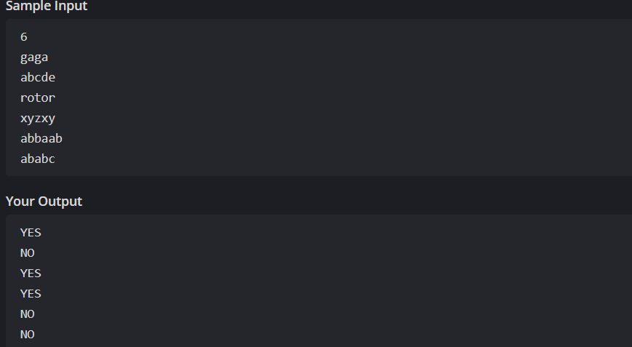

Result:
The program correctly identifies whether the given string is a Lapindrome. If both halves contain the same characters with the same frequency it prints YES otherwise it prints NO.

