Aim
To compare two triplets of integers representing scores of Alice and Bob and determine their respective points based on individual comparisons of corresponding elements.
Algorithm
- Start.
- Input three integers into list a (Alice’s triplet).
- Input three integers into list b (Bob’s triplet).
- Initialize two variables alice = 0 and bob = 0.
- Repeat steps 6–8 for i = 0 to 2.
- If a[i] > b[i], increment alice by 1.
- Else if a[i] < b[i], increment bob by 1.
- Else, no change in scores.
- Store alice and bob in a result list.
- Display the result.
- Stop.

Procedure
- Start the program.
- Import the required Java packages.
- Read the first line of input and store the three integers in a list representing Alice’s scores.
- Read the second line of input and store the three integers in a list representing Bob’s scores.
- Initialize two integer variables to store Alice’s score and Bob’s score.
- Compare the corresponding elements of both lists one by one using a loop.
- Increment Alice’s score if her value is greater than Bob’s value.
- Increment Bob’s score if his value is greater than Alice’s value.
- Ignore the comparison if both values are equal.
- Store the final scores of Alice and Bob in a list.
- Display the result.
- Stop the program.
Program:
import java.io.*;
import java.math.*;
import java.security.*;
import java.text.*;
import java.util.*;
import java.util.concurrent.*;
import java.util.function.*;
import java.util.regex.*;
import java.util.stream.*;
import static java.util.stream.Collectors.joining;
import static java.util.stream.Collectors.toList;

class Result {

/*
* Complete the 'compareTriplets' function below.
*
* The function is expected to return an INTEGER_ARRAY.
* The function accepts following parameters:
* 1. INTEGER_ARRAY a
* 2. INTEGER_ARRAY b
*/

public static List<Integer> compareTriplets(List<Integer> a, List<Integer> b) {
int alice = 0;
int bob = 0;

for (int i = 0; i < 3; i++) {
if (a.get(i) > b.get(i)) {
alice++;
} else if (a.get(i) < b.get(i)) {
bob++;
}
}

return Arrays.asList(alice, bob);

}

}

public class Solution {
public static void main(String[] args) throws IOException {
BufferedReader bufferedReader = new BufferedReader(new InputStreamReader(System.in));
BufferedWriter bufferedWriter = new BufferedWriter(new FileWriter(System.getenv("OUTPUT_PATH")));

List<Integer> a = Stream.of(bufferedReader.readLine().replaceAll("\\s+$", "").split(" "))
.map(Integer::parseInt)
.collect(toList());

List<Integer> b = Stream.of(bufferedReader.readLine().replaceAll("\\s+$", "").split(" "))
.map(Integer::parseInt)
.collect(toList());

List<Integer> result = Result.compareTriplets(a, b);

bufferedWriter.write(
result.stream()
.map(Object::toString)
.collect(joining(" "))
+ "\n"
);

bufferedReader.close();
bufferedWriter.close();
}
}

Output:
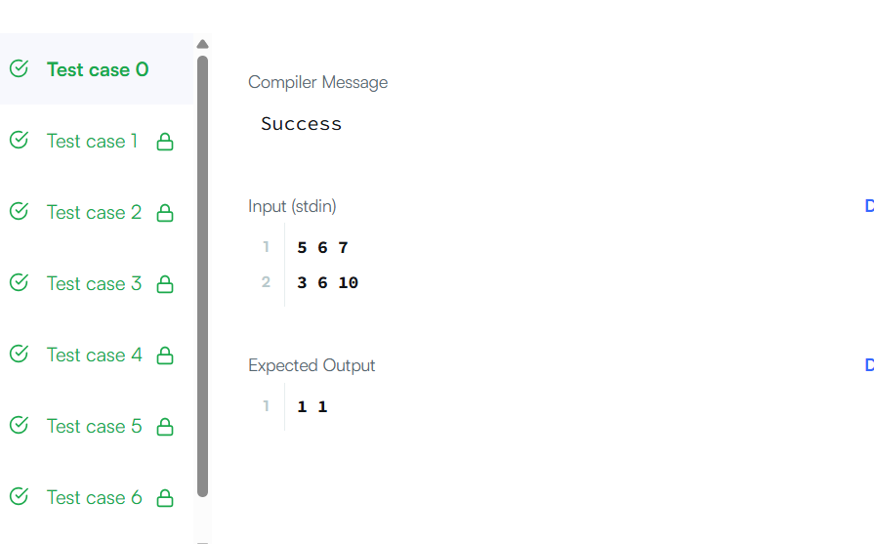

Result:
The program successfully compares the given triplets and outputs two integers: the first representing Alice’s total score and the second representing Bob’s total score, based on the comparison rules.
Aim
To check whether the given array of integers contains any duplicate elements.

Algorithm
- Start.
- Read the array of integers.
- Sort the array in ascending order.
- Traverse the array from the first element to the second last element.
- Compare each element with its next element.
- If any two adjacent elements are equal, return true.
- If no duplicates are found after completing the traversal, return false.
- Stop.

Procedure
- Start the program.
- Accept the integer array as input.
- Use the Arrays.sort() method to sort the array.
- Initialize a loop to iterate through the array elements.
- Compare the current element with the next element.
- If both elements are equal, conclude that a duplicate exists.
- Return true if a duplicate is found.
- If the loop completes without finding duplicates, return false.
- End the program.
Program:
class Solution {
public boolean containsDuplicate(int[] nums) {
Arrays.sort(nums);
for (int i = 0; i < nums.length - 1; i++) {
if (nums[i] == nums[i+1]) {
return true;
}
}
return false;
}
}
Output
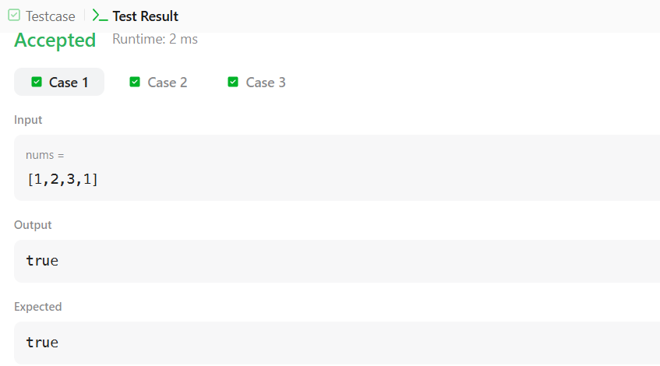

Result
The program successfully checks whether the given array contains duplicate elements. It returns true if duplicates are present and false if all elements are unique.

