**Date:03.09.25**

**TASK:6**

**Solve a Map Coloring problem using constraint satisfaction approach by**

**applying following constraints**

Solve a Map Coloring problem using constraint satisfaction approach by applying following constraints

•Assign each territory a color such that no two adjacent territories have the same color by considering following parameters: Domains, Variables and Constraints

•Apply Basic Greedy Coloring Algorithm: Color first vertex with first color, do following for remaining V-1 vertices.

•Consider the currently picked vertex and color it with the lowest numbered color that has not been used on any previously colored vertices adjacent to it. If all previously used colors appear on vertices adjacent to v, assign a new color to it.

**Tools- Python, Online Simulator -** [**https://graphonline.ru/en/**](https://graphonline.ru/en/)

**PROBLEM STATEMENT: CO3 S3**

In a university, four departments are located in adjacent buildings within the same campus. For the upcoming cultural festival, each department wants to decorate its building with a distinct theme color representing its identity. However, to maintain visual appeal and avoid confusion, no two neighboring departments are allowed to use the same color. The adjacency between the buildings is as follows: Department A is next to B, C, and D; Department B is next to A and C; Department C is next to A, B, and D; and Department D is next to A and C. The goal is to assign at most three available theme colors to the four departments in such a way that neighboring buildings always have different colors, and to check if such an arrangement is possible.

**MAP COLORING PROBLEM USING CONSTRAINT SATISFACTION**

**AIM**

Toimplement a graph coloring algorithm that assigns colors to university departments in such a way that no two neighboring nodes share the same color, using Python

**ALGORITHM**

**1:** Start the program.

**2:** Represent the departments/districts as a **graph**, where nodes represent departments and edges represent adjacency (neighbors).

**3:** Define the set of available **colors** (e.g., Red, Green, Blue).

**4:** Initialize an empty **assignment** to keep track of the color chosen for each department.

**5:** Create a function is_safe(dept, color) that checks whether assigning a particular color to a department is valid (i.e., no neighbor has the same color).

**6:** Create a recursive function assign_colors(departments, index) that tries to assign colors to each department.

**7:** If all departments are assigned a valid color (index == total departments), return success.

**8:** For the current department, try each available color:

* If safe, assign it temporarily and move to the next department.
* If not safe, try the next color.

**9:** If no color can be assigned, backtrack by removing the assignment and return failure.

**10:** After recursion finishes, print the assigned colors if successful, else print that no valid coloring is possible.

**PROGRAM**

**University Departments Decoration**

# Departments adjacency (Graph as dictionary)

graph = {

"A": ["B", "C", "D"],

"B": ["A", "C"],

"C": ["A", "B", "D"],

"D": ["A", "C"]

}

# Available theme colors

colors = ["Red", "Green", "Blue"]

# Store final assignment

assignment = {}

# Check if assigning a color is safe

def is_safe(dept, color):

for neighbor in graph[dept]:

if neighbor in assignment and assignment[neighbor] == color:

return False

return True

# Backtracking function

def assign_colors(departments, index=0):

if index == len(departments):

return True

dept = departments[index]

for color in colors:

if is_safe(dept, color):

assignment[dept] = color

if assign_colors(departments, index + 1):

return True

assignment.pop(dept) # backtrack

return False

# Main

departments = list(graph.keys())

if assign_colors(departments):

print("✅ Valid theme coloring found:")

for dept, color in assignment.items():

print(f"Department {dept} → {color}")

else:

print("❌ No valid coloring possible.")

**OUTPUT**

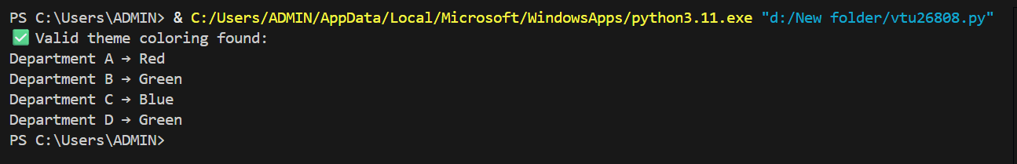

**RESULT**

Thus, the implementation a graph coloring algorithm that assigns colors to university departments in such a way that no two neighboring nodes share the same color, using Python was successfully executed and output was verified.