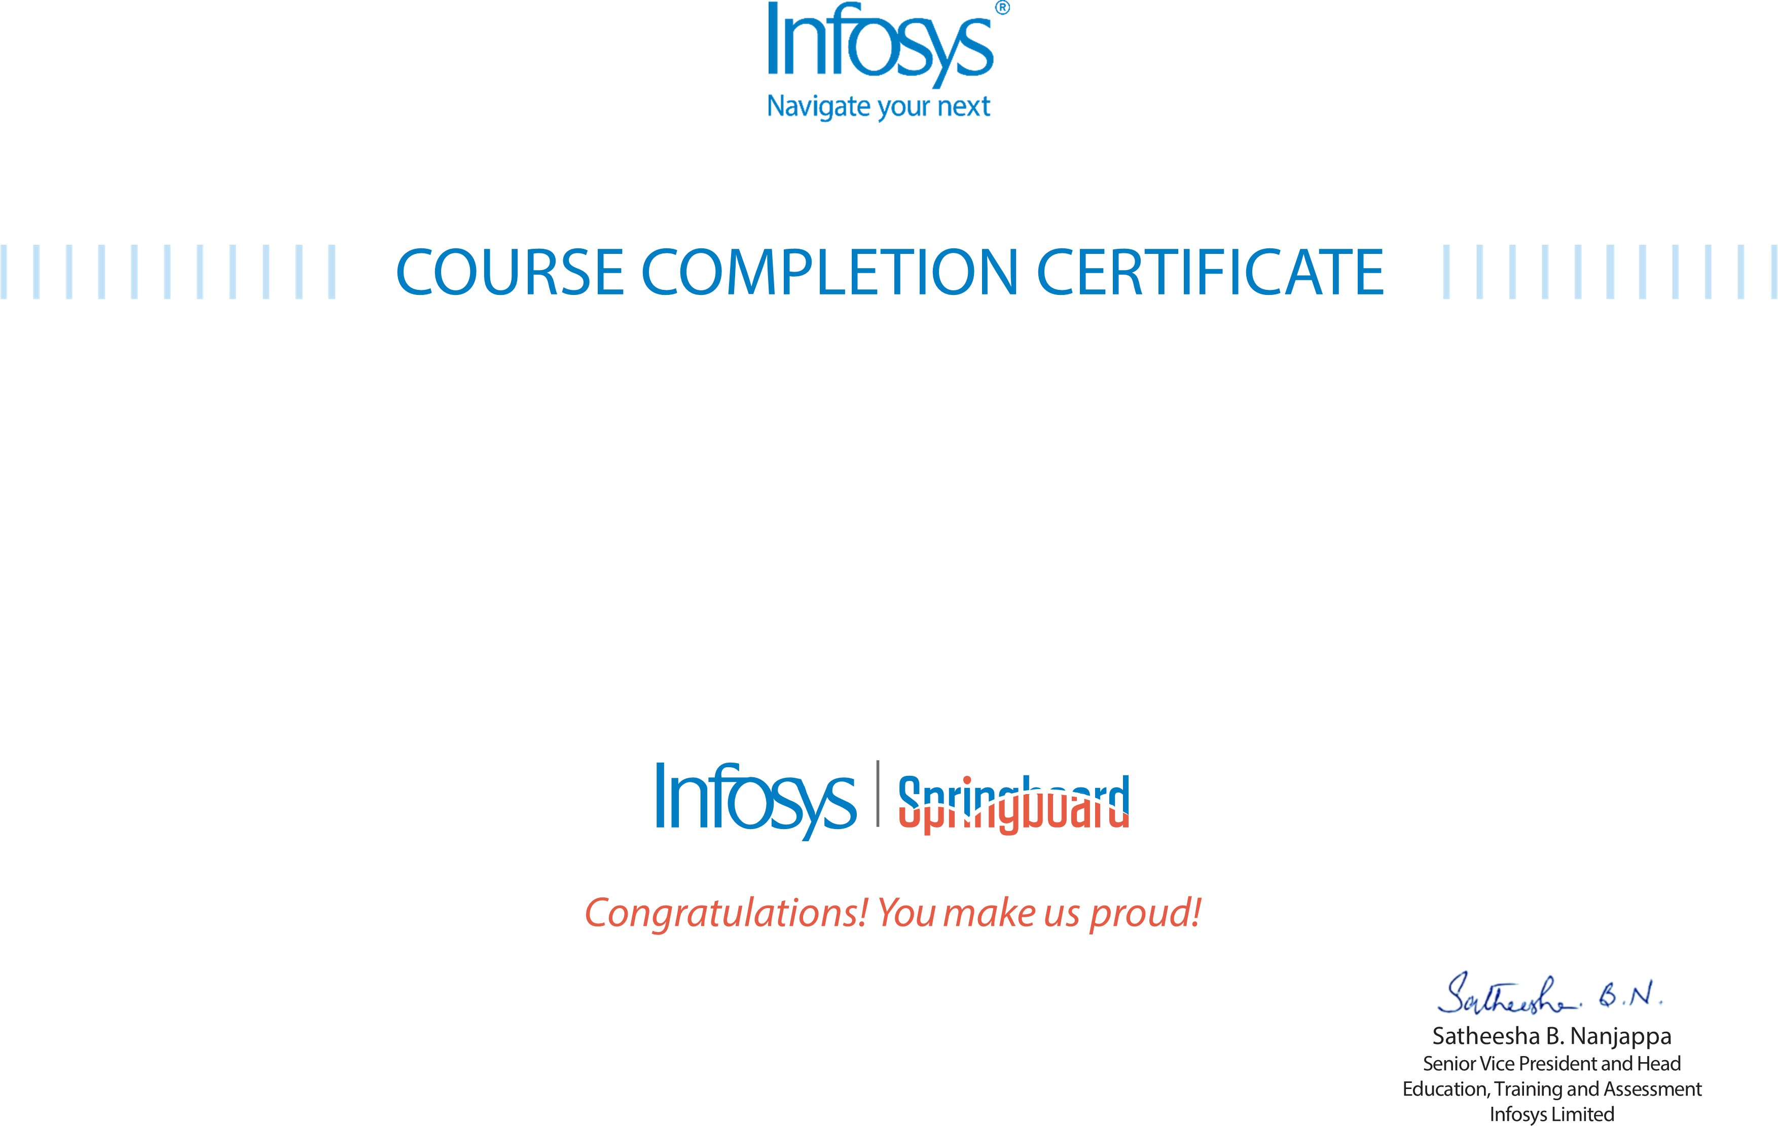
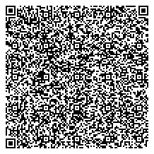

The certificate is awarded to

Grandhisila Sai Manikanta

for successfully completing the course
NodeJS Case Study - Movie App on Node JS and MongoDB on April 9, 2026

Issued on: Saturday, April 18, 2026
To verify, scan the QR code at https://verify .onwingspan.com

