Task No: 2  Date:10/10/25 | To configure, monitor, and administer a Data warehouse and perform basic Query operations on the DW.  Tools: SQL Server Management Studio (SSMS), Microsoft Azure SQL Pool

TASK 2a
AIM
Create a new database in SQL Server and execute the script to configure and load the sample database.
PROCEDURE:
Connect to the SQL Server by choosing the server name, enter the user and password and click the Connect button.
Right-click the Databases node in the Object Explorer and select the New Database… menu item
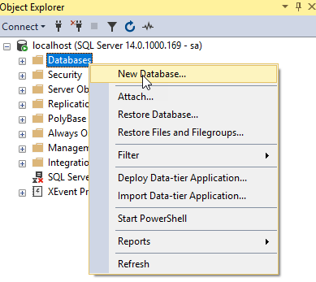
Enter the Database name as BikeStores and click the OK button to create the new database.
From the File menu, choose Open > File… menu item to open a script file.
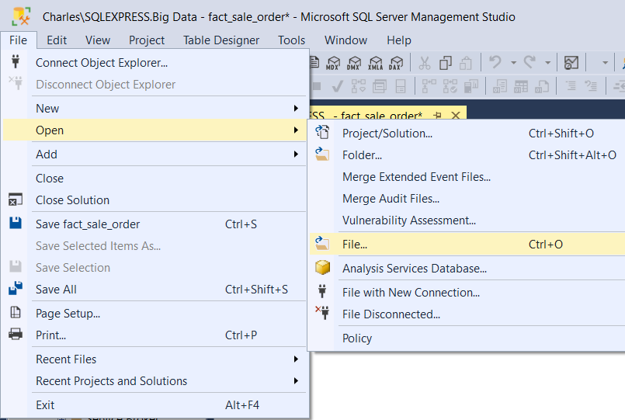
Select the BikeStores Sample Database – create objects.sql file and click the Open button

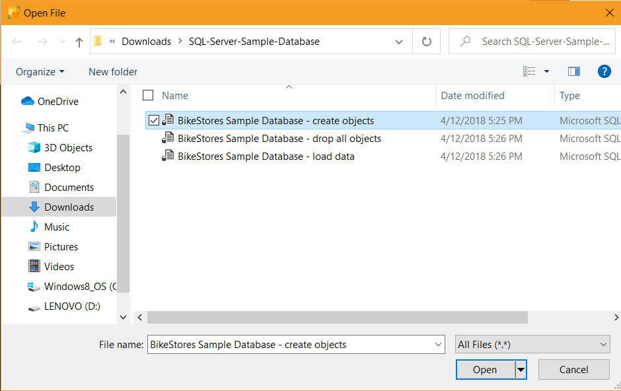

Click the Execute button to execute the SQL script
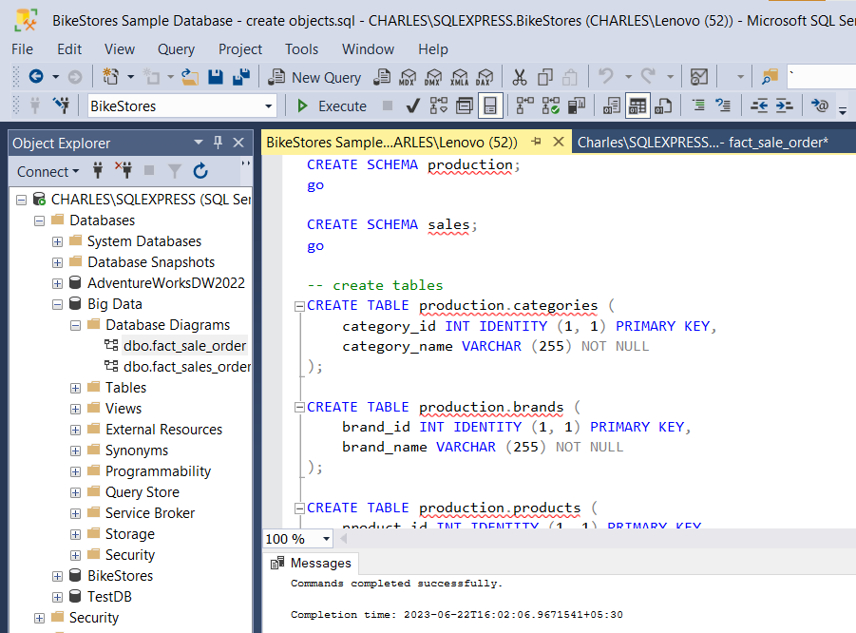

Choose the BikeStores Sample Database – load data.sql file and click the Open button.
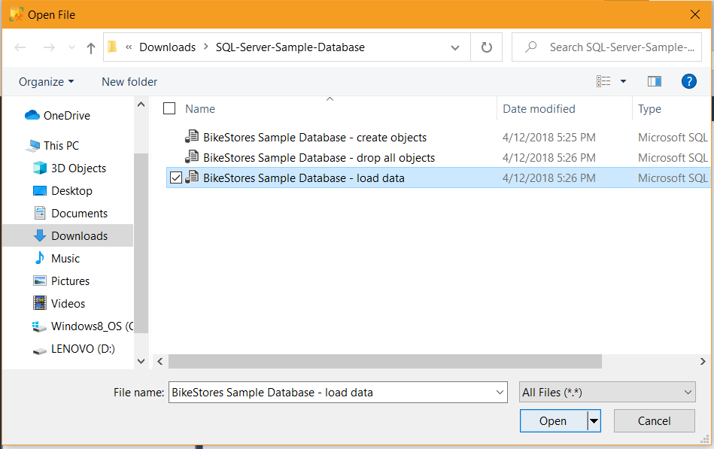
Click the Execute button to load data into the tables.
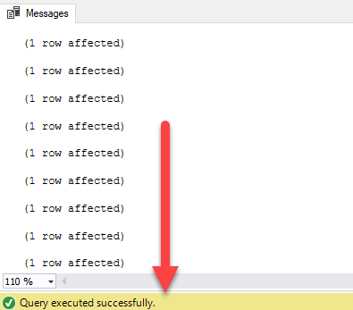
Execute query to display the values from production.products table.

QUERY OPERATIONS ON THE DATA WAREHOUSE
UNION OPERATION
SELECT first_name, last_name FROM sales.staffs UNION
SELECT first_name, last_name FROM sales.customers;
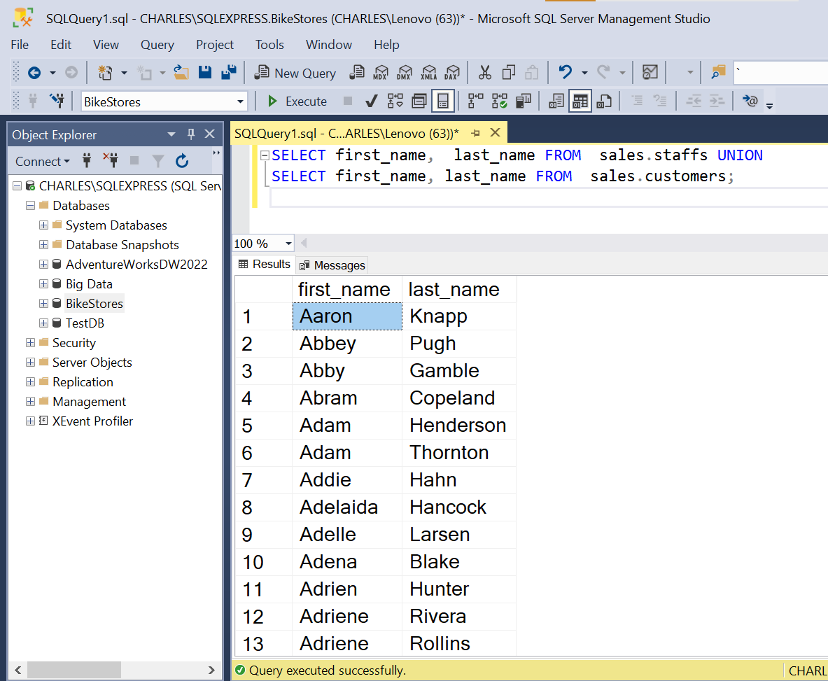
UNION ALL OPERATION
SELECT first_name, last_name FROM sales.staffs UNION ALL
SELECT first_name, last_name FROM sales.customers;
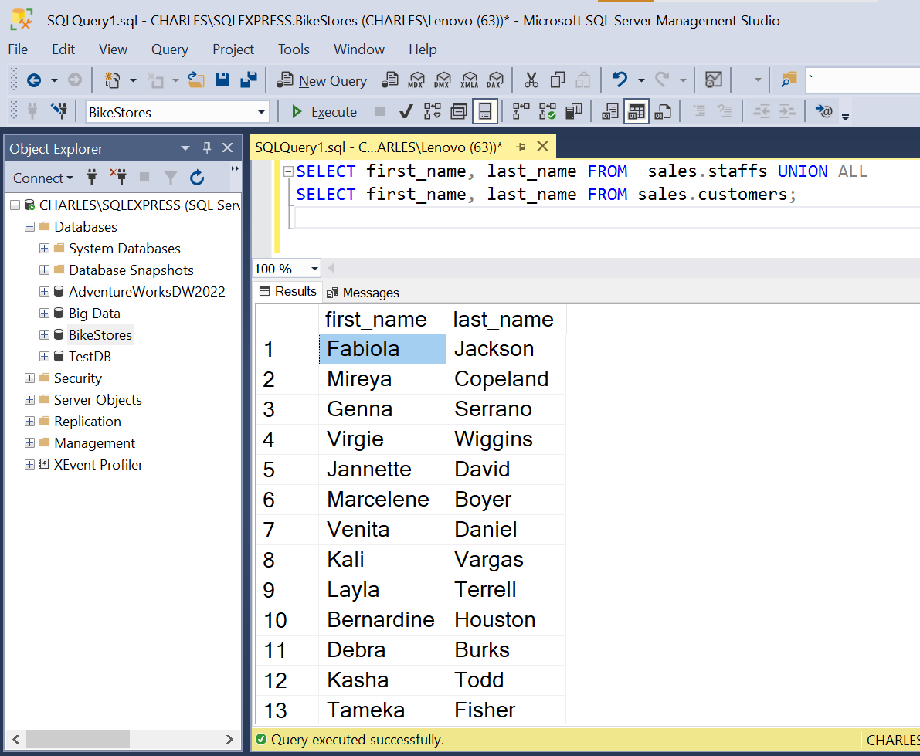
INTERSECT OPERATION
SELECT city FROM sales.customers INTERSECT
SELECT city FROM sales.stores ORDER BY city;
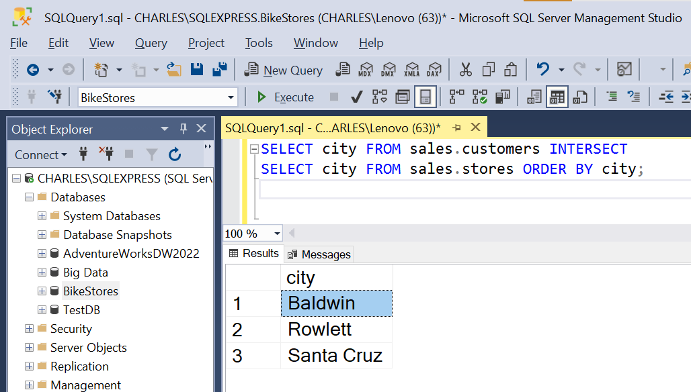

JOIN OPERATION
INNER JOIN
SELECT
product_name,
list_price,
category_id
FROM
production.products
ORDER BY
product_name DESC;

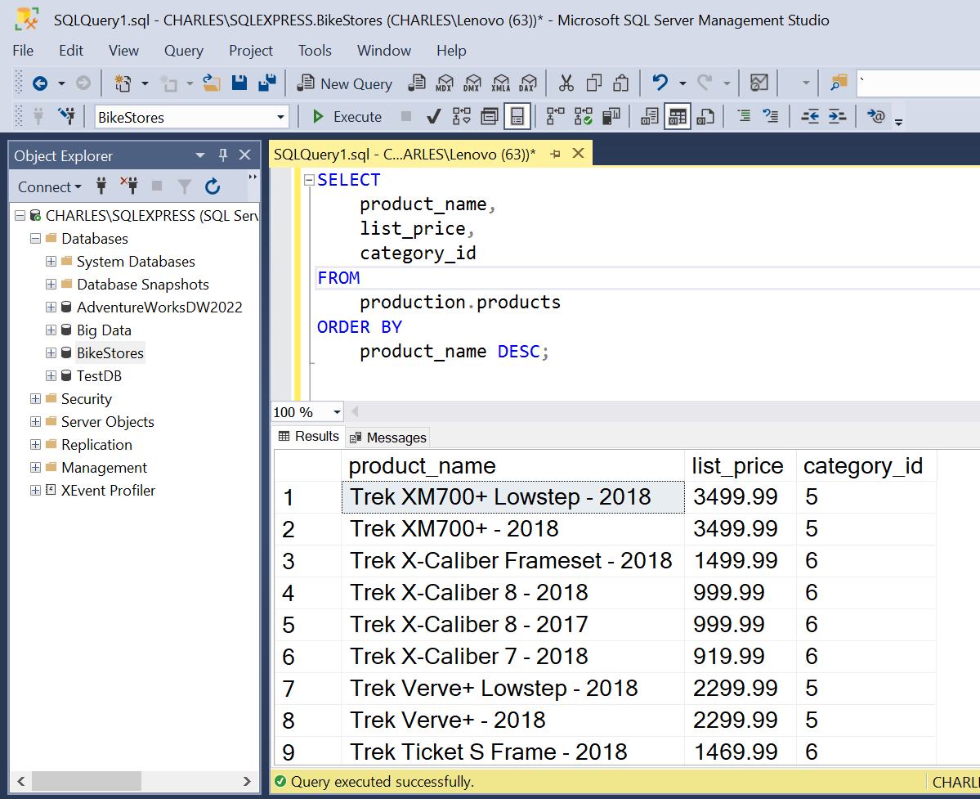

LEFT JOIN

SELECT
product_name,
order_id
FROM
production.products p
LEFT JOIN sales.order_items o ON o.product_id = p.product_id
ORDER BY
order_id;
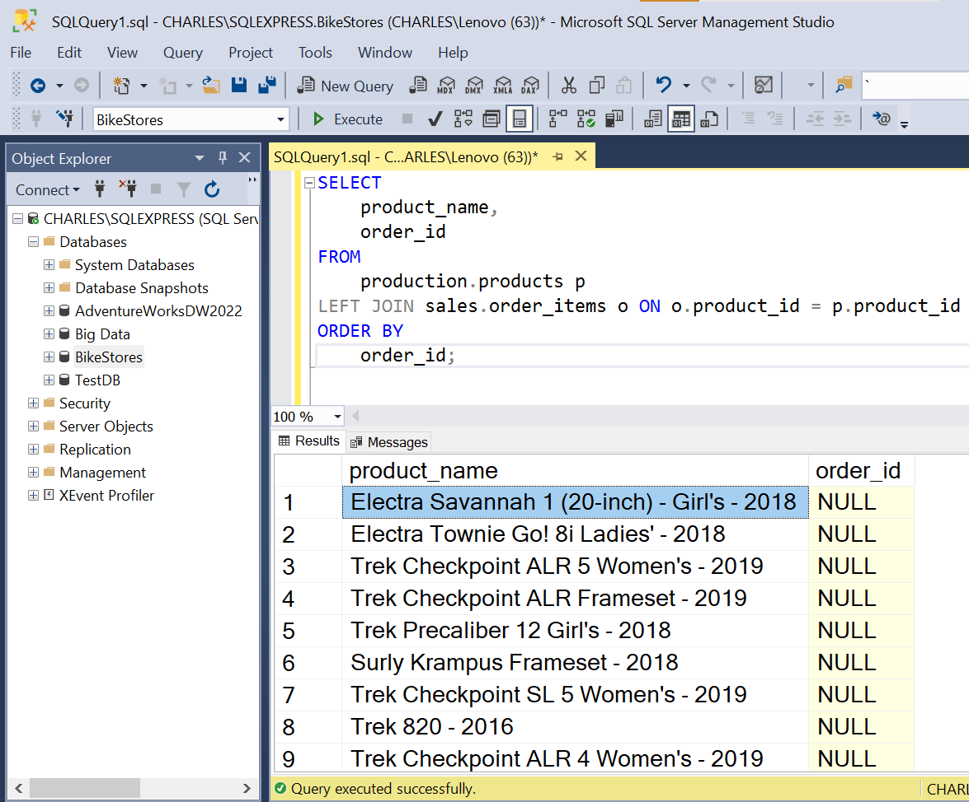

RESULT:

Thus the basic SQL operation was executed using MS Server Management Studio and SQL Server.

TASK 2b:
AIM
To configure, monitor, and administer a Data warehouse
PROCEDURE
- Install Microsoft SQL server Management Studio
- Install MS Sql Server Developer Edition
- Connect to the SQL Server
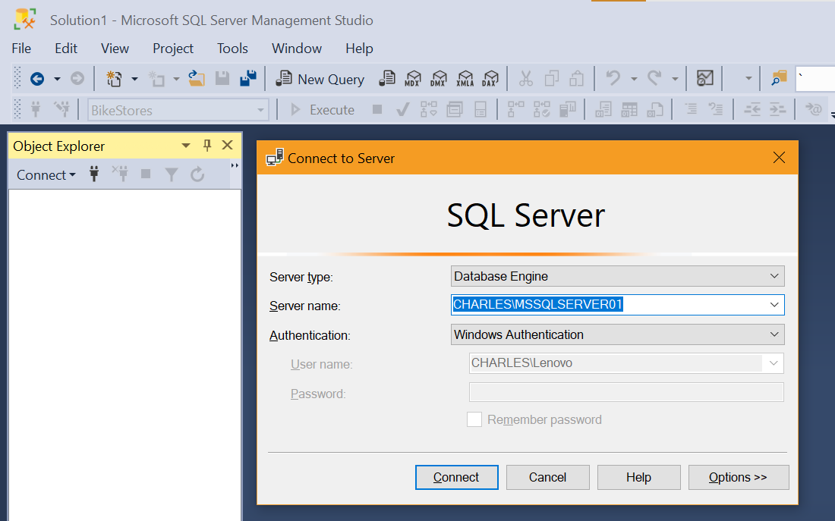
- Choose Management -> Data Collection in the left side navigation bar
- Right click on the Data collection - > Tasks -> Configure Management Data Warehouse and Configure the data warehouse settings
- Select Server Name and Database name and click next button
- Change the settings in map login and users
  - User mapped to this login
  - Database membership for BikeStores
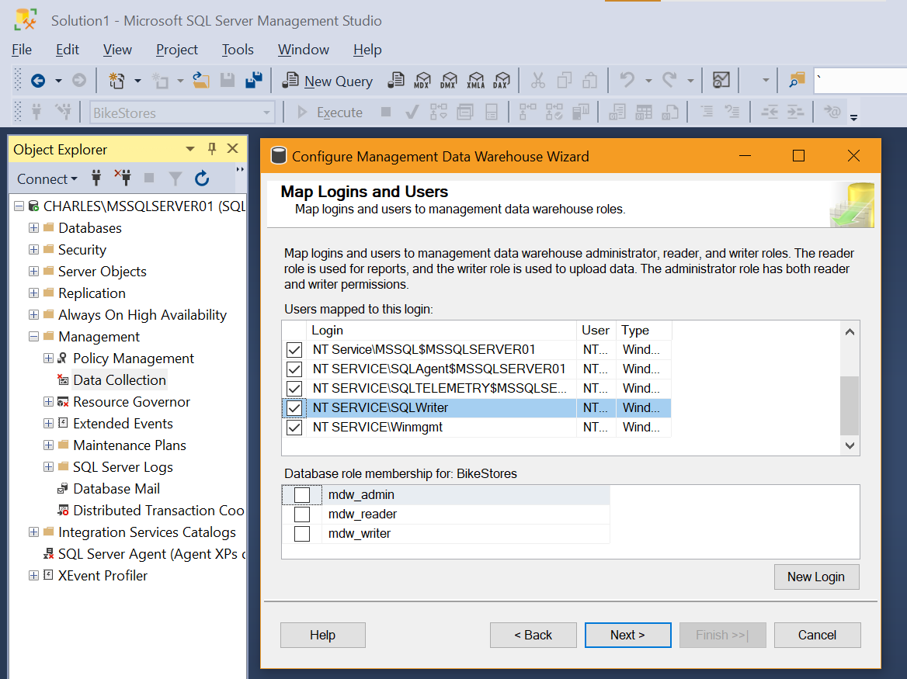

- Check the Settings and Click finish button
- Moniter and generate the various reports for the BikeStores, Right click the Bikestores-> Reports -> Standard Reports and select the reports needed.
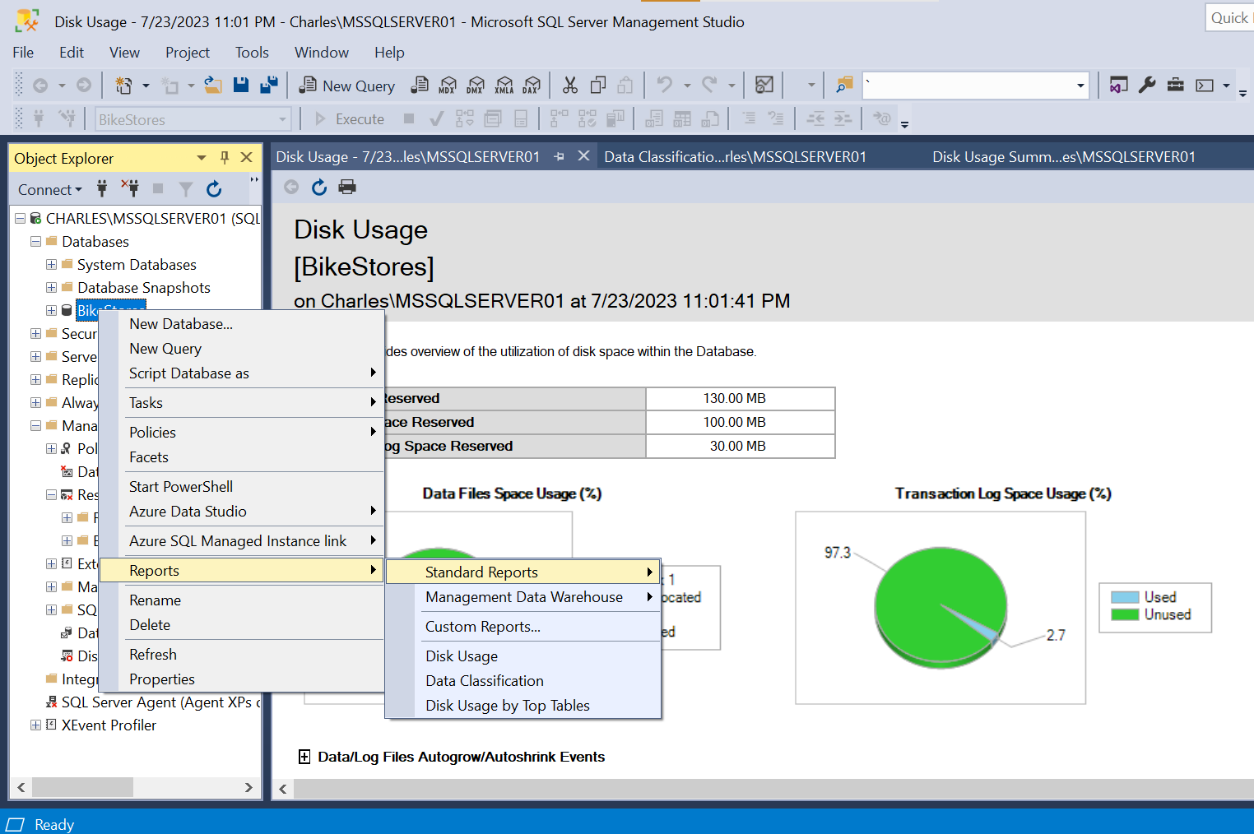

Result :
Thus a Data warehouse was configured, monitored, and administered using MS Server Management and SQL Server was completed successfully.

