Task No: 4  Date:13/10/25 | Implement matrix multiplication with Map Reduce

Task 4.1 VMWare AND Apache Hadoop
To Install VMWare AND Apache Hadoop, follow the steps
STEP 1. First of all, enter to the official site of VMware and download VMware Workstation https://www.vmware.com/tryvmware/?p=workstation-w
STEP 2. After downloading VMware workstation, install it on your PC
Step3: Installing Java 8 version.
Openjdk version "1.8.0_91"
OpenJDK Runtime Environment (build 1.8.0_91-8u91-b14-3ubuntu1~16.04.1-b14)
OpenJDK 64-Bit Server VM (build 25.91-b14, mixed mode)
This output verifies that OpenJDK has been successfully installed.
Note: To set the path for environment variables. i.e. JAVA_HOME
Step4: Installing Hadoop
With Java in place, we'll visit the Apache Hadoop Releases page to find the most
recent stable release. Follow the binary for the current release:
Download Hadoop from www.hadoop.apache.org
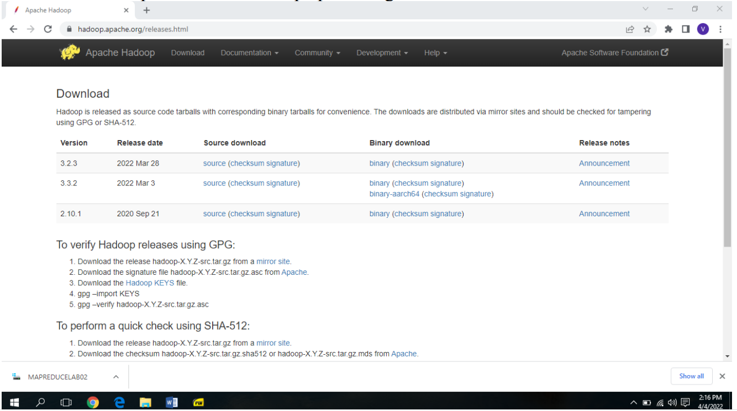

Task 4.2
Develop a MapReduce program to implement Matrix Multiplication.
Assumes that you are using the Hadoop MapReduce framework and have two input matrices, Matrix A and Matrix B, stored in separate files.
Mapper Function: The mapper function takes as input a row from Matrix A and a column from Matrix B. It emits key-value pairs, where the key is the index of the resulting cell in the output matrix, and the value is the partial product of the corresponding elements from Matrix A and Matrix B.
Reducer Function:
The reducer function takes as input a key representing the index of a cell in the output matrix and a list of values representing the partial products for that cell. It calculates the final product by summing up the partial products and emits the result as the output.
The implementation should perform matrix multiplication using the MapReduce paradigm by distributing the computation across multiple mappers and reducers, resulting in efficient processing of large-scale matrices.

Task 4.3
Develop a MapReduce program to find the maximum temperature in each year.
A MapReduce program to find the maximum temperature in each year using the MapReduce paradigm. Assumes that you are using the Hadoop MapReduce framework and have input data in the format: <Year> <Temperature>.
Mapper Function:
The mapper function takes as input a line from the input data file. It extracts the year and temperature from each line and emits key-value pairs, where the key is the year, and the value is the temperature.
Reducer Function:
The reducer function takes as input a year and a list of temperatures associated with that year. It iterates through the list of temperatures to find the maximum temperature and emits the result as the output.

